L - 1 ( Introduction )

- "Panel Data" or "Python Data Analysis"
- Used for analyzing,cleaning,exploring and manipulation of data
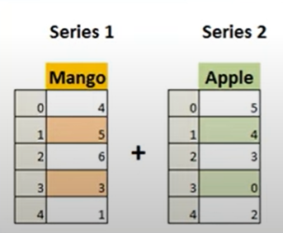
- It can work with - CSV,Text,Json,Zip,etc Files.

Types of Data Structures :-

1. Series : 1D Labeled arrays pd.Series(data).

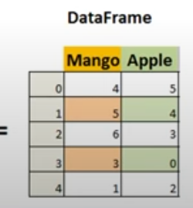
- Dataframes : 2D data structures of colums just like tables.

3. Panel : 3D container of data.

For installation of pandas : -

Write command in cmd : pip install pandas

For importing pandas in python : import pandas as pd

Importance of Pandas :-

1. Pandas allows us to analze big data and make connclusions based on statical theories.
2. Pandas can clean messy data set ,make them reliable and relevant.
3. Eassily handling of missing data (NaN) in floating as well as non-floating.
4. Size Mutability : Can insert and delete data from dataframe and higher dimensional objects.
5. Provide Data set merging and joining.

L - 2 ( Data Structures )

Series( ) : It is defined as the 1Darray capable of storing various types of data.

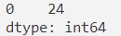
import pandas as pd
A = pd.Series(24)
print(A)
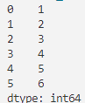
import pandas as pd
X = [1,2,3,4,5,6]
A = pd.Series(X)
print(A)

print(type(A)) # <class 'pandas.core.series.Series'>
print(A[1]) # 2

For Changing the index number
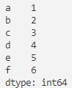
import pandas as pd
X = [1,2,3,4,5,6]
A = pd.Series(X,index=['a','b','c','d','e','f'])
print(A)
print( A['a'])
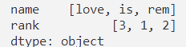
import pandas as pd
X = [1,2]
A = pd.Series(X,index=['a','b'],dtype="float",name="ishu")
print(A)

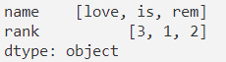
import pandas as pd
Dic = {"name":["love","is","rem"],"rank":[3,1,2]}
A = pd.Series(Dic)
print(A)

# name or rank can have more values .Here, the size of the of the list does not matter.

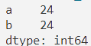
import pandas as pd
A = pd.Series(24,index=['a','b'])
print(A)

# We can use direct operation without the use of broadcasting rule.

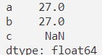
import pandas as pd
A = pd.Series(24,index=['a','b'])
B = pd.Series(3,index=['a','b','c'])
print(A+B)

# NaN : Not a Number
# Here you can see it is working with the missing data.

L - 3 ( DataFrame )

2D Data Structure is the DataFrame. (Eiher List or Dictionary)
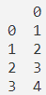
import pandas as pd
A = [1,2,3,4]
Var = pd.DataFrame(A)
print(Var)
print(type(Var)) # <class 'pandas.core.frame.DataFrame'>

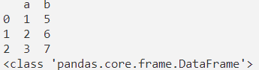
import pandas as pd
D = {"a":[1,2,3],"b":[5,6,7]}
Var = pd.DataFrame(D)
print(Var)
print(type(Var))

# Data must be of same length. In above you cannot put more than 2 element in a list.

To get a particular column data . Eg:- We need the column named as “a” .
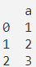
import pandas as pd
D = {"a":[1,2,3],"b":[5,6,7]}
Var = pd.DataFrame(D,columns=["a"])
print(Var)

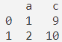
import pandas as pd
D = {"a":[1,2],"b":[5,6],"c":[9,10]}
Var = pd.DataFrame(D,columns=["a","c"])
print(Var)

To get the value from a DataFrame .

import pandas as pd
D = {"a":[1,2],"b":[5,6],"c":[9,10]}
Var = pd.DataFrame(D,columns=["a","c"])
print(Var["a"][0]) # 1

Note: we have to first specify the column then indexing of that data .

Convert a nested list into a DataFrame .

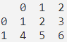
import pandas as pd
Ls = [[1,2,3],[4,5,6]]
Var = pd.DataFrame(Ls)
print(Vrar)

To convert series of data into DataFrame .
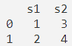
import pandas as pd
Sr = {"s1":pd.Series([1,2]),"s2":pd.Series([3,4])}
Var = pd.DataFrame(Sr)
print(Var)

L - 4 ( Arithmetic Operations )

Operations on columns.
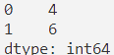
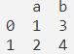
import pandas as pd
Var = pd.DataFrame({"a":[1,2],"b":[3,4]})
print(Var["a"]+Var["b"])

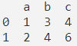
import pandas as pd
Var = pd.DataFrame({"a":[1,2],"b":[3,4]})
Var["c"] = Var["a"]+Var["b"]
print(Var)

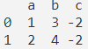
import pandas as pd
Var = pd.DataFrame({"a":[1,2],"b":[3,4]})
Var["c"] = Var["a"]-Var["b"]
print(Var)

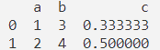
import pandas as pd
Var = pd.DataFrame({"a":[1,2],"b":[3,4]})
Var["c"] = Var["a"]/Var["b"]
print(Var)

import pandas as pd
Var = pd.DataFrame({"a":[1,2],"b":[3,4]})
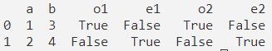
Var["o1"] = Var["a"]%2!=0
Var["e1"] = Var["a"]%2==0
Var["o2"] = Var["b"]%2!=0
Var["e2"] = Var["b"]%2==0
print(Var)

L - 4 ( Delete/Insert )

