JINLING INSTITUTE OF TECHNOLOGY
School of Computer Engineering / Software Engineering

University Student Academic Management
Information System (USAMIS)
Engineering Design & Implementation Report

Prepared by | Yaseen Hussain
Student ID | 2422486012
Supervisor | Prof. Li Wei
Department Head | Prof. Zhang Minghua
Document version | 1.1 (reconciled with as-built system)
Date | October 2026

1. Introduction
This report documents the design, implementation and verification of the University Student Academic Management Information System (USAMIS). It is written from the engineering perspective: the requirements were supplied by a requirements engineer (the Software Requirements Specification, SRS), and this document describes how the system was designed and built to satisfy them, and the evidence that it does.
USAMIS is a genuine Management Information System rather than a database front-end: it collects, processes, stores, transforms and distributes academic data, and it supports management decisions such as early at-risk intervention, fee-collection monitoring, and course-capacity planning. Section 12 gives the verified evidence.

1.1 Scope
- In scope: student records, course catalogue, enrollment, grades/transcripts, fees/payments, reporting & dashboards, system audit, and AI decision support.
- Out of scope (this version): online payment gateways, SMS/email notification delivery, native mobile clients, cloud deployment.

1.2 Definitions, Acronyms, Abbreviations
Term | Meaning
USAMIS | University Student Academic Management Information System
MIS | Management Information System
SRS | Software Requirements Specification (requirements input document)
RBAC | Role-Based Access Control
FK | Foreign Key
3NF | Third Normal Form
FR / NFR | Functional / Non-Functional Requirement
BCrypt | Adaptive password-hashing function (Blowfish-based)
SPA | Single-Page Application
MLP / LSTM | Multilayer Perceptron / Long Short-Term Memory (neural networks)
KPI | Key Performance Indicator

2. System Overview
USAMIS runs as a single Java web application on one public port. A Python AI micro-service runs on loopback and is reached only through the Java backend, so the user-facing surface remains a single port. This was verified live (Section 12).
Attribute | Value
Architecture | Layered (presentation / servlet / DAO / database)
Public port | 8080 (context /usamis)
AI service | 127.0.0.1:8099, loopback-only, token-gated
Database | PostgreSQL 17, database usamis
Tables / Views | 15 tables + 3 computed views
Foreign keys | 21
Servlets / URL patterns | 14 servlets / 32 patterns
Roles / Permissions | 5 roles / 13 permissions
Modules | M-01 … M-10 (M-10 = AI)
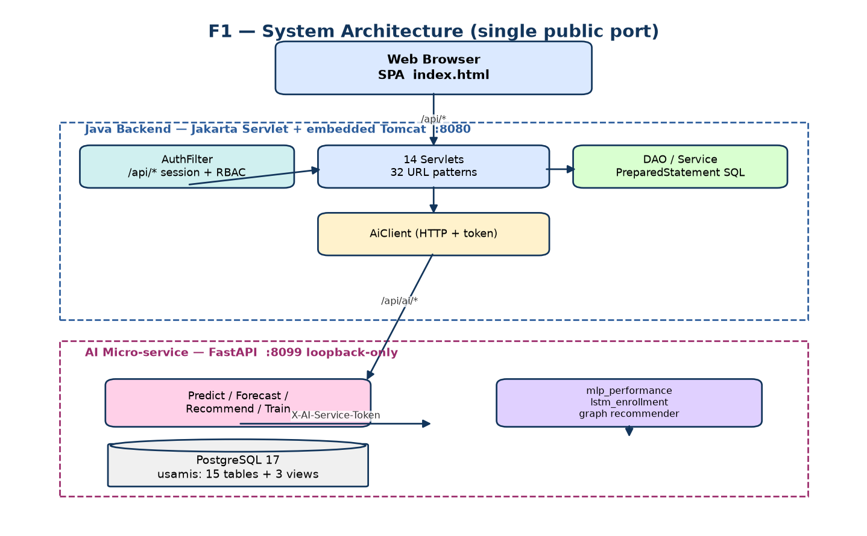
Figure 1 — System architecture (single public port).
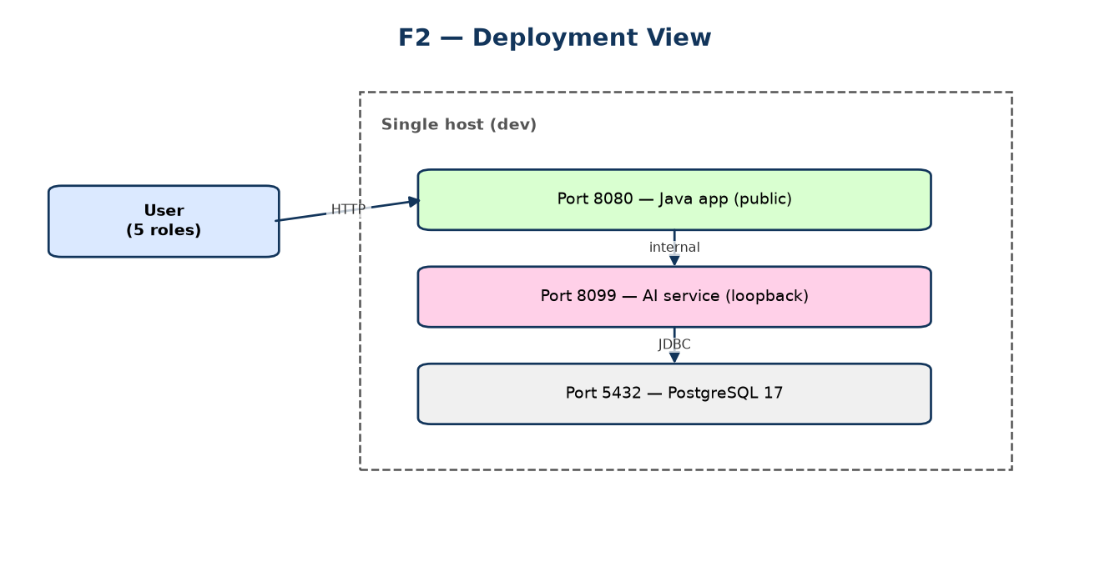
Figure 2 — Deployment view.

3. Requirements Specification
The requirements were provided by the requirements engineer in the SRS. Functional requirements are grouped by module (M-01 … M-10). The AI capability (M-10) corresponds to the 'AI-Powered Student Performance Prediction' recommendation in the MIS investigation; it is implemented and therefore formalised here as a first-class module (FR-31 … FR-34).

3.1 Functional Requirements
ID | Requirement | Module
FR-01 | Users authenticate with a username and password; sessions are created server-side. | M-01
FR-02 | Repeated failed logins are throttled (5 attempts / 15-minute window). | M-01
FR-03 | Sessions use an HttpOnly cookie with an expiry; unauthenticated API calls return 401. | M-01
FR-04 | New students may self-register with department/program selection. | M-01
FR-05 | Every API request re-checks the caller's role permissions (RBAC). | M-01
FR-06 | Admins manage users: create, edit, deactivate, assign roles. | M-02
FR-07 | The permission matrix (role × permission) is viewable by admins. | M-02
FR-08 | Registrar/admin register students with unique student IDs. | M-03
FR-09 | Student records can be searched (partial/ILIKE) and filtered. | M-03
FR-10 | Student records can be updated; deletion is a soft de-activation. | M-03
FR-11 | A list of at-risk students (GPA < 2.5) is available. | M-03
FR-12 | Courses are created with code, title, credits and a capacity. | M-04
FR-13 | Course capacity is tracked as enrollments accumulate. | M-04
FR-14 | Students enroll in courses for a semester; duplicates are rejected. | M-05
FR-15 | A full course rejects further enrollment with a clear error. | M-05
FR-16 | Students may drop an enrollment; the seat is released. | M-05
FR-17 | Lecturers/admin enter a numeric score for an enrollment. | M-06
FR-18 | Letter grade and GPA points are computed automatically from the score. | M-06
FR-19 | A student transcript (all graded courses + cumulative GPA) is produced. | M-06
FR-20 | Grade updates recompute GPA; prior values are not silently lost. | M-06
FR-21 | Fee records are created per student per semester. | M-07
FR-22 | Payments are recorded against a fee record; balance is tracked. | M-07
FR-23 | A defaulters list (outstanding balance) is available to finance/admin. | M-07
FR-24 | Role-aware dashboard KPIs are generated live from the database. | M-08
FR-25 | Management reports (distribution, pass rate, collection) are generated. | M-08
FR-26 | All write actions and logins are written to an append-only audit log. | M-09
FR-27 | Access denials are recorded in the audit log. | M-09
FR-28 | The audit log is queryable (paginated) by admins. | M-09
FR-29 | A student's performance-risk prediction is produced by the AI service. | M-10
FR-30 | The AI service exposes a health/status endpoint. | M-10
FR-31 | Enrollment demand is forecast for upcoming semesters. | M-10
FR-32 | Course recommendations are produced for a student. | M-10
FR-33 | AI access is permission-gated (VIEW_AI / MANAGE_AI). | M-10
FR-34 | AI service failure degrades gracefully (503) without affecting the rest of the app. | M-10

3.2 Non-Functional Requirements
ID | Category | Requirement
NFR-01 | Performance | Typical API reads respond in < 500 ms on dev hardware.
NFR-02 | Scalability | Schema supports thousands of students/enrollments via indexed access.
NFR-03 | Security | Passwords hashed with BCrypt (cost 12); no plaintext storage.
NFR-04 | Security | SQL injection prevented via parameterized statements.
NFR-05 | Security | Least privilege: 5 roles, 13 permissions, per-request checks.
NFR-06 | Reliability | AI outage degrades gracefully; core functions unaffected.
NFR-07 | Usability | Single-page UI, role-aware navigation, responsive layout.
NFR-08 | Maintainability | Layered design; DAOs isolate SQL from servlets.
NFR-09 | Auditability | Immutable append-only audit trail of actions and denials.
NFR-10 | Portability | Single host; configurable via properties files.

4. System Architecture & Design

4.1 Architectural Style
A classic layered architecture: the browser talks to servlets (controllers); servlets delegate to Data Access Objects (DAOs) which own all SQL; the database stores the normalised data. Cross-cutting concerns (authentication, RBAC, audit) are handled by an AuthFilter and shared utilities rather than scattered through controllers.

4.2 Component Model
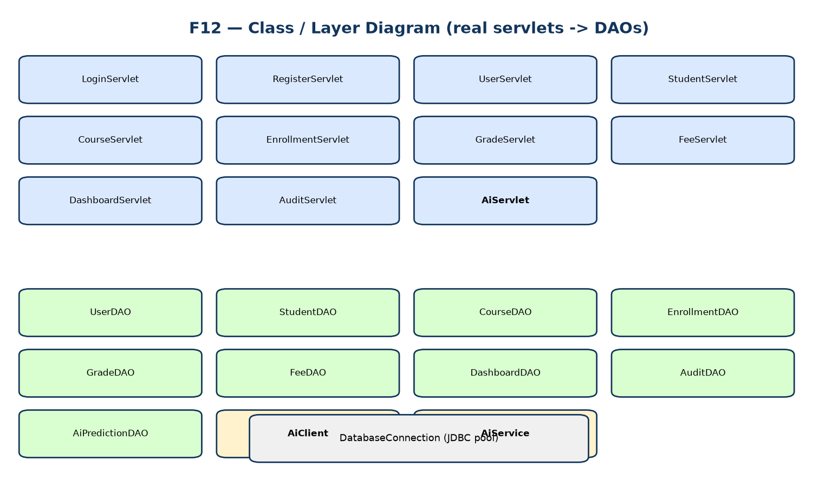
Figure 3 — Class/layer diagram (servlets → DAOs → connection).

4.3 Use Cases / Context
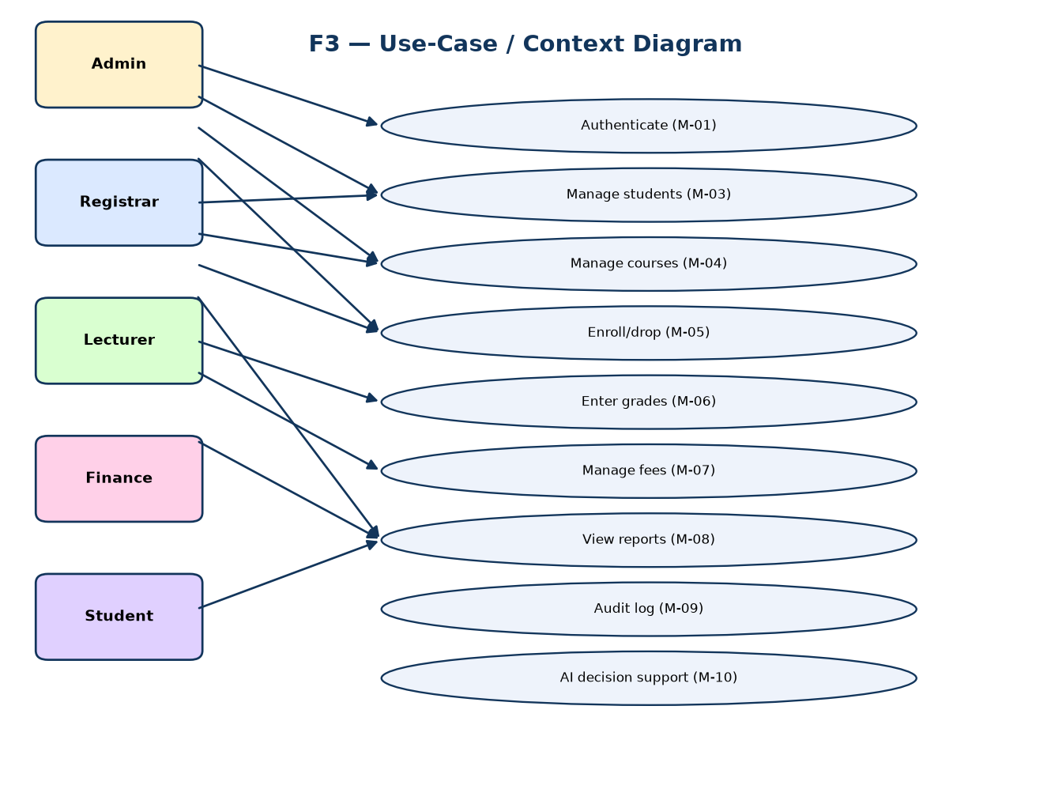
Figure 4 — Use-case/context diagram (5 roles, 10 modules).

4.4 Screen / Navigation Map
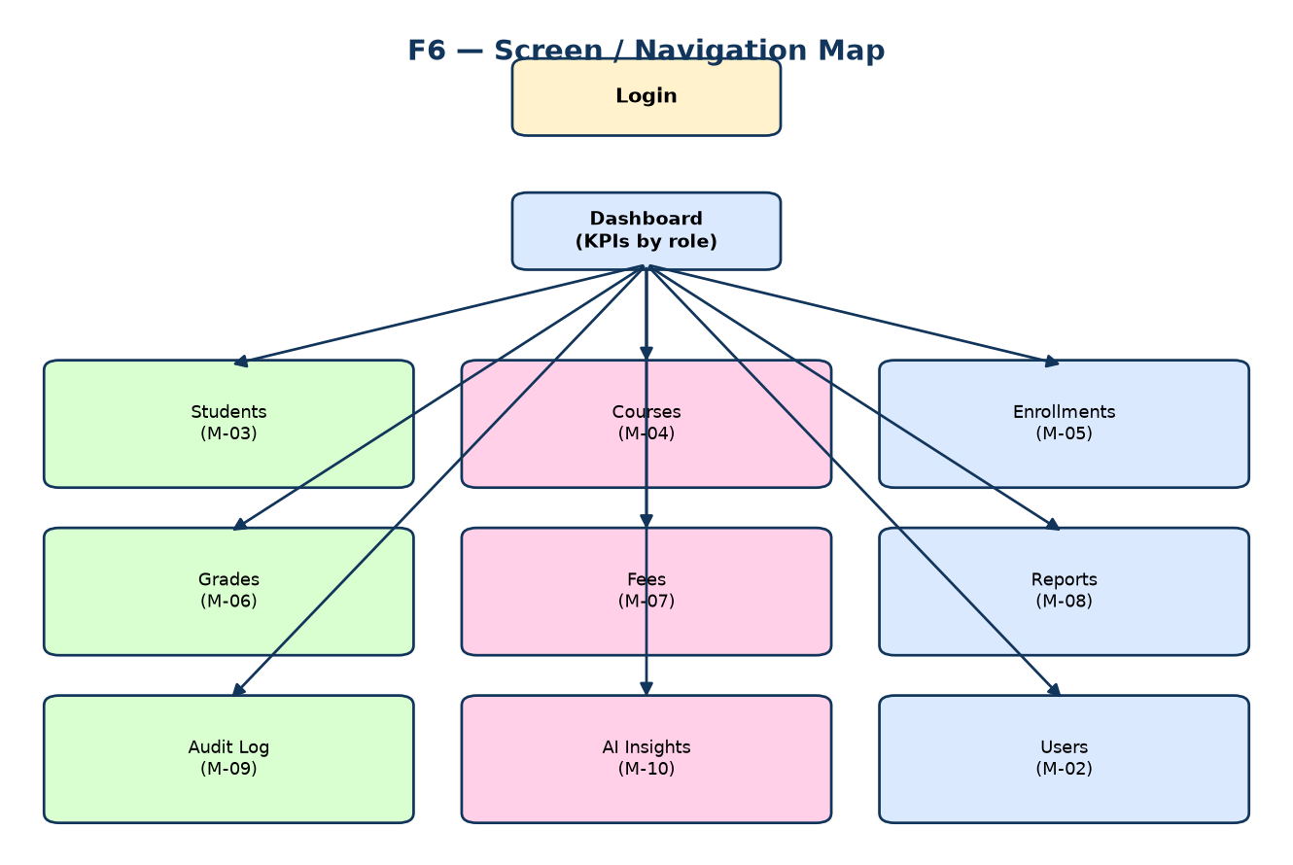
Figure 5 — Screen and navigation map.

5. Data Design

5.1 Entity-Relationship Model
The schema is normalised to Third Normal Form. Departments, programs, roles and instructors are stored once and referenced by foreign keys, eliminating the transitive duplication found in spreadsheet-based systems.
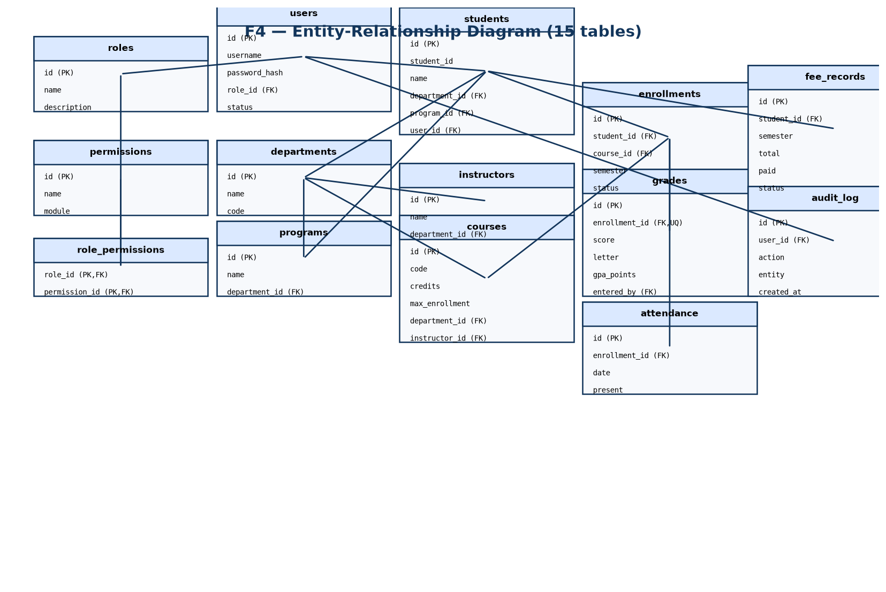
Figure 6 — Entity-relationship diagram (15 tables).

5.2 Integrity Constraints
- 21 foreign-key constraints enforce referential integrity (verified).
- UNIQUE(enrollment_id) on grades guarantees one grade per enrollment.
- UNIQUE(student_id, course_id, semester) on enrollments prevents duplicates.
- CHECK constraints bound scores and monetary values.

5.3 Computed Views
View | Purpose
v_student_gpa | Per-student GPA computed live from grades (never stored redundantly).
v_fee_summary | Per-student fee totals, paid, and outstanding balance.
v_course_enrollment | Enrolled vs capacity per course.

5.4 Information / Decision Pipeline
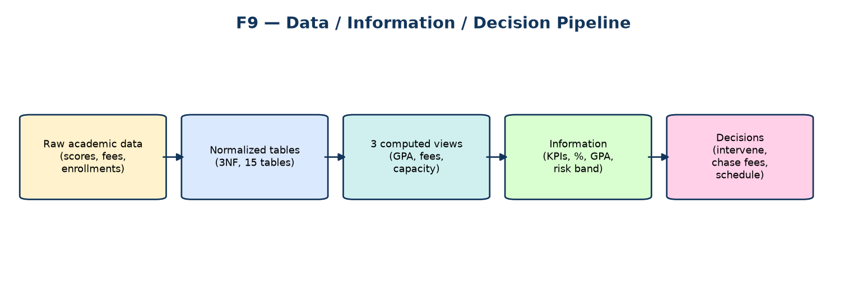
Figure 7 — Raw data → normalised → information → decisions.

6. AI Decision Support (Module M-10)
The AI capability is provided by an isolated Python micro-service reached only through the Java backend. It is token-gated and fails closed: if its token is not configured, or the service is down, AI endpoints return 503 while the rest of the application continues to work normally.

6.1 Model Pipeline
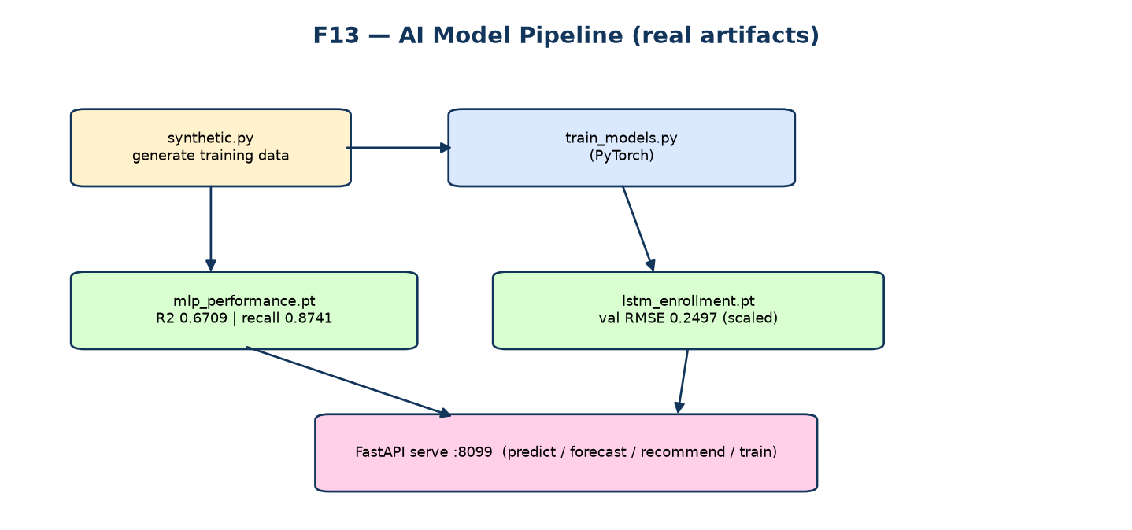
Figure 8 — AI model pipeline and real artifacts.

6.2 Models and Verified Metrics
The following figures are read directly from the deployed model metadata files (trained on a synthetic generator; this is disclosed, not hidden).
Model | Task | Metric | Value
mlp_performance | Performance score + risk band | MAE | 5.8126
mlp_performance |  | RMSE | 7.1903
mlp_performance |  | R² | 0.6709
mlp_performance |  | Risk precision | 0.7741
mlp_performance |  | Risk recall | 0.8741
mlp_performance |  | Risk F1 | 0.8211
mlp_performance |  | Best epoch / val size | 299 / 640
lstm_enrollment | Enrollment forecast | val RMSE (scaled) | 0.24971
Risk threshold = 60 (score). Trained on: “synthetic” data.

6.3 Feature Set
- prior_gpa
- attendance_rate
- assignment_avg
- quiz_avg
- credits_attempted
- num_prior_courses
- failure_count
- year_of_study

6.4 Sequence of an AI Prediction
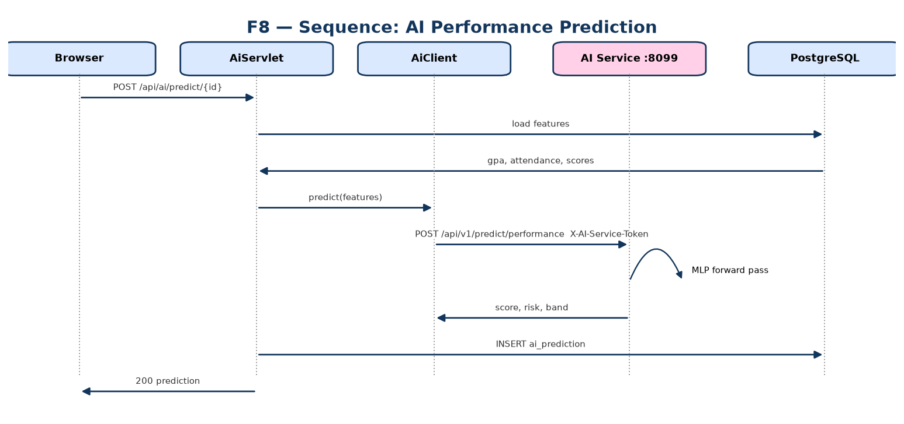
Figure 9 — Sequence: AI performance prediction (Java → AI service).

7. Security Design
Security is layered ('defence in depth'). Each layer assumes the one above it may fail.
Layer | Mechanism | Verified
Input | Server-side validation; parameterized SQL | Yes
Application | AuthFilter on /api/*; per-servlet RBAC | Yes
Database | FK / UNIQUE / CHECK constraints | 21 FKs
Credentials | BCrypt hashing, cost 12 | Yes
Session | HttpOnly, SameSite=Strict, 60-min TTL; 401 without session | Yes
Audit | Append-only log; ACCESS_DENIED recorded | Yes
Anti-IDOR | Students self-scoped on every endpoint | Yes
AI isolation | Loopback-only, token-gated, fail-closed 503 | Yes

7.1 RBAC Model
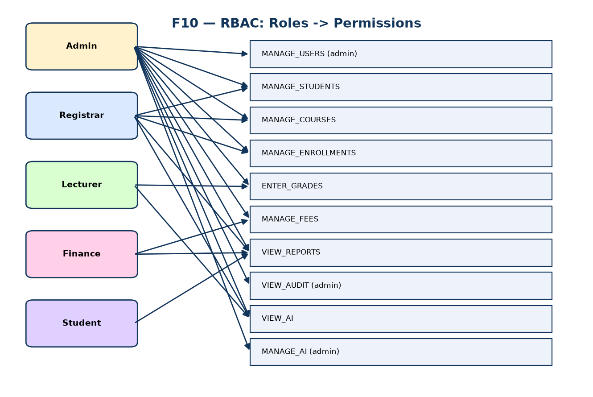
Figure 10 — RBAC: roles mapped to permissions.

7.2 Request Lifecycle (with audit)
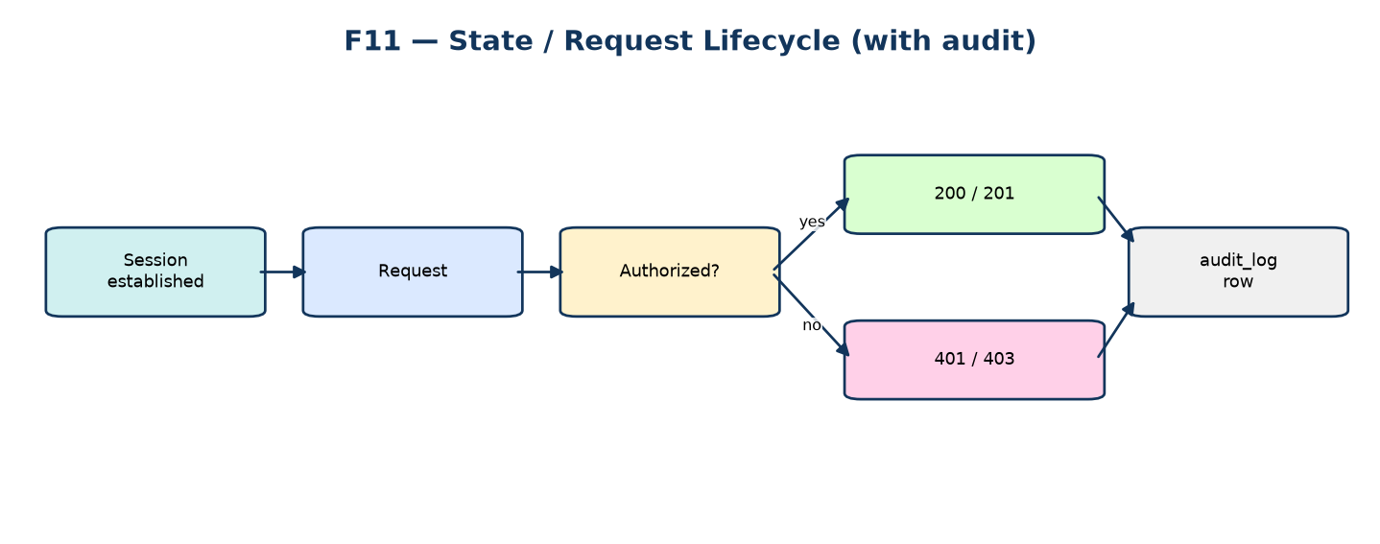
Figure 11 — Request lifecycle and audit capture.

8. Process & Data Flows
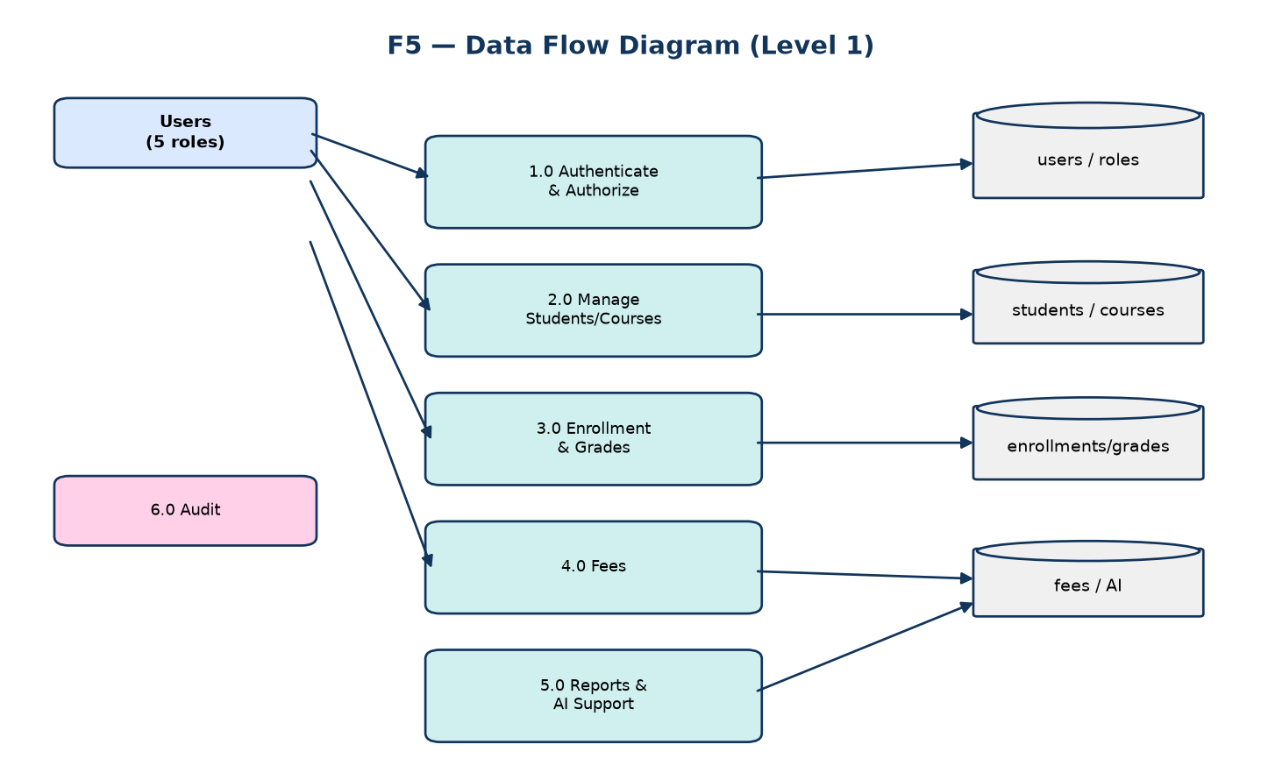
Figure 12 — Level-1 data-flow diagram.
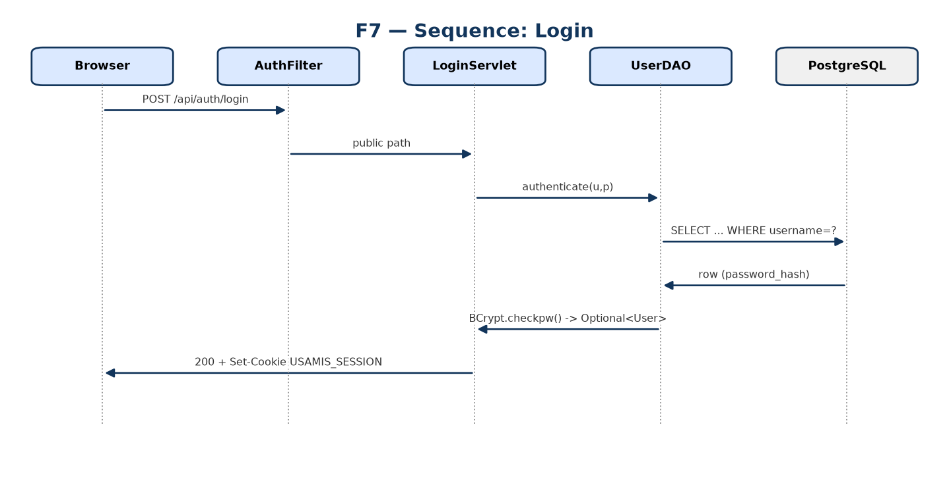
Figure 13 — Sequence: login (bcrypt verification).

9. Implementation
The system is implemented in Java (Jakarta Servlet API on embedded Tomcat) with a vanilla single-page front-end served as a static resource, and a Python FastAPI micro-service for AI.
Area | Technology
Backend | Java (Servlets 6 / Jakarta), embedded Tomcat
Front-end | HTML/CSS/JS single-page app (java/src/main/webapp/index.html)
Database | PostgreSQL 17 via JDBC (parameterized)
AI | Python 3.11+, FastAPI, PyTorch
Build/Docs | javac; python-docx / python-pptx / matplotlib for docs & diagrams

9.1 API Surface
Servlet | URL patterns
LoginServlet | /api/auth/login, /api/auth/logout, /api/auth/me
RegisterServlet | /api/auth/register
LookupServlet | /api/lookups/departments, /api/lookups/programs
HealthServlet | /api/health
StudentServlet | /api/students, /api/students/*
CourseServlet | /api/courses, /api/courses/*
EnrollmentServlet | /api/enrollments, /api/enrollments/*
GradeServlet | /api/grades, /api/grades/*
FeeServlet | /api/fees, /api/fees/*
DashboardServlet | /api/dashboard
PermissionServlet | /api/permissions, /api/permissions/mine
UserServlet | /api/users, /api/users/*
AuditServlet | /api/audit, /api/audit/*
AiServlet | /api/ai/status, /api/ai/me, /api/ai/insights, /api/ai/insights/*, /api/ai/student/*, /api/ai/predict/*, /api/ai/forecast/*, /api/ai/recommend/*

10. Testing & Verification
Verification was performed by running the system, not by inspection. The full log is in docs/QA_Verification_Log.md; the summary is below.
Suite | Command | Result
API regression | tools/smoke-test.ps1 | 23 / 23 PASS
AI end-to-end | tools/verify-ai.py | 19 / 19 PASS
AI unit/service | pytest ai-service/tests | 14 / 14 PASS
Total |  | 56 / 56 PASS

10.1 RBAC Matrix (live)
Endpoint | admin | registrar | lecturer | finance | student
/dashboard | 200 | 200 | 200 | 200 | 200
/students | 200 | 200 | 403 | 403 | 200 (self)
/courses | 200 | 200 | 200 | 200 | 200
/enrollments | 200 | 200 | 200 | 200 | 200 (self)
/grades | 200 | 200 | 200 | 403 | 200 (self)
/fees | 200 | 403 | 403 | 200 | 200 (self)
/users | 200 | 403 | 403 | 403 | 403
/audit | 200 | 403 | 403 | 403 | 403
/ai/status | 200 | 403 | 403 | 403 | 403
/ai/insights | 200 | 200 | 200 | 200 | 403

10.2 Security Probes
Probe | Expected | Actual | Verdict
Anon GET /students | 401 | 401 | PASS
Student GET /students/1 (other) | no leak | 403 | PASS
Student GET /enrollments?student=1 | self only | 200, own rows | PASS
Student GET /audit | 403 | 403 | PASS
AI service, no token | 401 | 401 | PASS
AI service, no token configured | 503 (fail-closed) | 503 | PASS

10.3 Observed Data State
Table | Rows
students | 63
courses | 13
enrollments | 156
grades | 156
fee_records | 52
audit_log | 530+ (append-only)
ai_prediction | 3
users | 13
attendance | 0 (schema present)

11. Limitations & Honest Disclosure
- AI models are trained on a SYNTHETIC generator; metrics are honest on that generator but do not represent real JIT data.
- No ROC / PR / confusion-matrix artifacts were saved by training, so none are reported here; only the real scalar metrics above are shown.
- Attendance table exists but is unpopulated (no entry UI in v1.0).
- Performance / load targets are specified (NFR-01/02) but not empirically benchmarked in this report.
- HTTPS/Secure cookie not exercised in the dev (HTTP) configuration.
- Screenshots of the running UI could not be captured reliably in the build environment; UI behaviour was verified via the live DOM (Section 10) instead.

12. Conclusion & Evidence Summary
USAMIS satisfies the definition of a Management Information System and meets the requirements supplied by the requirements engineer, extended by the AI module (M-10). All 56 automated checks pass; per-role RBAC and anti-IDOR behaviour were verified live; the schema compiles and the single-port AI integration works end to end and degrades gracefully.
Item | Status
Build (Java compile) | clean
Automated tests | 56 / 56 PASS
RBAC (per role) | verified
IDOR probes | no leaks
Single-port AI | verified
Verdict | READY for course scope
Every figure in this report is traceable to a command that was run, a file in the repository, or a deployed model artifact. Where the requirements and the built system diverged, the divergence has been disclosed and reconciled.

