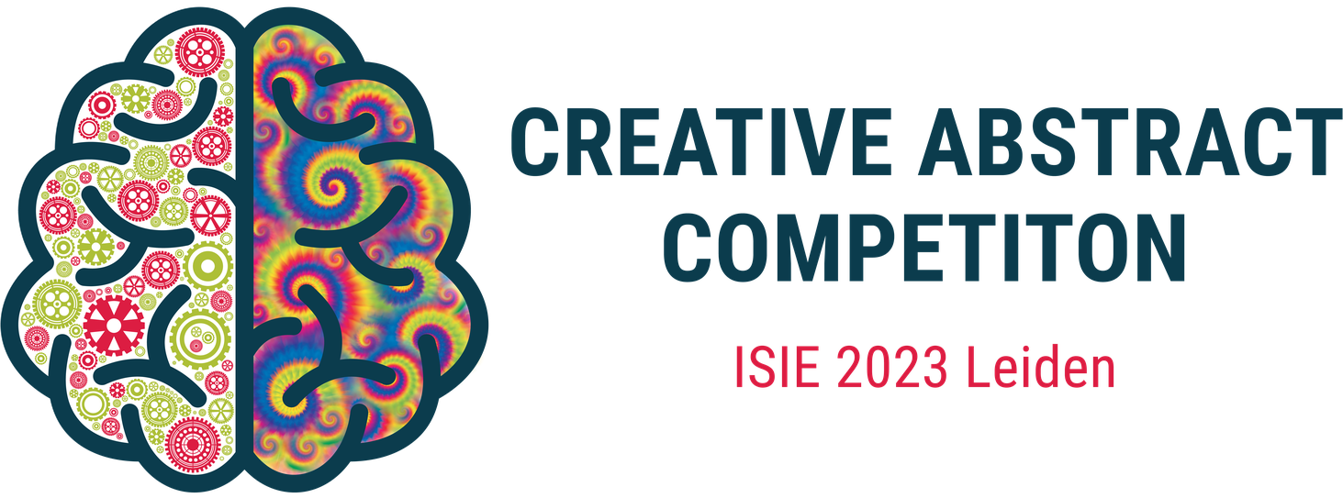

Subject: Invitation to participate in the Creative Abstract Competition at ISIE Conference 2023

Dear participant,

We are excited to invite you to participate in the "Creative Abstract Competition" at the International Society of Industrial Ecology (ISIE) Conference 2023. Would you like to shine a different light on your research, and maybe WIN A PRIZE? Come join the competition!

Abstracts should be informative, but could they also be fun? We believe ‘creative abstracts’ can be an antidote to mundane abstracts. A **creative abstract** has a similar objective to a scientific abstract in that the purpose is to **draw potential readers to the research**. However, the creative abstract s**hould not simply duplicate the scientific abstract** as is common with graphical or visual abstracts. We invite you to challenge yourself to **spark interest in your research and make your results accessible to a wider audience other than academia by** **producing a creative abstract in a text, image, video, audio, or a physical work.**

The competition is open to all ISIE conference presenters. You can submit your creative abstract at the website, please do so before June 23rd. Once all entries are in, a shortlist will be selected by a judging panel. Thereafter the winners will be selected by popular vote of ISIE attendees and will be announced during the conference. Exciting **prizes** will be awarded to recognize the top entries, more information about those will follow soon. On the website you can find more detailed entry guidelines and assessment criteria.

Hopefully you are as enthusiastic as we are for this opportunity to showcase your work and do something different with your intellectual and creative powers. If you have any questions or concerns, please do not hesitate to contact us. We look forward to receiving your submission and wish you good luck in the competition!

You can visit our website and see the complete documentation on our public GitHub repository.

Best regards,

The organising committee of the Creative Abstract Competition

ISIE Conference 2023