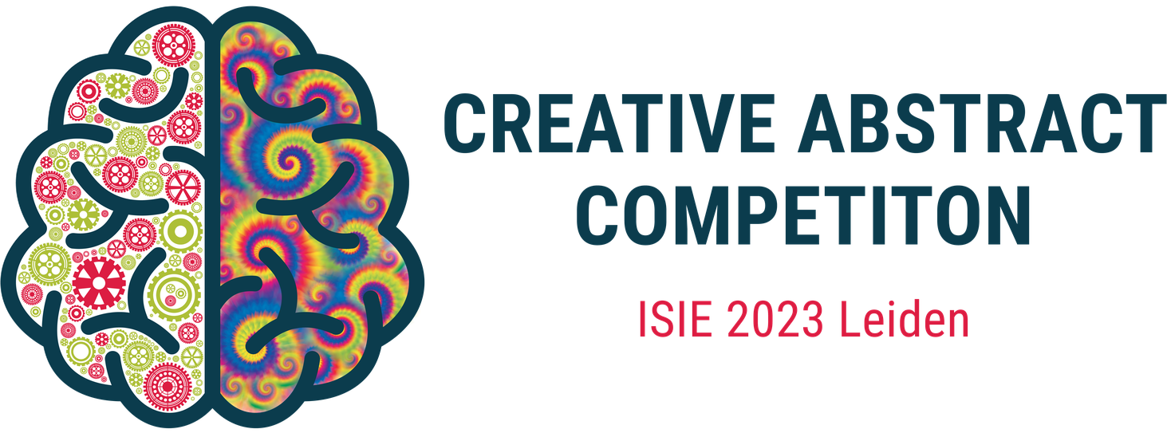

Subject: Invitation to Sponsor "Creative Abstract Competition" at ISIE 2023

Dear [Sponsor Contact Name],

I hope this email finds you well. My name is [Your Name] and I am a member of the committee organizing an event at the International Society of Industrial Ecology (ISIE) Conference to be held on 2-5 July 2023 in Leiden. On top of 600+ presentations, we are planning to host a "Creative Abstract Competition" to encourage researchers and professionals to showcase their research and ideas in an innovative and creative way.

To make this competition a success, we are seeking the support of industry sponsors to help provide exciting prizes for the winning entries. The competition is open to researchers and professionals from around the world, and we anticipate a large number of participants.

Sponsorship of this competition will give your organization the opportunity to showcase your commitment to innovative and creative research, and gain exposure to a diverse group of professionals, students, and academics. Your organization's name and logo will be prominently displayed on all competition-related materials, including the conference website, social media, and promotional materials. Your support will be acknowledged during the conference and the competition results will be shared with all sponsors and conference attendees. We could also offer free entry to a part of the conference for one or two representatives from your organization (the registration fee for the full conference is €1050).

We would be delighted to discuss the opportunity to sponsor the "Creative Abstract Competition" with you further. If you are interested, please let us know and we can arrange a meeting or call to discuss further details. You can also visit our [website](https://isie-2023-creativeabstractcompetition.github.io/) and see the complete documentation on our public [GitHub repository.](https://github.com/ISIE-2023-CreativeAbstractCompetition/)

Thank you for your time and consideration.

Best regards,

[Your Name]