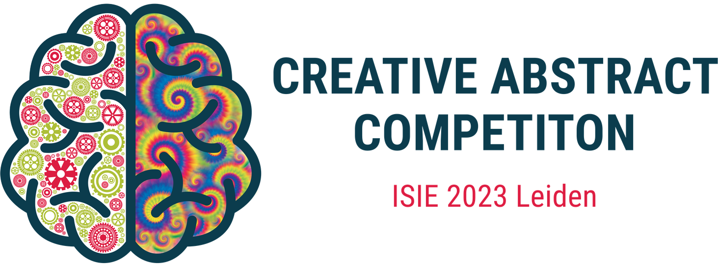

Get ready for the "Creative Abstract Competition" at the International Society of Industrial Ecology (ISIE) Conference, happening on 1-5 July 2023 in Leiden! We are inviting researchers and professionals from around the world to showcase their innovative ideas related to sustainability, innovation, and engineering in the form of text, physical, video, or audio. This is your chance to demonstrate your creativity and originality, and gain recognition for your work on a global platform. Join us for this exciting competition and get a chance to win amazing prizes! Check out our website for more information and to register your entry.

<https://isie-2023-creativeabstractcompetition.github.io/>

#ISIEConference2023 #CreativeAbstractCompetition #Innovation #Sustainability #Engineering