BACE Management Website

Chat History & Screenshots - September 19, 2026
ISKCON BACE - Jia Sarai - Community OS
All times are in IST (India Standard Time, UTC+5:30)

────────────────────────────────────────────────────────────────────────────────

NIGHT - Sep 18 ~12:47 AM IST | Reference UI Design (PlanIQ Top-Navbar Style)
You shared 3 reference screenshots of the PlanIQ-style top-navbar layout that you wanted the BACE website redesigned to look like (remove sidebar, add header navigation).

Reference Screenshot 1 Top Navbar Style
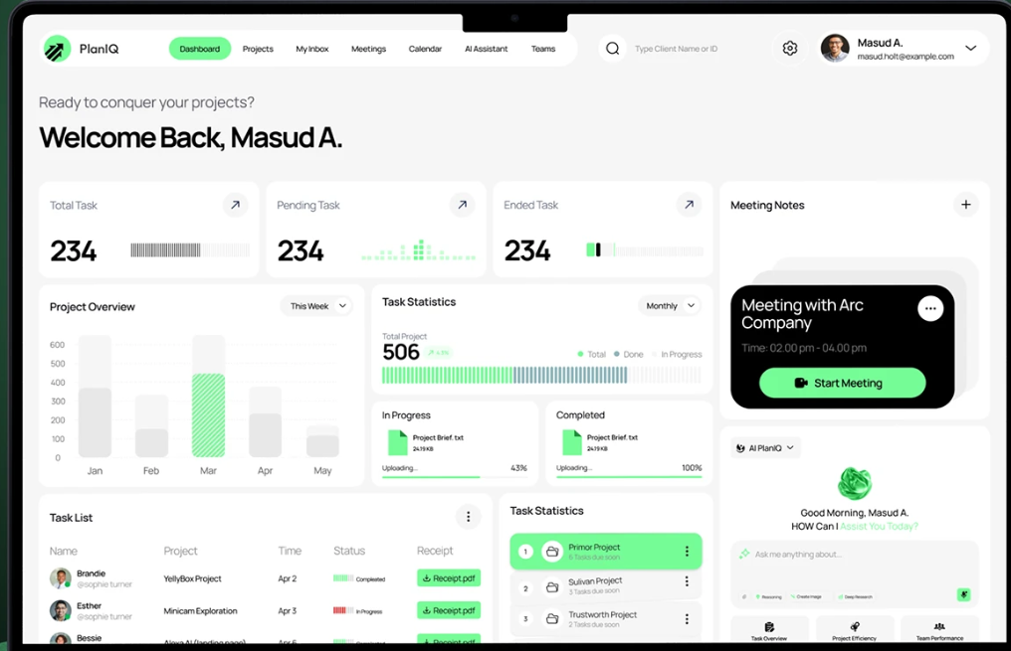

Reference Screenshot 2 Dashboard Cards Layout

Reference Screenshot 3 Layout Detail

────────────────────────────────────────────────────────────────────────────────

MORNING - ~10:54 AM IST | Early Session - Dashboard Before Edits
Dashboard state before morning edits began.
Dashboard Before Morning Edits (~10:54 AM)
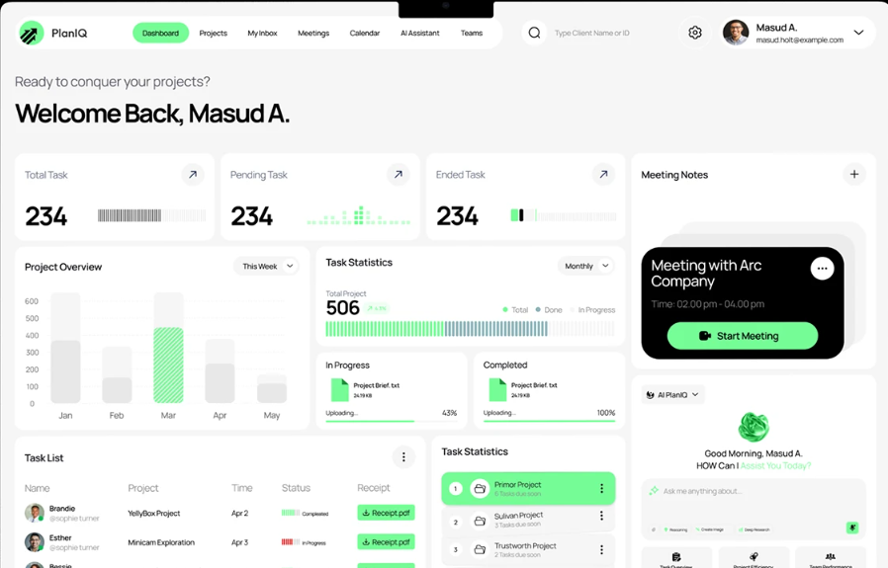

~11:26 AM IST
UI State - 11:26 AM (1 of 2)
UI State - 11:26 AM (2 of 2)
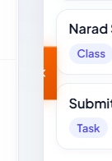

~11:34 AM IST
UI State - 11:34 AM
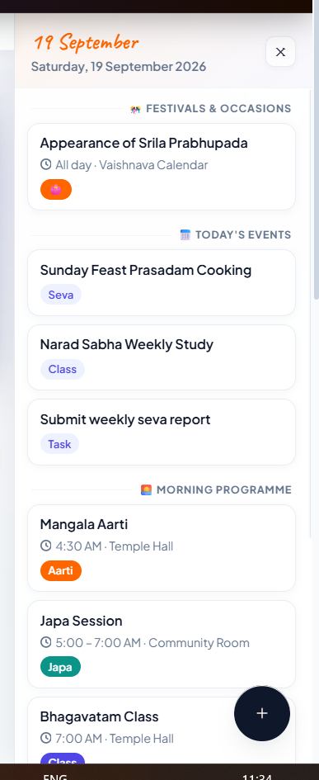

~11:49 AM IST
UI State - 11:49 AM
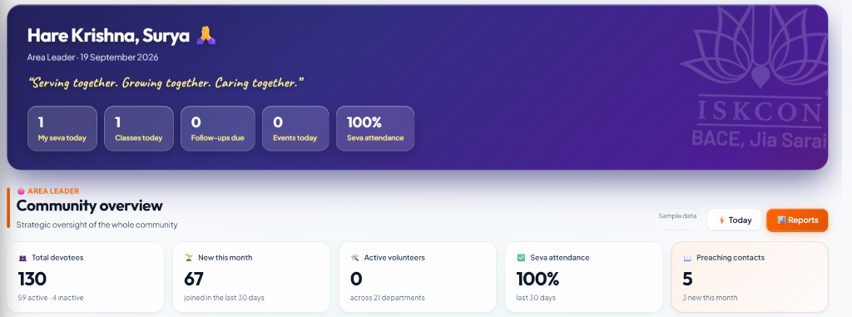

────────────────────────────────────────────────────────────────────────────────

12:03 PM IST | Dashboard Header Labels
YOUR REQUEST:
"instead of Area Leader change it to ISKCON BACE and add the relevant icon
and instead of Community overview change it to Community blocks"
Screenshot Dashboard before label changes
[DONE] Done: 'Area Leader' 'ISKCON BACE' with icon; 'Community overview' 'Community blocks'
────────────────────────────────────────────────────────────────────────────────

12:10 PM IST | Stat Card Changes
YOUR REQUEST:
"instead of new this month, give me no. of preaching batches - with right data
instead of seva attendance, give me overall health of BACE (combining percentage of morning program, deity...)"
Screenshot Stat cards before change
[DONE] Done: 'New This Month' Preaching Batches count; 'Seva Attendance' BACE Health composite score
────────────────────────────────────────────────────────────────────────────────

12:16 PM IST | Increase Main Number Size on Cards
YOUR REQUEST:
"can increase the size of the main numbers over the right side of each card"
Screenshot Stat cards with small numbers
[DONE] Done: Increased font size of main stat numbers on each dashboard card
────────────────────────────────────────────────────────────────────────────────

12:18 PM IST | Remove Graph from Main Page
YOUR REQUEST:
"remove this from the main page.. just the graph"
(No screenshot was attached you described the element verbally)
[DONE] Done: Removed the specified graph from the main dashboard page
────────────────────────────────────────────────────────────────────────────────

12:22 PM IST | Layout Adjustment
YOUR REQUEST:
"no no.. keep the community calendar widget should span the same amount like before
make the BACE Management, BACE Preaching and Devotee care blocks shift above.."
(No screenshot attached)
[DONE] Done: Calendar widget kept full-width; three pillar blocks moved up
────────────────────────────────────────────────────────────────────────────────

12:29 PM IST | Pillar Block Sub-Cards
YOUR REQUEST:
"here inside these three separate blocks.. I want to put small cards of the respective block.. for example inside the BACE Management there should be management dashboard card, departments card, assign seva card, attendance card..."
Screenshot Pillar blocks before sub-cards were added
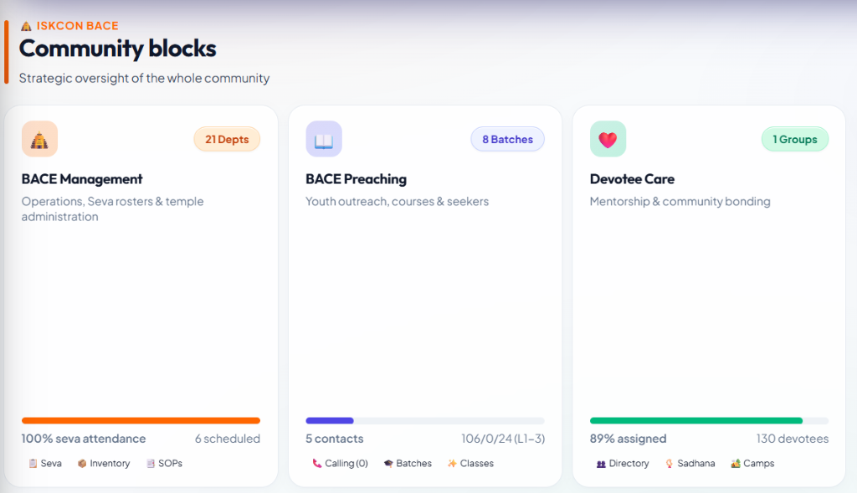
[DONE] Done: Clickable sub-cards added inside BACE Management, BACE Preaching, and Devotee Care blocks
────────────────────────────────────────────────────────────────────────────────

12:38 PM IST | Add Attendance Sub-Card and Devotee Care Cards
YOUR REQUEST:
"add attendance sub card inside the BACE preaching block.. maybe adjust the height of the block accordingly without adding any horizontal scroll
in the devotee care block give me all the [care sub-cards]"
Screenshot 1 Pillar blocks with sub-cards
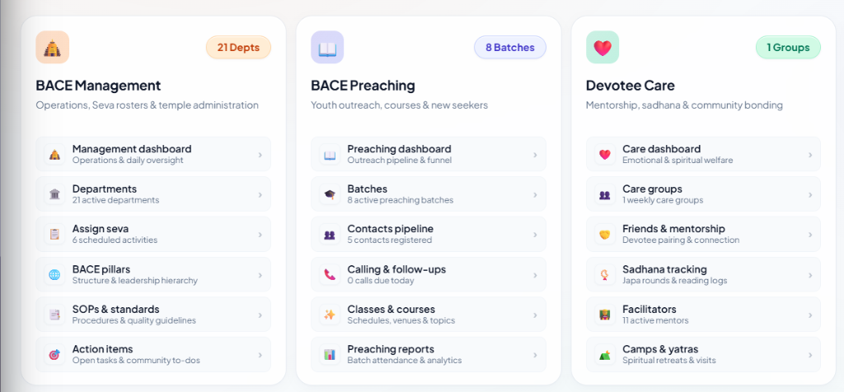
Screenshot 2 Devotee care block detail
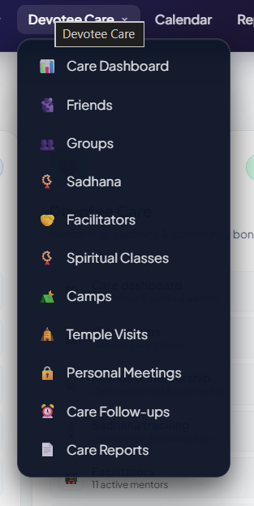
[DONE] Done: Attendance sub-card added to Preaching block; all care sub-cards added to Devotee Care block
────────────────────────────────────────────────────────────────────────────────

12:46 PM IST | Merge Preaching Reports and Dashboard
YOUR REQUEST:
"merge preaching reports & preaching dashboards into one page/section.. include everything, also don't repeat anything.. use your intelligence"
(No screenshot attached)
[DONE] Done: Merged into single unified Preaching page no repetition
────────────────────────────────────────────────────────────────────────────────

12:55 PM IST | Move Items to Contacts and Pipeline
YOUR REQUEST:
"shift all these items to contacts & pipeline page as it is by adding one more sub section to the contacts & pipeline named dashboard"
Screenshot Preaching section before move
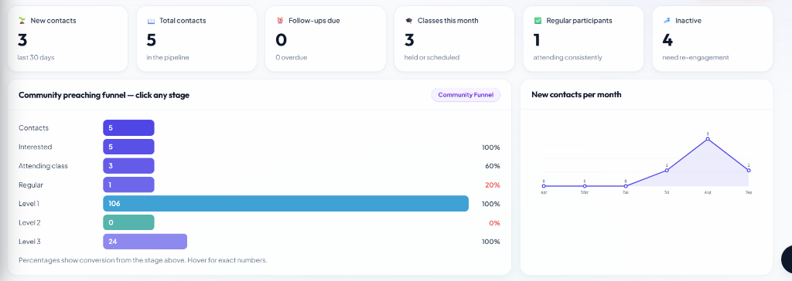
[DONE] Done: 'Dashboard' sub-section added to Contacts & Pipeline page; all items moved there
────────────────────────────────────────────────────────────────────────────────

1:01 PM IST | Remove Narrative Report and Shift Graph
YOUR REQUEST:
"remove this narrative report and also remove followup load overview
and shift the batch attendance comparison to the bottom of all community batches data"
Screenshot 1 Narrative report to remove
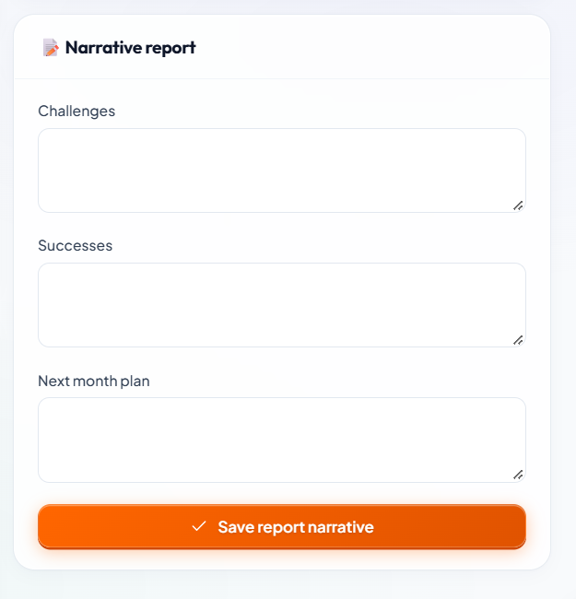
Screenshot 2 Followup load overview to remove
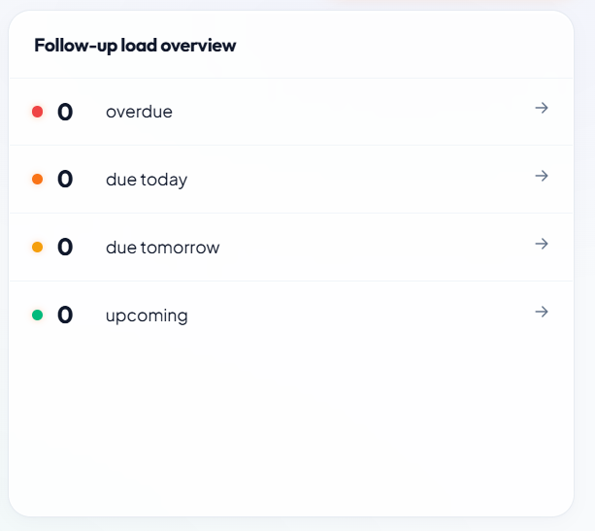
Screenshot 3 Batch attendance comparison placement
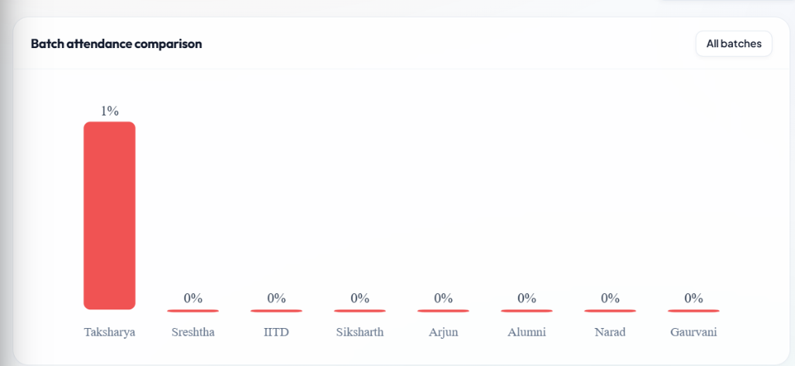
[DONE] Done: Narrative Report removed; Followup Load Overview removed; Batch Attendance Comparison moved to bottom
────────────────────────────────────────────────────────────────────────────────

1:06 PM IST | Shift Attendance Per Class Graph
YOUR REQUEST:
"shift this attendance per class graph to the bottom of batch follow up"
Screenshot Attendance per class graph position
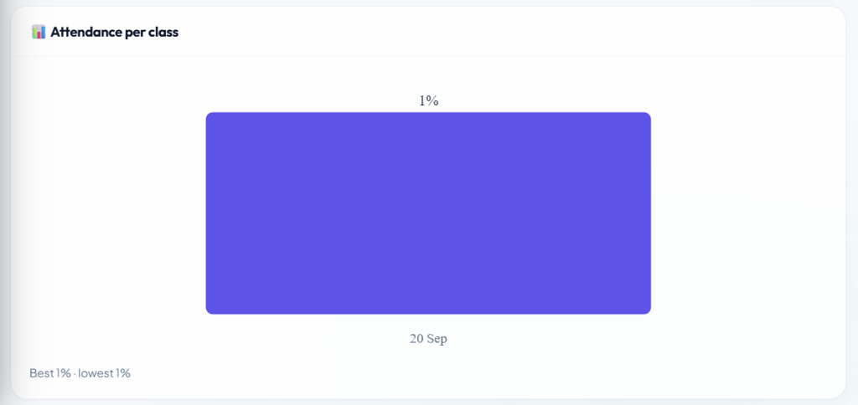
[DONE] Done: Attendance Per Class graph moved to bottom of Batch Follow-up section
────────────────────────────────────────────────────────────────────────────────

1:10 PM IST | Add Batch and Community Batches Sub-Sections
YOUR REQUEST:
"add two sub sections to this.. one for batch and other for community batches.. and shift the all community batches table and batch attendance comparison graph to the sub section of community batches"
Screenshot 1 Page before sub-sections
Screenshot 2 Detail view
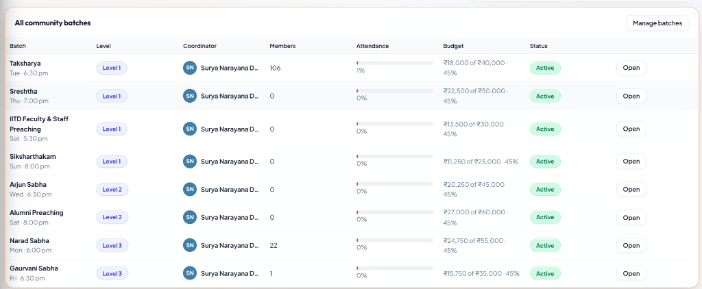
[DONE] Done: Two sub-sections added 'Batch' (individual) and 'Community Batches' (all table + comparison graph)
────────────────────────────────────────────────────────────────────────────────

1:25 PM IST | Remove CSV/PDF Buttons and Add Per-Batch PDF
YOUR REQUEST:
"remove both of the buttons of export csv & generate report pdf from here
and add generate PDF option for individual batches inside the batch sub section"
Screenshot 1 Buttons to remove

Screenshot 2 Batch sub section detail

[DONE] Done: Global CSV + PDF buttons removed; per-batch PDF generation button added inside Batch sub-section
────────────────────────────────────────────────────────────────────────────────

1:40 PM IST | PDF Layout Adjustments
YOUR REQUEST:
"make the top title centered aligned and keep it at the center of the pdf
remove this attendance per class breakdown graph
also remove individual batch preaching funnel graph"
Screenshot 1 PDF title alignment issue
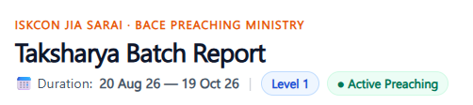
Screenshot 2 Attendance graph in PDF to remove
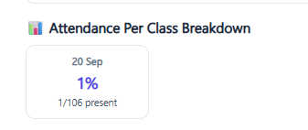
Screenshot 3 Preaching funnel graph to remove
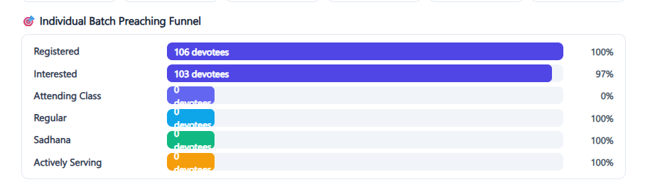
[DONE] Done: PDF title centered; Attendance Per Class Breakdown graph removed; Individual Batch Preaching Funnel graph removed
────────────────────────────────────────────────────────────────────────────────

1:44 PM IST | PDF Header and Remove Fields
YOUR REQUEST:
"instead of this give me ISKCON BACE, Jia Sarai
remove total marks & spent% from here"
Screenshot 1 PDF header to change
Screenshot 2 Fields to remove
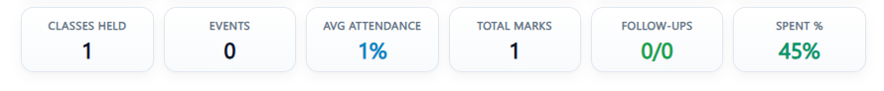
[DONE] Done: PDF header 'ISKCON BACE, Jia Sarai'; 'Total Marks' and 'Spent%' fields removed
────────────────────────────────────────────────────────────────────────────────

1:45 PM IST | Remove Icons from Devotee Names
YOUR REQUEST:
"remove the icons beside the names of these devotees"
Screenshot Devotee names with icons

[DONE] Done: Icons removed from beside devotee names in PDF attendee list
────────────────────────────────────────────────────────────────────────────────

2:58 PM IST | Bug Fix 1
YOUR REQUEST:
"getting this error when I open the local host.. fix this"
Screenshot Error on localhost
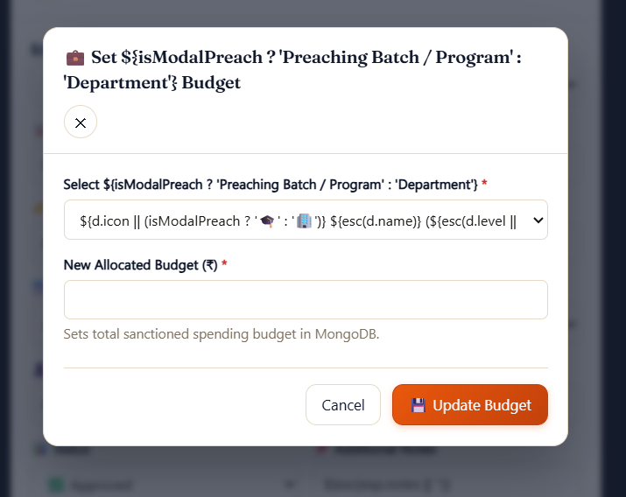
[DONE] Fixed
────────────────────────────────────────────────────────────────────────────────

3:13 PM IST | Bug Fix 2
YOUR REQUEST:
"I got one more error.. fix this"
Screenshot Second error
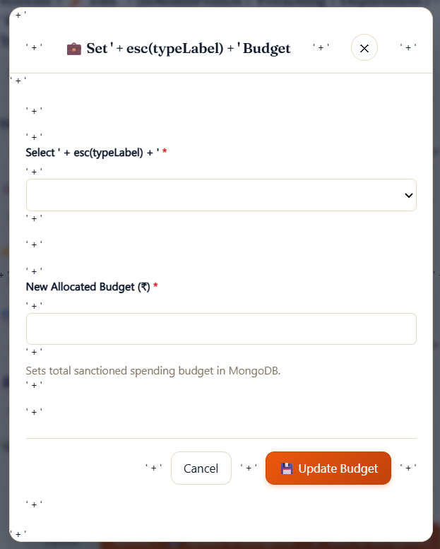
[DONE] Fixed
────────────────────────────────────────────────────────────────────────────────

3:23 PM IST | Bug Fix 3
YOUR REQUEST:
"now I am getting this error.. fix this"
Screenshot Third error
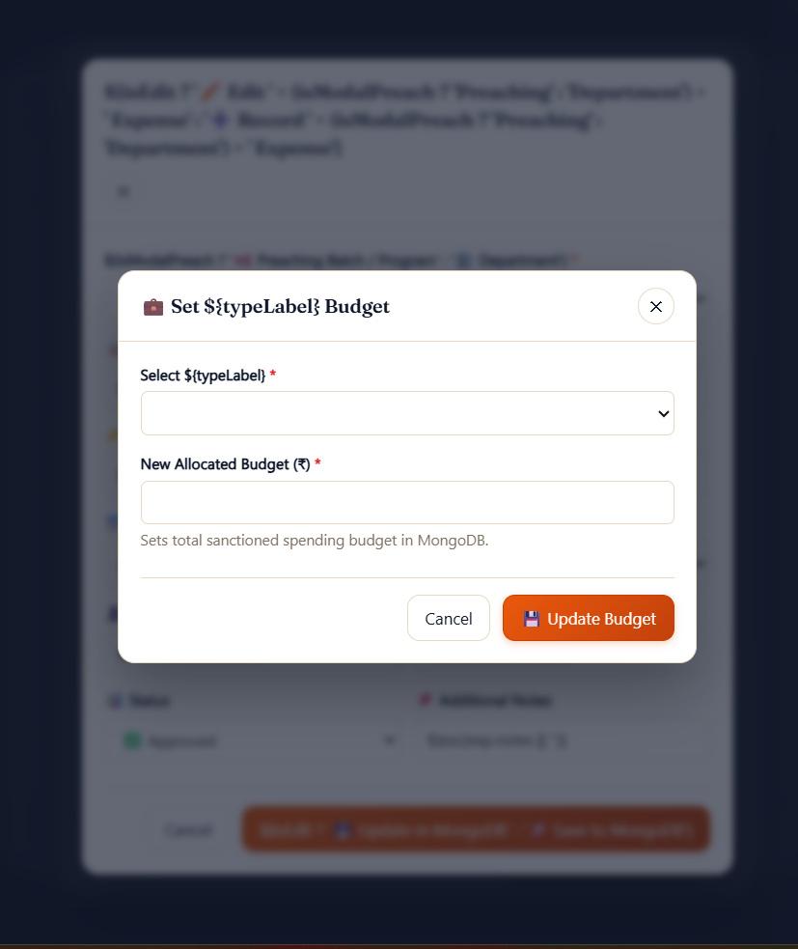
[DONE] Fixed
────────────────────────────────────────────────────────────────────────────────

3:44 PM IST | Blurred View / Modal Scrim Bug
YOUR REQUEST:
"I am getting this blurred view on the local host while I continually press the left click on my mouse then the second screenshot contents are appearing"
Screenshot 1 Blurred view on click-hold
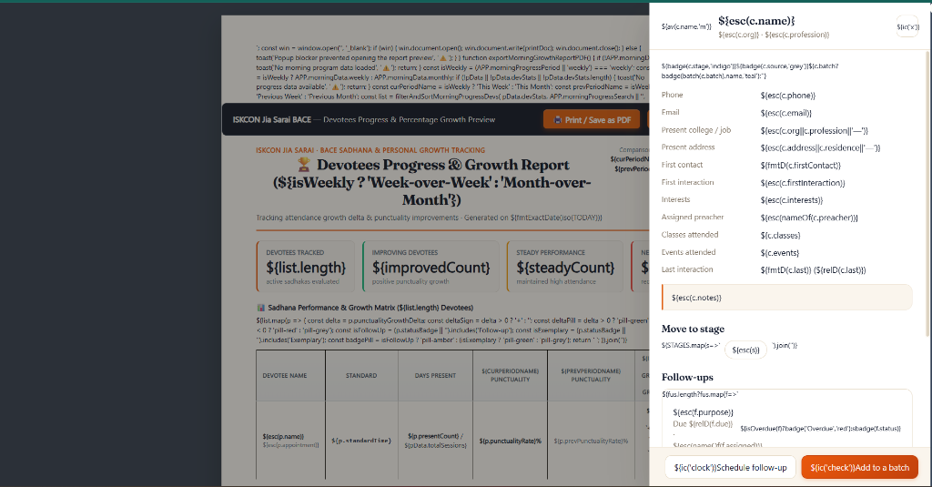
Screenshot 2 Contents appearing behind blur
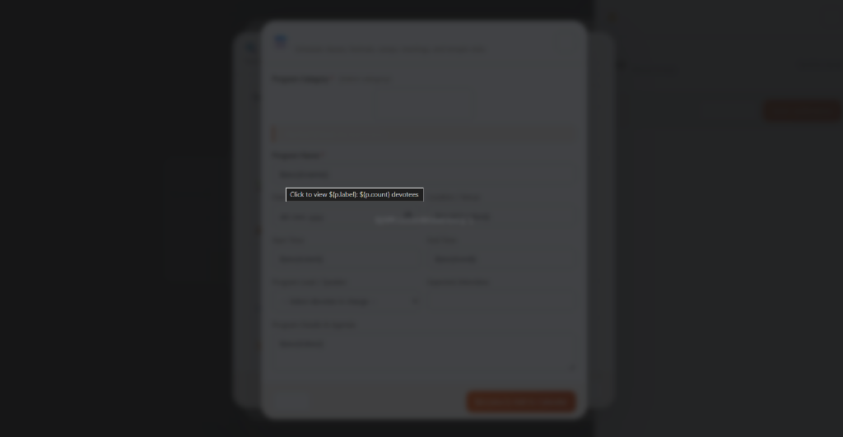
[DONE] Fixed: Modal scrim was triggering on mousedown instead of click fixed to close only on proper click event
────────────────────────────────────────────────────────────────────────────────

4:04 PM IST | Small Error Fix
YOUR REQUEST:
"correct this small error"
Screenshot The error
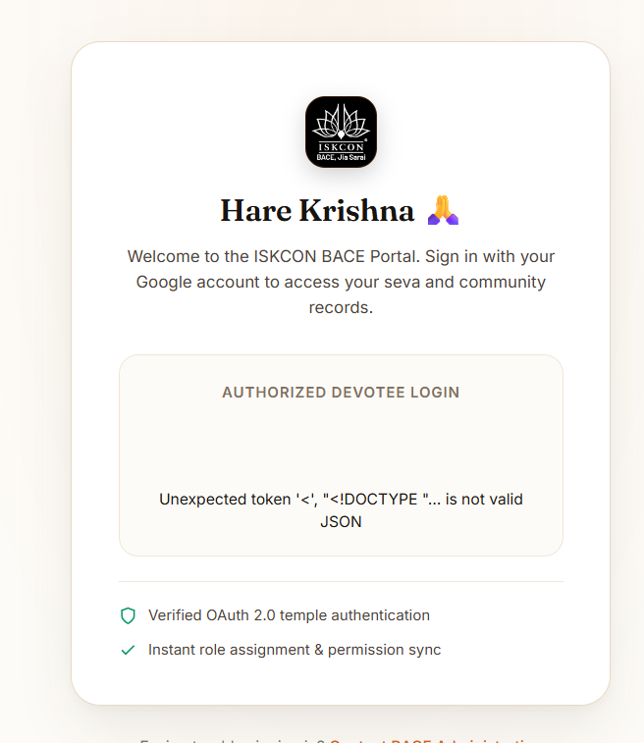
[DONE] Fixed
────────────────────────────────────────────────────────────────────────────────

4:22 PM IST | Final Screenshot of Session
Screenshot Final state before git reset
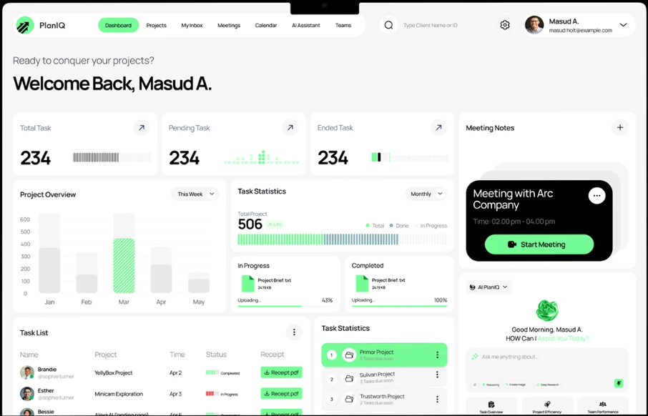
────────────────────────────────────────────────────────────────────────────────

END OF SESSION - All Work Lost to git reset --hard
At 4:19 PM, you ran: git reset --hard origin/main — this permanently wiped all uncommitted changes.
Work Area | Status
Theme: Remove sidebar → Top Navbar | ❌ Lost — git reset --hard
Dashboard: ISKCON BACE labels, Community Blocks | ❌ Lost — git reset --hard
Dashboard: Preaching Batches + BACE Health cards | ❌ Lost — git reset --hard
Dashboard: Bigger stat numbers | ❌ Lost — git reset --hard
Dashboard: Pillar block sub-cards | ❌ Lost — git reset --hard
Preaching: Merged reports & dashboard page | ❌ Lost — git reset --hard
Contacts & Pipeline: Dashboard sub-section | ❌ Lost — git reset --hard
PDF: Per-batch generation + layout + header changes | ❌ Lost — git reset --hard
Bug fixes (3 JS errors + modal scrim fix) | ❌ Lost — git reset --hard

Tip: Run 'git add -A && git commit' regularly to save progress safely.

