## 

## 

## Placeholder image

**Evaluation of the Effects of Opioid Regulation Policies in the USA**

November 26, 2024

**─**

**Practical Data Science**

Ilseop Lee (il72)

Ramil Mammadov (rm564)

Tursunai Turumbekova (tt284)

Yirang Liu (yl1041)

**Report Overview**

Executive Summary 3

Introduction 4

Research Question 4

Expected Results 4

Data Sources 5

State choices 5

Opioid Prescriptions (Shipment) 6

Mortality Data 6

Population 6

Pre-Post Analysis 7

Difference-in-Difference Analysis 8

Results 8

Opioid Mortality Rate 8

Pre-post analysis: Washigton 8

Difference-in-Difference analysis: Washington vs control states 9

Pre-post analysis: Florida 10

Difference-In-Difference Analysis: Florida vs Control States 11

Opioid Shipments 11

Pre-post analysis: Washigton 11

Difference-In-Difference Analysis: Washington Vs Control States 12

Pre-post analysis: Florida 13

Difference-in-Difference analysis: Florida vs control states 14

Conclusion 14

Appendices 16

Recommendations or Reflections (Further Investigation or Suggestions, if needed, otherwise just delete this part) 17

References 18

## 

## **Executive Summary**

This report evaluates the impact of state-level opioid regulations in Florida and This report evaluates the effectiveness of state-level opioid regulations in Florida and Washington in reducing opioid consumption and overdose mortality rates. Using pre-post and difference-in-differences analyses, it examines trends in opioid shipments and mortality data from 2006 to 2015. Opioid shipment data from the Washington Post served as a measure of consumption, while U.S. Vital Statistics mortality data tracked overdose deaths, with U.S. Census Bureau population data providing context for rate-based analyses. The study focuses on commonly misused prescription opioids, including hydrocodone, oxycodone, morphine, fentanyl, and methadone. Control states—Georgia, North Carolina, and South Carolina for Florida, and Colorado, Oregon, and Montana for Washington—were selected for their demographic and healthcare similarities, offering a baseline to distinguish policy impacts from broader trends.

Florida and Washington both initially stabilized opioid shipment growth after implementing their respective policies, though the outcomes varied. In Florida, policies introduced in 2010 curbed the sharp rise in opioid shipments, indicating some success in reducing overprescription. However, similar stabilization trends in Florida’s control states suggest broader regional or national factors may have played a role. In Washington, harm reduction policies enacted in 2012 led to a modest initial decline in opioid shipments, but this effect was short-lived, with shipment levels returning to pre-policy trends. In contrast, Washington’s control states showed more sustained declines, raising questions about the relative effectiveness of Washington’s measures. Mortality trends revealed distinct contrasts between the two states. Florida experienced a decrease in opioid-related deaths after its policies, though similar declines in control states point to additional national factors influencing the trend. Washington, on the other hand, saw a slight increase in overdose mortality during the same period. This suggests that while limiting prescription opioids may reduce misuse, it can also push individuals toward riskier alternatives like heroin or fentanyl. These findings highlight the need to balance prescription controls with complementary harm reduction strategies to address substitution risks effectively.

These findings emphasize the need to balance prescription regulations with strategies that mitigate substitution risks. Florida’s policies showed greater success in reducing overdose deaths, highlighting the importance of tailored approaches that account for each state’s unique challenges. To combat the opioid crisis effectively, flexible, data-driven strategies are essential, combining regulatory measures with public health initiatives like expanded treatment access and harm reduction programs. Insights from Florida and Washington offer valuable guidance for crafting interventions that address both the immediate and long-term complexities of opioid misuse.

## **Introduction**

The opioid crisis remains a critical public health challenge in the United States, characterized by widespread addiction, rising overdose deaths, and an increasing reliance on illicit substances such as heroin and fentanyl. Initially fueled by the overprescription of opioids, the epidemic led millions into dependency. As regulations restricted access to prescription opioids, many individuals turned to unregulated and more risky alternatives, intensifying overdose mortality rates. This dual challenge highlights the complexity of addressing opioid misuse, requiring a balance between curbing prescription availability and mitigating the risks associated with substitution to illicit drugs.

This study examines the impact of state-level opioid regulations in Florida and Washington, specifically assessing their effectiveness in reducing opioid shipments and overdose mortality rates. Florida’s measures, including prescription monitoring programsand pill mill laws, focused on limiting overprescription, while Washington adopted harm reduction policies aimed at minimizing misuse. To distinguish the effects of these interventions from broader trends, control states with comparable demographic, healthcare, and cultural characteristics were selected—Georgia, North Carolina, and South Carolina for Florida, and Colorado, Oregon, and Montana for Washington. Using pre-post and difference-in-differences analyses, this research provides a comprehensive evaluation of these policies, offering actionable insights to inform the development of more effective public health strategies.

### **Research Question**

The project aims to answer the following question:   
“What is the effect of opioid prescription regulations implemented in specific states on the volume of opioids prescribed and drug overdose deaths”

### **Expected Results**

Initially, the hypothesis for this project suggested that opioid prescription regulations would lead to a reduction in the volume of opioids prescribed. However, these regulations could have unintended consequences on drug overdose mortality rates. Individuals already struggling with opioid addiction might turn to illegal or alternative substances, which are often more dangerous, potentially resulting in an increase in overdose-related deaths. This complex relationship underscores the importance of a nuanced evaluation of both the intended and unintended effects of opioid policy interventions.

## **Data Sources**

This study leverages multiple datasets to analyze the impact of opioid-related policies. By integrating data from trusted sources, including the Centers for Disease Control and Prevention (CDC), state health departments, and the U.S. Vital Statistics Mortality Data, the analysis provides a comprehensive perspective on the opioid epidemic.

### **State choices**

To find suitable control states for your evaluation of opioid policies in Florida (FL) and Washington (WA), we need to focus on states with similar healthcare, cultural, and environmental conditions while also ensuring that the states have weak or no state-level opioid regulations, or have not enforced them strongly during our study period. Needless to say that it is important that the control states have weak or no state-level opioid regulations or enforcement during your study period to avoid confounding the results. Similar population size, demographic makeup and healthcare system characteristics ensure that differences in outcomes are more likely attributable to the state-level opioid policies rather than these underlying factors. Similar cultural attitudes toward drug use and the healthcare environment help to isolate the effects of opioid policies on the measures.

For Florida, we chose Georgia, North Carolina, and South Carolina. Georgia has a similar demographic profile to Florida, with a mix of urban and rural populations. It shares some healthcare challenges and has not enacted as strict opioid regulations compared to states like New York or Massachusetts. The climate is similar, and there is a comparable level of opioid use and overdose deaths. Georgia has a similar demographic profile to Florida, with a mix of urban and rural populations. It shares some healthcare challenges and has not enacted as strict opioid regulations compared to states like New York or Massachusetts. The climate is similar, and there is a comparable level of opioid use and overdose deaths. South Carolina shares many cultural and healthcare characteristics with Florida, including a mix of urban and rural populations, a high percentage of elderly individuals, and similar healthcare access issues. Opioid regulation in South Carolina has been less aggressive, making it a good comparison state for Florida.

For Washington, we chose Oregon, Colorado, and Montana. Oregon is geographically and culturally very similar to Washington, with a temperate climate, progressive policies, and similar healthcare systems. Both states have faced similar challenges regarding opioid misuse, but Oregon's regulations and enforcement have not been as strong as Washington’s in recent years, which makes it a good comparison for evaluating Washington's policies. Colorado has similar environmental and cultural characteristics to Washington, with a similar temperate climate. However, Colorado has had less aggressive state-level opioid regulation compared to Washington, making it a useful control state to assess the impact of Washington's opioid policies. Montana shares environmental and cultural similarities with Washington, particularly with respect to its rural areas and mountainous climate. Its healthcare system is more challenged, and opioid regulations are not as strictly enforced as in Washington, making it a reasonable control state for comparative analysis.

### **Opioid Prescriptions (Shipment)**

This dataset, obtained through a Freedom of Information Act (FOIA) request to the U.S. Drug Enforcement Agency (DEA) and released by the Washington Post in 2020 (updated in 2023), provides detailed records of prescription opioid shipments across U.S. counties from 2010 to 2019. It serves as a critical resource for understanding the distribution and availability of prescription opioids, enabling a detailed analysis of prescribing patterns and their potential link to overdose outcomes. According to the Substance Abuse and Mental Health Service Administration (SAMHSA), naloxone and nalmefene are the two FDA-approved opioid overdose reversal medications (OORM) and also under the umbrella of opioids. Drug names used for medical treatment that can readily lead to overdose include hydrocodone, oxycodone, morphine, fentanyl, buprenorphine, codeine, hydromorphone, methadone, meperidine, oxymorphone, tapentadol, powdered opium, levorphanol, and dihydrocodeine, which are the ones used in the research.

### **Mortality Data**

The dataset, spanning from 2003 to 2015, provides granular county-level mortality statistics derived from the U.S. Vital Statistics Mortality Data, a trusted source under the National Center for Health Statistics (NCHS). To ensure a focused and actionable analysis, the dataset includes only opioid-related overdose deaths, classified according to the Tenth Revision of the International Classification of Diseases (ICD–10).

To enhance the relevance and contextual understanding of the opioid crisis, state-level population data were integrated into the analysis. This allowed the calculation of mortality rates, enabling comparisons across counties and states. As it was mentioned previously, the geographic focus includes eight states—Florida, Washington, Georgia, North Carolina, South Carolina, Colorado, Oregon, and Montana—offering a diverse representation of regional trends. Additionally, some limitations in a form of privacy safeguards take place, including suppression of data with fewer than 10 deaths, maintaining confidentiality while aggregated data minimizes its impact on trend analysis.

### **Population**

Sourced from the U.S. Census Bureau, the data consists of decennial census statistics, divided into two datasets: 2000-2010 and 2010-2020. To ensure consistency across the data, only the estimated population figures were used, and the analysis focused on county-level data.

**Methodology**

This research employs two primary methodologies: pre-post analysis and difference-in-difference analysis. These approaches address the core challenge of causal inference by estimating outcomes that might have occurred in the absence of policy changes. Pre-post analysis facilitates a comparison of outcomes in Washington and Florida before and after policy implementation. Meanwhile, the difference-in-difference analysis assesses the policy’s impact by examining changes in opioid prescriptions and overdose mortality rates, comparing the treated states to control states with similar pre-policy trends.

The methodology integrates pre-post and difference-in-difference approaches. The pre-post analysis evaluates changes in opioid shipments and mortality within each target state before and after policy implementation, assuming that outcomes in the post-policy period would have remained similar to the pre-policy period in the absence of intervention. The DiD analysis extends this framework by comparing trends in the target states to control states, accounting for shared external factors such as federal initiatives or national trends in opioid prescribing.

### **Pre-Post Analysis**

The pre-post analysis compares opioid shipments and overdose mortality rates in Florida and Washington before and after the implementation of state-level opioid regulations. This method provides an initial measure of the policies’ direct effects within each state.

For Florida, the analysis focuses on policy changes implemented in 2010, which included the establishment of prescription monitoring programs and strict regulations on pain clinics. By comparing trends in opioid shipments and mortality rates from 2006–2009 (pre-policy) to 2010–2015 (post-policy), we assess whether the policies curtailed opioid misuse and related deaths.

In Washington, the focus is on policies enacted in 2012, emphasizing harm reduction strategies such as naloxone distribution and medication-assisted treatment (MAT). The analysis examines shipment volumes and mortality trends from 2008–2011 (pre-policy) to 2012–2015 (post-policy), evaluating the effectiveness of these measures in reducing opioid misuse and fatalities.

Although the pre-post analysis offers a clear and direct assessment of the policies' effects, it inherently assumes that any observed changes are entirely due to the regulations. To address this limitation and account for potential confounding factors, additional analytical methods are required.

### **Difference-in-Difference Analysis**

To address the limitations of the pre-post analysis, the difference-in-difference (DiD) method compares changes in opioid shipments and mortality rates in Florida and Washington to those in their respective control states. This approach accounts for broader trends and external factors that may influence outcomes in both target and control states.

For the Florida analysis, Georgia, North Carolina, and South Carolina were chosen as control states due to their comparable demographics, healthcare systems, and less stringent opioid regulations during the study period. By examining the differences in trends between Florida and these control states, the DiD analysis aims to distinguish the specific impact of Florida's policies from broader regional or national factors.

Similarly, in Washington, control states—Oregon, Colorado, and Montana—were chosen for their geographic and cultural similarities but less stringent opioid policies. The analysis examines whether Washington experienced significantly different changes in opioid shipments and mortality rates relative to these states following its policy implementation in 2012.

The DiD approach employs linear regression to estimate the differential impact of the policies, quantifying the extent to which changes in the target states exceed those observed in the control states. This method strengthens causal inference by leveraging the assumption that, in the absence of policy changes, trends in target and control states would have followed parallel trajectories

## **Results**

### **Opioid Mortality Rate**

#### **Pre-post analysis: Washigton**

Prior to the policy being enacted in 2012, the mortality rate showed a steady decline, indicated by the blue line. This suggests that mortality was decreasing in the years leading up to the policy implementation, possibly due to previous health interventions or improved public health initiatives. After the policy was introduced, we saw a noticeable shift in the trend. The red line shows a slight increase in the mortality rate, particularly after 2012. The introduction of the policy aimed at reducing mortality, likely through curbing the shipment of opioids, appears to have had a counterintuitive effect, with the mortality rate rising slightly instead of continuing its downward trajectory. The increase in mortality could be linked to individuals seeking alternative, illegal substances such as fentanyl and heroin in response to the restricted access to prescription opioids. The more potent and dangerous nature of these substances could explain the subsequent rise in mortality rates, as these drugs are often associated with higher risks of overdose. While the policy was designed to reduce opioid-related deaths, the findings suggest that unintended consequences, such as the rise of more dangerous street drugs, may have offset the expected benefits. This could indicate the need for a more comprehensive approach, including harm reduction strategies, better addiction treatment programs, and preventive measures to address the shift towards illegal substances.

**Effect Of Policy On Mortality Rate In Washington**

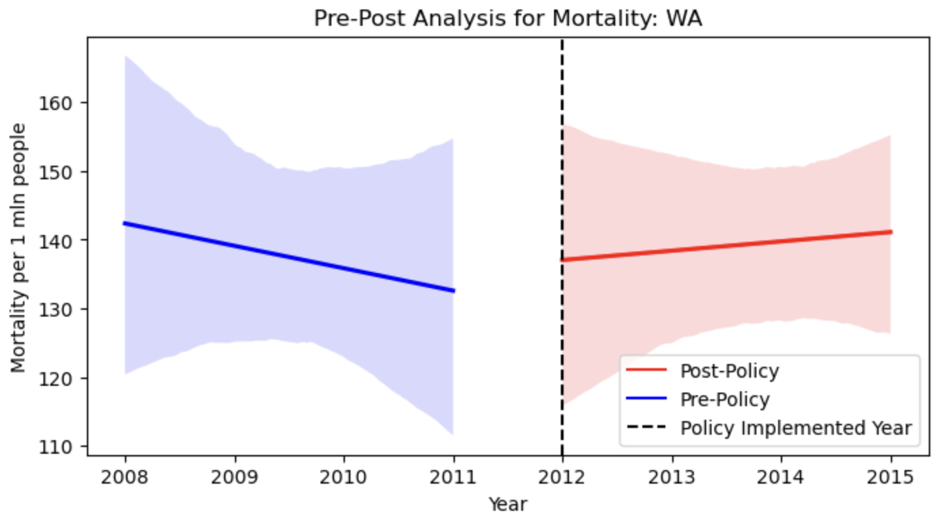

Figure 1: Mortality Rate per 1 mln Population by Year in Washington

#### **Difference-in-Difference analysis: Washington vs control states**

Prior to the policy, Washington's mortality rate was on a declining trend, while the control states' (Colorado, Oregon, and Montana) rates were on an increasing trend. This suggests that Washington and the control states were on different trajectories before the policy was enacted. After the policy implementation, Washington’s mortality rate shows a slight increase, while the control states experience a more pronounced rise in mortality rates. This suggests that, although both Washington and the control states saw an upward trend in mortality post-policy, the policy in Washington may have contributed to a slower increase in mortality compared to the control states, where the rise was more substantial. The Difference-in-Difference analysis indicates that while both Washington and the control states experienced an increase in mortality after the policy implementation, Washington's increase was less pronounced. This suggests that the policy had a modest effect in Washington, helping to slow the rise in mortality compared to the more significant increase observed in the control states.

**DiD Analysis of Mortality Rate in Washington vs. Control States**

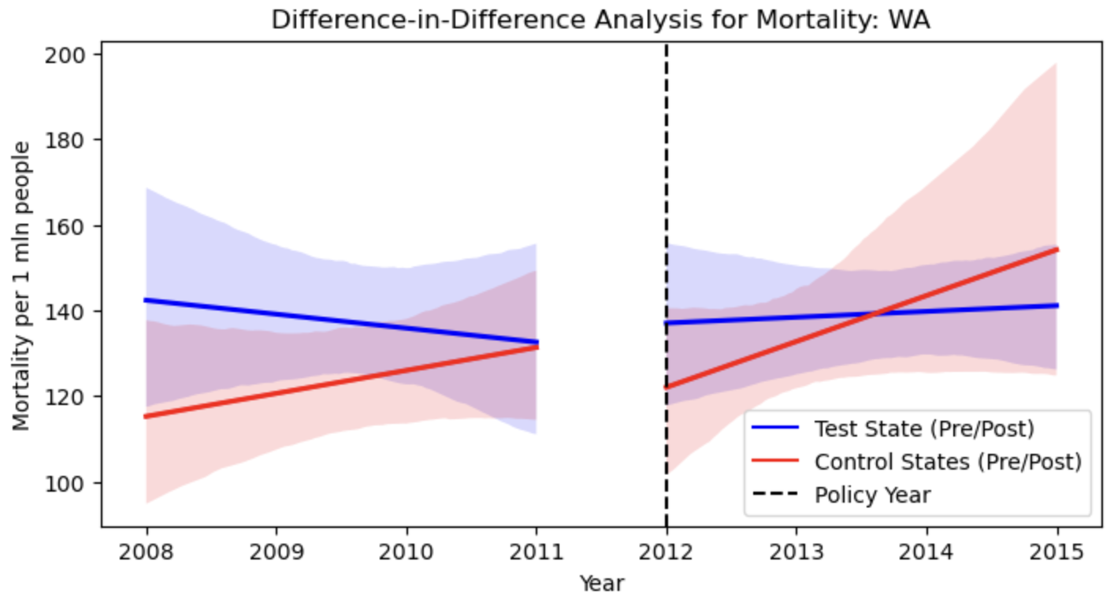

Figure 2: Mortality Rate per 1 mln Population by Year in Washington vs Control States

#### **Pre-post analysis: Florida**

The mortality rate in Florida before the policy implementation shows a gradual upward trend. After 2010, there was a clear decline in the mortality rate, indicating a significant reduction in deaths per 1 million people. The sharpness of this decline suggests the policy was effective in addressing the underlying factors contributing to mortality. The successful implementation underscores the importance of tailored interventions to address public health crises effectively. Further comparison with other states like Washington could help identify best practices for widespread adoption.

**Effect Of Policy On Mortality Rate In Florida**

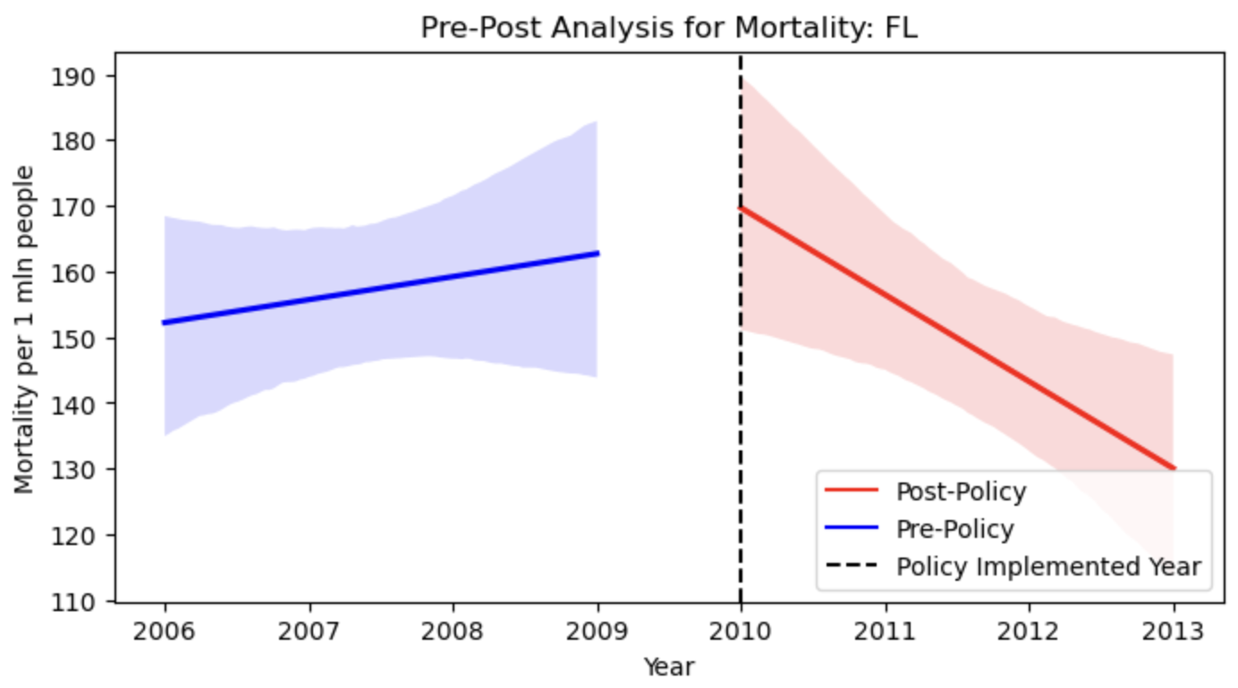

Figure 3: Mortality Rate per 1 mln Population by Year in Florida

#### **Difference-In-Difference Analysis: Florida vs Control States**

An analysis of the data, as shown in the graph, reveals that both Florida and the control states (Georgia, North Carolina, and South Carolina) were influenced by the implementation of policy changes on opioid drugs. However, it remains unclear whether the reduction in death rates observed in Florida can be attributed solely to the state’s policy changes, as similar downward trends are evident in the control states. This suggests that the decline might also be influenced by broader federal or nationwide initiatives rather than being exclusively driven by Florida’s policies.

**DiD Analysis of Mortality Rate in Washington vs. Control States**

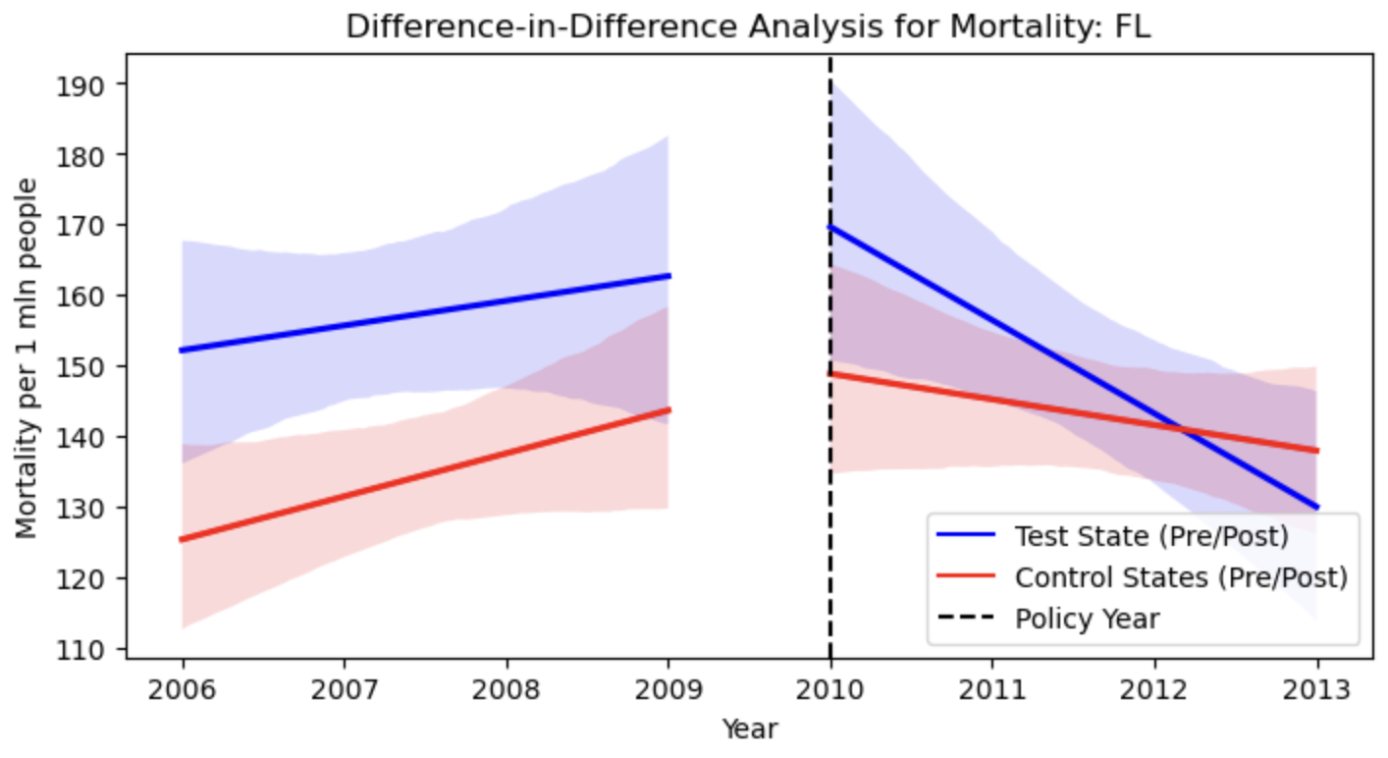

Figure 4: Mortality Rate per 1 mln Population by Year in Florida vs Control States

### **Opioid Shipments**

#### **Pre-post analysis: Washigton**

Figure 5 below illustrates the trend in Morphine Milligram Equivalent (MME), a standardized measure of opioid potency and consumption, shipped per capita in Washington, divided into pre-policy and post-policy periods around the implementation of harm reduction-focused opioid policies in 2012. In the pre-policy period, represented by the red line, MME shipments show a steady upward trend, reflecting a consistent rise in opioid distribution. Post-policy indicated minimal change in MME shipments. Shipment levels soon return to pre-policy trends, showing the policy's limited long-term impact.

**Effect Of Policy On Morphine Milligram Equivalent Shipped Per Capita In Washington**

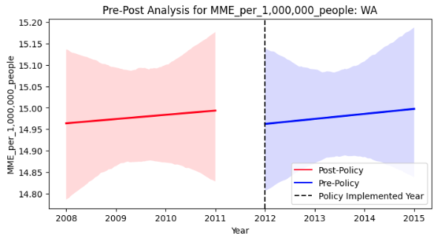

Figure 5: Average Morphine Milligram Equivalent Shipped per Capita by Year in Washington

#### **Difference-In-Difference Analysis: Washington Vs Control States**

This figure 6 below presents a Difference-in-Differences analysis of Morphine Milligram Equivalent (MME) shipped per capita in Washington and its control states—Colorado, Oregon, and Montana—before and after Washington’s harm reduction-focused opioid policies were implemented in 2012. The blue line represents Washington (the test state), while the red line represents the control states, with shaded regions indicating the confidence intervals. During the pre-policy period (2008–2011), Washington showed a relatively stable trend with minimal increases in MME shipments, while the control states experienced a gradual upward trajectory. Post-policy (2012–2015), Washington initially experienced stabilization, but MME shipments per capita did not exhibit a significant decline, remaining largely flat. In contrast, the control states demonstrated a substantial and sustained decrease in MME shipments following 2012.

These findings suggest that while Washington’s policies may have temporarily halted further increases in opioid shipments, their long-term impact was limited. The sharper decline in MME shipments observed in the control states indicates that broader regional or national factors may have played a more significant role in reducing opioid shipments. This raises questions about the effectiveness of Washington’s specific policy measures and highlights the need for more robust strategies to achieve sustained reductions in opioid distribution.

**DiD Analysis of MME Shipped per Capita in Washington vs. Control States**

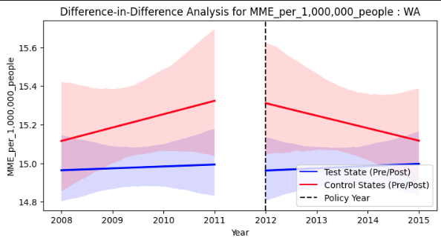

Figure 6: Morphine Milligram Equivalent Shipped per Capita in Washington vs. Control States

#### **Pre-post analysis: Florida**

In Florida, the opioid prescription rate per population increased sharply during the three years prior to the policy implementation. However, in the three years following the policy, this growth trend plateaued. While the policy may not have drastically reduced prescription rates, it appears to have contributed to curbing the upward trajectory.

The figure 7 below illustrates the trends in MME shipments before and after the implementation of opioid regulations in 2010. During the pre-policy period (2007–2010), represented by the red line, there is a steady upward trend in MME shipments per capita, reflecting increasing opioid distribution prior to the introduction of regulatory measures. In the post-policy period (2010–2013), shown by the blue line, the growth in MME shipments stabilizes, indicating that Florida's policies curbed the rapid rise in opioid shipments. The stabilization trend suggests that the policies had an immediate impact on overprescription.

**Effect Of Policy On Morphine Milligram Equivalent Shipped Per Capita In Florida**

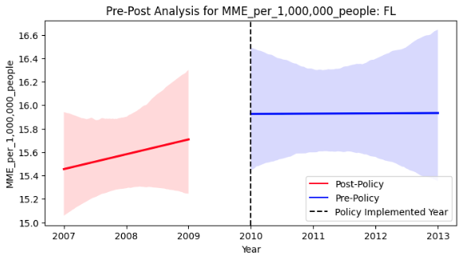

Figure 7: Average Morphine Milligram Equivalent Shipped per Capita by Year in Florida

#### **Difference-in-Difference analysis: Florida vs control states**

The figure 8 below presents a comparison of opioid shipments in Florida and its control states—Georgia, North Carolina, and South Carolina—before and after Florida implemented opioid prescription regulations in 2010. Before the policy implementation (2007–2010), represented on the left side of the graph, Florida exhibited a steady upward trend in MME shipments per capita, indicating a rise in opioid distribution. Similarly, the control states show a parallel increase. After the policy implementation (2010–2013), Florida’s MME shipments stabilized (even went down slightly), while the control states continued to exhibit a slight increase. This divergence suggests that Florida’s opioid policy implementations were effective in curbing the growth of opioid shipments, unlike the control states where no similar policies were implemented. However, broader national trends or external factors may have influenced these outcomes.

**DiD Analysis of MME Shipped per Capita in Florida vs. Control States**

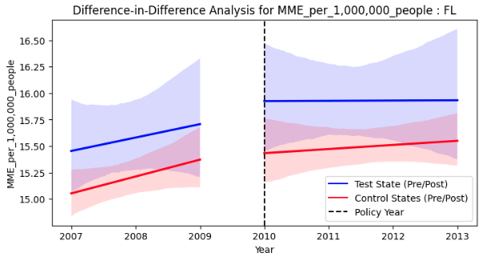

Figure 8: Morphine Milligram Equivalent Shipped per Capita in Florida vs. Control States

## **Conclusion**

Our analysis revealed significant differences in the effectiveness of state-level opioid policies in Florida and Washington. The study focused on misused prescription opioids, including hydrocodone, oxycodone, morphine, fentanyl, and methadone. In Florida, opioid prescription policies slowed the rapid increase in opioid shipments and significantly reduced overdose mortality rates. By contrast, Washington’s harm reduction-focused policies led to an initial modest decline in opioid shipments, but this effect was not sustained, and a slight increase in overdose mortality rates was observed. These findings underscore the highly context-dependent nature of policy outcomes, shaped by each state’s unique characteristics and challenges. Florida’s approach illustrates the potential of regulations to effectively lower overprescription and save lives, although the trend was present for control states as well, suggesting that another nation-wide factor was affecting the decline. The outcomes in Washington highlight unintended consequences, such as individuals seeming to turn to riskier alternatives like heroin or fentanyl when access to prescription opioids is restricted. This underscores the need for policymakers to balance regulatory controls with harm reduction strategies to minimize these risks. Our findings suggest that a one-size-fits-all approach is unlikely to succeed; instead, opioid policies must be tailored to address the distinct needs and demographics of individual states.

We also identified key areas where further research is essential. Evaluating local-level interventions, such as community-based treatment programs and public education initiatives, could shed light on their role in supporting state-level policies. Long-term studies are needed to understand the sustained impacts of opioid regulations and how they adapt to shifting drug use patterns. Additionally, exploring the effects of these policies across diverse population subgroups—such as age, race, and socioeconomic status—can help address disparities in outcomes and promote equity in combating the opioid crisis.

Our analysis faced certain limitations that should guide future research. Privacy-related data suppression and incomplete records for smaller counties constrained the scope of our findings. Additionally, unmeasured factors, such as variations in enforcement or regional dynamics, may have influenced the results. Future studies should prioritize using more granular data and refining analytical methods to provide a clearer understanding of policy impacts.

In conclusion, the study highlights both the opportunities and challenges associated with state-level opioid regulations. By learning from the outcomes observed in Florida and Washington, policymakers can develop more balanced, adaptable, and equitable strategies to effectively address the opioid epidemic.

## 

## **Appendices**

**Mortality Data Cleaning**   
The mortality dataset, which is central to this analysis, has undergone a detailed cleaning process to ensure its accuracy and usability. The dataset originally contained information on all drug-related deaths in the United States from 2003 to 2015, categorized by county and year. To focus the analysis on opioid overdose deaths specifically, we filtered the data to include only deaths classified under the following ICD–10 codes: unintentional overdoses (X40–X44), suicides (X60–X64), homicides (X85), and cases of undetermined intent (Y10–Y14). This targeted approach ensures that the analysis remains focused on opioid-related fatalities.

During the cleaning process, we addressed several challenges to make the data consistent and reliable for analysis. For instance, privacy rules in the dataset meant that information was suppressed when fewer than 10 deaths were recorded in a given county, year, or cause-of-death category. To manage this, the data was aggregated across years or counties when necessary, reducing the likelihood of missing or incomplete records while maintaining the validity of the trends.

The dataset also required reorganization to improve readability and facilitate analysis. Irrelevant columns, such as notes and unused cause-of-death codes, were removed to streamline the dataset. Additionally, any non-numeric values in the "Deaths" column, such as missing or invalid entries, were converted to a consistent format or excluded from the analysis.

To enable a fair comparison across regions and time periods, the dataset was merged with population data, allowing us to calculate per capita mortality rates. This adjustment is essential for accurately identifying patterns and disparities in opioid overdose deaths across different counties and states.

Overall, these cleaning efforts have transformed a raw, complex dataset into a structured, focused resource. This ensures that the data is not only reliable but also meaningful, enabling an accurate and insightful analysis of opioid overdose mortality trends. By addressing inconsistencies and aligning the dataset with the study's goals, we’ve laid a solid foundation for understanding the impact of opioid policies and interventions.

**Treating the missing values**

Both the shipping and mortality datasets contain missing values. Counties with smaller populations may have no recorded deaths or shipping data, or the data might not be meaningful (e.g., due to privacy concerns). Therefore, an appropriate cut-off level should be set to exclude such data entirely. Imputing missing values with arbitrary numbers is not considered, as it could distort the data, especially in time-series analyses examining changes before and after policy implementation. Excluding data from counties with populations below 20,000 would retain approximately 80% of the data for analysis.

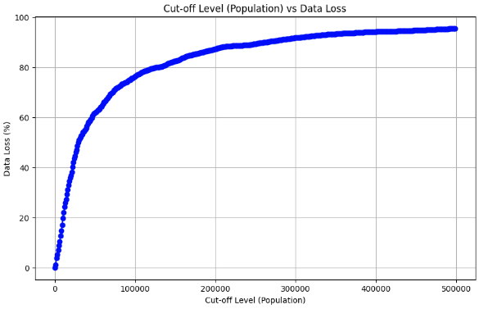

**Data Columns:**

| Opioid Prescription | Mortality | Population |
| --- | --- | --- |
| Year  Buyer State  Buyer County  MME(Morphine Milligram equivalent) | Year  State  County  County Code  Deaths (drug related only) | Year  State  County  County Code  Estimated Population  + FIPS code integrated |

### **Recommendations or Reflections (Further Investigation or Suggestions, if needed, otherwise just delete this part)**

* Conduct a detailed investigation by opioids by type(for rebah or not). If treating opioid addiction involves tapering doses of the same opioid, such as oxycodone, examine whether the MME for opioids used in addiction treatment has increased
* For shipping data, investigate why the control group for WA (CO, OR, MT) experienced a sharp increase in levels around 2011, followed by a decline.
* Customized Policy Approaches: Differences in state policy outcomes emphasize the need for opioid control strategies that are tailored to each state's unique needs and characteristics. Policymakers should design regulations that address these specific requirements.
* Controlling: Given the evolving opioid crisis, policies must remain flexible, with regular assessments and adjustments to maintain effectiveness over time.
* Comprehensive Strategy: Addressing the opioid crisis requires a diverse set of approaches. Integrating regulatory actions with public health initiatives, educational outreach, and rehabilitation resources can strengthen policy effectiveness and promote more enduring outcomes.

## **References**

1. Barrett, D., Rich, S., & Brown, A. (2020, January 14). *More than 100 billion pain pills saturated the nation over nine years*. The Washington Post.<https://www.washingtonpost.com/investigations/more-than-100-billion-pain-pills-saturated-the-nation-over-nine-years/2020/01/14/fde320ba-db13-11e9-a688-303693fb4b0b_story.html>
2. National Center for Health Statistics. (2003-2015). *Mortality Multiple Cause Files*. U.S. Department of Health and Human Services. Retrieved from<https://www.cdc.gov/nchs/data_access/vitalstatsonline.htm>

3. Substance Abuse and Mental Health Services Administration. (n.d.). *Opioid overdose*

*reversal medications.* Retrieved November 25, 2024, from<https://www.samhsa.gov/medications-substance-use-disorders/medications-counseling-related-conditions/opioid-overdose-reversal-medications>