ISL29177 Android Driver – Driver Notes

Purpose
This is a supplementary document for understanding the isl29177 android driver.

Audience
This document is intended to help understand different pieces of code from the driver that performs specific tasks. Having a fundamental knowledge of Linux driver model would be helpful in completely understanding this document. But certain parts of this document consists of flows which might be understood by all readers.

Driver Registration
The following piece of code does the i2c driver registration for the isl29177 sensor. The structure isl29177_driver consists of references to the required callbacks supported by the driver which are necessary for the operation of the driver.

static struct i2c_driver isl29177_driver = {
.driver = { .name = "isl29177"},
.id_table = isl_device_ids,
.probe = isl29177_probe,
.remove = isl29177_remove,
.suspend = isl29177_suspend,
.resume = isl29177_resume,
};

static int __init isl29177_init(void)
{
return i2c_add_driver(&isl29177_driver);
}

static void __exit isl29177_exit(void)
{

i2c_del_driver(&isl29177_driver);
}

Reference | Description
.driver.name (“isl29177”) | Name by which the driver would be identified in the Linux kernel
isl_device_ids | A table of i2c addresses or devices that would be supported by this driver
isl29177_probe | Called when i2c core finds a matching device
isl29177_remove | Called when this driver is removed from kernel
isl29177_suspend | Called when the android system goes to suspend mode. Any handling of sensor that needs to be done during suspend would be added here
isl29177_resume | Called when the android system wakes up from sleep. Any handling of sensor that needs to be done after resume of the system would be added here

Device Detection
The platform information or board file for target platform or its device tree (used to describe the devices associated with the platform) contains the information on presence of isl29177 sensor with I2C slave address 0x44h being connected.

Once the Linux I2C core driver probes the I2C bus and finds this device, any I2C driver which has registered the device id for isl29177 would be notified about its presence and the driver would now be provided with access to the device.

The function isl29177_probe is called to notify the device presence. The following flow diagram summarizes the activities done in this function.

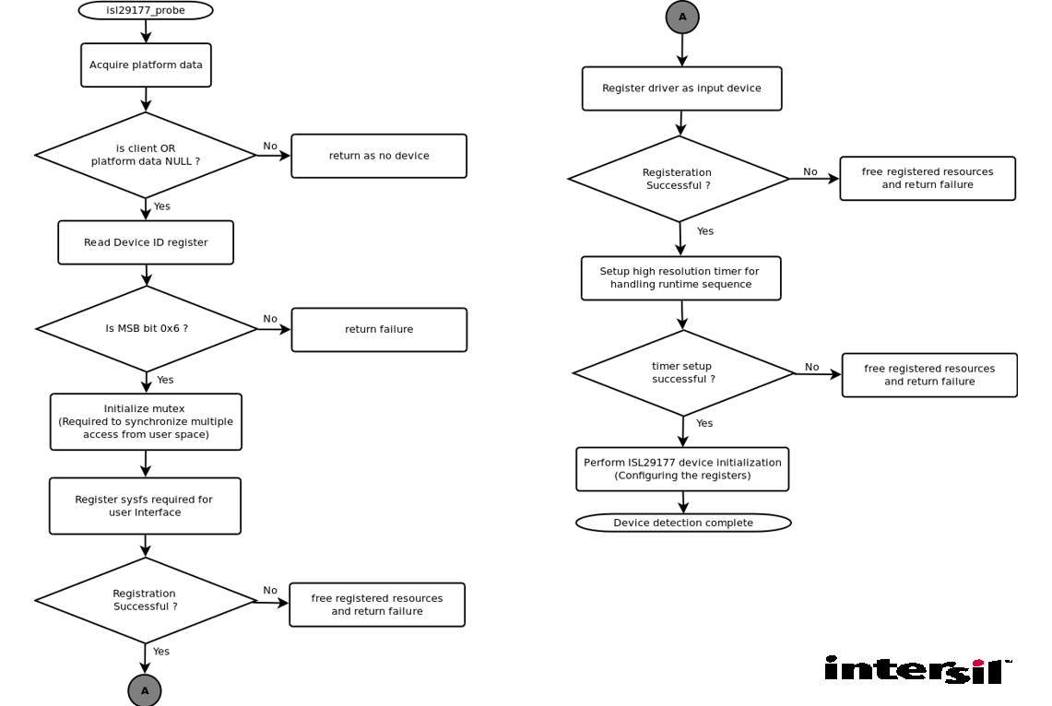

The following helper functions are called during device detection to perform the specified tasks

Function | Description
setup_debugfs | Register the user interface support in driver
setup_input_device | Register driver as an input device driver in order to report proximity events to userspace
setup_hrtimer | Register the high resolution timer handler which would handle the runtime sequence

Device Initialization
The function isl29177_initialize implements the device initialization for the ISL29177 sensor device. It primarily consists of the register writes to the device and a call to offset_adjust to do the initial compensation for the cross-talk.

Below table indicates the register writes and their description in order of initialization

REG | VAL | Description
0x09 | 0x38 | Reset sensor device
0x09 | 0x89 | Enable test mode
0x02 | 0x20 | Set high offset
0x03 | 0x02 | Set interrupt persistence
0x04 | 0x25 | Set the interrupt high threshold defined by PROX_HI_THRESHOLD in isl29177.h header
0x05 | 0x15 | Set the interrupt low threshold defined by  PROX_LO_THRESHOLD in isl29177.h header
0x0C | 0x00 | Disable residue reading
0x0F | 0x40 | Enable OTP
0x01 | 0x80 | Enable prox sensing

Register Read / Write API
The following two functions are used in the driver to provide access to a specific set of bits or the complete register in the ISL29177 register space

- isl_read_field(unsigned char reg, unsigned char mask, unsigned char *val)
- isl_write_field(unsigned char reg, unsigned char mask, unsigned char val)

The usage of these A Pis are well documented in the driver source code.

Runtime Sequence
Currently the driver performs updates to the proximity and other associated data at the interval of 100ms. The driver had already registered a high resolution timer during device detection. High resolution timer (hrtimer) would trigger a software interrupt at defined intervals of 100ms. The hrtimer handler registered is isl29177_hrtimer_handler. This function internally schedules the thread sensor_irq_thread which does the actual work required to be done during runtime.
The function Xtalkadjuct is called when offset is reduced for fixed number of times.
The function measbase which is used to calculate net baseline value is called when proximity value is below baseline for fixed number of times

The below flowchart represents the task done in the function sensor_irq_thread (Runtime)
We divide the runtime sequence function in 2 following subsequences:
  - Read prox value from the register and remeasure the baseline if required
  - Washout detection and tracking
2.1 Adjustment for high offset
2.2 measure base if require

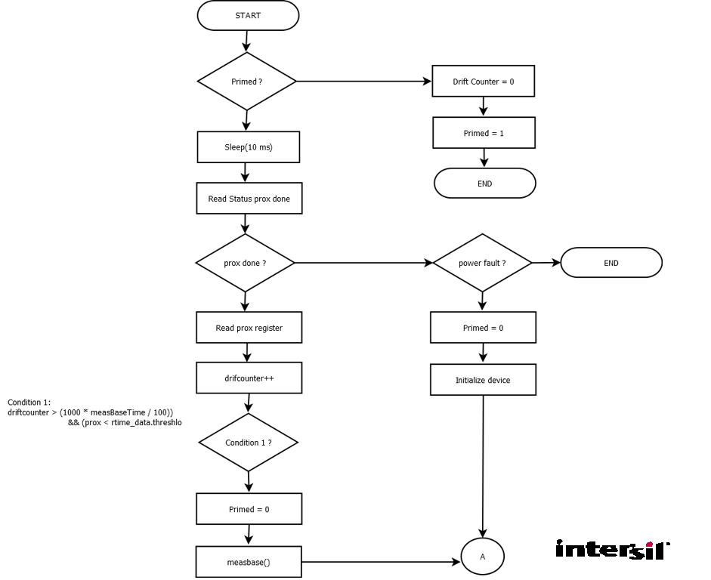
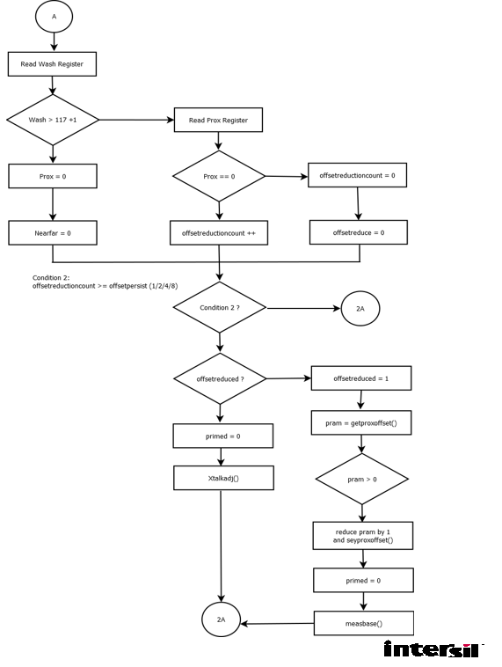

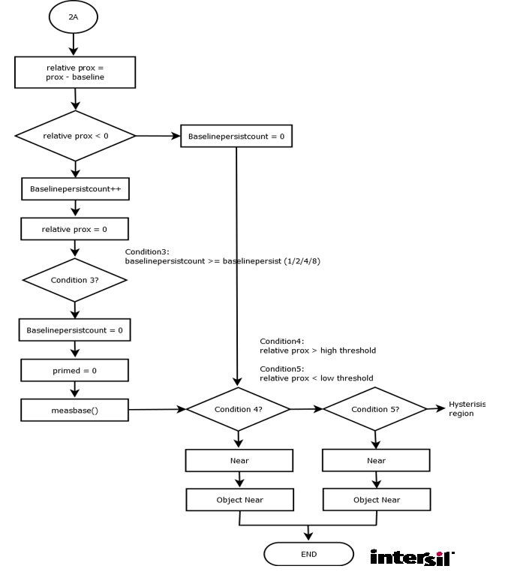

Xtalk Adjusment
The following proximity ranges are handle to compensate the offset value and range with the help of getproxoffset and setproxoffset functions. These function are basically used to get and set the proximity offset and range value respectively by taking the reference of Look up table.
  - prox = FULL SCALE RANGE
  - 100 < prox < 255
  - 0 < prox < 10
  - Prox = 0

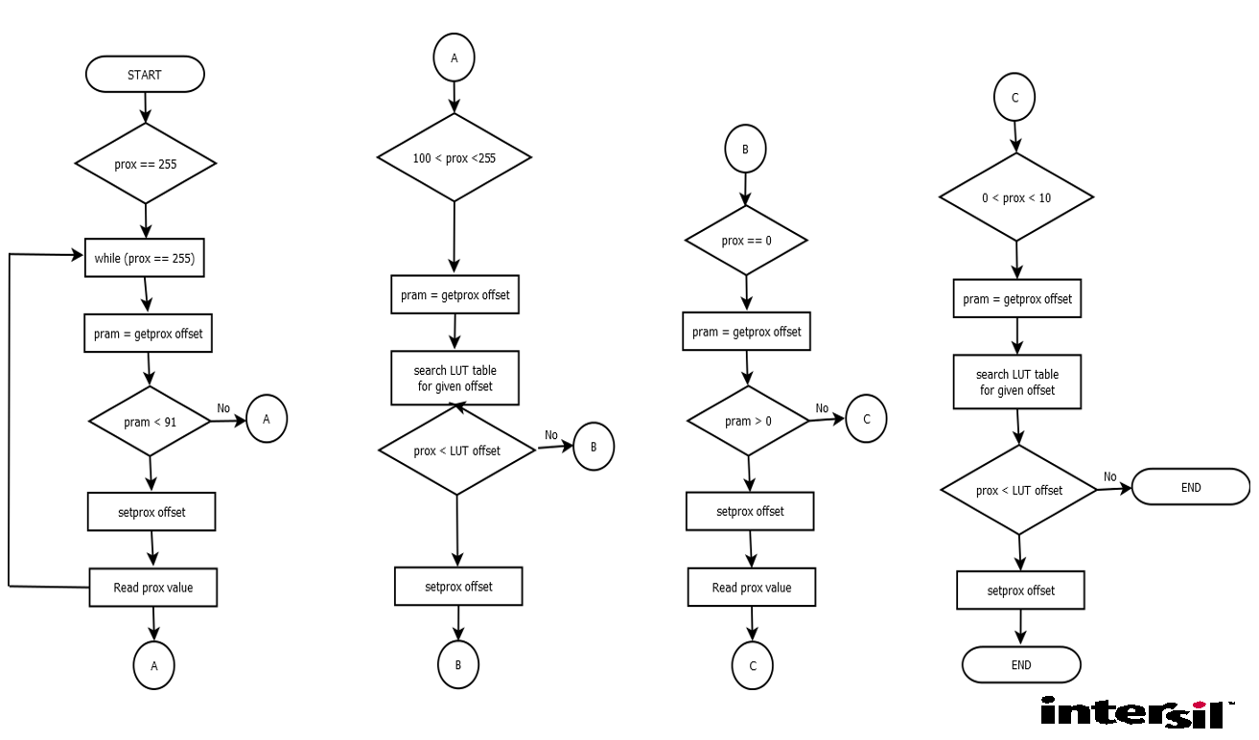

measBase
Function are mainly used to calculate the baseline again and again when we have to require to calculate the baseline we select the minimum prox value which we read from the sensor device and make it as a current baseline
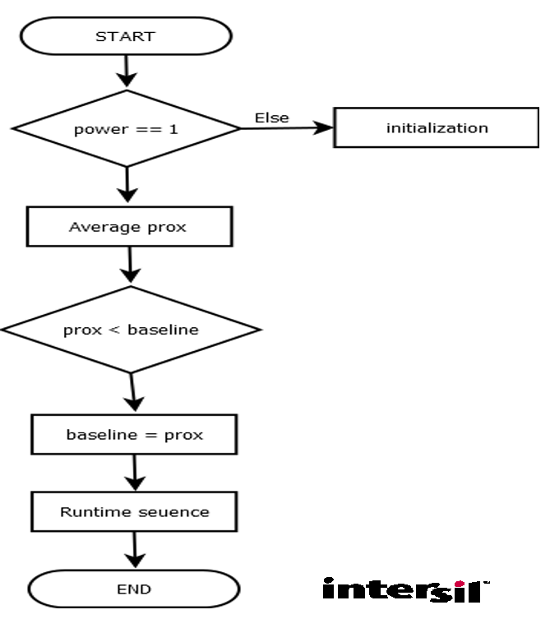

SetProx Offset
Function setproxoffset are mainly used to get the current range, offset prox and scattering value from the sensor device.
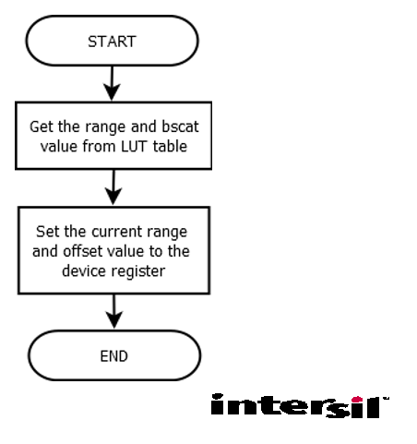
GetProx Offset
Function getproxoffset are mainly used to get the current range, offset prox and scattering value with the reference of LUT index number from the sensor device.

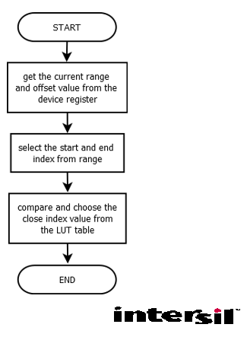
User Interface
The driver implements the user interface using the “linux sysfs” infrastructure.

The driver provides access to three files from the userspace
- enable
- debug
- reg_map

IMPORTANT NOTE: To know how to use the user interface please refer to the android driver integration guide provided by Intersil.

Enable
This sysfs file allows user to enable or disable the proximity conversion and runtime operations.

The following methods implement the read and write implementations of the enable sysfs file
- enable_show – callback when user reads from this file
- enable_store – callback when user writes to this file

Debug
This sysfs file allows user to get user friendly view of data related to sensor and also configure some of the parameters.

The following methods implement the read and write implementations of the debug sysfs file
- show_log – callback when the user reads from this file
- cmd_hndlr – callback when the user writes to this file

Reg_map
This sysfs file allows user to dump entire register of the ISL29177 sensor device as well as to write to individual registers of the device.

The following methods implement the read and write implementations of the debug sysfs file
- reg_dump_show – callback when the user read from this file
- reg_write – callback when the user writes to this file

IMPORTANT NOTE: If the end user has the information on the register details of the device, he / she can debug the device behavior at register level using the reg_map interface.

