# Feature Catalogue ISO 19135-1 Procedures for Registration - Extended schema

**Version:**

unknown

**Date:**

09.06.2015

**Scope:**

unknown

**Responsible organisation:**

unknown

## Application schema: ISO 19135-1 Procedures for Registration - Core schema

**Diagram(s):**

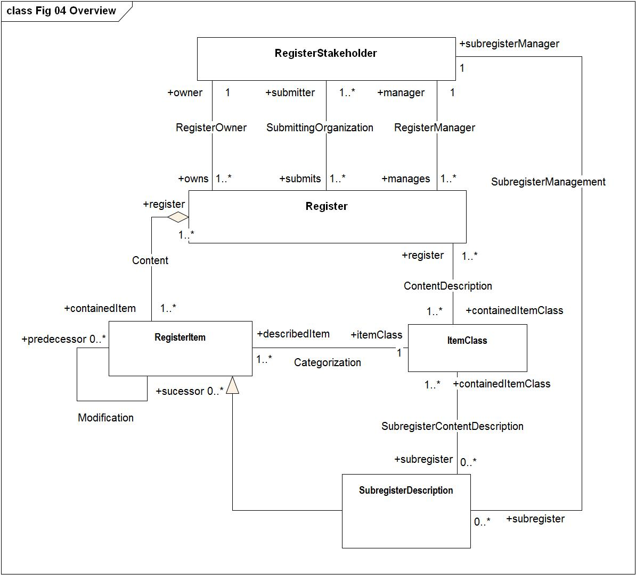

Figure - Fig 04 Overview

### ItemClass

|  |  |  |  |  |  |  |
| --- | --- | --- | --- | --- | --- | --- |
| **ItemClass**   |  |  | | --- | --- | | **Definition:** | The class "ItemClass" is a description of a class of geographic information items specified in a technical standard. | | **Supertype of:** | RE_ItemClass | | **Type:** | Object type | |
| **Association role**   |  |  | | --- | --- | | **Name:** | describedItem | | **Definition:** | The role describedItem connects an instance of a "RegisterItem" to an "ItemClass" | | **Multiplicity:** | 1..* | | **Value type:** | RegisterItem (object type type) | |
| **Attribute:**   |  |  | | --- | --- | | **Name:** | identifier | | **Definition:** | The attribute "identifier" shall be represented as a CharacterString containing a compact and human-readable designator that is used to denote a class of item.  The <i>identifier</i> that designates an item class held in a register that conforms to this International Standard shall uniquely denote the item class within the context of the register. | | **Multiplicity:** | 1 | | **Value type:** | CharacterString | |
| **Association role**   |  |  | | --- | --- | | **Name:** | register | | **Definition:** | The role register connects an instance of an item class to a register | | **Multiplicity:** | 1..* | | **Value type:** | Register (object type type) | |
| **Association role**   |  |  | | --- | --- | | **Name:** | subregister | | **Definition:** | The role subregister connects an instance of an item class to a subregister | | **Multiplicity:** | 0..* | | **Value type:** | SubregisterDescription (object type type) | |

### RE_Version

|  |  |  |  |  |
| --- | --- | --- | --- | --- |
| **RE_Version**   |  |  | | --- | --- | | **Definition:** | A dataType that uniquely defines a version | | **Type:** | Data type | |
| **Attribute:**   |  |  | | --- | --- | | **Name:** | versionDate | | **Definition:** | The attribute "date" shall be represented as an instance of the class <<Date>> [ISO 19103] that specifies the date (which may be of reduced precision) of the version.  EXAMPLE 2002-10-21. | | **Multiplicity:** | 1 | | **Value type:** | Date | |
| **Attribute:**   |  |  | | --- | --- | | **Name:** | versionNumber | | **Definition:** | The attribute "versionNumber" shall be represented as a constrained CharacterString that denotes the version. The CharacterString shall be of the form <first positive integer> <dot> <second positive integer> <letter characters> (“#.#a”), where:  <ul>  <li><first positive integer> (one or more digits) shall specify the major version designation;</li>  </ul>  <ul>  <li><dot> (“.”) shall delimit the <first positive integer> from the <second positive integer> when there is a <second positive integer>;</li>  </ul>  <ul>  <li><second positive integer> (one or more digits) shall optionally specify the minor version designation; and</li>  </ul>  <ul>  <li><letters> (one or more characters) shall optionally specify the minor subversion designation.</li>  </ul>  EXAMPLE “2.1a”. | | **Multiplicity:** | 1 | | **Value type:** | CharacterString | |

### Register

|  |  |  |  |  |  |  |
| --- | --- | --- | --- | --- | --- | --- |
| **Register**   |  |  | | --- | --- | | **Definition:** | The class RE_Register specifies information about the register itself. | | **Supertype of:** | RE_Register | | **Type:** | Object type | |
| **Association role**   |  |  | | --- | --- | | **Name:** | containedItem | | **Definition:** | Describes that the RegisterItem for the association Content describes the contained items held in the register. | | **Multiplicity:** | 1..* | | **Value type:** | RegisterItem (object type type) | |
| **Association role**   |  |  | | --- | --- | | **Name:** | containedItemClass | | **Definition:** | The role "containedItemClass" describes that the "ItemClass" for the association "ContentDescription" contains the item classes in the register. | | **Multiplicity:** | 1..* | | **Value type:** | ItemClass (object type type) | |
| **Attribute:**   |  |  | | --- | --- | | **Name:** | dateOfLastChange | | **Definition:** | The conditional attribute "dateOfLastChange" shall be represented as an instance of the class <<Date>> [ISO 19103] and specify the (full precision) date of the most recent change to the status of an item in the register was made. A value shall be provided for this attribute if a value of "version" is not supplied. | | **Multiplicity:** | 0..1 | | **Value type:** | Date | |
| **Attribute:**   |  |  | | --- | --- | | **Name:** | identifier | | **Definition:** | The attribute "identifier" represents a designator that is used to uniquely denote that register within the set of registers maintained by the register owner. In the case of a hierarchical register, the "identifier" of a subregister shall uniquely identify that subregister within the scope of all registers established by the owner of the principal register. It shall be represented as a CharacterString containing a compact and human-readable designator.  EXAMPLE: “ISO/TC 211 Register of Feature Data Dictionaries and Feature Catalogues” might be the identifier of the principal register of a hierarchical register. “DGIWG FACC Data Dictionary” and “IHO S-57 Object Dictionary” might be the identifiers of subregisters within the hierarchy. | | **Multiplicity:** | 1 | | **Value type:** | CharacterString | |
| **Association role**   |  |  | | --- | --- | | **Name:** | manager | | **Definition:** | The role "manages" describes that the RegisterStakeholder for the association RegisterManager is the manager for the register. | | **Multiplicity:** | 1 | | **Value type:** | RegisterStakeholder (object type type) | |
| **Association role**   |  |  | | --- | --- | | **Name:** | owner | | **Definition:** | The role name owner describes that the RegisterStakeholder for the association RegisterOwner is the owner of the register. | | **Multiplicity:** | 1 | | **Value type:** | RegisterStakeholder (object type type) | |
| **Association role**   |  |  | | --- | --- | | **Name:** | submitter | | **Definition:** | The role "submitter" describes that the RegisterStakeholder for the association RegisterStakeholder is the submitting organization for the register. | | **Multiplicity:** | 1..* | | **Value type:** | RegisterStakeholder (object type type) | |
| **Attribute:**   |  |  | | --- | --- | | **Name:** | version | | **Definition:** | The conditional attribute "version" shall be represented as an instance of class RE_Version that specifies a unique state in the life of the register. A value shall be provided for this attribute if a value of "dateOfLastChange" is not supplied. | | **Multiplicity:** | 0..1 | | **Value type:** | RE_Version (data type) | |
| **Constraint:**   |  |  | | --- | --- | | **Name:** | {count of(version + dateOfLastChange) >= 1} | | **Expression:** | --/at least one of the attributes version and dateOfLastChange must be provided. | |

**Diagram(s):**

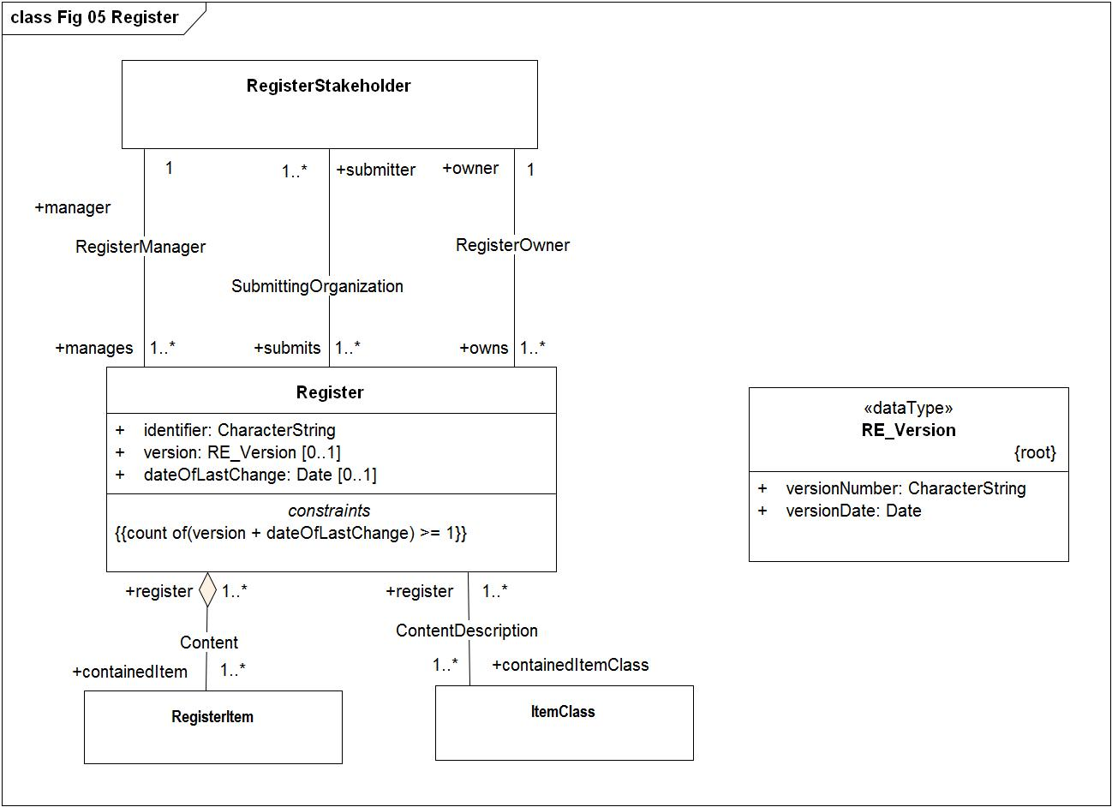

Figure - Fig 05 Register

### RegisterItem

|  |  |  |  |  |  |  |
| --- | --- | --- | --- | --- | --- | --- |
| **RegisterItem**   |  |  | | --- | --- | | **Definition:** | The class RegisterItem) specifies elements of information to be recorded for each item held in a register. The technical standard that specified an item class may specify additional elements to be recorded. | | **Supertype of:** | RE_RegisterItem  SubregisterDescription | | **Type:** | Object type | |
| **Attribute:**   |  |  | | --- | --- | | **Name:** | dateTimeAddition | | **Definition:** | The attribute "dateTimeAddition" shall specify the date on which the item was added | | **Multiplicity:** | 1 | | **Value type:** | DateTime | |
| **Attribute:**   |  |  | | --- | --- | | **Name:** | dateTimeInvalidation | | **Multiplicity:** | 0..1 | | **Value type:** | DateTime | |
| **Attribute:**   |  |  | | --- | --- | | **Name:** | dateTimeRetirement | | **Multiplicity:** | 0..1 | | **Value type:** | DateTime | |
| **Attribute:**   |  |  | | --- | --- | | **Name:** | dateTimeSupersession | | **Definition:** | The attribute "dateTimeSupersession" shall specify the date and time on which an item has been superseeded. This attribute is mandatory if status is superseded. | | **Multiplicity:** | 0..1 | | **Value type:** | DateTime | |
| **Association role**   |  |  | | --- | --- | | **Name:** | itemClass | | **Definition:** | The role "itemClass" describes that the "ItemClass" for the association "Categorization" describes the class that the register items belong to. | | **Multiplicity:** | 1 | | **Value type:** | ItemClass (object type type) | |
| **Attribute:**   |  |  | | --- | --- | | **Name:** | itemIdentifier | | **Definition:** | The attribute "itemIdentifier" shall be represented as a Character that is used to uniquely denote that item within the register and is intended for information processing. Values shall be assigned sequentially in the order in which items are proposed for entry into the register. Once a value has been assigned, it shall not be reused.  <b>NOTE</b> When a register contains items from different item classes, each item will be uniquely identifiable by the item identifier alone. | | **Multiplicity:** | 1 | | **Value type:** | CharacterString | |
| **Association role**   |  |  | | --- | --- | | **Name:** | predecessor | | **Definition:** | The role "predecessor" describes a previous concept of the "RegisterItem" | | **Multiplicity:** | 0..* | | **Value type:** | RegisterItem (object type type) | |
| **Association role**   |  |  | | --- | --- | | **Name:** | register | | **Multiplicity:** | 1..* | | **Value type:** | Register (object type type) | |
| **Attribute:**   |  |  | | --- | --- | | **Name:** | status | | **Definition:** | The attribute "status" shall be represented as an instance of RE_ItemStatus that identifies the registration status of the RegisterItem | | **Multiplicity:** | 1 | | **Value type:** | RE_ItemStatus (enumeration) | | **Values** | |  |  | | --- | --- | | submitted | The item has been entered into the register, but the control body has not accepted the proposal to add it. | | valid | The item has been accepted, is recommended for use, and has not been superseded or retired. | | superseded | The item has been superseded by another item and is no longer recommended for use. | | retired | A decision has been made that the item is no longer recommended for use. It has not been superseded by another item. | | invalid | A decision has been made that a previously valid register item contains a substantial error and is invalid, and will normally have been replaced by a corrected item. | | |
| **Association role**   |  |  | | --- | --- | | **Name:** | sucessor | | **Definition:** | The role "sucessor" describes a later concept of the "RegisterItem" | | **Multiplicity:** | 0..* | | **Value type:** | RegisterItem (object type type) | |
| **Constraint:**   |  |  | | --- | --- | | **Name:** | {status = #invalid implies dateTimeInvalidation -> notEmpty} | | **Expression:** | /dataTimeInvalidation" is mandatory if "status" is invalid/ | |
| **Constraint:**   |  |  | | --- | --- | | **Name:** | {status = #retired implies dateTimeRetirement -> notEmpty} | | **Expression:** | /dataTimeRetirement" is mandatory if "status" is superseded/ | |
| **Constraint:**   |  |  | | --- | --- | | **Name:** | {status = #superseded implies dateTimeSupersession -> notEmpty} | | **Expression:** | /dataTimeSupersession" is mandatory if "status" is superseded/ | |

**Diagram(s):**

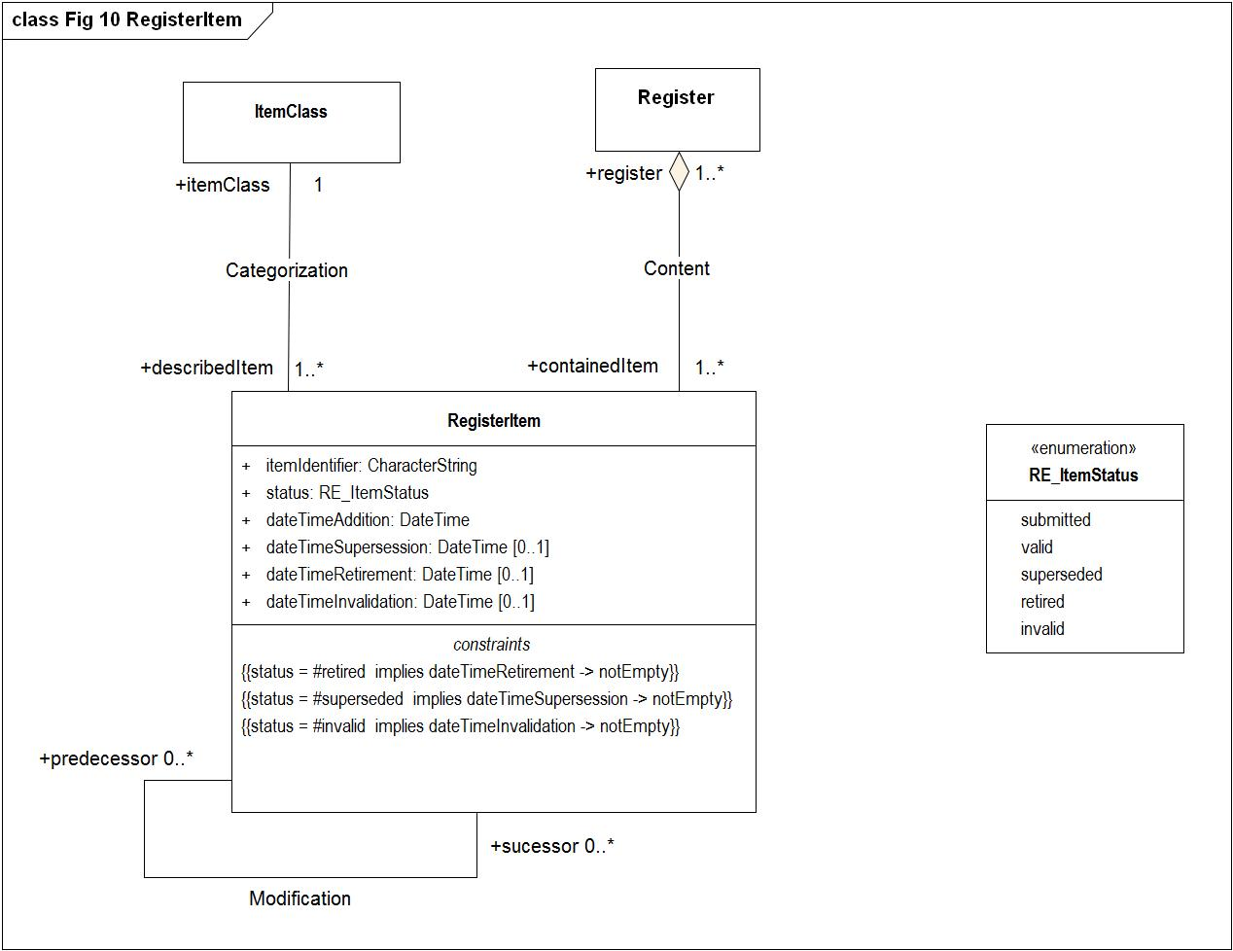

Figure - Fig 10 RegisterItem

### RegisterStakeholder

|  |  |  |  |  |  |  |
| --- | --- | --- | --- | --- | --- | --- |
| **RegisterStakeholder**   |  |  | | --- | --- | | **Definition:** | The class RegisterStakeholder specifies information about the register stakeholder, which is either a manager, owner or submitter. A stakeholder can serve one or more roles.  NOTE This International Standard does not require that a register stakeholder name be unique, since an stakeholder will, in general, have had a name before undertaking a role in connection with a register. | | **Supertype of:** | RE_RegisterStakeholder | | **Type:** | Object type | |
| **Attribute:**   |  |  | | --- | --- | | **Name:** | contact | | **Definition:** | The attribute "contact" shall be represented as an instance of CI_Responsibility [ISO 19115-1], either in the form of contact information for an individual or an organization that ist he contact point for the stakeholder, either in the role as manager, owner or submitter of register information the register. | | **Multiplicity:** | 1 | | **Value type:** | CI_Responsibility | |
| **Association role**   |  |  | | --- | --- | | **Name:** | manages | | **Definition:** | The role "manager" identifies the register stakeholder as the manager of the register. | | **Multiplicity:** | 1..* | | **Value type:** | Register (object type type) | |
| **Attribute:**   |  |  | | --- | --- | | **Name:** | name | | **Definition:** | The attribute <i>name</i> shall be represented as a CharacterString containing a compact and human-readable designator that is used to denote the stakeholder of that register.  EXAMPLE “ISO/TC 211,” “Digital Geographic Information Working Group,” and “International Hydrographic Bureau”. | | **Multiplicity:** | 1 | | **Value type:** | CharacterString | |
| **Association role**   |  |  | | --- | --- | | **Name:** | owns | | **Definition:** | The role name "owns" identifies the register stakeholder as the owner of the register. | | **Multiplicity:** | 1..* | | **Value type:** | Register (object type type) | |
| **Association role**   |  |  | | --- | --- | | **Name:** | submits | | **Definition:** | The role name "submits" identifies the register stakeholder as the submitting organization of the register. | | **Multiplicity:** | 1..* | | **Value type:** | Register (object type type) | |
| **Association role**   |  |  | | --- | --- | | **Name:** | subregister | | **Multiplicity:** | 0..* | | **Value type:** | SubregisterDescription (object type type) | |

**Diagram(s):**

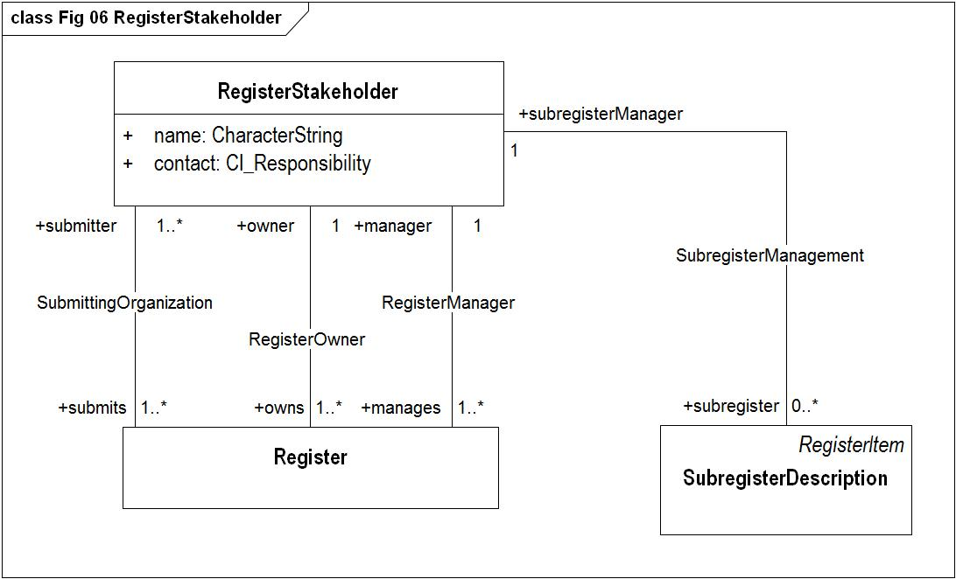

Figure - Fig 06 RegisterStakeholder

### SubregisterDescription

|  |  |  |  |  |  |  |  |  |
| --- | --- | --- | --- | --- | --- | --- | --- | --- |
| **SubregisterDescription**   |  |  | | --- | --- | | **Definition:** | "SubregisterDescription" is a subclass of "RegisterItem" that shall be used in the principal register of a hierarchical register to describe each of the affiliated subregisters. Their semantics are unchanged, but a few are subject to additional  constraints or conditions specified.  NOTE Because a subregister is a type of register, it contains an instance of "Register" that describes itself. "SubregisterDescription" carries similar information about the subregister, but it is contained within the principal register. | | **Subtype of:** | RegisterItem | | **Supertype of:** | RE_SubregisterDescription | | **Type:** | Object type | |
| **Association role**   |  |  | | --- | --- | | **Name:** | containedItemClass | | **Definition:** | The role "containedItemClass" describes that the "ItemClass" for the association "SubregisterContentDescription" contains the item classes in the subregister. | | **Multiplicity:** | 1..* | | **Value type:** | ItemClass (object type type) | |
| **Attribute:**   |  |  | | --- | --- | | **Name:** | dateTimeAddition | | **Definition:** | The attribute "dateTimeAddition" shall specify the date on which the item was added | | **Multiplicity:** | 1 | | **Value type:** | DateTime | |
| **Attribute:**   |  |  | | --- | --- | | **Name:** | dateTimeInvalidation | | **Multiplicity:** | 0..1 | | **Value type:** | DateTime | |
| **Attribute:**   |  |  | | --- | --- | | **Name:** | dateTimeRetirement | | **Multiplicity:** | 0..1 | | **Value type:** | DateTime | |
| **Attribute:**   |  |  | | --- | --- | | **Name:** | dateTimeSupersession | | **Definition:** | The attribute "dateTimeSupersession" shall specify the date and time on which an item has been superseeded. This attribute is mandatory if status is superseded. | | **Multiplicity:** | 0..1 | | **Value type:** | DateTime | |
| **Association role**   |  |  | | --- | --- | | **Name:** | itemClass | | **Definition:** | The role "itemClass" describes that the "ItemClass" for the association "Categorization" describes the class that the register items belong to. | | **Multiplicity:** | 1 | | **Value type:** | ItemClass (object type type) | |
| **Attribute:**   |  |  | | --- | --- | | **Name:** | itemIdentifier | | **Definition:** | The attribute "itemIdentifier" shall be represented as a Character that is used to uniquely denote that item within the register and is intended for information processing. Values shall be assigned sequentially in the order in which items are proposed for entry into the register. Once a value has been assigned, it shall not be reused.  <b>NOTE</b> When a register contains items from different item classes, each item will be uniquely identifiable by the item identifier alone. | | **Multiplicity:** | 1 | | **Value type:** | CharacterString | |
| **Association role**   |  |  | | --- | --- | | **Name:** | predecessor | | **Definition:** | The role "predecessor" describes a previous concept of the "RegisterItem" | | **Multiplicity:** | 0..* | | **Value type:** | RegisterItem (object type type) | |
| **Association role**   |  |  | | --- | --- | | **Name:** | register | | **Multiplicity:** | 1..* | | **Value type:** | Register (object type type) | |
| **Attribute:**   |  |  | | --- | --- | | **Name:** | status | | **Definition:** | The attribute "status" shall be represented as an instance of RE_ItemStatus that identifies the registration status of the RegisterItem | | **Multiplicity:** | 1 | | **Value type:** | RE_ItemStatus (enumeration) | | **Values** | |  |  | | --- | --- | | submitted | The item has been entered into the register, but the control body has not accepted the proposal to add it. | | valid | The item has been accepted, is recommended for use, and has not been superseded or retired. | | superseded | The item has been superseded by another item and is no longer recommended for use. | | retired | A decision has been made that the item is no longer recommended for use. It has not been superseded by another item. | | invalid | A decision has been made that a previously valid register item contains a substantial error and is invalid, and will normally have been replaced by a corrected item. | | |
| **Association role**   |  |  | | --- | --- | | **Name:** | subregisterManager | | **Multiplicity:** | 1 | | **Value type:** | RegisterStakeholder (object type type) | |
| **Association role**   |  |  | | --- | --- | | **Name:** | sucessor | | **Definition:** | The role "sucessor" describes a later concept of the "RegisterItem" | | **Multiplicity:** | 0..* | | **Value type:** | RegisterItem (object type type) | |
| **Constraint:**   |  |  | | --- | --- | | **Name:** | {status = #invalid implies dateTimeInvalidation -> notEmpty} | | **Expression:** | /dataTimeInvalidation" is mandatory if "status" is invalid/ | |
| **Constraint:**   |  |  | | --- | --- | | **Name:** | {status = #retired implies dateTimeRetirement -> notEmpty} | | **Expression:** | /dataTimeRetirement" is mandatory if "status" is superseded/ | |
| **Constraint:**   |  |  | | --- | --- | | **Name:** | {status = #superseded implies dateTimeSupersession -> notEmpty} | | **Expression:** | /dataTimeSupersession" is mandatory if "status" is superseded/ | |

**Diagram(s):**

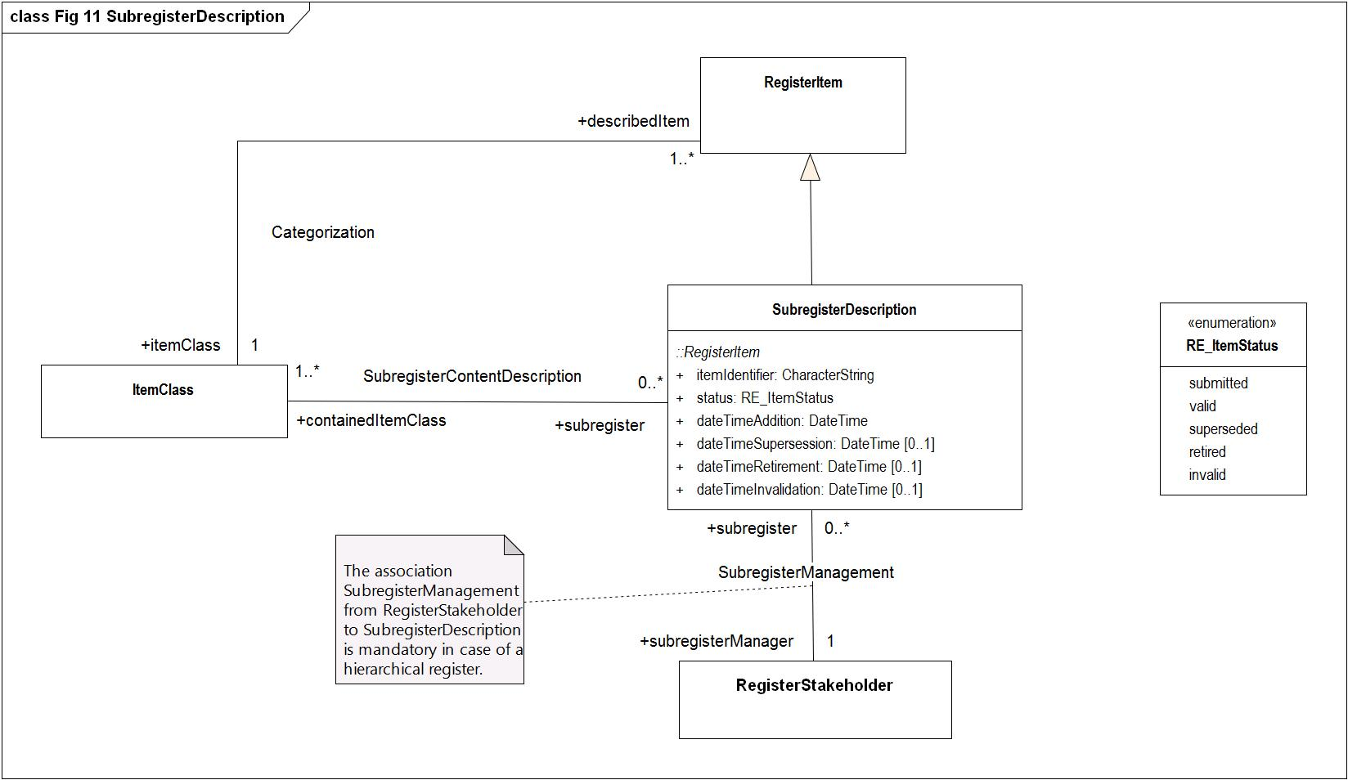

Figure - Fig 11 SubregisterDescription

## Application schema: ISO 19135-1 Procedures for Registration - Extended schema

### RE_AdditionInformation

|  |  |  |  |  |  |  |
| --- | --- | --- | --- | --- | --- | --- |
| **RE_AdditionInformation**   |  |  | | --- | --- | | **Definition:** | The subclass RE_AdditionInformation contains management information about a proposal to add an item to a register. | | **Subtype of:** | RE_ProposalManagementInformation | | **Type:** | Object type | |
| **Attribute:**   |  |  | | --- | --- | | **Name:** | controlBodyDecisionEvent | | **Definition:** | The attribute controlBodyDecisionEvent<i> </i>shall be represented as a CharacterString that identifies a meeting or other event associated with the control body’s decision concerning the proposed change. | | **Multiplicity:** | 0..1 | | **Value type:** | CharacterString | |
| **Attribute:**   |  |  | | --- | --- | | **Name:** | controlBodyNotes | | **Definition:** | The attribute "controlBodyNotes" shall be represented as a CharacterString containing notes relevant to the control body’s decision concerning the proposal. Individual entries within the notes should be dated. | | **Multiplicity:** | 0..1 | | **Value type:** | CharacterString | |
| **Attribute:**   |  |  | | --- | --- | | **Name:** | dateDisposed | | **Definition:** | The conditional attribute dateDisposed<i> </i>shall be represented as an instance of the class <<Date>> [ISO 19103] and specify the (full precision) date on which the disposition of the proposal was  determined. | | **Multiplicity:** | 0..1 | | **Value type:** | Date | |
| **Attribute:**   |  |  | | --- | --- | | **Name:** | dateProposed | | **Definition:** | The attribute "dateProposed" shall be represented as an instance of the class <<Date>> [ISO 19103] and specify the (full precision) date on which the item was entered into the register.  EXAMPLE 2002-11-27. | | **Multiplicity:** | 1 | | **Value type:** | Date | |
| **Attribute:**   |  |  | | --- | --- | | **Name:** | disposition | | **Definition:** | The conditional attribute <i>disposition </i>shall be represented as an instance of RE_Disposition that identifies the disposition of the proposal. | | **Multiplicity:** | 0..1 | | **Value type:** | RE_Disposition (enumeration) | | **Values** | |  |  | | --- | --- | | withdrawn | The submitting organization has withdrawn the proposal. | | accepted | The control body decided to accept the proposal. | | notAccepted | The control body decided not to accept the proposal. | | |
| **Association role**   |  |  | | --- | --- | | **Name:** | item | | **Definition:** | The role "addtionInformation" identifies the class RE_AdditionInformation for addtional information about the registerItem | | **Multiplicity:** | 1 | | **Value type:** | RE_RegisterItem (object type type) | |
| **Attribute:**   |  |  | | --- | --- | | **Name:** | justification | | **Definition:** | The attribute justification<i> </i>shall be represented as a CharacterString that explains why the proposed change  should be implemented. | | **Multiplicity:** | 1 | | **Value type:** | CharacterString | |
| **Attribute:**   |  |  | | --- | --- | | **Name:** | registerManagerNotes | | **Definition:** | The attribute registerManagerNotes<i> </i>shall be represented as a CharacterString containing notes relevant to the register manager’s handling of the proposal. Individual entries within the notes should be dated. | | **Multiplicity:** | 0..1 | | **Value type:** | CharacterString | |
| **Association role**   |  |  | | --- | --- | | **Name:** | sponsor | | **Definition:** | The role "sponsor " identifies the class RE_RegisterStakeholder to be submitting proposal management information to the registry | | **Multiplicity:** | 1 | | **Value type:** | RE_RegisterStakeholder (object type type) | |
| **Attribute:**   |  |  | | --- | --- | | **Name:** | status | | **Definition:** | The attribute "status"<i> </i>shall be represented as an instance of RE_DecisionStatus that identifies the standing of the proposed change within the approval process. | | **Multiplicity:** | 1 | | **Value type:** | RE_DecisionStatus (enumeration) | | **Values** | |  |  | | --- | --- | | pending | No decision has been made. | | tentative | A decision has been made, but it is still subject to appeal. | | final | A decision has been made and the time limit for appeal has run out or an appeal has been resolved. | | |
| **Constraint:**   |  |  | | --- | --- | | **Name:** | {status <> #pending implies dateDisposed -> notEmpty} | | **Expression:** | /a date shall be provided if the value of <i>status </i>is “tentative” or “final”. The date shall be revised when the value of <i>status </i>is changed from “tentative” to “final”./ | |
| **Constraint:**   |  |  | | --- | --- | | **Name:** | {status <> #pending implies disposition -> notEmpty} | | **Expression:** | /a value shall be provided if the value of <i>status </i>is “tentative” or “final”./ | |

**Diagram(s):**

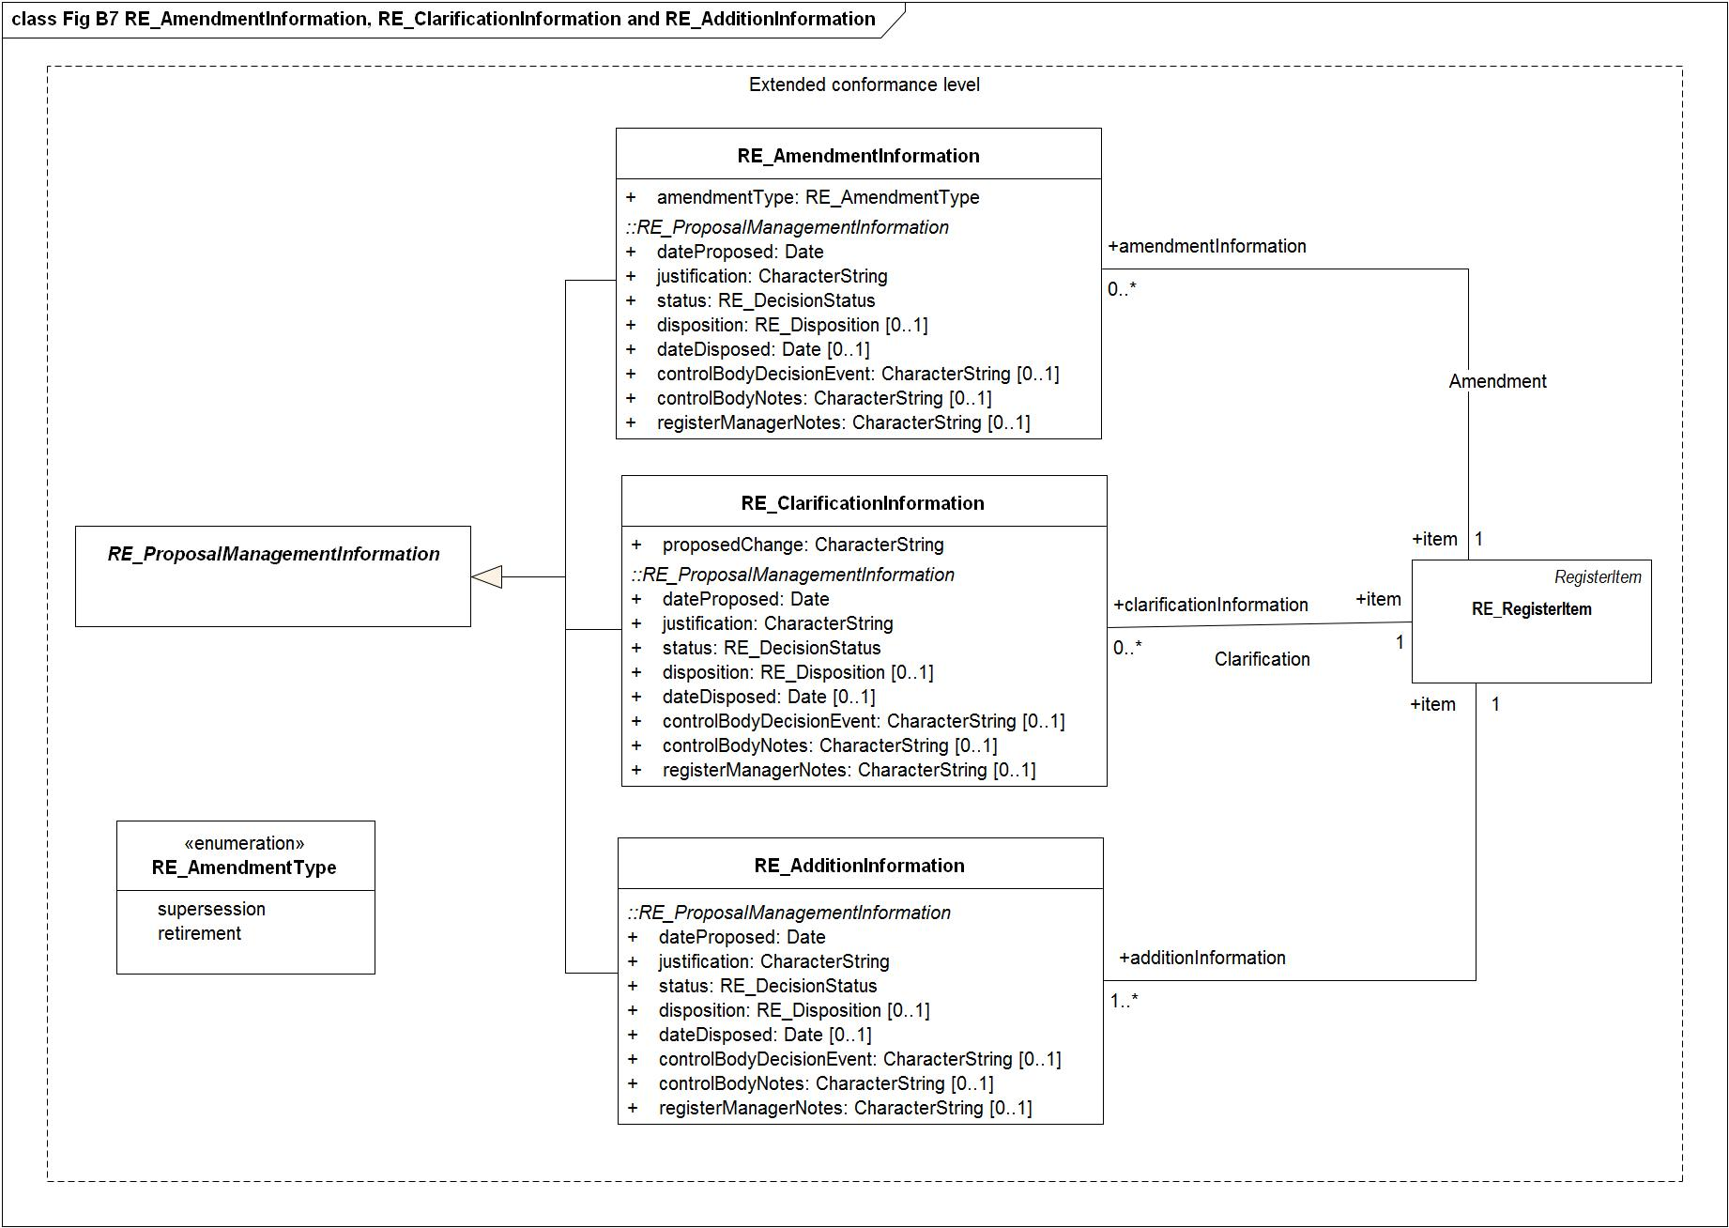

Figure - Fig B7 RE_AmendmentInformation, RE_ClarificationInformation and RE_AdditionInformation

### RE_AlternativeExpression

|  |  |  |  |  |
| --- | --- | --- | --- | --- |
| **RE_AlternativeExpression**   |  |  | | --- | --- | | **Definition:** | The class RE_AlternativeExpression is a data type used to provide information about a register item in an alternative language. Subclasses of  RE_AlternativeExpression may be specified in order to add additional attributes appropriate for particular item classes.  EXAMPLE A specification for a metadata element register could identify a subclass of RE_AlternativeExpression that would include the data dictionary fields specified in ISO 19115-1(obligation/condition, data type, and domain) as additional attributes. | | **Type:** | Data type | |
| **Attribute:**   |  |  | | --- | --- | | **Name:** | definition | | **Definition:** | The attribute "definition"<i> </i>shall be represented as a CharacterString whose content meets the requirements of RE_RegisterItem.definition<i> </i>except that the applicable locale shall be that specified in RE_AlternativeExpression.locale. | | **Multiplicity:** | 0..1 | | **Value type:** | CharacterString | |
| **Attribute:**   |  |  | | --- | --- | | **Name:** | description | | **Definition:** | The attribute description<i> </i>shall be represented as a CharacterString whose content meets the requirements of RE_RegisterItem.description<i> </i>except that the applicable locale shall be that specified in RE_AlternativeExpression.locale. | | **Multiplicity:** | 0..1 | | **Value type:** | CharacterString | |
| **Attribute:**   |  |  | | --- | --- | | **Name:** | fieldOfApplication | | **Definition:** | The attribute fieldOfApplication<i> </i>shall be represented as a set of instances of RE_FieldOfApplication whose content meets the requirements of RE_RegisterItem.fieldOfApplication<i> </i>except that the applicable locale shall be that specified in RE_AlternativeExpression.locale | | **Multiplicity:** | 0..1 | | **Value type:** | Set<RE_FieldOfApplication> | |
| **Association role**   |  |  | | --- | --- | | **Name:** | locale | | **Definition:** | The role "expression" identifies the class RE_AlternativeExpression for language information as specified in RE_Locale | | **Multiplicity:** | 1 | | **Value type:** | RE_Locale (object type type) | |
| **Attribute:**   |  |  | | --- | --- | | **Name:** | name | | **Definition:** | The attribute "name"<i> </i>shall be represented as a CharacterString whose content meets the requirements of RE_RegisterItem.name<i> </i>except that the applicable locale shall be that specified in RE_AlternativeExpression.locale. | | **Multiplicity:** | 1 | | **Value type:** | CharacterString | |

### RE_AlternativeName

|  |  |  |  |  |
| --- | --- | --- | --- | --- |
| **RE_AlternativeName**   |  |  | | --- | --- | | **Definition:** | The class RE_AlternativeName is a data type used to provide the name of an item class in an alternative language. | | **Type:** | Data type | |
| **Association role**   |  |  | | --- | --- | | **Name:** | locale | | **Definition:** | The role "name" identifies that information in the class RE_Locale gives further information about the language of the name i RE_AlternativeName | | **Multiplicity:** | 1 | | **Value type:** | RE_Locale (object type type) | |
| **Attribute:**   |  |  | | --- | --- | | **Name:** | name | | **Multiplicity:** | 1 | | **Value type:** | CharacterString | |

### RE_AmendmentInformation

|  |  |  |  |  |  |  |
| --- | --- | --- | --- | --- | --- | --- |
| **RE_AmendmentInformation**   |  |  | | --- | --- | | **Definition:** | The subclass RE_AmendmentInformation contains management information about a proposal to amend an item in a register. | | **Subtype of:** | RE_ProposalManagementInformation | | **Type:** | Object type | |
| **Attribute:**   |  |  | | --- | --- | | **Name:** | amendmentType | | **Definition:** | The attribute "amendmentType"<i> </i>shall be represented as an instance of RE_AmendmentType that identifies the type of amendment proposed. | | **Multiplicity:** | 1 | | **Value type:** | RE_AmendmentType (enumeration) | | **Values** | |  |  | | --- | --- | | supersession | The proposal requests that an item be superseded. | | retirement | The proposal requests that an item be retired. | | |
| **Attribute:**   |  |  | | --- | --- | | **Name:** | controlBodyDecisionEvent | | **Definition:** | The attribute controlBodyDecisionEvent<i> </i>shall be represented as a CharacterString that identifies a meeting or other event associated with the control body’s decision concerning the proposed change. | | **Multiplicity:** | 0..1 | | **Value type:** | CharacterString | |
| **Attribute:**   |  |  | | --- | --- | | **Name:** | controlBodyNotes | | **Definition:** | The attribute "controlBodyNotes" shall be represented as a CharacterString containing notes relevant to the control body’s decision concerning the proposal. Individual entries within the notes should be dated. | | **Multiplicity:** | 0..1 | | **Value type:** | CharacterString | |
| **Attribute:**   |  |  | | --- | --- | | **Name:** | dateDisposed | | **Definition:** | The conditional attribute dateDisposed<i> </i>shall be represented as an instance of the class <<Date>> [ISO 19103] and specify the (full precision) date on which the disposition of the proposal was  determined. | | **Multiplicity:** | 0..1 | | **Value type:** | Date | |
| **Attribute:**   |  |  | | --- | --- | | **Name:** | dateProposed | | **Definition:** | The attribute "dateProposed" shall be represented as an instance of the class <<Date>> [ISO 19103] and specify the (full precision) date on which the item was entered into the register.  EXAMPLE 2002-11-27. | | **Multiplicity:** | 1 | | **Value type:** | Date | |
| **Attribute:**   |  |  | | --- | --- | | **Name:** | disposition | | **Definition:** | The conditional attribute <i>disposition </i>shall be represented as an instance of RE_Disposition that identifies the disposition of the proposal. | | **Multiplicity:** | 0..1 | | **Value type:** | RE_Disposition (enumeration) | | **Values** | |  |  | | --- | --- | | withdrawn | The submitting organization has withdrawn the proposal. | | accepted | The control body decided to accept the proposal. | | notAccepted | The control body decided not to accept the proposal. | | |
| **Association role**   |  |  | | --- | --- | | **Name:** | item | | **Multiplicity:** | 1 | | **Value type:** | RE_RegisterItem (object type type) | |
| **Attribute:**   |  |  | | --- | --- | | **Name:** | justification | | **Definition:** | The attribute justification<i> </i>shall be represented as a CharacterString that explains why the proposed change  should be implemented. | | **Multiplicity:** | 1 | | **Value type:** | CharacterString | |
| **Attribute:**   |  |  | | --- | --- | | **Name:** | registerManagerNotes | | **Definition:** | The attribute registerManagerNotes<i> </i>shall be represented as a CharacterString containing notes relevant to the register manager’s handling of the proposal. Individual entries within the notes should be dated. | | **Multiplicity:** | 0..1 | | **Value type:** | CharacterString | |
| **Association role**   |  |  | | --- | --- | | **Name:** | sponsor | | **Definition:** | The role "sponsor " identifies the class RE_RegisterStakeholder to be submitting proposal management information to the registry | | **Multiplicity:** | 1 | | **Value type:** | RE_RegisterStakeholder (object type type) | |
| **Attribute:**   |  |  | | --- | --- | | **Name:** | status | | **Definition:** | The attribute "status"<i> </i>shall be represented as an instance of RE_DecisionStatus that identifies the standing of the proposed change within the approval process. | | **Multiplicity:** | 1 | | **Value type:** | RE_DecisionStatus (enumeration) | | **Values** | |  |  | | --- | --- | | pending | No decision has been made. | | tentative | A decision has been made, but it is still subject to appeal. | | final | A decision has been made and the time limit for appeal has run out or an appeal has been resolved. | | |
| **Constraint:**   |  |  | | --- | --- | | **Name:** | {status <> #pending implies dateDisposed -> notEmpty} | | **Expression:** | /a date shall be provided if the value of <i>status </i>is “tentative” or “final”. The date shall be revised when the value of <i>status </i>is changed from “tentative” to “final”./ | |
| **Constraint:**   |  |  | | --- | --- | | **Name:** | {status <> #pending implies disposition -> notEmpty} | | **Expression:** | /a value shall be provided if the value of <i>status </i>is “tentative” or “final”./ | |

**Diagram(s):**



Figure - Fig B7 RE_AmendmentInformation, RE_ClarificationInformation and RE_AdditionInformation

### RE_ClarificationInformation

|  |  |  |  |  |  |  |
| --- | --- | --- | --- | --- | --- | --- |
| **RE_ClarificationInformation**   |  |  | | --- | --- | | **Definition:** | The subclass RE_ClarificationInformation contains management information about a proposal to clarify an item in a register. | | **Subtype of:** | RE_ProposalManagementInformation | | **Type:** | Object type | |
| **Attribute:**   |  |  | | --- | --- | | **Name:** | controlBodyDecisionEvent | | **Definition:** | The attribute controlBodyDecisionEvent<i> </i>shall be represented as a CharacterString that identifies a meeting or other event associated with the control body’s decision concerning the proposed change. | | **Multiplicity:** | 0..1 | | **Value type:** | CharacterString | |
| **Attribute:**   |  |  | | --- | --- | | **Name:** | controlBodyNotes | | **Definition:** | The attribute "controlBodyNotes" shall be represented as a CharacterString containing notes relevant to the control body’s decision concerning the proposal. Individual entries within the notes should be dated. | | **Multiplicity:** | 0..1 | | **Value type:** | CharacterString | |
| **Attribute:**   |  |  | | --- | --- | | **Name:** | dateDisposed | | **Definition:** | The conditional attribute dateDisposed<i> </i>shall be represented as an instance of the class <<Date>> [ISO 19103] and specify the (full precision) date on which the disposition of the proposal was  determined. | | **Multiplicity:** | 0..1 | | **Value type:** | Date | |
| **Attribute:**   |  |  | | --- | --- | | **Name:** | dateProposed | | **Definition:** | The attribute "dateProposed" shall be represented as an instance of the class <<Date>> [ISO 19103] and specify the (full precision) date on which the item was entered into the register.  EXAMPLE 2002-11-27. | | **Multiplicity:** | 1 | | **Value type:** | Date | |
| **Attribute:**   |  |  | | --- | --- | | **Name:** | disposition | | **Definition:** | The conditional attribute <i>disposition </i>shall be represented as an instance of RE_Disposition that identifies the disposition of the proposal. | | **Multiplicity:** | 0..1 | | **Value type:** | RE_Disposition (enumeration) | | **Values** | |  |  | | --- | --- | | withdrawn | The submitting organization has withdrawn the proposal. | | accepted | The control body decided to accept the proposal. | | notAccepted | The control body decided not to accept the proposal. | | |
| **Association role**   |  |  | | --- | --- | | **Name:** | item | | **Definition:** | The role "clarificationInformation " identifies the class RE_ClarificationInformation for clarifying information about the registerItem | | **Multiplicity:** | 1 | | **Value type:** | RE_RegisterItem (object type type) | |
| **Attribute:**   |  |  | | --- | --- | | **Name:** | justification | | **Definition:** | The attribute justification<i> </i>shall be represented as a CharacterString that explains why the proposed change  should be implemented. | | **Multiplicity:** | 1 | | **Value type:** | CharacterString | |
| **Attribute:**   |  |  | | --- | --- | | **Name:** | proposedChange | | **Definition:** | The attribute "proposedChange"<i> </i>shall be represented as a CharacterString containing a description of the clarification that shall identify the elements of the register item that are changed and the prior and subsequent values of each.  EXAMPLE The definition of this item was changed to correct a typographical error. The misspelled word “phenomnon” was changed to “phenomenon”. | | **Multiplicity:** | 1 | | **Value type:** | CharacterString | |
| **Attribute:**   |  |  | | --- | --- | | **Name:** | registerManagerNotes | | **Definition:** | The attribute registerManagerNotes<i> </i>shall be represented as a CharacterString containing notes relevant to the register manager’s handling of the proposal. Individual entries within the notes should be dated. | | **Multiplicity:** | 0..1 | | **Value type:** | CharacterString | |
| **Association role**   |  |  | | --- | --- | | **Name:** | sponsor | | **Definition:** | The role "sponsor " identifies the class RE_RegisterStakeholder to be submitting proposal management information to the registry | | **Multiplicity:** | 1 | | **Value type:** | RE_RegisterStakeholder (object type type) | |
| **Attribute:**   |  |  | | --- | --- | | **Name:** | status | | **Definition:** | The attribute "status"<i> </i>shall be represented as an instance of RE_DecisionStatus that identifies the standing of the proposed change within the approval process. | | **Multiplicity:** | 1 | | **Value type:** | RE_DecisionStatus (enumeration) | | **Values** | |  |  | | --- | --- | | pending | No decision has been made. | | tentative | A decision has been made, but it is still subject to appeal. | | final | A decision has been made and the time limit for appeal has run out or an appeal has been resolved. | | |
| **Constraint:**   |  |  | | --- | --- | | **Name:** | {status <> #pending implies dateDisposed -> notEmpty} | | **Expression:** | /a date shall be provided if the value of <i>status </i>is “tentative” or “final”. The date shall be revised when the value of <i>status </i>is changed from “tentative” to “final”./ | |
| **Constraint:**   |  |  | | --- | --- | | **Name:** | {status <> #pending implies disposition -> notEmpty} | | **Expression:** | /a value shall be provided if the value of <i>status </i>is “tentative” or “final”./ | |

**Diagram(s):**



Figure - Fig B7 RE_AmendmentInformation, RE_ClarificationInformation and RE_AdditionInformation

### RE_FieldOfApplication

|  |  |  |  |  |
| --- | --- | --- | --- | --- |
| **RE_FieldOfApplication**   |  |  | | --- | --- | | **Definition:** | RE_FieldOfApplication is a data type used to provide information about a use for a register item. | | **Type:** | Data type | |
| **Attribute:**   |  |  | | --- | --- | | **Name:** | description | | **Definition:** | The attribute description provides as a CharacterString a description of the field of application.  EXAMPLE “Pertaining to the science, art, and business of cultivating soil, producing crops, and raising livestock.”  “Pertaining to the science or art of conducting ships or vessels from one place to another at sea.” | | **Multiplicity:** | 0..1 | | **Value type:** | CharacterString | |
| **Attribute:**   |  |  | | --- | --- | | **Name:** | name | | **Definition:** | The attribute "name"<i> </i>shall be represented as a CharacterString used to identify the field of application.  EXAMPLE “Agricultural Production”, “Marine Navigation”. | | **Multiplicity:** | 1 | | **Value type:** | CharacterString | |

### RE_ItemClass

|  |  |  |  |  |  |  |
| --- | --- | --- | --- | --- | --- | --- |
| **RE_ItemClass**   |  |  | | --- | --- | | **Definition:** | RE_ItemClass is a description of a class of geographic information items specified in a technical standard. | | **Subtype of:** | ItemClass | | **Type:** | Object type | |
| **Attribute:**   |  |  | | --- | --- | | **Name:** | alternativeName | | **Definition:** | The attribute alternativeNames<i> </i>contains a set of instances of RE_AlternativeName, each of which is a translation of the "name" of the RE_ItemClass into a language other than the "operatingLanguage"<i> </i>of the RE_Register. | | **Multiplicity:** | 1 | | **Value type:** | Set<RE_AlternativeName> | |
| **Association role**   |  |  | | --- | --- | | **Name:** | describedItem | | **Definition:** | The role describedItem connects an instance of a "RegisterItem" to an "ItemClass" | | **Multiplicity:** | 1..* | | **Value type:** | RegisterItem (object type type) | |
| **Attribute:**   |  |  | | --- | --- | | **Name:** | identifier | | **Definition:** | The attribute "identifier" shall be represented as a CharacterString containing a compact and human-readable designator that is used to denote a class of item.  The <i>identifier</i> that designates an item class held in a register that conforms to this International Standard shall uniquely denote the item class within the context of the register. | | **Multiplicity:** | 1 | | **Value type:** | CharacterString | |
| **Attribute:**   |  |  | | --- | --- | | **Name:** | name | | **Definition:** | The attribute "name"<i> </i>shall be represented as a CharacterString containing a compact and human-readable designator that is used to denote a class of item.  The "name"<i> </i>that designates an item class held in a register that conforms to this International Standard shall:  a) uniquely denote the item class within the context of the register; and  b) be based on the item class designation used in the applicable technical standard. | | **Multiplicity:** | 1 | | **Value type:** | CharacterString | |
| **Association role**   |  |  | | --- | --- | | **Name:** | register | | **Definition:** | The role register connects an instance of an item class to a register | | **Multiplicity:** | 1..* | | **Value type:** | Register (object type type) | |
| **Association role**   |  |  | | --- | --- | | **Name:** | subregister | | **Definition:** | The role subregister connects an instance of an item class to a subregister | | **Multiplicity:** | 0..* | | **Value type:** | SubregisterDescription (object type type) | |
| **Attribute:**   |  |  | | --- | --- | | **Name:** | technicalStandard | | **Definition:** | The attribute technicalStandard<i> </i>shall be represented as an instance of CI_Citation [ISO 19115-1] that shall specify the technical standard (and the specific portion thereof) to which items in the item class shall conform. | | **Multiplicity:** | 1 | | **Value type:** | CI_Citation | |

**Diagram(s):**

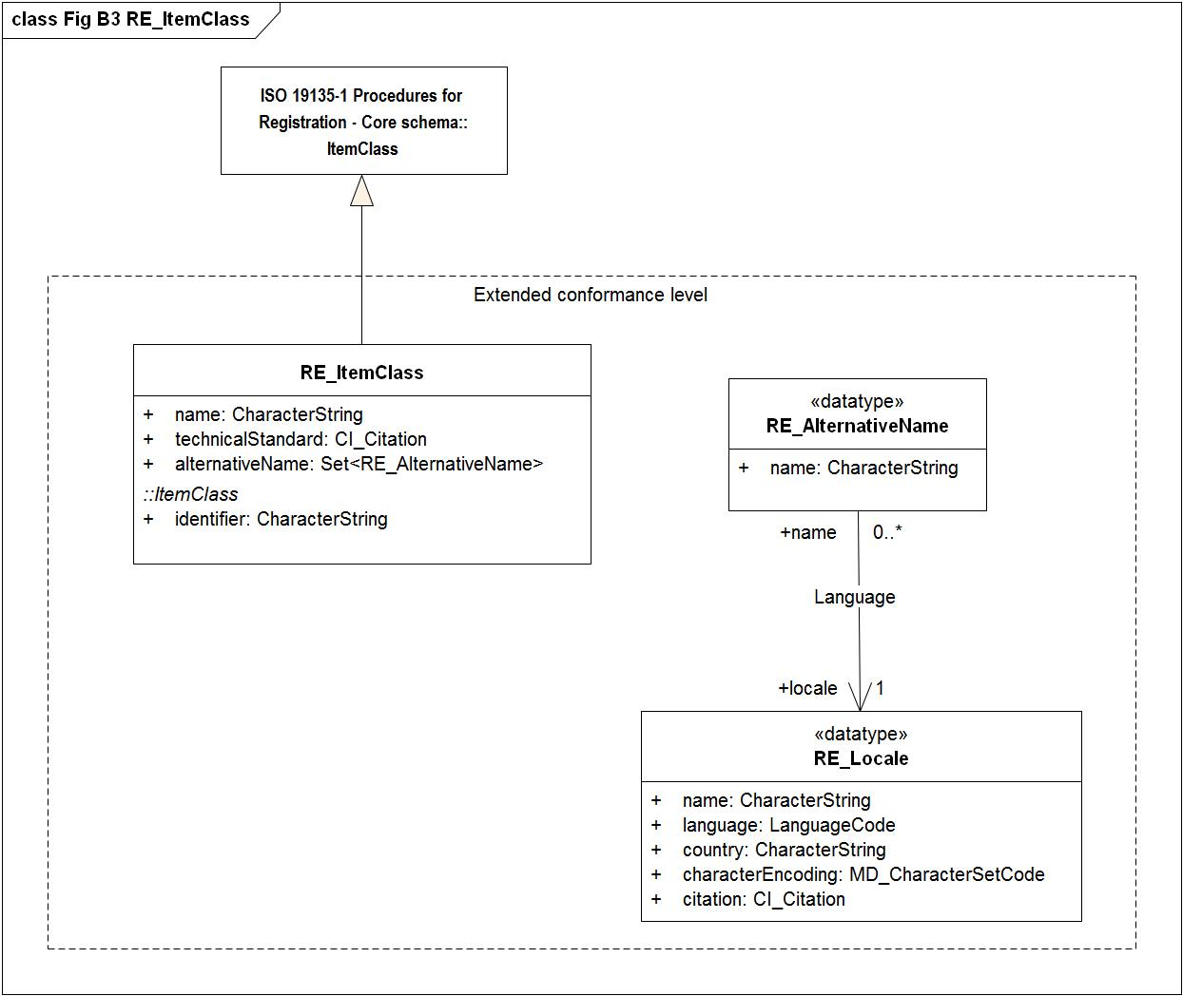

Figure - Fig B3 RE_ItemClass

### RE_Locale

|  |  |  |  |  |
| --- | --- | --- | --- | --- |
| **RE_Locale**   |  |  | | --- | --- | | **Definition:** | The class RE_Locale provides information about languages used in a register. | | **Type:** | Data type | |
| **Attribute:**   |  |  | | --- | --- | | **Name:** | characterEncoding | | **Definition:** | The attribute <i>characterEncoding </i>shall be represented as an instance of MD_CharacterSetCode that specifies the name of the character coding standard used. | | **Multiplicity:** | 1 | | **Value type:** | MD_CharacterSetCode | |
| **Attribute:**   |  |  | | --- | --- | | **Name:** | citation | | **Definition:** | The optional attribute "citation"<i> </i>shall be represented as an instance of CI_Citation [ISO 19115-1] that identifies a resource that provides more information about the locale.  EXAMPLE An instance of CI_Citation could provide information about a specific dialect of the language identified for the locale, or about some other culturally significant aspect of information presentation, such as a specific method of formatting numbers. | | **Multiplicity:** | 1 | | **Value type:** | CI_Citation | |
| **Attribute:**   |  |  | | --- | --- | | **Name:** | country | | **Definition:** | The attribute <i>country </i>shall be represented as a CharacterString that holds a 3-character numerical country code as specified in ISO 3166-1.  NOTE The list of codes is available from the URL ftp.ics.uci.edu/pub/ietf/http/related/iso3166.txt or the ISO 3166  Maintenance Agency at URL http://www.iso.ch/iso/en/prods-services/iso3166ma/index.html. | | **Multiplicity:** | 1 | | **Value type:** | CharacterString | |
| **Association role**   |  |  | | --- | --- | | **Name:** | expression | | **Definition:** | The role "locale" identifies the class RE_Locale for further information about the language used for the alternative expression | | **Multiplicity:** | 0..* | | **Value type:** | RE_AlternativeExpression (object type type) | |
| **Attribute:**   |  |  | | --- | --- | | **Name:** | language | | **Definition:** | The attribute <i>language </i>shall take as its value a 3-character language code as specified in ISO 639-2.  NOTE The list of codes maintained by the ISO 639-2 Registration Authority is available at the URL  http://www.loc.gov/standards/iso639-2/langcodes.html. | | **Multiplicity:** | 1 | | **Value type:** | LanguageCode | |
| **Attribute:**   |  |  | | --- | --- | | **Name:** | name | | **Definition:** | The attribute "name"<i> </i>shall be represented as a CharacterString that describes the locale.  EXAMPLE “Welsh” | | **Multiplicity:** | 1 | | **Value type:** | CharacterString | |

### RE_ProposalManagementInformation

|  |  |  |  |  |  |  |
| --- | --- | --- | --- | --- | --- | --- |
| **RE_ProposalManagementInformation**   |  |  | | --- | --- | | **Definition:** | The class RE_ProposalManagementInformation specifies elements of management information to be recorded for each proposal to add or modify a register item. | | **Supertype of:** | RE_AdditionInformation  RE_AmendmentInformation  RE_ClarificationInformation | | **Type:** | Object type | |
| **Attribute:**   |  |  | | --- | --- | | **Name:** | controlBodyDecisionEvent | | **Definition:** | The attribute controlBodyDecisionEvent<i> </i>shall be represented as a CharacterString that identifies a meeting or other event associated with the control body’s decision concerning the proposed change. | | **Multiplicity:** | 0..1 | | **Value type:** | CharacterString | |
| **Attribute:**   |  |  | | --- | --- | | **Name:** | controlBodyNotes | | **Definition:** | The attribute "controlBodyNotes" shall be represented as a CharacterString containing notes relevant to the control body’s decision concerning the proposal. Individual entries within the notes should be dated. | | **Multiplicity:** | 0..1 | | **Value type:** | CharacterString | |
| **Attribute:**   |  |  | | --- | --- | | **Name:** | dateDisposed | | **Definition:** | The conditional attribute dateDisposed<i> </i>shall be represented as an instance of the class <<Date>> [ISO 19103] and specify the (full precision) date on which the disposition of the proposal was  determined. | | **Multiplicity:** | 0..1 | | **Value type:** | Date | |
| **Attribute:**   |  |  | | --- | --- | | **Name:** | dateProposed | | **Definition:** | The attribute "dateProposed" shall be represented as an instance of the class <<Date>> [ISO 19103] and specify the (full precision) date on which the item was entered into the register.  EXAMPLE 2002-11-27. | | **Multiplicity:** | 1 | | **Value type:** | Date | |
| **Attribute:**   |  |  | | --- | --- | | **Name:** | disposition | | **Definition:** | The conditional attribute <i>disposition </i>shall be represented as an instance of RE_Disposition that identifies the disposition of the proposal. | | **Multiplicity:** | 0..1 | | **Value type:** | RE_Disposition (enumeration) | | **Values** | |  |  | | --- | --- | | withdrawn | The submitting organization has withdrawn the proposal. | | accepted | The control body decided to accept the proposal. | | notAccepted | The control body decided not to accept the proposal. | | |
| **Attribute:**   |  |  | | --- | --- | | **Name:** | justification | | **Definition:** | The attribute justification<i> </i>shall be represented as a CharacterString that explains why the proposed change  should be implemented. | | **Multiplicity:** | 1 | | **Value type:** | CharacterString | |
| **Attribute:**   |  |  | | --- | --- | | **Name:** | registerManagerNotes | | **Definition:** | The attribute registerManagerNotes<i> </i>shall be represented as a CharacterString containing notes relevant to the register manager’s handling of the proposal. Individual entries within the notes should be dated. | | **Multiplicity:** | 0..1 | | **Value type:** | CharacterString | |
| **Association role**   |  |  | | --- | --- | | **Name:** | sponsor | | **Definition:** | The role "sponsor " identifies the class RE_RegisterStakeholder to be submitting proposal management information to the registry | | **Multiplicity:** | 1 | | **Value type:** | RE_RegisterStakeholder (object type type) | |
| **Attribute:**   |  |  | | --- | --- | | **Name:** | status | | **Definition:** | The attribute "status"<i> </i>shall be represented as an instance of RE_DecisionStatus that identifies the standing of the proposed change within the approval process. | | **Multiplicity:** | 1 | | **Value type:** | RE_DecisionStatus (enumeration) | | **Values** | |  |  | | --- | --- | | pending | No decision has been made. | | tentative | A decision has been made, but it is still subject to appeal. | | final | A decision has been made and the time limit for appeal has run out or an appeal has been resolved. | | |
| **Constraint:**   |  |  | | --- | --- | | **Name:** | {status <> #pending implies dateDisposed -> notEmpty} | | **Expression:** | /a date shall be provided if the value of <i>status </i>is “tentative” or “final”. The date shall be revised when the value of <i>status </i>is changed from “tentative” to “final”./ | |
| **Constraint:**   |  |  | | --- | --- | | **Name:** | {status <> #pending implies disposition -> notEmpty} | | **Expression:** | /a value shall be provided if the value of <i>status </i>is “tentative” or “final”./ | |

**Diagram(s):**

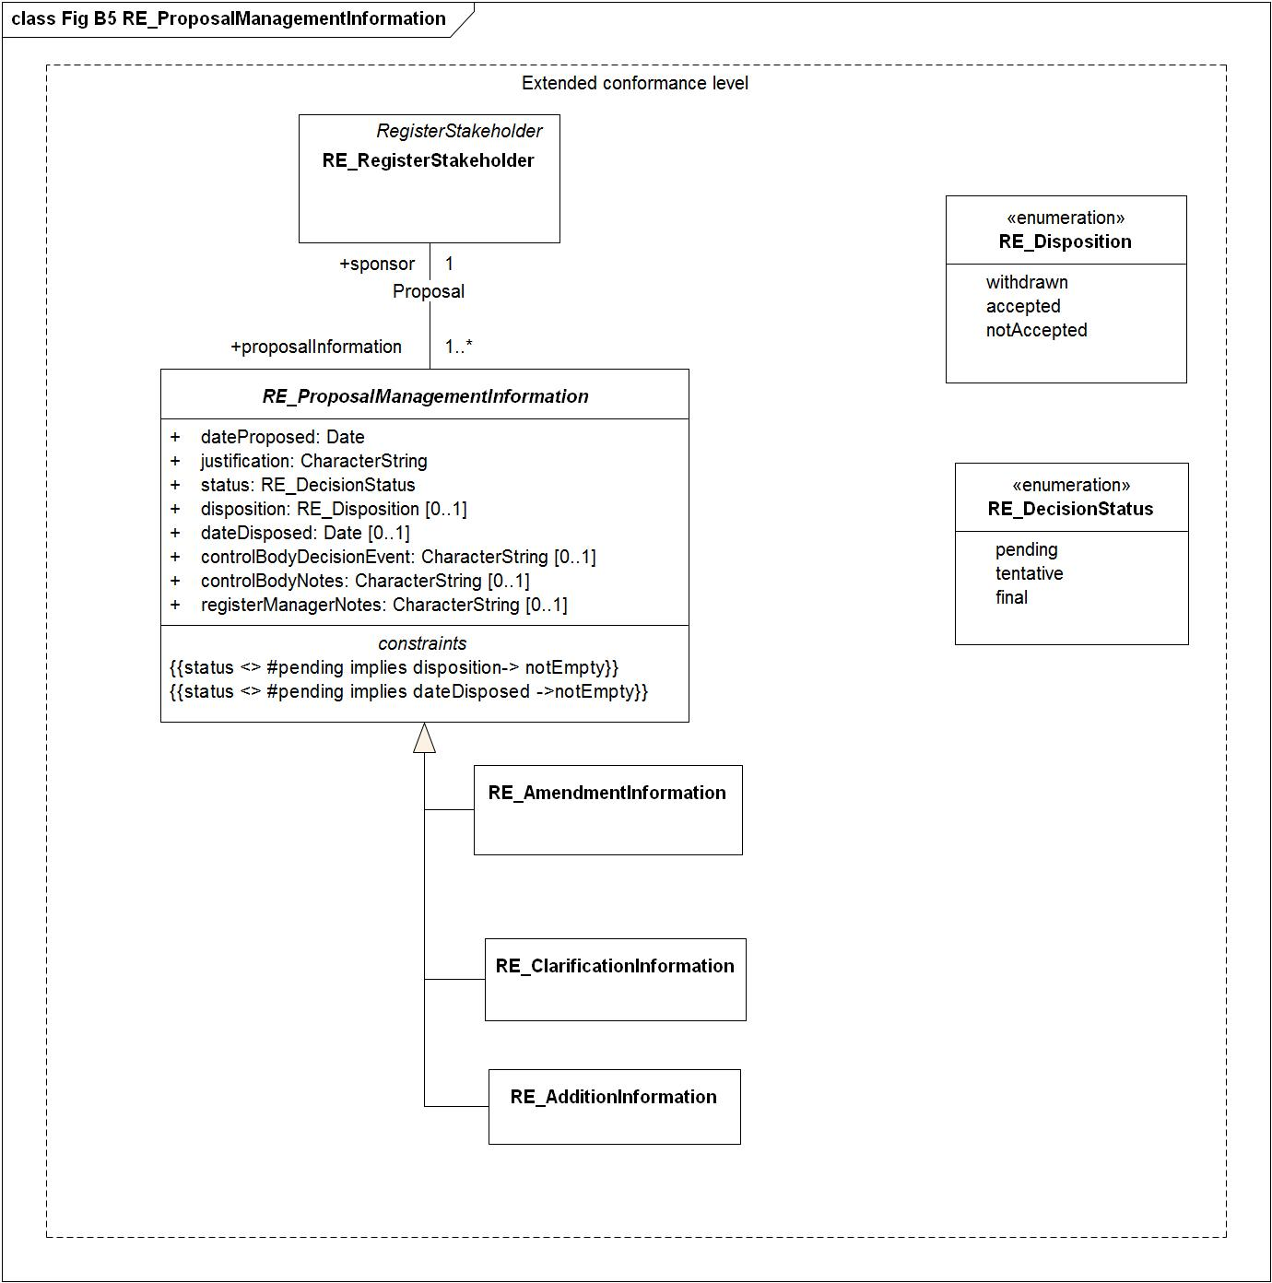

Figure - Fig B5 RE_ProposalManagementInformation

### RE_Reference

|  |  |  |  |  |
| --- | --- | --- | --- | --- |
| **RE_Reference**   |  |  | | --- | --- | | **Definition:** | The class RE_Reference specifies information about the source and/or lineage of a specific RE_RegisterItem derived from an external document or register. | | **Type:** | Object type | |
| **Association role**   |  |  | | --- | --- | | **Name:** | item | | **Definition:** | The role "item" identifies the information in RE_Reference is for the register item. | | **Multiplicity:** | 0..* | | **Value type:** | RE_RegisterItem (object type type) | |
| **Attribute:**   |  |  | | --- | --- | | **Name:** | itemIdentifierAtSource | | **Definition:** | The attribute "itemIdentifierAtSource"<i> </i>shall be represented as a CharacterString that provides the value of the item identifier in the source document or register from which the specification of the RE_RegisterItem is derived. | | **Multiplicity:** | 1 | | **Value type:** | CharacterString | |
| **Attribute:**   |  |  | | --- | --- | | **Name:** | notes | | **Definition:** | The optional attribute "notes"<i> </i>shall be represented as a CharacterString that may be used to provide additional information about the derivation of the specification of a register item from an external source. | | **Multiplicity:** | 0..1 | | **Value type:** | CharacterString | |
| **Attribute:**   |  |  | | --- | --- | | **Name:** | referenceText | | **Definition:** | The optional attribute "referenceText"<i> </i>shall be represented as a CharacterString that may be used to provide a copy of documentation about the item from the RE_ReferenceSource.  NOTE This attribute is intended for use in cases where the RE_ReferenceSource may not be readily accessible to users of the register. | | **Multiplicity:** | 0..1 | | **Value type:** | CharacterString | |
| **Attribute:**   |  |  | | --- | --- | | **Name:** | similarity | | **Definition:** | The attribute "similarity"<i> </i>shall use a value from the <<CodeList>> RE_SimilarityToSource that specifies the type of change that has been made to the item specification relative to the item specification in the external source. | | **Multiplicity:** | 1 | | **Value type:** | RE_SimilarityToSource (code list) | | **Values** | |  |  | | --- | --- | | 1 | **identical**  No change has been made to the specification. | | 2 | **restyled**  The style of the specification has been changed to match the style and structure of other specifications in the register that has imported the specification. | | 3 | **contextAdded**  The specification includes information about its context that is not explicit in the specification in the external source. | | 4 | **generalization**  The specification of the register item has been generalized to have a broader  meaning than the item specified in the external source. | | 5 | **specialization**  The specification of the register item has been specialized to have a narrower meaning than the item specified in the external source. | | 6 | **unspecified**  The nature of the differences between the register item and the similar item in the external source is unspecified. | | |
| **Association role**   |  |  | | --- | --- | | **Name:** | sourceCitation | | **Definition:** | The role "itemReference" identifies that the information in the RE_ReferenceSource is the citation for the RE_Reference. | | **Multiplicity:** | 1 | | **Value type:** | RE_ReferenceSource (object type type) | |
| **Association role**   |  |  | | --- | --- | | **Name:** | specifiedItem | | **Definition:** | The role "specificationSource" identifies the reference infromation for the register item. | | **Multiplicity:** | 1 | | **Value type:** | RE_RegisterItem (object type type) | |

**Diagram(s):**

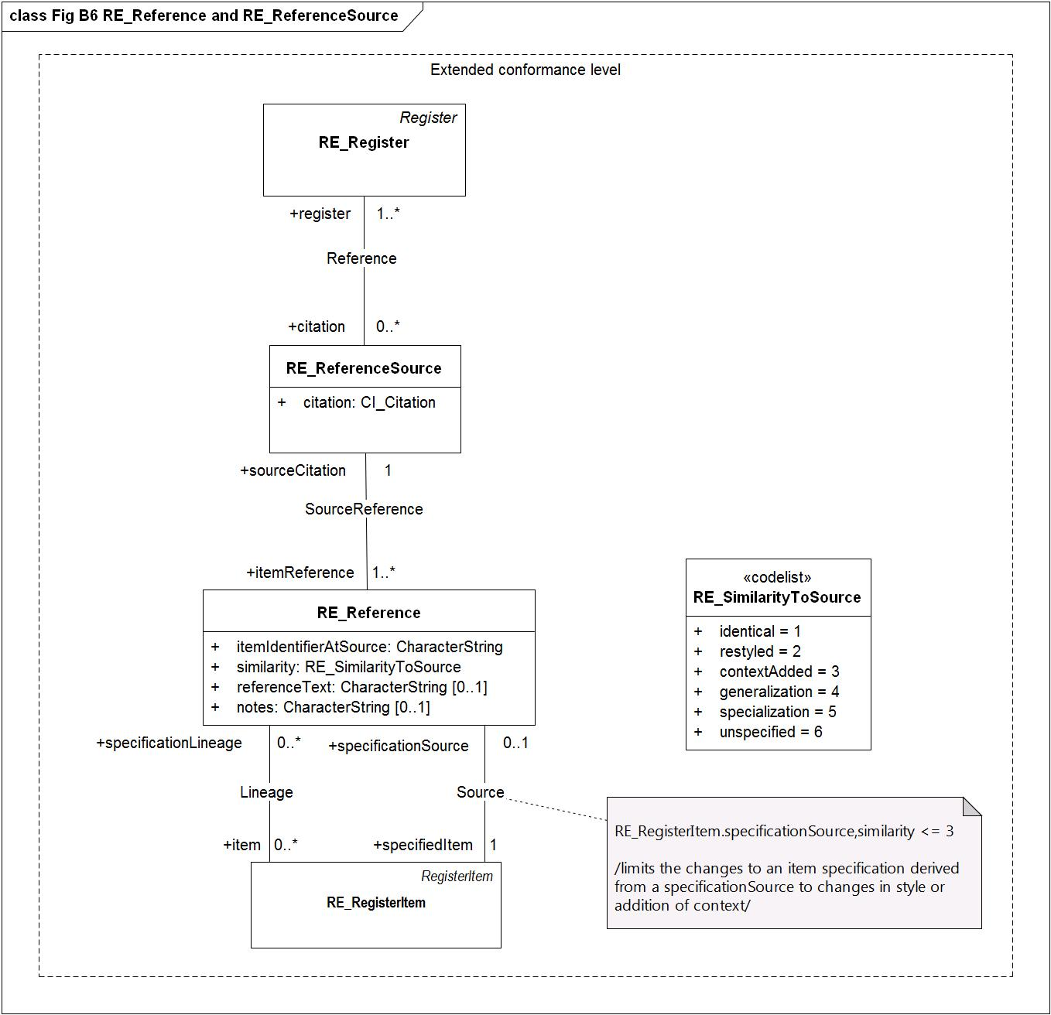

Figure - Fig B6 RE_Reference and RE_ReferenceSource

### RE_ReferenceSource

|  |  |  |  |  |
| --- | --- | --- | --- | --- |
| **RE_ReferenceSource**   |  |  | | --- | --- | | **Definition:** | The class RE_ReferenceSource specifies information about the source of RE_RegisterItem specifications taken from an external document or register. | | **Type:** | Object type | |
| **Attribute:**   |  |  | | --- | --- | | **Name:** | citation | | **Multiplicity:** | 1 | | **Value type:** | CI_Citation | |
| **Association role**   |  |  | | --- | --- | | **Name:** | itemReference | | **Definition:** | The role "sourceCitation" identifies the information in RE_ReferenceSource is the source for the reference information for the register item. | | **Multiplicity:** | 1..* | | **Value type:** | RE_Reference (object type type) | |
| **Association role**   |  |  | | --- | --- | | **Name:** | register | | **Definition:** | The role "citation" identifies reference source for the items in the RE_Register. | | **Multiplicity:** | 1..* | | **Value type:** | RE_Register (object type type) | |

**Diagram(s):**



Figure - Fig B6 RE_Reference and RE_ReferenceSource

### RE_Register

|  |  |  |  |  |  |  |
| --- | --- | --- | --- | --- | --- | --- |
| **RE_Register**   |  |  | | --- | --- | | **Definition:** | The class RE_Register specifies information about the register itself. It is a subtype of the Register class in the core profile | | **Subtype of:** | Register | | **Type:** | Object type | |
| **Attribute:**   |  |  | | --- | --- | | **Name:** | alternativeLanguages | | **Definition:** | The attribtue "alternativeLanguages" supports cultural and linguistic adaptability, individual items in a register may provide elements of information in additional languages other than the operating language of the register.  The attribute <i>alternativeLanguages </i>shall be represented as a set of instances of RE_Locale, each specifying an additional unique locale used by items in the register. Every member of the set shall be used by at least one item in the register. The <i>locale </i>of every <i>alternativeExpression </i>used by any item in the register shall be included in this set of RE_Locales.  This attribute provides a summary of alternative locales used by items in a register. Register owners shall specify and publish their policy as to whether all or only some of the items in a register shall have alternative expressions. | | **Multiplicity:** | 0..* | | **Value type:** | RE_Locale (data type) | |
| **Association role**   |  |  | | --- | --- | | **Name:** | citation | | **Definition:** | The role "register" describes that the register for the association Reference is the reference for one or more items in the register. | | **Multiplicity:** | 0..* | | **Value type:** | RE_ReferenceSource (object type type) | |
| **Association role**   |  |  | | --- | --- | | **Name:** | containedItem | | **Definition:** | Describes that the RegisterItem for the association Content describes the contained items held in the register. | | **Multiplicity:** | 1..* | | **Value type:** | RegisterItem (object type type) | |
| **Association role**   |  |  | | --- | --- | | **Name:** | containedItemClass | | **Definition:** | The role "containedItemClass" describes that the "ItemClass" for the association "ContentDescription" contains the item classes in the register. | | **Multiplicity:** | 1..* | | **Value type:** | ItemClass (object type type) | |
| **Attribute:**   |  |  | | --- | --- | | **Name:** | contentSummary | | **Definition:** | The attribute "contentSummary"<i> </i>shall be represented as a CharacterString containing a general statement of the purpose for which items in the register are made available to potential users. It should also specify any limits to the scope of the register and identify the types of applications for which the items are intended.  NOTE The scope of a register could be limited by theme, by region, by language or other criteria.  EXAMPLE The scope of a terminology register could be limited to Spanish terms used to describe landforms in Latin America. | | **Multiplicity:** | 1 | | **Value type:** | CharacterString | |
| **Attribute:**   |  |  | | --- | --- | | **Name:** | dateOfLastChange | | **Definition:** | The conditional attribute "dateOfLastChange" shall be represented as an instance of the class <<Date>> [ISO 19103] and specify the (full precision) date of the most recent change to the status of an item in the register was made. A value shall be provided for this attribute if a value of "version" is not supplied. | | **Multiplicity:** | 0..1 | | **Value type:** | Date | |
| **Attribute:**   |  |  | | --- | --- | | **Name:** | identifier | | **Definition:** | The attribute "identifier" represents a designator that is used to uniquely denote that register within the set of registers maintained by the register owner. In the case of a hierarchical register, the "identifier" of a subregister shall uniquely identify that subregister within the scope of all registers established by the owner of the principal register. It shall be represented as a CharacterString containing a compact and human-readable designator.  EXAMPLE: “ISO/TC 211 Register of Feature Data Dictionaries and Feature Catalogues” might be the identifier of the principal register of a hierarchical register. “DGIWG FACC Data Dictionary” and “IHO S-57 Object Dictionary” might be the identifiers of subregisters within the hierarchy. | | **Multiplicity:** | 1 | | **Value type:** | CharacterString | |
| **Association role**   |  |  | | --- | --- | | **Name:** | manager | | **Definition:** | The role "manages" describes that the RegisterStakeholder for the association RegisterManager is the manager for the register. | | **Multiplicity:** | 1 | | **Value type:** | RegisterStakeholder (object type type) | |
| **Attribute:**   |  |  | | --- | --- | | **Name:** | name | | **Definition:** | The attribute "name"<i> </i>shall be represented as a CharacterString containing a compact and human-readable designator that is used to uniquely denote that register within the set of registers maintained by the register owner. In the case of a hierarchical register, the <i>name </i>of a subregister shall uniquely identify that subregister within the scope of all registers established by the owner of the principal register.  EXAMPLE “ISO/TC 211 Register of Feature Data Dictionaries and Feature Catalogues” might be the name of the principal register of a hierarchical register. “DGIWG FACC Data Dictionary” and “IHO S-57 Object Dictionary” might be the names of subregisters within the hierarchy. | | **Multiplicity:** | 1 | | **Value type:** | CharacterString | |
| **Attribute:**   |  |  | | --- | --- | | **Name:** | operatingLanguage | | **Definition:** | The attribute "operatingLanguage"<i> </i>shall be represented as an instance of class RE_Locale that is used to specify language, country information and character encoding for the proper interpretation of the content of character strings in the register.  The values of all character strings in the register shall be in accordance with the value of "operatingLanguage", unless otherwise stated. | | **Multiplicity:** | 1 | | **Value type:** | RE_Locale (data type) | |
| **Association role**   |  |  | | --- | --- | | **Name:** | owner | | **Definition:** | The role name owner describes that the RegisterStakeholder for the association RegisterOwner is the owner of the register. | | **Multiplicity:** | 1 | | **Value type:** | RegisterStakeholder (object type type) | |
| **Association role**   |  |  | | --- | --- | | **Name:** | submitter | | **Definition:** | The role "submitter" describes that the RegisterStakeholder for the association RegisterStakeholder is the submitting organization for the register. | | **Multiplicity:** | 1..* | | **Value type:** | RegisterStakeholder (object type type) | |
| **Attribute:**   |  |  | | --- | --- | | **Name:** | uniformResourceIdentifier | | **Definition:** | The attribute "uniformResourceIdentifier"<i> </i>shall take as its value a set of URI's, each referencing information about online resources associated with the register.  EXAMPLE “http://www.digest.org/Navigate2.htm” and “http://www.epa.gov/opppmsd1/PPISdata/index.html” are  sample values  <i>  </i><i>  </i>  corresponding value of the attribute <i>OnLineResource.linkage </i>specifies a resource providing access to the  complete content of the register.  EXAMPLE “http://www.digest.org/Navigate2.htm” and “http://www.epa.gov/opppmsd1/PPISdata/index.html” are  sample values of <i>OnLineResource.linkage</i>. | | **Multiplicity:** | 1..* | | **Value type:** | URI | |
| **Attribute:**   |  |  | | --- | --- | | **Name:** | version | | **Definition:** | The conditional attribute "version" shall be represented as an instance of class RE_Version that specifies a unique state in the life of the register. A value shall be provided for this attribute if a value of "dateOfLastChange" is not supplied. | | **Multiplicity:** | 0..1 | | **Value type:** | RE_Version (data type) | |
| **Constraint:**   |  |  | | --- | --- | | **Name:** | count(self.version +self.dateOfLastChange) >= 1 | |
| **Constraint:**   |  |  | | --- | --- | | **Name:** | {count of(version + dateOfLastChange) >= 1} | | **Expression:** | --/at least one of the attributes version and dateOfLastChange must be provided. | |

**Diagram(s):**

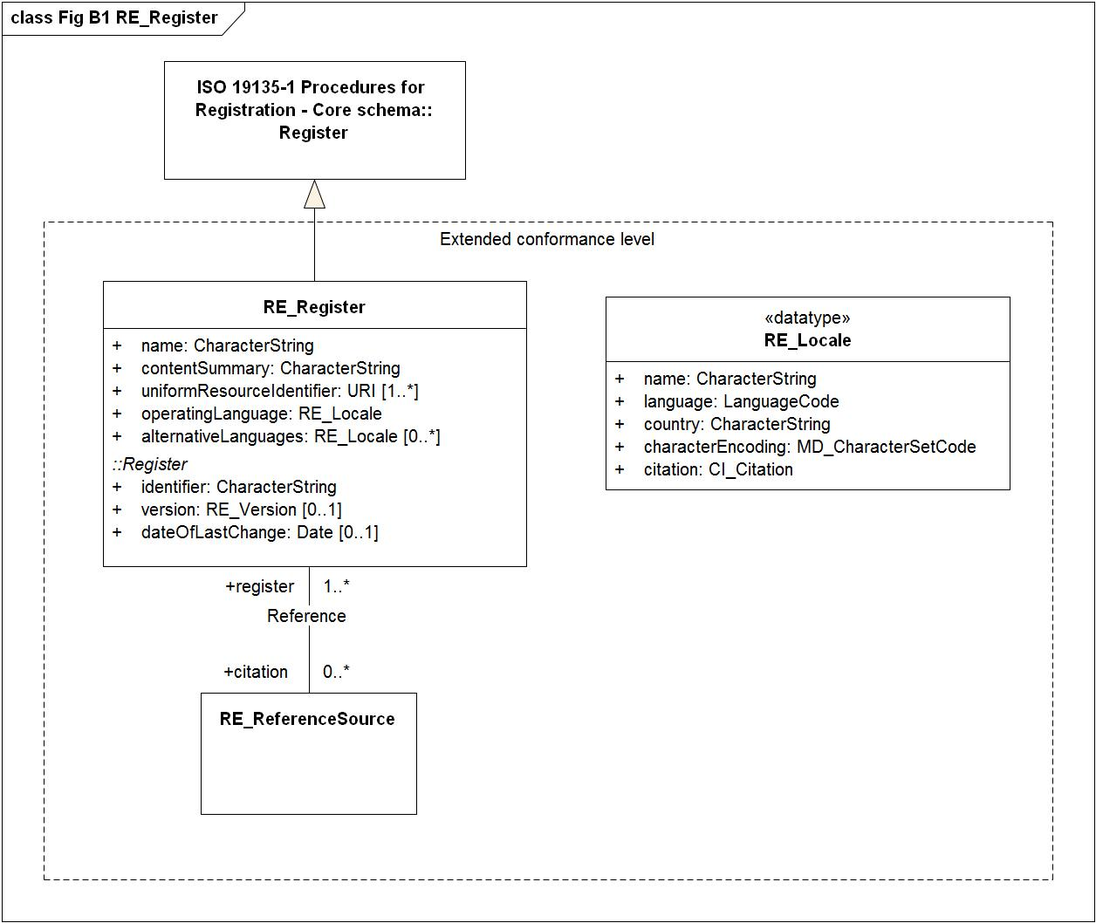

Figure - Fig B1 RE_Register

### RE_RegisterItem

|  |  |  |  |  |  |  |
| --- | --- | --- | --- | --- | --- | --- |
| **RE_RegisterItem**   |  |  | | --- | --- | | **Definition:** | The class RE_RegisterItem specifies elements of information to be recorded for each item held in a register. It has nine attributes and eight associations. The technical standard that specified an item class may specify additional elements to be recorded. | | **Subtype of:** | RegisterItem | | **Type:** | Object type | |
| **Association role**   |  |  | | --- | --- | | **Name:** | additionInformation | | **Definition:** | The role "item" identifies the class RE_RegisterItem for addtional nformation in the RE_AdditionalInformation | | **Multiplicity:** | 1..* | | **Value type:** | RE_AdditionInformation (object type type) | |
| **Attribute:**   |  |  | | --- | --- | | **Name:** | alternativeExpressions | | **Definition:** | The attribute "alternativeExpressions"<i> </i>represents as a set of instances of RE_AlternativeExpression, each specifying an alternative name and optionally additional information in a locale different from that of the register. No two instances of RE_AlternativeExpression within the set shall have the same value for <i>locale</i>. | | **Multiplicity:** | 0..1 | | **Value type:** | Set<RE_AlternativeExpression> | |
| **Association role**   |  |  | | --- | --- | | **Name:** | amendmentInformation | | **Definition:** | The role "amendmentInformation" identifies that amendment information to the register item may be available in the RE_AmendmentInformation class | | **Multiplicity:** | 0..* | | **Value type:** | RE_AmendmentInformation (object type type) | |
| **Association role**   |  |  | | --- | --- | | **Name:** | clarificationInformation | | **Definition:** | The role "item" identifies that the information in the class RE_ClarificationInormation s related to a register item. | | **Multiplicity:** | 0..* | | **Value type:** | RE_ClarificationInformation (object type type) | |
| **Attribute:**   |  |  | | --- | --- | | **Name:** | dateAccepted | | **Definition:** | The conditional attribute "dateAccepted" shall specify the date on which a proposal to add the item to the register was accepted. The condition is identified by the constraint:  {status <> #notValid implies dateAccepted -> notEmpty}.  The value is derived from information in RE_AdditionInformation:  DateAccepted = self.additionInformation.dateDisposed | | **Multiplicity:** | 0..1 | | **Value type:** | Date | |
| **Attribute:**   |  |  | | --- | --- | | **Name:** | dateAmended | | **Definition:** | The conditional attribute "dateAmended"<i> </i>specifies the date on which a proposal to supersede or retire the item was accepted. The condition is identified by the constraint:  {status = #superseded or status = #retired implies dateAmended -> notEmpty}.  The value is derived from information in RE_AmendmentInformation:  DataAmended = self.amendmentInformation.dateDisposed | | **Multiplicity:** | 0..1 | | **Value type:** | Date | |
| **Attribute:**   |  |  | | --- | --- | | **Name:** | dateTimeAddition | | **Definition:** | The attribute "dateTimeAddition" shall specify the date on which the item was added | | **Multiplicity:** | 1 | | **Value type:** | DateTime | |
| **Attribute:**   |  |  | | --- | --- | | **Name:** | dateTimeInvalidation | | **Multiplicity:** | 0..1 | | **Value type:** | DateTime | |
| **Attribute:**   |  |  | | --- | --- | | **Name:** | dateTimeRetirement | | **Multiplicity:** | 0..1 | | **Value type:** | DateTime | |
| **Attribute:**   |  |  | | --- | --- | | **Name:** | dateTimeSupersession | | **Definition:** | The attribute "dateTimeSupersession" shall specify the date and time on which an item has been superseeded. This attribute is mandatory if status is superseded. | | **Multiplicity:** | 0..1 | | **Value type:** | DateTime | |
| **Attribute:**   |  |  | | --- | --- | | **Name:** | definition | | **Definition:** | The attribute "definition"<i> </i>shall be represented as a CharacterString containing the definition of the concept  embodied by that item and expressed in the operating language of the register. The "definition" shall be a precise statement of the nature, properties, scope or essential qualities of the concept as realized by the item.  If a definition is taken from an external source, RE_Reference shall be used to provide information about that source together with the unique identifier of the item in the external source where available.  EXAMPLE “Equipment consisting of a platform, which is often enclosed, that is raised and lower ed in a vertical shaft to transport humans, equipment or materials; a lift or (U.S.) elevator” and “The shape of a buoy”. | | **Multiplicity:** | 1 | | **Value type:** | CharacterString | |
| **Attribute:**   |  |  | | --- | --- | | **Name:** | description | | **Definition:** | The attribute "description"<i> </i>shall be<i> </i> represented as a CharacterString containing a description of the concept embodied by that item and expressed in the operating language of the register. The "description"<i> </i>shall be a statement of the nature, properties, scope, or non-essential qualities of the concept that are realized by the item but are not specified by the "definition"<i> </i>element.  EXAMPLE 1 “A lift may be moved through a system of overhead cables, lateral traction or under-floor hydraulics.”  EXAMPLE 2 “Buoy shape is generally based on the portion visible above the water line.” | | **Multiplicity:** | 0..1 | | **Value type:** | CharacterString | |
| **Attribute:**   |  |  | | --- | --- | | **Name:** | fieldOfApplication | | **Definition:** | The attribute "fieldOfApplication"<i> </i>shall be represented as a set of instances of RE_FieldOfApplication, each of which shall describe a kind of use of the item. The fieldOfApplication<i> </i>may be used as the basis for creating metadata for submission to search engines.  EXAMPLES “Agricultural Production” and “Marine Navigation”. | | **Multiplicity:** | 0..* | | **Value type:** | RE_FieldOfApplication (data type) | |
| **Association role**   |  |  | | --- | --- | | **Name:** | itemClass | | **Definition:** | The role "itemClass" describes that the "ItemClass" for the association "Categorization" describes the class that the register items belong to. | | **Multiplicity:** | 1 | | **Value type:** | ItemClass (object type type) | |
| **Attribute:**   |  |  | | --- | --- | | **Name:** | itemIdentifier | | **Definition:** | The attribute "itemIdentifier" shall be represented as a Character that is used to uniquely denote that item within the register and is intended for information processing. Values shall be assigned sequentially in the order in which items are proposed for entry into the register. Once a value has been assigned, it shall not be reused.  <b>NOTE</b> When a register contains items from different item classes, each item will be uniquely identifiable by the item identifier alone. | | **Multiplicity:** | 1 | | **Value type:** | CharacterString | |
| **Attribute:**   |  |  | | --- | --- | | **Name:** | name | | **Definition:** | The attribute "name"<i> </i>shall be represented as a CharacterString containing a compact and human-readable designator that is used to denote a register concept. Each "name"<i> </i>shall:  - denote an item concept in the scope of an item class; and  - be a succinct expression of the item concept it denotes.  EXAMPLE “Lift” and “buoy shape”.  The "name"<i> </i>shall be unique within a register according to the following rules:  - Multiple items of the same item class may use the same value for "name"<i> </i>but only one such item may have a status of “valid”.  - Items in different item classes may use the same value for name.  The "name"<i> </i>may be used to support searches for items of interest to a human user of the register. | | **Multiplicity:** | 1 | | **Value type:** | CharacterString | |
| **Association role**   |  |  | | --- | --- | | **Name:** | predecessor | | **Definition:** | The role "predecessor" describes a previous concept of the "RegisterItem" | | **Multiplicity:** | 0..* | | **Value type:** | RegisterItem (object type type) | |
| **Association role**   |  |  | | --- | --- | | **Name:** | register | | **Multiplicity:** | 1..* | | **Value type:** | Register (object type type) | |
| **Association role**   |  |  | | --- | --- | | **Name:** | specificationLineage | | **Definition:** | The role "item" identifies the information in RE_Reference is for the register item. | | **Multiplicity:** | 0..* | | **Value type:** | RE_Reference (object type type) | |
| **Association role**   |  |  | | --- | --- | | **Name:** | specificationSource | | **Definition:** | The role "specifiedItem " describes that the RE_Reference for the association "source" is the reference source for specification of the register item. | | **Multiplicity:** | 0..1 | | **Value type:** | RE_Reference (object type type) | |
| **Attribute:**   |  |  | | --- | --- | | **Name:** | status | | **Definition:** | The attribute "status" shall be represented as an instance of RE_ItemStatus that identifies the registration status of the RegisterItem | | **Multiplicity:** | 1 | | **Value type:** | RE_ItemStatus (enumeration) | | **Values** | |  |  | | --- | --- | | submitted | The item has been entered into the register, but the control body has not accepted the proposal to add it. | | valid | The item has been accepted, is recommended for use, and has not been superseded or retired. | | superseded | The item has been superseded by another item and is no longer recommended for use. | | retired | A decision has been made that the item is no longer recommended for use. It has not been superseded by another item. | | invalid | A decision has been made that a previously valid register item contains a substantial error and is invalid, and will normally have been replaced by a corrected item. | | |
| **Association role**   |  |  | | --- | --- | | **Name:** | sucessor | | **Definition:** | The role "sucessor" describes a later concept of the "RegisterItem" | | **Multiplicity:** | 0..* | | **Value type:** | RegisterItem (object type type) | |
| **Constraint:**   |  |  | | --- | --- | | **Name:** | status <> #notValid implies dateAccepted -> notEmpty | | **Expression:** | /Status not valid implies that dateAccepted is mandatory/ | |
| **Constraint:**   |  |  | | --- | --- | | **Name:** | status = #superseded or status = #retired implies dateAmended -> notEmpty | | **Expression:** | /Status = superseded or retired implies that dateAmended is mandatory/ | |
| **Constraint:**   |  |  | | --- | --- | | **Name:** | {status = #invalid implies dateTimeInvalidation -> notEmpty} | | **Expression:** | /dataTimeInvalidation" is mandatory if "status" is invalid/ | |
| **Constraint:**   |  |  | | --- | --- | | **Name:** | {status = #retired implies dateTimeRetirement -> notEmpty} | | **Expression:** | /dataTimeRetirement" is mandatory if "status" is superseded/ | |
| **Constraint:**   |  |  | | --- | --- | | **Name:** | {status = #superseded implies dateTimeSupersession -> notEmpty} | | **Expression:** | /dataTimeSupersession" is mandatory if "status" is superseded/ | |

**Diagram(s):**

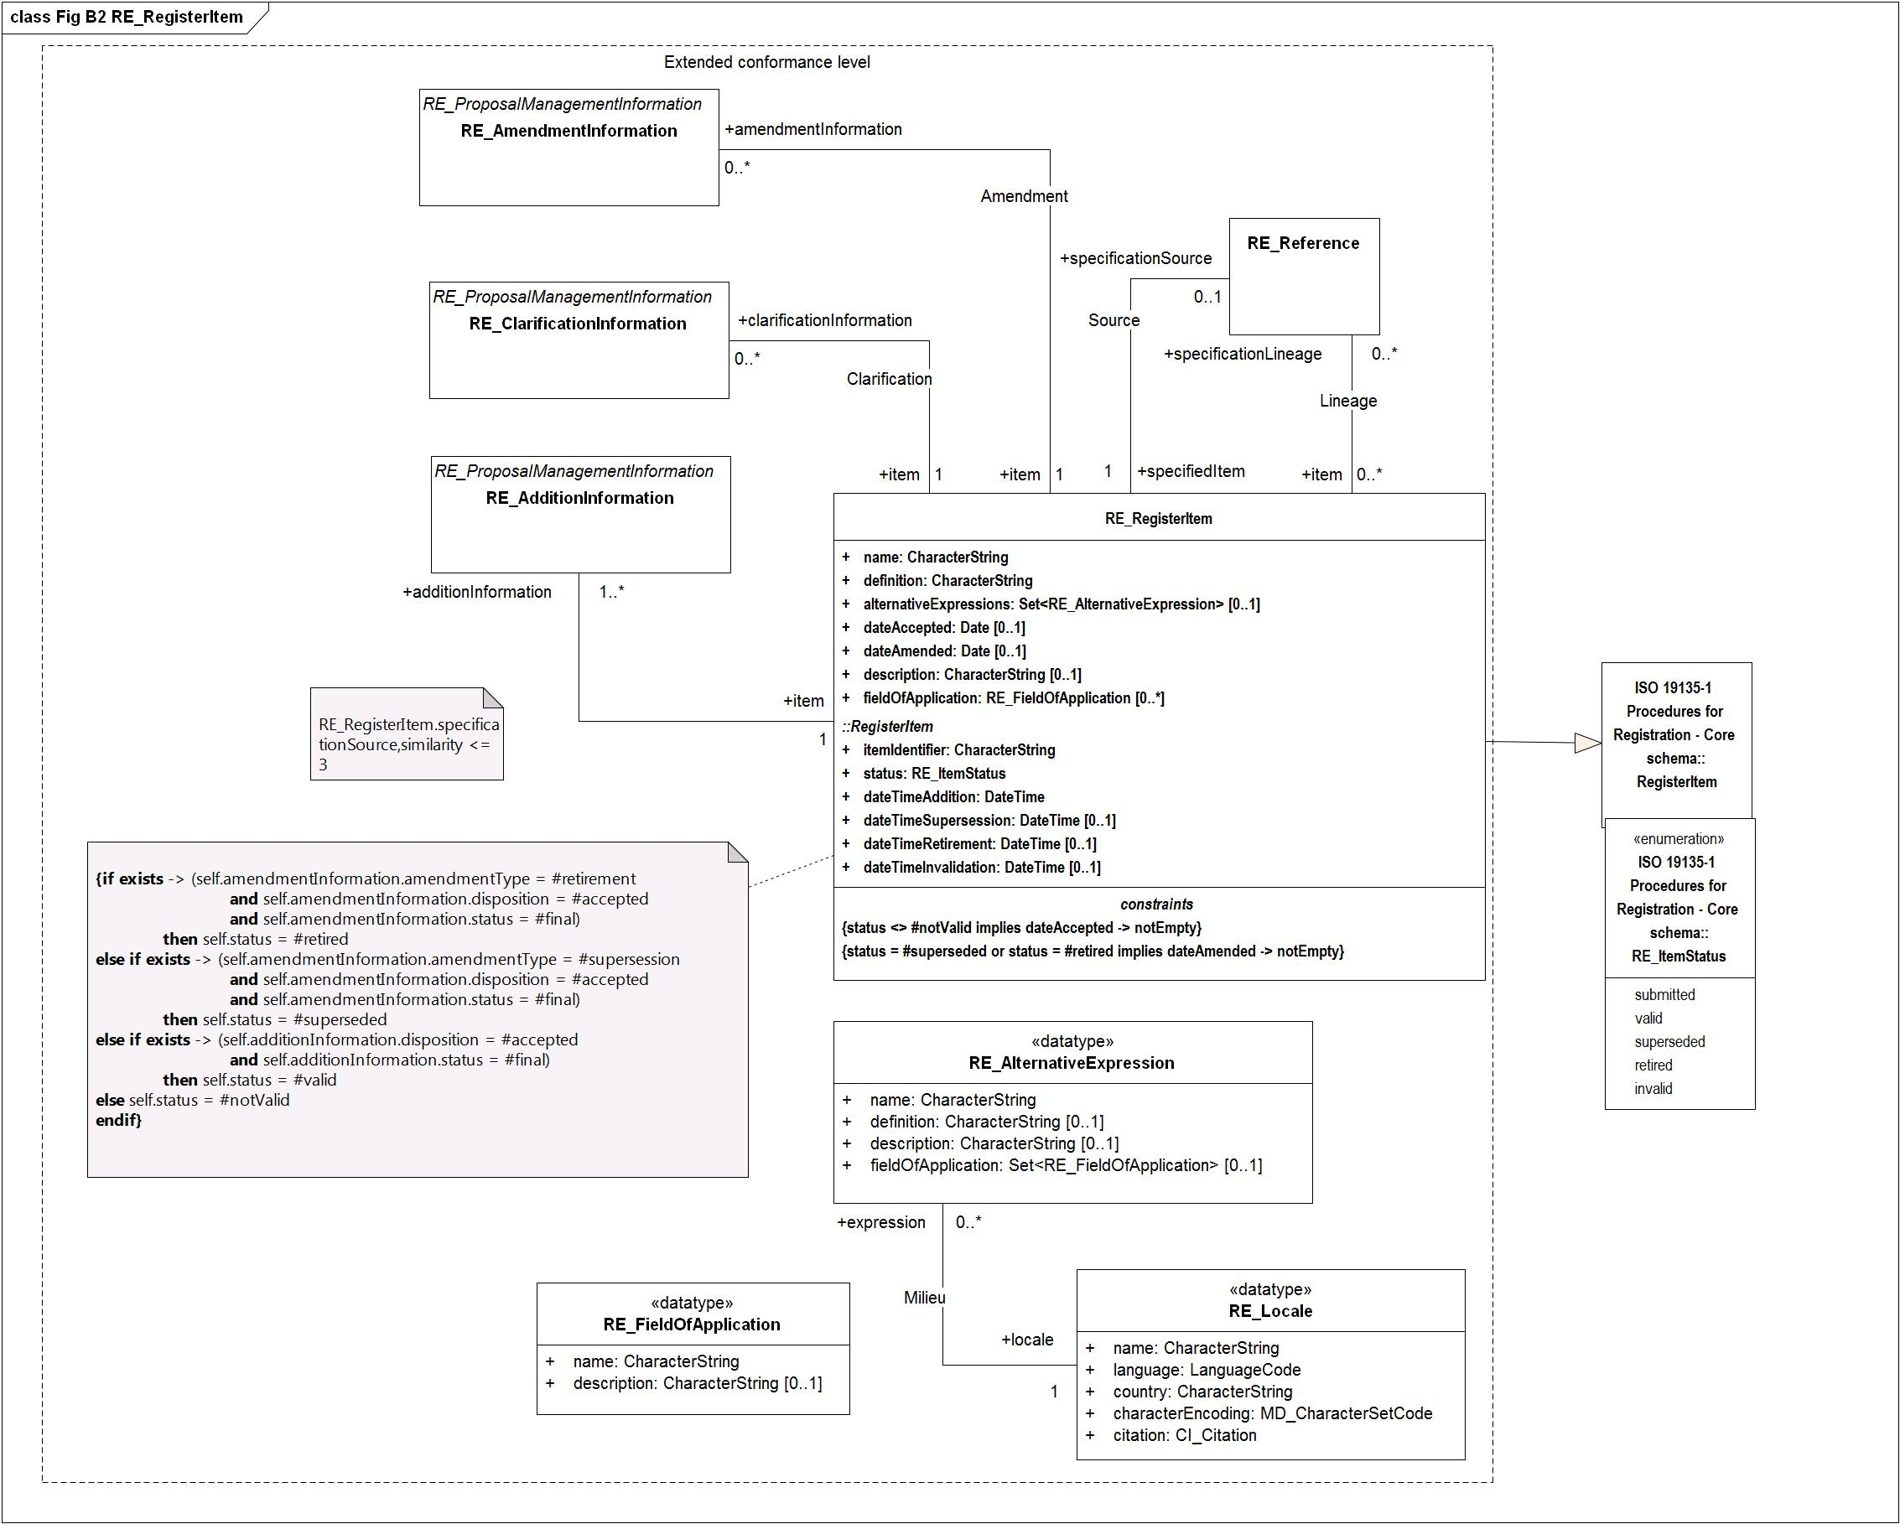

Figure - Fig B2 RE_RegisterItem

### RE_RegisterStakeholder

|  |  |  |  |  |
| --- | --- | --- | --- | --- |
| **RE_RegisterStakeholder**   |  |  | | --- | --- | | **Subtype of:** | RegisterStakeholder | | **Type:** | Object type | |
| **Attribute:**   |  |  | | --- | --- | | **Name:** | contact | | **Definition:** | The attribute "contact" shall be represented as an instance of CI_Responsibility [ISO 19115-1], either in the form of contact information for an individual or an organization that ist he contact point for the stakeholder, either in the role as manager, owner or submitter of register information the register. | | **Multiplicity:** | 1 | | **Value type:** | CI_Responsibility | |
| **Association role**   |  |  | | --- | --- | | **Name:** | manages | | **Definition:** | The role "manager" identifies the register stakeholder as the manager of the register. | | **Multiplicity:** | 1..* | | **Value type:** | Register (object type type) | |
| **Attribute:**   |  |  | | --- | --- | | **Name:** | name | | **Definition:** | The attribute <i>name</i> shall be represented as a CharacterString containing a compact and human-readable designator that is used to denote the stakeholder of that register.  EXAMPLE “ISO/TC 211,” “Digital Geographic Information Working Group,” and “International Hydrographic Bureau”. | | **Multiplicity:** | 1 | | **Value type:** | CharacterString | |
| **Association role**   |  |  | | --- | --- | | **Name:** | owns | | **Definition:** | The role name "owns" identifies the register stakeholder as the owner of the register. | | **Multiplicity:** | 1..* | | **Value type:** | Register (object type type) | |
| **Association role**   |  |  | | --- | --- | | **Name:** | proposalInformation | | **Definition:** | The role "proposalnformation" identifies that the stakeholder in the function of a proposer has proposed proposal managment information to the registry. | | **Multiplicity:** | 1..* | | **Value type:** | RE_ProposalManagementInformation (object type type) | |
| **Association role**   |  |  | | --- | --- | | **Name:** | submits | | **Definition:** | The role name "submits" identifies the register stakeholder as the submitting organization of the register. | | **Multiplicity:** | 1..* | | **Value type:** | Register (object type type) | |
| **Association role**   |  |  | | --- | --- | | **Name:** | subregister | | **Multiplicity:** | 0..* | | **Value type:** | SubregisterDescription (object type type) | |

### RE_SubregisterDescription

|  |  |  |  |  |  |  |
| --- | --- | --- | --- | --- | --- | --- |
| **RE_SubregisterDescription**   |  |  | | --- | --- | | **Definition:** | RE_SubregisterDescription is a subclass of SubregisterDescription that shall be used in the principal register of a hierarchical register to describe additional information for each of the affiliated subregisters. | | **Subtype of:** | SubregisterDescription | | **Type:** | Object type | |
| **Association role**   |  |  | | --- | --- | | **Name:** | containedItemClass | | **Definition:** | The role "containedItemClass" describes that the "ItemClass" for the association "SubregisterContentDescription" contains the item classes in the subregister. | | **Multiplicity:** | 1..* | | **Value type:** | ItemClass (object type type) | |
| **Attribute:**   |  |  | | --- | --- | | **Name:** | dateTimeAddition | | **Definition:** | The attribute "dateTimeAddition" shall specify the date on which the item was added | | **Multiplicity:** | 1 | | **Value type:** | DateTime | |
| **Attribute:**   |  |  | | --- | --- | | **Name:** | dateTimeInvalidation | | **Multiplicity:** | 0..1 | | **Value type:** | DateTime | |
| **Attribute:**   |  |  | | --- | --- | | **Name:** | dateTimeRetirement | | **Multiplicity:** | 0..1 | | **Value type:** | DateTime | |
| **Attribute:**   |  |  | | --- | --- | | **Name:** | dateTimeSupersession | | **Definition:** | The attribute "dateTimeSupersession" shall specify the date and time on which an item has been superseeded. This attribute is mandatory if status is superseded. | | **Multiplicity:** | 0..1 | | **Value type:** | DateTime | |
| **Association role**   |  |  | | --- | --- | | **Name:** | itemClass | | **Definition:** | The role "itemClass" describes that the "ItemClass" for the association "Categorization" describes the class that the register items belong to. | | **Multiplicity:** | 1 | | **Value type:** | ItemClass (object type type) | |
| **Attribute:**   |  |  | | --- | --- | | **Name:** | itemIdentifier | | **Definition:** | The attribute "itemIdentifier" shall be represented as a Character that is used to uniquely denote that item within the register and is intended for information processing. Values shall be assigned sequentially in the order in which items are proposed for entry into the register. Once a value has been assigned, it shall not be reused.  <b>NOTE</b> When a register contains items from different item classes, each item will be uniquely identifiable by the item identifier alone. | | **Multiplicity:** | 1 | | **Value type:** | CharacterString | |
| **Attribute:**   |  |  | | --- | --- | | **Name:** | operatingLanguage | | **Definition:** | The attribute "operatingLanguage"<i> </i>shall be represented as an instance of class RE_Locale that is used to specify language, country information and character encoding for the proper interpretation of the content of character strings in the subregister. | | **Multiplicity:** | 1 | | **Value type:** | RE_Locale (data type) | |
| **Association role**   |  |  | | --- | --- | | **Name:** | predecessor | | **Definition:** | The role "predecessor" describes a previous concept of the "RegisterItem" | | **Multiplicity:** | 0..* | | **Value type:** | RegisterItem (object type type) | |
| **Association role**   |  |  | | --- | --- | | **Name:** | register | | **Multiplicity:** | 1..* | | **Value type:** | Register (object type type) | |
| **Attribute:**   |  |  | | --- | --- | | **Name:** | status | | **Definition:** | The attribute "status" shall be represented as an instance of RE_ItemStatus that identifies the registration status of the RegisterItem | | **Multiplicity:** | 1 | | **Value type:** | RE_ItemStatus (enumeration) | | **Values** | |  |  | | --- | --- | | submitted | The item has been entered into the register, but the control body has not accepted the proposal to add it. | | valid | The item has been accepted, is recommended for use, and has not been superseded or retired. | | superseded | The item has been superseded by another item and is no longer recommended for use. | | retired | A decision has been made that the item is no longer recommended for use. It has not been superseded by another item. | | invalid | A decision has been made that a previously valid register item contains a substantial error and is invalid, and will normally have been replaced by a corrected item. | | |
| **Association role**   |  |  | | --- | --- | | **Name:** | subregisterManager | | **Multiplicity:** | 1 | | **Value type:** | RegisterStakeholder (object type type) | |
| **Association role**   |  |  | | --- | --- | | **Name:** | sucessor | | **Definition:** | The role "sucessor" describes a later concept of the "RegisterItem" | | **Multiplicity:** | 0..* | | **Value type:** | RegisterItem (object type type) | |
| **Attribute:**   |  |  | | --- | --- | | **Name:** | uniformResourceIdentifier | | **Definition:** | The attribute "uniformResourceIdentifier"<i> </i>shall take as its value a set of URI's, each referencing information about online resources associated with the register. | | **Multiplicity:** | 1 | | **Value type:** | URI | |
| **Constraint:**   |  |  | | --- | --- | | **Name:** | {status = #invalid implies dateTimeInvalidation -> notEmpty} | | **Expression:** | /dataTimeInvalidation" is mandatory if "status" is invalid/ | |
| **Constraint:**   |  |  | | --- | --- | | **Name:** | {status = #retired implies dateTimeRetirement -> notEmpty} | | **Expression:** | /dataTimeRetirement" is mandatory if "status" is superseded/ | |
| **Constraint:**   |  |  | | --- | --- | | **Name:** | {status = #superseded implies dateTimeSupersession -> notEmpty} | | **Expression:** | /dataTimeSupersession" is mandatory if "status" is superseded/ | |

**Diagram(s):**

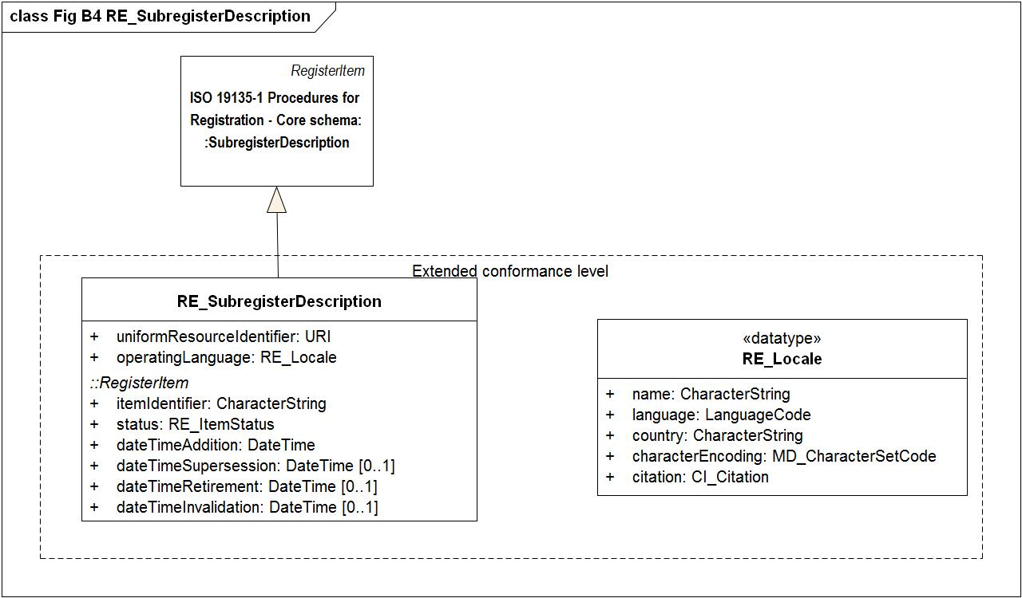

Figure - Fig B4 RE_SubregisterDescription