November 2026

Internet Resilience in France
  - DNSSEC diagnostics report and action plan
ISOC Pulse

DO NOT PUBLISH – INTERNAL DOCUMENT

Table of contents
Executive summary 2
Key numbers at a glance 2
1. Where France stands 3
2. Where France is improving 4
2.1 Robust ccTLD Authoritative Infrastructure 4
2.2 Stable DNS Resolution Health 4
3. Where France could improve 5
3.1 Low DNSSEC Validation Across the Ecosystem 5
3.2 Inconsistent DNSSEC Adoption Among Major ASNs 5
3.3 Underutilization of IPv6 for DNS Queries 6
4. A staged plan to improve resilience 7
4.1 Short term (0–12 months) 7
4.2 Medium term (1–3 years) 8
4.3 Long term (3–7 years) 8
5. Quick wins 9
6. Policy gaps and loopholes 10
6.1 Where policy is absent or unenforced 10
6.2 Loopholes to avoid creating 10
7. Measuring progress 11
Conclusion 11
Data sources and notes 12

How to interpret the numbers in this report?
The values presented in this document are the Internet Resilience Index, normalized to 1–100. These values should be interpreted as a score rather than an absolute value. In some cases, the raw absolute values are presented to provide additional context.

Executive summary
France's .fr ccTLD infrastructure demonstrates robust foundational elements for resilience, with all 3 authoritative nameservers fully supporting IPv6 connectivity and distributed across 4 distinct Autonomous Systems. This technical capability indicates a strong underlying network architecture for the country's top-level domain. However, this infrastructural strength currently contrasts with the operational deployment of DNSSEC validation across the national ecosystem, indicating a gap between capability and widespread implementation.
Only 9.98% of observed DNS queries in France resolve to DNSSEC-signed domains and are successfully validated (SECURE), while a substantial 84.05% query unsigned domains (INSECURE). This overall figure masks significant disparities among major network operators, with secure validation rates ranging from a low of 2.05% for Datacamp Limited to a high of 19.84% for Bouygues Telecom. The national .fr ccTLD itself accounts for a minor share (2.16%) of overall DNS traffic, with global TLDs like .com dominating at 59.15%. Furthermore, despite 100% IPv6 readiness at the .fr ccTLD authoritative level, IPv6 only accounts for 7.28% of observed DNS queries, indicating that infrastructure readiness currently exceeds end-user adoption. These combined factors suggest a critical need for coordinated efforts to drive wider DNSSEC validation and IPv6 adoption among Internet Service Providers (ISPs) and across the national user base.

Key numbers at a glance
Indicator | France | Benchmark | Reading
.fr ccTLD Authoritative Nameservers | 3 | 100% target | Foundational capacity
.fr ccTLD Nameserver IPv6 Enablement | 100.0% | 100% target | Fully enabled
.fr ccTLD Nameserver ASN Diversity | 4 distinct ASNs | >3 distinct ASNs | Well distributed
Overall DNSSEC Secure Validation | 9.98% | 100% target | Significant under-deployment
Highest ASN DNSSEC Secure Validation | 19.84% (Bouygues Telecom) | 100% target | Operator leadership shown
Lowest ASN DNSSEC Secure Validation | 2.05% (Datacamp Limited) | 100% target | Requires intervention
.fr ccTLD Query Share | 2.16% | >10% target | Limited national TLD usage
IPv6 DNS Query Share | 7.28% | >50% target | Low user adoption

1. Where France stands
France currently presents a paradox in its DNS security posture. While the foundational infrastructure for the .fr ccTLD demonstrates strong technical resilience, with 100% IPv6 enablement for its authoritative nameservers and a distributed architecture across multiple Autonomous Systems, the operational deployment of DNSSEC validation across the broader ecosystem remains significantly underdeveloped. This contrast indicates that while the technical capability for a secure DNS environment exists at the core, its benefits are not yet widely extended to end-users and the broader internet community within the country.
Two readings matter for policy. First, the robust and diversified infrastructure for .fr, coupled with stable DNS resolution health, signals a high level of preparedness and operational maturity for the national top-level domain. This existing strength can serve as a launchpad for broader security initiatives. Second, the low overall DNSSEC validation rate of 9.98%, combined with significant disparities among major network operators, highlights a critical operational gap. Addressing this gap requires targeted policy intervention and concerted engagement with ISPs to ensure that the security benefits of DNSSEC are uniformly delivered to internet users across France.
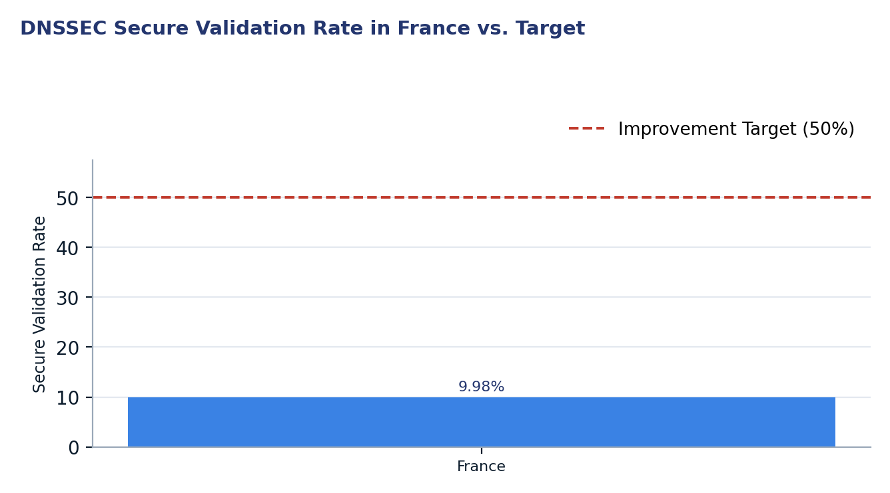
Figure 1. DNSSEC Secure Validation Rate in France vs. Target

2. Where France is improving

2.1 Robust ccTLD Authoritative Infrastructure
The authoritative DNS infrastructure for the .fr ccTLD exhibits strong technical resilience and forward-looking adoption of modern internet protocols. All three authoritative nameservers for .fr are fully enabled with IPv6, achieving a 100% IPv6 enablement rate. This comprehensive support ensures that the national domain can be resolved efficiently over both IPv4 and IPv6 networks, contributing to overall network accessibility and performance.
Further enhancing resilience, these authoritative nameservers are distributed across 4 distinct Autonomous Systems. This diversity mitigates single points of failure, protecting against potential outages or routing incidents that could affect individual networks. By spreading critical DNS functions across multiple independent ASNs, the .fr ccTLD maintains a robust and highly available resolution service, a key factor in national internet stability.
Nameserver | IPv6 Enabled
d.nic.fr | Yes
f.ext.nic.fr | Yes
g.ext.nic.fr | Yes

2.2 Stable DNS Resolution Health
France's DNS ecosystem demonstrates a high level of operational stability, as evidenced by its robust DNS resolution health metrics. Approximately 81.37% of all DNS queries observed successfully completed with a NOERROR response, indicating reliable and accurate resolution. Critically, the rate of SERVFAIL responses remained low, at under 2%, which is a strong indicator of well-maintained and efficiently operating DNS infrastructure across the country.
Furthermore, the observed DNS cache behavior shows that nearly 75.58% of DNS queries were answered using positive cache entries. This high positive cache rate suggests that resolvers are efficiently caching responses, which reduces upstream query load and improves resolution latency for end-users. Such stable and efficient resolution contributes positively to the overall user experience and the foundational reliability of internet access in France.
Response Code | Query Share
NOERROR | 81.37%
NXDOMAIN | 16.75%
SERVFAIL | 1.79%
NOTIMP | 0.06%
REFUSED | 0.03%
FORMERR | 0.00%

3. Where France could improve
France could significantly enhance its internet resilience by addressing the low overall DNSSEC validation, disparate operator adoption, and limited IPv6 query deployment.

3.1 Low DNSSEC Validation Across the Ecosystem
A primary area for improvement in France's DNS security posture is the overall low rate of DNSSEC validation. Only 9.98% of observed DNS queries are securely validated, while a significant 84.05% pertain to insecure, unsigned domains. This indicates that the vast majority of DNS traffic in France is not protected by DNSSEC, leaving users vulnerable to DNS spoofing and cache poisoning attacks. The small fraction of "Invalid" responses (0.04%) suggests that while errors in DNSSEC chains are rare, the sheer volume of unsigned or unvalidated queries represents a systemic security vulnerability.
This widespread lack of DNSSEC validation means that the integrity and authenticity of DNS responses for most internet traffic cannot be cryptographically verified. While some domains may not be signed at their origin, a greater concern is the low validation rate for those that are. Enhancing DNSSEC validation would significantly bolster the trustworthiness of DNS resolution across the country, making it more resilient against manipulation and enhancing user confidence in online services.
Status | Percentage
Secure | 9.98%
Insecure | 84.05%
Invalid | 0.04%
Other | 5.93%

3.2 Inconsistent DNSSEC Adoption Among Major ASNs
The deployment of DNSSEC validation varies considerably across major Autonomous Systems (ASNs) operating in France, highlighting an inconsistent approach to DNS security among network operators. While Bouygues Telecom (AS5410) demonstrates leadership with 19.84% secure validation and Orange France (AS3215) and SFR Group (AS15557) also show strong efforts at 16.09% and 16.61% respectively, other significant players lag considerably. For instance, Datacamp Limited (AS212238) registers only 2.05% secure validation, and Contabo GmbH (AS51167) stands at 4.57%.
This wide disparity in secure validation rates suggests a fragmented security landscape where the level of protection users receive depends heavily on their internet service provider. Networks with low validation rates not only expose their own users to greater risks but also diminish the overall security posture of the national internet ecosystem. Targeted engagement and potential policy incentives are necessary to encourage these lower-performing ASNs to prioritize and implement DNSSEC validation more broadly, aiming for a more uniform and robust security baseline across all networks.
ASN | Network | Query Share | Secure Validation
AS51167 | Contabo GmbH | 17.00% | 4.57%
AS3215 | Orange France | 10.18% | 16.09%
AS16276 | OVHcloud | 10.17% | 11.53%
AS12322 | Free SAS | 8.66% | 13.97%
AS14593 | Space Exploration Technologies Corporation | 6.14% | 4.74%
AS5410 | Bouygues Telecom | 4.93% | 19.84%
AS15557 | SFR Group | 4.75% | 16.61%
AS12876 | ONLINE DEDIBOX ISDNET TIF PONEY-TELECOM | 2.89% | 8.70%
AS212238 | Datacamp Limited | 1.74% | 2.05%

3.3 Underutilization of IPv6 for DNS Queries
Despite the .fr ccTLD authoritative nameservers fully supporting IPv6, the observed share of DNS queries utilizing IPv6 in France remains low at 7.28%, with IPv4 dominating at 92.72%. This disparity indicates a significant gap between the readiness of core internet infrastructure and its adoption by end-users and their local DNS resolvers. The underutilization of IPv6 for DNS queries represents a missed opportunity to leverage the benefits of the newer protocol, including potentially improved performance, enhanced routing efficiency, and greater network address availability.
A higher IPv6 query share would contribute to a more modern and resilient internet ecosystem, reducing reliance on the increasingly congested IPv4 address space. Promoting broader IPv6 deployment among ISPs and encouraging the configuration of resolvers to prefer IPv6 where available would allow France to fully capitalize on its already advanced ccTLD infrastructure and ensure a more future-proof internet experience for its citizens.
IP Version | Query Share
IPv4 | 92.72%
IPv6 | 7.28%

4. A staged plan to improve resilience
Improving France's internet resilience, particularly regarding DNSSEC validation and IPv6 adoption, necessitates a phased approach. Phase 1 focuses on immediate, low-cost configuration and administrative actions achievable within 12 months. Phase 2 involves targeted coordination and incentivization over 1-3 years. Phase 3 aims for long-term structural capacity building, spanning 3-7 years, to embed these security and protocol enhancements deeply into the national internet fabric.
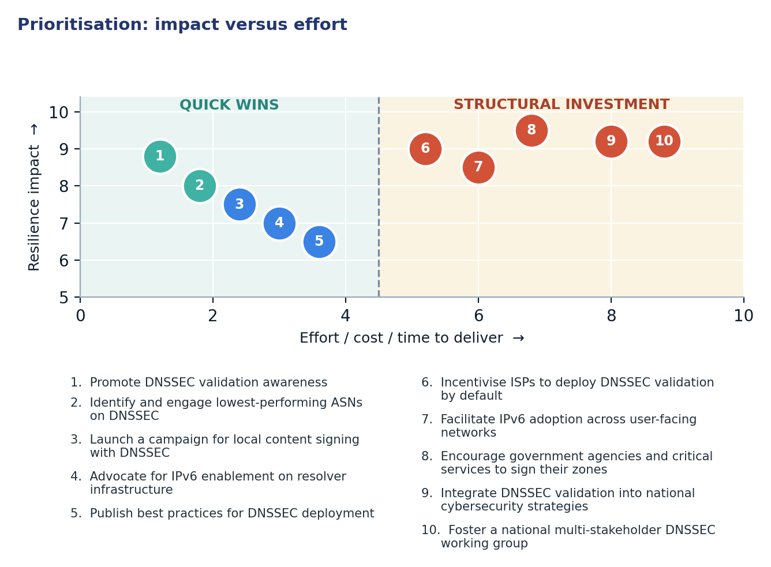
Figure 2. Prioritisation: impact versus effort

4.1 Short term (0–12 months)
Action | Description | Owner | Indicator moved
1. Promote DNSSEC validation awareness | Conduct targeted outreach and educational campaigns for ISPs, enterprises, and public entities on the importance and benefits of DNSSEC validation. | ARCEP, AFNIC, ISOC France | Overall DNSSEC Secure Validation 9.98% → >15%
2. Identify and engage lowest-performing ASNs on DNSSEC | Initiate direct communication with ASNs exhibiting low DNSSEC validation rates to offer technical assistance and best practice guidance for implementation. | ARCEP, ISOC France, Technical Community | Lowest ASN DNSSEC Secure Validation 2.05% → >5%
3. Launch a campaign for local content signing with DNSSEC | Encourage French domain holders, especially for high-traffic .fr domains, to sign their zones with DNSSEC to increase the pool of securable content. | AFNIC, Domain Registrars | .fr ccTLD Query Share (secure) N/A → >5%
4. Advocate for IPv6 enablement on resolver infrastructure | Promote the configuration of ISP and enterprise DNS resolvers to fully support and utilize IPv6 for query resolution where available. | ARCEP, Internet Service Providers | IPv6 DNS Query Share 7.28% → >10%
5. Publish best practices for DNSSEC deployment | Develop and widely disseminate clear, actionable guidelines and technical documentation for implementing and maintaining DNSSEC validation on various platforms. | ANSSI, AFNIC, Technical Community | DNSSEC implementation errors (implied) N/A → Reduced

4.2 Medium term (1–3 years)
Action | Description | Owner | Indicator moved
6. Incentivise ISPs to deploy DNSSEC validation by default | Explore regulatory or economic incentives for ISPs to enable DNSSEC validation by default for their customers, or set voluntary targets. | ARCEP, Ministry of Economy and Finance | Overall DNSSEC Secure Validation >15% → >35%
7. Facilitate IPv6 adoption across user-facing networks | Support initiatives that enable ISPs and mobile operators to accelerate IPv6 deployment for end-user connectivity, thereby increasing IPv6 DNS traffic. | ARCEP, Internet Service Providers, Mobile Operators | IPv6 DNS Query Share >10% → >25%
8. Encourage government agencies and critical services to sign their zones | Work with public sector bodies and critical national infrastructure providers to ensure their public-facing domains are DNSSEC-signed and maintained. | ANSSI, Inter-ministerial Directorate for Digital Affairs (DINUM) | DNSSEC signed government domains N/A → >80%

4.3 Long term (3–7 years)
Action | Description | Outcome
9. Integrate DNSSEC validation into national cybersecurity strategies | Embed DNSSEC validation as a fundamental requirement within broader national cybersecurity frameworks and compliance standards. | A resilient and trusted national internet infrastructure, aligned with global best practices for DNS security.
10. Foster a national multi-stakeholder DNSSEC working group | Establish a permanent forum involving government, industry, academia, and civil society to continually assess, promote, and coordinate DNSSEC deployment efforts. | Sustained collaboration and innovation in DNS security, ensuring France remains at the forefront of internet resilience.

5. Quick wins
The following five interventions represent quick wins that require configuration or administrative coordination rather than significant capital investment. They can be implemented within months to achieve measurable improvements in France's internet resilience.
# | Quick win | Why it is quick | Effort | Expected effect
1 | Promote DNSSEC validation awareness | Leverages existing communication channels and educational materials, requiring coordination rather than technical deployment. | 2–4 weeks of coordinated outreach | Raise overall DNSSEC Secure Validation from 9.98% to >15% by increasing understanding and demand.
2 | Identify and engage lowest-performing ASNs on DNSSEC | Direct outreach and technical assistance can resolve specific configuration issues for key operators in a short timeframe. | 1–2 months of targeted engagement | Improve Lowest ASN DNSSEC Secure Validation from 2.05% to >5%.
3 | Launch a campaign for local content signing with DNSSEC | Involves registry coordination and outreach to domain holders, leveraging existing registrar interfaces for DNSSEC signing. | 1–2 weeks of registry coordination for campaign launch | Increase secure .fr ccTLD Query Share to >5% by encouraging local domain owners to sign their zones.
4 | Advocate for IPv6 enablement on resolver infrastructure | Primarily a configuration change on existing resolver software, requiring policy advocacy and communication to ISPs. | Days of operator work per network | Increase IPv6 DNS Query Share from 7.28% to >10% by configuring resolvers to utilize IPv6.
5 | Publish best practices for DNSSEC deployment | Consolidates existing knowledge and experience into accessible guides, benefiting from community contributions. | 1–2 months for drafting and review | Shift DNSSEC implementation errors (implied) N/A → Reduced

6. Policy gaps and loopholes

6.1 Where policy is absent or unenforced
Gap | Consequence | Remedy
Lack of mandatory DNSSEC validation for government and critical infrastructure domains. | Public sector and vital services remain vulnerable to DNS spoofing, undermining public trust and national security. | Mandate DNSSEC validation for all government domains and critical national infrastructure providers, enforced through procurement or regulatory compliance.
Absence of incentives for Internet Service Providers (ISPs) to deploy DNSSEC validation by default. | Stagnant adoption rates for DNSSEC validation across the broader user base, leading to a fragmented and less secure national internet. | Introduce regulatory or economic incentives for ISPs that implement DNSSEC validation by default for their subscribers.
No explicit national strategy or coordination body specifically for DNS security. | Disjointed efforts and a lack of unified direction in advancing DNSSEC adoption and other DNS security measures. | Establish a dedicated national multi-stakeholder working group or integrate DNS security as a specific pillar within the national cybersecurity strategy.

6.2 Loopholes to avoid creating
- Mandating specific DNS resolver hardware or software, which stifles innovation and creates vendor lock-in.
- Imposing blanket DNS blocking policies that lack transparent oversight and due process, potentially leading to censorship or over-blocking.
- Creating national-only DNS resolvers that could fragment the global DNS and introduce single points of failure or surveillance.
- Requiring client-side DNSSEC validation without sufficient server-side support, leading to user experience issues and unnecessary complexity.
- Implementing policies that force all DNS traffic through a limited set of national providers, increasing centralization and reducing resilience.

7. Measuring progress
Every action outlined in this report maps to publicly verifiable metrics, enabling transparent tracking of progress and accountability. Regular measurement will ensure that interventions are effective and that France's internet resilience is consistently improving.
Indicator | Baseline | 12-month target | Source
Overall DNSSEC Secure Validation Rate | 9.98% | >15% | Cloudflare Radar / ISOC Pulse
Lowest ASN DNSSEC Secure Validation Rate | 2.05% (Datacamp Limited) | >5% | Cloudflare Radar / ISOC Pulse
IPv6 DNS Query Share | 7.28% | >10% | Cloudflare Radar / ISOC Pulse
DNSSEC Signed .fr Domains (proxy for local content) | — | >5% of .fr queried domains | AFNIC statistics / IYP
Government/Critical Infrastructure DNSSEC Signed Domains | — | >20% | ANSSI / IYP

Conclusion
France possesses a robust and resilient foundational DNS infrastructure for its .fr ccTLD, characterized by 100% IPv6 enablement for its authoritative nameservers and strong ASN diversity. This technical capability, however, currently stands in disconnect with the operational deployment of DNSSEC validation across the broader national ecosystem. The low overall secure validation rate of 9.98% and significant disparities among network operators indicate a substantial gap between inherent capacity and widespread security implementation, leaving the majority of DNS traffic vulnerable to known threats.
To effectively bridge this gap and enhance national internet resilience, it is crucial to sequence strategic interventions, prioritizing immediate, low-cost configuration and administrative "quick wins" before embarking on capital-heavy structural projects. Initiatives such as targeted awareness campaigns, direct engagement with underperforming ASNs, and the promotion of IPv6 on resolver infrastructure can build significant momentum. This approach will demonstrate tangible progress, generate buy-in from stakeholders, and pave the way for more comprehensive policy frameworks and long-term investments needed to secure France's digital future.

Data sources and notes
This report leverages data from established internet measurement platforms and open-source intelligence tools to provide an objective assessment of France's DNSSEC posture. The insights are derived from the Internet Yellow Pages (IYP) DNSSEC Policy Engine and Cloudflare Radar.
- ISOC Pulse — Country Report for France: https://pulse.internetsociety.org/en/reports/fr/
- ISOC Pulse — Internet Resilience Index for France: https://pulse.internetsociety.org/en/resilience/fr/
- RIPEstat — Country ASNs & Routing Status for FR: https://stat.ripe.net/FR
- PeeringDB — IXP & Facility Directory for FR: https://www.peeringdb.com/advanced_search?country=FR
- RIPE Atlas — Active Probes & Anchors in FR: https://atlas.ripe.net/probes/?country=FR
- Packet Clearing House (PCH) — IXP Directory: https://www.pch.net/ixp/dir

Measurement caveats. The data presented reflects measurements captured on 2026-11-04 11:25. All metrics are derived from aggregated samples and may not represent 100% of all internet traffic or infrastructure within France. Specific figures, particularly those related to DNSSEC validation, are based on traffic observed by public DNS resolvers such as Cloudflare's 1.1.1.1, which may not capture the full diversity of resolvers used across the country. Trends and relative comparisons remain robust indicators, but absolute values should be interpreted with an understanding of their sample-based nature.

