November 2026

Internet Resilience in India
  - DNSSEC diagnostics report and action plan
ISOC Pulse

DO NOT PUBLISH – INTERNAL DOCUMENT

Table of contents
Executive summary 2
Key numbers at a glance 2
1. Where India stands 3
2. Where India is improving 4
2.1 Robust .in ccTLD Infrastructure and IPv6 Enablement 4
2.2 Authoritative Nameserver ASN Diversity 4
3. Where India could improve 6
3.1 Low DNSSEC Secure Validation Rate 6
3.2 Inconsistent DNSSEC Validation Across Major Networks 6
3.3 Low .in ccTLD Query Share and IPv6 Traffic Adoption 7
4. A staged plan to improve resilience 8
4.1 Short term (0–12 months) 8
4.2 Medium term (1–3 years) 9
4.3 Long term (3–7 years) 9
5. Quick wins 10
6. Policy gaps and loopholes 11
6.1 Where policy is absent or unenforced 11
6.2 Loopholes to avoid creating 11
7. Measuring progress 12
Conclusion 12
Data sources and notes 13

How to interpret the numbers in this report?
The values presented in this document are the Internet Resilience Index, normalized to 1–100. These values should be interpreted as a score rather than an absolute value. In some cases, the raw absolute values are presented to provide additional context.

Executive summary
India presents a contrasting landscape in its DNSSEC deployment. While the foundational infrastructure for the national .in ccTLD demonstrates robust security and resilience, the operational deployment of DNSSEC validation across the broader internet ecosystem remains significantly underdeveloped. The .in ccTLD is served by 4 authoritative nameservers, all of which are IPv6 enabled, achieving a 100.0% enablement rate. These nameservers are strategically distributed across 3 distinct Autonomous Systems, enhancing resilience against single points of failure. This architectural strength at the national registry level provides a solid foundation for DNSSEC adoption, positioning India favorably in terms of core domain security capabilities.
Despite this strong infrastructure, actual DNSSEC secure validation at the resolver level is markedly low, with only 9.18% of observed DNS queries being validated as SECURE. Conversely, 87.08% of queries resolve to unsigned domains (INSECURE), indicating a widespread lack of DNSSEC implementation or validation by network operators. Significant disparities exist in validation rates across major networks, ranging from a low of 3.87% to a high of 19.01%. Furthermore, the national .in ccTLD accounts for only 2.39% of total DNS queries, and IPv6 traffic constitutes merely 10.90% of DNS queries, suggesting that while the technical capacity for a secure and modern internet exists at the ccTLD level, its benefits are not yet fully leveraged by the end-user ecosystem. This gap between readiness and active deployment underscores the need for targeted interventions to drive broader DNSSEC adoption and validation.

Key numbers at a glance
Indicator | India | Benchmark | Reading
.in ccTLD Authoritative Nameservers | 4 | 100% target | Adequate infrastructure
Authoritative Nameservers IPv6 Enabled | 4 of 4 | 100% target | Full IPv6 enablement
Authoritative Nameservers IPv6 Enablement Rate | 100.0% | 100% target | Optimal compliance
Authoritative Nameservers ASN Diversity | 3 distinct ASNs | >2 distinct ASNs | Resilient distribution
DNSSEC Secure Validation Share | 9.18% | 100% target | Suboptimal deployment
DNSSEC Insecure Validation Share | 87.08% | 0% target | Widespread non-validation
Highest Per-ASN Secure Validation | 19.01% (AS9498) | >80% target | Significant operator variance
Lowest Per-ASN Secure Validation | 3.87% (AS9829) | >80% target | Critical underperformance
.in TLD Query Share | 2.39% | >10% target | Limited national domain usage
IPv6 DNS Query Share | 10.90% | >50% target | Underutilised IPv6 capacity

1. Where India stands
India's DNSSEC posture is characterised by a notable divergence between its foundational capabilities and operational realities. The nation's .in ccTLD infrastructure is robust, with all 4 authoritative nameservers supporting IPv6 and distributed across 3 distinct Autonomous Systems, fulfilling best practices for resilience and modern internet protocols. This robust backend infrastructure provides a solid technical base for securing domain name resolution. However, the broader ecosystem lags significantly in adopting DNSSEC validation. Only 9.18% of DNS queries observed from India's networks are securely validated, falling critically short of optimal security targets. This figure places India far behind regions and countries with comprehensive DNSSEC adoption strategies, where secure validation rates often exceed 50-70% and aim for 100%.
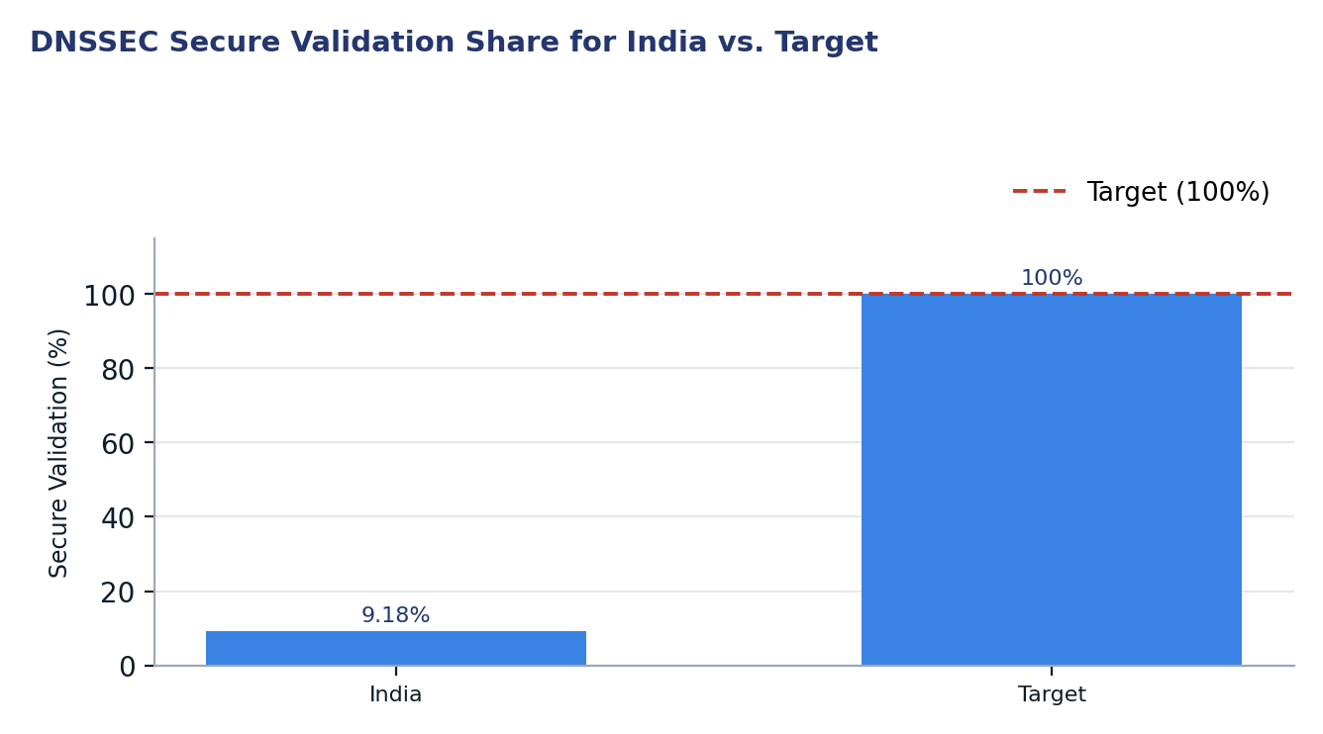
Figure 1. DNSSEC Secure Validation Share for India vs. Target
Two readings matter for policy. First, the excellent technical health of the .in ccTLD's authoritative DNS infrastructure demonstrates national competence in deploying critical internet security mechanisms, indicating that the technical expertise for DNSSEC exists within the country. Second, the alarmingly low rate of secure DNSSEC validation by end-user resolvers, coupled with significant disparities across major networks, points to a clear policy and implementation gap. This indicates that despite the availability of secure infrastructure, network operators and internet service providers (ISPs) have not universally enabled DNSSEC validation, leaving a vast majority of users vulnerable to DNS-related attacks.

2. Where India is improving

2.1 Robust .in ccTLD Infrastructure and IPv6 Enablement
The .in ccTLD demonstrates strong foundational health, with its authoritative DNS infrastructure fully adhering to modern internet standards. All 4 authoritative nameservers for the .in domain are IPv6 enabled, achieving a 100.0% enablement rate. This comprehensive support for IPv6 ensures that the national domain can be resolved efficiently and securely over both IPv4 and IPv6 networks, providing redundancy and future-proofing the core domain infrastructure.
Nameserver | IPv6 Enabled
ns1.registry.in | Yes
ns2.registry.in | Yes
ns3.registry.in | Yes
ns4.registry.in | Yes

The proactive deployment of IPv6 across all authoritative nameservers for the .in ccTLD is a significant positive indicator. It reflects a commitment to advanced internet protocols at the national registry level. This complete IPv6 readiness stands as a robust asset, ready to support increasing IPv6 adoption rates among end-users and network operators. This technical leadership from the ccTLD registry provides a strong example for other critical internet infrastructure providers within India.

2.2 Authoritative Nameserver ASN Diversity
The authoritative DNS infrastructure for the .in ccTLD exhibits commendable resilience through its distribution across multiple Autonomous Systems (ASNs). The 4 authoritative nameservers are hosted across 3 distinct ASNs, which significantly mitigates the risk of single-point failures. This diversity ensures that resolution for .in domains remains operational even in the event of an outage or routing issue affecting a single network provider.
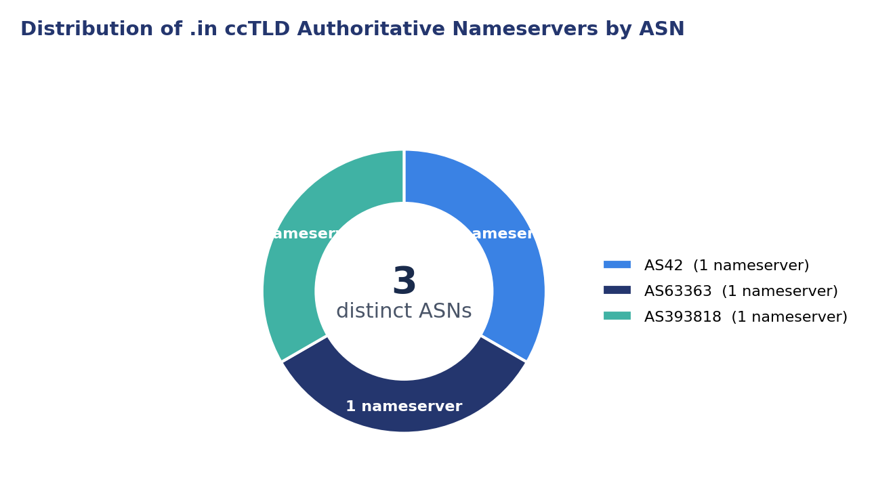
Figure 2. Distribution of .in ccTLD Authoritative Nameservers by ASN
This strategic distribution across ASNs is a critical best practice for maintaining the availability and integrity of a country code Top-Level Domain. It ensures robust redundancy and protects against various network-centric threats, including DDoS attacks or routing incidents specific to a single network operator. Such diversity enhances the overall security posture of the .in domain, creating a more stable and reliable foundation for internet users in India.

3. Where India could improve
India's internet resilience could be significantly enhanced by addressing its low DNSSEC validation rates, inconsistent operator performance, and underutilised IPv6 potential, each of which contributes to a less secure and less efficient national internet experience.

3.1 Low DNSSEC Secure Validation Rate
A primary area for improvement is the alarmingly low rate of DNSSEC secure validation across India's networks. Only 9.18% of all observed DNS queries are securely validated, meaning the vast majority of DNS resolutions are vulnerable to manipulation and spoofing. This exposes internet users to risks such as phishing, malware distribution, and man-in-the-middle attacks, undermining trust in the internet infrastructure.
Status | Percentage
Secure | 9.18%
Insecure | 87.08%
Invalid | 0.09%
Other | 3.65%

The high percentage of insecure queries (87.08%) indicates that most internet service providers and network operators have not enabled DNSSEC validation on their recursive resolvers. This fundamental oversight negates the security benefits of DNSSEC, even for domains that are properly signed. Addressing this requires widespread adoption of validating resolvers across the national network ecosystem.

3.2 Inconsistent DNSSEC Validation Across Major Networks
The observed DNSSEC validation rates vary significantly among major network operators in India, highlighting a fragmented approach to DNS security. While some networks, such as Bharti Airtel Limited (AS9498), show a relatively higher secure validation rate of 19.01%, others, like the National Internet Backbone (AS9829), exhibit a critically low rate of 3.87% despite accounting for a significant share of DNS traffic (15.93%).
ASN | Network | Secure Validation
AS9829 | National Internet Backbone | 3.87%
AS55836 | Jio Platforms Ltd | 9.08%
AS24560 | Bharti Airtel Ltd., Telemedia Services | 15.15%
AS45609 | Bharti Airtel Ltd. AS for GPRS Service | 5.74%
AS9498 | Bharti Airtel Limited | 19.01%
AS24309 | Atria Convergence Technologies Pvt. Ltd. Broadband Internet Service Provider INDIA | 15.55%

This inconsistency indicates a lack of uniform best practices or regulatory mandates regarding DNSSEC validation. Large networks with substantial user bases and low validation rates pose a disproportionately higher risk to the overall security of the Indian internet. A concerted effort to bring all major operators up to a higher baseline is essential to ensure consistent protection for all internet users.

3.3 Low .in ccTLD Query Share and IPv6 Traffic Adoption
Despite the .in ccTLD's robust and IPv6-enabled authoritative infrastructure, its share of DNS queries remains low at 2.39%. This suggests that local content and services are not predominantly using the national domain, potentially limiting the direct impact of the ccTLD's security enhancements on the broader internet experience for Indian users. Furthermore, only 10.90% of observed DNS traffic uses IPv6, which is significantly lower than the 100% IPv6 enablement rate of the .in ccTLD nameservers.
TLD | Query Share
.com | 68.44%
.net | 11.93%
.in | 2.39%

The disparity between ccTLD IPv6 readiness and actual IPv6 traffic adoption highlights a critical gap in end-user and network operator IPv6 deployment. While the ccTLD is prepared for the next generation of the internet, the ecosystem's slow transition means that most users are not benefiting from the efficiencies and potential security enhancements that IPv6 offers. Efforts are needed to encourage both greater adoption of the .in ccTLD for local services and accelerated deployment of IPv6 by ISPs and businesses.

4. A staged plan to improve resilience
Improving India's DNSSEC posture requires a strategic, phased approach, starting with immediate, low-cost administrative actions, followed by targeted coordination efforts, and culminating in long-term structural capacity building. This prioritisation ensures that quick wins build momentum for more complex, capital-intensive projects.
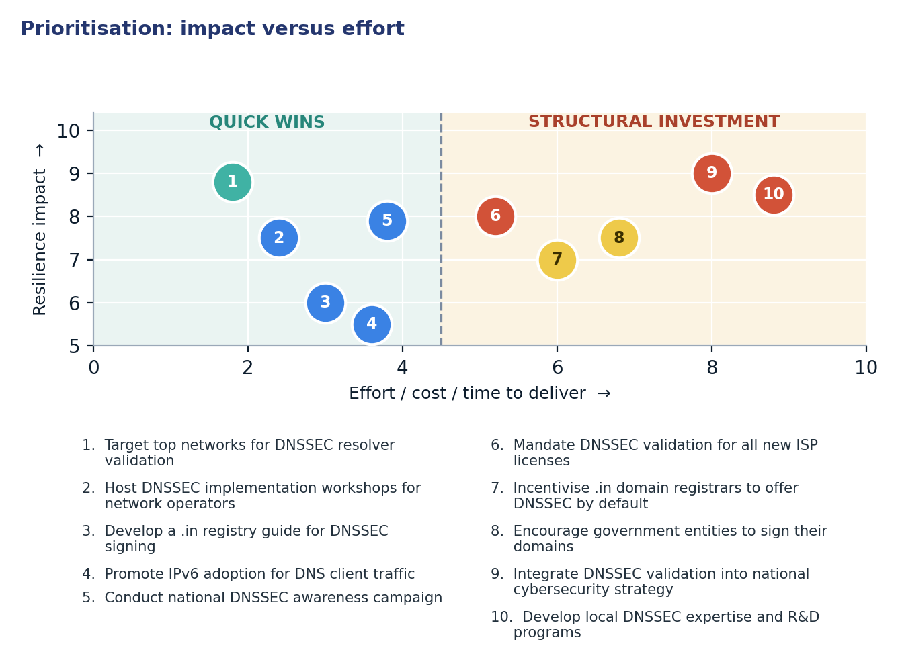
Figure 3. Prioritisation: impact versus effort

4.1 Short term (0–12 months)
Action | Description | Owner | Indicator moved
1. Target top networks for DNSSEC resolver validation | Engage large ISPs (e.g., AS9829, AS55836) with low validation rates to enable DNSSEC on their recursive resolvers. | TRAI, MeitY, ISPAI, Major ISPs | DNSSEC Secure Validation Share 9.18% → >15%
2. Host DNSSEC implementation workshops for network operators | Provide practical training and technical assistance to ISPs on configuring and maintaining validating recursive resolvers. | NIXI, ISOC, Industry Associations | Lowest Per-ASN Secure Validation 3.87% → >5%
3. Develop a .in registry guide for DNSSEC signing | Create a simplified, step-by-step guide for .in domain holders and registrars to implement DNSSEC signing easily. | .in Registry (NIXI) | .in domains signed (conceptual) → Increased rate
4. Promote IPv6 adoption for DNS client traffic | Launch campaigns to encourage ISPs to deploy IPv6 more widely to end-users, leveraging the .in ccTLD's existing IPv6 readiness. | MeitY, TRAI, ISPs | IPv6 DNS Query Share 10.90% → >15%
5. Conduct national DNSSEC awareness campaign | Educate businesses and end-users about the importance and benefits of DNSSEC for online security. | MeitY, CERT-In, Consumer Advocacy Groups | Public awareness of DNSSEC (proxy) → Higher adoption

4.2 Medium term (1–3 years)
Action | Description | Owner | Indicator moved
6. Mandate DNSSEC validation for all new ISP licenses | Integrate a requirement for DNSSEC validation on recursive resolvers into the licensing framework for new Internet Service Providers. | TRAI, DoT | DNSSEC Secure Validation Share 9.18% → >30%
7. Incentivise .in domain registrars to offer DNSSEC by default | Introduce incentives or policy guidelines for .in registrars to provide DNSSEC signing as a default or highly promoted option. | .in Registry (NIXI), TRAI | Share of DNSSEC-signed .in domains → Increased
8. Encourage government entities to sign their domains | Prioritise and support all government (.gov.in) and critical infrastructure domains to implement DNSSEC signing. | MeitY, NIC, State IT Departments | Government domain DNSSEC signing rate → >80%

4.3 Long term (3–7 years)
Action | Description | Outcome
9. Integrate DNSSEC validation into national cybersecurity strategy | Formalise DNSSEC validation as a core component of India's national cybersecurity policy and allocate sustained resources for its enforcement and advancement. | Robust national DNS security posture and enhanced trust in online services.
10. Develop local DNSSEC expertise and R&D programs | Invest in academic and industry research and development initiatives focused on DNSSEC, including local tool development and talent cultivation. | Self-sustaining DNS security innovation and a globally recognised pool of DNSSEC experts in India.

5. Quick wins
These five interventions require primarily configuration changes or administrative coordination rather than significant capital investment, making them achievable within a short timeframe. They focus on immediately improving DNSSEC validation and IPv6 adoption rates.
# | Quick win | Why it is quick | Effort | Expected effect
1 | Target top networks for DNSSEC resolver validation | Involves configuration changes by a few key ISPs, directly impacting a large user base. | Days of operator work per network | Raise DNSSEC Secure Validation Share from 9.18% to >15%
2 | Host DNSSEC implementation workshops for network operators | Leverages existing expertise; hands-on training accelerates configuration across multiple networks. | 2-4 weeks of coordination and workshop delivery | Raise Lowest Per-ASN Secure Validation from 3.87% to >5%
3 | Develop a .in registry guide for DNSSEC signing | A documentation effort that empowers registrars and domain holders with clear instructions. | 1-2 weeks of registry coordination | Shift .in domains signed (conceptual) → Increased rate
4 | Promote IPv6 adoption for DNS client traffic | Leverages existing ccTLD IPv6 readiness; requires ISP configuration changes and minor marketing. | Weeks of ISP operational changes and public messaging | Raise IPv6 DNS Query Share from 10.90% to >15%
5 | Conduct national DNSSEC awareness campaign | Primarily involves public information dissemination through existing channels. | Months of public information outreach | Shift Public awareness of DNSSEC (proxy) → Higher adoption

6. Policy gaps and loopholes

6.1 Where policy is absent or unenforced
Gap | Consequence | Remedy
Lack of mandatory DNSSEC validation for ISPs | Widespread insecure DNS resolution, leaving users vulnerable to DNS spoofing and cache poisoning. | Introduce regulatory mandates for all licensed ISPs to enable DNSSEC validation on their recursive resolvers.
Insufficient incentives for .in domain holders to sign their domains | Limited number of .in domains are DNSSEC-signed, reducing the overall security of the national domain space. | Implement incentive programs or policy guidance for registrars to promote and simplify DNSSEC signing for .in domains.
Absence of a comprehensive national strategy for DNSSEC adoption | Fragmented and inconsistent deployment of DNSSEC across different networks and government entities. | Develop and integrate a formal national DNSSEC adoption strategy within India's cybersecurity framework.
Low public and enterprise awareness of DNSSEC benefits | Lack of demand from end-users and businesses for DNSSEC-secured services, reducing pressure on operators to implement it. | Launch broad national awareness campaigns targeting both technical and non-technical audiences on the importance of DNSSEC.

6.2 Loopholes to avoid creating
- Mandating specific DNSSEC validating resolver software or hardware, which could stifle innovation and competition among service providers.
- Implementing overly complex or costly DNSSEC signing processes for .in domain holders, discouraging adoption.
- Allowing a "whitelist" approach to DNSSEC where only pre-approved domains are validated, rather than a universal validation of all signed domains.
- Introducing policies that inadvertently favour large operators at the expense of smaller, regional ISPs, creating further market concentration.
- Automatically blocking or quarantining unsigned domains without clear policy justification, which could disrupt legitimate services.

7. Measuring progress
Every action outlined in this plan maps to a publicly verifiable metric, enabling transparent tracking of progress and accountability. These indicators will serve as benchmarks to assess the effectiveness of implemented policies and initiatives over time.
Indicator | Baseline | 12-month target | Source
DNSSEC Secure Validation Share | 9.18% | >15% | Cloudflare Radar, ISOC Pulse
Lowest Per-ASN Secure Validation | 3.87% | >5% | Cloudflare Radar, ISOC Pulse
IPv6 DNS Query Share | 10.90% | >15% | Cloudflare Radar, ISOC Pulse
Government domain DNSSEC signing rate | (Not directly measured) | >25% (conceptual) | NIC, relevant government departments
.in ccTLD Authoritative Nameservers IPv6 Enablement Rate | 100.0% | 100.0% | IYP Neo4j, ISOC Pulse

Conclusion
India's DNSSEC landscape presents a classic disconnect between physical network presence and operational security configuration. While the .in ccTLD boasts a robust and resilient authoritative DNS infrastructure with full IPv6 enablement and diverse ASN distribution, the actual secure validation of DNS queries by end-users remains critically low. This paradoxical situation means that a strong foundation has been laid, yet the final crucial step of enabling validation at the resolver level—the primary mechanism for users to benefit from DNSSEC's security—is largely overlooked. The wide variance in validation rates across major operators further underscores this uneven operational maturity, highlighting specific bottlenecks that require targeted intervention.
To overcome this, a strategic sequencing of interventions is crucial. Prioritising immediate, configuration-based "quick wins" for DNSSEC validation across major ISPs, coupled with awareness campaigns and simplified registry processes, can yield rapid, measurable improvements without significant capital outlay. These initial successes can then build regulatory momentum and industry confidence, paving the way for more comprehensive policy mandates, stronger incentives for domain signing, and long-term integration of DNSSEC into the national cybersecurity strategy. By systematically addressing the operational gaps and capitalising on the existing strong ccTLD infrastructure, India can significantly enhance its internet resilience and provide a more secure online environment for its citizens and businesses.

Data sources and notes
This report draws upon measurement data from the Internet Yellow Pages (IYP) Neo4j platform and Cloudflare Radar, providing a snapshot of India's DNSSEC status based on the ISOC Internet Resilience Index — Security Pillar (DNS Security) framework.
- ISOC Pulse — Country Report for India: https://pulse.internetsociety.org/en/reports/in/
- ISOC Pulse — Internet Resilience Index for India: https://pulse.internetsociety.org/en/resilience/in/
- RIPEstat — Country ASNs & Routing Status for IN: https://stat.ripe.net/IN
- PeeringDB — IXP & Facility Directory for IN: https://www.peeringdb.com/advanced_search?country=IN
- RIPE Atlas — Active Probes & Anchors in IN: https://atlas.ripe.net/probes/?country=IN
- Packet Clearing House (PCH) — IXP Directory: https://www.pch.net/ixp/dir

Measurement caveats. All reported figures are based on data collected at the specified timestamp and may not reflect real-time changes. DNS traffic analysis from Cloudflare Radar is based on queries to their 1.1.1.1 public resolver, which represents a significant but not exhaustive sample of global DNS traffic. This methodology provides a strong indicator of general trends and operator behaviour but should be interpreted within the context of sampled telemetry.

