November 2026

Internet Resilience in France
  - IPv6 diagnostics report and action plan
ISOC Pulse

DO NOT PUBLISH – INTERNAL DOCUMENT

Table of contents
Executive summary 2
Key numbers at a glance 2
1. Where France stands 3
2. Where France is improving 4
2.1 High National IPv6 Adoption and ISP Compliance 4
2.2 Strong IXP IPv6 Readiness 4
3. Where France could improve 5
3.1 Improving RPKI Coverage for IPv6 Routes 5
3.2 Enhancing Web Services IPv6 Readiness 5
3.3 Increasing ccTLD and DNS Infrastructure IPv6 Adoption 6
4. A staged plan to improve resilience 7
4.1 Short term (0–12 months) 7
4.2 Medium term (1–3 years) 8
4.3 Long term (3–7 years) 8
5. Quick wins 9
6. Policy gaps and loopholes 10
6.1 Where policy is absent or unenforced 10
6.2 Loopholes to avoid creating 10
7. Measuring progress 11
Conclusion 11
Data sources and notes 12

How to interpret the numbers in this report?
The values presented in this document are the Internet Resilience Index, normalized to 1–100. These values should be interpreted as a score rather than an absolute value. In some cases, the raw absolute values are presented to provide additional context.

Executive summary
France currently demonstrates a leading position in national IPv6 adoption, with 86.0% of its internet users capable of accessing content over IPv6. This places the country at a strong global rank of #4, significantly above the global average. A key strength is the universal compliance of major Internet Service Providers (ISPs), indicating widespread network readiness at the access layer. Despite this impressive user-side deployment, a structural paradox exists where operational configuration and content readiness lag behind network capability. Specifically, there is effectively zero IPv6 readiness among the nation's popular web domains (0.0%), and government websites show only a modest 22.92% readiness, highlighting a significant disconnect between user access and content availability over the modern internet protocol.
Further analysis reveals critical areas for improvement in routing security and DNS infrastructure. While overall RPKI coverage for IPv6 prefixes is high at 97.87%, several networks still exhibit weak adoption, posing potential security vulnerabilities. Domestic Internet Exchange Points (IXPs) are largely IPv6-ready (96.3% with IPv6 LANs), but a segment of their members (9.3%) has yet to enable IPv6 peering, indicating room for optimisation. The national .fr ccTLD shows 39.50% AAAA record readiness, which is lower than comparable TLDs, and authoritative nameserver IPv6 reachability stands at 81.14%. Critically, only 36.67% of glue records are IPv6-capable, suggesting a fragility in core DNS infrastructure that could affect resilience and reachability. Addressing these gaps in RPKI, web content, and DNS will be essential to fully leverage France's strong IPv6 user adoption and secure its digital ecosystem.

Key numbers at a glance
Indicator | France | Benchmark | Reading
National IPv6 Adoption | 86.0% | 24.4% (Global Avg) | Highly adopted
Underserved Market Share (IPv6) | 0.0% | 0% (Ideal) | Effectively zero non-compliance
IPv6 RPKI Coverage | 97.87% | 100% (Target) | Strong, but minor gaps
IXPs with IPv6 LAN | 96.3% | 100% (Target) | Near-universal readiness
IXP Members with IPv6 Peering | 90.7% | 100% (Target) | Good, but some members not peering
Popular Web IPv6 Readiness | 0.00% | >50% (Target) | Effectively zero deployment
Government IPv6 Readiness | 22.92% | >50% (Target) | Suboptimal public sector deployment
.fr ccTLD AAAA Readiness | 39.50% | >50% (Target) | Below peer TLDs
Authoritative NS IPv6 Reachability | 81.14% | 100% (Target) | Room for improvement
Glue Record IPv6 Readiness | 36.67% | 100% (Target) | Weak core DNS resilience

1. Where France stands
France exhibits a formidable position in global IPv6 adoption, with 86.0% of its internet users operating over the protocol. This places the nation as the 4th highest globally out of 243 countries, significantly surpassing the global average of 24.4%. This high level of adoption is largely driven by ubiquitous IPv6 deployment among major Internet Service Providers, with 0.0% of the subscriber market served by non-compliant ISPs. Such widespread enablement positions France as a leader in consumer-facing IPv6 readiness, allowing its citizens to benefit from the modern internet protocol. The closest peer country by adoption score, UM (United States Minor Outlying Islands), stands at 88.31%, indicating that France is at the vanguard of national IPv6 transition efforts.
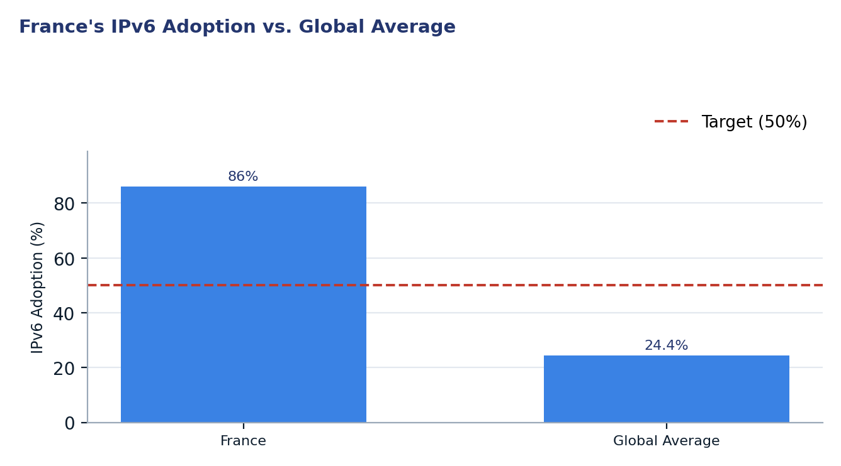
Figure 1. France's IPv6 Adoption vs. Global Average
Two readings matter for policy. First, the exceptionally high national IPv6 adoption rate underscores successful ISP-led deployment initiatives and highlights France's commitment to modern internet infrastructure. The full compliance of major ISPs indicates that foundational access to IPv6 is largely resolved, shifting the focus towards leveraging this widespread capability. Second, despite the strong user adoption, significant vulnerabilities remain in the national digital ecosystem's security posture and content availability over IPv6, particularly concerning routing security (RPKI), popular web content, government services, and fundamental DNS infrastructure. These areas represent critical next steps to ensure the security, resilience, and full utility of France's IPv6-enabled internet.

2. Where France is improving

2.1 High National IPv6 Adoption and ISP Compliance
France has achieved an impressive national IPv6 adoption rate of 86.0%, positioning it as a global leader. This high level of adoption is largely attributable to proactive deployment by major Internet Service Providers, with zero market share currently served by non-compliant ISPs. The commitment of these operators to IPv6 ensures that a vast majority of internet users in France can leverage the protocol, providing a strong foundation for future digital growth and innovation.
The analysis of ISP compliance indicates that all major service providers, including those with significant market shares, are classified as compliant. This collective effort by key players like Orange S.A., Free SAS, and Bouygues Telecom SA, which together account for a substantial portion of the market, has been instrumental in driving the high national adoption figures. The early deployment ages for many of these top ISPs further underscore a sustained, long-term commitment to IPv6 transition within the French telecommunications sector.
ASN | ISP | Market Share | Adoption Est. | Archetype
AS3215 | AS3215 Orange S.A. | 36.2% | 81.3% | OK — Compliant
AS12322 | PROXAD Free SAS | 18.3% | 75.1% | OK — Compliant
AS5410 | BOUYGTEL-ISP Bouygues Telecom SA | 17.2% | 74.7% | OK — Compliant
AS15557 | LDCOMNET Societe Francaise Du Radio | 16.7% | 74.6% | OK — Compliant
AS51207 | FREEM Free Mobile SAS | 5.0% | 70.5% | OK — Compliant

2.2 Strong IXP IPv6 Readiness
France's Internet Exchange Point (IXP) ecosystem demonstrates strong readiness for IPv6, with 96.3% of the 27 domestic IXPs providing an IPv6 LAN. This high rate indicates that the foundational infrastructure for IPv6 peering is largely in place across the country's interconnection points. The widespread availability of IPv6 peering facilities at IXPs is crucial for fostering local traffic exchange and reducing reliance on international transit for IPv6 content.
Furthermore, 90.7% of IXP members (1334 out of 1471) have already enabled IPv6 peering. This metric signifies a high level of operational engagement with IPv6 at the peering layer, contributing to more efficient and direct IPv6 routing paths within France. Major IXPs such as France-IX Paris, Equinix Paris, and nine exhibit strong IPv6 member participation, with many approaching or achieving full IPv6 peering among their members, such as BGP.Exchange - Lyon, BreizhIX, and AuvernIX, which report 100% IPv6 member participation.
IXP | IPv6 LAN | Members | IPv6 Members | IPv6 %
France-IX Paris | Yes | 452 | 400 | 88.5%
Equinix Paris | Yes | 241 | 214 | 88.8%
nine | Yes | 140 | 133 | 95.0%
DE-CIX Marseille | Yes | 120 | 103 | 85.8%
France-IX Marseille | Yes | 110 | 106 | 96.4%
France-IX AURA | Yes | 74 | 62 | 83.8%

3. Where France could improve
France could significantly enhance its digital infrastructure resilience by addressing weaknesses in RPKI coverage, web content readiness, and authoritative DNS IPv6 deployment.

3.1 Improving RPKI Coverage for IPv6 Routes
Despite a high overall RPKI coverage of 97.87% for IPv6 routing prefixes in France, which indicates a strong commitment to routing security, a closer examination reveals that certain operators still fall short of full compliance. The remaining 2.13% of unprotected prefixes represent potential vulnerabilities that could be exploited for route hijacks or other routing incidents. While the overall figure is positive, ensuring comprehensive RPKI adoption across all networks is critical for maintaining the integrity and trustworthiness of the national routing table.
Several ISPs, despite their significant IPv6 routing presence, continue to exhibit weaker RPKI coverage compared to the national average. For instance, ALPHALINK-AS Alphalink SASU, FLEXNETWORK-AS FLEX NETWORK SARL, and BANDWIDTH-AS Hydra Communications Ltd show RPKI coverage below 90%. Addressing these specific gaps through targeted outreach and technical assistance is necessary to achieve near-100% RPKI coverage, thereby fortifying France's IPv6 routing infrastructure against common security threats.
ISP | IPv6 Prefixes | RPKI Coverage
ALPHALINK-AS Alphalink SASU | 7 | 71.43%
FLEXNETWORK-AS FLEX NETWORK SARL | 5 | 80.00%
BANDWIDTH-AS Hydra Communications Ltd | 19 | 89.47%
VELIANET-AS velia.net Internetdienste Gm | 10 | 90.00%
ZEN-DPS - Zenlayer Inc | 89 | 91.01%

3.2 Enhancing Web Services IPv6 Readiness
A significant gap exists in the IPv6 readiness of popular web services in France, with 0.00% of analyzed popular domains being IPv6-reachable. This indicates that despite high user-side IPv6 adoption, the content accessible over IPv6 remains critically limited. This disparity hinders the full potential of IPv6 for end-users and can lead to inefficient network paths or a degraded user experience when accessing IPv4-only content over dual-stack networks.
The situation is only marginally better within the public sector, where Government IPv6 Readiness stands at a suboptimal 22.92%. This suggests that a substantial portion of government digital infrastructure still relies exclusively on IPv4, limiting its accessibility and resilience. While some sectors like Ecommerce (56.88%) and Education (47.14%) show comparatively higher IPv6 readiness, the overall lack of popular web content over IPv6 remains a major challenge. This is further highlighted by the observation that IPv6 deployment is significantly stronger among CDN-backed services, suggesting that self-hosted infrastructure needs greater attention.
Sector | Domains | IPv6 Readiness
Banking | 31 | 38.71%
News | 78 | 43.59%
Education | 70 | 47.14%
Ecommerce | 109 | 56.88%

3.3 Increasing ccTLD and DNS Infrastructure IPv6 Adoption
The national .fr ccTLD exhibits a moderate IPv6 AAAA readiness of 39.50% based on sampled domains. While not critically low, this figure falls below that of the global .com TLD (50.28%) and is comparable to .de (40.10%) and .in (42.18%). This suggests that a significant portion of domains under the .fr ccTLD have yet to enable IPv6 connectivity, potentially limiting the reachability and efficiency of access to French-specific online services for IPv6-only users in the future.
Furthermore, a notable vulnerability lies in the IPv6 readiness of glue records, with only 36.67% of assessed glue-style nameservers being IPv6-capable. Glue records are essential for resolving domain names within their own zone and their limited IPv6 enablement poses a foundational weakness in the resilience of the .fr DNS infrastructure. Although authoritative nameserver IPv6 reachability is higher at 81.14%, the low glue record readiness indicates that self-hosted authoritative DNS infrastructure specifically requires focused attention to improve overall IPv6 health and resilience for the national ccTLD.
TLD | IPv6 Readiness
.fr | 39.50%
.com | 50.28%
.de | 40.10%
.in | 42.18%

4. A staged plan to improve resilience
Improving France's internet resilience requires a strategic, phased approach, beginning with immediate, no-capital configuration changes (Phase 1, within 12 months), followed by targeted coordination efforts (Phase 2, 1-3 years), and culminating in long-term structural capacity building (Phase 3, 3-7 years). This sequencing ensures that quick wins build momentum for more significant, resource-intensive projects.
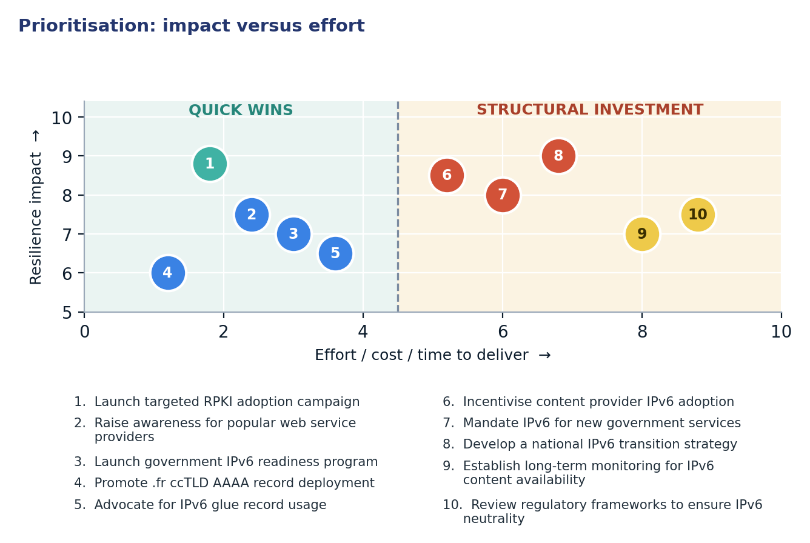
Figure 2. Prioritisation: impact versus effort

4.1 Short term (0–12 months)
Action | Description | Owner | Indicator moved
1. Launch targeted RPKI adoption campaign | Engage specific ISPs with low RPKI coverage to assist with ROA record publication and validation. | ARCEP, RIPE NCC, ISPs | IPv6 RPKI Coverage 97.87% → >99%
2. Raise awareness for popular web service providers | Conduct outreach to top popular domain holders about the benefits and steps for IPv6 enablement. | ISOC France, AFNIC, Industry associations | Popular Web IPv6 Readiness 0.00% → >10%
3. Launch government IPv6 readiness program | Initiate a program for government agencies to assess and begin transitioning their websites and services to IPv6. | DINSIC, Ministry of Digital Affairs | Government IPv6 Readiness 22.92% → >40%
4. Promote .fr ccTLD AAAA record deployment | Collaborate with AFNIC and domain registrars to encourage .fr domain holders to publish AAAA records. | AFNIC, Registrars | .fr ccTLD AAAA Readiness 39.50% → >50%
5. Advocate for IPv6 glue record usage | Educate registrars and domain owners about the importance of IPv6-capable glue records for DNS resilience. | AFNIC, Registrars, DNS Operators | Glue Record IPv6 Readiness 36.67% → >50%

4.2 Medium term (1–3 years)
Action | Description | Owner | Indicator moved
6. Incentivise content provider IPv6 adoption | Develop incentive schemes or technical support programs for major content and application providers to transition to IPv6. | Ministry of Digital Affairs, Industry bodies | Popular Web IPv6 Readiness >10% → >30%
7. Mandate IPv6 for new government services | Implement a policy requiring all new government-developed digital services and procurement to be IPv6-enabled. | DINSIC, Prime Minister's Office | Government IPv6 Readiness >40% → >60%
8. Develop a national IPv6 transition strategy | Formulate a comprehensive national strategy outlining timelines, responsibilities, and resources for full IPv6 deployment across all sectors. | Ministry of Digital Affairs, Cross-sector taskforce | National IPv6 Adoption 86.0% → >90%

4.3 Long term (3–7 years)
Action | Description | Outcome
9. Establish long-term monitoring for IPv6 content availability | Implement sustained, automated monitoring mechanisms to track IPv6 readiness across all key sectors and domain types. | Data-driven policy refinement and continuous improvement in IPv6 content availability.
10. Review regulatory frameworks to ensure IPv6 neutrality | Assess and update existing regulations and policies to ensure they are technology-neutral and do not inadvertently hinder IPv6 adoption. | A regulatory environment that actively supports and enables the full transition to IPv6 for all stakeholders.

5. Quick wins
These five interventions require configuration or administrative coordination rather than significant capital expenditure. They can be initiated swiftly to yield measurable improvements in France's IPv6 security and content accessibility.
# | Quick win | Why it is quick | Effort | Expected effect
1 | Launch targeted RPKI adoption campaign | Involves direct engagement and technical assistance for specific ISPs to configure existing infrastructure. | Days of operator work per ASN | Raise IPv6 RPKI coverage from 97.87% to >99%
2 | Raise awareness for popular web service providers | Primarily an outreach and informational campaign leveraging existing industry communication channels. | Months of targeted outreach | Increase Popular Web IPv6 Readiness from 0.00% to >10%
3 | Launch government IPv6 readiness program | Can begin with an assessment phase and initial pilot projects within willing agencies. | Weeks of inter-agency coordination | Increase Government IPv6 Readiness from 22.92% to >40%
4 | Promote .fr ccTLD AAAA record deployment | Requires coordinated communication from the ccTLD registry and registrars to domain holders. | 1–2 weeks of registry coordination | Raise .fr ccTLD AAAA Readiness from 39.50% to >50%
5 | Advocate for IPv6 glue record usage | Focuses on educational campaigns and best practice dissemination among registrars and DNS operators. | Weeks of registrar/operator outreach | Improve Glue Record IPv6 Readiness from 36.67% to >50%

6. Policy gaps and loopholes

6.1 Where policy is absent or unenforced
Gap | Consequence | Remedy
Absence of a national IPv6 web content strategy | Lagging content availability over IPv6, limiting end-user benefits despite high network adoption. | Develop incentives and clear guidelines for content providers and web hosts to enable IPv6.
Lack of specific RPKI adoption mandates or strong guidance for ISPs | Residual routing insecurity from non-compliant ASNs, increasing vulnerability to BGP hijacks. | ARCEP to issue regulatory guidance or a soft mandate requiring RPKI ROA publication for all IPv6 prefixes.
Insufficient policy mandating IPv6 for government digital services | Continued reliance on legacy IPv4 for public services, hindering universal accessibility and future-proofing. | Implement a clear policy requiring IPv6-only or dual-stack for all new government platforms and procurements.
Limited policy focus on DNS infrastructure IPv6 readiness for .fr ccTLD | Suboptimal reachability and resilience for national domains, particularly with low glue record IPv6 readiness. | AFNIC to promote best practices and offer technical assistance for AAAA records and IPv6-capable glue records.

6.2 Loopholes to avoid creating
- Avoid mandating specific IPv6 implementation technologies or vendor solutions, preserving market competition and operator flexibility.
- Refrain from imposing arbitrary IPv6 transition deadlines without adequate capacity building, technical assistance, and financial support for affected stakeholders.
- Do not prematurely mandate IPv6-only environments for all services, as a gradual dual-stack transition is generally more practical and less disruptive.
- Prevent the creation of policies that disproportionately increase administrative or financial burdens on small and medium-sized enterprises (SMEs) during the IPv6 transition.

7. Measuring progress
Every recommended action maps to a publicly verifiable metric, enabling transparent tracking of progress and accountability. Baselines are derived from the current report's data, with 12-month targets set to achieve tangible, incremental improvements.
Indicator | Baseline | 12-month target | Source
IPv6 RPKI Coverage | 97.87% | >99% | RIPE NCC Stat, ISOC Pulse
Popular Web IPv6 Readiness | 0.00% | >10% | ISOC Pulse, IYP Graph
Government IPv6 Readiness | 22.92% | >40% | ISOC Pulse, IYP Graph (.gouv.fr namespace)
.fr ccTLD AAAA Readiness | 39.50% | >50% | ISOC Pulse, AFNIC
Authoritative NS IPv6 Reachability | 81.14% | >90% | ISOC Pulse, IYP Graph
Glue Record IPv6 Readiness | 36.67% | >50% | ISOC Pulse, IYP Graph

Conclusion
France stands at a unique juncture in its IPv6 transition, characterised by exceptionally high user adoption rates, demonstrating robust network-side deployment by its Internet Service Providers. This success in enabling IPv6 access for the majority of its citizens forms a strong foundation for a more resilient and future-proof internet. However, a significant disconnect persists between this widespread user capability and the operational readiness of web content, government services, and critical DNS infrastructure. The negligible IPv6 readiness of popular web domains and the suboptimal adoption within the public sector represent key challenges that prevent the full realisation of IPv6's benefits.
Addressing these specific gaps through a staged approach, starting with no-capital configuration changes and administrative coordination, is paramount. Prioritising quick wins such as targeted RPKI outreach, promoting AAAA record deployment, and launching government IPv6 readiness programs can rapidly enhance security and content availability. By sequencing these initiatives before embarking on more capital-heavy projects, France can build regulatory momentum, demonstrate tangible progress, and progressively align its content and security posture with its impressive user-side IPv6 adoption, ensuring a more resilient and robust internet for all its citizens.

Data sources and notes
This report leverages data from the Internet Society's Pulse platform, the Internet Yellow Pages (IYP) Neo4j graph database, and other internet measurement platforms. The analysis is based on a snapshot taken on 2026-11-04.
- ISOC Pulse — Country Report for France: https://pulse.internetsociety.org/en/reports/fr/
- ISOC Pulse — Internet Resilience Index for France: https://pulse.internetsociety.org/en/resilience/fr/
- RIPEstat — Country ASNs & Routing Status for FR: https://stat.ripe.net/FR
- PeeringDB — IXP & Facility Directory for FR: https://www.peeringdb.com/advanced_search?country=FR
- RIPE Atlas — Active Probes & Anchors in FR: https://atlas.ripe.net/probes/?country=FR
- Packet Clearing House (PCH) — IXP Directory: https://www.pch.net/ixp/dir

Measurement caveats. All metrics presented in this report represent a snapshot in time. Internet measurements are inherently complex, often relying on sample-based telemetry, inference, and publicly available routing and registration data. While robust methodologies are employed, these measurements may not capture every nuance of real-world internet operations. Market share data for ISPs are estimates based on various population proxies and may not reflect precise subscriber numbers.

