November 2026

Internet Resilience in India
  - IPv6 diagnostics report and action plan
ISOC Pulse

DO NOT PUBLISH – INTERNAL DOCUMENT

Table of contents
Executive summary 2
Key numbers at a glance 2
1. Where India stands 3
2. Where India is improving 4
2.1 Strong User Adoption and Global Ranking 4
2.2 Advancing IXP IPv6 Readiness and Peering 4
2.3 Sustained Top ISP IPv6 Deployment 5
2.4 Progressive .in TLD IPv6 Readiness 5
3. Where India could improve 6
3.1 Weak RPKI Coverage in Specific Networks 6
3.2 Suboptimal Web Services IPv6 Readiness 6
3.3 Lagging Government and Sectoral IPv6 Adoption 6
3.4 Absence of IPv6 Glue Records 7
4. A staged plan to improve resilience 8
4.1 Short term (0–12 months) 8
4.2 Medium term (1–3 years) 9
4.3 Long term (3–7 years) 9
5. Quick wins 10
6. Policy gaps and loopholes 11
6.1 Where policy is absent or unenforced 11
6.2 Loopholes to avoid creating 11
7. Measuring progress 12
Conclusion 12
Data sources and notes 13

How to interpret the numbers in this report?
The values presented in this document are the Internet Resilience Index, normalized to 1–100. These values should be interpreted as a score rather than an absolute value. In some cases, the raw absolute values are presented to provide additional context.

Executive summary
India has achieved a notably high IPv6 adoption rate of 76.4%, positioning the country as a global leader, ranking #5 worldwide and significantly surpassing the global average of 24.4%. This impressive user-side transition underscores successful, large-scale deployment efforts by major Internet Service Providers, establishing a robust foundation for the future of the Internet in India. However, this progress is tempered by several critical operational and security deployment gaps, particularly in the realm of routing security, web service readiness, and fundamental DNS infrastructure.
All major ISPs have been classified as compliant, with 0.0% of the subscriber market underserved by non-compliant providers, indicating successful initial deployment by key players. Despite an overall IPv6 RPKI coverage of 92.78% for announced prefixes, a concerning number of specific networks with significant IPv6 presence exhibit critically low or non-existent RPKI adoption, posing routing security risks. While 85.0% of domestic Internet Exchange Points (IXPs) support IPv6 LANs and 78.0% of their members peer over IPv6, web services IPv6 readiness for popular domains remains at an effectively zero 0.00%. Government websites show only 16.50% IPv6 readiness, with critical sectors such as banking, news, education, and e-commerce also presenting moderate adoption levels. Furthermore, a non-existent 0.00% readiness for IPv6 glue records points to fundamental vulnerabilities in the national DNS infrastructure, highlighting an urgent need to translate high user adoption into a fully secure and resilient IPv6 ecosystem.

Key numbers at a glance
Indicator | India | Benchmark | Reading
National IPv6 Adoption | 76.4% | Global avg 24.4% | Very strong adoption
Global IPv6 Adoption Rank | #5 of 243 | #1 target | Leading globally
IPv6 RPKI Prefix Coverage | 92.78% | 100% target | Good, but specific gaps
ISP Market Share Underserved (IPv6) | 0.0% | 0% ideal | All major ISPs compliant
Domestic IXPs with IPv6 LAN | 85.0% (34 of 40) | 100% target | Strong IXP readiness
IXP Members with IPv6 Peering | 78.0% (1508 of 1934) | 100% target | Healthy participation
Web Services IPv6 Readiness | 0.00% | >50% target | Effectively zero deployment
Government Website IPv6 Readiness | 16.50% | >50% target | Significantly lagging
ccTLD (.in) IPv6 AAAA Readiness | 42.18% | >75% target | Moderate, room for growth
Authoritative NS IPv6 Reachability | 55.72% | 100% target | Suboptimal reachability
Glue Record IPv6 Readiness | 0.00% | 100% target | Non-existent deployment

1. Where India stands
India has achieved a remarkable IPv6 adoption rate of 76.4%, positioning the country at #5 globally out of 243 assessed nations. This figure is substantially higher than the global average of 24.4%, demonstrating significant progress in transitioning end-users to the next generation Internet protocol. This leadership in user adoption is a testament to the proactive deployment efforts by major Internet Service Providers within the country.
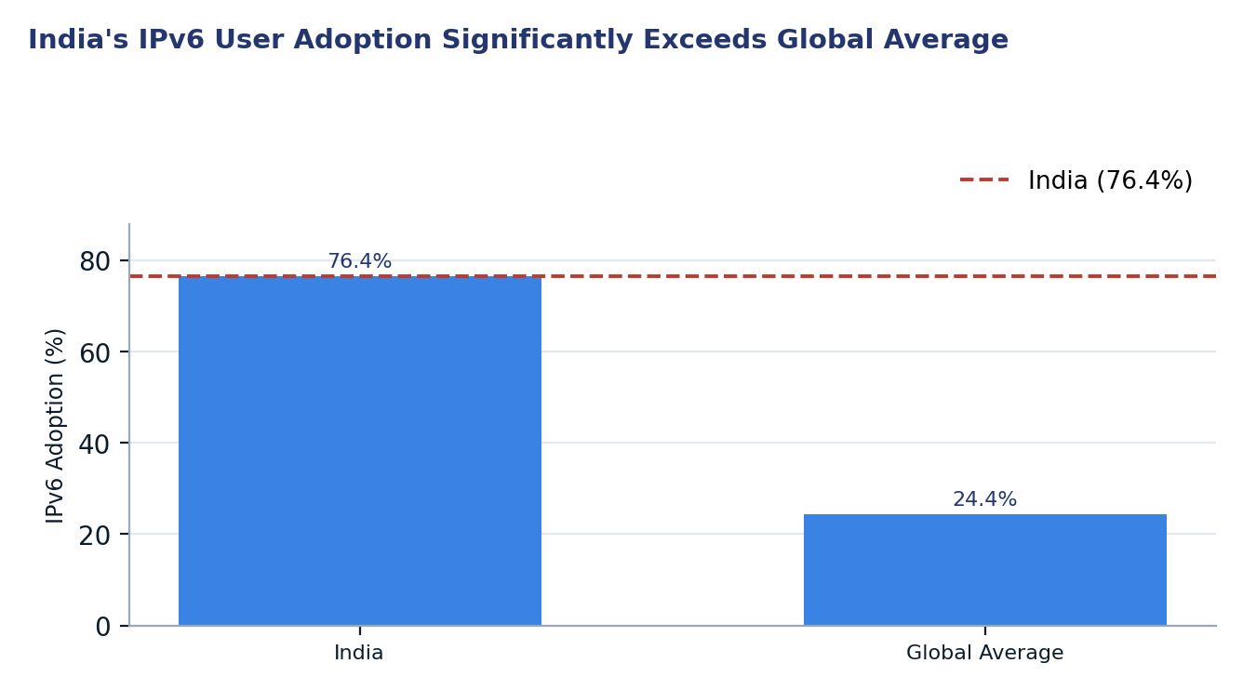
Figure 1. India's IPv6 User Adoption Significantly Exceeds Global Average
Two readings matter for policy. First, India's high user adoption indicates a robust demand-side readiness and successful large-scale deployment by key access providers. Second, the disparity between this high user adoption and the nascent IPv6 readiness of popular web services, government domains, and critical DNS infrastructure, such as glue records, highlights a crucial supply-side operational gap.

2. Where India is improving

2.1 Strong User Adoption and Global Ranking
India demonstrates strong user-side IPv6 adoption, currently at 76.4%, which places the country in the top tier globally. This indicates successful deployment initiatives by major Internet service providers, ensuring a significant portion of the population can access the Internet via IPv6. The sustained growth underscores a positive trajectory for nationwide IPv6 transition.
India's position as the 5th highest country for IPv6 adoption worldwide highlights its leadership in this domain. Comparative analysis with other leading nations reveals a consistent and substantial lead over the global average, reflecting a mature user-facing IPv6 ecosystem. This strong foundation can serve as a catalyst for further ecosystem-wide IPv6 integration.
Country | Adoption | Gap (vs IN)
India | 76.40% | 0.0 pp
Saudi Arabia | 74.83% | -1.6 pp
Germany | 72.95% | -3.5 pp
Malaysia | 72.47% | -3.9 pp
Belgium | 72.02% | -4.4 pp

2.2 Advancing IXP IPv6 Readiness and Peering
A substantial majority of domestic Internet Exchange Points (IXPs) in India have enabled IPv6 on their peering LANs, with 34 out of 40 (85.0%) IXPs supporting IPv6. This widespread availability of IPv6 peering infrastructure at IXPs is a critical enabler for local content and service delivery over IPv6, reducing reliance on international transit for IPv6 traffic.
Furthermore, a significant proportion of IXP members, 1508 out of 1934 (78.0%), are actively peering over IPv6. This high participation rate among connected networks at IXPs indicates an operational commitment to IPv6 at the peering layer. Leading IXPs like Kolkata IX (93.1%) and Extreme IX Kolkata (92.3%) showcase particularly strong IPv6 member adoption.
IXP | IPv6 LAN | Members | IPv6 Members | IPv6 %
DE-CIX Mumbai | Yes | 450 | 323 | 71.8%
Extreme IX Mumbai | Yes | 254 | 202 | 79.5%
Extreme IX Delhi | Yes | 182 | 142 | 78.0%
NIXI Mumbai | Yes | 180 | 149 | 82.8%
NIXI Delhi | Yes | 115 | 87 | 75.7%
DE-CIX Delhi | Yes | 103 | 78 | 75.7%
Extreme IX Chennai | Yes | 94 | 78 | 83.0%
DE-CIX Chennai | Yes | 76 | 56 | 73.7%
AMS-IX Mumbai | Yes | 75 | 58 | 77.3%
NIXI Chennai | Yes | 57 | 50 | 87.7%
Extreme IX Bangalore | Yes | 42 | 36 | 85.7%
ANI-IX Delhi | Yes | 30 | 15 | 50.0%
Kolkata IX | Yes | 29 | 27 | 93.1%
NIXI Kolkata | Yes | 29 | 26 | 89.7%
Extreme IX Kolkata | Yes | 26 | 24 | 92.3%

2.3 Sustained Top ISP IPv6 Deployment
The leading Internet Service Providers in India demonstrate strong compliance with IPv6 deployment, collectively covering the vast majority of the subscriber market. Providers such as Reliance Jio Infocomm Limited (AS55836) and Bharti Airtel Ltd. (AS45609, AS24560) exhibit high IPv6 adoption estimates (75.5%, 68.1%, and 63.8% respectively) and are classified as "Compliant," indicating robust and mature IPv6 service offerings to their user bases.
This widespread IPv6 readiness among major operators ensures that 0.0% of the market share is underserved by non-compliant ISPs, a significant achievement. Furthermore, several of these key ISPs have maintained IPv6 deployments for over a decade, with BSNL-NIB (AS9829) notably deploying its first IPv6 prefixes as early as 2009, reflecting a long-term commitment to the protocol.
ASN | ISP | Market Share | Adoption Est. | First IPv6 Seen | Age (yrs)
AS55836 | RELIANCEJIO-IN - Reliance Jio Infocomm Limited | 47.2% | 75.5% | 2012-12-10 | 13.9
AS45609 | BHARTI-MOBILITY-AS-AP - Bharti Airtel Ltd. AS for GPRS Service | 22.8% | 68.1% | 2013-12-05 | 12.9
AS24560 | AIRTELBROADBAND-AS-AP - Bharti Airtel Ltd., Telemedia Services | 9.0% | 63.8% | 2018-12-03 | 7.9
AS9829 | BSNL-NIB - National Internet Backbone | 2.8% | 62.0% | 2009-06-29 | 17.3
AS133982 | EXCITEL-AS-IN - Excitel Broadband Private Limited | 0.9% | 61.4% | 2018-08-17 | 8.2

2.4 Progressive .in TLD IPv6 Readiness
The national country code Top-Level Domain (ccTLD), .in, demonstrates progressive improvement in its IPv6 / AAAA readiness. Sample-based analysis indicates that 42.18% of .in domains are IPv6-enabled. This figure, while still having room for growth, positions the .in TLD comparatively well against other major global TLDs such as .fr (39.50%) and .de (40.10%).
The trend data shows a consistent upward trajectory in IPv6 readiness for .in domains. Over the observed period, IPv6-enabled domains increased from 40.9% to 42.2%, reflecting a 1.3 percentage point improvement in just a few months. This positive momentum indicates ongoing efforts within the .in ecosystem to support IPv6 resolution for hosted services.
Date | Domains Sampled | IPv6-Enabled | Readiness
2026-06-05 | 5000 | 2045 | 40.9%
2026-06-12 | 5000 | 2045 | 40.9%
2026-06-26 | 5000 | 2045 | 40.9%
2026-07-10 | 5000 | 2045 | 40.9%
2026-11-04 | 5000 | 2109 | 42.2%

3. Where India could improve
India's Internet resilience could be significantly enhanced by addressing critical gaps in routing security, web content readiness, government and sectoral IPv6 adoption, and foundational DNS infrastructure.

3.1 Weak RPKI Coverage in Specific Networks
Despite an overall IPv6 RPKI coverage of 92.78% across 17,468 prefixes, several networks with substantial IPv6 routing presence exhibit critically low or non-existent RPKI adoption. For instance, TATAPLAYBROADBAND-AS-AP and DNA-AS-AP show 0.00% RPKI coverage, leaving their IPv6 prefixes vulnerable to route hijacks or misorigination.
This concentrated weakness within specific operators presents a significant security risk for the routing integrity of the national IPv6 ecosystem. While some operators like FIVENET-IN and BBIL-AP show partial RPKI coverage, their figures (32.99% and 52.50% respectively) are well below the national average and best practice targets, requiring immediate attention to prevent potential disruptions to connectivity.
ISP | IPv6 Prefixes | RPKI Coverage
TATAPLAYBROADBAND-AS-AP - TATA PLAY BROA | 627 | 0.00%
DNA-AS-AP - DIGITAL NETWORK ASSOCIATES P | 102 | 0.00%
FIVENET-IN - Microscan Internet Limited | 97 | 32.99%
BBIL-AP - BHARTI Airtel Ltd. | 160 | 52.50%
EXCITEL-AS-IN - Excitel Broadband Privat | 138 | 93.48%

3.2 Suboptimal Web Services IPv6 Readiness
India faces a substantial challenge in the IPv6 readiness of its popular web services, with 0.00% of analyzed popular domains being IPv6-reachable. This indicates that despite high user-side IPv6 adoption, the content and application layer largely remains inaccessible over IPv6, potentially leading to performance issues due to IPv4 fallback mechanisms or limiting the utility of native IPv6 connectivity.
A comparative analysis of CDN-backed versus self-hosted domains reveals a stark contrast: while 52 of 65 (80%) CDN-backed domains are IPv6-capable, 481 of 935 (51.44%) self-hosted domains remain IPv4-only. This indicates that reliance on third-party CDN infrastructure significantly correlates with IPv6 deployment, whereas local hosting environments are substantially lagging in their transition.
Domain Hosting Type | Domains Assessed | IPv6-Capable Domains | IPv4-Only Domains | IPv6 Readiness
CDN-Backed Domains | 65 | 52 | 13 | 80.00%
Self-Hosted Domains | 935 | 454 | 481 | 48.56%

3.3 Lagging Government and Sectoral IPv6 Adoption
Government digital infrastructure in India exhibits comparatively weak IPv6 adoption, with only 16.50% of assessed government domains being IPv6-capable. This limited readiness poses a risk to the accessibility and future-proofing of public services, especially given the country's high national user-side IPv6 adoption.
Sectoral analysis further highlights disparities, with sectors like Banking (52.21%), News (50.00%), and Education (40.03%) showing moderate IPv6 readiness, while E-commerce stands at 44.85%. This uneven adoption across critical sectors suggests a lack of consistent policy drivers or awareness, leading to fragmented IPv6 deployment at the application layer.
Sector | Domains | IPv6 Readiness
Banking | 113 | 52.21%
News | 116 | 50.00%
Education | 587 | 40.03%
Ecommerce | 136 | 44.85%

3.4 Absence of IPv6 Glue Records
A significant deficiency identified in the .in ccTLD ecosystem is the complete absence of IPv6-capable glue records, registering at 0.00% readiness. Glue records are crucial for the resilience and performance of DNS resolution, particularly for authoritative nameservers that are "in-bailiwick" (i.e., whose hostnames fall within the same domain hierarchy as the delegated domain).
This absence implies that for domains relying on such self-hosted authoritative DNS infrastructure, resolution over IPv6 is compromised or entirely dependent on IPv4. This vulnerability introduces a single point of failure and limits the full benefit of end-to-end IPv6 connectivity, undermining the overall robustness of the national DNS infrastructure.

4. A staged plan to improve resilience
A comprehensive approach to enhancing India's IPv6 resilience involves a phased implementation, prioritizing immediate configuration and administrative actions before proceeding to more coordinated efforts and long-term structural investments.
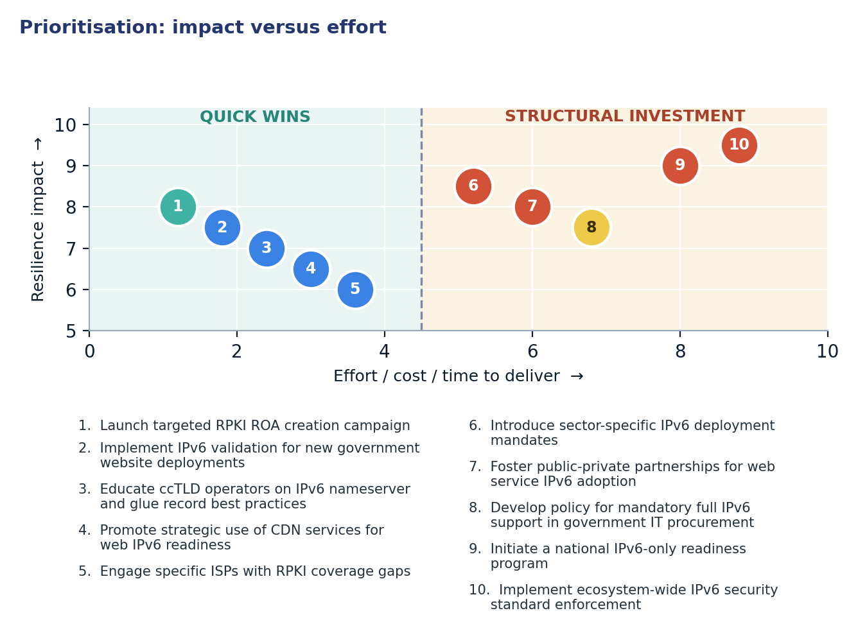
Figure 2. Prioritisation: impact versus effort

4.1 Short term (0–12 months)
Action | Description | Owner | Indicator moved
1. Launch targeted RPKI ROA creation campaign | Engage specific ISPs with low RPKI coverage to create Route Origin Authorization (ROA) records for their IPv6 prefixes. | Telecom Regulatory Authority of India (TRAI), Ministry of Communications (MoC), RIRs, NIXI | IPv6 RPKI Prefix Coverage 92.78% → >95%
2. Implement IPv6 validation for new government website deployments | Establish a mandatory check for IPv6 reachability and AAAA record presence for all new government website launches. | Ministry of Electronics and Information Technology (MeitY), National Informatics Centre (NIC) | Government Website IPv6 Readiness 16.50% → >25%
3. Educate ccTLD operators on IPv6 nameserver and glue record best practices | Conduct workshops and provide resources for .in domain registrars and registrants on enabling IPv6 for authoritative nameservers and glue records. | National Internet Exchange of India (NIXI), Indian Registry for Internet Names and Numbers (IRINN) | Glue Record IPv6 Readiness 0.00% → >15%
4. Promote strategic use of CDN services for web IPv6 readiness | Encourage popular web services and enterprises to leverage Content Delivery Networks (CDNs) that natively support IPv6 to accelerate their IPv6 web content delivery. | MeitY, Industry associations (e.g., IAMAI, NASSCOM) | Web Services IPv6 Readiness 0.00% → >15%
5. Engage specific ISPs with RPKI coverage gaps | Conduct direct outreach to networks exhibiting weak RPKI coverage to provide technical assistance and motivation for ROA deployment. | NIXI, RIRs, IRINN | ISP RPKI compliance for specific ASNs → Improved

4.2 Medium term (1–3 years)
Action | Description | Owner | Indicator moved
6. Introduce sector-specific IPv6 deployment mandates | Develop and enforce phased mandates for critical sectors (e.g., Banking, News, Education, E-commerce) to achieve minimum IPv6 content readiness levels. | Sectoral Regulators (e.g., RBI for Banking), MeitY | Sectoral IPv6 Readiness (average) 46.77% → >60%
7. Foster public-private partnerships for web service IPv6 adoption | Establish collaborative initiatives between government and industry to share best practices, provide technical guidance, and potentially offer incentives for migrating popular web services to IPv6. | MeitY, Private sector industry leaders | Web Services IPv6 Readiness >15% → >40%
8. Develop policy for mandatory full IPv6 support in government IT procurement | Implement a comprehensive policy requiring all new IT hardware, software, and service procurements by government entities to be fully IPv6-compliant. | Department of Expenditure (Ministry of Finance), MeitY | Government Website IPv6 Readiness >25% → >50%

4.3 Long term (3–7 years)
Action | Description | Outcome
9. Initiate a national IPv6-only readiness program | Develop a long-term strategy and roadmap for testing and transitioning critical national infrastructure and services to an IPv6-only operational environment. | Reduced IPv4 dependency, enhanced network efficiency, and future-proofed digital infrastructure.
10. Implement ecosystem-wide IPv6 security standard enforcement | Establish and enforce national cybersecurity standards that specifically address IPv6 security best practices, including mandatory RPKI for all announced prefixes and DNSSEC with IPv6 support. | Significantly improved routing security, DNS integrity, and overall resilience of the national IPv6 Internet.

5. Quick wins
These five interventions require primarily configuration or administrative coordination rather than significant capital investment, allowing for rapid implementation and measurable improvements in critical areas.
# | Quick win | Why it is quick | Effort | Expected effect
1 | Launch targeted RPKI ROA creation campaign | ROA creation is a configuration task for network operators, requiring minimal technical effort. | Days of operator work per network | Raise IPv6 RPKI Prefix Coverage from 92.78% to >95%
2 | Implement IPv6 validation for new government website deployments | This is a policy change and simple technical check integrated into existing deployment workflows. | Weeks of policy adjustment and integration | Raise Government Website IPv6 Readiness from 16.50% to >25%
3 | Educate ccTLD operators on IPv6 nameserver and glue record best practices | Educational workshops and clear documentation can quickly disseminate essential knowledge. | 2–4 weeks of registry coordination | Raise Glue Record IPv6 Readiness from 0.00% to >15%
4 | Promote strategic use of CDN services for web IPv6 readiness | Leveraging existing CDN infrastructure allows immediate IPv6 content delivery without major re-architecture for content owners. | Weeks of awareness campaign and outreach | Raise Web Services IPv6 Readiness from 0.00% to >15%
5 | Engage specific ISPs with RPKI coverage gaps | Direct, one-on-one technical assistance can resolve specific RPKI configuration issues efficiently. | Hours per network for targeted assistance | Shift ISP RPKI compliance for specific ASNs → Improved

6. Policy gaps and loopholes

6.1 Where policy is absent or unenforced
Gap | Consequence | Remedy
Absence of mandatory RPKI for IPv6 prefix announcements | Increased vulnerability to route hijacks and misorigination for IPv6 traffic, undermining routing security. | Implement a regulatory framework requiring all announced IPv6 prefixes to be covered by valid RPKI ROAs.
Lack of clear IPv6 deployment mandates for government websites and critical infrastructure | Public services remain predominantly IPv4-only, limiting accessibility and resilience for IPv6-native users and hindering the national transition. | Mandate IPv6-only or dual-stack readiness for all new and existing government digital services and procurement.
No specific policy encouraging IPv6 content and application layer readiness | High user-side IPv6 adoption is not matched by content availability, leading to suboptimal user experience and reduced incentives for full IPv6 transition. | Introduce incentives and guidelines for web hosts, content providers, and application developers to enable IPv6.
Insufficient awareness and regulatory guidance on IPv6 glue records for ccTLDs | Critical DNS infrastructure, particularly for self-hosted domains, lacks IPv6 reachability, creating single points of failure and hindering resilience. | Develop and disseminate clear guidelines and technical support for ccTLD registrars and registrants on IPv6 glue record deployment.

6.2 Loopholes to avoid creating
- Mandating specific, rapidly evolving technical solutions rather than focusing on desired outcomes and performance metrics.
- Imposing unfunded IPv6 deployment mandates on smaller operators or content providers without corresponding financial incentives or technical assistance programs.
- Creating policies that inadvertently incentivize or allow content providers to rely exclusively on IPv4-to-IPv6 translation services, thereby bypassing native IPv6 content deployment.
- Restricting innovation by overly prescriptive regulations that do not account for diverse deployment scenarios and technological advancements in IPv6 transition.
- Overlooking the supply chain for IT equipment and software, potentially mandating IPv6 support without ensuring that vendors can meet those requirements within reasonable timeframes.

7. Measuring progress
Every action taken to improve India's IPv6 resilience maps to publicly verifiable metrics, enabling transparent monitoring and evaluation of progress against established baselines and targets.
Indicator | Baseline | 12-month target | Source
IPv6 RPKI Prefix Coverage | 92.78% | >95% | ISOC Pulse API, RIPEstat
Government Website IPv6 Readiness | 16.50% | >25% | ISOC Pulse API (IYP Graph)
Glue Record IPv6 Readiness | 0.00% | >15% | ISOC Pulse API (IYP Graph)
Web Services IPv6 Readiness | 0.00% | >15% | ISOC Pulse API (IYP Graph)
Sectoral IPv6 Readiness (Average) | 46.77% | >60% | ISOC Pulse API (IYP Graph)
Authoritative Nameserver IPv6 Reachability | 55.72% | >65% | ISOC Pulse API (IYP Graph)

Conclusion
India has achieved significant success in user-side IPv6 adoption, demonstrating a mature and widely deployed IPv6 access infrastructure that positions the country as a global leader. This strong foundation, however, coexists with notable operational and security configuration gaps, particularly in routing security, web content readiness, and critical DNS infrastructure. The disparity between high end-user IPv6 capability and lagging content/service availability underscores a critical need to shift policy focus from simply enabling access to ensuring a fully functional, secure, and resilient end-to-end IPv6 ecosystem.
Prioritizing cheap configuration wins, such as RPKI ROA creation, IPv6 validation for government services, and educating ccTLD operators on glue records, can generate rapid, measurable improvements without extensive capital investment. These initial successes can build regulatory momentum and demonstrate the tangible benefits of a complete IPv6 transition, paving the way for more complex, capital-heavy projects in the medium to long term. By systematically addressing these identified weaknesses, India can fully leverage its impressive IPv6 user base to unlock enhanced security, resilience, and future-proof digital infrastructure across all sectors.

Data sources and notes
The analysis presented in this report draws upon data collected from the Internet Society (ISOC) Pulse API, Internet Yellow Pages (IYP) Neo4j database, and RIPEstat, current as of 2026-11-04.
- ISOC Pulse — Country Report for India: https://pulse.internetsociety.org/en/reports/in/
- ISOC Pulse — Internet Resilience Index for India: https://pulse.internetsociety.org/en/resilience/in/
- RIPEstat — Country ASNs & Routing Status for IN: https://stat.ripe.net/IN
- PeeringDB — IXP & Facility Directory for IN: https://www.peeringdb.com/advanced_search?country=IN
- RIPE Atlas — Active Probes & Anchors in IN: https://atlas.ripe.net/probes/?country=IN
- Packet Clearing House (PCH) — IXP Directory: https://www.pch.net/ixp/dir

Measurement caveats. This report relies on data collected at a specific point in time (2026-11-04) and is subject to the inherent limitations of internet measurement, including sampling biases and dynamic network changes. Metrics such as IPv6 adoption are estimates derived from client-side measurements, and other indicators, like RPKI coverage or web readiness, depend on the observability and accuracy of routing and DNS data at the time of collection.

