November 2026

Internet Resilience in Morocco
  - IPv6 diagnostics report and action plan
ISOC Pulse

DO NOT PUBLISH – INTERNAL DOCUMENT

Table of contents
Executive summary 2
Key numbers at a glance 2
1. Where Morocco stands 3
2. Where Morocco is improving 4
2.1 Incremental ccTLD modernization 4
2.2 Targeted security compliance among mid-tier providers 4
3. Where Morocco could improve 5
3.1 High-impact ISP bottlenecks 5
3.2 Infrastructure and interconnection gaps 5
3.3 Web services and DNS health 5
4. A staged plan to improve resilience 7
4.1 Short term (0–12 months) 7
4.2 Medium term (1–3 years) 7
4.3 Long term (3–7 years) 8
5. Quick wins 9
6. Policy gaps and loopholes 10
6.1 Where policy is absent or unenforced 10
6.2 Loopholes to avoid creating 10
7. Measuring progress 11
Conclusion 11
Data sources and notes 12

How to interpret the numbers in this report?
The values presented in this document are the Internet Resilience Index, normalized to 1–100. These values should be interpreted as a score rather than an absolute value. In some cases, the raw absolute values are presented to provide additional context.

Executive summary
Morocco currently exhibits a national IPv6 adoption rate of 3.8%, positioning the country significantly below the global average of 24.4%. While preliminary graph-based analysis indicates that 100% of assessed domestic Internet Service Providers (ISPs) possess IPv6-capable upstream reachability, there is a stark disconnect between transit capability and end-user delivery. This structural paradox—where the core is ready but the edge remains stagnant—leaves 99.9% of the national subscriber market served by ISPs classified as non-compliant or laggards in IPv6 transition.
The deployment landscape is defined by extreme market concentration. Two bottleneck providers, Office National des Postes et Telecommunications (IAM) and MEDITELECOM, together control over 95% of the market but maintain adoption rates below 4.1%. Security metrics further highlight operational gaps; national RPKI coverage for IPv6 prefixes stands at 34.17%, primarily due to a total absence of Route Origin Authorizations (ROAs) within the dominant provider's network. Furthermore, domestic interconnection infrastructure via CAS-IX and FEZIX lacks IPv6 LAN support, and 0% of popular domestic web domains are reachable via IPv6, indicating a total reliance on legacy IPv4 infrastructure for local digital services.

Key numbers at a glance
Indicator | Morocco | Benchmark | Reading
National IPv6 User Adoption | 3.80% | 24.40% Global | Subcritical adoption levels
Underserved Market Share | 99.90% | 0% Target | High concentration of laggards
RPKI IPv6 Coverage | 34.17% | 100% Target | Significant routing security gap
IPv6-Capable Upstream Reachability | 100.00% | 100% Target | Strong transit capability
Domestic IXP IPv6 LAN Readiness | 0.00% | 100% Target | Interconnection bottleneck
Popular Web Domain Readiness | 0.00% | 100% Target | Total IPv4 dependency
Government Website Readiness | 20.59% | 100% Target | Early-stage public sector lead
ccTLD (.ma) AAAA Readiness | 39.94% | 50.28% (.com) | Suboptimal DNS modernization
IPv6 Glue Record Readiness | 0.00% | 100% Target | Critical DNS infrastructure gap

1. Where Morocco stands
Morocco ranks 187th globally in IPv6 adoption, trailing behind regional peers and international benchmarks. With a score of 3.8%, the country sits nearly 21 percentage points below the global average. The growth trajectory has been largely stagnant, moving from 1.0% in 2020 to 3.8% in late 2026. This sluggish performance suggests that while the technical foundations are present in the core networks, there is a lack of regulatory or commercial momentum to push deployment to the last mile.
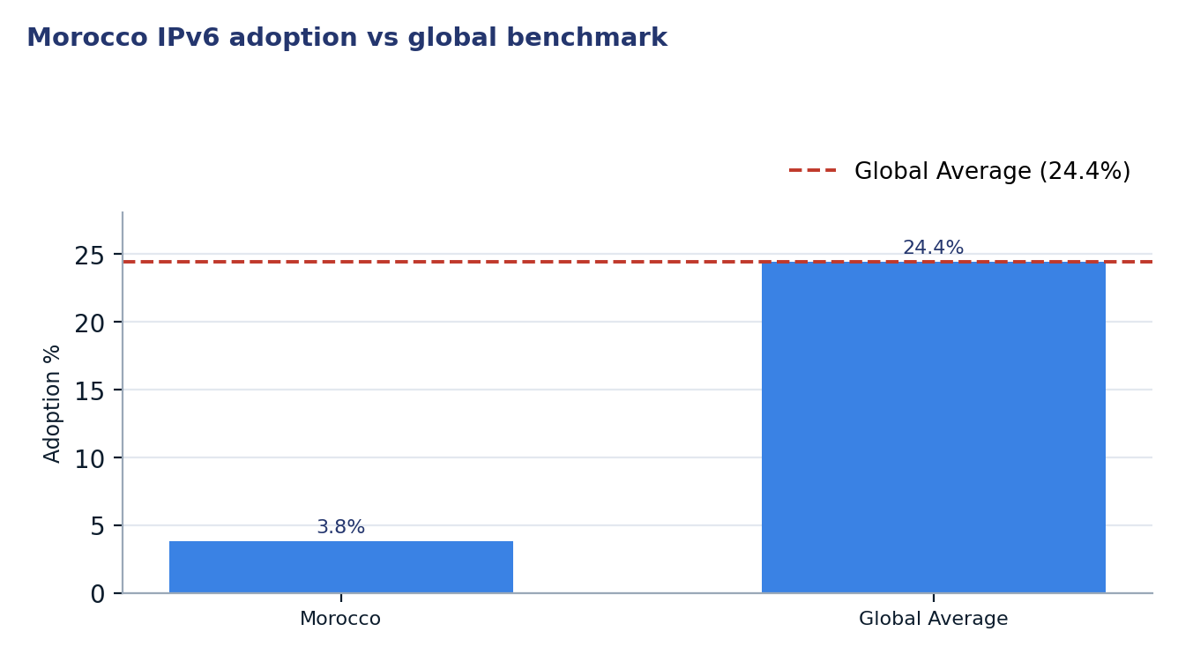
Figure 1. Morocco IPv6 adoption vs global benchmark
Two readings matter for policy. First, the 100% upstream reachability indicates that there are no external technical barriers to IPv6; the bottleneck is entirely internal and likely related to Customer Premises Equipment (CPE) or internal network configurations. Second, the heavy market concentration means that policy interventions targeting just two Autonomous Systems (IAM and MEDITELECOM) would resolve over 90% of the national adoption deficit.

2. Where Morocco is improving

2.1 Incremental ccTLD modernization
The .ma ccTLD ecosystem is showing signs of modernization, particularly in the DNS layer. Currently, 39.9% of sampled .ma domains resolve to IPv6-capable infrastructure, an increase of 2.8 percentage points since mid-2026. This growth indicates that hosting providers and registrars are increasingly enabling dual-stack configurations, even if the underlying end-user ISPs have not yet enabled the protocol for subscribers.
Date | Domains Sampled | IPv6-Enabled | Readiness %
2026-06-26 | 5000 | 1858 | 37.2%
2026-11-04 | 5000 | 1997 | 39.9%

2.2 Targeted security compliance among mid-tier providers
While national RPKI coverage is low, select providers have achieved full compliance. MEDITELECOM (AS36925) and CNRST (AS30983) maintain 100% RPKI coverage for their IPv6 prefixes. This demonstrates that the local technical community possesses the necessary expertise to implement routing security; the challenge is scaling these best practices to the dominant provider, IAM, which currently hosts 78 prefixes with 0% coverage.
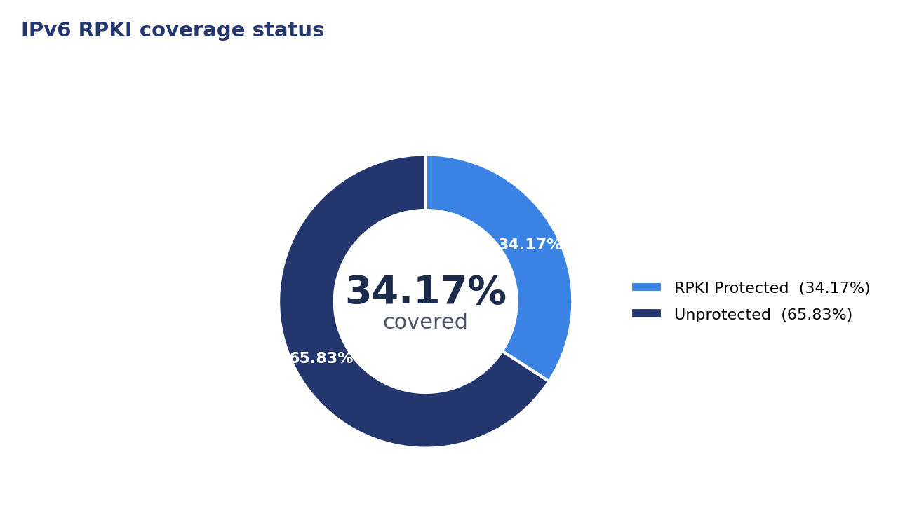
Figure 2. IPv6 RPKI coverage status

3. Where Morocco could improve
The current state of IPv6 in Morocco is undermined by three primary bottlenecks: extreme ISP inertia, absent local interconnection support, and a lack of DNS glue record modernization.

3.1 High-impact ISP bottlenecks
The national adoption rate is severely suppressed by two major operators. Office National des Postes et Telecommunications (IAM) holds a 62.7% market share but has only achieved 4.0% adoption. MEDITELECOM, with 33.1% market share, sits at 3.6% adoption. Both networks have had IPv6 allocations for over a decade, indicating that the delay is not due to lack of resources but rather operational prioritization.
ASN | ISP Name | Market Share | IPv6 Age (Yrs) | Proj. National Impact
AS36903 | Maroc Telecom (IAM) | 62.7% | 11.6 | +60.2 pp
AS36925 | MEDITELECOM | 33.1% | 14.3 | +31.9 pp
AS6713 | Maroc Telecom (IAM-AS6713) | 2.9% | 18.8 | +2.8 pp
AS36884 | Wana Corporate | 1.1% | 13.3 | +1.0 pp

3.2 Infrastructure and interconnection gaps
Domestic Internet Exchange Points (IXPs) are not currently facilitating IPv6 traffic exchange. Neither CAS-IX nor FEZIX provides an IPv6 LAN for peering. While some members at CAS-IX are IPv6-capable, the lack of a native IPv6 fabric at the exchange forces domestic traffic to either remain on IPv4 or trombone through international transit points, increasing latency and costs.
IXP Name | IPv6 LAN Status | Total Members | IPv6 Members | IPv6 %
CAS-IX | No | 3 | 3 | 100.0%
FEZIX | No | 3 | 0 | 0.0%

3.3 Web services and DNS health
Reachability for popular domestic websites remains at 0%, meaning no major Moroccan commercial site is natively accessible over IPv6. Furthermore, 0% of glue-style nameservers for the .ma TLD are IPv6-capable. This creates a circular dependency where IPv6-only users (globally) may struggle to resolve Moroccan domains if their DNS resolvers cannot reach .ma nameservers over IPv6.
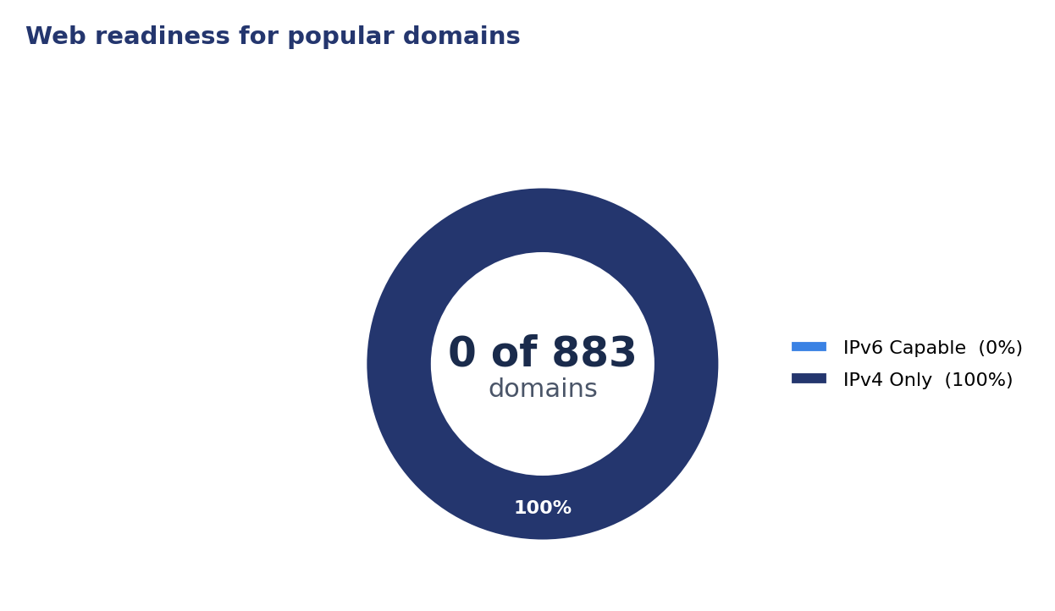
Figure 3. Web readiness for popular domains

4. A staged plan to improve resilience
The following plan prioritizes low-cost configuration changes and administrative mandates to break the current state of inertia, followed by long-term structural hardware upgrades.
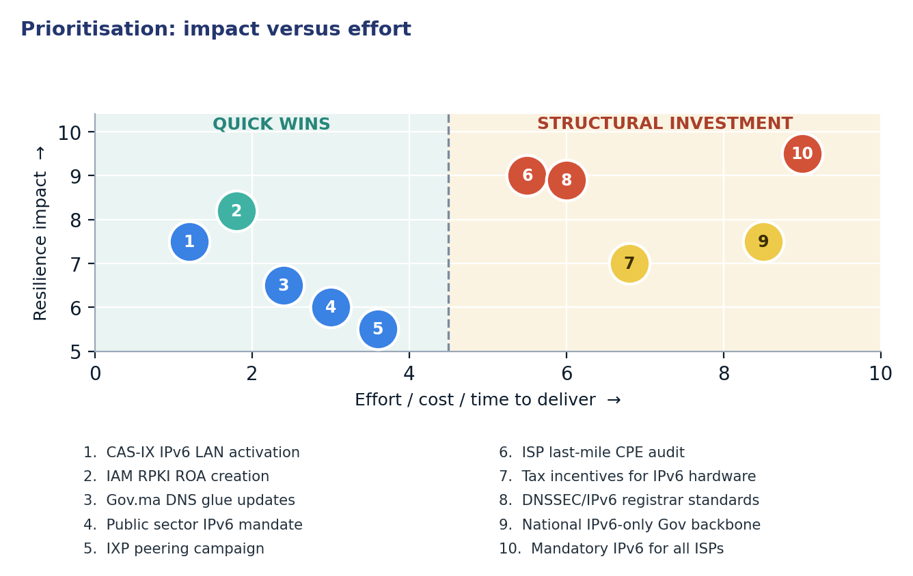
Figure 4. Prioritisation: impact versus effort

4.1 Short term (0–12 months)
Action | Description | Owner | Indicator moved
1. CAS-IX IPv6 LAN activation | Configure IPv6 peering LAN and assign addresses to all 3 existing members. | IXP Operators | IXP IPv6 Readiness 0% → 50%
2. IAM RPKI ROA creation | Generate RPKI ROAs for the 78 unprotected IPv6 prefixes in AS36903. | Maroc Telecom | RPKI Coverage 34.1% → >80%
3. Gov.ma DNS glue updates | Coordinate with ANRT to add AAAA records for all .gov.ma authoritative nameservers. | ANRT / Registry | Glue IPv6 Readiness 0% → 25%
4. Public sector IPv6 mandate | Require all government-hosted services to enable dual-stack connectivity. | Digital Development Agency | Gov Readiness 20.6% → 50%
5. IXP peering campaign | Technical workshop to enable FEZIX members for IPv6 peering. | ANRT / IXP Members | FEZIX IPv6 Members 0 → 3

4.2 Medium term (1–3 years)
Action | Description | Owner | Indicator moved
6. ISP last-mile CPE audit | Formal review of deployed CPEs at IAM and Meditelecom to identify firmware barriers. | ANRT | Underserved Market 99.9% → <50%
7. Tax incentives for IPv6 hardware | Reduction in import duties for network equipment that passes IPv6-ready certification. | Ministry of Finance | User Adoption 3.8% → >15%
8. DNSSEC/IPv6 registrar standards | Integrate IPv6 support requirements into the registrar accreditation for .ma. | ANRT | ccTLD AAAA Readiness 39.9% → 60%

4.3 Long term (3–7 years)
Action | Description | Outcome
9. National IPv6-only Gov backbone | Transition public sector internal networks to IPv6-only with NAT64 for legacy access. | Complete removal of IPv4 costs for state infrastructure.
10. Mandatory IPv6 for all ISPs | Regulation requiring 90% IPv6 subscriber adoption as a condition for license renewal. | National adoption parity with global leaders (>60%).

5. Quick wins
The following five interventions require configuration or administrative coordination rather than significant capital expenditure.
# | Quick win | Why it is quick | Effort | Expected effect
1 | CAS-IX IPv6 LAN activation | Software configuration on existing exchange switches. | Days of operator work | IXP IPv6 Readiness 0% → 50%
2 | IAM RPKI ROA creation | Administrative action via the AFRINIC/RIR portal. | Hours per network | Raise RPKI coverage to >80%
3 | Gov.ma DNS glue updates | Database update at the .ma registry level. | 1–2 weeks of registry coordination | Shift Glue IPv6 Readiness 0% → 25%
4 | Public sector IPv6 mandate | Executive order leveraging existing hosting contracts. | Administrative decree | Raise Gov readiness to 50%
5 | IXP peering campaign | Direct outreach to existing 6 IXP members. | 2–4 weeks of IXP outreach | 100% IXP member readiness (FEZIX IPv6 Members 0 → 3)

6. Policy gaps and loopholes

6.1 Where policy is absent or unenforced
Gap | Consequence | Remedy
Absence of CPE standards | ISPs continue importing IPv4-only or locked hardware. | Set minimum IPv6 certification for imported routers.
No IXP funding for IPv6 | Local exchanges remain legacy-only, increasing transit costs. | Subsidy for IXP IPv6-only peering fabrics.
Stagnant government readiness | Public sector fails to lead by example. | Mandatory IPv6 in all digital government tenders.
Lack of RPKI enforcement | High risk of BGP hijacking for IPv6 prefixes. | ANRT requirement for ROAs on all critical prefixes.

6.2 Loopholes to avoid creating
- Allowing "carrier-grade NAT" (CGNAT) investment to be used as a justification for delaying IPv6 deployment.
- Permitting ISPs to claim IPv6 readiness based solely on core-network BGP announcements without last-mile user enablement.
- Exempting small or regional ISPs from IPv6 mandates, which creates a multi-speed digital economy.
- Ignoring the DNS layer (Glue records) while focusing only on traffic, which leaves infrastructure brittle.

7. Measuring progress
Indicator | Baseline | 12-month target | Source
National IPv6 Adoption | 3.80% | 8.00% | ISOC Pulse / APNIC
RPKI IPv6 Coverage | 34.17% | 80.00% | RIPEstat / NIST
IXP IPv6 LANs | 0 of 2 | 1 of 2 | PeeringDB
.ma Glue IPv6 Readiness | 0.00% | 25.00% | IYP Graph / ccTLD Scan
Popular Domain Readiness | 0.00% | 10.00% | ISOC Pulse / IYP

Conclusion
Morocco faces a critical disconnect between its core network capabilities and operational reality. While the country's ISPs have successfully secured IPv6 transit and maintained active upstream reachability, the failure to transition the last mile and secure the routing layer with RPKI has resulted in one of the lowest adoption rates in the region. The concentration of the market within two primary operators presents a unique opportunity: targeted regulatory pressure on these entities could single-handedly elevate Morocco to a regional leader.
The path forward requires sequencing cheap configuration wins, such as enabling RPKI and updating DNS glue records, before embarking on capital-heavy projects. By mandating IPv6 in public sector procurement and auditing ISP CPE stocks, the regulator can build the necessary momentum to ensure that Morocco's digital infrastructure is resilient, secure, and ready for the global transition away from legacy IPv4.

Data sources and notes
This report integrates metrics from the Internet Society Pulse platform, the Internet Yellow Pages (IYP) Neo4j graph database, and RIR telemetry.
- ISOC Pulse — Country Report for Morocco: https://pulse.internetsociety.org/en/reports/ma/
- ISOC Pulse — Internet Resilience Index for Morocco: https://pulse.internetsociety.org/en/resilience/ma/
- RIPEstat — Country ASNs & Routing Status for MA: https://stat.ripe.net/MA
- PeeringDB — IXP & Facility Directory for MA: https://www.peeringdb.com/advanced_search?country=MA
- RIPE Atlas — Active Probes & Anchors in MA: https://atlas.ripe.net/probes/?country=MA
- Packet Clearing House (PCH) — IXP Directory: https://www.pch.net/ixp/dir

Measurement caveats. All metrics reflect the state of the network as of November 2026. Adoption percentages are derived from sample-based telemetry and may vary slightly between measurement platforms. Market share is estimated based on population proxies and ASN cone size.

