November 2026

Internet Resilience in Somalia
  - IPv6 diagnostics report and action plan
ISOC Pulse

DO NOT PUBLISH – INTERNAL DOCUMENT

Table of contents
Executive summary 2
Key numbers at a glance 2
1. Where Somalia stands 3
2. Where Somalia is improving 4
2.1 Routing security and prefix protection 4
2.2 DNS Infrastructure and ccTLD Readiness 4
3. Where Somalia could improve 5
3.1 High-impact ISP bottlenecks 5
3.2 Administrative "Ghost" networks 5
4. A staged plan to improve resilience 6
4.1 Short term (0–12 months) 6
4.2 Medium term (1–3 years) 6
4.3 Long term (3–7 years) 7
5. Quick wins 8
6. Policy gaps and loopholes 9
6.1 Where policy is absent or unenforced 9
6.2 Loopholes to avoid creating 9
7. Measuring progress 10
Conclusion 10
Data sources and notes 11

How to interpret the numbers in this report?
The values presented in this document are the Internet Resilience Index, normalized to 1–100. These values should be interpreted as a score rather than an absolute value. In some cases, the raw absolute values are presented to provide additional context.

Executive summary
Somalia currently faces a profound digital development paradox. While the country's foundational routing security is exceptionally high, with 100.0% RPKI coverage for its existing IPv6 prefixes, the actual deployment of IPv6 to end-users remains effectively stagnant at 0.5%. This puts Somalia in the bottom tier of global connectivity (ranked #216 of 243 countries), trailing the global average of 24.4% by a significant margin. The national ecosystem is characterized by high capability in core administrative configurations but a near-total absence of operational execution within the last-mile infrastructure of the country’s dominant telecommunications providers.
The technical landscape is defined by extreme market concentration where two "Bottleneck" providers—Hormuud Telecom (42.9% market share) and Telesom (18.4% market share)—hold the keys to national modernization. Neither provider has achieved meaningful IPv6 adoption, despite Telesom maintaining 54 prefixes in the global routing table. Furthermore, 11 of the 15 assessed ISPs (covering 36.2% of the market) are classified as "Ghost" networks, possessing no IPv6 allocations whatsoever. While the public sector shows promising signs of readiness with a 75% IPv6-capability rate among government domains, the broader commercial web ecosystem is virtually invisible on the modern internet, with 0% of popular domestic domains resolving over IPv6. Addressing these configuration and hardware bottlenecks at the top-tier ISP level represents the single most efficient path to internet resilience in Somalia.

Key numbers at a glance
Indicator | Somalia | Benchmark | Reading
National IPv6 Adoption | 0.5% | 24.4% (Global) | Critical adoption lag
RPKI IPv6 Coverage | 100.0% | 100% (Target) | Global best-practice security
Underserved Market Share | 100.0% | 0% (Ideal) | Universal deployment gap
Tier-1 ISP IPv6 Readiness | 0 of 5 | 5 of 5 (Target) | Top-tier market bottleneck
Web Readiness (Popular Domains) | 0.0% | 100% (Target) | Non-existent IPv6 presence
Government IPv6 Readiness | 75.0% | 100% (Target) | Strong public sector lead
ccTLD (.so) DNS Readiness | 51.1% | >50% (Benchmark) | Moderate registry health
IXP IPv6 LAN Capability | 100.0% | 100% (Target) | Foundation ready, peers missing
ISP IPv6 Upstream Reachability | 100.0% | 100% (Target) | Connectivity available

1. Where Somalia stands
In comparison to its regional and global peers, Somalia is currently underperforming in the transition to modern internet protocols. With 0.5% adoption, Somalia sits at the same level as Cambodia (0.48%) and Lebanon (0.48%), and slightly behind neighbors like Tanzania (0.55%). The gap between Somalia and the global average (24.4%) is a substantial 23.9 percentage points, reflecting a market that has not yet prioritized the migration away from legacy IPv4 address space. Despite this, the underlying infrastructure is not the primary barrier; 100% of assessed ISPs have upstream connectivity to IPv6-capable networks, and the national Internet Exchange Point (SoIXP) is fully IPv6-enabled on its LAN.
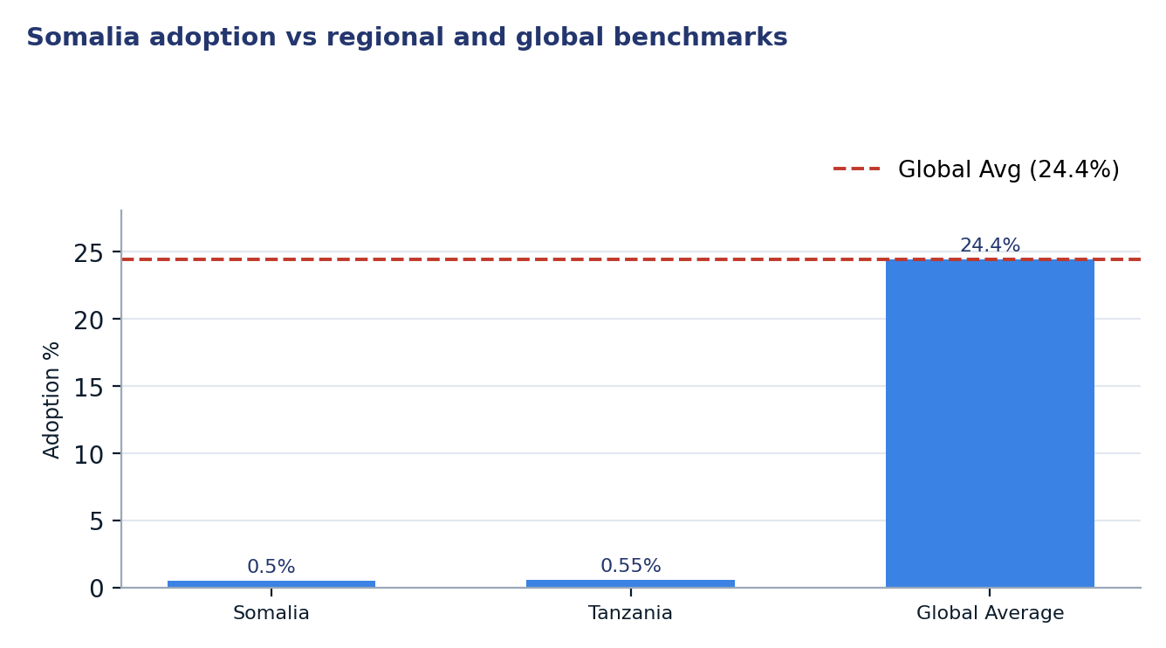
Figure 1. Somalia adoption vs regional and global benchmarks
Two readings matter for policy. First, the 100% RPKI coverage indicates that when Somali operators do deploy IPv6, they do so with a high degree of routing security, which is a rare and valuable asset. Second, the "Ghost" status of 36.2% of the market suggests that a lack of RIPE NCC membership or administrative awareness is preventing over a third of the market from even beginning the transition process.

2. Where Somalia is improving

2.1 Routing security and prefix protection
Somalia is a global leader in IPv6 routing security relative to its size. Every IPv6 prefix currently announced by Somali operators is covered by a Route Origin Authorization (ROA), ensuring that 100% of the country’s IPv6 footprint is protected against BGP hijacking. This provides a secure foundation for future growth, meaning that as adoption increases, the traffic will be inherently more secure than in many more "advanced" neighboring markets.
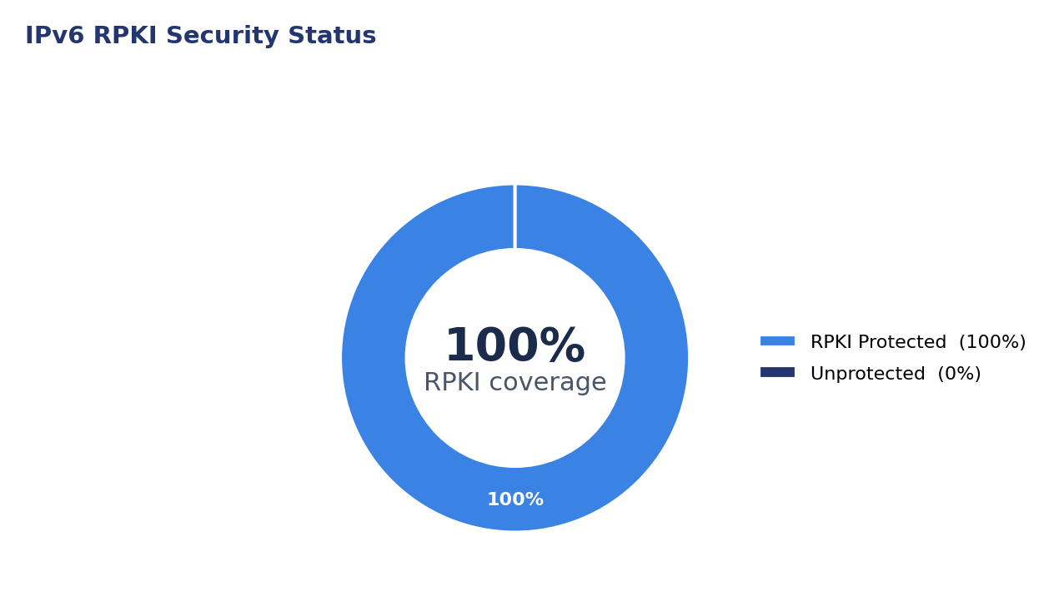
Figure 2. IPv6 RPKI Security Status
ISP | IPv6 Prefixes | RPKI Coverage | Security Status
Telesom | 18 | 100.00% | Fully Secured
SomCable | 1 | 100.00% | Fully Secured

2.2 DNS Infrastructure and ccTLD Readiness
The .so country-code Top Level Domain (ccTLD) shows significant signs of modernization. Sampled data indicates that 51.1% of .so domains are IPv6-ready, which is actually slightly higher than the .com readiness within the same market (50.3%). Furthermore, 80.9% of the authoritative nameservers supporting the .so ecosystem are reachable via IPv6, and 66.7% of glue records are already IPv6-capable. This suggests that the registry and name-resolution layers are far ahead of the consumer access layer.
Infrastructure Component | Assessed Count | IPv6 Capable | Readiness Rate
.so Sampled Domains | 732 | 374 | 51.09%
Authoritative Nameservers | 1009 | 816 | 80.87%
Glue Record Nameservers | 12 | 8 | 66.67%
Government Domains (.gov.so) | 4 | 3 | 75.00%

3. Where Somalia could improve
The following weaknesses are ordered by their impact on national resilience: the total absence of adoption by market leaders constitutes a 61.3% resilience gap, followed by a lack of RIR allocations for smaller ISPs and the failure of domestic networks to peer via IPv6.

3.1 High-impact ISP bottlenecks
The most critical bottleneck in Somalia is the lack of deployment by the two largest operators. Hormuud Telecom and Telesom together control over 61% of the market. Hormuud, in particular, has 0.0% adoption despite its massive 42.9% market share. Targeted intervention with these two providers would effectively solve the national adoption crisis.
ASN | Operator | Market Share | Adoption | Projected Impact
AS37371 | Hormuud Telecom | 42.9% | 0.0% | +42.9 pp
AS37473 | Telesom | 18.4% | 0.4% | +18.3 pp
AS37563 | Somtel International | 11.5% | 0.0% | +11.5 pp
AS328250 | Golis Telecom | 11.3% | 0.0% | +11.3 pp

3.2 Administrative "Ghost" networks
A secondary challenge is the high number of "Ghost" networks—ISPs that are active in the market but have zero IPv6 prefixes in the global routing table. This indicates a failure at the administrative level to secure IP resources from RIPE NCC or AFRINIC. Currently, 11 ISPs fall into this category, representing over 36% of Somali internet users who have no path to IPv6 connectivity regardless of their hardware.
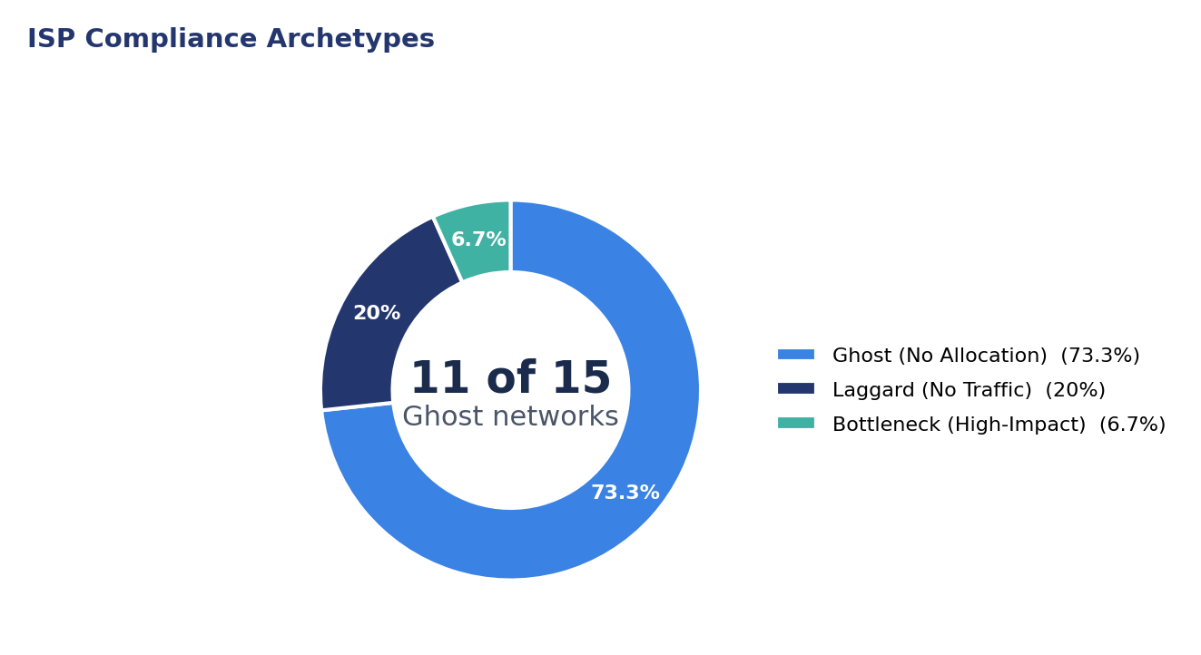
Figure 3. ISP Compliance Archetypes

4. A staged plan to improve resilience
The following plan prioritizes zero-capital administrative fixes in the short term to build momentum, followed by targeted technical coordination and long-term hardware standards to ensure sustainability.
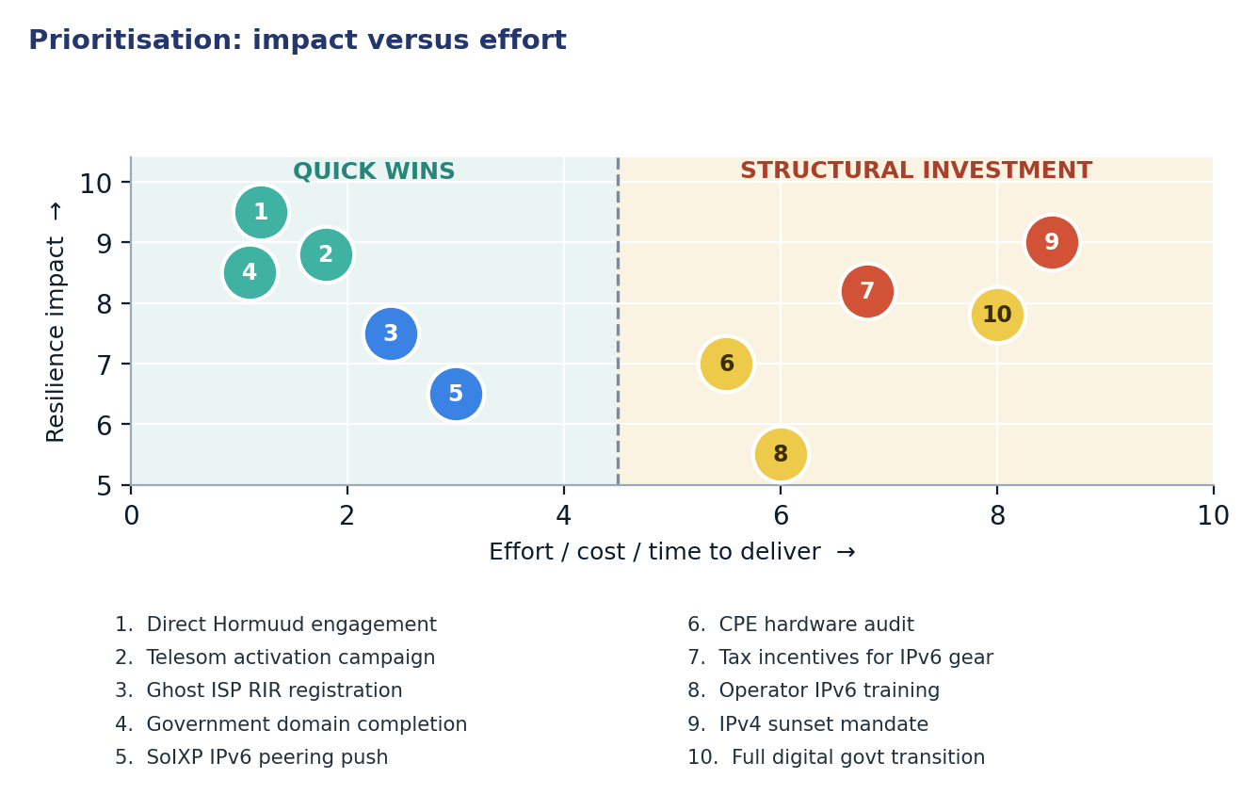
Figure 4. Prioritisation: impact versus effort

4.1 Short term (0–12 months)
Action | Description | Owner | Indicator moved
1. Direct Hormuud engagement | Bilateral meetings to address 0% adoption status. | Regulator / Ministry | National Adoption 0.5% → >40%
2. Telesom activation campaign | Technical support to move from 0.4% to full adoption. | Operator / ISOC | National Adoption 0.5% → >18%
3. Ghost ISP RIR registration | Workshop to help 11 ISPs obtain IPv6 allocations. | Regulator / RIPE NCC | Ghost ISP Count 11 → <3
4. Government domain completion | Ensure the remaining 25% of .gov.so sites are AAAA-ready. | Ministry of Tech | Gov Readiness 75% → 100%
5. SoIXP IPv6 peering push | Onboard existing members to the IPv6 LAN. | SoIXP Management | IPv6 Peering Members 0 → >5

4.2 Medium term (1–3 years)
Action | Description | Owner | Indicator moved
6. CPE hardware audit | Identify and replace non-compliant subscriber routers. | ISPs | Laggard Market Share 2.4% → <0.5%
7. Tax incentives for IPv6 gear | Exempt IPv6-compliant networking equipment from import duties. | Ministry of Finance | Web Readiness 0% → >20%
8. Operator IPv6 training | Hands-on deployment labs for Tier-2 and Tier-3 providers. | NOG / ISOC | ISP Compliance Scorecard

4.3 Long term (3–7 years)
Action | Description | Outcome
9. IPv4 sunset mandate | Regulated timeline for phasing out IPv4-only public services. | Fully dual-stacked national digital economy.
10. Full digital govt transition | All citizen-facing digital services default to IPv6-only. | Global leadership in modern internet standards.

5. Quick wins
These five interventions require configuration or administrative coordination rather than capital, and can be implemented through direct policy engagement.
# | Quick win | Why it is quick | Effort | Expected effect
1 | Direct Hormuud engagement | Leverages existing large-scale infrastructure. | 2–4 weeks of executive outreach | Raise national adoption from 0.5% to >40%
2 | Telesom activation campaign | Prefixes are already allocated and partially active. | Days of operator work | Raise national adoption from 0.5% to >18%
3 | Ghost ISP RIR registration | Administrative process for "Ghost" ISPs. | 1–2 weeks of registry coordination | Eliminate "Ghost" status for 11 providers (Ghost ISP Count 11 → <3)
4 | Government domain completion | Simple AAAA record addition for existing sites. | Hours per network | Achieve 100% Government IPv6 readiness (Gov Readiness 75% → 100%)
5 | SoIXP IPv6 peering push | Enabling IPv6 on existing IXP ports. | One maintenance window per member | Move IPv6 peering from 0 to >5 members

6. Policy gaps and loopholes

6.1 Where policy is absent or unenforced
Gap | Consequence | Remedy
Lack of CPE Import Standards | Market flooded with legacy IPv4-only hardware. | Mandate IPv6 support for all new telecom imports.
No IPv6 Govt Procurement Rule | State spends money on legacy technology. | Require IPv6 compliance in all public IT tenders.
Unmonitored RIR status | 36% of market lacks basic protocol resources. | Link license renewals to active RIR membership.
Non-peering at SoIXP | Domestic traffic takes high-latency international routes. | Incentivize local IPv6 peering via licensing perks.

6.2 Loopholes to avoid creating
- Carrier-Grade NAT (CGN) complacency: Do not allow ISPs to rely indefinitely on CGN as a substitute for IPv6; it degrades performance and increases security costs.
- Proprietary transition silos: Discourage ISPs from using non-standard transition mechanisms that fragment the local internet.
- Static licensing: Avoid licensing frameworks that do not require periodic updates to technical standards, which can leave Somalia stuck on legacy protocols.
- Exempting small ISPs: While large ISPs are bottlenecks, exempting "Ghost" ISPs from RIR requirements prevents them from ever scaling securely.

7. Measuring progress
Every action in this plan maps to a publicly verifiable metric that should be monitored quarterly to ensure the transition remains on track.
Indicator | Baseline | 12-month target | Source
National IPv6 Adoption | 0.5% | 60.0% | ISOC Pulse
Ghost ISP Market Share | 36.2% | <5.0% | RIPEstat / IYP
Bottleneck ISP Compliance | 0 of 2 | 2 of 2 | ISOC Scorecard
Government IPv6 Readiness | 75.0% | 100.0% | IYP Graph
IXP Peering Members | 0 | 5 | PeeringDB

Conclusion
Somalia is currently in a state of operational readiness that is not yet matched by actual traffic delivery. The country has successfully implemented high-level security (100% RPKI) and basic exchange infrastructure (IPv6-ready IXP LAN), but has failed to bridge the "last mile" to the user. The extreme concentration of the market means that Somalia does not require a thousand small changes; it requires two significant shifts by its leading operators, Hormuud and Telesom.
By sequencing these cheap administrative and configuration wins before moving to capital-heavy hardware upgrades, Somalia can rapidly vault from the bottom of global rankings to a position of regional leadership. The readiness of the .so ccTLD and the public sector demonstrates that the technical talent exists domestically; what is now required is the regulatory momentum to ensure the commercial sector follows this lead.

Data sources and notes
This report was generated using data from the ISOC Pulse platform and the Internet Yellow Pages (IYP) Neo4j database, incorporating real-time routing and adoption telemetry.
- ISOC Pulse — Country Report for Somalia: https://pulse.internetsociety.org/en/reports/so/
- ISOC Pulse — Internet Resilience Index for Somalia: https://pulse.internetsociety.org/en/resilience/so/
- RIPEstat — Country ASNs & Routing Status for SO: https://stat.ripe.net/SO
- PeeringDB — IXP & Facility Directory for SO: https://www.peeringdb.com/advanced_search?country=SO
- RIPE Atlas — Active Probes & Anchors in SO: https://atlas.ripe.net/probes/?country=SO
- Packet Clearing House (PCH) — IXP Directory: https://www.pch.net/ixp/dir

Measurement caveats. Adoption estimates are derived from sample-based telemetry which may vary by provider based on local caching and DNS behavior. Market share data is based on population proxies and may not reflect real-time subscriber shifts.

