November 2026

Internet Resilience in Morocco
  - Peering diagnostics report and action plan
ISOC Pulse

DO NOT PUBLISH – INTERNAL DOCUMENT

Table of contents
Executive summary 2
Key numbers at a glance 2
1. Where Morocco stands 3
2. Where Morocco is improving 4
2.1 Operational status of regional exchange hubs 4
2.2 Automation and Route Server adoption 4
3. Where Morocco could improve 5
3.1 Extremely low domestic IXP penetration 5
3.2 Tier-1 CDN and content localization gap 5
4. A staged plan to improve resilience 6
4.1 Short term (0–12 months) 6
4.2 Medium term (1–3 years) 6
4.3 Long term (3–7 years) 7
5. Quick wins 8
6. Policy gaps and loopholes 9
6.1 Where policy is absent or unenforced 9
6.2 Loopholes to avoid creating 9
7. Measuring progress 10
Conclusion 10
Data sources and notes 11

How to interpret the numbers in this report?
The values presented in this document are the Internet Resilience Index, normalized to 1–100. These values should be interpreted as a score rather than an absolute value. In some cases, the raw absolute values are presented to provide additional context.

Executive summary
The peering ecosystem in Morocco presents a structural paradox where foundational infrastructure exists but remains significantly underutilized by domestic network operators. With 30 actively routed autonomous systems (ASNs) and five established data center facilities, the technical prerequisites for a robust interconnection fabric are present. However, the operational reality is characterized by a low domestic IXP penetration rate of 13.33% and a total absence of Tier-1 Content Delivery Network (CDN) presence at local exchange points. This lack of local peering forces a substantial portion of domestic traffic to be exchanged internationally, resulting in a low traffic localization ratio of 13.91%.
Technical performance metrics highlight the consequences of this interconnection deficit. The median eyeball edge latency stands at 52.21 ms, which is significantly higher than the sub-20 ms threshold typically observed in markets with localized content and mature peering. While Morocco has successfully established two operational Internet Exchange Points (IXPs)—CAS-IX in Casablanca and FEZIX in Fez—the participation is limited to just four domestic ASNs. Furthermore, none of the nine global Tier-1 CDNs have localized their infrastructure within domestic facilities or at the IXPs, creating a heavy reliance on high-latency international transit for content delivery.

Key numbers at a glance
Indicator | Morocco | Benchmark | Reading
Active Routed ASNs | 30 | — | Moderate network diversity
Domestic IXP Penetration Rate | 13.33% | >50% target | Suboptimal local peering
Tier-1 CDNs at Domestic IXPs | 0 of 9 | 9 of 9 global | Total lack of edge localization
Tier-1 CDNs in Domestic Facilities | 0 of 9 | 9 of 9 global | Insufficient infrastructure attraction
Traffic Localization Ratio | 13.91% | >50% target | High international dependency
Route Server Utilization Rate | 50.00% | 100% target | Incomplete peering automation
Median Eyeball Edge Latency | 52.21 ms | <20 ms target | Poor user experience for content
Geographic Concentration (HHI) | 0.5000 | <0.15 diversified | Highly centralized in two hubs

1. Where Morocco stands
Morocco’s peering landscape is currently in a nascent stage compared to regional peers and global best practices. While the country has successfully moved beyond a single-monopoly gateway by authorizing 30 routed ASNs, the interconnection between these networks is not happening domestically. The 13.91% traffic localization ratio indicates that nearly 86% of traffic is likely leaving the country to be exchanged at European hubs like Marseille, Madrid, or Frankfurt, even when the destination is a domestic user. This "international tromboning" is the primary driver behind the 52.21 ms median latency.
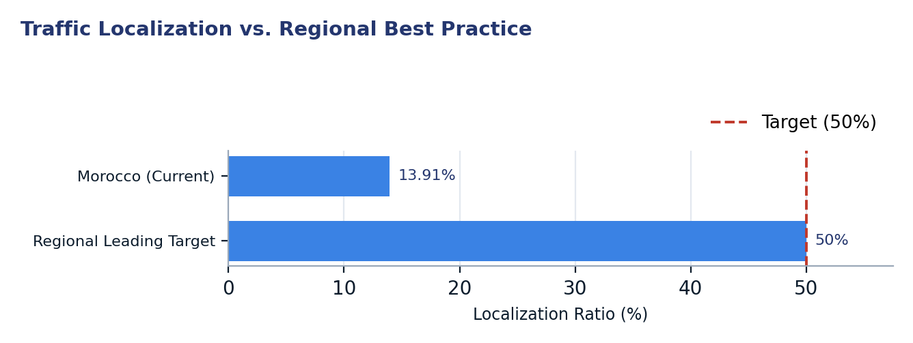
Figure 1. Traffic Localization vs. Regional Best Practice
Two readings matter for policy. First, the existence of five peering facilities suggests that the bottleneck is not physical space or power, but rather the commercial and regulatory frameworks that govern interconnection. Second, the total absence of all nine Tier-1 CDNs indicates that the "eyeball" networks in Morocco have not yet achieved the peering density or price transparency required to attract global content caches, which would otherwise provide immediate latency relief for citizens.

2. Where Morocco is improving

2.1 Operational status of regional exchange hubs
Unlike many emerging markets that struggle to launch a single IXP, Morocco has successfully operationalized two exchange points in geographically distinct cities. This provides a baseline for disaster recovery and regional resilience. Both CAS-IX and FEZIX are currently reported as operational with connected networks, ensuring that the technical platform for peering is already established without requiring new capital expenditure for basic switching infrastructure.
City | IXP Name | Status | Connected Networks | Peering Facilities
Casablanca | CAS-IX | Operational | 3 | 1
Fez | FEZIX | Operational | 3 | 1

2.2 Automation and Route Server adoption
Among the small cohort of networks that do peer at domestic IXPs, there is a 50% utilization rate of Route Servers. This indicates that half of the peering participants are utilizing automated BGP session management rather than relying solely on bilateral agreements. This technical readiness is a positive sign for scalability; as more ASNs join the exchange, the existing Route Server infrastructure will allow them to interconnect with multiple peers through a single session, reducing the administrative burden on network engineers.
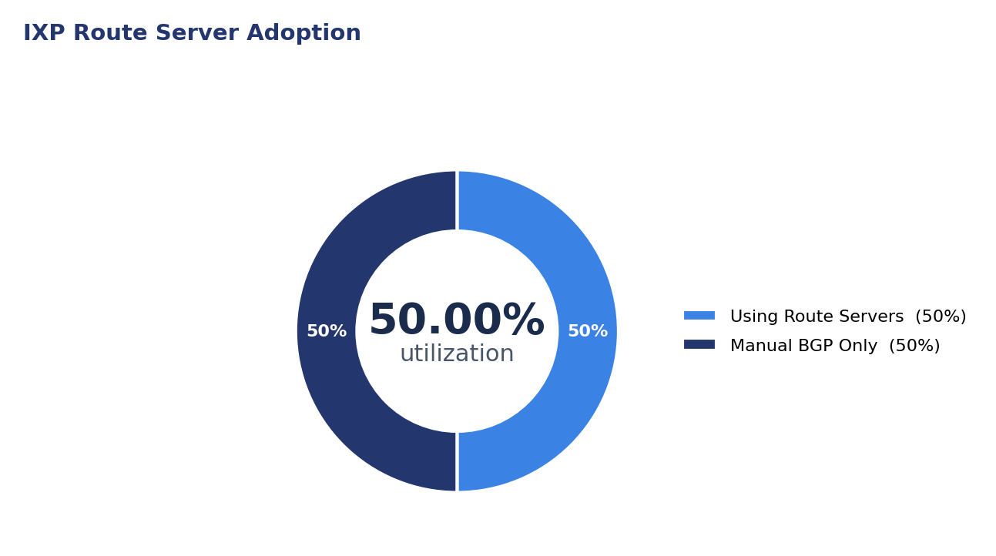
Figure 2. IXP Route Server Adoption

3. Where Morocco could improve
The primary weaknesses in Morocco's peering ecosystem are ordered by their impact on resilience: first, the near-total lack of domestic ASN participation in local exchanges; second, the absence of localized global content; and third, the lack of telemetry reporting which obscures traffic visibility.

3.1 Extremely low domestic IXP penetration
With only 4 out of 30 active ASNs participating at local IXPs, the vast majority of Moroccan networks remain siloed. This means that an ISP in Casablanca likely sends traffic to a local government agency via an international transit provider rather than a local cross-connect. This increases costs for operators and degrades performance for end-users.
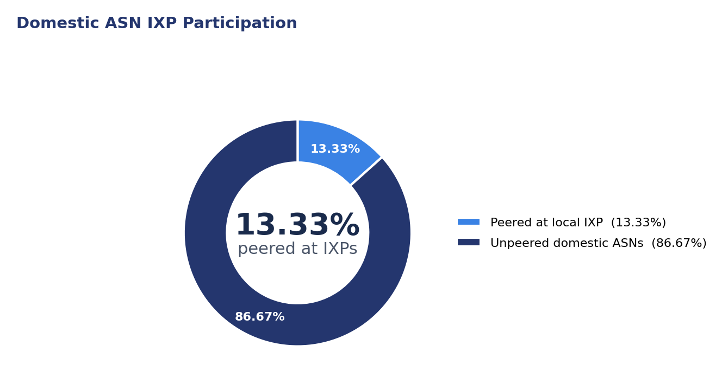
Figure 3. Domestic ASN IXP Participation

3.2 Tier-1 CDN and content localization gap
Morocco currently hosts 0 out of 9 major global CDNs at its IXPs or within its five data center facilities. This is the single largest contributor to high latency. In a mature peering ecosystem, at least 5-7 of these providers would be present locally to serve popular video, social media, and cloud content directly from Moroccan soil.
CDN Category | Provider Presence | IXP Peering | Facility Presence
Search/Video | Google (AS15169) | None | None
Social/Media | Meta (AS32934) | None | None
Cloud/Retail | Amazon (AS16509) | None | None
Edge/Security | Cloudflare (AS13335) | None | None
Software/OS | Microsoft (AS8075) | None | None

4. A staged plan to improve resilience
The following plan prioritizes low-cost configuration and coordination efforts to build momentum before moving toward larger structural and commercial shifts.
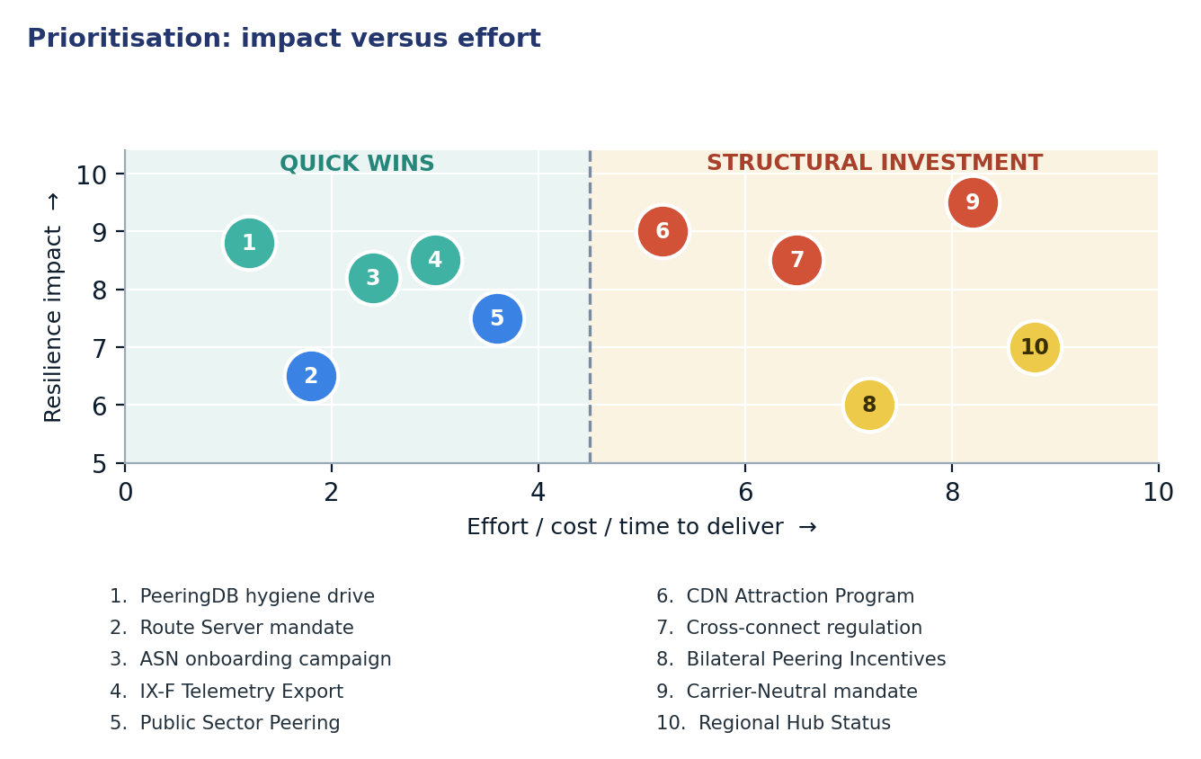
Figure 4. Prioritisation: impact versus effort

4.1 Short term (0–12 months)
Action | Description | Owner | Indicator moved
1. PeeringDB hygiene drive | Mandate all 30 active ASNs to update their PeeringDB profiles for visibility. | ANRT / Operators | PDB Visibility 0% → 100%
2. Route Server mandate | Configure Route Servers on both IXPs as the default for all new members. | IXP Managers | RS Utilization 50% → 100%
3. ASN onboarding campaign | Targeted outreach to the 26 unpeered ASNs to join CAS-IX or FEZIX. | IXP Managers | IXP Penetration 13% → >30%
4. IX-F Telemetry Export | Implement IX-F JSON schemas to report traffic data to Pulse/PCH. | IXP Managers | Reporting IXPs 0 → 2
5. Public Sector Peering | Require all government and educational (MARWAN) ASNs to peer at local IXPs. | Gov/Research Nets | Local Traffic Ratio 13% → >20%

4.2 Medium term (1–3 years)
Action | Description | Owner | Indicator moved
6. CDN Attraction Program | Offer free rack space/power for 12 months to first 3 Tier-1 CDNs (Akamai/Google). | DC Operators | CDN Presence 0/9 → 3/9
7. Cross-connect regulation | Limit fees for IXP cross-connects to prevent "virtual" barriers to entry. | ANRT (Regulator) | IXP Penetration 30% → >50%
8. Bilateral Peering Incentives | Reduce international transit tax for operators that peer >40% of traffic locally. | Ministry of Finance | Localization Ratio 13% → >40%

4.3 Long term (3–7 years)
Action | Description | Outcome
9. Carrier-Neutral mandate | Formalize "Carrier Neutrality" for all new Tier-III data center builds. | National Resilient Infrastructure
10. Regional Hub Status | Establish Morocco as a transit hub for West African sub-regions. | Reduced Regional Latency

5. Quick wins
These five interventions require configuration or administrative coordination rather than significant capital expenditure.
# | Quick win | Why it is quick | Effort | Expected effect
1 | PeeringDB hygiene drive | Requires only administrative time to fill in network data. | Hours per network | Improve global visibility for 30 ASNs (PDB Visibility 0% → 100%)
2 | Route Server mandate | Software configuration on existing IXP switches. | 1–2 weeks of config | Shift RS Utilization 50% → 100%
3 | ASN onboarding campaign | Email and webinar outreach to the 26 unpeered ASNs. | 2–4 weeks of outreach | Raise penetration from 13.33% to >30%
4 | IX-F Telemetry Export | Standard script installation on IXP management servers. | Days of technical work | Shift Reporting IXPs 0 → 2
5 | Public Sector Peering | Administrative directive for state-owned networks. | 1–2 months of policy | Immediate 5-7% boost in local traffic (Local Traffic Ratio 13% → >20%)

6. Policy gaps and loopholes

6.1 Where policy is absent or unenforced
Gap | Consequence | Remedy
No Peering Mandate | Dominant ISPs refuse to peer with smaller entrants locally. | Introduce "Peer-or-Pay" frameworks for dominant ASNs.
High Cross-Connect Fees | Physical connection costs exceed the value of peering. | Regulate IXP cross-connect pricing to cost-recovery levels.
Cloud Localization Barriers | Global CDNs avoid the market due to data residency uncertainty. | Clarify data protection laws for cached non-personal content.
Lack of Neutral Facilities | ISPs are forced to peer in competitor-owned data centers. | Incentivize truly carrier-neutral 3rd party facilities.

6.2 Loopholes to avoid creating
- Avoid mandatory data localized in transit: Forcing all traffic through a single government "clearinghouse" IXP will create a single point of failure and increase latency.
- Avoid high licensing fees for IXPs: Treating an IXP as a full telecommunications carrier with expensive license fees discourages non-profit community exchanges.
- Do not subsidize international transit: Lowering the cost of international bandwidth without incentivizing local peering will further entrench the dependency on European hubs.
- Prevent exclusive peering: Ensure that dominant operators cannot sign exclusive peering deals with CDNs that exclude smaller ISPs from accessing local caches.

7. Measuring progress
Every action in this report maps to a publicly verifiable metric that should be monitored quarterly.
Indicator | Baseline | 12-month target | Source
Domestic IXP Penetration Rate | 13.33% | 35.00% | PeeringDB / RIPEstat
Tier-1 CDN Presence | 0 of 9 | 2 of 9 | PeeringDB / Pulse
Traffic Localization Ratio | 13.91% | 25.00% | ISOC Pulse
Median Eyeball Edge Latency | 52.21 ms | <40.00 ms | RIPE Atlas
IXP Telemetry Reporting | 0 IXPs | 2 IXPs | PCH / IX-F

Conclusion
Morocco possesses a credible physical infrastructure with 30 active networks and five data centers, yet its interconnection maturity is lagging. The primary obstacle is not a lack of capacity, but a disconnect between network allocation and operational peering participation. By failing to peer locally, Moroccan operators are essentially paying international transit providers to carry traffic that could be exchanged for the price of a local cross-connect, while simultaneously subjecting citizens to latencies that are double the global best-practice target.
The path forward requires a transition from isolated network silos to a collaborative peering ecosystem. By executing the five identified quick wins—specifically onboarding the remaining 26 domestic ASNs and localizing at least two global CDNs—Morocco can significantly improve its Internet resilience and user experience. Sequencing these low-cost configuration and policy adjustments before pursuing capital-heavy infrastructure projects will build the regulatory and commercial momentum necessary to transform Morocco into a regional digital hub.

Data sources and notes
This report integrates real-time telemetry and registry data from the following platforms:
- ISOC Pulse — Country Report for Morocco: https://pulse.internetsociety.org/en/reports/ma/
- ISOC Pulse — Internet Resilience Index for Morocco: https://pulse.internetsociety.org/en/resilience/ma/
- RIPEstat — Country ASNs & Routing Status for MA: https://stat.ripe.net/MA
- PeeringDB — IXP & Facility Directory for MA: https://www.peeringdb.com/advanced_search?country=MA
- RIPE Atlas — Active Probes & Anchors in MA: https://atlas.ripe.net/probes/?country=MA
- Packet Clearing House (PCH) — IXP Directory: https://www.pch.net/ixp/dir

Measurement caveats. All metrics are based on snapshots as of November 2026. Latency figures are derived from a limited set of RIPE Atlas probes and may vary based on specific ISP routing policies. CDN presence is verified via PeeringDB and may not account for private, undisclosed peering agreements or on-net caches that are not publicly advertised.

