November 2026

Internet Resilience in Somalia
  - Peering diagnostics report and action plan
ISOC Pulse

DO NOT PUBLISH – INTERNAL DOCUMENT

Table of contents
Executive summary 2
Key numbers at a glance 2
1. Where Somalia stands 3
2. Where Somalia is improving 4
3. Where Somalia could improve 5
3.1 Low Domestic IXP Participation and Route Server Utilization 5
3.2 Absence of Tier-1 CDN Content Localization 5
3.3 Minimal Traffic Localization and High Latency 6
3.4 Concentrated IXP Infrastructure 6
4. A staged plan to improve resilience 7
4.1 Short term (0–12 months) 7
4.2 Medium term (1–3 years) 8
4.3 Long term (3–7 years) 8
5. Quick wins 9
6. Policy gaps and loopholes 10
6.1 Where policy is absent or unenforced 10
6.2 Loopholes to avoid creating 10
7. Measuring progress 11
Conclusion 11
Data sources and notes 12

How to interpret the numbers in this report?
The values presented in this document are the Internet Resilience Index, normalized to 1–100. These values should be interpreted as a score rather than an absolute value. In some cases, the raw absolute values are presented to provide additional context.

Executive summary
Somalia's Internet ecosystem demonstrates a foundational presence of autonomous systems (ASNs), with 19 of 24 allocated ASNs actively routed, representing a significant 79.17% active routing ratio. However, the country's peering and interconnection landscape exhibits severe underdevelopment, posing substantial barriers to local traffic exchange, content localization, and overall Internet resilience. The sole listed Internet Exchange Point (IXP), SoIXP in Mogadishu, is currently non-operational with zero connected networks and no route server utilization. This critical gap translates directly into a 0.00% domestic IXP penetration rate among active ASNs, indicating a complete absence of local peering. Despite the presence of two peering facilities, there is no in-country presence or peering activity from any of the nine global Tier-1 Content Delivery Networks (CDNs), further exacerbating the reliance on costly international transit for locally destined traffic.
The consequences of this underdeveloped peering infrastructure are evident in key performance indicators. Somalia's traffic localization ratio stands at a critically low 1.00%, confirming that the vast majority of domestic Internet traffic must traverse international links, incurring higher costs and increased latency. This inefficiency is reflected in a median eyeball edge latency of 85.57 ms, significantly higher than regional and global best practice targets. The high geographic concentration of the single IXP in Mogadishu (HHI 1.0000) also highlights a lack of infrastructure diversity, exposing the entire national Internet fabric to single points of failure. Addressing these deficiencies requires a concerted effort to operationalize the existing IXP, attract domestic network participation, and secure local content caching, beginning with low-effort configuration and administrative actions to build momentum for strategic, capital-intensive investments.

Key numbers at a glance
Indicator | Somalia | Benchmark | Reading
Active Routed ASNs | 19 of 24 | — | Established base
Active Routing Ratio | 79.17% | >80% target | Approaching optimal
Total Internet Exchange Points (IXPs) | 1 | Multiple active recommended | Effectively zero deployment
Operational IXPs (with members) | 0 of 1 | 100% of active IXPs | Non-operational
Domestic ASN IXP Penetration Rate | 0.00% | >50% target | Non-existent
Tier-1 CDNs at Domestic IXPs | 0 of 9 | 9 of 9 global | Completely absent
Tier-1 CDNs in Domestic Facilities | 0 of 9 | 9 of 9 global | Completely absent
Traffic Localization Ratio | 1.00% | >50% target | Critically low
Geographic Concentration Index (HHI) | 1.0000 | <0.15 diversified | Highly concentrated
Median Eyeball Edge Latency | 85.57 ms | <20 ms target | Significantly suboptimal

1. Where Somalia stands
Somalia's current standing in the peering ecosystem reveals a nascent but largely unutilized infrastructure. While 79.17% of allocated ASNs are actively routed, indicating a reasonable foundation of network operators, this capability is not translated into local interconnection. Compared to a regional average for active routing ratios, Somalia's figure is competitive; however, in terms of local peering infrastructure and content localization, the country falls significantly short of continental and global benchmarks. The complete absence of domestic ASNs peering at an IXP, a 0.00% domestic IXP penetration rate, stands in stark contrast to the ISOC best practice target of over 50% and even to emerging markets where 20-30% is often a baseline. The country's traffic localization ratio of 1.00% is also dramatically lower than the >50% target for efficient local traffic exchange, highlighting a pervasive reliance on international transit.
The median eyeball edge latency of 85.57 ms further underscores the sub-optimal state of local interconnection. This figure is considerably higher than the sub-20 ms target for efficient and responsive Internet access, suggesting that local users experience significant delays due to traffic hair-pinning or distant content sources. The total lack of Tier-1 CDN presence either at the single non-operational IXP or within local data center facilities means that popular content is served from outside the country, contributing directly to the high latency and low localization. The high geographic concentration index (HHI) of 1.0000, stemming from the single IXP being located in one city, also indicates a severe lack of redundancy and resilience in the national interconnection landscape.
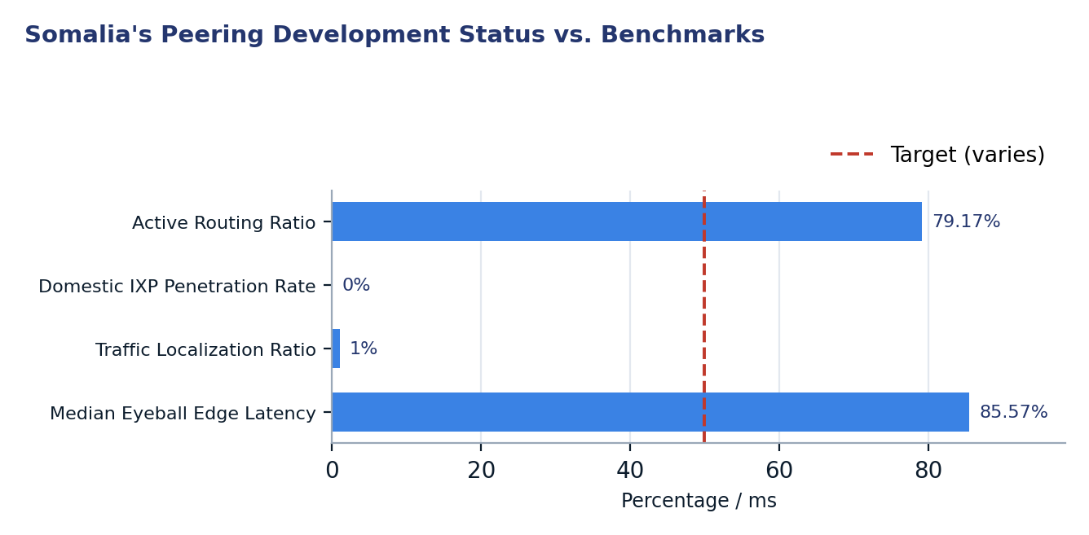
Figure 1. Somalia's Peering Development Status vs. Benchmarks
Two readings matter for policy. First, the 79.17% active routing ratio indicates that a substantial number of domestic networks are operational and therefore potential participants in a local peering ecosystem. This active base represents a critical resource that can be leveraged to activate the existing IXP. Second, the effectively non-existent domestic IXP penetration rate (0.00%) and the alarmingly low traffic localization ratio (1.00%) reveal the most pressing policy challenge: enabling local exchange of traffic that is currently routed internationally. Overcoming this will require a combination of technical enablement, community building, and policy incentives to make local peering the preferred and most efficient option for domestic operators.

2. Where Somalia is improving
While Somalia's peering ecosystem faces significant challenges, foundational elements are present that can support future growth and improvement. The current active routing ratio for domestic ASNs stands at 79.17%, meaning that a substantial majority of the country's allocated autonomous systems are actively participating in the global routing table. This high ratio indicates a healthy base of operational networks that can be targeted for local peering initiatives, suggesting a relatively stable and engaged community of Internet service providers and content hosts.
This engagement contrasts sharply with countries where a significant portion of allocated ASNs remain unrouted, signifying a more fundamental lack of network development. Leveraging this established base of active ASNs will be crucial for populating and operationalizing local interconnection points. The presence of two distinct peering facilities further provides physical locations suitable for future CDN deployment and for the expansion of local peering infrastructure, even if these facilities currently host no Tier-1 CDNs.
Metric | Value
Total Allocated ASNs | 24
Unrouted / Dormant ASNs | 5
Total Peering Facilities | 2

3. Where Somalia could improve
Somalia's Internet resilience is significantly hampered by several core bottlenecks, ordering them by increasing cost to resilience: the complete lack of domestic IXP participation, the absence of local content caching, the minimal localization of traffic leading to high latency, and the concentrated nature of its existing interconnection infrastructure.

3.1 Low Domestic IXP Participation and Route Server Utilization
The most immediate and addressable weakness in Somalia's peering ecosystem is the complete lack of domestic network participation at its sole IXP, SoIXP. With 0 of 19 active domestic ASNs peering locally, the domestic IXP penetration rate stands at 0.00%. Consequently, there is no utilization of IXP route servers, which are critical for simplifying peering agreements and fostering a robust local peering environment. This situation indicates that even basic local traffic exchange is not occurring through a dedicated interconnection point, forcing all domestic Internet traffic to transit through costly and distant international upstream providers. Operationalizing the existing IXP by onboarding domestic ASNs is a fundamental first step to enable efficient local traffic exchange and build a foundation for an resilient Internet ecosystem.
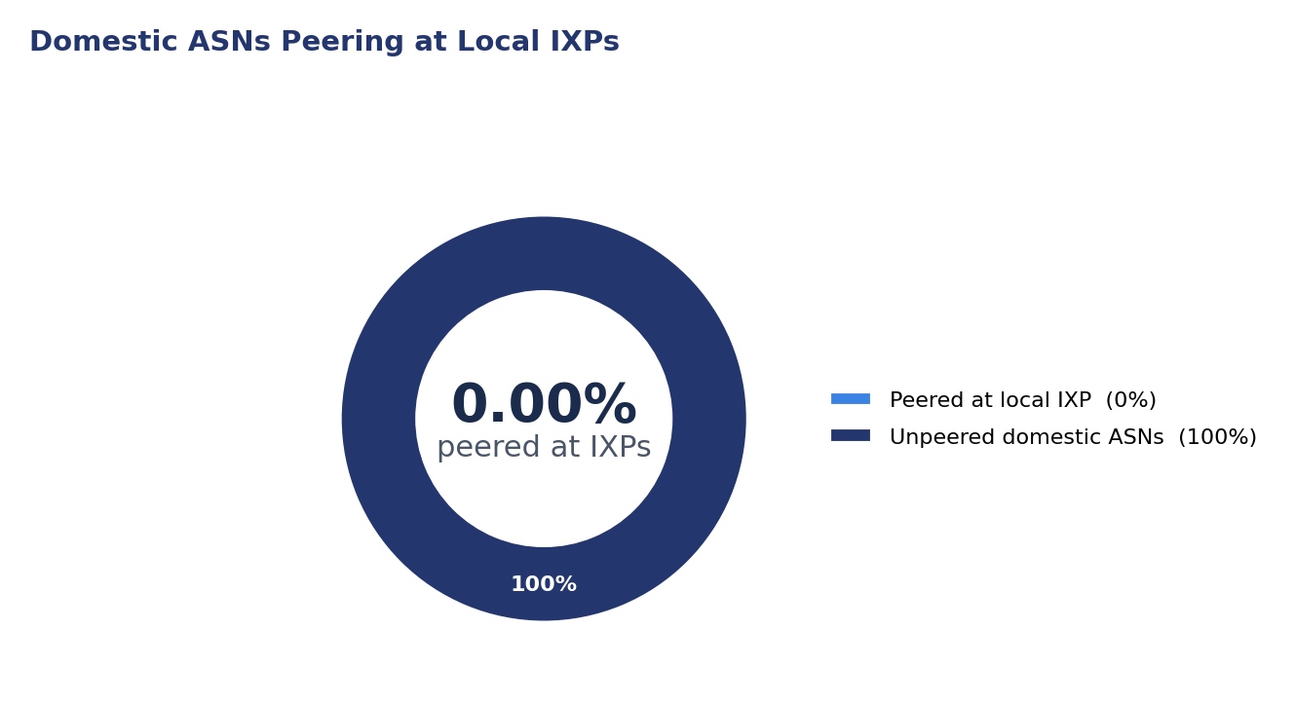
Figure 2. Domestic ASNs Peering at Local IXPs

3.2 Absence of Tier-1 CDN Content Localization
A critical factor contributing to Somalia's high latency and low traffic localization is the complete absence of Tier-1 Content Delivery Networks (CDNs) within the country. None of the nine global Tier-1 CDN providers are peering at the domestic IXP, nor are they present in any of the two domestic data center facilities. This means that popular content from providers such as Google, Meta, and Netflix must be fetched from servers located outside Somalia, often incurring significant latency and consuming expensive international bandwidth. Localizing this content by attracting CDNs to deploy caches and peer within Somalia would dramatically reduce latency, improve user experience, and decrease operational costs for local ISPs.
Tier-1 CDN Provider | ASN | Peering at Domestic IXPs | Present in Domestic Facilities
Akamai | AS20940 | No (Not at IXP) | No
Amazon | AS16509 | No (Not at IXP) | No
Cloudflare | AS13335 | No (Not at IXP) | No
Fastly | AS54113 | No (Not at IXP) | No
Google | AS15169 | No (Not at IXP) | No
Limelight / Edgio | AS22822 | No (Not at IXP) | No
Meta | AS32934 | No (Not at IXP) | No
Microsoft | AS8075 | No (Not at IXP) | No
Netflix | AS2906 | No (Not at IXP) | No

3.3 Minimal Traffic Localization and High Latency
Somalia's traffic localization ratio of 1.00% is indicative of an Internet ecosystem where nearly all traffic, even that destined for domestic users, is routed outside the country. This extremely low score highlights significant peering inefficiencies and directly correlates with the elevated median eyeball edge latency of 85.57 ms. When content and services are not locally accessible, data must travel longer physical distances, introducing delays at every hop. The current latency figures are significantly above the desirable threshold of <20 ms for optimal user experience and digital service performance, affecting everything from web browsing to cloud application responsiveness. Improving traffic localization through local peering and content caching is essential to reduce these delays.
Metric | Value
Peering Efficiency Score | 0.0100
Median Edge Latency | 85.57 ms
Minimum Edge Latency | 68.97 ms
Maximum Edge Latency | 102.00 ms

3.4 Concentrated IXP Infrastructure
The current IXP infrastructure in Somalia is highly concentrated, with the single listed SoIXP located exclusively in Mogadishu. This results in a Geographic Concentration Index (HHI) of 1.0000, signifying absolute infrastructure concentration. While having an IXP, even if non-operational, is a starting point, relying on a single point of presence creates vulnerability. Any disruption to the IXP facility or its immediate connectivity would severely impact national Internet traffic exchange. Furthermore, networks located outside Mogadishu face additional costs and latency to connect to this sole IXP, potentially hindering broader participation. Diversifying IXP locations or establishing additional peering points in other major population centers would significantly enhance the overall resilience and accessibility of local interconnection across the country.
City | IXP Count | Share of National IXPs
Mogadishu | 1 | 100.00%

4. A staged plan to improve resilience
Improving Somalia's peering resilience requires a pragmatic, staged approach. Phase 1 focuses on zero-capital, configuration-based and administrative actions that can yield significant improvements within 12 months. Phase 2 entails targeted coordination and community building within 1-3 years, and Phase 3 involves long-term, capital-heavy structural investments over 3-7 years to solidify the gains and expand capacity.
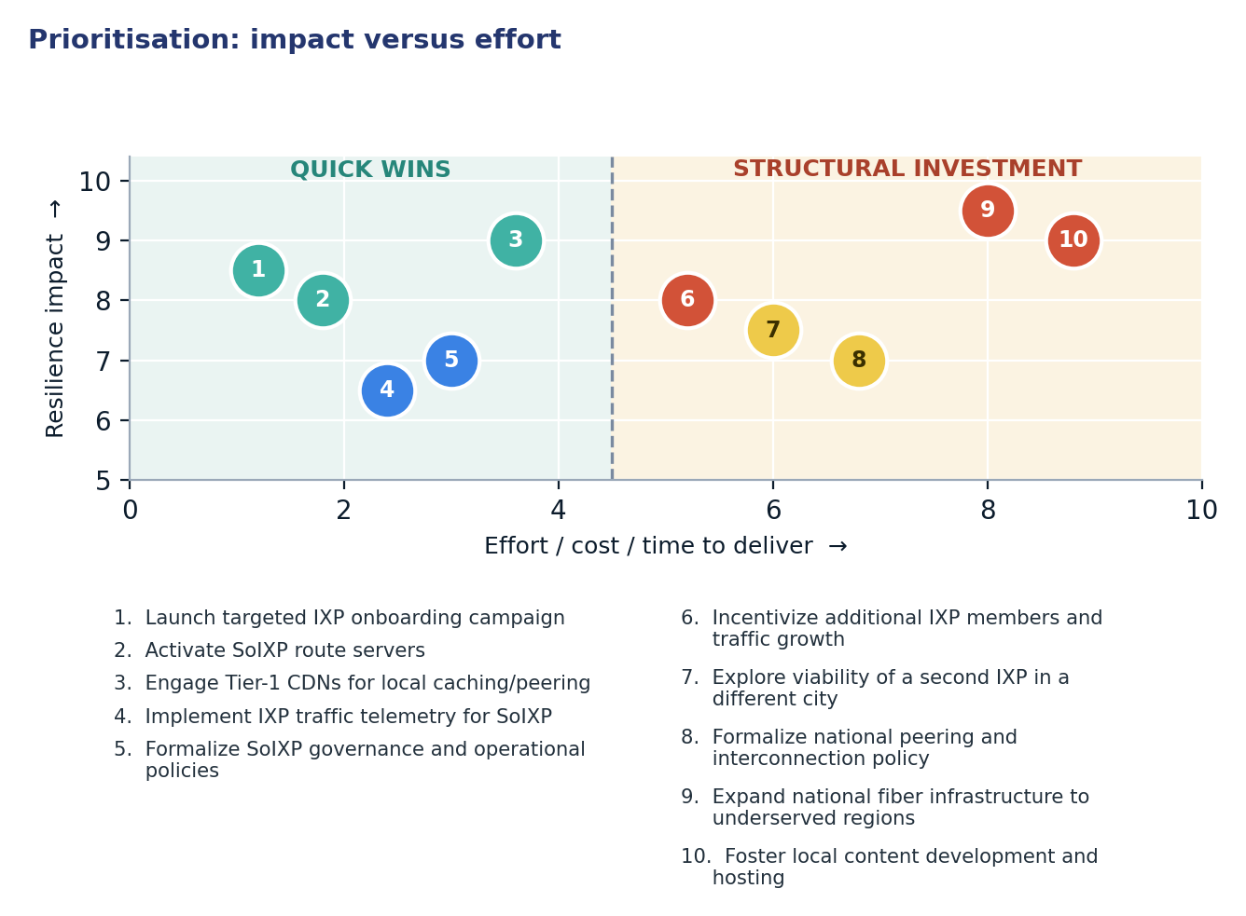
Figure 3. Prioritisation: impact versus effort

4.1 Short term (0–12 months)
Action | Description | Owner | Indicator moved
1. Launch targeted IXP onboarding campaign | Initiate direct outreach to all 19 active domestic ASNs to encourage connection to SoIXP. Provide technical assistance and demonstrate benefits of local peering. | SoIXP Steering Committee, Regulator (support) | Domestic ASN IXP Penetration Rate 0.00% → >20%
2. Activate SoIXP route servers | Configure and activate route servers at SoIXP to simplify peering agreements and reduce administrative overhead for new members. | SoIXP Technical Team | Route Server Utilization Rate 0.00% → >10%
3. Engage Tier-1 CDNs for local caching/peering | Proactively reach out to key Tier-1 CDNs (e.g., Google, Cloudflare, Meta) to advocate for local cache deployments or peering at SoIXP and domestic facilities. | Regulator, SoIXP, Major ISPs | Tier-1 CDNs at Domestic IXPs/Facilities 0 of 9 → 2 of 9
4. Implement IXP traffic telemetry for SoIXP | Deploy and configure monitoring tools to collect and report traffic statistics (peak, average) for SoIXP, improving transparency and attractiveness for new members. | SoIXP Technical Team | IXPs Reporting Traffic Telemetry 0 of 1 → 1 of 1
5. Formalize SoIXP governance and operational policies | Establish clear, transparent, and non-discriminatory governance structures, peering policies, and operational procedures for SoIXP to build trust and attract members. | SoIXP Steering Committee, Member ISPs | IXP Operational Status (members) 0 → >0

4.2 Medium term (1–3 years)
Action | Description | Owner | Indicator moved
6. Incentivize additional IXP members and traffic growth | Develop regulatory or commercial incentives (e.g., lower port fees for initial period, traffic-based rebates) to encourage more networks to join SoIXP and actively exchange traffic. | Regulator, SoIXP, Ministry of Telecoms | Traffic Localization Ratio 1.00% → >15%
7. Explore viability of a second IXP in a different city | Conduct a feasibility study for establishing an additional IXP in a major population center outside Mogadishu to diversify infrastructure and improve regional connectivity. | Regulator, Ministry of Telecoms, Local Governments | Geographic Concentration Index HHI 1.0000 → <0.70
8. Formalize national peering and interconnection policy | Develop and implement a national policy framework that defines the roles and responsibilities of stakeholders, promotes open peering, and supports IXP development. | Regulator, Ministry of Telecoms | Policy Framework for Interconnection Established

4.3 Long term (3–7 years)
Action | Description | Outcome
9. Expand national fiber infrastructure to underserved regions | Invest in extending robust fiber optic networks to remote and underserved areas, facilitating broader Internet access and enabling distributed peering points. | Enhanced national resilience, reduced regional disparities, lower aggregate latency
10. Foster local content development and hosting | Support initiatives for local content creation, digital entrepreneurship, and the establishment of domestic data centers to generate and host more in-country traffic. | Increased traffic localization, reduced reliance on international transit, vibrant local digital economy

5. Quick wins
The following five interventions represent quick wins for Somalia's peering ecosystem. They primarily require configuration changes or administrative coordination rather than significant capital expenditure, making them feasible for rapid implementation and immediate impact on resilience.
# | Quick win | Why it is quick | Effort | Expected effect
1 | Launch targeted IXP onboarding campaign | Leverages existing networks and infrastructure; requires outreach and technical support. | 2–4 weeks of IXP outreach | Raise domestic ASN IXP penetration from 0.00% to >20% by onboarding existing active ASNs.
2 | Activate SoIXP route servers | A technical configuration change on existing IXP equipment; simplifies peering for new members. | Days of operator work | Increase route server utilization from 0.00% to >10% among peered ASNs.
3 | Engage Tier-1 CDNs for local caching/peering | Primarily administrative and advocacy effort to persuade CDNs to deploy caches. | Weeks of diplomatic engagement | Achieve presence of 2 of 9 global Tier-1 CDNs at domestic IXPs or facilities (Tier-1 CDNs at Domestic IXPs/Facilities 0 of 9 → 2 of 9)
4 | Implement IXP traffic telemetry for SoIXP | A technical deployment of monitoring tools; enhances transparency and attractiveness. | One maintenance window per member | Enable 1 of 1 domestic IXPs to report traffic telemetry, improving operational visibility.
5 | Formalize SoIXP governance and operational policies | An administrative and legal process to establish clear rules for the IXP's operation. | 1–2 months of stakeholder coordination | Shift IXP operational status from 0 members to actively serving domestic ASNs.

6. Policy gaps and loopholes

6.1 Where policy is absent or unenforced
Gap | Consequence | Remedy
Absence of national interconnection policy | Lack of clear guidelines and incentives for local peering and IXP development. ISPs prioritize international transit due to lack of a structured local framework. | Develop and implement a comprehensive national interconnection policy promoting open peering and IXP growth.
Lack of explicit IXP neutrality and open access mandate | Potential for a single dominant player to control interconnection or for the IXP to become a closed club, hindering broader participation. | Enact regulatory provisions ensuring IXPs operate on principles of neutrality, non-discrimination, and open access for all licensed operators.
No regulatory incentives for domestic peering | ISPs face no economic or regulatory pressure to peer locally, leading to continued reliance on international and often more expensive routes. | Introduce incentives such as reduced regulatory fees for IXP members or preferential treatment in licensing for operators committed to local peering.
Limited enforcement of service quality standards | Without enforceable quality of service (QoS) standards, there is less impetus for operators to optimize routes and reduce latency through local peering. | Establish and enforce clear QoS and latency benchmarks for Internet services, encouraging operators to seek more efficient local interconnection.

6.2 Loopholes to avoid creating
- Avoid mandatory local peering for all domestic traffic, as this can stifle competition, create artificial bottlenecks, and penalize smaller operators with limited technical capacity or financial resources to peer.
- Do not impose direct price controls on peering services; peering should largely remain a commercial negotiation between willing parties, facilitated by an open and competitive environment, rather than a regulated utility.
- Refrain from mandating specific technical equipment or software for IXPs or peering setups, as this can hinder innovation, increase costs, and prevent operators from adopting more efficient or suitable technologies.
- Do not restrict the number of IXPs or facilities, as this can lead to geographic concentration, reduce redundancy, and limit competition in the interconnection market.
- Avoid creating disincentives for international transit by over-regulating it; international connectivity remains vital, and local peering should be a complementary, efficiency-driven choice, not a forced substitute.

7. Measuring progress
Every proposed action maps directly to publicly verifiable metrics, enabling transparent tracking of progress towards a more resilient peering ecosystem in Somalia. Regular monitoring of these indicators will provide essential feedback for policy adjustments and strategic planning.
Indicator | Baseline | 12-month target | Source
Domestic ASN IXP Penetration Rate | 0.00% | >20% | PeeringDB / ISOC Pulse
Route Server Utilization Rate | 0.00% | >10% | PeeringDB / IXP Statistics
Tier-1 CDNs at Domestic IXPs / Facilities | 0 of 9 | 2 of 9 | PeeringDB / ISOC Pulse
Traffic Localization Ratio | 1.00% | >5% | ISOC Pulse
Median Eyeball Edge Latency | 85.57 ms | <70 ms | RIPE Atlas / ISOC Pulse
IXPs Reporting Traffic Telemetry | 0 of 1 | 1 of 1 | PCH / ISOC Pulse
IXP Operational Status (members) | 0 members | >5 members | PeeringDB

Conclusion
Somalia currently faces a significant disconnect between the foundational presence of active domestic autonomous systems and the operational deployment of a robust, localized peering infrastructure. While a substantial 79.17% of allocated ASNs are actively routed, the country's sole IXP remains non-operational, resulting in a 0.00% domestic IXP penetration rate and an alarmingly low 1.00% traffic localization ratio. This structural deficiency necessitates that nearly all domestic Internet traffic hairpins through international transit, contributing to a high median eyeball edge latency of 85.57 ms and leaving the country vulnerable to single points of failure due to concentrated infrastructure.
The path forward for Somalia begins with a strategic focus on inexpensive, configuration-based quick wins and administrative actions. By prioritizing efforts such as onboarding existing domestic ASNs to the SoIXP, activating its route servers, and proactively engaging Tier-1 CDNs, Somalia can rapidly improve its peering landscape without immediate significant capital outlay. These early successes will build critical regulatory momentum and demonstrate tangible benefits, paving the way for more substantial medium-term policy reforms and long-term capital-intensive investments in diversified infrastructure and local content development. A structured, phased approach, starting with the immediate activation of existing resources, is essential to transform Somalia's Internet resilience and unlock its digital potential.

Data sources and notes
This report synthesizes data from multiple authoritative Internet measurement and infrastructure platforms, providing a comprehensive view of Somalia's peering ecosystem. The analysis draws upon real-time routing information, IXP and facility directories, and active probe measurements to assess the country's current state and identify areas for improvement.
- ISOC Pulse — Country Report for Somalia: https://pulse.internetsociety.org/en/reports/so/
- ISOC Pulse — Internet Resilience Index for Somalia: https://pulse.internetsociety.org/en/resilience/so/
- RIPEstat — Country ASNs & Routing Status for SO: https://stat.ripe.net/SO
- PeeringDB — IXP & Facility Directory for SO: https://www.peeringdb.com/advanced_search?country=SO
- RIPE Atlas — Active Probes & Anchors in SO: https://atlas.ripe.net/probes/?country=SO
- Packet Clearing House (PCH) — IXP Directory: https://www.pch.net/ixp/dir

Measurement caveats. The data presented in this report reflects snapshots taken at the time of generation (2026-11-04 11:27). Internet infrastructure is dynamic, and real-time conditions may vary. Latency measurements are based on samples from RIPE Atlas probes within the country, which, while indicative, may not represent the entire user population. Traffic localization and peering efficiency scores are derived from ISOC Pulse methodologies, which rely on observed routing paths and CDN presence. The absence of data, particularly for IXP traffic telemetry, indicates a lack of reporting rather than necessarily an absence of traffic, although in Somalia's case, 0 members implies minimal to no traffic. All benchmarks are provided as general guidance and may require adaptation to specific local contexts and development stages.

