November 2026

Internet Resilience in India
  - Peering diagnostics report and action plan
ISOC Pulse

DO NOT PUBLISH – INTERNAL DOCUMENT

Table of contents
Executive summary 2
Key numbers at a glance 2
1. Where India stands 3
2. Where India is improving 4
2.1 Robust IXP Infrastructure and Geographic Diversification 4
2.2 Strong Tier-1 CDN Presence and Excellent Routing Efficiency 4
3. Where India could improve 6
3.1 Suboptimal Domestic IXP Penetration 6
3.2 Low Traffic Localization and Inadequate Telemetry 7
3.3 Route Server Underutilization 8
4. A staged plan to improve resilience 10
4.1 Short term (0–12 months) 10
4.2 Medium term (1–3 years) 11
4.3 Long term (3–7 years) 11
5. Quick wins 12
6. Policy gaps and loopholes 13
6.1 Where policy is absent or unenforced 13
6.2 Loopholes to avoid creating 13
7. Measuring progress 14
Conclusion 14
Data sources and notes 15

How to interpret the numbers in this report?
The values presented in this document are the Internet Resilience Index, normalized to 1–100. These values should be interpreted as a score rather than an absolute value. In some cases, the raw absolute values are presented to provide additional context.

Executive summary
India's peering ecosystem demonstrates a foundational strength in physical infrastructure, with a notable number of Internet Exchange Points (IXPs) and a significant presence of global content delivery networks (CDNs). The country's 42 operational IXPs across 12 cities, coupled with 246 peering facilities, indicate a broad distribution of interconnection points. This widespread physical capacity is further bolstered by a strong commitment from global Tier-1 CDNs, with 8 of 9 major providers actively peering at domestic IXPs and present in local data center facilities. This positions India advantageously for efficient content delivery and reduced latency, as evidenced by a low median eyeball edge latency of 12.84 ms and a commendable 0.0% rate of domestic tromboning.
However, a significant paradox emerges when examining the operational utilization of this infrastructure. Despite the extensive physical presence, the domestic ASN IXP penetration rate remains suboptimal at 27.19%, meaning a large proportion of India's 2,972 active routed ASNs are not leveraging local IXPs for traffic exchange. This underutilization contributes to a low traffic localization ratio of 26.60%, suggesting that a substantial amount of domestic traffic is still exchanged internationally or via private interconnection, bypassing local IXPs. Furthermore, while route server utilization among peering ASNs is high at 86.63%, nearly half of the PCH-listed domestic IXPs do not report traffic telemetry, hindering a comprehensive understanding of traffic flows and hindering policy formulation. Addressing these operational and policy gaps, particularly the low IXP penetration and traffic localization, is crucial to fully capitalize on India's substantial peering infrastructure and enhance its overall Internet resilience.

Key numbers at a glance
Indicator | India | Benchmark | Reading
Total Allocated ASNs | 6317 | — | Significant national presence
Active Routed ASNs | 2972 | — | Moderately active BGP participation
Domestic IXP Penetration Rate | 27.19% | >50% target | Suboptimal local peering
Route Server Utilization Rate | 86.63% | 100% of active IXPs | Good but room for improvement
Tier-1 CDNs at Domestic IXPs | 8 of 9 | 9 of 9 global | Strong CDN cache footprint
Traffic Localization Ratio | 26.60% | >50% target | Below desired threshold
Geographic Concentration HHI | 0.1451 | <0.15 diversified | Geographically diversified
Domestic Tromboning Rate | 0.00% | 0% ideal | Excellent routing efficiency
Median Eyeball Edge Latency | 12.84 ms | <20 ms target | Low and competitive latency

1. Where India stands
India's peering landscape presents a dual narrative of robust physical infrastructure coupled with significant opportunities for operational enhancement. The country's 42 operational Internet Exchange Points (IXPs) distributed across 12 cities signify a widespread commitment to local interconnection, a strong foundation compared to many developing economies. This geographical dispersion is reflected in a low Geographic Concentration HHI of 0.1451, which indicates a healthy distribution of interconnection points beyond a single dominant hub. Furthermore, the strong presence of global content, with 8 out of 9 Tier-1 CDNs peering at domestic IXPs and present in local facilities, underpins the potential for a highly localized and low-latency Internet experience.
However, despite these structural advantages, India's performance on key operational metrics trails desired targets. The Domestic IXP Penetration Rate of 27.19% is considerably lower than the benchmark of over 50%, meaning a majority of active domestic ASNs do not participate in local peering. This directly impacts the Traffic Localization Ratio, which stands at 26.60% against a target of over 50%, indicating that a large volume of domestic traffic likely exits and re-enters the country or relies on private interconnection, missing out on the benefits of local exchange. While the Route Server Utilization Rate is a respectable 86.63%, the overall low IXP penetration remains a critical barrier to realizing the full benefits of India's extensive infrastructure.
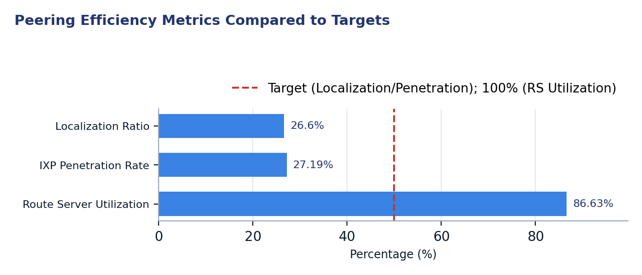
Figure 1. Peering Efficiency Metrics Compared to Targets
Two readings matter for policy. First, the low Domestic IXP Penetration Rate and Traffic Localization Ratio underscore a critical need for policy interventions that incentivize broader participation in local peering. The existence of numerous IXPs and data centers provides the necessary physical foundation, but active engagement from a wider array of Autonomous Systems is essential to transform physical presence into operational efficiency. Second, the excellent 0.0% domestic tromboning rate and low median eyeball edge latency (12.84 ms) demonstrate that when traffic is routed efficiently, India's network performs very well. This highlights that current inefficiencies are primarily due to suboptimal peering policies and practices rather than fundamental infrastructure limitations.

2. Where India is improving

2.1 Robust IXP Infrastructure and Geographic Diversification
India has established a substantial and geographically distributed Internet Exchange Point (IXP) infrastructure, comprising 42 operational IXPs across 12 distinct cities. This extensive network of interconnection points significantly reduces the reliance on single points of failure and minimizes long-haul domestic traffic. The low Geographic Concentration HHI of 0.1451 further confirms a healthy distribution, mitigating risks associated with over-reliance on a few major metropolitan hubs for interconnection.
This distributed model provides a strong foundation for future growth and resilience, enabling local peering opportunities closer to end-users and content providers in various regions. The presence of multiple IXPs within major cities like Mumbai (10 IXPs) and Delhi (8 IXPs) also fosters competition and offers diverse peering options for networks. This widespread availability of interconnection points is a critical enabler for improved traffic localization and reduced latency nationwide.
City | IXP Count | Share of National IXPs
Mumbai | 10 | 23.81%
Delhi | 8 | 19.05%
Kolkata | 6 | 14.29%
Chennai | 5 | 11.90%
Hyderabad | 4 | 9.52%
Bengaluru | 3 | 7.14%
Ahmedabad | 1 | 2.38%
Amaravati | 1 | 2.38%
Guntur | 1 | 2.38%
Guwahati | 1 | 2.38%
Ghaziabad | 1 | 2.38%
Pune | 1 | 2.38%

2.2 Strong Tier-1 CDN Presence and Excellent Routing Efficiency
India benefits from a very strong presence of global Tier-1 Content Delivery Networks, with 8 out of 9 major providers actively peering at domestic IXPs and deploying infrastructure in local data centers. This high level of content localization ensures that a vast majority of widely consumed online content is available within India's borders, minimizing the need to retrieve it from international sources. The pervasive presence of these CDNs is a critical factor in delivering a low-latency experience to end-users and reducing transit costs for domestic Internet Service Providers.
Furthermore, the country exhibits excellent routing efficiency, evidenced by a 0.0% domestic tromboning rate. This indicates that traffic originating and terminating within India is not unnecessarily routed through international backbones. This efficiency is a testament to the robust underlying network architecture and the effectiveness of existing routing policies and practices, contributing directly to a superior user experience with a median eyeball edge latency of 12.84 ms.
Tier-1 CDN Provider | ASN | Peering at Domestic IXPs | Present in Domestic Facilities
Akamai | AS20940 | Yes (Peering at IXP) | Yes (In Local Facility)
Amazon | AS16509 | Yes (Peering at IXP) | Yes (In Local Facility)
Cloudflare | AS13335 | Yes (Peering at IXP) | Yes (In Local Facility)
Fastly | AS54113 | Yes (Peering at IXP) | Yes (In Local Facility)
Google | AS15169 | Yes (Peering at IXP) | Yes (In Local Facility)
Limelight / Edgio | AS22822 | No (Not at IXP) | No
Meta | AS32934 | Yes (Peering at IXP) | Yes (In Local Facility)
Microsoft | AS8075 | Yes (Peering at IXP) | Yes (In Local Facility)
Netflix | AS2906 | Yes (Peering at IXP) | Yes (In Local Facility)

3. Where India could improve
India's peering ecosystem, despite its robust physical infrastructure, faces several key challenges that impact its resilience and efficiency, most critically the suboptimal domestic IXP penetration, followed by low traffic localization, and inadequate IXP telemetry reporting.

3.1 Suboptimal Domestic IXP Penetration
Despite the proliferation of 42 IXPs across the country, the domestic IXP penetration rate stands at a mere 27.19%, meaning that 2,164 of India's 2,972 active routed ASNs are not currently peering at any local IXP. This indicates a significant underutilization of the existing interconnection infrastructure. Many IXPs, even established ones, show a wide disparity in their connected network counts, with several having minimal or zero members, despite being listed as operational. This fragmentation suggests that while the physical capacity exists, the critical mass of peering participants has not been achieved uniformly, leading to missed opportunities for localized traffic exchange and cost savings for operators.
The lack of widespread participation at IXPs necessitates that a large volume of domestic traffic either transits through expensive international upstream providers or relies on bilateral private peering arrangements, which can be less efficient and scalable than multilateral peering at an IXP. Boosting this penetration rate is fundamental to strengthening India's internal traffic exchange, fostering local content ecosystems, and reducing overall operational costs for Internet service providers.
IXP Name | City | Status | Connected Networks | Peering Facilities | IX-F Member Count
DE-CIX Mumbai | Mumbai | ok | 452 | 20 | 0
Extreme IX Mumbai | Mumbai | ok | 243 | 15 | 245
NIXI Mumbai | Mumbai | ok | 178 | 22 | 0
Extreme IX Delhi | Delhi | ok | 172 | 13 | 173
NIXI Delhi | Delhi | ok | 115 | 11 | 0
DE-CIX Delhi | Delhi | ok | 109 | 11 | 0
Extreme IX Chennai | Chennai | ok | 90 | 10 | 90
DE-CIX Chennai | Chennai | ok | 78 | 10 | 0
AMS-IX Mumbai | Mumbai | ok | 69 | 3 | 85
NIXI Chennai | Chennai | ok | 56 | 7 | 0
Extreme IX Bangalore | Bangalore | ok | 46 | 6 | 46
MX-IX Kolkata | Kolkata | ok | 34 | 3 | 0
ANI-IX Delhi | Delhi | ok | 30 | 3 | 0
NIXI Kolkata | Kolkata | ok | 29 | 2 | 0
Extreme IX Hyderabad | Hyderabad | ok | 24 | 5 | 24
Extreme IX Kolkata | Kolkata | ok | 24 | 2 | 24
Equinix Mumbai | Mumbai | ok | 24 | 2 | 0
NIXI Hyderabad | Hyderabad | ok | 23 | 2 | 0
DE-CIX Kolkata | Kolkata | ok | 19 | 3 | 0
DE-CIX Hyderabad | Hyderabad | ok | 14 | 4 | 0
Amaravati IX | Amaravati | ok | 13 | 1 | 17
Extreme IX Pune | Pune | ok | 11 | 3 | 0
MX-IX Delhi | Delhi | ok | 9 | 6 | 0
OpenSwitch-IX | Kolkata | ok | 9 | 0 | 0
Insta-IX Delhi | Delhi | ok | 8 | 2 | 0
AMS-IX Hyderabad | Hyderabad | ok | 8 | 2 | 8
WSNL-IX | Mumbai | ok | 7 | 0 | 0
DE-CIX Bengaluru | Bengaluru | ok | 6 | 4 | 0
NIXI Bangalore | Bangalore | ok | 6 | 2 | 0
AMS-IX Kolkata | Kolkata | ok | 6 | 2 | 6
X3M-IX | Mumbai | ok | 6 | 1 | 0
MX-IX Mumbai | Mumbai | ok | 5 | 8 | 0
Fiblib Digital Networks | New Delhi | ok | 4 | 6 | 0
SP-iXP Mumbai | Mumbai | ok | 2 | 4 | 0
MX-IX Chennai | Chennai | ok | 2 | 3 | 0
REDIX Chennai | Chennai | ok | 2 | 2 | 0
Bharat IX - Mumbai | Mumbai | ok | 2 | 0 | 0
Remki Internet Exchange (RIX) | Guntur | ok | 1 | 1 | 0
NIXI Guwahati | Guwahati | ok | 1 | 1 | 0
SURAJ IX | Ghaziabad | ok | 1 | 0 | 0
NIXI Ahmedabad | Ahmedabad | ok | 0 | 2 | 0
IPNET-DELHI | Delhi | ok | 0 | 0 | 0

3.2 Low Traffic Localization and Inadequate Telemetry
India's traffic localization ratio of 26.60% indicates that a significant portion of domestic Internet traffic is not exchanged within the country, falling short of the desired >50% benchmark. This implies that much of India's domestic traffic either traverses international links or relies on costly private peering arrangements, rather than being efficiently exchanged at local IXPs. This low localization rate contributes to higher operational costs for ISPs and potentially increased latency for end-users, despite the excellent technical routing efficiency for traffic that *does* remain localized.
Compounding this issue is the inadequate level of IXP telemetry reporting. Out of 32 PCH-listed domestic IXPs, only 18 (56.25%) consistently report their traffic statistics. This lack of transparency and data visibility hinders a comprehensive understanding of traffic flows, bottlenecks, and the actual utilization of IXP infrastructure. Without robust telemetry, it becomes challenging for policymakers and IXP operators to make data-driven decisions regarding capacity planning, incentive programs for peering, and strategic development of the peering ecosystem.
IXP Name (PCH) | City | Status | Peak Traffic (Gbps) | Average Traffic (Gbps)
Extreme IX New Delhi | New Delhi | Active | 5.622 | 1.894
MX-IX Delhi | New Delhi | Active | 0.864 | 0.784
National Internet Exchange of India - New Delhi | New Delhi | Active | 0.049 | 0.001
Equinix Internet Exchange Mumbai | Mumbai | Active | 0.033 | 0.017
Amaravati Internet Exchange | Amaravati | Active | 0.008 | 0.006
National Internet Exchange of India - Mumbai | Mumbai | Active | 0.008 | 0.003
National Internet Exchange of India - Chennai | Chennai | Active | 0.000 | 0.000
National Internet Exchange of India - Kolkata | Kolkata | Active | 0.000 | 0.000
National Internet Exchange of India - Bangalore | Bangalore | Active | 0.000 | 0.000
National Internet Exchange of India - Hyderabad | Hyderabad | Active | 0.000 | 0.000
National Internet Exchange of India - Ahmedabad | Ahmedabad | Active | 0.000 | 0.000
ANI Peering Exchange | New Delhi | Active | 0.000 | 0.000
National Internet Exchange of India - Guwahati | Guwahati | Active | 0.000 | 0.000
DE-CIX Delhi | New Delhi | Active | 0.000 | 0.000
DE-CIX Bangalore | Bangalore | Active | 0.000 | 0.000

3.3 Route Server Underutilization
While a commendable 86.63% of domestic ASNs peering at local IXPs utilize route servers, this still means 13.37% of peering ASNs are not leveraging this crucial tool for simplified multilateral peering. Route servers significantly reduce the administrative burden of establishing and maintaining numerous bilateral peering sessions, thereby lowering barriers to entry for smaller networks and encouraging broader participation in IXPs. The underutilization of route servers represents a missed opportunity to further streamline peering operations and attract more networks to join IXPs and peer efficiently.
Encouraging 100% route server utilization among peering ASNs can enhance the efficiency and attractiveness of IXPs, particularly for new or smaller networks. This improvement would foster a more inclusive peering environment, allowing networks to quickly establish peering with a multitude of participants through a single agreement, thereby contributing to the overall health and resilience of the domestic peering ecosystem.

4. A staged plan to improve resilience
This staged plan outlines a strategic approach to enhance India's Internet resilience, prioritizing interventions based on their impact and effort. Phase 1 focuses on immediate, low-capital configuration and administrative actions; Phase 2 involves targeted coordination within a 1-3 year timeframe; and Phase 3 outlines long-term structural capacity development over 3-7 years.
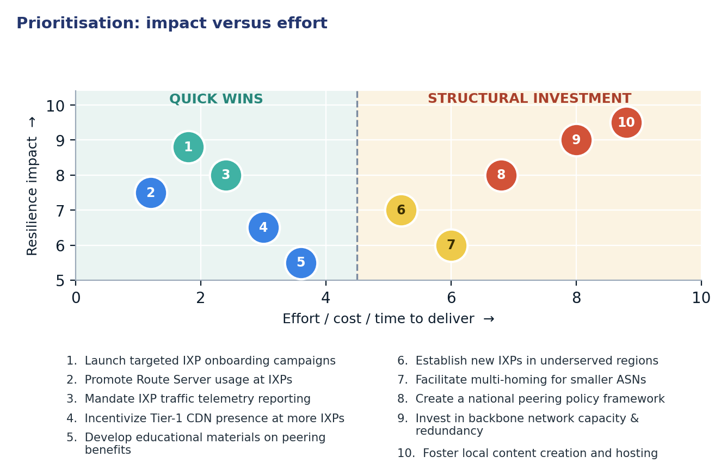
Figure 2. Prioritisation: impact versus effort

4.1 Short term (0–12 months)
Action | Description | Owner | Indicator moved
1. Launch targeted IXP onboarding campaigns | Actively engage and incentivize the 2,164 unpeered active domestic ASNs to connect to local IXPs through outreach programs, workshops, and reduced initial fees. | IXP Operators, NOGs | Domestic IXP Penetration Rate 27.19% → >35%
2. Promote Route Server usage at IXPs | Educate IXP members, especially those not currently using route servers, on the benefits of multilateral peering via route servers to simplify interconnection. | IXP Operators, Member ASNs | Route Server Utilization Rate 86.63% → >95%
3. Mandate IXP traffic telemetry reporting | Implement a regulatory requirement for all operational IXPs to consistently report anonymized traffic statistics to a central body (e.g., ISOC Pulse, NIXI) for enhanced visibility. | Regulator (TRAI/DoT), IXP Operators | PCH-Listed IXPs Reporting Traffic 18 of 32 → >25 of 32
4. Incentivize Tier-1 CDN presence at more IXPs | Engage with the missing Tier-1 CDN provider and other major content providers to encourage their presence and peering at additional domestic IXPs. | Regulator (TRAI/DoT), IXP Operators, CDN Providers | Tier-1 CDNs at Domestic IXPs 8 of 9 → 9 of 9
5. Develop educational materials on peering benefits | Create and disseminate resources (guides, webinars, case studies) for ISPs and content providers on the technical, operational, and economic advantages of local peering. | ISOC, NOGs, Industry Associations | Active Routing Ratio 47.05% → >50%

4.2 Medium term (1–3 years)
Action | Description | Owner | Indicator moved
6. Establish new IXPs in underserved regions | Conduct feasibility studies and provide support for the establishment of new IXPs in strategic tier-2/tier-3 cities to further extend local peering capabilities. | Local Governments, IXP Operators, Investors | Cities Hosting IXPs 12 → >15
7. Facilitate multi-homing for smaller ASNs | Develop programs or subsidies to assist smaller Internet Service Providers in adopting multi-homing strategies to enhance their resilience and peering options. | Operators, Regulator (TRAI/DoT) | Active Routed ASNs 2972 → >3500
8. Create a national peering policy framework | Develop a comprehensive national policy that defines the roles and responsibilities of IXPs, establishes peering best practices, and removes regulatory barriers to interconnection. | Regulator (TRAI/DoT), Industry Stakeholders | Traffic Localization Ratio 26.60% → >40%

4.3 Long term (3–7 years)
Action | Description | Outcome
9. Invest in backbone network capacity & redundancy | Support investment in upgrading and expanding national fiber optic backbone networks, ensuring diverse routes and increased capacity to handle growing domestic traffic. | Enhanced national network resilience and capacity to support localized traffic and reduce dependence on international transit.
10. Foster local content creation and hosting | Implement policies and initiatives to encourage local businesses, governments, and creators to host their content and services within domestic data centers and cloud infrastructure. | Increased domestic traffic exchange, reduced international bandwidth consumption, and accelerated growth of India's digital economy.

5. Quick wins
The following five interventions represent quick wins, requiring minimal capital investment and primarily involving configuration or administrative coordination. Their implementation can yield immediate and measurable improvements in India's peering ecosystem.
# | Quick win | Why it is quick | Effort | Expected effect
1 | Launch targeted IXP onboarding campaigns | Primarily outreach and administrative coordination with existing unpeered ASNs, leveraging existing IXP infrastructure. | 2–4 weeks of IXP outreach | Raise domestic ASN IXP penetration from 27.19% to >35%
2 | Promote Route Server usage at IXPs | Educational effort and minor configuration changes for existing IXP members; no new infrastructure needed. | Days of operator work | Increase route server utilization rate from 86.63% to >95%
3 | Mandate IXP traffic telemetry reporting | Requires a clear regulatory directive and minor technical implementation by IXP operators; data collection systems are often already in place. | 1–2 months of regulatory coordination and IXP technical adjustment | Increase PCH-listed IXPs reporting traffic from 18 of 32 to >25 of 32
4 | Incentivize Tier-1 CDN presence at more IXPs | Strategic engagement and negotiation with the remaining Tier-1 CDN, leveraging existing IXP and facility contacts. | 1–2 months of business development and technical coordination | Achieve 9 of 9 Tier-1 CDNs peering at domestic IXPs (Tier-1 CDNs at Domestic IXPs 8 of 9 → 9 of 9)
5 | Develop educational materials on peering benefits | Content development and dissemination, leveraging existing industry associations and online platforms. | 3–6 weeks of content creation and communication | Contribute to increasing active routing ratio from 47.05% to >50%

6. Policy gaps and loopholes

6.1 Where policy is absent or unenforced
Gap | Consequence | Remedy
Lack of a clear national IXP policy and regulatory framework. | Ambiguity in operational requirements for IXPs (e.g., neutrality, uptime, telemetry reporting), inconsistent quality of service, and lack of enforcement mechanisms. | Establish a dedicated IXP policy framework that defines operational standards, governance, and regulatory oversight for all licensed IXPs.
Absence of incentives for domestic ASNs to join and peer at local IXPs. | Low domestic IXP penetration rate (27.19%) due to perceived high cost or low benefit for smaller ASNs, leading to increased reliance on international transit. | Introduce financial incentives (e.g., tax breaks, subsidies for port fees) or non-financial incentives (e.g., streamlined licensing for IXP members) for domestic ASNs.
Limited or no policy mandating government/public sector entities to peer locally. | Government traffic often transits inefficiently, incurring higher costs and potentially longer latencies, and failing to stimulate local peering. | Implement a "Peer Local First" policy for all government agencies and public sector undertakings (PSUs) to connect to and peer at domestic IXPs.
Inadequate regulatory clarity on data residency requirements and local hosting. | Uncertainty for cloud providers and content hosts regarding local data storage, potentially stifling investment in domestic data centers and content localization. | Promulgate clear, unambiguous policies on data residency and encourage domestic hosting through favorable regulatory environments and infrastructure support.

6.2 Loopholes to avoid creating
- Avoid mandating specific peering arrangements (e.g., requiring all networks to peer at specific IXPs or forcing private peering). Such mandates can distort market dynamics, stifle innovation, and lead to suboptimal peering choices.
- Refrain from imposing artificial price controls on IXP port fees or peering services. This could disincentivize private sector investment in IXP infrastructure and expansion, ultimately limiting capacity and competition.
- Guard against excessive licensing or bureaucratic hurdles for new IXPs or for ASNs wishing to connect to existing IXPs. Overly complex processes can deter entry and growth, hindering the development of a competitive peering landscape.
- Do not implement data residency requirements without ensuring adequate local data center and backbone infrastructure. Such policies, if poorly supported by infrastructure, could increase costs, reduce service quality, and force traffic through suboptimal domestic routes rather than facilitating efficient local exchange.
- Avoid creating policies that favor incumbent operators or specific IXP models over others. A level playing field is essential to foster healthy competition and allow the market to determine the most efficient peering solutions.

7. Measuring progress
Every action outlined in this report maps to a publicly verifiable metric, enabling transparent tracking of progress towards enhanced Internet resilience in India. Regular monitoring of these indicators will provide essential feedback for policy adjustments and strategic planning.
Indicator | Baseline | 12-month target | Source
Domestic IXP Penetration Rate | 27.19% | >35% | PeeringDB
Route Server Utilization Rate | 86.63% | >95% | PeeringDB
PCH-Listed IXPs Reporting Traffic | 18 of 32 | >25 of 32 | Packet Clearing House (PCH)
Tier-1 CDNs at Domestic IXPs | 8 of 9 | 9 of 9 | PeeringDB
Traffic Localization Ratio | 26.60% | >30% | ISOC Pulse API
Active Routing Ratio | 47.05% | >50% | RIPEstat
Cities Hosting IXPs | 12 | >13 | PeeringDB

Conclusion
India possesses a robust physical foundation for a resilient and efficient peering ecosystem, characterized by numerous Internet Exchange Points and a strong presence of global content delivery networks. However, the disconnect between this extensive infrastructure and its operational utilization is a critical challenge. The low domestic IXP penetration rate and traffic localization ratio indicate that a significant portion of potential local traffic exchange opportunities are currently unrealized, leading to suboptimal routing and higher operational costs for networks. Addressing these gaps is paramount to fully leverage the country's investment in interconnection infrastructure and enhance its overall Internet resilience.
The proposed staged action plan emphasizes a pragmatic approach, beginning with "quick win" interventions that require minimal capital and focus on configuration changes, administrative coordination, and targeted outreach. By sequencing these cost-effective measures before embarking on more capital-intensive, long-term projects, India can build regulatory momentum and demonstrate tangible improvements in peering efficiency. This strategy not only improves the immediate state of the Internet but also cultivates an environment conducive to future structural investments, ultimately fostering a more localized, resilient, and cost-effective Internet for all users in India.

Data sources and notes
This report draws upon data from various authoritative Internet measurement and infrastructure platforms, providing a comprehensive overview of India's peering ecosystem. Data for active ASNs and routing status was sourced from RIPEstat, while IXP infrastructure details, member rosters, and CDN presence were obtained from PeeringDB. Traffic telemetry was referenced from Packet Clearing House (PCH), and latency measurements were derived from RIPE Atlas probes. The Traffic Localization Ratio was provided by the ISOC Pulse API.
- ISOC Pulse — Country Report for India: https://pulse.internetsociety.org/en/reports/in/
- ISOC Pulse — Internet Resilience Index for India: https://pulse.internetsociety.org/en/resilience/in/
- RIPEstat — Country ASNs & Routing Status for IN: https://stat.ripe.net/IN
- PeeringDB — IXP & Facility Directory for IN: https://www.peeringdb.com/advanced_search?country=IN
- RIPE Atlas — Active Probes & Anchors in IN: https://atlas.ripe.net/probes/?country=IN
- Packet Clearing House (PCH) — IXP Directory: https://www.pch.net/ixp/dir

Measurement caveats. All measurements reflect a snapshot in time, captured on 2026-11-02 15:31. Data from platforms like RIPE Atlas relies on a sample of active probes and anchors, which may not represent every segment of the network. Traffic telemetry reported by IXPs to PCH is voluntary, and inconsistencies or gaps in reporting may exist, as highlighted in the report. Some figures, particularly those derived from PeeringDB, are dependent on the accuracy and timeliness of data submitted by network operators and IXP administrators.

