**Step 1: Setting Up the Company Structure**

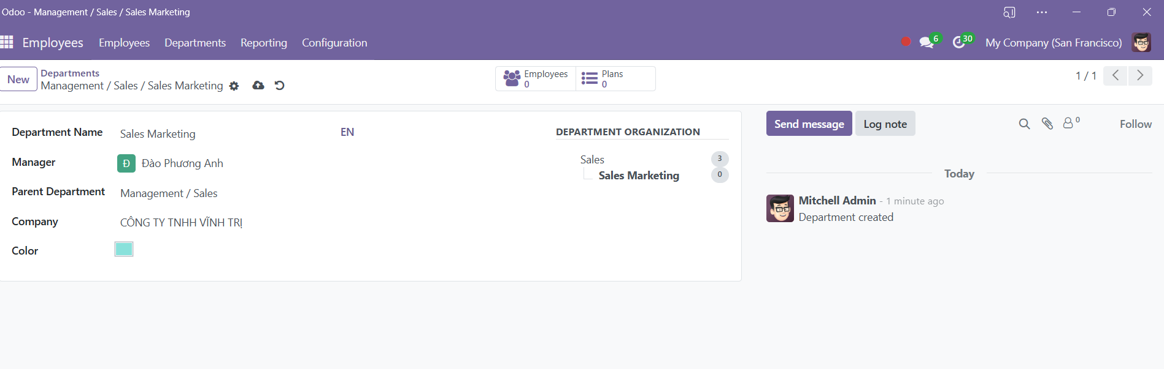

**Step 2: Defining Positions**

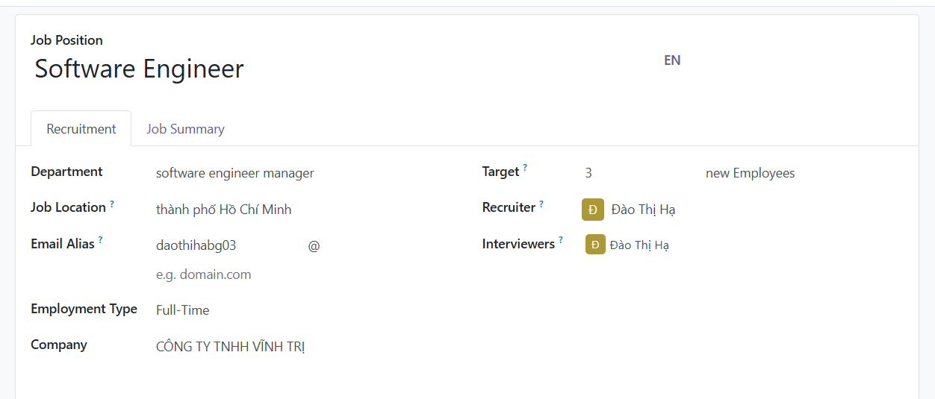

**2. Assign Positions to Employees:**

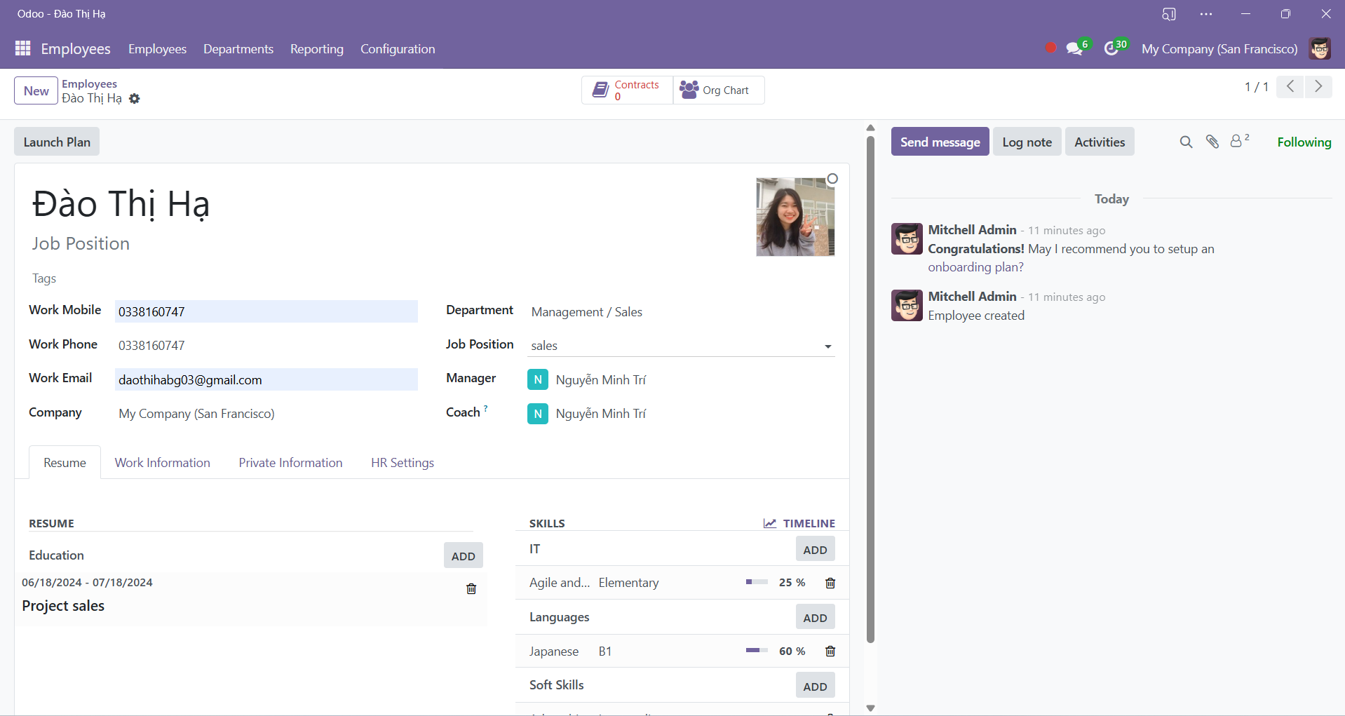

**Step 3: Managing Skills**

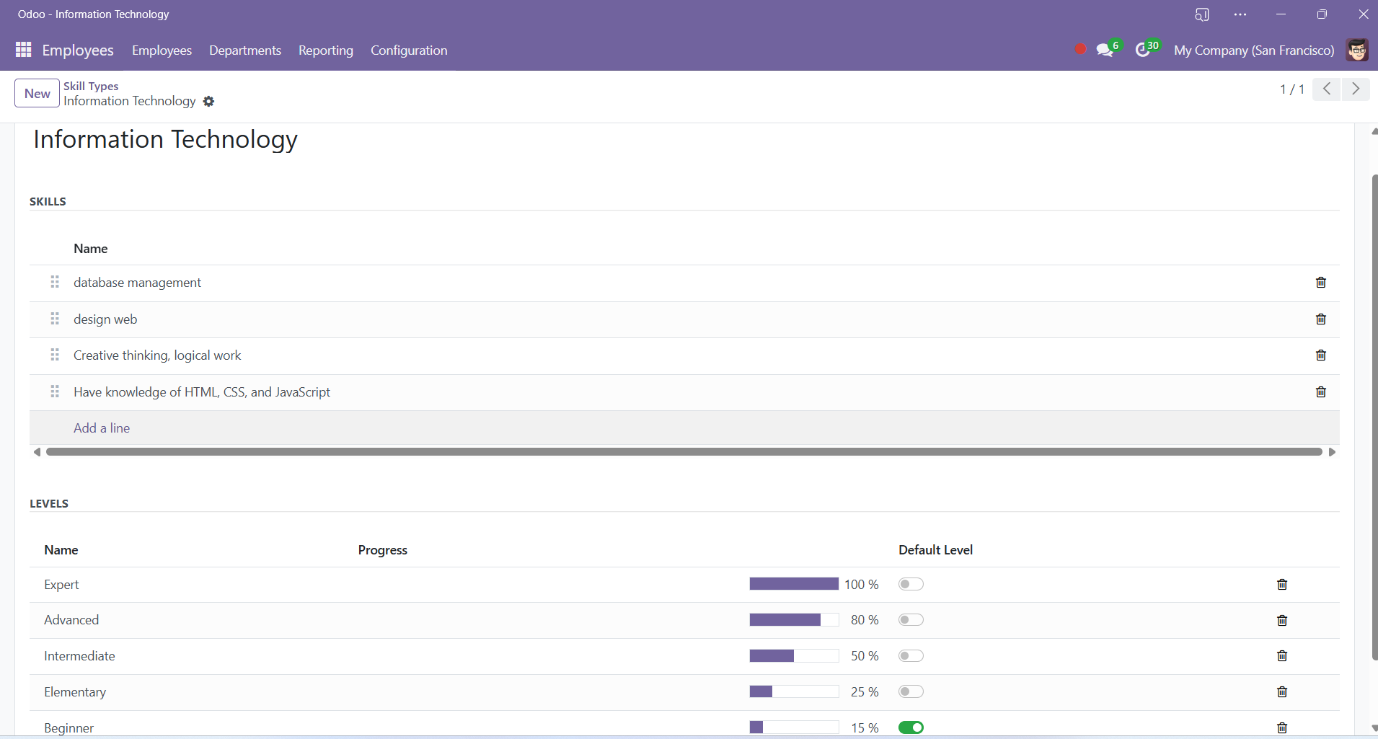

**2. Assign Skills to Employees:**

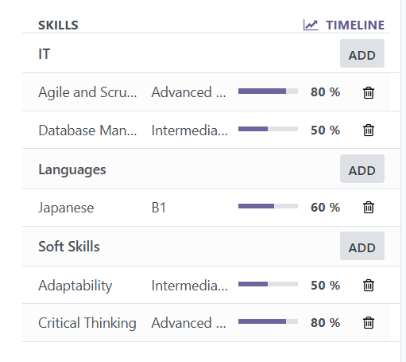

**Step 4: Reporting and Analysis**

