REPOSITORY

Steps to do a repository on GitHub inside your organization:

1-Open your organization then click on **repository**:

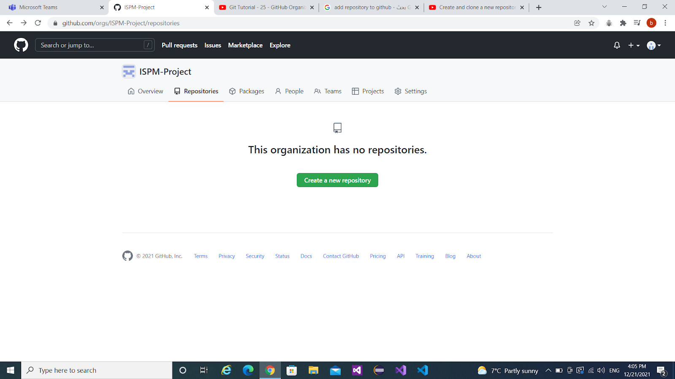

2-

A. Choose a repository name.

B. write a description to describe it.

C. if you want all people see your repository choose **public** if you want to choose how can see your repository click on **private**.

D. Initialize your repository with the best choice for you:

     a-add a README file. (preferred)

     b-add. gitignore.

     c- choose a license.

E. Click on Create repository.

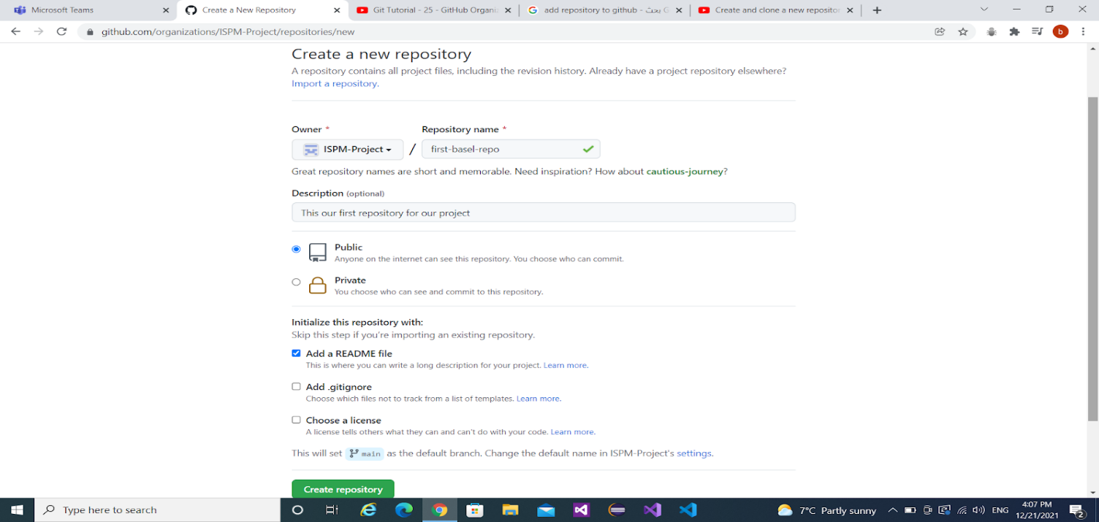

3-Now, you can create or upload files to your repository.

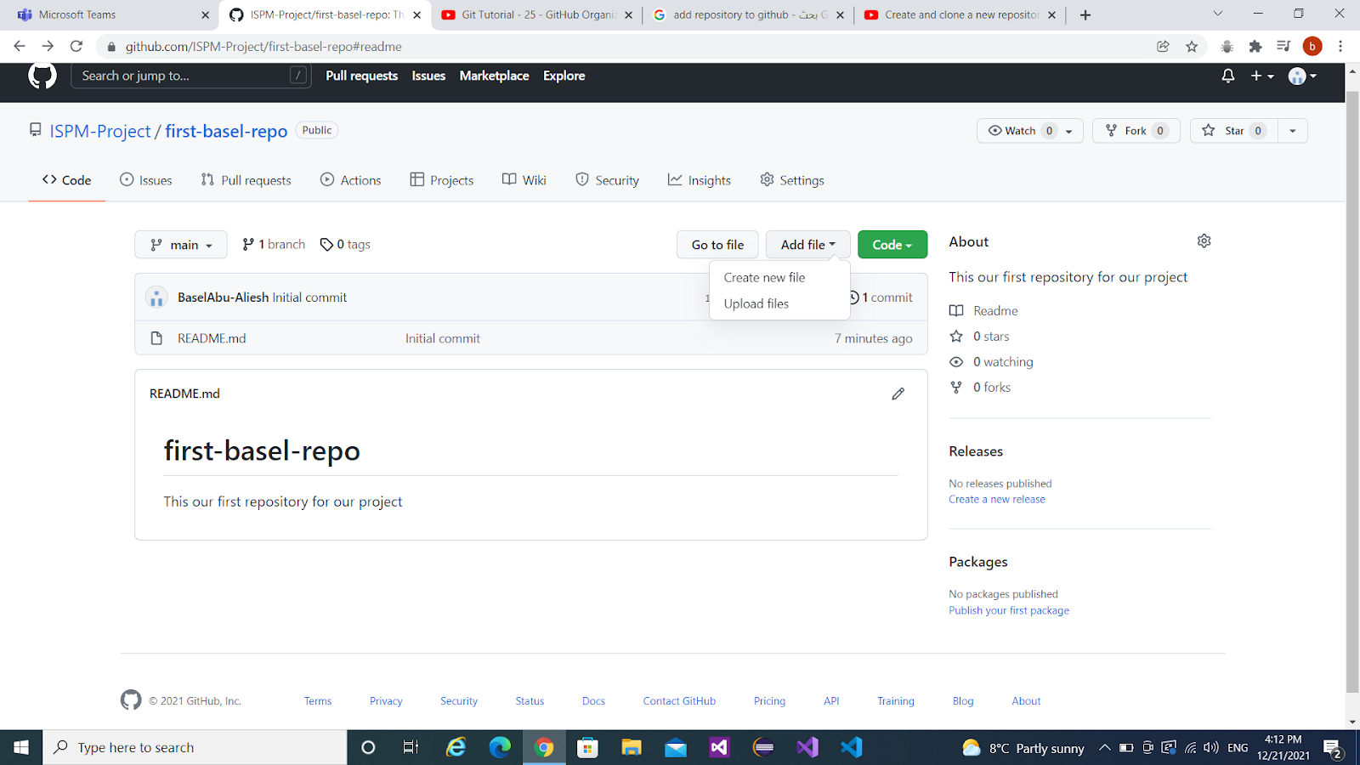

4-If we choose to upload files you can put the files you want from your computer, you can write a description for each file you add & it's important to choose the main branch, click on create.

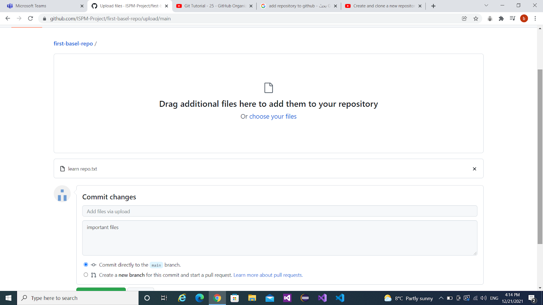

5-Now, your files were added successfully.

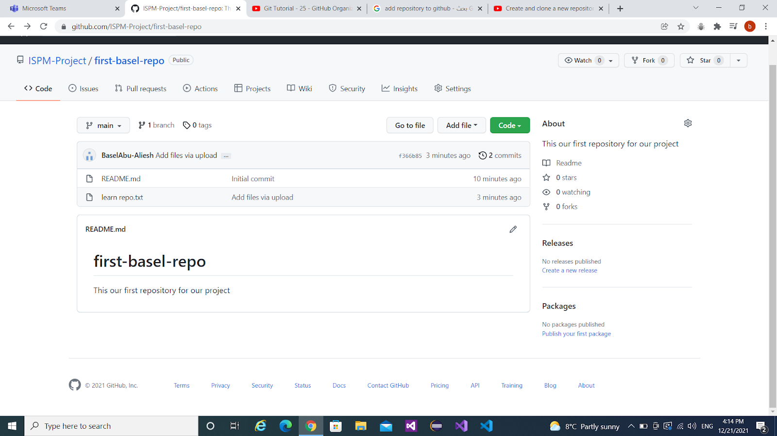

6-You can add a repository to a team in your organization.

