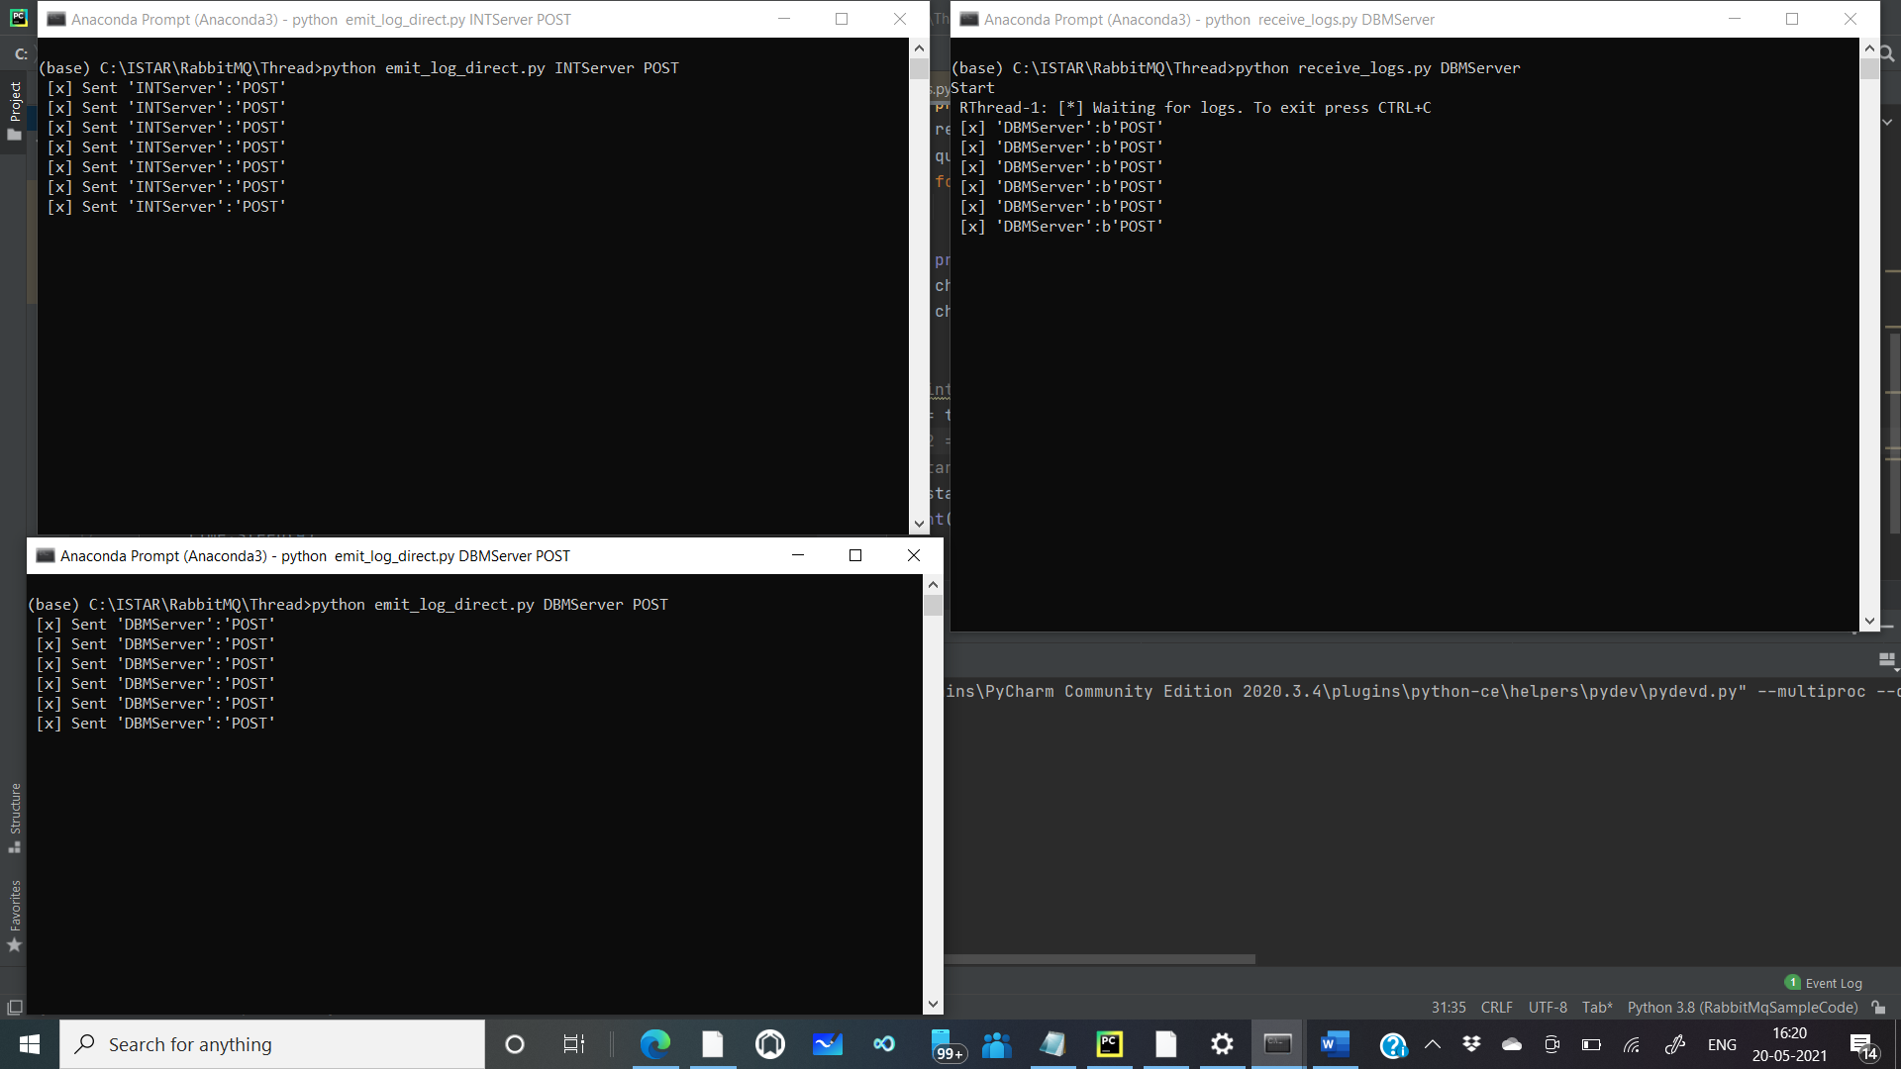

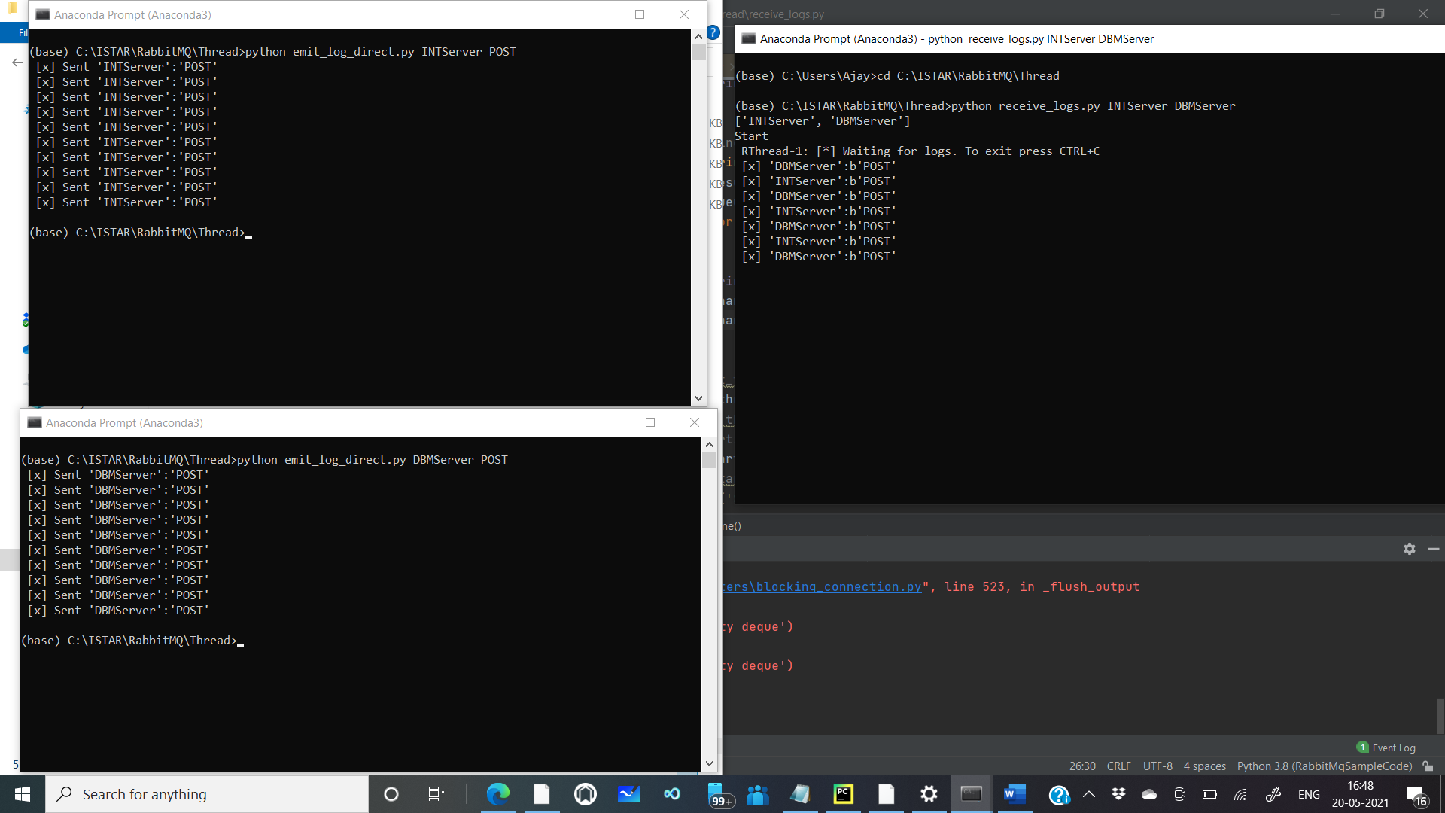

POST - INT

Queue-2

Mission Controller

Queue-1

Thread 1 DBM

POST - DBM

Exchange

INT Server

DBM Server