Overview of the DMP Tool and Data Management & Analysis Priority Plan
FAQ
Q: What is the DMP Tool?
A: The DMP Tool developed by the California Digital Library, is designed to provide funder-specific guidance to help researchers develop data management plans.
Q: What is the Data Management & Analysis Priority Plan?
A: DMAC would like you (trainees) to create a Data Management & Analysis Priority Plan (short name: Priority Plan) at the beginning of their research project. The Priority Plan documents the types and characteristics of data you expect to generate, statistical methods you anticipate using, and published datasets associated with the project. The Priority Plan is intended for administrative purposes only and is designed to require minimal effort and be easy to update over time.
Q: Why should we use the DMP Tool to create the Priority Plan?
A: The DMP Tool platform is repurposed to provide a customized template for creating your Priority Plan. You can update your Priority Plan in any phase of your project and add published datasets.
Q: What other benefits of using the DMP Tool?
A: Sharing your Priority Plan in the DMP Tool platform will save you time by providing us with additional information about your project and data when you consult with us on data management or statistical analysis. It will also help administrative staff to easily gather information about published datasets for reporting purposes.
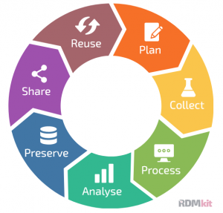
Q: How will the Priority Plan/DMP Tool fit the research data lifecycle?
Add published datasets to your Priority Plan using DMP Tool
Update your Priority Plan using DMP Tool when needed
Create a Priority Plan using DMP Tool
Your Priority Plan helps DMAC get prepared for a consultation
How to Use the DMP Tool Instructions
- Go to the DMP Tool website: https://dmptool.org/ and click on “Login” in the upper right corner.
- Enter your hawkmail in the “Email address” field and click “Continue”.
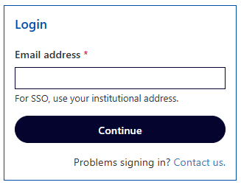
- The system will recognize your email address as being associated with the University of Iowa. Click “Sign in with Institution (SSO)”.
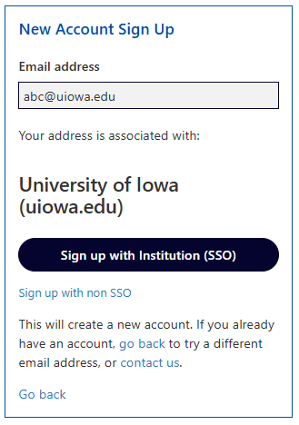
- Enter your hawkID and password.
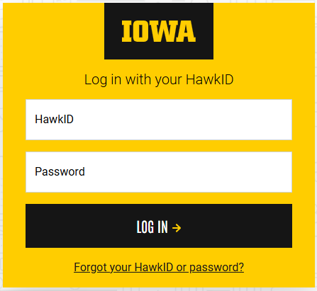
- On “My Dashboard”, click the “Create plan” button. You’ll be taken to the “Create a new plan” page. You may not see a table of plans if it’s your first time to login.

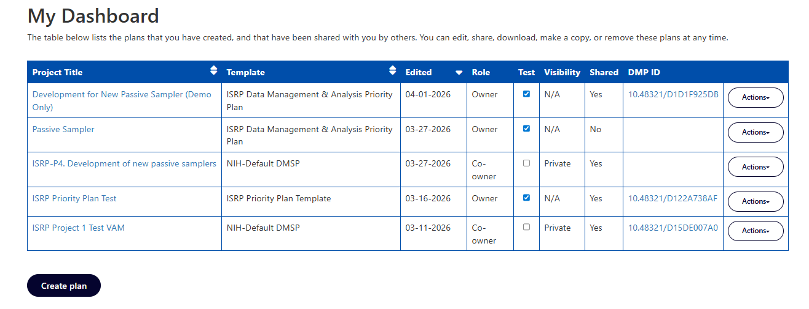

- Provide a title for this plan and keep the default research organization. Select “No funder associated with this plan or my funder is not listed.” This step is important because it will direct you to the ISRP Data Management & Analysis Priority Plan template. Click the “Create plan”, and a blank plan will be created.
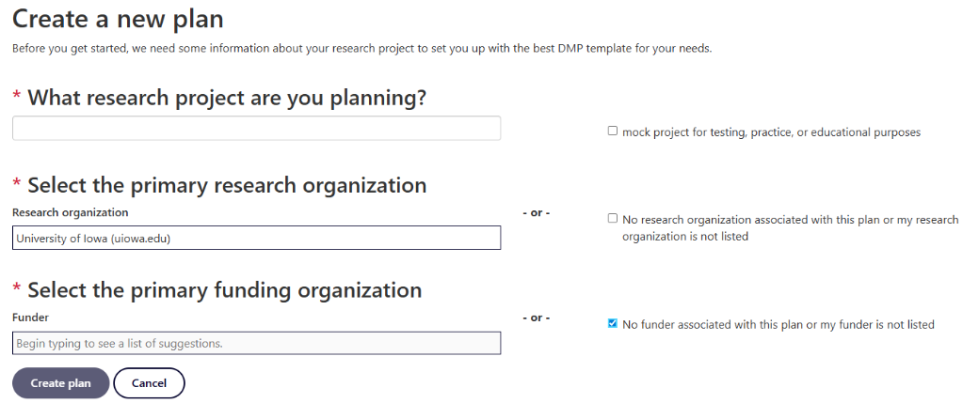
- Under the “Project Details” tab, fill out fields. Please select “NIEHS” as the funder and enter “P42 ES013661” as the grant number.
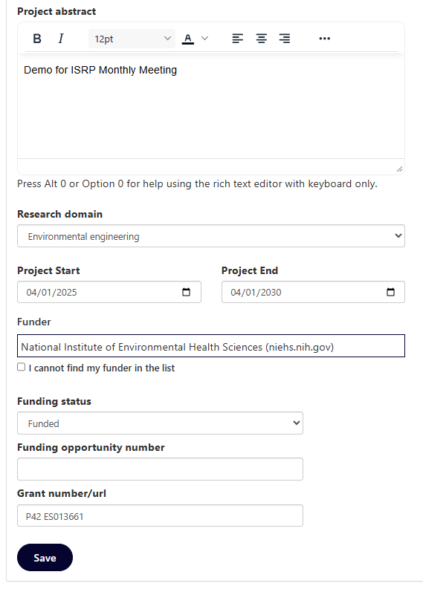
- Under the “Collaborators” tab, add the following DMAC members and David Purdy as DMP Collaborators with either “Editor” or “Read Only” permission so that we can access your plan:
andres-martinez@uiowa.edu; kai-wang@uiowa.edu; qianjin-zhang@uiowa.edu;
david-purdy@uiowa.edu
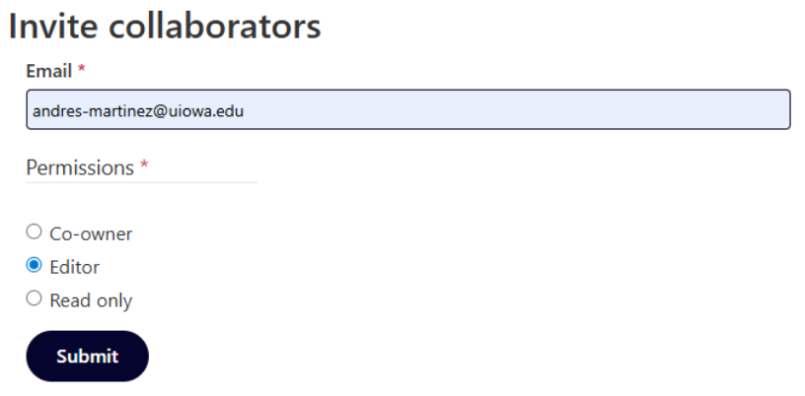
- Under the “Write Plan” tab, expand sections and answer the questions. The guidance and example answers are also provided for your reference. In the “Published Datasets” section, you will need to add and update it when you publish a dataset.
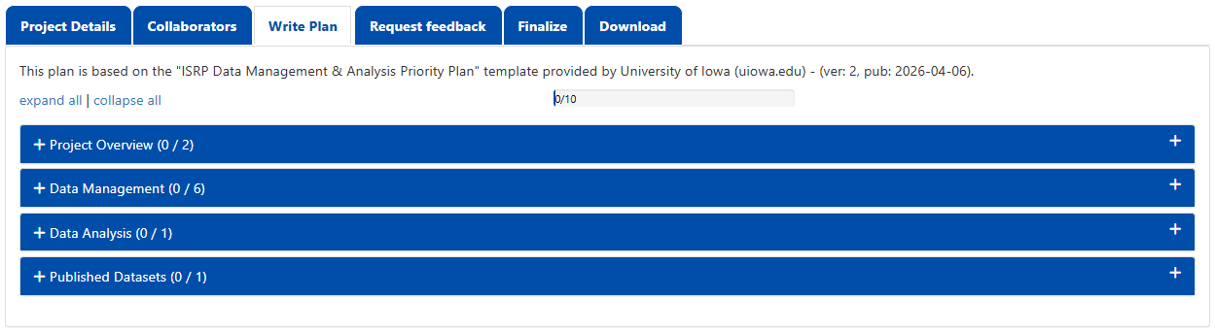
- Please ignore the “Request feedback” tab, as it sends messages to lib-data@uiowa.edu at the Main Library, not DMAC.
- Under the “Download” tab, it’s highly recommended that you download a version of your plan once it is finished or before making any significant changes.
- Optional: Under the “Finalize” tab, you can set your plan private. To register your plan, click “Register plan” to obtain a DOI (DMP ID). Note that at least 50% of your plan must be completed before you can register. This step is important because registering your plan enables the “Follow-Up” tab to appear. Please refer to #13 for retrieving datasets by adding dataset DOIs in the “Follow-Up” tab.
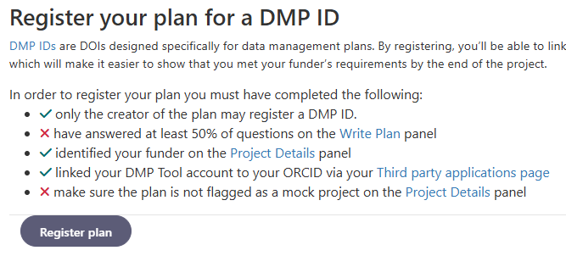
- Optional: Under the “Follow-Up” tab, add research outputs by entering a DOI or other URL based identifier. If you enter an DOI, make sure you start with “https://doi.org/”
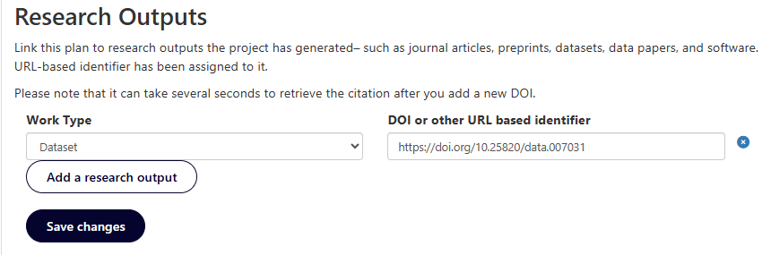

The instructions are created on April 6, 2026.

