|  |  |  |
| --- | --- | --- |
| **GeneLab SOP for Tissue homogenization using Bullet Blender Gold Bead Beater** | Document No.: | GL-SOP-2.1 |
| Version: | 1.0 |
| Created: | 01_08_2019 |
| Last revised: | 05_05_2020 |
| Last revised by: | Valery Boyko |

**Purpose/Scope:**

The procedure below describes the steps required to lyse and homogenize biological material using a Bullet Blender 24 Gold bead beater. This procedure was validated for downstream RNA/DNA extraction using the Qiagen AllPrep kits (SOP#3.1), it is also possible to use the procedure with downstream RNA extraction using Trizol (SOP#3.2).

**Equipment and consumables:**

1. Eppendorf Centrifuge 5424/5424 R
2. Styrofoam box and dissection tools (forceps, scalpel, scissors)
3. Bullet Blender 24 Gold (NextAdvanced Cat#BB24-AU)
4. Sterile Microcentrifuge Tube 1.5 mL RINO® (NextAdvanced Cat# TUBE1R5-S or Navy, Red, Green kits, refer to Table 1 to select appropriate tube/bead combination)

**Procedure:**

1. Obtain dry ice, it will be used to maintain a cold environment inside the bead beater.
2. Select the homogenization bead type, homogenization duration and homogenization speed setting based on the material processed, using the table below:

Table 1 Validated homogenization settings (preferred condition – bolded).

|  |  |  |  |  |
| --- | --- | --- | --- | --- |
| Tissue/Bead type | NAVY kit (Next Advanced #NAVYR5)/Speed setting | Zirconium Oxide 2.0mm (Next Advance #ZROB20-RNA)/Speed setting | Red kit (Next Advanced #REDR5-RNA)/Speed setting | SSB (Next Advanced #SSB14B-RNA) /Speed setting |
| Liver | **3min/12** | 3min/12 |  |  |
| Thymus | **3min/12** |  |  |  |
| Feces | **3min/12** |  |  |  |
| Colon | **3min/12** | 5min/12 |  |  |
| Lung |  | **3min/12** |  |  |
| Skin | TBD | TBD |  |  |
| Spleen |  | **5min/12** |  |  |
| Muscle |  |  |  | **5min/12** |
| Kidney | **3min/12** |  |  |  |
| Brain | 3min/10 |  | **3min/10** |  |
| Heart |  |  |  | **5min/12** |
| Lymph Nodes |  |  | **3min/10** |  |
| White Adipose |  |  | **3min/10** |  |
| Brown Adipose |  |  | **3min/10** |  |
| Reproductive Tract | **3min/12** |  |  |  |
| Adrenal Gland |  | **3min/12** |  |  |

* If using beads that are not part of the kit, use RINO tubes (Next Advance #TUBE1R5-S).
* Kits (Navy, Red, Green) have tubes pre-filled with beads.

1. Select a lysis buffer depending on the downstream extraction protocol used:

* If following SOP #3.1, on the day of the extraction prepare 600-800uL of QIAGEN buffer RLT + 1% b-ME per sample.
* If following SOP #3.2, on the day of the extraction prepare 600-800uL of TRIzol solution per sample.
* If following SOP #3.3, on the day of the extraction prepare 1000uL CTAB buffer per sample.

1. Pre-chill a centrifuge that can fit RINO tubes to 4°C (Suggested Eppendorf Centrifuge 5424/5424 R, this equipment will be used in the consecutive extraction SOP’s).

**Cooling of Bead Beater**

1. Fill the Bullet Blender Gold (BBG) side compartment with dry ice pellets or crushed dry ice.

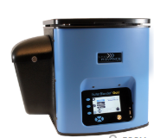

Figure 1- Ice compartment on the left

1. Pre-chill the bullet blender by closing the tube compartment and turning the BBG on for 5min at speed setting 12.
2. When the BBG is cold, a blue “4°C” indicator light will show on the front screen.

**Tissue handling**

1. Follow SOP#1.2 for tissue cutting procedures. When completed, you should have lysis tubes with a tissue ready.

**Homogenization**

1. Close the RINO tubes **tightly** and place them inside the pre-chilled BBG. Make sure to equally distribute the weight of the RINO tubes throught the rotor.

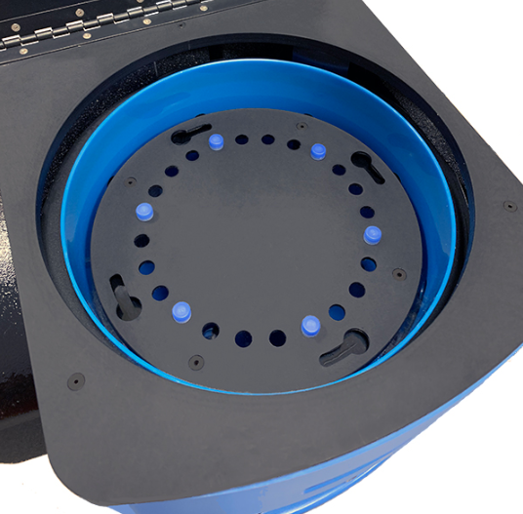

Figure 2- Example of a well balanced rotor with 6 sample tubes (in blue)

1. Homogenize the tissues following the speed and time setting indicated in Table 1.
2. Move RINO tubes with the homogenate into the centrifuge and spin for 5min at full speed in 4°C. {Full speed using Eppendorf 5424 is 21130 x g/15000 rpm.)
3. Carefully transfer lysate in to clean, labeled 1.5ml Eppendorf tube and proceed with SOP #3.1/3.2/3.3.

**Homogenizer cleaning**

1. Take out the dry ice pellets and return to storage.
2. Wipe the inside of the dry ice pocket and the tube rotor.