|  |  |  |
| --- | --- | --- |
| **GeneLab SOP for Feces DNA Extraction using Maxwell RSC instrument with Purefood GMO kit.** | Document No.: | GL-SOP-3.3 |
| Version: | 1.0 |
| Created: | 11_23_2018 |
| Last revised: | 05_05_2020 |
| Last revised by: | Valery Boyko |

**Purpose/Scope:**

The procedure below describes the steps required to isolate DNA from mouse fecal pellets using Maxwell RSC instrument with Purefood GMO kit.

**Reagents and consumables:**

1. Maxwell RSC Purefood GMO and Authentication kit (Promega, Cat#AS1600)
2. OneStep PCR Inhibitor Removal kit (Zymo Research, Cat#D6030)
3. NAVY stainless steel RNAse-free beads in RINO cap tubes (Next Advance, Cat#NAVYR5-RNA)
4. RNase/DNase Free Water (Thermo Fisher Scientific, Cat#10977023 or similar)
5. Dry ice
6. 1.5-2 mL RNase/DNase free Microcentrifuge tubes

**Equipment:**

1. Analytical scale
2. Eppendorf Centrifuge 5424/5424 R
3. Maxwell RSC instrument (Promega, Cat#AS4500)
4. Bullet Blender 24 Gold (NextAdvanced, Cat#BB24-AU)
5. ThermoMixer C (Eppendorf, Cat#2231000667)

Table top vortex(VWR, Cat#102091-234 or similar)

1. Bench top microcentrifuge to accommodate 1.5mL tubes (Thermo Scientific Cat#75004081 or similar)

**Procedure:**

1. Pre-heat the ThermoMixer to 95°C.
2. From Purefood GMO kit, add 1mL CTAB to NAVY tubes. Leave homogenization solution in tubes at RT.

2. Cut fecal pellet to about half on dry ice and weigh ranging 5-10mg.

3. Add pellet into homogenization solution and vortex for 30sec.

4. Heat sample mix at 95°C for 5min. Remove sample from heat and let cool for 2min.

5. Vortex thoroughly for 1min.

6. Homogenize using bead beater settings for feces, according to Tissue Homogenization SOP #2.1.

7. Add 40uL Proteinase K and 20uL RNase A and vortex vigorously to resuspend.

1. Place in heat block at 70°C for 10min.
2. Prepare Maxwell cartridges by adding kit cartridges to deck tray, 300uL lysis buffer to well 1, plunger to well 8.
3. Place 0.5mL sterile microfuge tube into deck tray, add 105uL RNase/DNase free water for elution and leave tube uncapped. 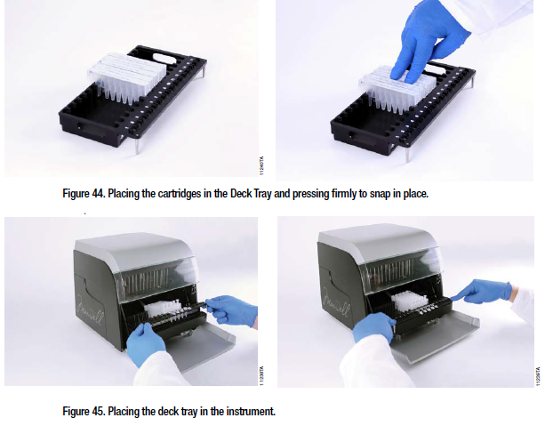
4. Centrifuge at 10,000 rpm for 5 min at RT to separate oil and solid.
5. Transfer 300uL clear (yellow) lysates to two cartridges in well 1.

13. Maxwell run:

a. Turn on Maxwell Instrument and Tablet PC.

b. Select **Start** to find Methods screen.

c. From Methods, select PureFood GMO and Authentication method.

d. Select **Proceed** to Cartridge setup.

e. Select cartridge position and enter sample name.

f. Insert deck tray when door prompted to open.

g. Select **Start** to begin extraction run.

1. Prepare OneStep cleanup columns:

a. Insert columns to collection tubes.

b. Add 600uL Prep Solution and centrifuge at 8,000 RCF for 3min.

c. Transfer columns to 1.5mL microcentrifuge tubes.

1. After extraction, add eluted DNA solution to OneStep columns and centrifuge at 16,000 RCF for 3min at RT.
2. Combine cleaned up DNA technical replicates into one tube.
3. Measure concentration by Qubit DNA BR according to SOP #4.1
4. Measure DNA Integrity Number (DIN) using TapeStation according to SOP #4.2
5. Dispose used cartridge reagent as biohazard waste.
6. Aliquote the samples following SOP#1.1