|  |  |  |
| --- | --- | --- |
| **GeneLab SOP for RNA/DNA/miRNA/cDNA quantification using Qubit Fluorimeter** | Document No.: | GL-SOP-4.1 |
| Version: | 1.0 |
| Created: | 01_10_2019 |
| Last revised: | 05_06_2020 |
| Last revised by: | Valery Boyko |

**Purpose/Scope:**

This procedure describes the steps required to perform quantification of RNA/DNA or cDNA using the Invitrogen (Thermo Fisher Scientific) fluorimeter – Qubit and the Qubit kits. Flourimetric methods are advantageous over spectrophotometric methods since they are more precise and specific to the molecule being measured.

**Equipment and consumable:**

1. Qubit Assay optical tubes (Thermo Fisher Scientific, Cat#Q32856)
2. DNA LoBind Microcentrifuge Tubes1.5mL (Thermo Scientific, Cat#13-698-791)
3. Kimwipes (Fisher Scientific, Cat#06-666 or similar)

**Reagents:**

1. One of the following Qubit assays:
   1. Qubit RNA BR Assay Kit (Thermo Fisher Cat#Q10210/Q10211)
   2. Qubit RNA HS Assay Kit (Thermo Fisher CatQ32852/Q32855)
   3. Qubit dsDNA BR Assay Kit (Thermo Fisher CatQ32850/Q32853)
   4. Qubit dsDNA HS Assay Kit (Thermo Fisher Cat#Q32851/Q32854)
   5. Qubit miRNA Assay Kit (Thermo Fisher Cat#Q32880/Q32881)
   6. Qubit 1X dsDNA HS Assay Kit (Thermo Fisher Cat#Q33231/30 – preferred for cDNA library quantification)

* All kits listed come with the appropriate standards.
* Choose a kit based on the type of extract is being quantified and the Quantifiable Range of the kits presented in **Figure 1.**

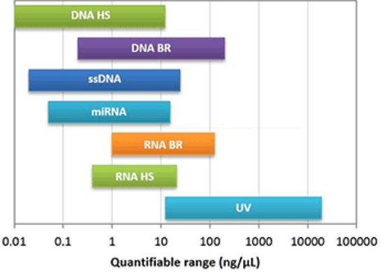

Figure 1 Comparison of sample concentration ranges for the Qubit Assays

1. RNAseZap decontamination solution (Thermo Fisher Scientific, Cat#AM9780 or Cat#AM9782 or Cat#AM9784 or similar)

**Procedure:**

* Store all kit reagents at RT and insert all assay tubes into the instrument only for as much time as it takes the instrument to measure the fluorescence.

Make sure that the Qubit had been calibrated for the specific assay within the last month. If calibration is required, refer to **Appendix A.** If no calibration required, proceed with sample preparation steps below.

**Preparing samples**

* If working with more than 32 samples, consider conducting the measurement in 2 batches to avoid photobleaching of the dye in the solution while the samples are incubating.

1. Set up a Qubit assay tube for each sample by labeling the tubes and arranging them on a tube rack.
2. Prepare Qubit working solution by diluting the Qubit dye in Qubit buffer at 1:200 ratio. Prepare 200ul of working solution for each sample. Include 10% overage to account for pipetting bias.
3. Into each of the assay tubes combine 198uL of working solution prepared in step 2 with 2uL of appropriate sample:
   1. Add 198uL of Working solution to all qubit tubes.
   2. To obtain precise measurement of concentration, the ratio of working solution to sample has to be exact. **Optional step**: Using a pipette, measure a few selected working solution tubes from step 3a to make sure that the volume is precisely 198uL.
   3. Add 2uL of test sample into their designated tube with working solution.
4. Vortex tubes for 3sec.
5. Incubate the tubes for 2 min at RT. Keep away from light.

**Reading samples**

1. On **home** screen, press the **assay type** for which you wish to read new standards.
2. Select the desired **assay**.
3. Press **Run samples**
4. In the sample volume screen, select the sample volume and the desired units:
   1. Press +/- buttons to select volume added to the assay tube. (1-20uL)
   2. From drop down menu select the desired units for the output sample concentration
5. Insert sample tube into the sample chamber, close the lid, and press “**Read tube**”.
   * Reading results will be displayed on the “Results screen”. Record the results.
   * If the results are within assay’s range, the concentration will be displayed in large font in the middle of the screen. This value is the concentration of the original sample.
   * Bottom value in smaller font is the diluted concentration (conc. Of the sample in the tube)
   * If the results are outside of the assay’s range, an “Out of Range” message is displayed. In this case, swipe right to view the Fluorescence vs. concentration graph:
     + Open circles represent the standards
     + Yellow circles represent samples that fall within the assay’s extended range
     + Red circles represent samples that fall outside the assay’s range.
   * Identify if the sample is too high or too low for the assay and select an alternative kit/dilute the sample with RNase/DNase free water.
6. Remove current sample, insert new sample and repeat the procedure.

**Appendix A**

Qubit Calibration using kit provided Standards

1. On **home** screen, select the **assay type** for which you wish to read new standards.
2. Select the desired **assay**.
3. Check the date below the “Read Standards” button.
   1. If Qubit was last calibrated within the last month, proceed with reading the samples using the previous calibration.
   2. If Qubit was last calibrated more than a month ago, proceed with step 4.
4. Select Read Standards.

**Reading new standards for calibration**

1. Prepare the standards:
   1. Label 2 Assay tubes for the standards: std1, std2.
   2. Prepare Qubit working solution by diluting the Qubit reagent 1:200 in Qubit buffer. Prepare 200ul of working solution for each standard and sample.
   3. In to each of the assay tubes combine 190uL of working solution from step 5.b. with 10uL of appropriate Standard.
   4. Vortex tubes for 3sec
   5. Incubate the tubes for 2 min at RT. Keep away from light.
2. At the prompt, insert **Standard #1** into the sample chamber and press **Read standard**.
3. At the prompt, insert **Standard #2** into the sample chamber and press **Read standard**.
4. The calibration is complete.
   * If the calibration was successful, the software will display the Read standard screen, showing a Fluorescence vs. Concentration graph.
   * The standard data points will be connected by a straight line and open circled will represent correct standards.
   * If calibration is not successful, the software will display the “Calibration error”. In this case, press “**OK**” and repeat step 5-7.