|  |  |  |
| --- | --- | --- |
| **GeneLab SOP for qPCR quantification of Illumina sequencing libraries** | Document No.: | GL-SOP-6.1 |
| Version: | 1.0 |
| Created: | 08_21_2018 |
| Last revised: | 02_24_2020 |
| Last revised by: | Valery Boyko |

**Purpose/Scope:**

This SOP describes the steps used by NASA GeneLab for qPCR quantification of Illumina Sequencing libraries using a QIAgility.

**Equipment:**

1. Qiagen 990512 Conducting filter-tips, 50 ul (960)
2. 96-well semi skirted plate
3. Tabletop centrifuge and vortex mixer

**Reagents:**

1. Kapa KK4873 *– 07960336001* ROX Low qPCR Master Mix

*or*

Kapa KK4824 *– 07960140001* Universal qPCR Master Mix

1. These both contain DNA standards (1-6), Primer Mix (1 mL), KAPA SYBR® FAST qPCR Master Mix (5 mL). The universal contains ROX High and ROX Low to be added separately, the ROX Low has the ROX Low already added.
2. Library pool(s) diluted to 1:10,000, 1:20,000, 1:100,000, 1:200,000 according to GL-SOP-002.2 in 1.5 ml tapered tubes

**For 1 library pool:**

Requires 34, 50 ul tips

650 ul 2x Mix

70 ul water

41 ul each of 6 standards

30 ul each of 4 dilutions

**For 2 library pools:**

Requires 46, 50 ul tips

866 ul 2x Mix

70 ul water

41 ul each of 6 standards

30 ul each of 4 dilutions of each library

**For 3 library pools:**

Requires 58, 50 ul tips

1085 ul 2x Mix

70 ul water

41 ul each of 6 standards

30 ul each of 4 dilutions of each library

**For 4 library pools:**

Requires 70, 50 ul tips

1303 ul 2x Mix

70 ul water

41 ul each of 6 standards

30 ul each of 4 dilutions of each library

**Procedure:**

1. Thaw all components at room temperature for 15 min.
2. Vortex all components until well mixed.
3. Centrifuge until all droplets are collected.
4. Set-up QIAgility deck:

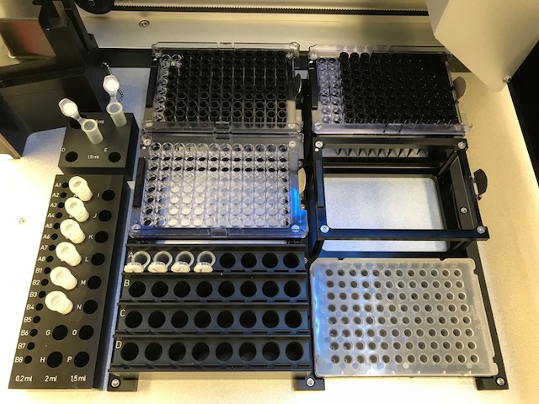

M1: Master Mix Block:

648 (or appropriate volume) 2x reaction mix in tapered tube in position B

70 ul water in tapered tube in position C

A1: 50 ul conductive tips

A2: (optional): 200 ul conductive tips

B1: (optional): 50 ul conductive tips

B2: (optional): 50 ul conductive tips

R1: Reagent block with 41 ul of each standard in position A - F

C1: Flip cap block with 30 ul of each library dilution at A1 - A4 (continuing in groups of 4 with more libraries)

C2: 96 sample qPCR plate

**Set-up QIAgility**

1. Start the QIAgility set-up manager.
2. Click on the appropriate template (e.g. 1 Lib Quant).
3. Click Assignment and select 3 for the number of replicates and then click assign.
4. Click Worktable.
5. Click each gold worktable box and confirm loading.
6. Click the green Start run button to begin the run.
7. Following the run, generate a report and save in the Reports folder.

**Clean-up QIAgility**

1. Remove samples, standards and reagents from QIAgility deck and store or dispose of them properly.
2. Close the lid.
3. Turn off QIAgility by clicking File > Exit and following prompts.
4. Turn off the computer.

**Run qPCR**

1. Seal the plate (details TBD).
2. Run the qPCR (details TBD).
3. Analyze the data (details TBD).

|  |  |  |  |
| --- | --- | --- | --- |
| Dilutions | |  |  |
|  | Serial dilution on both pools: | | |
| Dilution | Sample vol. | Buffer vol. |  |
| (1:10) | 1 | 9 |  |
| (1:100) | 2 | 18 |  |
| (1:1000) | 2 | 18 |
| (1:10,000) | 10 | 90 |
| (1:2) | 20 | 20 |
| (1:100,000) | 10 | 90 |  |
| (1:2) | 20 | 20 |  |