Paper Title

X. Y. Author1*, X. Y Author2, X. Y. Author1

1 University/Company, Institute/Department/Division, Zip code, City, Country

2 University/Company, Institute/Department/Division, Zip code, City, Country

* corresponding.author@example.com

Abstract

This section must have approximately 250 to 500 words. Utilize Times New Roman font, size 11.

***Keywords***: Keyword1; Keyword2; Keyword3; Keyword4;

1. Introduction

Please use this template to create your final full-length paper, which should be between 6 and 10 pages in length. Do not include page numbers, as these will be assigned later in the symposium proceedings document. Please submit the PDF file following the ***submission instructions*** in the XXV ISSSD event on the Asystos system (tutorial available, see in the document *“Instructions for Submission”*). **The evaluation is a double-blind peer review, so it is important to guarantee anonymity, therefore authors' names and affiliations should be OMITTED in the submitted version (and in all revisions) and added only in the “Final Version” of the** **ACCEPTED paper**. Submission of the full paper must be done within the established deadlines. The PDF (only PDF is accepted) file should have a unique name, e.g. “*XXVISSSD_shortTitle.pdf*”.

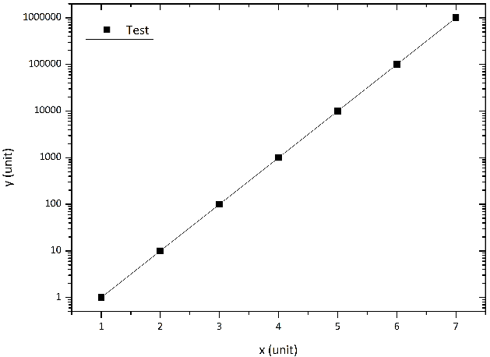Figure 1: This is a test figure.

Figure 1 is an example of a figure. An example for a subfigure is shown in Figure 2(a).

Here are three examples of citations for a book, conference proceeding and journal article: Adrian and Westerweel (2011), (Adrian and Westerweel, 2011), Discetti et al. (2015), (Discetti et al., 2015), and Christensen (2004), (Christensen, 2004). Please use the provided bibliography style which is loaded in the provided document class file. If you need to include greek symbols in the text use Symbol instead of Times New Roman, i.e.      etc., as in Equation 1.

$y=m∙x+t$ (1)

(a) (b)

Figure 2: Two test figures. Please try to match the font sizes in the figures with the text. (a) Test figure. (b) Test figure.

2 Main Part 1

Main Part 1. Main Part 1. Main Part 1. Main Part 1. Main Part 1. Main Part 1. Main Part 1. Main Part 1. Main Part 1. Main Part 1. Main Part 1. Main Part 1. Main Part 1. Main Part 1. Main Part 1. Main Part 1. Main Part 1. Main Part 1. Main Part 1. Main Part 1. Main Part 1. Main Part 1. Main Part 1. Main Part 1. Main Part 1. Main Part 1. Main Part 1. Main Part 1. Main Part 1. Main Part 1. Main Part 1. Main Part 1. Main Part 1. Main Part 1. Main Part 1. Main Part 1.

2.1 Sub-Main Part 1

Sub-main Part 1. Sub-main Part 1. Sub-main Part 1. Sub-main Part 1. Sub-main Part 1. Sub-main Part 1. Sub-main Part 1. Sub-main Part 1. Sub-main Part 1. Sub-main Part 1. Sub-main Part 1. Sub-main Part 1. Sub-main Part 1.

Table 1: Table Example.

|  |  |  |
| --- | --- | --- |
| **Sample** | **Volume**  **(cm3)** | **Temperature**  **(oC)** |
| Green | 2.2 ± 0.1 | 123 ± 3% |
| Yellow | 0.25 ± 0.04 | 2.5 ± 1.2% |

3 Main Part X

Main Part x. Main Part x. Main Part x. Main Part x. Main Part x. Main Part x. Main Part x. Main Part x. Main Part x. Main Part x. Main Part x. Main Part x. Main Part x. Main Part x. Main Part x. Main Part x. Main Part x. Main Part x. Main Part x. Main Part x. Main Part x. Main Part x. Main Part x. Main Part x. Main Part x. Main Part x. Main Part x. Main Part x. Main Part x. Main Part x. Main Part x. Main Part x. Main Part x.

4 Conclusions

Conclusion. Conclusion. Conclusion. Conclusion. Conclusion. Conclusion. Conclusion. Conclusion. Conclusion. Conclusion. Conclusion. Conclusion. Conclusion. Conclusion. Conclusion. Conclusion. Conclusion. Conclusion. Conclusion. Conclusion. Conclusion. Conclusion. Conclusion. Conclusion. Conclusion. Conclusion. Conclusion. Conclusion. Conclusion. Conclusion. Conclusion. Conclusion. Conclusion. Conclusion. Conclusion. Conclusion. Conclusion. Conclusion.

Acknowledgements

Put acknowledgments here.

References

In this section include the references alphabetically

Adrian R. J. and Westerweel J. (2011) *Particle image velocimetry*. Cambridge University Press

Christensen K. T. (2004) The influence of peak-locking errors on turbulence statistics computed from PIV ensembles. *Experiments in Fluids* 36:484–497

Discetti S., Agüera N., Cafiero G., and Astarita T. (2015) Ensemble 3D PTV for high resolution turbulent statistics. in *11th International Symposium on Particle Image Velocimetry* *- PIV15, Santa Barbara, California, USA, September 14-16*