TA Recruitment System
User Manual
BUPT International School TA Hiring System (tapj)
Version 1.0 — 2026

Table of Contents
1. Getting Started — Login & Registration
2. TA User Guide (ta.html)
3. MO User Guide (mo.html)
4. Admin User Guide (admin.html)
5. Messaging Center (message.html)
6. AI Career Advice (suggestion.html)
7. Troubleshooting

1. Getting Started — Login & Registration
Entry page: index.html (welcome page) or login.html (standalone login).
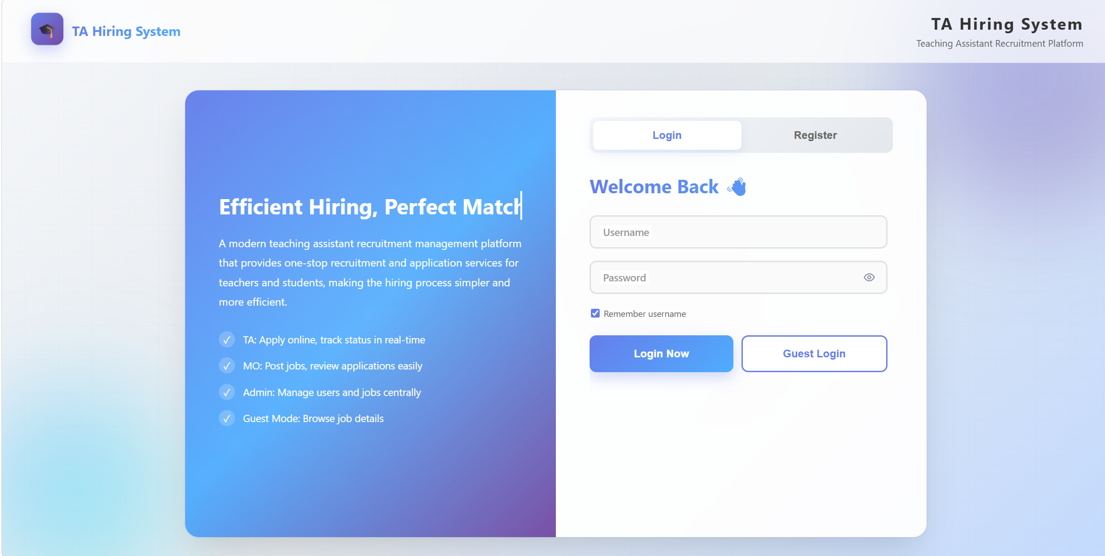

Registering a new account
- On index.html, click the Register tab.
- Choose your role from the dropdown: TA or MO. (Admin accounts must be created by an existing administrator.)
- Fill in the required fields (marked with *):
- Username (must be unique) and Password
- Real name, email
- TA-only: Student ID, Major, Education, Grade
- MO-only: Staff ID, Department
- Click Register Now. On success, you are logged in automatically and redirected to your role's home page.
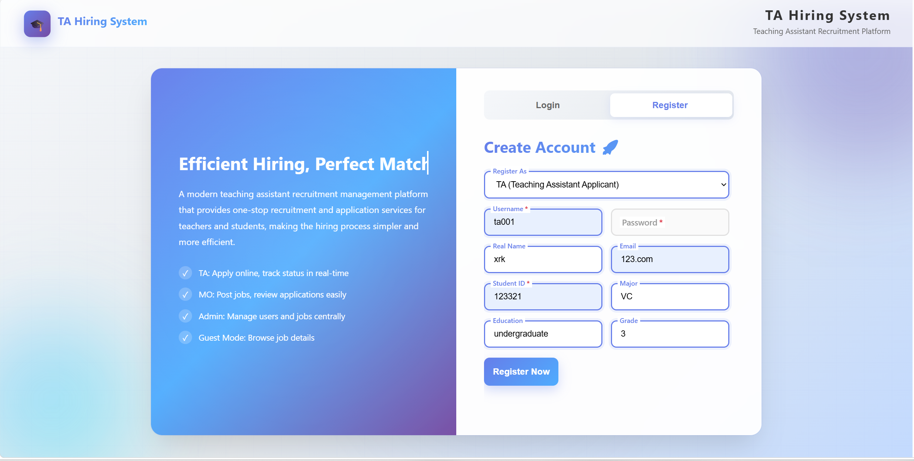

Logging in
- Enter your username and password on the Login tab.
- (Optional) Tick "Remember username" to save your username for next time.
- Click Login Now or press Enter.
- The system automatically redirects you based on your role: TA → ta.html, MO → mo.html, Admin → admin.html.

Login page features
Feature | How to use
Show / Hide password | Click the eye icon next to the password field
Caps Lock warning | Auto-displayed if Caps Lock is on while typing password
Remember username | Tick the checkbox; username is saved locally
Guest Login | Click Guest Login to browse jobs without registering
Auto-redirect | If a session is active, you are redirected immediately

2. TA User Guide
Page: ta.html — your home page after logging in as a Teaching Assistant.
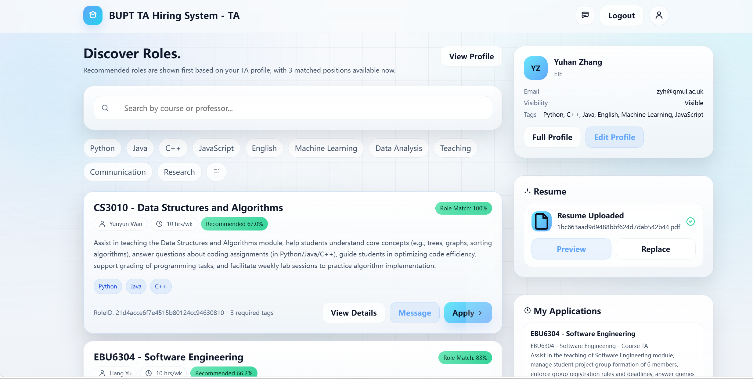

Top navigation
Icon / Button | Action
✉ Message icon | Open the messaging center
👤 Avatar icon | View and edit your profile
Logout | End your session

Browsing roles
- The main panel shows recommended jobs first (matched to your tags & skills), then all other open positions.
- Each card shows: course/module, required skills, weekly workload, deadline, and a match percentage.
- Click View Details on any card to open the full description.
- Use the search bar to filter by course or professor.

Applying for a position
- Click View Details on a job card.
- Scroll to the Submit Application section in the modal.
- Tick the relevant checkboxes (taken course before, can attend in-person).
- (Optional) Add notes explaining why you're a good fit.
- Click Submit Application. Track status in the right sidebar.
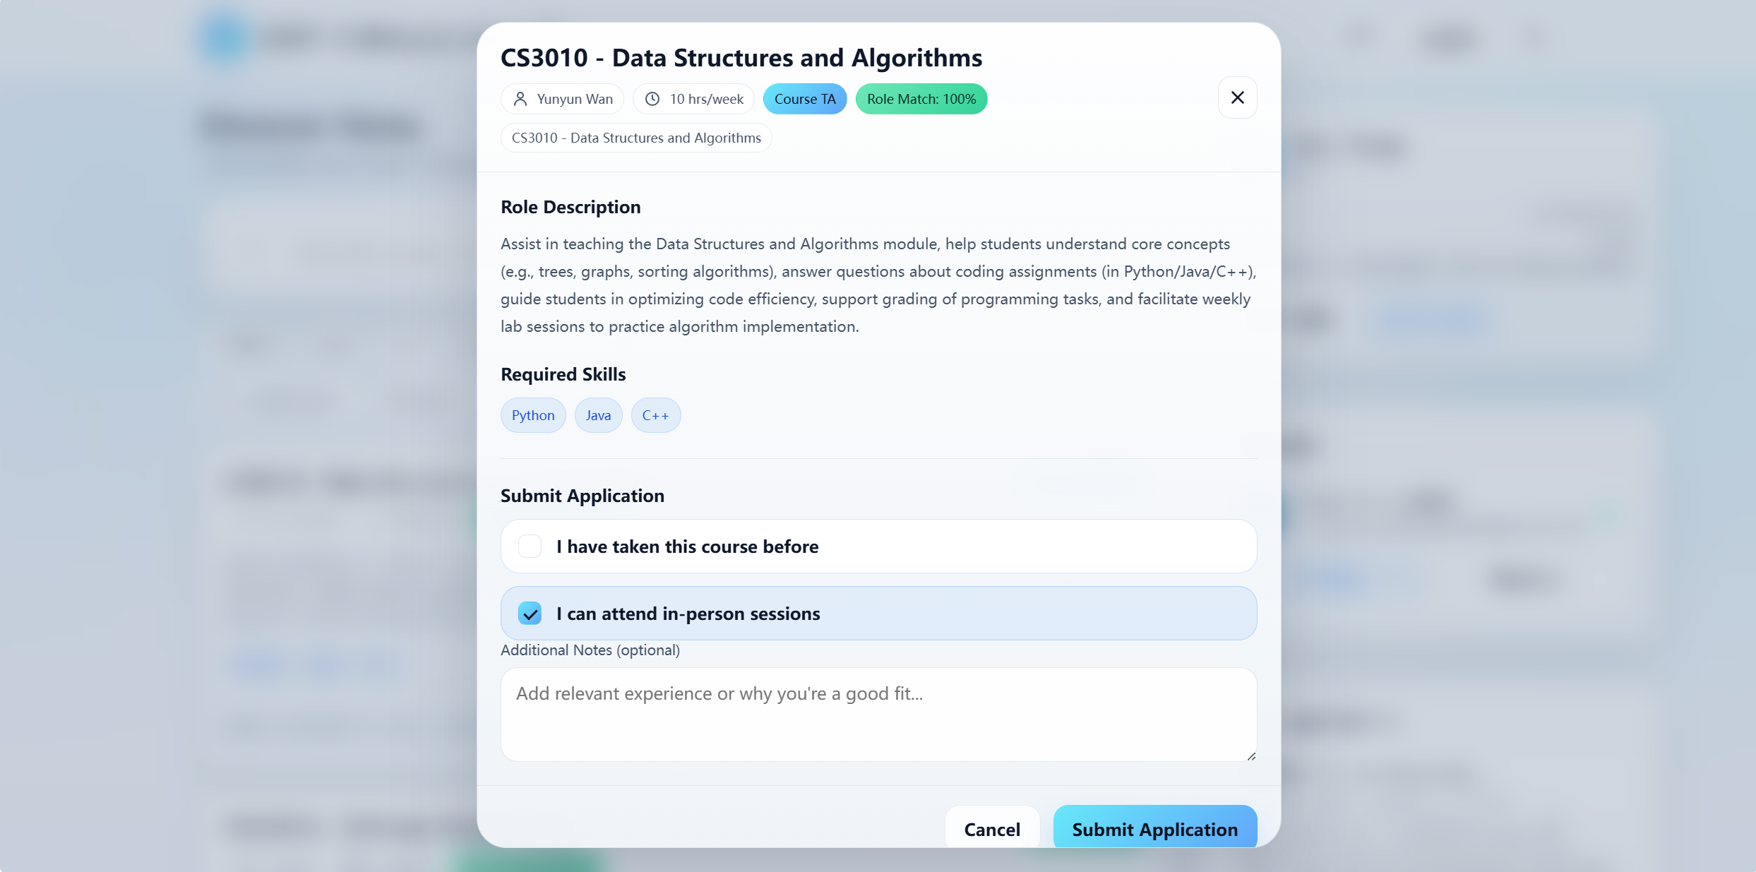

Editing your profile
- Click your avatar (top-right).
- Update name, email, major, bio, and skill tags.
- Toggle visibility to allow MOs to discover you.
- Click Save Changes.
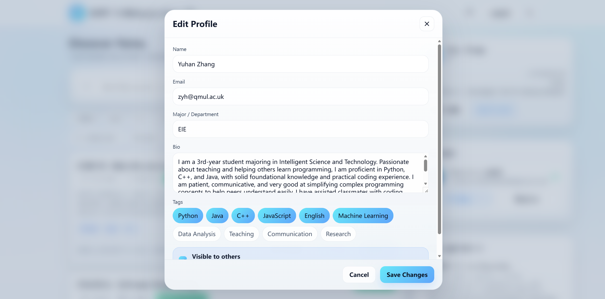

Resume management
- Upload Resume — attach a PDF in the profile modal.
- Preview Resume — open in built-in viewer.
- Replace File — upload a new version to overwrite.

AI features for TAs
- Recommendation Center — top-matched jobs sorted by AI score (recommend.html).
- AI Career Advice — personalized guidance on suggestion.html (see Section 6).

3. MO User Guide
Page: mo.html — your home page after logging in as a Module Organizer.
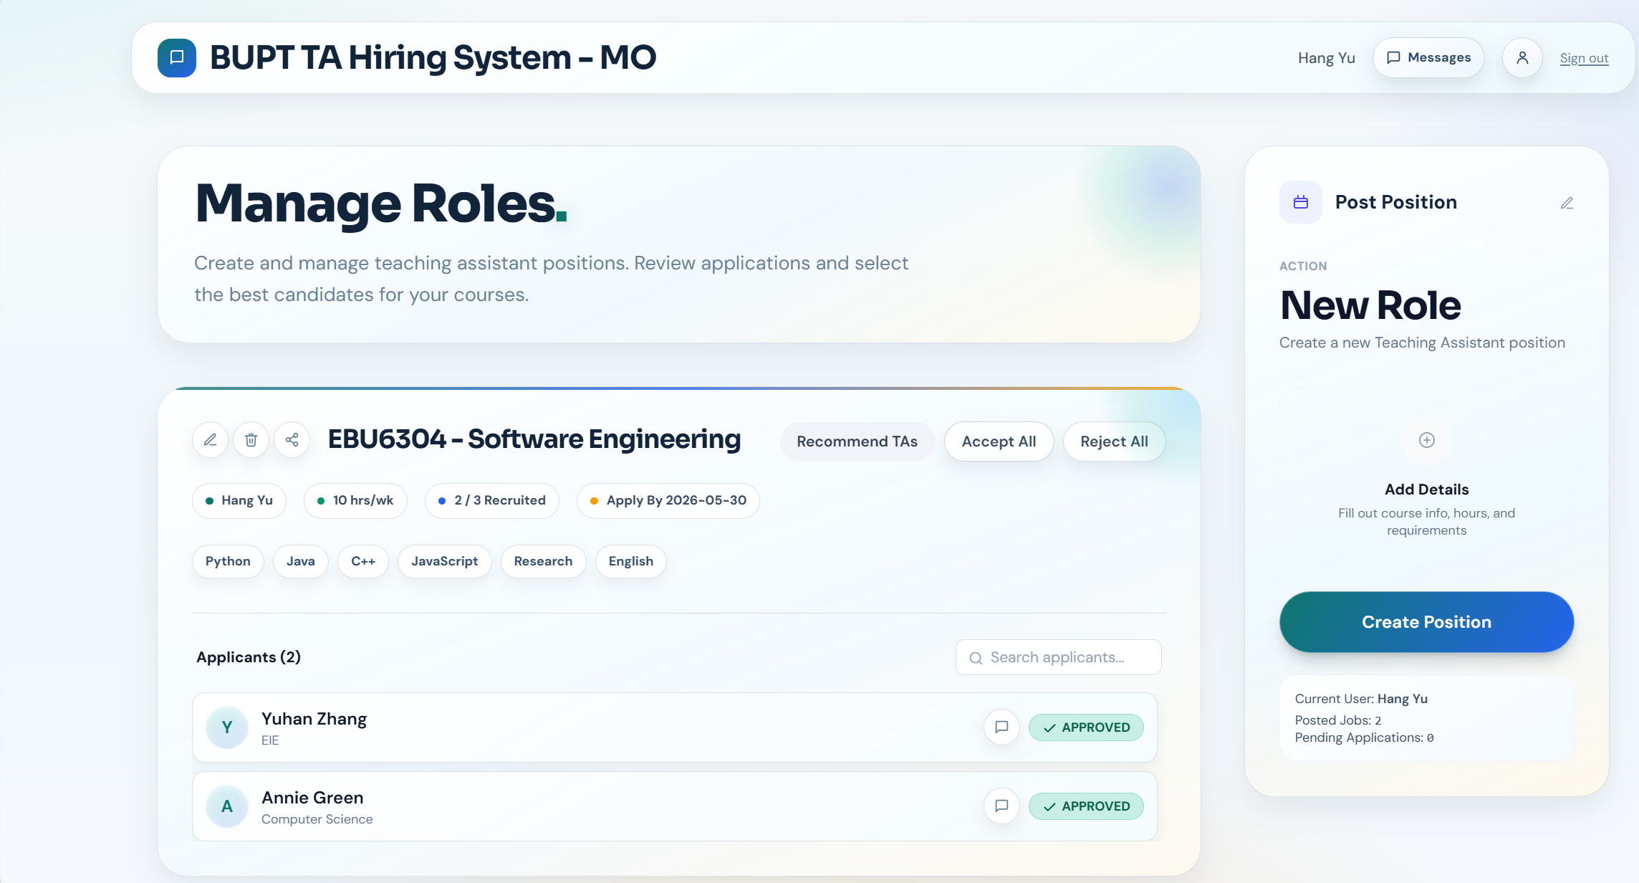

Posting a new position
- Click + Post Position in the header.
- Fill in the modal form:
- Position title (e.g. "CS101: Intro to Programming TA")
- Belongs to module
- Job description — responsibilities and requirements
- Weekly work hours, recruit number, deadline, tags
- Click Post Position. The job is immediately visible to TAs.
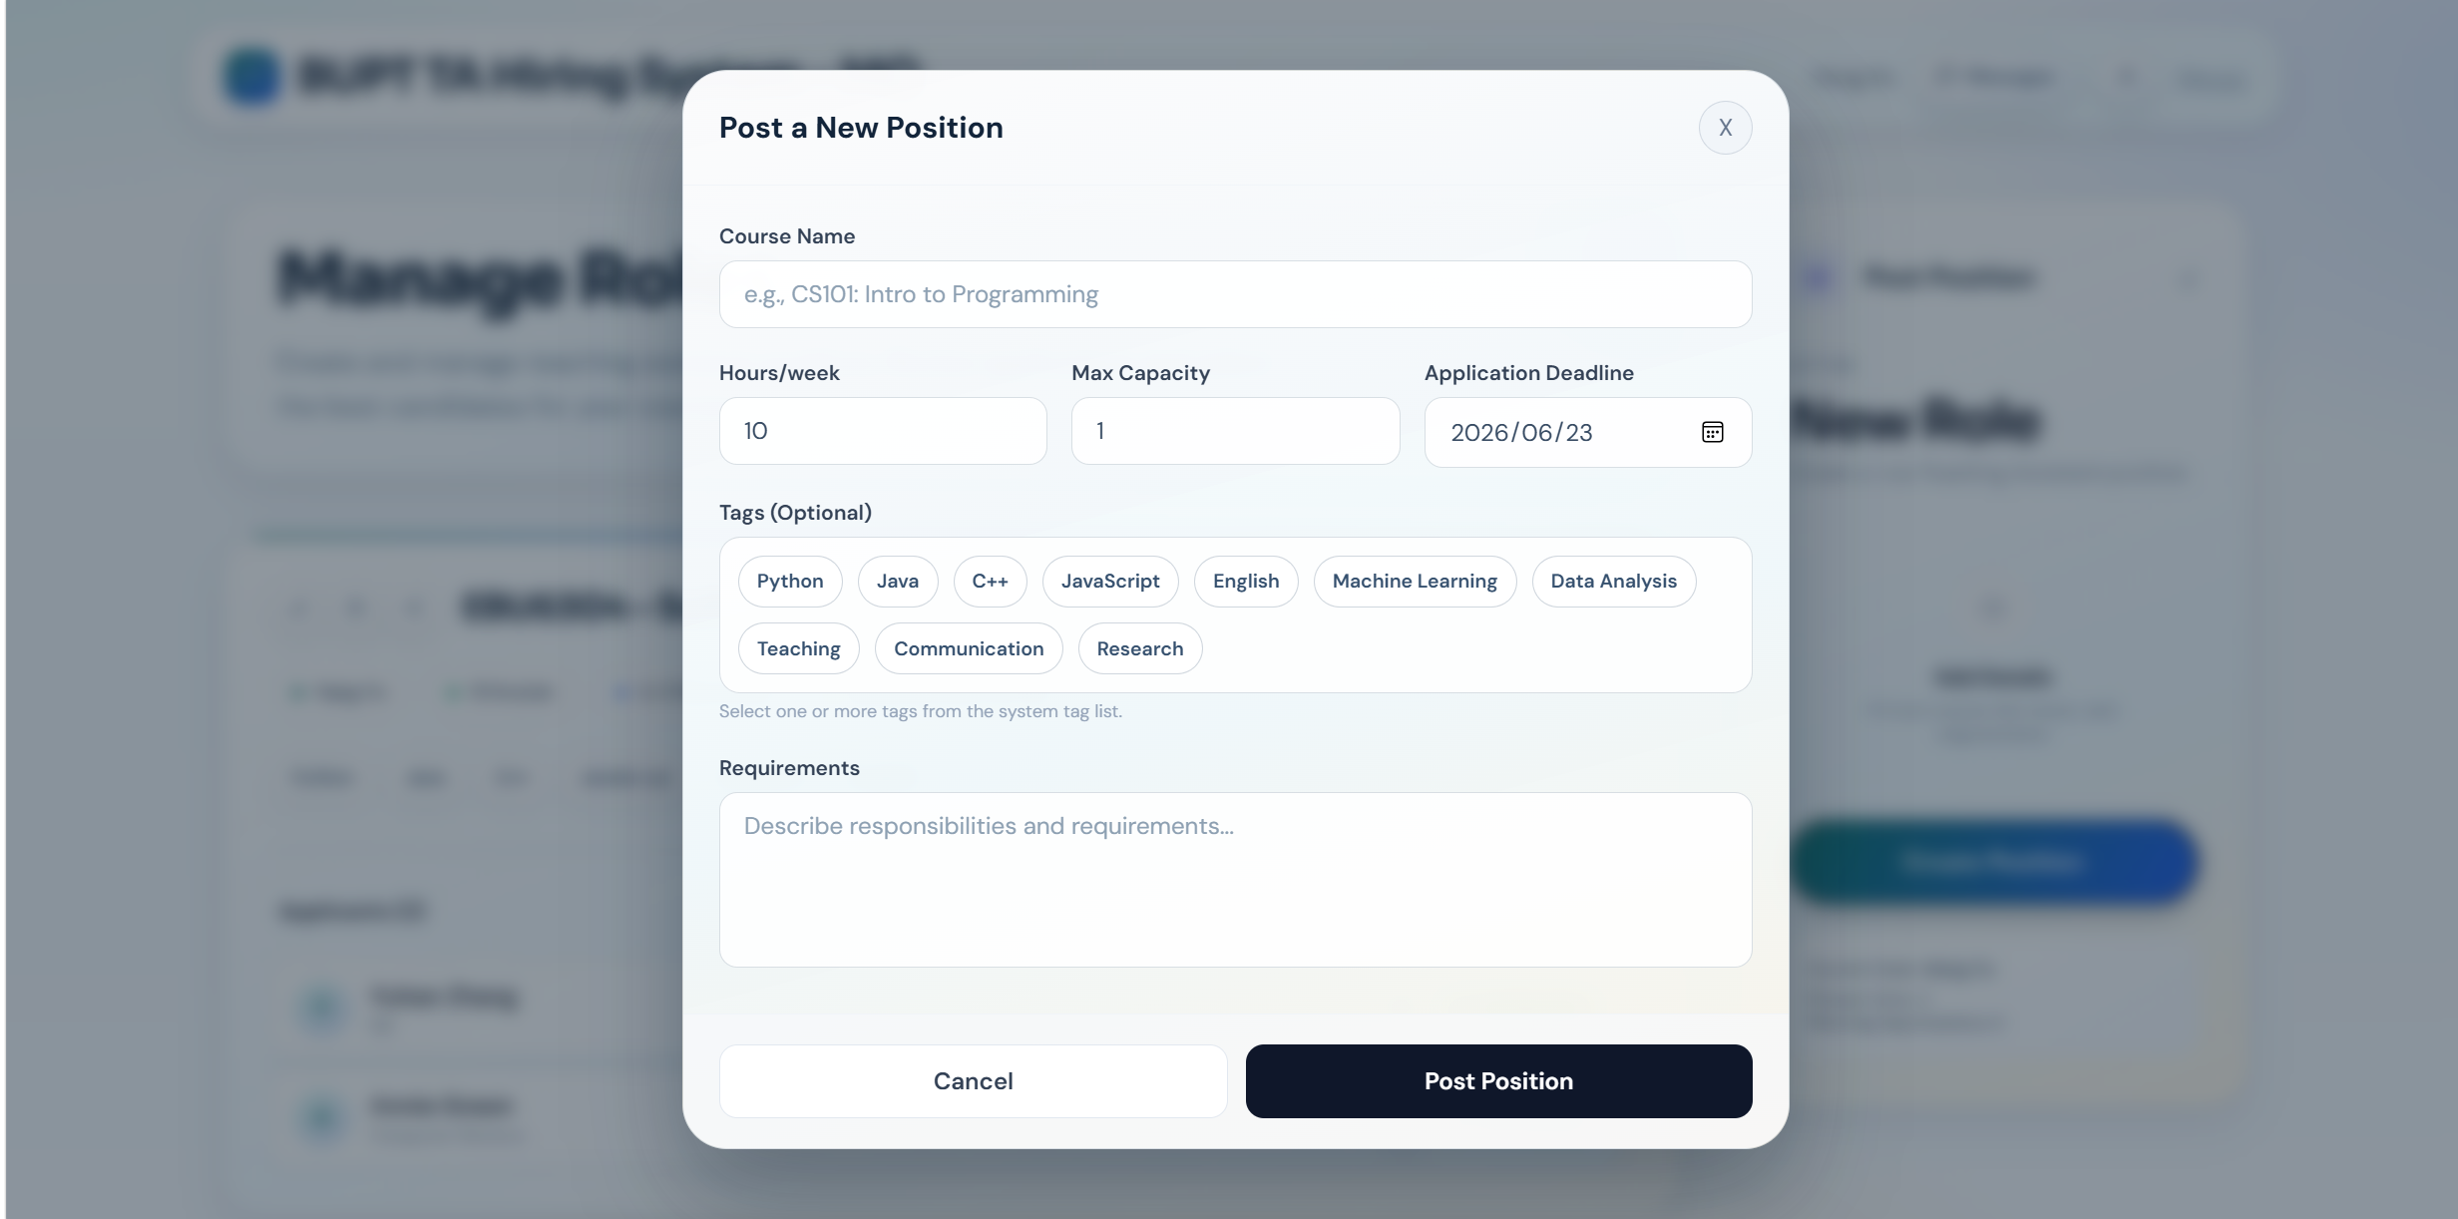

Managing your positions
Action | Description
View Applicants | See all TAs who applied for this position
Edit | Open the post form pre-filled to modify details
Close / Delete | Stop further applications or remove the post (cascades to applications)

Reviewing applications
- Click View Applicants on a position.
- Click any TA to open their Applicant Profile.
- Choose an action:
- Approve — application status → Approved; hired count increases. Position auto-closes when quota is filled.
- Reject — application status → Rejected.
- Send Message — open chat with the applicant (jumps to message.html pre-filled).
- (Optional) Add a remark before approving/rejecting.
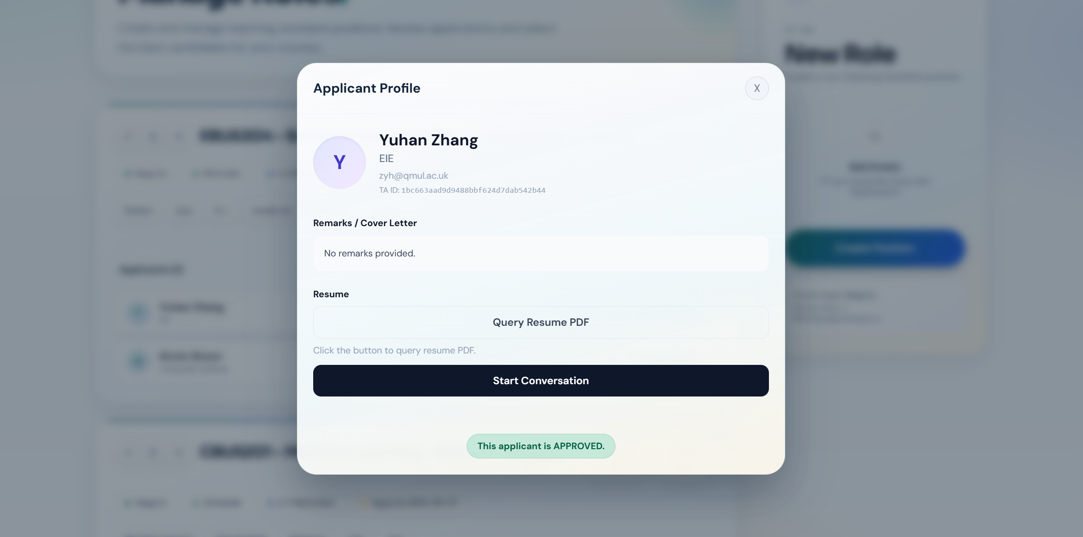

Recommendations for MOs
Click Recommend TAs (or visit recommend.html) to get an AI-ranked list of best-matching candidates for any of your positions.

4. Admin User Guide
Page: admin.html — only accessible to users with administrator privileges.
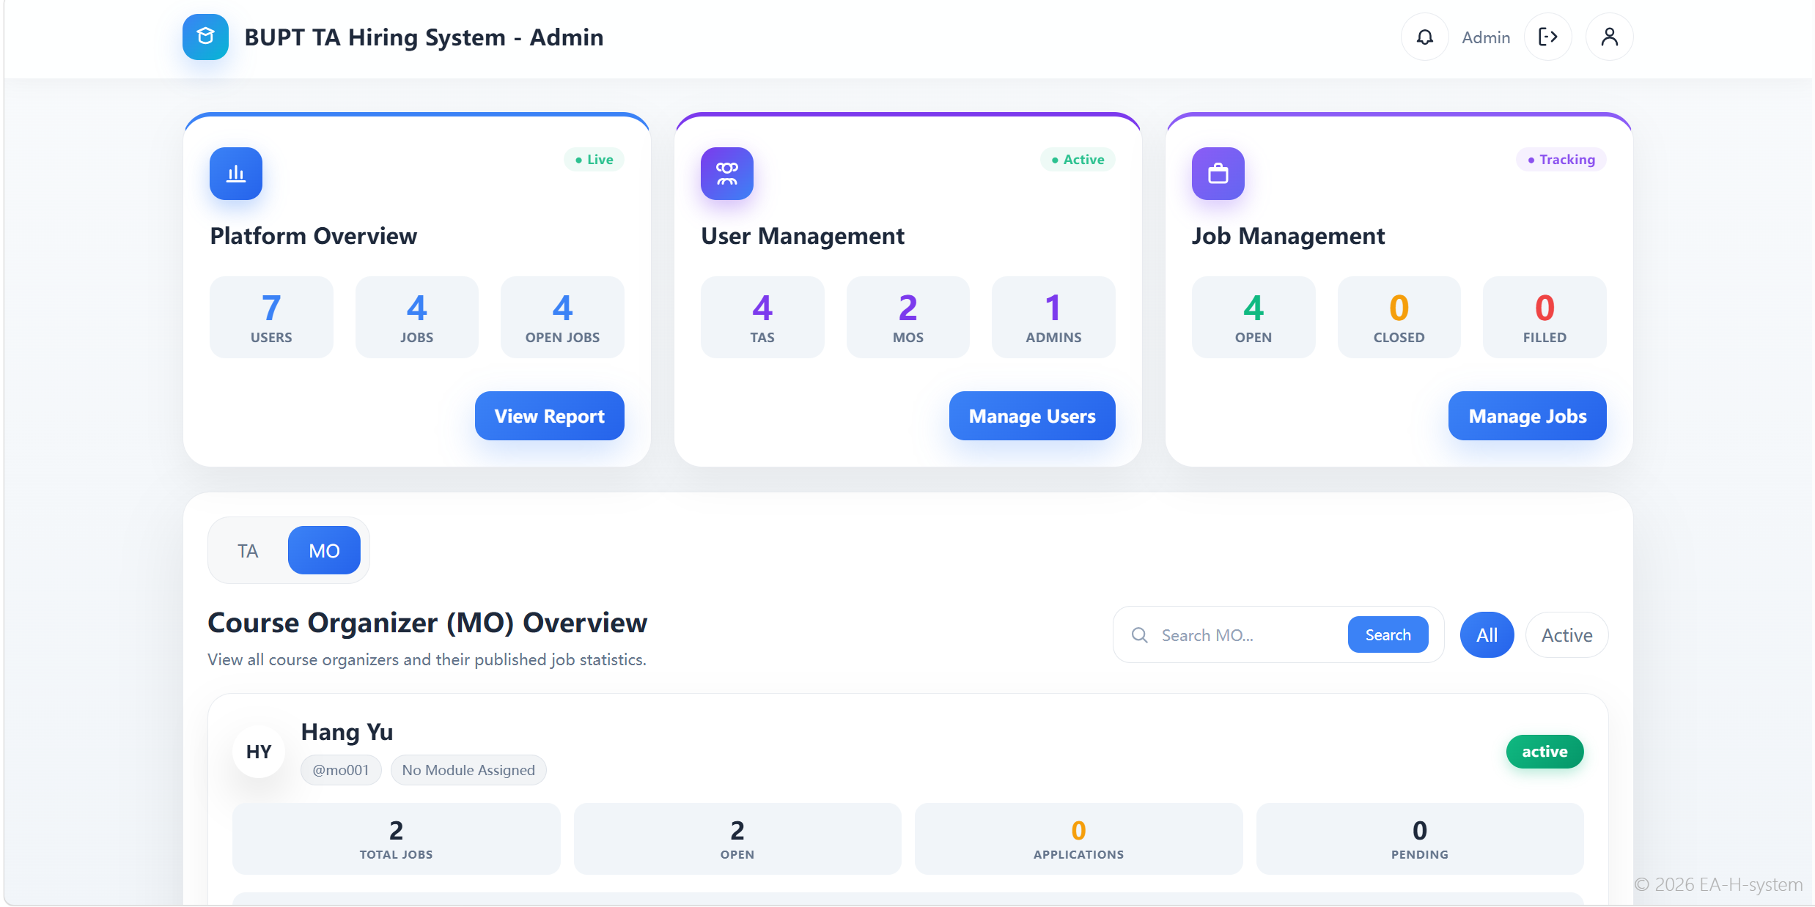

Dashboard sections
- System Statistics Report — aggregate counts of users, jobs, and applications.
- System Users Management — full list of registered users.
- Role Change Requests — review and approve/reject pending role changes.
- All Jobs Management — view and moderate every posted position.

Managing users
- The user table shows username, real name, role, email, and registration date.
- Click a row to open Teaching Assistant Details (or MO/Admin details).
- Delete a user — removes their account and cascading data. This action cannot be undone.
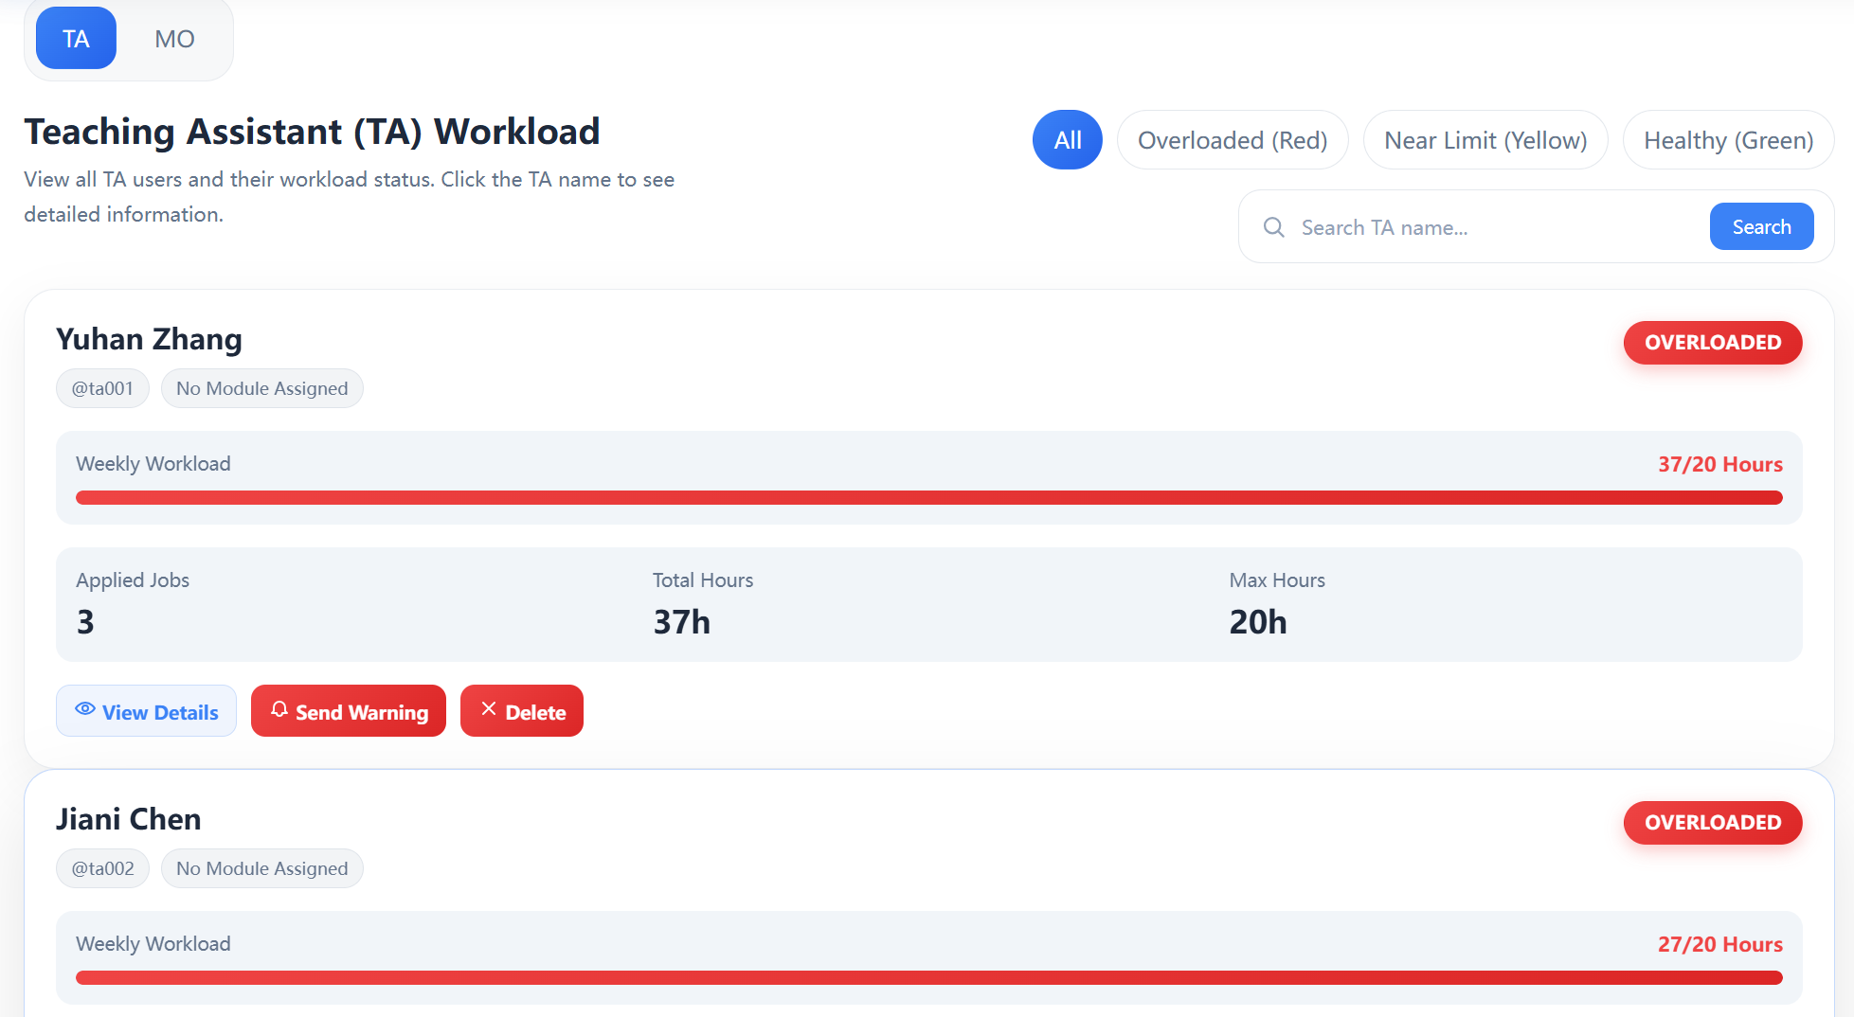

Managing jobs
- The job table lists every position from every MO.
- Click a job to view its details and applicant list.
- Delete a job — removes the position and all associated applications.

Best practices
- Verify user identities before approving role changes.
- Before deleting a user, check pending applications or active positions.
- Use the statistics dashboard to monitor recruitment health each semester.

5. Messaging Center
Page: message.html — accessible from the ✉ icon on any role's main page.
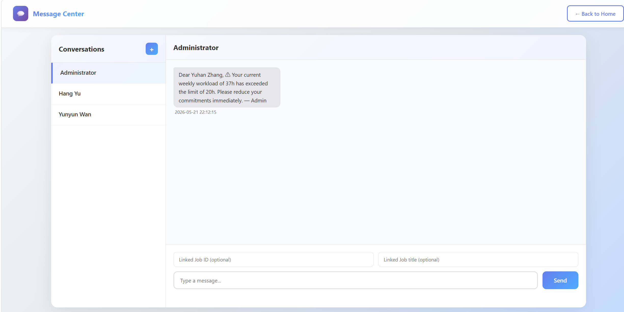

Layout
- Left panel — your conversation list. A red dot marks unread messages.
- Right panel — the active chat window with the selected user.

Starting a new conversation
- Click the + button at the top of the conversation list.
- Enter the recipient's User ID and a name/note.
- Click Start Chat.
Tip: Clicking "Send Message" on an applicant card or job poster card auto-fills the recipient — no manual ID lookup needed.

Sending a message
- Click any conversation in the left list.
- (Optional) Fill in Linked Job ID and Linked Job title for context.
- Type your message — maximum 500 characters (counter appears above 400).
- Press Enter to send, or click Send. Use Shift+Enter for line break (future).

Reading messages
- Opening a conversation marks all its unread messages as read.
- The unread badge in the top bar updates automatically.
- Press ESC to close any open dialog.

6. AI Career Advice
Page: suggestion.html — TA-only feature that generates personalized application advice using AI (DeepSeek).
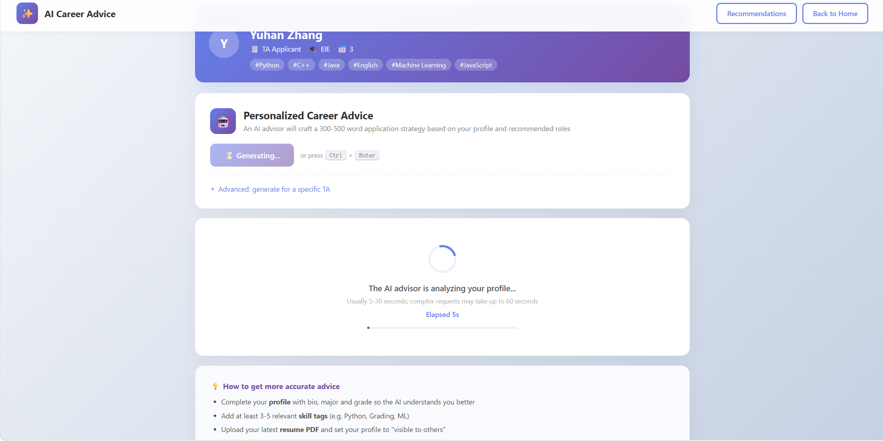

What it does
The AI advisor analyzes your profile (major, grade, tags, self-introduction) and your top recommended jobs, then produces 300-500 words of tailored career guidance — covering competitive strengths, application strategy, and skills to improve.

Generating advice
- Open suggestion.html (entry from the TA home page).
- The page automatically generates your first piece of advice if no cached result exists.
- To regenerate, click "✨ Generate Advice" or press Ctrl + Enter.

Reading the result
- The result card shows formatted advice with headings, bullets, bold text.
- Top of result: timestamp, word count, your name, freshness badge (Just generated / Cached).
- Loading time: typically 5-30 seconds — a live timer shows elapsed seconds.

Saving / sharing your advice
Button | Action
📋 Copy | Copy plain text to clipboard
⬇ Download | Save as a Markdown file: suggestion_<name>_<date>.md
🖨 Print | Open the print dialog (or "Save as PDF")
🔄 Regenerate | Run the AI again for a fresh perspective

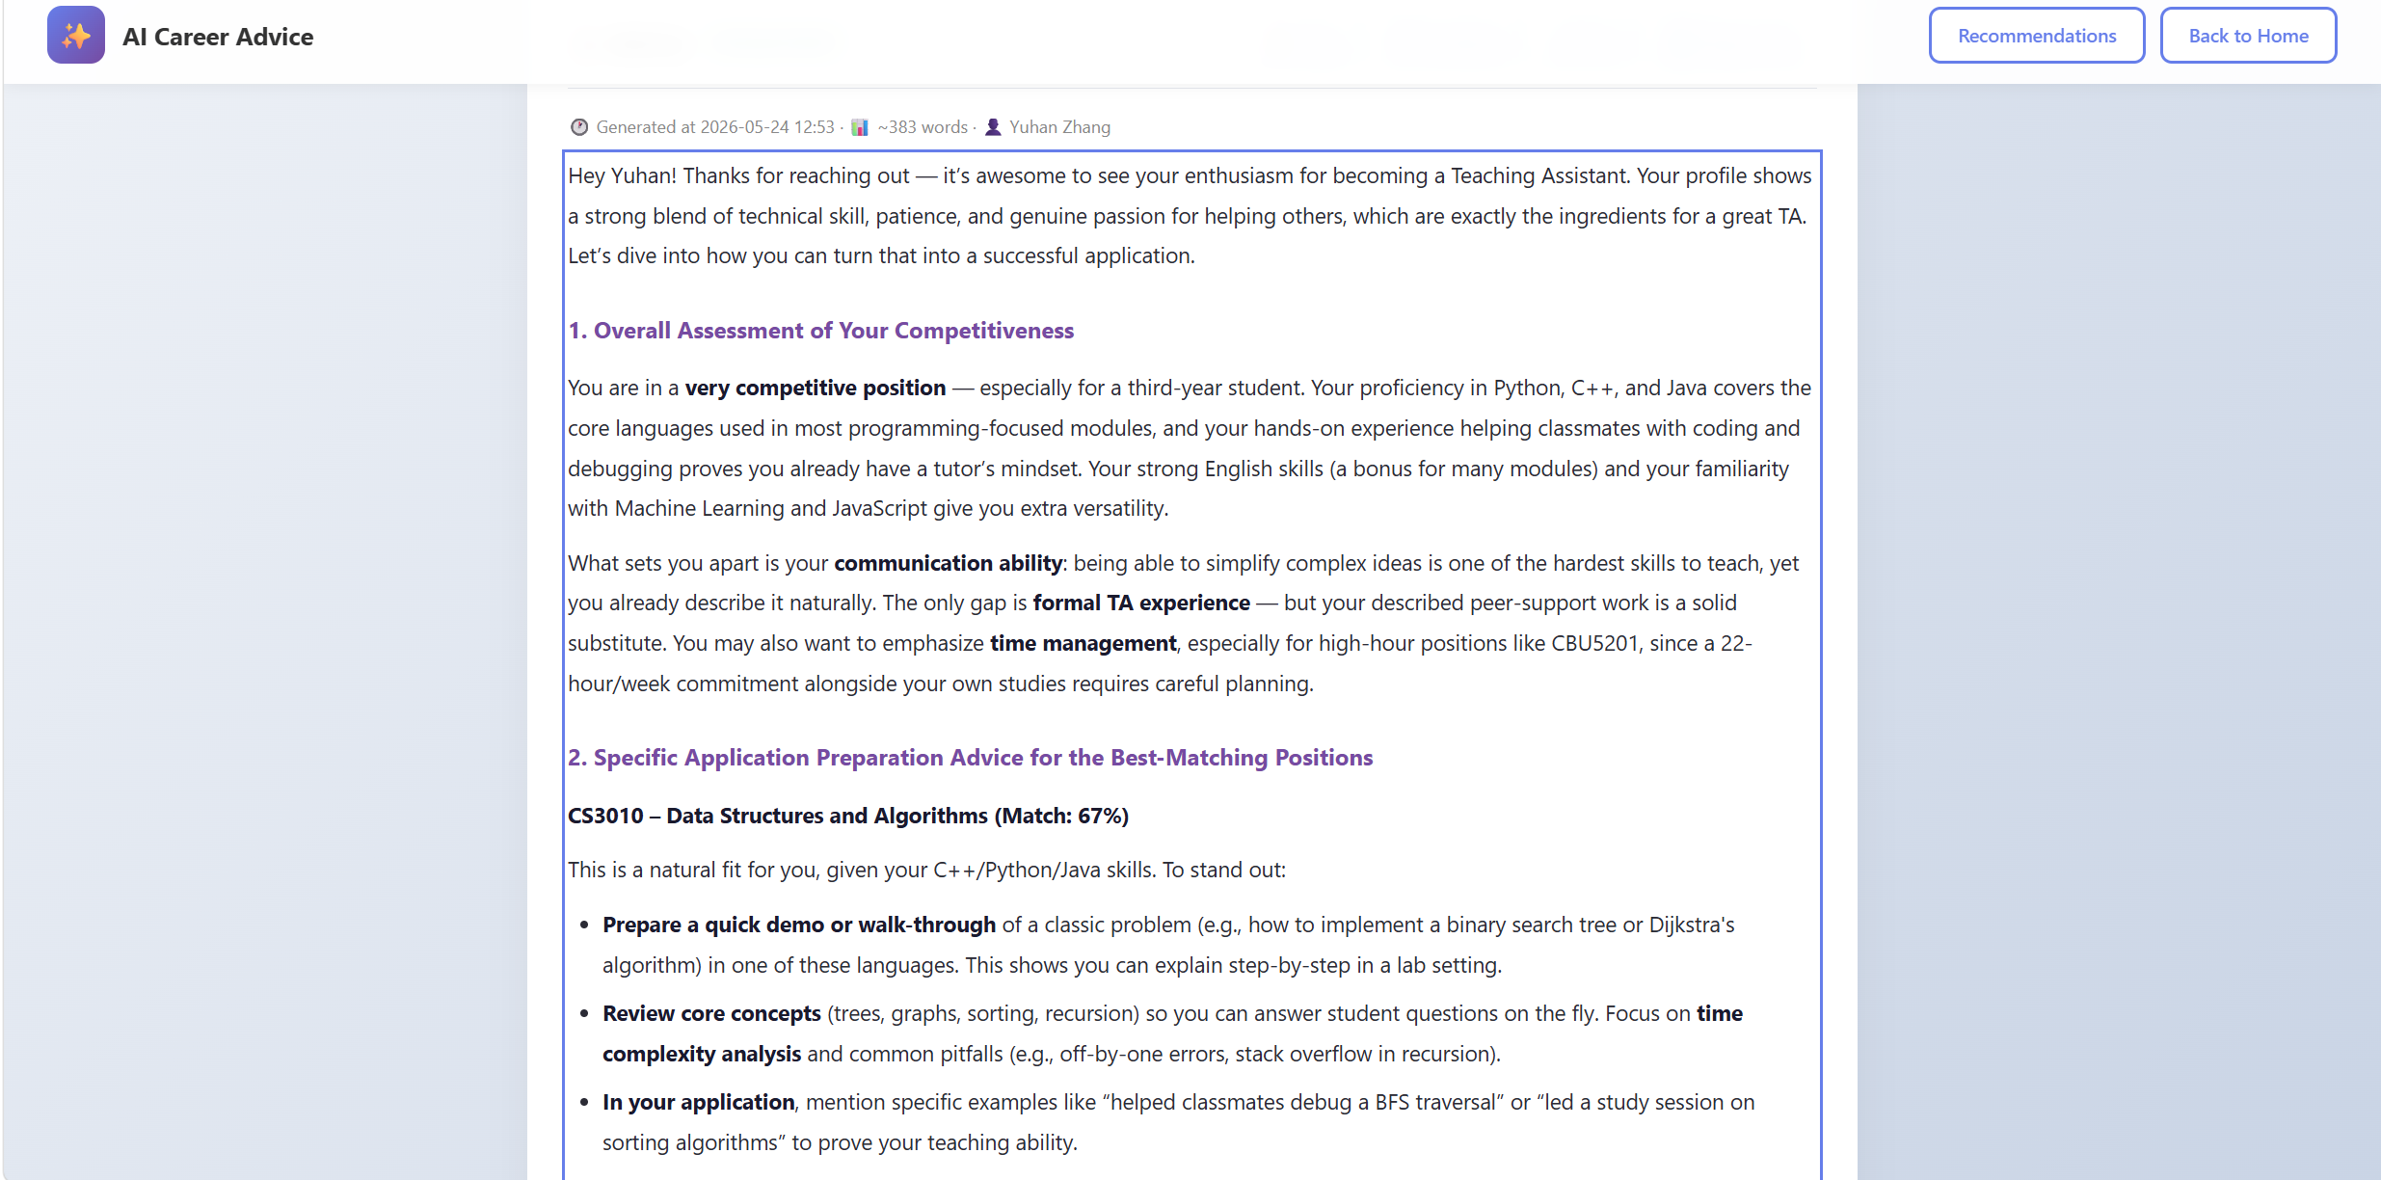

Tips for better advice
- Complete your profile: bio, major, grade
- Add 3-5 relevant skill tags (e.g. Python, Grading, ML)
- Upload your resume and set profile to "visible to others"
- Results may vary slightly between generations — compare and pick the best

7. Troubleshooting
Problem | Solution
"Not signed in" error | Your session expired (after 1 hour). Sign in again.
"Permission denied" on suggestion page | Only TA users can generate advice. MO/Admin will see 403.
AI advice fails: "AI_API_TOKEN not configured" | Backend has no AI key set. Contact the administrator.
Can't apply to a job | The job may be closed, filled, or you may have already applied.
Messages not sending | Check the recipient's user ID is correct; the user must still exist.
Caps Lock warning on login | Disable Caps Lock and try again.
Page won't load after login | Clear browser cookies and re-login. Cookies must be enabled.
Resume preview is blank | File upload may have failed; click Replace File to retry.
Forgot password | Contact an administrator — no self-service reset yet.

Browser requirements
- Modern browsers: Chrome 90+, Firefox 88+, Edge 90+, Safari 14+
- JavaScript must be enabled
- Cookies must be enabled (used for session management)
- Recommended screen width: 1280 px or wider; mobile layouts available below 600 px

Getting help
- For account / system issues: contact your Administrator
- For TA application questions: contact the MO via the Messaging Center
- For technical bugs: report via your group's project repository

