**Milestone 2 - SDLC**

Team LLL - Zhimin Lin, YaLing Lian, Linjian Chen

We plan to using Iterative SDLC Model for our project. The process of Iterative Model is unlike the Waterfall Model, which moving step by step, Iterative Model is more like cyclic, keep evolving each version, gain more complexity and broader feature until it’s ready to implement.

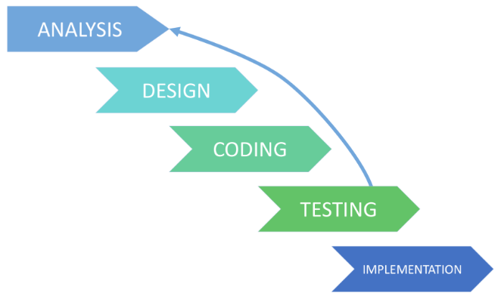

The Advantages:

1. It does not request start with a full specification of requirements.
2. New version of the software is produced with each phase.
3. More flexibility, easier to changes in the demands.
4. It is easier to control the risks.
5. The easier to test and debugging.
6. Use the less time to create document and more time to design.

