Quick guide to get the Data Science club’s files onto your computer.

______________________________________________ This is a quick guide for you to use to be able to grab the files from our github page and put them on your computer.

I’m going to skip the overarching idea of github here because there is a lot that goes with it, so we will get right into getting the files.

1. First you need to create a directory(folder) on your computer where you are going to store the files.
   1. Preferably, you want it to be in a place where there are no directories beneath it.
   2. Name it DS_Club_Files

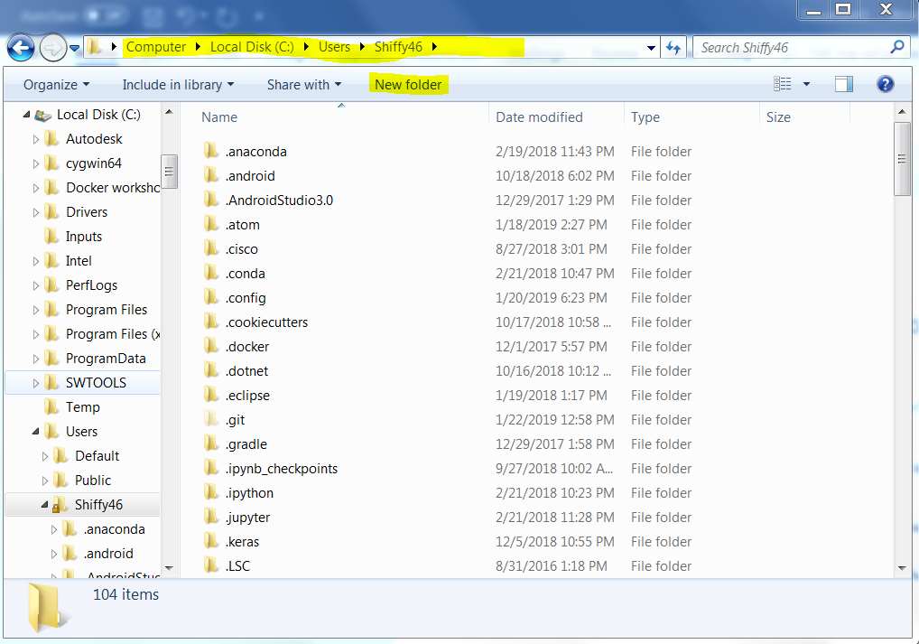Yes.. windows 7:/

1. With the newly created directory you should now be able to use the terminal(mac) or git bash(Windows) to add the files from the github to your machine.
   1. You need to download “git” from the web to proceed, if you already have it you’re good to go
2. Open up Terminal/Git Bash (I will be using git bash but the commands are the same for mac terminal)

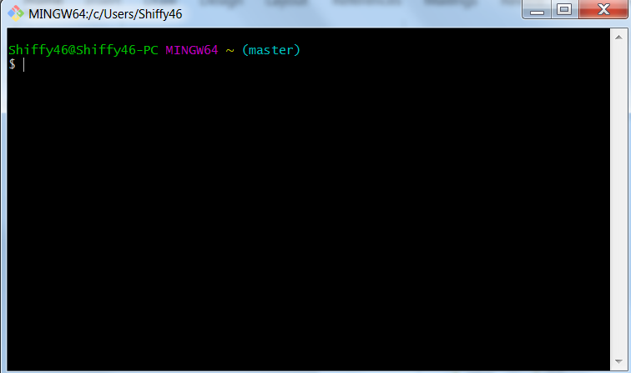

It should look like this for windows and somewhat similar on mac

1. Navigate to your directory named “DS_Club_Files”
   1. The “cd” command will “change directories” for you
   2. The “ls” command will list the files within that folder(make sure it doesn’t show anything right now)

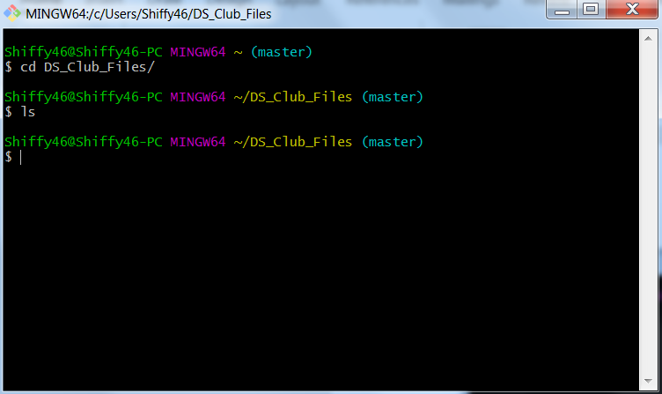

1. If you have a directory with no files in it you are good to go for now, the next step is to grab the files from github and “clone” them to your machine.
   1. Go to <https://github.com/ISU-DataScienceClub/DS_Club_Spring_2019>

And click the “clone or download” button

* 1. This should show a link, copy that link

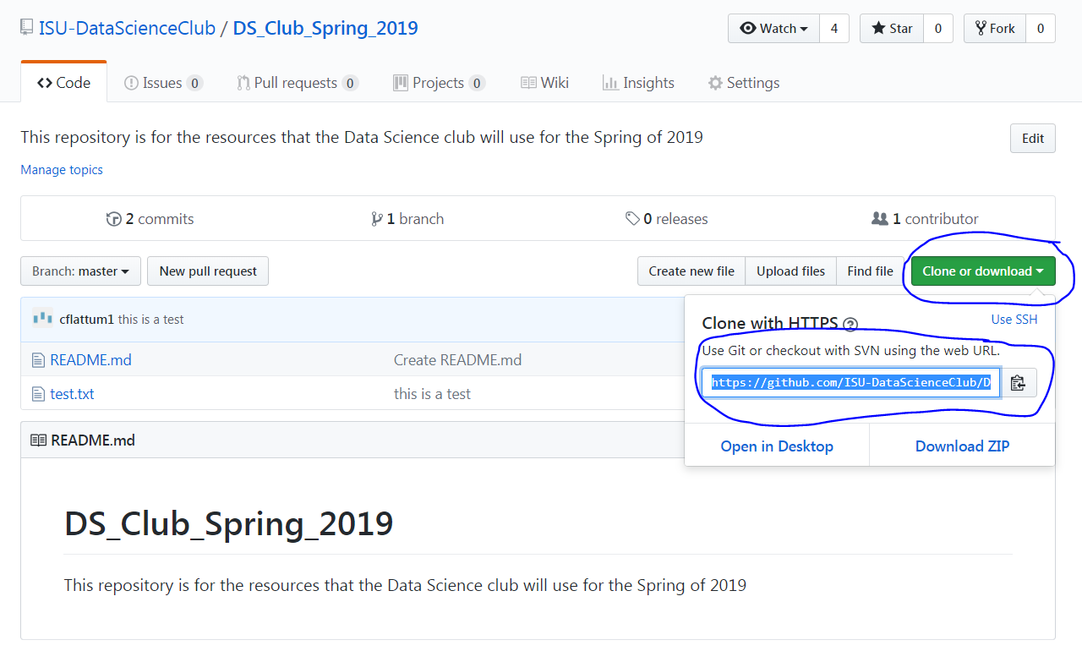

1. Once you have copied the link, go back to you Git Bash/Terminal and type “git clone” and then paste the link in there. It should look like this, type “ls” to see if it was executed correctly

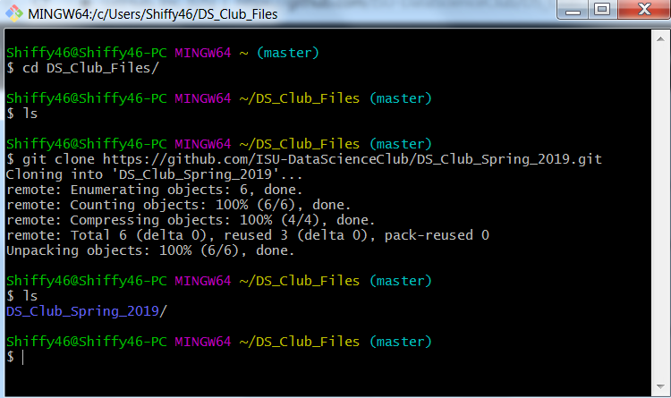

1. Congrats, go to your file explorer and check to see if the files from github are in there!

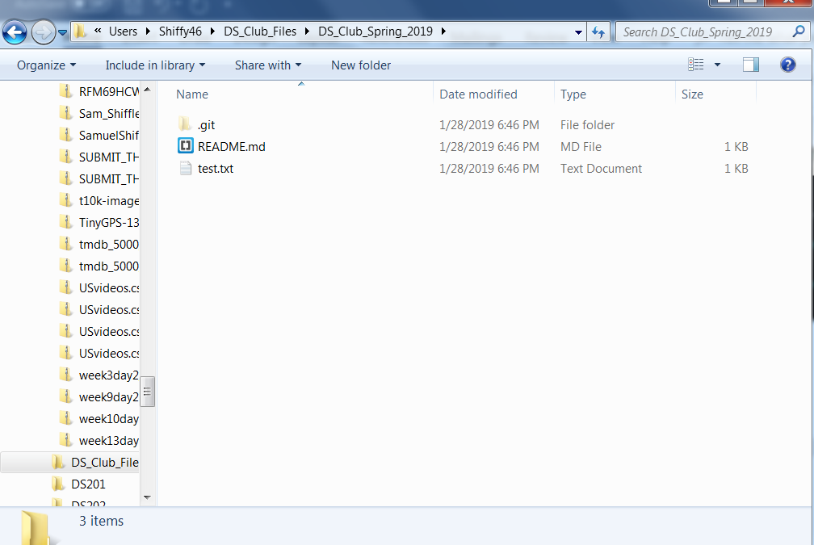

1. In order to keep the files up to date you will need to issue pull requests(this is for the future)
   1. Once we add files to the github as the semester progresses, you will need to update your machines files, but it is not the same as the process above
   2. In order to do that, we need to repeat steps 3 and 4 in order to have our directory be correct
   3. BUT, we need to change our directory to be the github repository so we need to “cd” into the “DS_Club_Spring_2019” folder

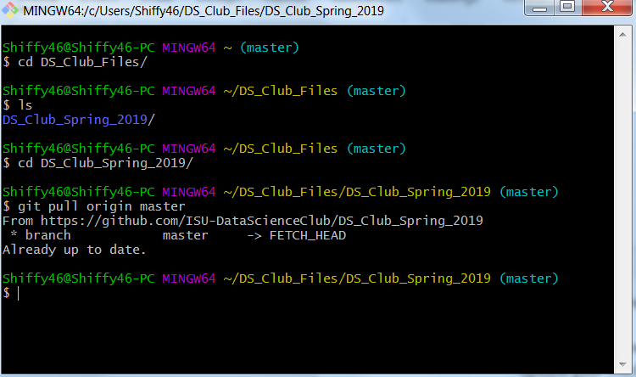

1. Once we are in the “DS_Club_Spring_2019” folder, we can run “git pull origin master” in order to update our files on our machine.(If you do this immediately after the first part of this tutorial, you will get a message saying “Already up to date” that means you’ve done the pull correctly but there is no new files to add.)

That’s how you get the files onto your machine everyone, thanks for following along!