1.

What I have attempted to model in the following pages is the behavior of a semi – tractor attempting to stop while descending a slope – specifically how the heat of the brakes may affect performance. I have created the model to represent a semi that has lost all engine braking ability. The only forces that I have included to help stop the semi is wind resistance and braking force (both of which are variable). Most of what I have included involves using a fully loaded semi (80k lbs). This would effectively show the worst case situation for semi. I will include a few graphs of a non-fully loaded semi as well to highlight the stopping distance. It seemed that for each situation that I modeled the system would come close to an equilibrium with regard to the deceleration of the rig. I have also modeled the situations off of a dry road with normal tires in regards to the semi. A wet road would be more determinate on the amount of slippage by the tires instead of how the brakes are performing. I used a kinetic energy approach to model how much heat was entering into the brake drums, as well as many equations derived from empirical data collected.

2.

The process that I modeled is the velocity and position of a semi, as well as the brake performance and heat characteristics.

Equations:

$$\frac{dx}{dt}=v$$

$$\frac{dv}{dt}=\frac{mgsin\left(α\right)-F_{d}-F_{b}}{m}$$

$$F_{d}=C_{d}*.625*ρ*v^{2}*A$$

$$F_{b}=B_{t}*N_{b}*R_{w}$$

$$k_{t}=-0.0000117*T_{b}^2 + 0.0141129*T_{b} - 3.8559705$$

$$B_{t}= 75000*k_{t}-9000$$

$$\frac{dQ}{dt}=Q+\left(.5*m*{\left(v_{i}-v_{f}\right)}^{2}-h*A_{i}*\left(T_{b}-T_{a}\right)\right)$$

$$T_{b}=Q/(c*m_{b})$$

Variables:

Bt = Brake torque (Nm), Nb = Number of brakes, Rw = radius of wheel.

v = velocity; m = total mass, g = gravity, F_d = wind drag force, F_b = brake drag force;

C_d = wind drag coefficient; A = frontal area of semi; $ρ$ = air density; F_bi = initial brake force;

K_t = braking coefficient; T_b = temperature of brake drum; v_i = previous velocity;

v_f = final velocity; A_i = inside brake non-lining area; T_a = ambient temperature;

Q = total heat; c = specific heat; m_b = mass of brake drum

The rate of change of velocity is proportional to the effect of gravity down the hill, the air drag force, and the braking force, and is inversely proportional to the mass of the system.

The rate of change of position is proportional to the velocity of the system.

The rate of change of the amount of heat in the brake drums is proportional to the change in kinetic energy, and also is proportional to the effects of cooling by air on the surface area of the brake drums.

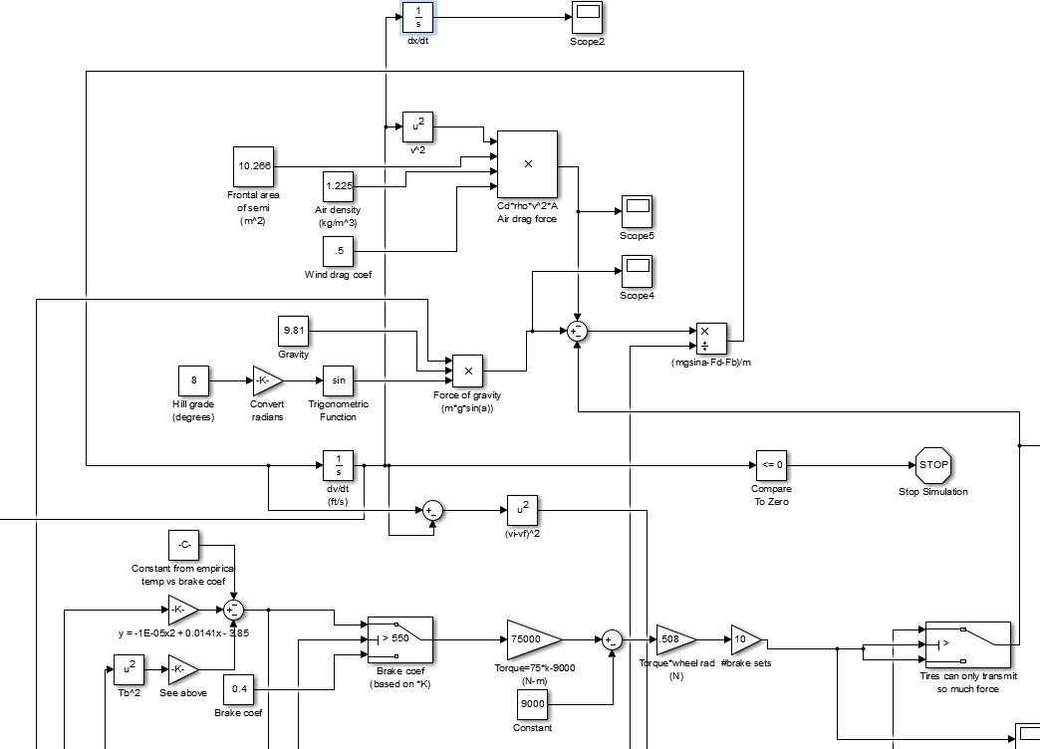

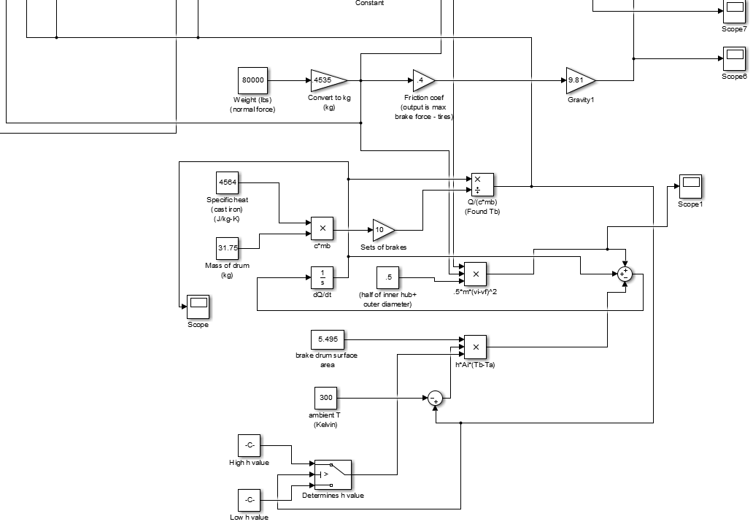

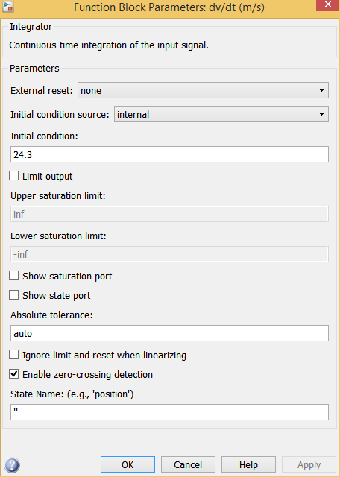

e)

In my particular model I had over 10 different parameters or initial values that I could change. I found that changing some of these even small amounts could throw everything out of line, and resulted in plots and graphs that were not realistic (going to infinity, etc.). For the simple cases that I was able to run however it seemed to work well. Changing the mass of the rig and the slope of the hill showed significant changes throughout the graphs, with some situations being able to stop and others coming to equilibrium.

3) Here are some results from a “base” case of a fully loaded semi and a slope of 8 degrees. Once the brake temperature graph moves to equilibrium (which happens quickly), the velocity then starts to decrease linearly.

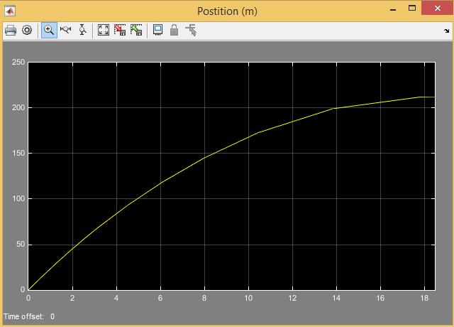

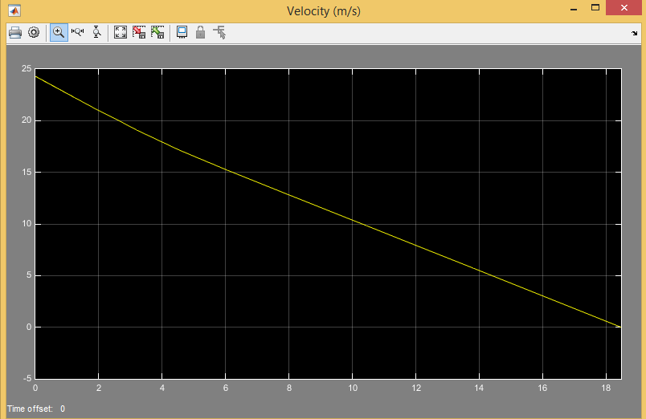

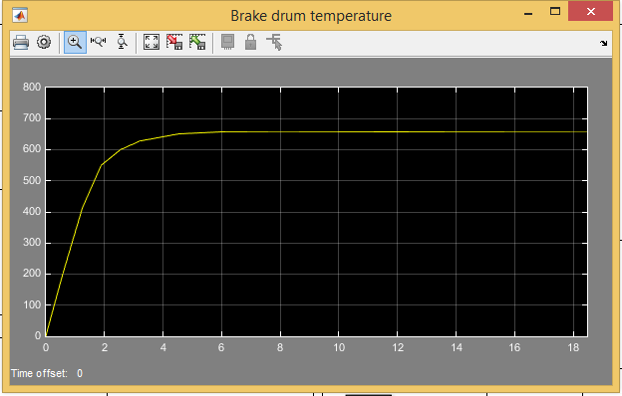

Here’s another case with the slope increased to 14 degrees.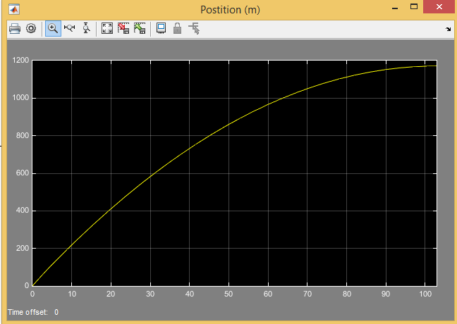

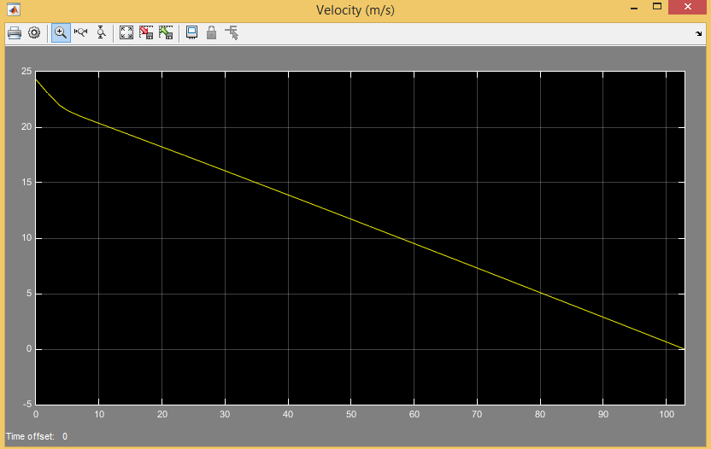

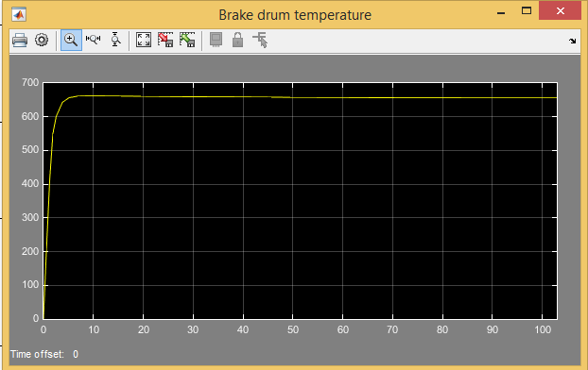

With a slope of 8 and a weight of 120,000 lbs. It is easy to notice the difference in stopping time compared to the smaller weight model. Again the brake drum temperature quickly came to equilibrium and with it the brake force.

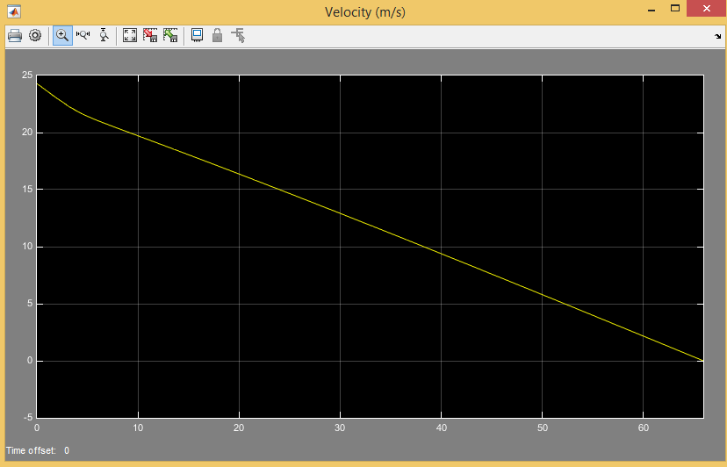

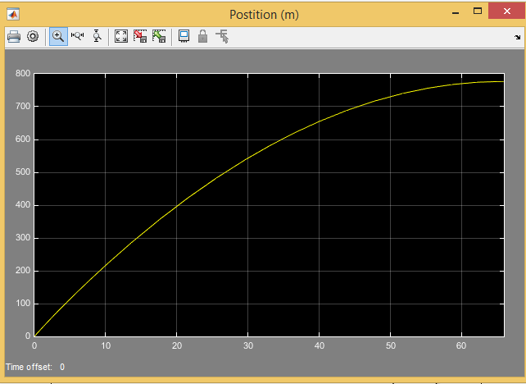

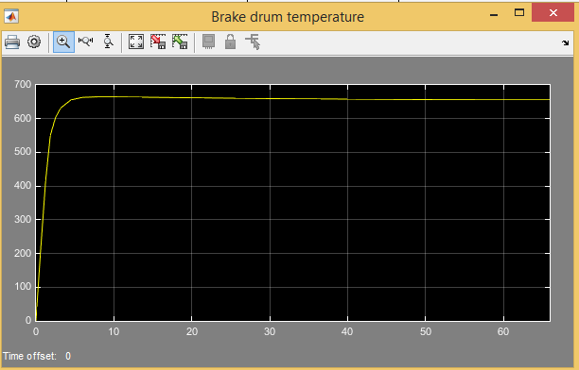

B) The first takeaway that I found from this system is that it is much more complex than I had first imagined. I had initially imagined that the brake force would balance out with the brake drum temperature, but I did not imagine it to be so sudden. I had figured that the equilibrium brake temperature would be closer to 750-800K than 650K. I found that the initial wind drag had a huge effect on the initial braking of my system. The huge effect that it had makes me wonder if there are other factors (such as rolling resistance) that would significantly alter my model.

C)

I found that my results for velocity and position were predictable, but I was surprised by my results for the brake drum temperature. I chose to use the change in kinetic energy as the heat input into the brake drums, but after finding how complex this method was (and could be made even more complex than the model I used) I was forced to wonder if there wasn’t a simpler method. One thing that surprised me as well is that the model could be thrown into complete disarray by changing the initial parameters too much. For example if I were to increase my ambient temperature by 50K or so the temperature numbers would quickly rise to infinity, as the ambient cooling would not be enough to offset the heat generated. Another surprise that I ran into was that there was very little information to be found on this type of a model. The only information that I was able to find was of a couple research papers that measured the heat or performance of the brakes. I had to combine empirical data from several difference sources, then plot their data in excel, and then derive equations from them for my model. Combining data from multiple different sources and situations is always something that can introduce error into a model. One such question might be what was the ambient temperature of one compared to another? Unfortunately many of the variables there is no way of knowing how different/close they were.