Opportunistic In-Band DNS Freshness
Chromium PoC & Experimental Evidence
Technical Evidence Report v0.3
Author: Marc Nicolai Fronemann
Frozen evidence through 25 August 2026 | related-work-aware review revision

Purpose
Provide an external engineering team with a falsifiable, reproducible account of what the local PoC demonstrated, what was measured, what is inferred, and what still requires independent validation. This revision sharpens the contribution boundary against HTTP Alt-Svc, SVCB/HTTPS, QUIC preferred_address, DNS Push, short-TTL operation, and RFC 9102 TLS DNSSEC Chain; it also narrows the statistical and single-capture wire claims.

Evidence class | Result
DEMONSTRATED | Modified Chromium 151 learned endpoint 172.18.0.12 through signed in-band Freshness, the old 172.18.0.61 endpoint was then physically removed, and the next HTTP/3 request reached 172.18.0.12 with HTTP 200 while the Authority observed zero DNS queries for a.service.test during the cutover.
MEASURED | Across 100 paired Chromium/H3 repetitions, Delta and NoChange distributions overlapped strongly (means 29.374 ms vs 29.251 ms; paired Delta-NoChange range -6.747 ms to +8.229 ms). The same application QUIC connection was used in 100/100 repetitions. The +0.123 ms paired mean is retained only as a descriptive point estimate, not as a statistically resolved protocol overhead.
OBSERVED (n=1) | One H3/QUIC capture observed Delta 733 B UDP vs NoChange 495 B UDP (+238 B total UDP; +182 B approximate L3). These wire-byte and packet deltas are trace-specific observations, not protocol constants. The deterministic fullstack Delta object size (273 B COSE) is the stronger object-level size fact.
NOT CLAIMED | No direct production-grade end-to-end Classic-DNS-vs-Freshness recovery latency delta, no Internet-scale validation, no universal superiority over DNS or DNS Push, and no production readiness claim.

External-review posture: reproduce it, stress it, and try to break it.

1. Executive Summary
This report documents a local research PoC for opportunistic, signed DNS-state freshness carried on natural application traffic. The design does not replace DNS. DNS remains the bootstrap path, DNSSEC-rooted trust source, recovery mechanism, and fallback when application-path continuity or authorization cannot be established. After admission, active service state can be reconciled using signed Snapshot, Checkpoint and Delta objects transported on ordinary H2/H3 traffic.
Core architectural idea
For an admitted active service, the design changes the freshness operating point from timer-driven revalidation toward opportunistic change-driven reconciliation. A surviving authorized application path can carry an Authority-signed transition before stale endpoints disappear, so the client can converge to new DNS-derived connectivity state without waiting for TTL expiry or first suffering a connection failure. The carrier is traffic the application was already going to send; the signed object carries the authority proof independently of the relay.
Contribution boundary
Neither in-band advertisement of a future HTTP endpoint nor in-band carriage of DNSSEC-validatable material is claimed as novel. RFC 7838 Alt-Svc establishes the former; RFC 9102 TLS DNSSEC Chain is a close precedent for the latter in the DANE/TLSA handshake context. The system studied here is a DNSSEC-rooted, independently verifiable reconciliation layer for DNS-derived service state: Authority-signed scope membership, generation plus state digest, exact Delta ancestry, bounded leases, fork/gap detection, emergency root reset, eviction semantics, scope-wide repair, and fail-safe DNS recovery. The application path is the opportunistic carrier, not the source of authority.

- DNS remains authoritative for cold admission, root trust and recovery.
- Freshness is opportunistic: no application traffic means no Freshness-only traffic.
- State is Authority-signed; an application relay can transport/cache objects but cannot forge authorized state without the relevant signing key.
- Active-interest generation gaps, forks, trust expiry and lease expiry fail toward recovery rather than silent state advancement.
- Eviction ends update interest; a later reuse is a fresh admission at the current authoritative head, not an obligation to reconstruct discarded generations.
- The strongest target operating point is an actively used service where application traffic already exists. DNS Push retains a distinct advantage when updates must arrive during complete application silence.

2. Problem and Operating Point
Classic DNS caching is intentionally time-based: a TTL bounds how long cached data may be reused; it is not a change-notification channel. After an Authority changes state, a client that continues to rely on a still-valid cached answer does not receive a DNS-level change signal solely because that Authority state changed. Resolver prefetch, proactive revalidation, or application-specific mechanisms can shorten this window in practice, so this is not a claim that every client must remain stale until TTL expiry. In the lab, after the Authority moved a.service.test from 172.18.0.61 to 172.18.0.12, the Classic Unbound resolver was explicitly observed still returning 172.18.0.61 with a positive remaining TTL. This is normal TTL behavior, not a resolver defect.
Opportunistic Freshness explores a different operating point for services that are already active and still have at least one authorized usable path. Signed Snapshot, Checkpoint, or Delta state can reconcile the bounded service scope on natural application traffic, allowing pre-failure convergence to a replacement state while a valid Freshness lease is active. When continuity, trust, exact ancestry, or lease validity is lost, conventional DNS/cache policy resumes authority. The design therefore does not abolish TTL; it removes timer expiry from the recurring freshness-critical path of successfully admitted active state.
Property | Classic DNS / TTL | DNS Push | Opportunistic Freshness
Cold bootstrap | Yes | Yes | Yes
Freshness while app idle | TTL-driven / on demand | Asynchronous push capable | No delivery until natural app traffic
Dedicated update relationship | No | Yes (DSO subscription/session) | No
Freshness-only idle traffic | No | Session/keepalive may exist | 0 by design
Natural app path transports updates | No | Not the primary mechanism | Yes
Best fit | Universal deployment / bootstrap / recovery | Immediate updates during silence | Actively used services with existing app traffic

2.1 Related Work and Design Differentiation
The transport ingredients behind this work are not new. Existing standards already support in-band alternative-service advertisement, richer DNS service binding, transport migration addresses, asynchronous DNS Push, and even in-band DNSSEC-validatable material for DANE/TLSA. The research question here is narrower: whether a surviving application path can safely carry independently verifiable, DNSSEC-authorized, incrementally versioned reconciliation of coherent DNS-derived service state, while preserving explicit consistency and recovery boundaries.
Mechanism | Established capability | Boundary relative to this work
HTTP Alt-Svc (RFC 7838) | An origin can advertise an alternative ALPN/host/port in-band, with an independent freshness lifetime (ma), and clients may use it for new connections. | Direct prior art for in-band endpoint advertisement. It is origin-level alternative-service routing authenticated through the HTTP/TLS authority model; it does not define independently signed DNS-state objects, multi-RR scope reconciliation, generation/digest ancestry, fork/gap handling, or DNSSEC root reset.
SVCB / HTTPS (RFC 9460) | DNS can publish multiple authoritative alternative endpoints plus connection parameters before connection establishment. | Highly relevant discovery baseline. State is learned through DNS resolution/caching; it is not a post-admission, application-carried state-reconciliation channel. This PoC uses SVCB/HTTPS for DNSSEC-authenticated capability/bootstrap rather than replacing it.
QUIC preferred_address (RFC 9000) | A QUIC server can provide a preferred IP address/port for migration of the current connection. | Transport-layer cousin, but the advertised addresses are valid only for the connection in which they are provided and MUST NOT be reused for other connections. It does not reconcile a DNS-derived service scope.
DNS Push (RFC 8765) | Asynchronous DNS changes can be delivered over a stateful DSO subscription, including while the application is silent. | Complementary rather than obsolete. Push is stronger for immediate delivery during application silence; Opportunistic Freshness targets active services without a separate subscription/session or Freshness-only idle traffic.
Short DNS TTLs | Bound stale-cache duration by forcing more frequent conventional DNS revalidation. | Essential baseline, not a free substitute. It remains timer-driven and trades shorter stale windows for more frequent DNS work. Production evaluation must compare convergence, query load, prefetch behavior, failure attempts, battery/CPU cost, and implementation complexity.
TLS DNSSEC Chain (RFC 9102) | Experimental TLS extension carrying the DNSSEC authentication chain needed for DANE/TLSA in-band during the handshake; can include authenticated denial of existence and avoid separate out-of-band DNS lookups for that authentication data. | Close precedent for self-validating DNSSEC material on the application security path. Its scope is handshake-time DANE/TLSA authentication and cached/rebuilt DNSSEC chains; it does not define post-admission incremental connectivity-state reconciliation, generation/digest ancestry, scope-wide endpoint transitions, bounded Freshness leases, or fork/gap recovery.
Opportunistic Freshness v0.1 | Carries signed Snapshot/Checkpoint/Delta state on natural application traffic and commits verified state into the client resolver/cache. | Target contribution: independently verifiable DNS-derived state reconciliation with DNSSEC-rooted trust, bounded leases/state/history, exact ancestry, fork/gap detection, scope-wide repair, emergency reset, and DNS fallback.
Counterargument worth testing: the expired individual Internet-Draft "HTTP Alternative Services, Plan B" (draft-thomson-httpbis-alt-svcb-01, 2023) argued that RFC 7838 created problematic dual sources/caching for service reachability and proposed using in-band advertisement only as a prompt to consult DNS. The draft is expired, archived, and explicitly has no IETF endorsement or formal standards standing. Its deployment critique is nevertheless a serious falsification target for this work: the signed generation/digest state model must justify its extra complexity by avoiding enough stale-state, recovery, or transaction cost in real deployments.

2.2 Why Not Simply Use Short TTLs?
Short TTLs are the simplest conventional response to stale endpoint mappings and therefore remain a first-class baseline. They reduce cache-age windows by causing more frequent conventional DNS revalidation across the population during the low-TTL period, whether or not a particular client has already learned a change through an active service path. Opportunistic Freshness explores a different trade: active admitted clients reconcile change-driven state on traffic that already exists, while inactive clients generate no Freshness-only traffic. The PoC demonstrates the mechanism and zero-idle-traffic property, but it does not yet quantify population-wide query-load savings. Production evaluation must compare convergence, DNS query volume, resolver prefetch behavior, stale/failure attempts, mobile cost, and implementation complexity.

3. Architecture and State Model
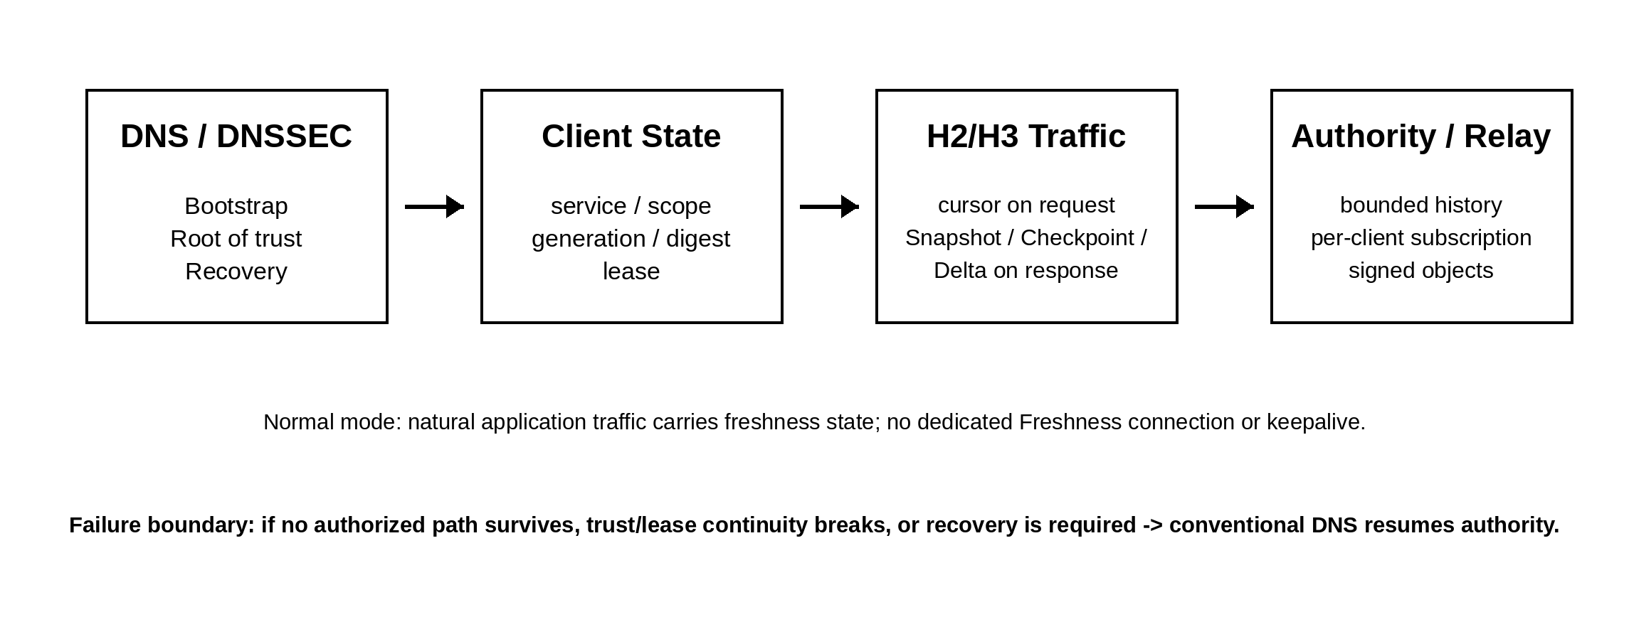
Figure 1. Control and data-path split. Freshness reuses natural application traffic; DNS remains the safety boundary for bootstrap and recovery.
State identity: root_epoch + service_id + scope_id + generation + state_digest.
Lifecycle: INACTIVE -> DNS_BOOTSTRAP -> ACTIVE_UNASSURED -> ACTIVE_AUTHORIZED -> RECOVERY_REQUIRED, with transitions driven by trust, admission, lease and continuity conditions.
Active-interest rule: While interest is continuously active, an unbridgeable forward generation jump is a recovery condition. The receiver must not silently skip a missing bridge.
Eviction rule: Eviction ends interest and discards the cursor/scope tracking. Later reuse is a new admission at the current head; missing intermediate generations are not reconstructed unless a separate audit/history function requires them.
Atomicity rule: No state mutation is committed until object structure, bounds, signature, ancestry/digest and authorization checks pass. Partial delivery or validation failure leaves state unchanged.
Trust split: DNSSEC controls the root trust namespace and root_epoch. Operational Freshness keys can rotate below it; root_epoch can reset compromised lower counters without being blocked by attacker-inflated generations.

4. Wire Profile and Security Boundaries
Element | v0.1 experimental profile
Discovery | DNSSEC-authenticated HTTPS/SVCB capability; private-use SvcParamKey 65400 in the lab
Identifiers | 128-bit opaque service_id; 128-bit Authority-opaque scope_id; opaque DNSSEC-authenticated admission_context
State objects | Snapshot, Checkpoint, Delta, ResyncRequired
Serialization | Deterministic CBOR
Signature container | COSE_Sign1, CBOR Tag 18
Signature algorithm | Fully specified Ed25519, COSE alg -19
HTTP carrier | Structured Field Byte Sequence
Current Chromium fullstack sizes | Snapshot 325 B; Delta 273 B; bootstrap cursor 23 B raw; active one-scope cursor 86 B raw
Experimental resource limits | 4096 B COSE; 64 Delta operations; 32 cursor scopes; CBOR depth 32; 5466-byte textual SF ceiling for a 4096-byte decoded object

Gate 13 established deterministic DNS-state encoding and reproducible COSE vectors. Semantically identical DNS states with case/order differences produced the same deterministic encoding and digest; actual state changes changed the digest. Tampered payloads, non-deterministic encodings and deprecated alg=-8 were rejected. Gate 16 independently verified the frozen COSE/signature vectors in Go, but did not implement the complete semantic state machine; this is therefore partial wire/security interoperability rather than a second full implementation.

5. Evidence Ledger: Gates 1–18
Gate | Status | Focus | Result / supported claim
1–2 | PASS | Functional/security foundation | DNS bootstrap; signed in-band reconciliation; later use without another DNS lookup; total-path failure -> DNS recovery; monotone epoch/generation; replay/tamper/wrong-service/wrong-view rejection; transactional multi-RR update; TLS validation; atomic commit/crash safety.
3 / 3B | PASS / GO | Performance & external-validity lab | In-band update added small marginal processing on an already-active path; separate DNS and Push paths scaled with injected/real RTT. Idle 5 s generated IDLE_PACKETS=0.
4 | PASS | Signal tax & bounded state | Early textual signal +26 B/request, +0 packets. History window 8 remained bounded with 100,000 random cursors; no persisted per-client subscription growth.
5 | PASS | Signed Checkpoint | Time-bounded generation/digest authorization; expiry and tamper behavior exercised. Checkpoint is bounded authorization, not proof that no later state exists.
6 | PASS | Scoped versioning | Atomic A+AAAA change within one scope; wrong-scope reject; 10,002 Authority scopes + 100,000 irrelevant changes left two active client scopes unchanged.
7 | PASS | Key rotation | Legitimate K1->K2 accepted with bounded overlap/retirement; fake/replayed transitions rejected.
8 | PASS | DNSSEC trust bootstrap | Signed DNS hierarchy bootstrapped Freshness key; tampered published key produced DNSSEC bogus and was not installed.
9 | PASS | Fork detection | Same generation + different digest detected as fork; wrong from/to digests rejected.
10 | PASS | Negative DNS state | RRset removal -> NODATA, whole-name removal -> NXDOMAIN, stale positive rejection, authorized recreation, no partial invalid operation commit.
11 | PASS | Compromised-key reset | Lower Freshness layer cannot detect theft of a valid private key; DNSSEC-published newer trust state successfully replaced compromised chain.
12 | PASS | Separate root_epoch | Attacker-inflated lower counters to 2^63-1 did not block DNSSEC root_epoch reset; old-root objects and rollback were rejected.
13 | PASS | Deterministic CBOR/COSE | Concrete deterministic signed binary profile with reproducible vectors and measured size. Frozen Gate-13 Delta COSE = 266 B.
14 | PASS | admission_context | Validly signed wrong-cohort Snapshot rejected; DNSSEC context change cleared old scope and required new admission.
15 | PASS | Resource bounds | Oversize rejected before expensive work; exact operation/scope/depth limits exercised; producer can fall back to small ResyncRequired.
16 | PASS | Independent Go verification | Independent CBOR/Ed25519 stack matched hashes and signatures; not a complete second semantic implementation.
17 | PASS | Real HTTP/2 carrier | Exact Gate-13 Delta rode stream 3 on the same h2/TLS connection; no dedicated Freshness connection.
18 | PASS | Real HTTP/3 carrier | Exact Gate-13 Delta rode stream 4 on one QUIC connection/handshake; no second Freshness handshake.

6. Real Chromium Full-Stack Integration
The later phase moved beyond the synthetic Gate-18 aioquic carrier into a patched Chromium 151.0.7922.34 vertical slice. The lab used a DNSSEC-validating resolver behind Secure DoH; Chromium relied on the trusted validating resolver and AD-authenticated discovery rather than acting as a full DNSSEC validator itself.
Component | Lab value
Chromium | 151.0.7922.34, patched Network Service / HostResolver integration
Docker network | dns-service-sync-net (172.18.0.0/16)
Authority | 172.18.0.54
Secure DoH | 172.18.0.55
Normal H3 endpoint | 172.18.0.61
Cutover endpoint | 172.18.0.12
Classic Unbound baseline | 172.18.0.2
State transition | Gen100: .61 -> signed Delta -> Gen101: .12

- FreshnessStateStore instantiated per NetworkContext and partitioned by Network Anonymization Key.
- Native deterministic CBOR cursor emitted on outgoing Chromium requests.
- DNSSEC-authenticated discovery fields included service_id, admission_context, root_epoch and root key material.
- Generic Snapshot/Checkpoint/Delta/ResyncRequired processing implemented, including state digest and lifecycle checks.
- Committed DNS/Freshness state was integrated into Chromium resolver/cache state rather than only observed in an application script.

7. Hard Zero-DNS Endpoint Cutover
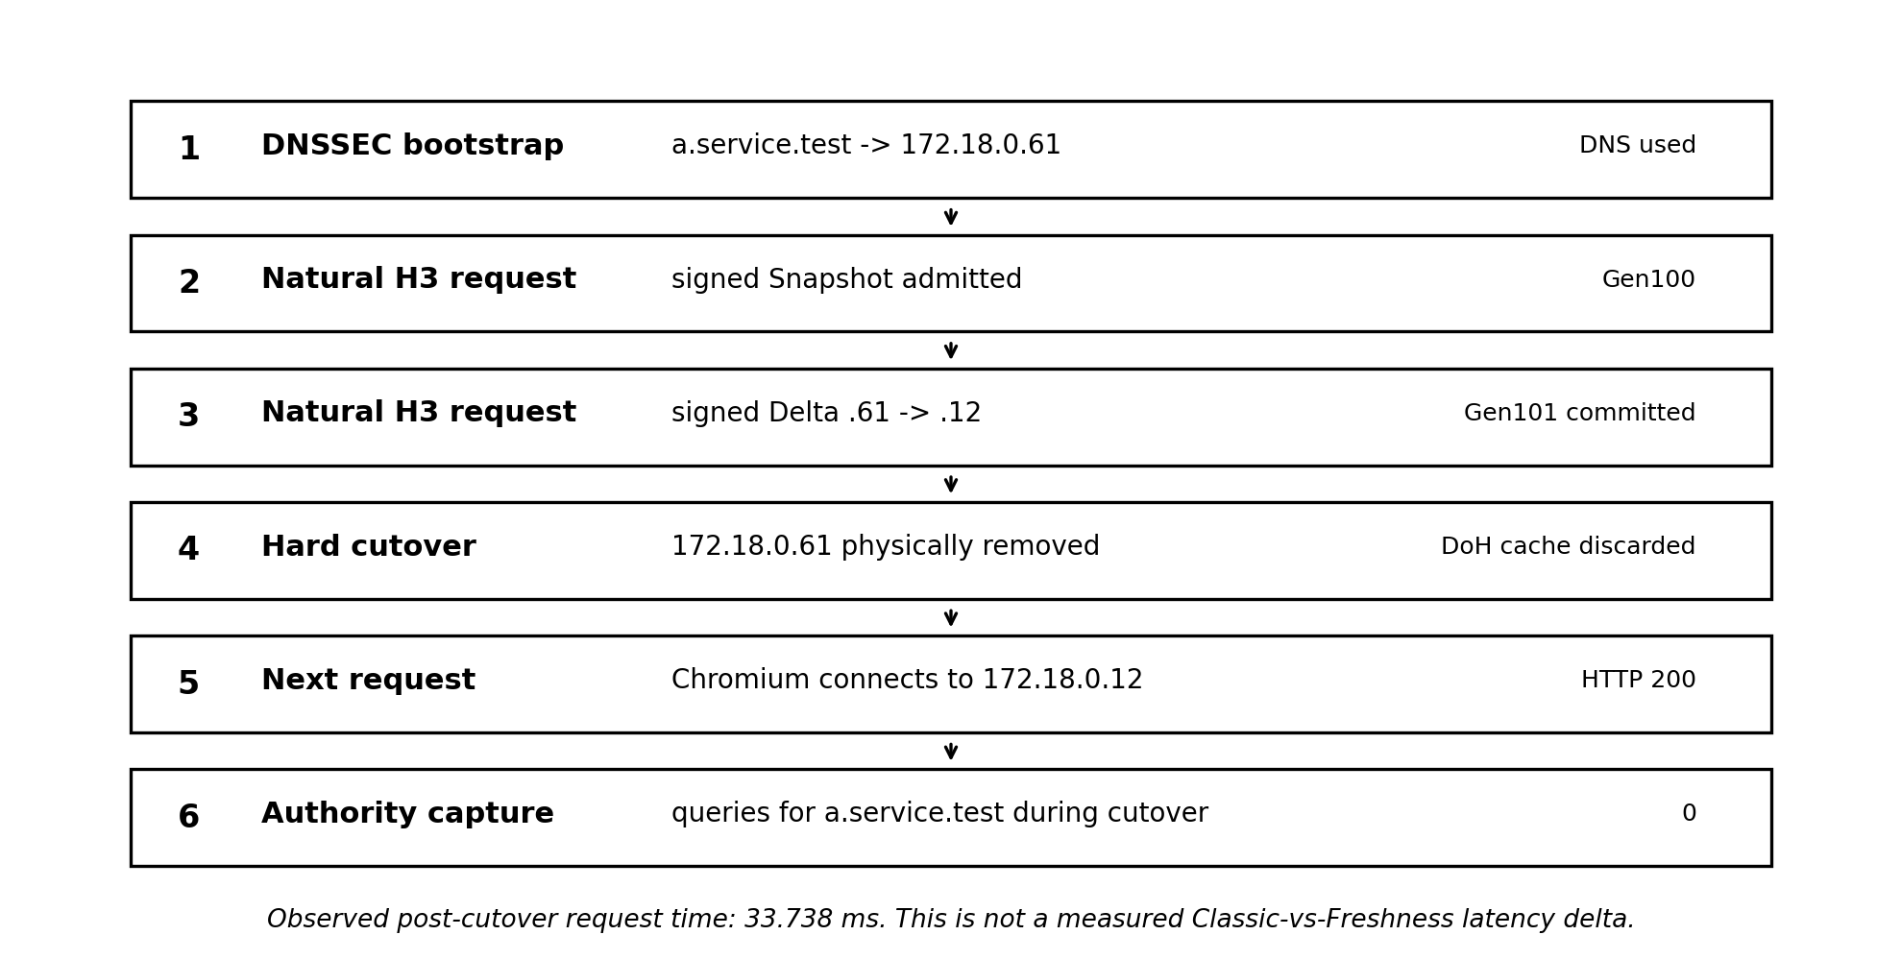
Figure 2. Canonical hard cutover proof. The resolver cache was deliberately discarded after Gen101 commit; the old endpoint was physically removed before the next request.
Checkpoint | Observed result
Secure DNSSEC discovery | PASS
Snapshot Gen100 -> 172.18.0.61 | PASS
Delta Gen100->101 -> 172.18.0.12 committed before cutover | PASS
Snapshot and Delta on same pre-cutover H3 connection | PASS
Old endpoint 172.18.0.61 physically removed | PASS
New endpoint 172.18.0.12 used | PASS
Post-cutover HTTP status | 200
Authority queries for a.service.test during cutover | 0
Observed post-cutover page.goto time | 33.738 ms

Supported claim
In this isolated Chromium/H3/DNSSEC lab, the browser learned a replacement endpoint through signed natural application traffic before the old endpoint disappeared. After the old endpoint was removed, the next request reached the new endpoint successfully without a DNS query for the target name during the cutover.

Critical boundary
33.738 ms is the measured Freshness post-cutover request time, not a measured latency advantage over Classic DNS. The attempted dedicated Classic hard-cutover harness was not completed and is intentionally excluded from quantitative claims.

8. Quantitative Results

8.1 Gate 3B: RTT behavior
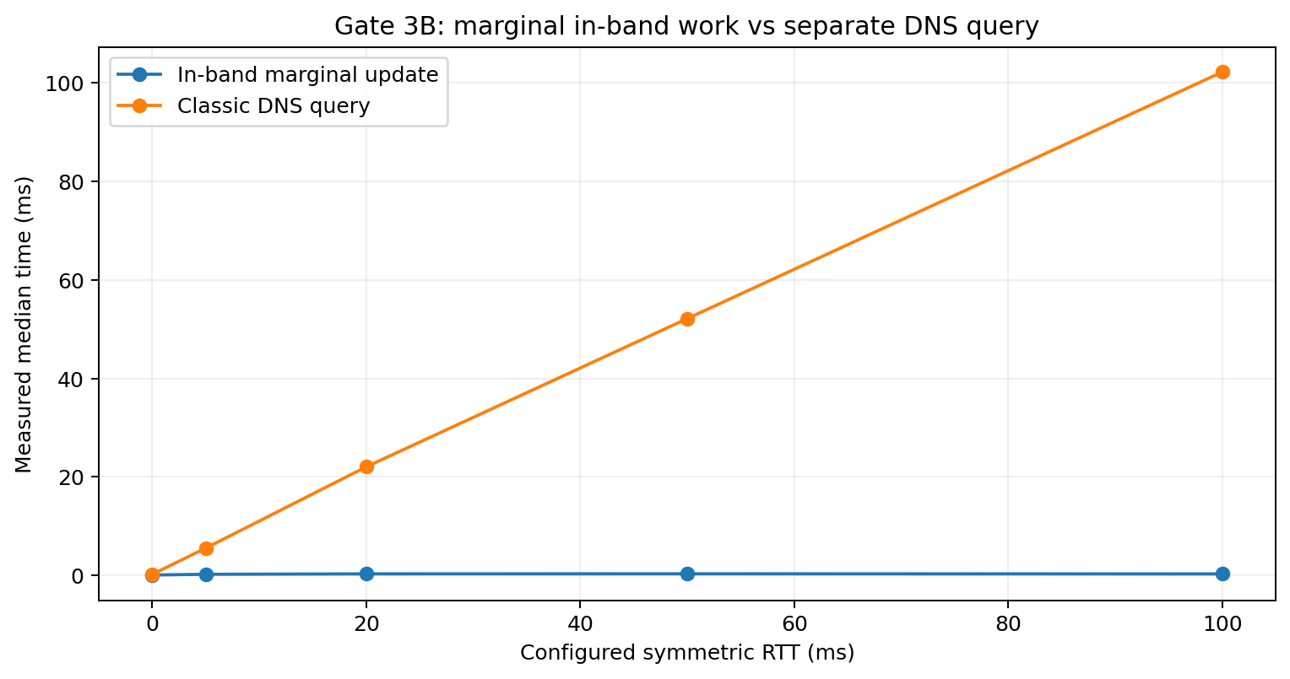
Figure 3. Controlled Gate-3B measurement. The in-band value is marginal work on an application path that already pays the application RTT; DNS is a separate query path. This is not an end-to-end Chromium Classic-vs-Freshness comparison.
Configured RTT | In-band normal median | In-band update median | Marginal median | DNS median | Push median
0 ms | 205.76 us | 305.17 us | 93.63 us | 241.59 us | 285.66 us
5 ms | 5600.33 us | 5834.60 us | 232.26 us | 5560.09 us | 6096.60 us
20 ms | 21895.71 us | 22263.13 us | 324.14 us | 22064.12 us | 22203.83 us
50 ms | 52083.48 us | 52451.97 us | 336.05 us | 52145.39 us | 52155.48 us
100 ms | 102040.92 us | 102385.16 us | 311.53 us | 102203.49 us | 102264.74 us

Interpretation: when a natural application request already occurred, the tested Freshness update did not add another network round trip. Its paired marginal median remained sub-millisecond while configured RTT increased, whereas the separate DNS and Push transactions tracked path RTT. DNS and Push are control paths for the cost of a separate network transaction, not matched application-layer workloads: the Push harness also performs HTTPS response handling, Base64/JSON parsing, Ed25519 verification, and semantic checks. Differences between DNS and Push medians therefore must not be read as a ranking of DNS versus Push efficiency; the supported comparison is RTT dependence of a separate transaction versus in-band work on an already-active path.

8.2 Chromium H3 100-repetition paired benchmark
Metric | Delta | NoChange | Paired Delta-NoChange
n | 100 | 100 | 100
min | 24.401 ms | 23.347 ms | -6.747 ms
mean | 29.374 ms | 29.251 ms | +0.123 ms
p50 | 29.378 ms | 28.997 ms | +0.145 ms
p95 | 32.720 ms | 33.315 ms | +3.853 ms
p99 | 34.717 ms | 34.505 ms | +4.743 ms
max | 34.788 ms | 34.701 ms | +8.229 ms

- Same application QUIC connection: 100/100 paired repetitions.
- Descriptive paired summaries: mean Delta-NoChange = +0.123 ms; p50 = +0.145 ms. These values are point summaries, not a resolved estimate of protocol processing cost.
- The paired differences span -6.747 ms to +8.229 ms and the Delta/NoChange distributions overlap strongly. The browser-visible incremental cost is therefore not statistically resolved by the summary statistics in this harness; the safe claim is that no material per-request penalty was detected at this measurement resolution.
- Inferential statistics are not reported from the summary quantiles alone. The archived 100-pair raw vector is the correct source for any confidence interval; no interval is inferred or fabricated from min/mean/percentile summaries in this report.

8.3 H3 wire observation: Delta vs NoChange
Single observed capture (n=1) | Packets | Client -> Server UDP | Server -> Client UDP | Total UDP | Approx. L3
Delta | 5 | 217 B | 516 B | 733 B | 873 B
NoChange | 7 | 314 B | 181 B | 495 B | 691 B
Delta - NoChange | -2 | -97 B | +335 B | +238 B | +182 B

This is a single QUIC capture (n=1). Packet count, ACK behavior, QPACK state, pacing, and packetization can change both directions and the resulting UDP/L3 totals; therefore neither -2 packets nor +238 B UDP is treated as a protocol constant or robust general overhead estimate. The stronger deterministic size fact is the current fullstack Delta COSE object itself (273 B raw); its HTTP Structured Field representation and resulting QUIC wire cost depend on framing/compression/transport state. The capture is retained as an observed example only.

9. TTL Interaction and Surviving-Path Self-Healing
The design separates ordinary DNS lifetime from Freshness authorization. Before admission, normal DNS TTL behavior applies. A verified Snapshot, Delta or Checkpoint is a new signed Authority freshness statement. While its validity interval is active, Freshness-managed state may remain usable even after the original bootstrap TTL would otherwise have expired. Interest alone does not suspend TTL indefinitely: once the signed Freshness assertion expires, conventional DNS/cache policy becomes authoritative again.
Surviving-path property
A single still-usable endpoint can carry the cursor and a signed transition that reconciles the entire scope. This allows the client to remove dead members, retain surviving members and add replacement members without requiring DNS solely because one cached endpoint failed. If no authorized path survives, DNS recovery remains mandatory.

Generalized example: old scope A/B/C/D -> new scope D/E/F. If A/B/C fail while D still works, D can carry the signed transition and repair the client to D/E/F. The Chromium hard-cutover is a concrete endpoint-replacement instance: Gen100 .61 -> Gen101 .12 was committed before .61 was removed.

10. Failure, Recovery and Abuse Model
Condition | Required behavior
Valid exact-chain Delta | Verify completely, then atomically commit.
Partial object / interrupted transfer | No mutation. 25%, 75% and 99% interrupted-delivery tests did not commit.
Stale / duplicate object | Ignore safely when ancestry/digest rules show no advancement is needed.
Same generation, different digest | Fork -> recovery; do not overwrite.
Active interest + unbridgeable newer generation | Recovery condition; do not skip silently.
Evicted/inactive interest + later higher generation | Fresh admission at current head; not a missing-update fault.
Lease expiry | Freshness authorization ends; conventional DNS/cache policy resumes.
Operational key compromise | Lower layer cannot self-detect a valid stolen key; DNSSEC root reset is the emergency boundary.
All known paths fail | Conventional DNS recovery.
Oversize / resource abuse | Reject before expensive parse/crypto where possible; no partial mutation.

11. What the Evidence Supports - and What It Does Not
Claim | Evidence class | Status
Signed DNS-state updates can ride natural application traffic | PoC-validated | Supported on H1 precursor, real lab H2/H3, and patched Chromium H3 vertical slice.
No dedicated Freshness connection/handshake is required | PoC-validated | Supported in tested active paths.
Zero Freshness-only traffic while the application is idle | PoC-validated | Supported for tested 5 s idle interval.
No per-client subscription state is required | PoC-validated | Supported by bounded-history/cursor model test.
DNSSEC can bootstrap and reset Freshness trust | PoC-validated | Supported in isolated signed hierarchy.
A surviving application path can repair endpoint state | PoC-validated | Supported by state model and Chromium .61 -> .12 cutover.
Active Freshness can outlive the original bootstrap TTL | Design + tested lease semantics | Supported within signed validity interval; not indefinite.
Every normal HTTP request becomes substantially faster | Not supported | False framing. Warm cache-hit requests are expected to be roughly unchanged apart from cursor/processing cost.
Classic recovery is exactly X ms slower than Freshness | Not measured | Direct fullstack Chromium Classic hard-cutover latency benchmark was not completed.
Internet-scale / production-ready / universal superiority | External validation required | Not supported by local PoC.

12. External Reproduction and Falsification Plan
The local lab has reached the point where the highest-value work is external validation rather than more self-contained happy-path gates. A production-grade networking team should attempt to reproduce the core result and deliberately attack the assumptions below.
- Apply a clean Chromium patch against a pinned revision and reproduce the DNSSEC bootstrap -> Snapshot -> Delta -> hard cutover sequence.
- Repeat on Firefox/Necko and WebKit/NetworkProcess or another independent resolver/browser stack.
- Exercise real CDN/edge topologies, reverse proxies, HTTP field normalization/stripping, WAFs, service meshes and anycast.
- Test QUIC migration, 0-RTT, connection coalescing, alt-svc changes, multiple concurrent H2/H3 streams and response reordering.
- Measure large working sets, scope churn, history truncation, update storms and bounded resource behavior under adversarial inputs.
- Quantify the hard-discontinuity rate and overlap window: how often all previously authorized paths disappear before a signed transition can be learned, versus rolling/draining/partial-change cases in which at least one path survives long enough to reconcile state.
- Run direct end-to-end Classic DNS/TTL vs Freshness recovery measurements in a production-grade browser harness, including long-TTL stale mappings, resolver prefetch behavior, explicit 30 s / 60 s short-TTL baselines, and Alt-Svc + HTTPS/SVCB where applicable. Measure not only request latency but population-wide DNS query volume over change windows and varying client activity ratios.
- Measure CPU, memory, cryptographic verification cost, cursor compression/QPACK effects and battery impact on mobile devices.
- Simulate clock skew, root/operational key compromise, replay windows and emergency DNSSEC root resets.
- Attempt to dominate the proposal with simpler existing mechanisms: Alt-Svc, HTTPS/SVCB, short TTLs, resolver prefetch, and combinations of them. If they provide the same convergence/recovery benefit with materially less state, trust machinery, or implementation complexity, the proposal should be rejected or narrowed.
Recommended kill criteria
Reject or redesign the approach if independent testing shows that it commonly adds a network RTT, cannot preserve trust/view boundaries through real intermediaries, creates unbounded client/server state, or is dominated by a simpler existing mechanism in the same operating point. In particular, the broad proposal fails if real services rarely retain an authorized overlap path long enough to deliver useful pre-failure reconciliation, or if Alt-Svc/HTTPS-SVCB plus conventional short-TTL/prefetch policy achieves comparable convergence and failure recovery with materially less complexity and without materially greater population-wide DNS work.

13. Recommended External Research Package
Artifact | Purpose
README / Technical Evidence Report | Problem, architecture, evidence classes, key results and claim boundaries.
chromium-freshness-v0.1.patch | Minimal reproducible diff against a pinned Chromium revision, ideally behind a feature flag.
docker-compose / lab topology | Authority, validating resolver / Secure DoH, H3 endpoints and control network.
run-zero-dns-cutover.sh | Single-command reproduction of the .61 -> .12 hard cutover and zero-target-DNS proof.
run-wire-benchmark.sh | Paired Delta vs NoChange capture and byte accounting.
run-100-reps.sh | Paired latency benchmark with frozen summary statistics.
FALSIFICATION.md | Explicit failure hypotheses and kill criteria.
EVIDENCE/ | Frozen logs, pcaps, vectors, manifests, hashes and environment metadata.

14. Conclusion
The contribution supported by this report is not the generic idea of advertising a future endpoint over an existing connection, nor the generic idea of transporting DNSSEC-validatable material in-band; RFC 7838 Alt-Svc and RFC 9102 TLS DNSSEC Chain establish those adjacent design spaces. The PoC instead exercised a DNSSEC-rooted, independently verifiable DNS-state reconciliation model: bounded scope state, generation plus digest identity, exact signed transitions, fork/gap recovery, key rotation and emergency root reset, negative DNS state, resource limits, H2/H3 carriage, and a patched Chromium path that committed a signed endpoint transition into resolver state. Its strongest demonstrated property is pre-failure convergence: Gen101 / 172.18.0.12 was verified and committed before 172.18.0.61 was physically removed; the next request then reached the replacement with zero target-name DNS queries during the cutover.
Gate 3B demonstrated the mechanism-level opportunity: reconciliation can be folded into an application exchange that is already paying the path RTT, while a conventional refresh or separate push transaction is another RTT-bearing network transaction. The 100-pair Chromium result detected no material browser-visible penalty at the resolution of that harness; its +0.123 ms paired mean is descriptive only, not a statistically resolved effect. The decisive external questions are now operational: how often a usable overlap path exists before hard discontinuity, how much population-wide DNS work short-TTL/prefetch alternatives require for comparable convergence, and whether the richer state/trust model survives real CDN, browser, resolver, proxy, mobile, and anycast complexity.

Appendix A. Frozen Evidence and Artifact Index
Evidence | Reported path / identifier
Evidence Freeze v0.1 | opportunistic_dns_freshness_evidence_freeze_v0.1_de
Protocol Spec v0.1 | opportunistic_dns_freshness_protocol_spec_v0.1_frozen_de
Chromium fullstack state machine | /mnt/user/appdata/dns-service-sync-lab/benchmark/results/browser-fullstack-state-machine/20260824T193702Z
Hard zero-DNS cutover | /mnt/user/appdata/dns-service-sync-lab/benchmark/results/browser-zero-dns-cutover/20260825T052433Z
Canonical hard-cutover snapshot | /mnt/user/appdata/dns-service-sync-lab/snapshots/hard-zero-dns-cutover-pass-20260825T052433Z
Hard-cutover freeze content SHA-256 | 1950d5b91dda3aa13d6f93c128c70c70aecc3a041b851c2a3e8edc1980bc54c1
Hard-cutover archive SHA-256 | 1da526d51aacc145f63736a5f45be54705dadfa26c05030c06de2165887bc506
Wire Delta/NoChange | /mnt/user/appdata/dns-service-sync-lab/benchmark/results/browser-wire-delta-nochange/20260825T054759Z
Chromium 100-rep benchmark | /mnt/user/appdata/dns-service-sync-lab/benchmark/results/browser-freshness-100/20260825T055014Z
Gate 3B RTT runner | /mnt/user/appdata/dns-service-sync-lab/benchmark/run_gate3b_rtt.sh
Gates 4–18 | /mnt/user/appdata/dns-service-sync-lab/benchmark/gate4-bounded/ through gate18-http3/

Appendix B. Selected Frozen Vector Hashes
Vector | SHA-256
Gate-13 checkpoint.cose | 6d7fd17b85c798242044cce0aa0938163954adbd7a0ff396dd7905f7003ef45d
Gate-13 delta.cose | 94f0882665abfa18913323a6776629f5087fee73710846273cee72e50b1cb92c

Appendix C. Standards Alignment and Related Work Used by v0.1
- RFC 4034 - canonical DNS name/RR forms and RRset ordering basis for deterministic state identity.
- RFC 8949 - deterministic CBOR profiles may be required and validated by a protocol.
- RFC 9052 - COSE_Sign1 as CBOR Tag 18 / four-element structure.
- RFC 9864 - fully specified COSE Ed25519 algorithm -19.
- RFC 9651 - Structured Field Byte Sequence representation.
- RFC 9113 - HTTP/2 multiplexed streams on one connection.
- RFC 9114 - HTTP semantics over QUIC; request stream numbering used in H3 evidence.
- RFC 9460 - SVCB/HTTPS; private-use SvcParamKey range used only for the lab experiment.
- RFC 8765 - DNS Push / DSO subscription precedent and complementary idle-delivery capability.
- RFC 7838 - HTTP Alternative Services; direct prior art for authoritative in-band alternative service advertisement with an ma freshness lifetime.
- RFC 9000 - QUIC preferred_address; server-supplied migration address scoped only to the connection in which it is provided.
- RFC 9102 - TLS DNSSEC Chain Extension; Experimental Independent Submission for in-band carriage of the DNSSEC authentication chain needed for DANE/TLSA, including authenticated denial of existence and avoidance of separate out-of-band DNS lookups for that authentication data. Close precedent for in-band self-validating DNSSEC material, but not a post-admission incremental DNS-derived connectivity-state reconciliation protocol.
- draft-thomson-httpbis-alt-svcb-01 (2023) - expired individual Internet-Draft; proposed DNS as the singular source of service reachability and in-band alternative names as a prompt to query DNS. Not IETF-endorsed; retained here as a design counterargument, not a standard.
Evidence policy note: If a broader narrative conflicts with the frozen evidence ledger, the frozen ledger should prevail until new evidence exists.

