IGEMS
CAD/CAM/NEST
IGEMS R2026.1.4498
Date: 2026, May 12

1 How to install revision 2 9
2 General user interface 10
2.1 System menu 10
2.2 Recover 12
2.3 Recent files 13
2.4 Save 13
2.5 Save as 13
2.6 Save as template 14
2.7 Export 14
2.8 Support 14
2.9 Close 15
2.10 Close all 15
2.11 Plot 15
2.12 Limits 16
2.13 Dump image 17
2.14 Preferences 17
2.15 Password 23
2.16 Translate 24
2.17 Shortkeys 24
2.18 Point style 26
2.19 Subscription 27
2.20 About 27
2.21 Changelog 28
2.22 Check for updates 29
2.23 Exit 29
2.24 Command menu 29
2.25 Quick access toolbar 30
2.26 Add to custom toolbar 30
2.27 Shortkeys 31
2.28 Command line area 31
2.29 Multiple drawings 34
2.30 Zoom and Pan 34
2.31 Coordinate input 34
2.32 Distance input 36
2.33 Object snap 36
2.34 Grips 38
2.35 Select objects 38
2.36 Auto base point 41
3 System menu 42
3.1 Undo 42
3.2 Redo 42
3.3 Purge 43
3.4 Status 43
3.5 Shared folder 44
3.6 Service center 44
3.7 Support 44
4 CAD commands 46
4.1 Line 46
4.2 Circle 46
4.3 Rectangle 47
4.4 Point 47
4.5 Arc 47
4.6 Polyline 48
4.7 Sketch 48
4.8 Spline 48
4.9 Ellipse (Shift+E) 48
4.10 Solid 49
4.11 Hatch 49
4.12 Parametric shapes 50
4.13 N-gon 51
4.14 Obround 52
4.15 Swell 52
4.16 Unswell 52
4.17 Puzzle 53
4.18 Boundary poly 53
4.19 Offset 54
4.20 Fillet 54
4.21 Trim 54
4.22 Zero fillet 55
4.23 Chamfer 55
4.24 Smooth connect 56
4.25 Lengthen 56
4.26 Extend 56
4.27 Boolean 56
4.28 Polyline editor 57
4.29 Break 58
4.30 Delete 58
4.31 Join 58
4.32 Layer 58
4.33 Explode 59
4.34 Create block 59
4.35 Insert block 60
4.36 Group 61
4.37 Save block 61
4.38 Define attributes 61
4.39 Move 62
4.40 Rotate 63
4.41 Copy 63
4.42 Mirror 63
4.43 Scale 63
4.44 Quick move 64
4.45 Stretch 64
4.46 Skew 64
4.47 Array 65
4.48 Dimension 66
4.49 Text 67
4.50 Diameter 68
4.51 Radius 68
4.52 Positions 68
4.53 Angular dimension 69
4.54 Leader 69
4.55 Dimension style 69
4.56 Zoom extents 72
4.57 Pan 72
4.58 Zoom 72
4.59 Zoom window 72
4.60 Zoom object 72
4.61 Line type 73
4.62 Line weight 73
4.63 Send to back 74
4.64 Bring to front 74
4.65 Info 74
4.66 Distance 75
5 CAM-Tools 77
5.1 Clean up 77
5.2 Edgefix 78
5.3 Curvefit 78
5.4 Boundary scan 79
5.5 Replace 80
5.6 Analyze 81
5.7 Boundary trim 81
5.8 Poly joint 82
5.9 Corner cutout 82
5.10 Vectorize 83
5.11 Divide 83
5.12 Pocketing 83
5.13 Convex hull 84
5.14 Align 84
5.15 Dovetail 84
6 SignMaker 85
6.1 Font tracer 85
6.2 Image 86
6.3 Image tracer 87
6.4 Optimize 88
7 Tile maker 89
7.1 Tile 89
7.2 Tile cut 90
7.3 Inlay 93
8 Data Exchange 98
8.1 NC reader 98
9 IGEMS Camera 100
9.1 Mounting and calibration of the camera 100
9.2 Using a separate camera table 104
9.3 Camera troubleshooting 105
10 CAM 106
10.1 Select machine 106
10.2 Create Part 107
10.3 Quality 112
10.4 Tool setup 117
10.5 TAC-LAG 119
10.6 Properties 120
10.7 Add Other object 121
10.8 Part text (THIS COMMAND SHOULD BE UPDATED) 121
10.9 Inkjet 122
10.10 Browser 125
10.11 Join 125
10.12 Split 126
10.13 Part Stretch 126
10.14 Part Offset 127
10.15 Part Clone 127
10.16 Contour 128
10.17 Quick 141
10.18 Marking 145
10.19 Holes 146
10.20 Manual 149
10.21 Loops FIXA DETTA NÄR VI HAR EN NY DIALOGBOX 154
10.22 Bridges 154
10.23 Common cutlines 156
10.24 Cutoff 161
10.25 GridCut 164
10.26 Clone toolpath VI SKALL ÄNDRA DETTA KOMMANDO 165
10.27 Break toolpath 165
10.28 Edit toolpath VI BÖR HA ETT MÖTE OM DETTA KOMMANDO 165
10.29 Delete toolpath 168
10.30 Micro joints MÅSTE KOMPLETERAS MULTI FUNKAR EJ 168
10.31 Chain BYT UT DIALOGBOXEN TILL EN LÄNGRE 170
10.32 Disconnect 171
10.33 Poly lead SKALL VI TA BORT DETTA KOMMANDO 171
11 Bevel 172
11.1 Bevel design 172
11.2 Bevel cut 175
12 3D-5X 179
12.1 General interface 179
12.2 Open 180
12.3 Samples 180
12.4 Import 181
12.5 Recent file 181
12.6 Save 182
12.7 Save as 182
12.8 Export STEP 182
12.9 Layer 182
12.10 Preferences 182
12.11 Properties 184
12.12 Print 184
12.13 Test 184
12.14 Display options 185
12.15 Undo 189
12.16 Redo 189
12.17 Sketch plane 189
12.18 Align 191
12.19 Z-Position 192
12.20 Rotate 193
12.21 Curves 193
12.22 Toolpaths 196
12.23 Add a toolpath 198
12.24 The list of toolpath 201
12.25 Edit toolpath: Lead settings 202
12.26 Piercing 202
12.27 Edit toolpath: Type 205
12.28 Fixed type 205
12.29 Ruled type 206
12.30 Edit toolpath: Tool position 207
12.31 Variable Z 207
12.32 Fixed Z 209
12.33 Engagement 210
12.34 Various 213
12.35 Zero point 214
12.36 Global zero point 215
12.37 Stock 216
12.38 Create part 216
12.39 Z-axis control 217
12.40 CAD 218
13 2D-5X 221
13.2 Cut bevel 224
13.3 Quick bevel 226
14 CAM – Material setup 227
14.1 Material groups 228
14.2 Material qualities 231
14.3 Material thickness 233
14.4 AWJ 234
14.5 General import 242
15 TVL 243
15.2 Create your own TVL-data 245
15.3 Add more thicknesses 248
16 CAM – Sheet commands 249
16.1 Sheet Create 249
16.2 From hole 251
16.3 Lock sheet 251
16.4 Unlock 252
16.5 Divide 253
16.6 Sheet export 253
16.7 Sheet open 254
16.8 History 254
16.9 Inventory 255
16.10 Migrate 256
17 Nest Level 1 257
17.1 Quick nest 257
17.2 Glide nest 258
17.3 Single nest 259
17.4 Rectangle nest 260
17.5 Circle nest 261
17.6 Nest Report 261
18 Nest Level 2 263
18.1 Auto nest 263
18.2 Re-nest 278
19 CAM - Process 280
19.1 Process 280
19.2 Order 285
20 Cutting parameters and Strategy 292
20.1 Cutting parameters 292
20.2 Strategy 293
21 CAM – Machine setup 307
21.1 Table layout 308
21.2 Cutting tools 311
21.3 Z-axis control 313
21.4 Marking tools 318
21.5 Drilling tools 322
21.6 Speeds 323
21.7 Postprocessor 326
21.8 Geometry 329
21.9 5-axis kinematic settings 335
21.10 Rotation axis 340
21.11 Cutting equipment 342
21.12 Delays 347
21.13 Various 349
22 Organizer 351
22.1 Register 351
22.2 Organizer 353
22.3 Automatic count down 356
23 APPS 357
23.1 Load app 357
24 Messages 359
25 Subscription and temporary licenses 360
25.1 Activate a temporary license 360
25.2 Activate an industrial license 360
26 Floating License Manager 361
26.1 Error codes 362
27 The CNC-controller 363
28 Final words 364

How to install revision 2
Machine and postprocessor and other required files

Step 1
Be sure that you have an IGEMS version later than 2022.2.2714. If not, then download and install the latest version available from our web site. www.igems.se

Step 2
Double click on an attached ISF file.

Step 3
In the CAM tab, click on the Machine setup command from the drop-down menu.

Step 4
Following dialog box will be shown
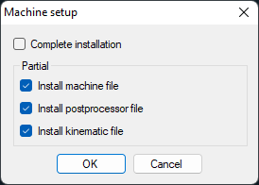
By activate optional checkboxes you can select what to install.
Note: If this is the first installation of revision 2 then you need all three suggested files.

General user interface

System menu
Use the IGEMS system menu to handle standard functions like "Open", "Save", "Plot" and "Settings".
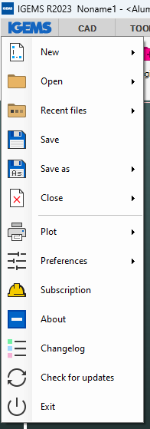

New
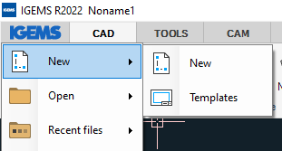
Use this command to start a new drawing.

Templates
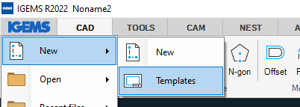
A template is a normal IGEMS drawing (DIG) file. A template is used to start IGEMS with custom settings, for example, to switch between metric and inches. This option shows the following dialog box.
See also Save as template
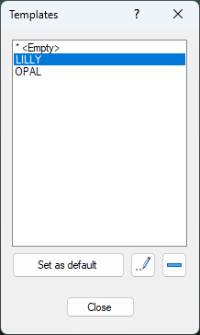
Use the star button to set a template to default, there is also buttons to rename or delete existing templates. The template will be used every time to start a new drawing.
Are there other reasons to use templates?
It is a simple way to customize IGEMS. All settings like layers, colors, line types, dimension settings are saved in a template. Use a template to set these values once.

Open
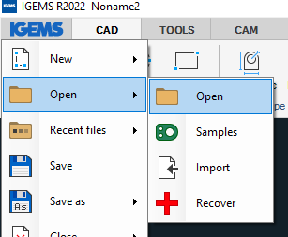
As standard IGEMS can open following files. If you have the Data Extension module then you can open other type of files.
Type | Description
.ACD | IGEMS R3 to R9 drawing format
.DIG | IGEMS R10 standard drawing format
.DWF | Drawing Web Format
.DWG | AutoCAD Drawing files
.DXF | Drawing Exchange Format
.ICDF | Igems Cnc Data File
.IGS | Iges files (Use the 3D interface)
.STP | Step file (Use the 3D interface)
.ISF | Igems Suport File
By holding down CTRL or SHIFT command you can open multiple files at the same time.
Is it possible to write an application that can read other kinds of files?
Yes, such applications can be made in ILISP script languages.

Samples
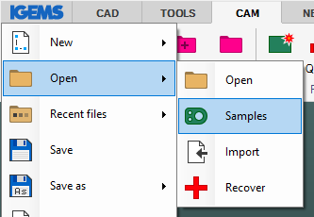
IGEMS has a set of sample files already installed. These files are used as examples in this documentation.

Import
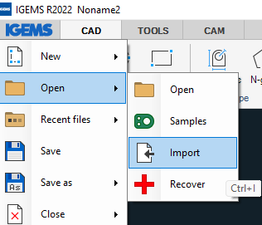
The Import command will open and import all selected files into actual drawing.
The "Import" command inserts selected drawing files into the current drawing.
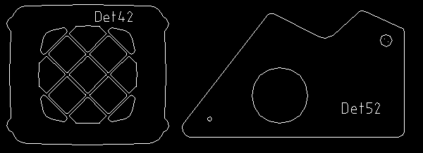
Hold down CTRL or SHIFT while inserting the part to also insert the name of the file as text. This text can be used to identify the name when making parts. The "Import" command can use the same files as "Open". The text can be used for generating automatic part names.

Recover
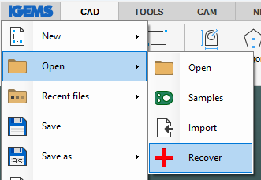
The "Recover" command can be used to recover drawings (DIG files) in the event of a system failure. The "Recover" opens a file dialog box with all Auto saved files. The interval (minutes) for auto save is set in the "Preferences" menu and if this value is set to zero (standard) then the "Recover" command is disabled.
Note! Auto saved files older than 24 hours will automatically be deleted from the list.

Recent files
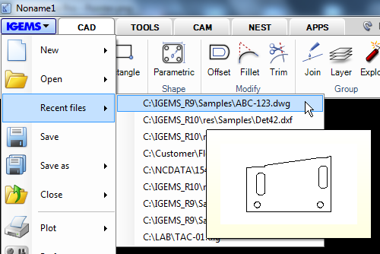
This command shows the fastest way to view and find a list of recently opened files.

Save
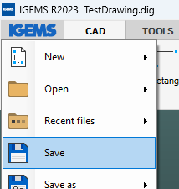
This command saves the active drawing into an IGEMS DIG file.

Save as
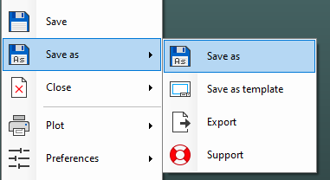
This command saves the active drawing under another name.

Save as template
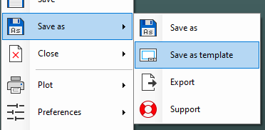
A template is a normal IGEMS drawing that can be used to start IGEMS in different predefined modes. A template ‘s settings can be modified to create layers, limit values, modify colors or draw objects desired as the drawing’s default. Select "Save as template" to have IGEMS ask for a name of the template.
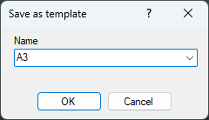
All template drawing is saved in a Shared folder that can be used by other users. See also Templates.

Export
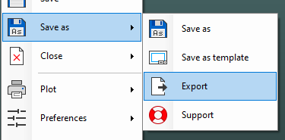
This command exports selected objects or the whole drawing to another format, such as a DIG, DXF, SVG and SVGZ.
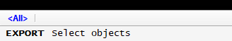

Support
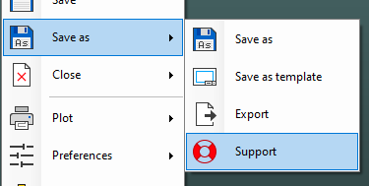
A support file will save the drawing and all other relevant files such as postprocessor, material and machine configuration) in a compressed (all inclusive) file. This file type is used when you want to ask a question or reporting problems to IGEMS support.

Close
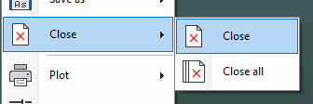
"Close" will close the active drawing. A prompt will ask to leave the file unsaved or saved before closing if the file was modified since the last "Save".

Close all
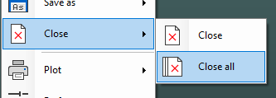
This command will close all open files. A prompt will ask to leave the file unsaved or saved before closing if the file was modified since the last "Save".

Plot
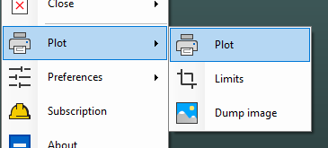
The "Plot" command is used to print out drawings from IGEMS to a PDF file to use to print out to any type of printer/plotter.
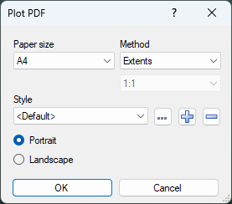
Plotting in IGEMS creates a PDF file as an intermediate step before sending it to the printer/plotter.

Paper size
Select the paper size used for the plotting.

Method
This describes the method that will be used in the plotting area.
- Paper size: Select the proper paper size to use for the plotting.
- Method: Set the proper area to plot.
- Plot Style: Customize the plotting result with line weights and color settings.

Style
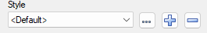
Select the style to use from the drop-down list.
Create new or delete existing styles by using the "plus" and "minus" buttons.
Change parameters in the selected style by the "…" button.

- Press the "plus" button and create a style called "TEST".
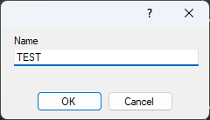
- Press the "Edit" button
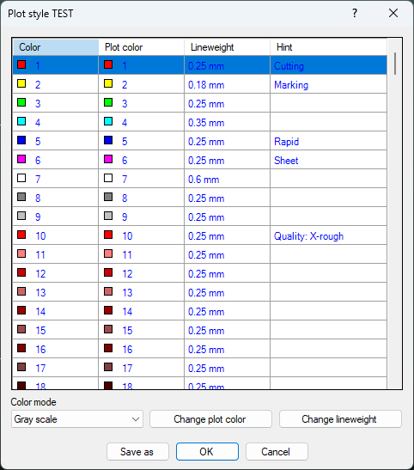
From this dialog box, you can map the colors on the screen to different colors on the paper. Use the line weight to apply different thickness to different colors. The color mode controls how the different colors should be plotted on the paper.

Limits
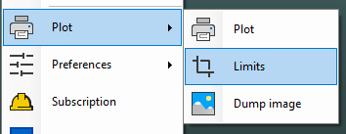
"Limits" predefines a rectangular plotting area by selecting 2 points diagonally on the drawing area. The limits area is saved in the drawing and is visible when the grid is activated.

Dump image
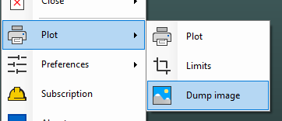
This command creates a bitmap image out of the geometry. Select the geometry to be included and enter width and height of the image before saving the file. The values are defined in pixels.
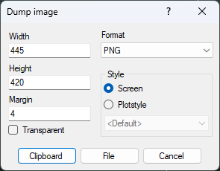
Supported file formats are PNG, JPG, BMP and EMF files.

Preferences
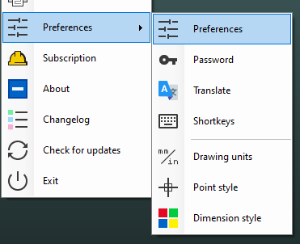
The "Preferences" command includes functions to customize the drawing environment for language, units and dimensioning.

Display
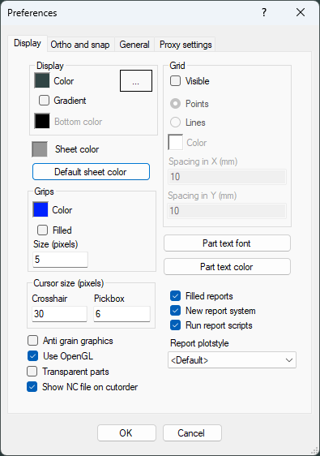

Background
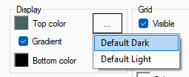
This setting allows users to customize the preferred background color(s). Checking the gradient checkbox enables different colors to be shown in the top and bottom of the screen.
You can also select one of the default color combinations Default Dark or Default Light

Sheets
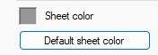
In the "Display options" you can control if sheets should be colored or not. Here in preference, you can control what color should be used.
By clicking on the button "Default sheet color" the color will be set to a predefined color.

Grips
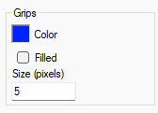
When no command is active, and an object is selected IGEMS will show the grip points on the objects. This setting customizes the size and the color of the grips.

Cursor
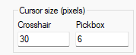
This controls the size of the crosshair and the size of the selection box (Pickbox). The Pickbox is used when selecting objects and by the "Object snap".

Grid
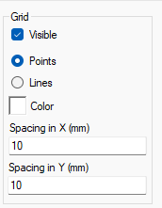
These settings control how the grid is shown (by points or lines), the color and the distance between the grids. The grid area is the same as the limits area.

Part text properties
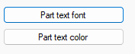
This is the font and color for the Part text command.

Various settings
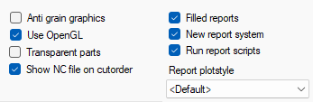

Anti grain graphics
Anti grain graphics will generate the objects in a smoother way. Some people like this other not. Anti grain graphics will use more computer power.
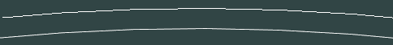

Use OpenGL
The system requirement is OpenGL 2.0, but there is also possible to use an inbuild software driver. This should be used only if there is problem with the OpenGL driver.

Transparent part
This will make parts transparent. I have no idea why we have done this.

Show NC-File on cutorder
This will show the name of actual CNC-file at the cutorder after you have postprocessed the job.

Filled reports
If parts should be color filled in reports.

New report system
If the new report system launched in 2018.3 should be used.

Run report script
This toggle should be activated. If you are developing customized script and it's an error in the script, then it is not possible to generate the report. If you uncheck this option then the report will be generated without the script.

Report plot style
Default you should use the <report> plot style. You can generate new plot style from the Plot command

Ortho and snap
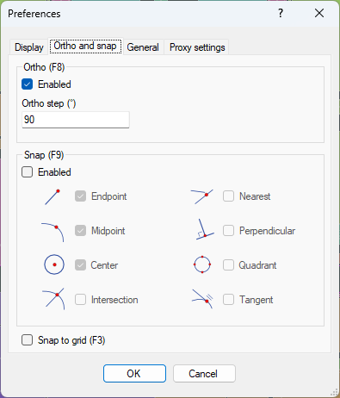
These settings control the "Ortho" and the "Auto snap".

General
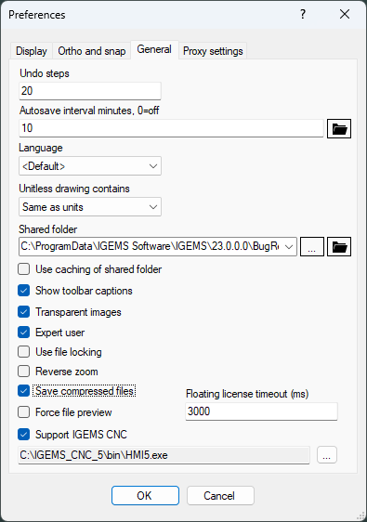

Undo steps
This is the number of Undo/Redo steps that will be possible to make. Default number is 20. Increasing the value may slow down the system on large drawings.

Auto Save
When working in an unstable environment it can be helpful for IGEMS to automatically save the drawing in a timed interval. If the value is 0 then the function is disabled. You can open an auto saved drawing from the Recover command.

Language
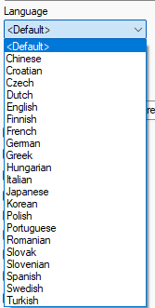
The language will automatically be set to the same language of the operating system but can also be changed here. If that language is currently not yet supported IGEMS will default to English.

Unitless drawings
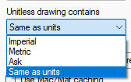
Some files (WMF, DXF and DWG) have no information about units. This setting controls which format these files should be converted to. If the setting is "Same as units" then it will be converted to the actual setting of IGEMS.

Shared folder
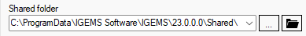
The shared folder includes all settings that can be shared with other users in the same network (machine settings, material settings, post processor settings, etc.).
To change the location of the shared folder, press the "…" button and select the folder to use.
Note! If an empty folder is selected, then all information in the current folder will be copied to the new folder. If a non-empty folder is selected, nothing will be copied.
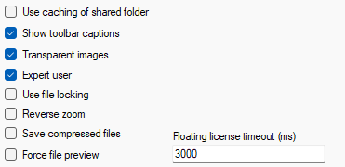

Use catching of shared folder
If the shared folder is located on a server and IGEMS feels slow because of this then you can activate this checkbox. IGEMS will then store the files in memory and just reload files if they have been changed on the network. This will speed up IGEMS.

Transparent images
When "Copy" and "Paste" are used to copy geometry in IGEMS, an image is created that can be inserted into other documents. This setting defines whether the background of this image should be transparent or not.

Expert user
If this setting is activated, then the user can change machine and material settings. If not then following message will be shown when user try to change this settings.
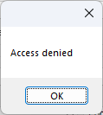

Use file locking
IGEMS are using Windows standard file locking system. If file locking is activated and you open a file, then this file will be locked. It's not possible for another user to open this file as long as it is open by you.

Reverse zoom
IGEMS require a wheel mouse for zooming in and out. By checking this option, you reverse the direction of the mouse.

Save compressed files
IGEMS drawing files has extension the ".DIG". If this option is activated, then IGEMS will save information as compressed files. We recommend that this option always should be activated.

Force file preview
If it's deactivated IGEMS will only show previews of DIG-files in the Open dialog. When its activated IGEMS will show preview of all supported files.
The reason why we have this toggle is that IGEMS can feels slow because all files must be open internally to generate the pictures. If you think its lazy uncheck this option.

Floating license timeout
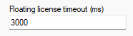
If you have a floating license, then IGEMS will often be in contact with the server. If the network is very slow you may need to increase this value.

Support IGEMS CNC
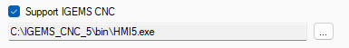
If you have IGEMS CNC installed at the same computer, and want a more seamless connection then you can activate this option and select the location of the IGEMS cnc executable file.

Proxy settings
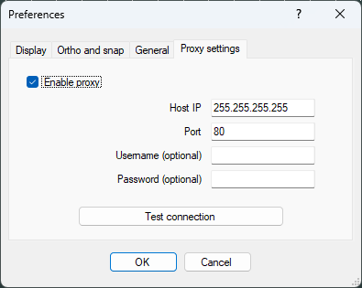
Sorry, someone that knows more about this has to put the text here.

Password
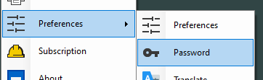
If you have a USB-license then following dialog will be shown.
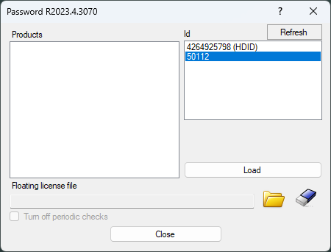
Plug the USB-dongle into an USB port. The number of the USB-Dongle should now be visible on the on the list. You should also have received a PWD file that have information about what modules that should be activated.

Translate
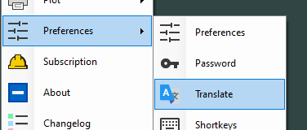
IGEMS can be translated to many languages. The translation is often done by resellers or end users. To be authorized to make translations you must receive a password from IGEMS. The password is different for different languages. Please contact IGEMS if you want to help us translate the software.
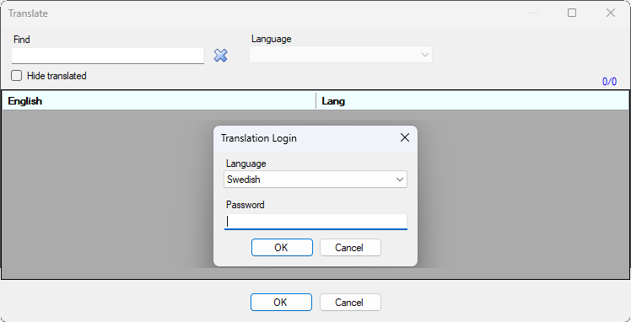

Shortkeys
IGEMS can use shortkeys to start different commands and options. We have some users that have asked for the possibility to make their own sets of keys.
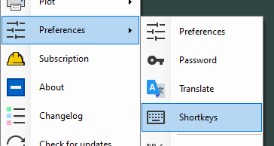
If you start the command, then you will see following dialog.
By clicking on the title, the list can be sorted in increasing or decreasing order.
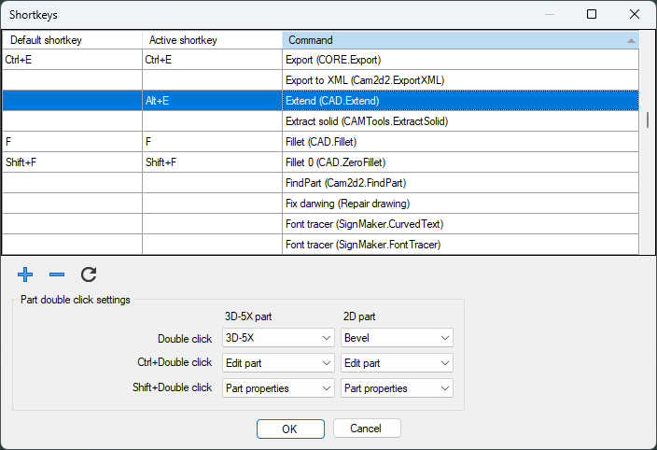
If you double-click on a command. In this case Extend. You will see following dialog.
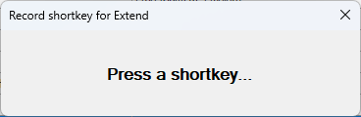
Click ALT+E to assign the short key to the selected command.
Use the + and – buttons to add or remove Shortkeys.

Part double click setting
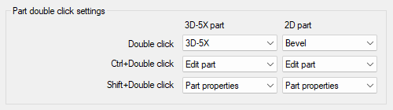
In this frame you can decide what should happens when you click on a part. You can chose following:
Open in 3D-5X, Bevel, Part properties or Edit part.

Drawing units
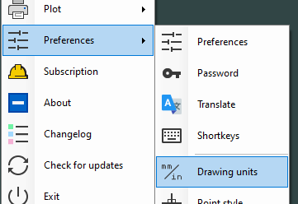
The drawing units are saved in the drawing. IGEMS will open a file in the same units used when the drawing was saved.
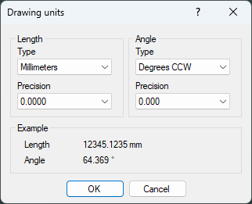
IGEMS stores all numerical values as high precision (0.0000). These settings only affect what is displayed to the user on screen. Use this dialog box to specify special units for dimensions and other outputs. You can also change the drawing units from the Quick options

Length units
Select if the units should be in Millimeter or Inches and set how many decimals to show.

Angle
Select if the angles should be in Degrees or Radians and set how many decimals to show.

Point style
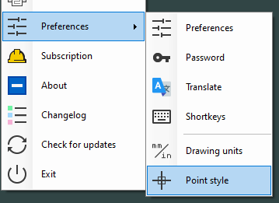
"Point style" controls how points will appear on the screen.
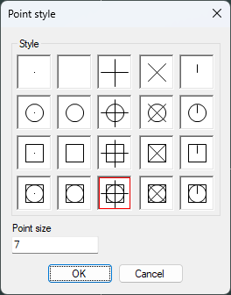
Select the type of point and the size; a larger value means a larger point. The visual size (in pixel) will be the same no matter of zoom factor.

Subscription
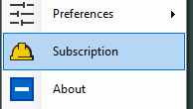
I think Joakim already has written some good text on this. We will add that.

About
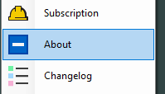
This command displays the following information.
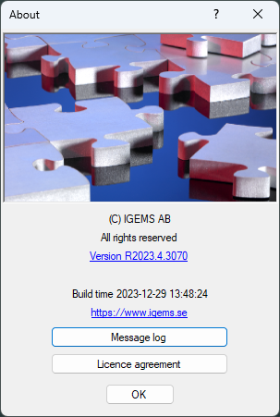

Version
This is the actual version that are installed. If you click on the version, you will open the Change log.

Message log
IGEMS will send information on improvements and other interesting information. If you click on this you will see a log on previous messages we have sent.
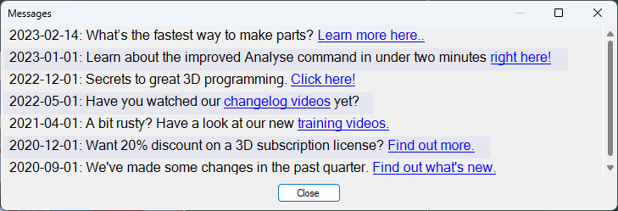
Most of these messages are videos that describe new cool features.

License agreement
When you install IGEMS you have accepted the license agreement. When you click on this button you will see a copy of the license agreement.

Changelog
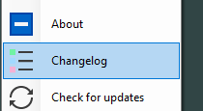
We have a great cooperation with our waterjet machine builders and also with many users. We get a lot of input and we are updating IGEMS CAD/CAM as often we can. Some quarters we release 8 to 15 new versions. By clicking on this command, you will see a log of all changes we do.
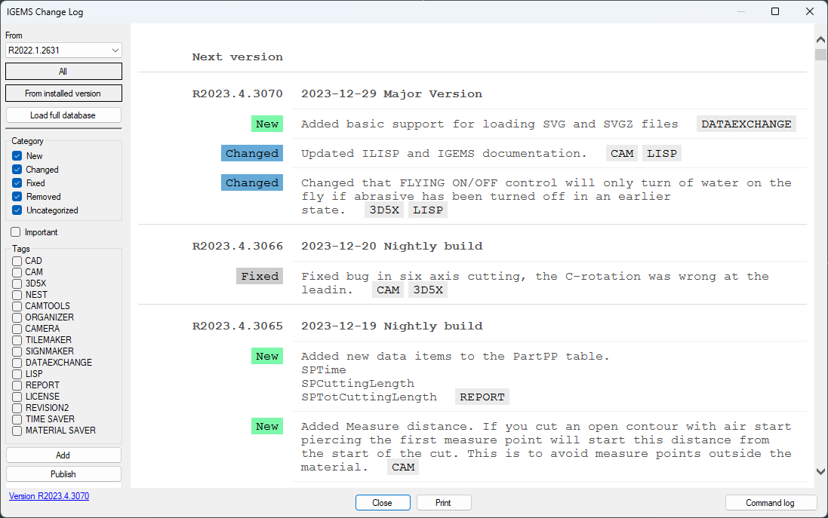

Check for updates
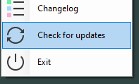
This command will check if there is a newer version available.
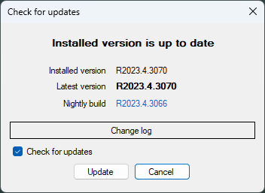

Exit
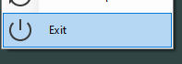
Use this command to close IGEMS and all open drawings.

Command menu
IGEMS will display the menus horizontally on the top of screen after installing.
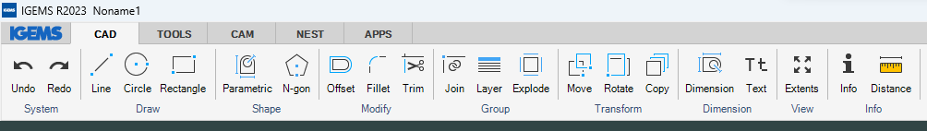
IGEMS is modular system, it will only show commands that are installed and that could be used. Your menu could therefore look different from the picture above.

Quick access toolbar
Frequently used commands can be grouped into the "Quick access toolbar" to save time with fewer mouse clicks.
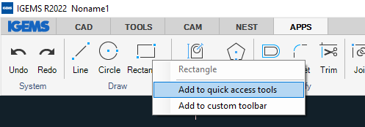
To add a command, click on the command by right mouse button and select "Add to Quick Access tools". All commands will appear on the right side of the APPS tab. To remove the command from the Quick access toolbar, simply move the mouse pointer over the command and right mouse click to delete.
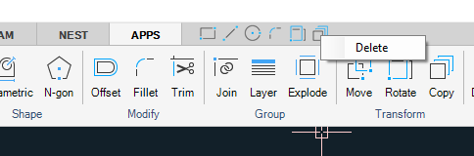

Add to custom toolbar
Another method is to add commands to a custom toolbar. Use the right mouse button and click on the command.
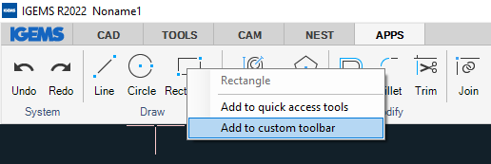
All commands selected in this way will be placed on a separate CUSTOM tab
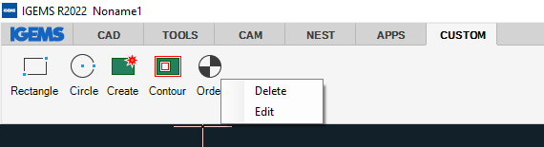
If you want to remove a command from the custom tab then click on the command using right mouse button and select the option Delete. If you want to modify the order between commands then select the option Edit.
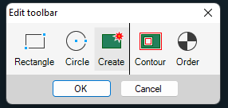
Use the mouse to change the order between the commands.

Shortkeys
Hold the mouse pointer over a command to see the shortkey for this command. Shortkeys are available for most used commands. For example, by pressing key "N" you will start the Rectangle command.
You can program your own set of shortkeys here.
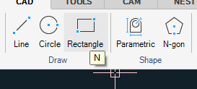
To repeat a previously used command, simply press the spacebar or Enter key.

Command line area
On the bottom left side will be the name of the actual command (in this case Circle)
Above the command name shows different options. You can ether click on the option or type the actual shortcut character.
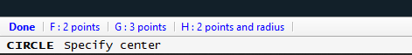
On the bottom right side will be actual coordinates that the cursor is pointing at.
There is also information about the width of the actual screen. In this case the screen shows 578 mm.

Quick options
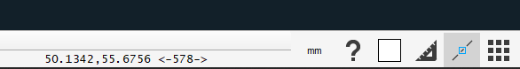

Drawing units
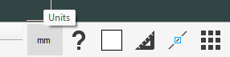
Use this to change Drawing units

Help
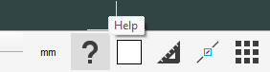
This will open IGEMS_R2024/DOC/IGEMS.docx. If possible, it will show information about active command.
Note! If you want to have documentation on paper, you can print this documentation as a reference manual.

Color
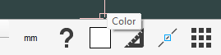
When you click on this button following dialog will be shown.
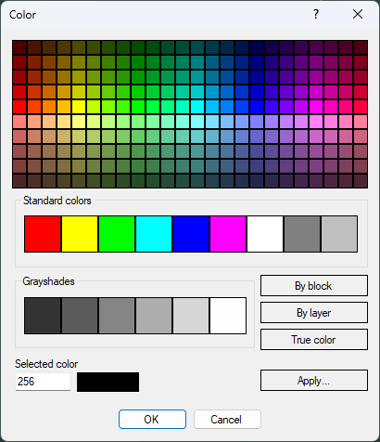
There are two different ways of using this.
- If you have selected some objects on the screen, you will change the color on selected objects.
- If no objects are selected, then all new objects will have the new color.
What is the "By block" color?
If the objects are in By block color. Then inserts of the block will have actual color.
What is the "By layer" color?
In the Layer command you can attach a color to each layer. You can read more about layer here.

Ortho
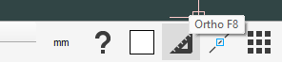
This button that also can be toggled by the F8 Shortkey. When it's activated, you can only point in specified directions. If you click on the button with right mouse button, you will come to Ortho and Snap settings.

Object snap
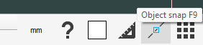
This button can also be toggled by the F9 Shortkey. When it's activated the running object snap will be activated. You can set up what snap modes that should be activated by clicking on the button with the right mouse button. It will take you to Ortho and Snap settings

Display options
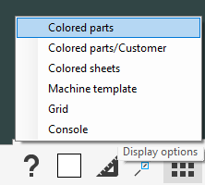

Colored part
If it's activated, then all parts will be colored. As default all identical parts will have the same color.

Colored parts / Customer
This is more like a command. All parts that belong to the same customer will have the same color.

Colored sheets
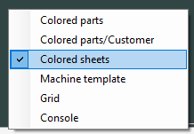
The color can be changed in Sheet settings in the preference command.

Machine template
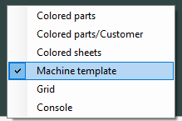
It is possible to make a background drawing that can show the machine. By this toggle you can turn this background On and Off. You can read more about machine template here.

Grid
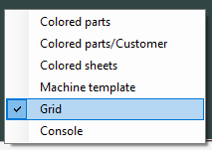
You can turn on and off the grid by this option.

Console
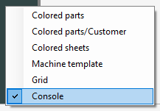
With this option you can toggle the console On/Off.

Multiple drawings
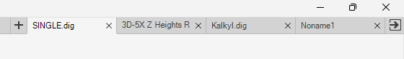
On the upper right corner of the screen you can se all open drawings. You can jump to a drawing just by clicking on the tab. You can also close and open new drawings by clicking on X or +.

Zoom and Pan
A mouse with scroll wheel is needed to work properly with IGEMS.
- Zoom: Zoom in and out by scrolling the mouse wheel.
- Pan: Press and hold the mouse wheel down to pan.
- Zoom extents: Double click the scroll wheel and the drawing will zoom to full screen.
If the scroll wheel is not working in this way then check the mouse settings in the control panel. The mouse wheel button should be configured as "Mid" button.
The value between < > indicates the width of the screen.

Coordinate input
The coordinate system in IGEMS supports the Cartesian coordinate system.
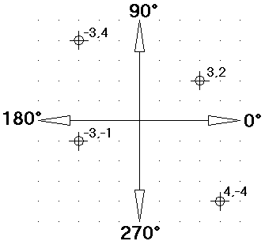
When IGEMS expects a numeric value input and any digit is typed, it will show the following dialog box for input of values.
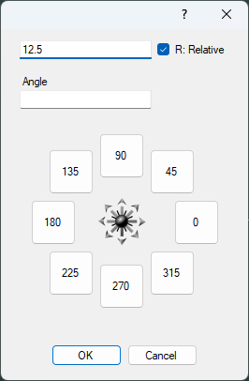

Absolute coordinates
Always refer to IGEMS fixed zero point. It is typed X, Y as in the following example: 110.5, 220.18
The decimal point is used to separate the integer part from the fractional part of a number. The decimal comma is used to separate two different values (X and Y)

Relative coordinates
This refers to the last used point as a distance rather than a coordinate. To use relative coordinates, check the "Relative" checkbox.
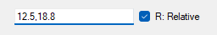

Absolute polar coordinate
Always refer to IGEMS fixed zero point.
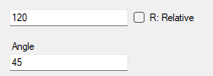

Relative polar coordinate
Always refer to the last used point.
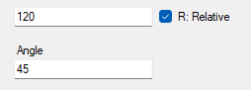

Direction coordinate
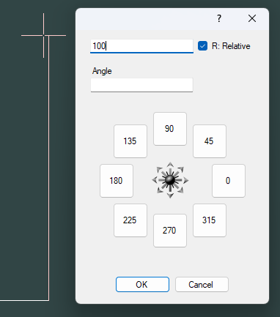
This is the fastest way to enter coordinates. You just move the crosshair in the wanted direction and then type how long the distance should be. This method often used together with Ortho mode.

Distance input
Several commands in IGEMS ask for a numerical value that refers to a distance, for example the "Offset" command.
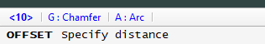
These options are available when a command asks for a distance:
Press the spacebar or Enter to accept the value inside <>
Enter another value by using the numerical keyboard.
Pick two points and the distance between the points will be the input.

Object snap
Use "Object snap" to snap exactly to different geometrical points on existing objects. The "object snap" can be used inside other commands when a point is required. The "object snap" can be selected from a menu opened with the right mouse button, when IGEMS asks for a point. If will show the suggested point by a colored marker. In the case below the object snap "Quadrant".
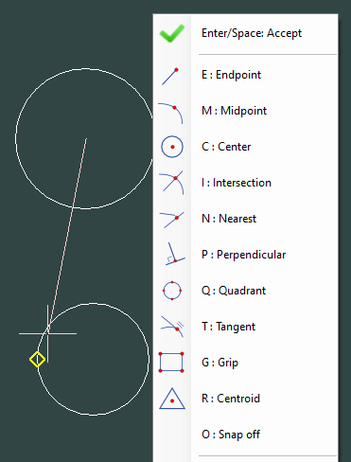
Available object snaps:
Snap | Shortkey | Description
Endpoint | E | Snap to endpoint of all drawn objects.
Midpoint | M | Snap to midpoint of all drawn objects.
Center | C | Snap to center of Circles, Arcs and Ellipses.
Intersection | I | Snap to Intersection between drawn objects.
Nearest | N | Snap to an object near the selected point.
Perpend | P | Snap to a perpendicular point on the picked object from the direction of the previous position.
Quadrant | Q | Snap to point on 0, 90, 180 or 270 degrees from center on Arcs, Circles or Ellipses.
Tangent | T | Snap to a Tangential position on an Arc, Circle or Ellipse.
Grip | G | Snap to Grip points on object.
Centroid | R | Snap to the center of gravity on an object.
Off | O | Turn off the Auto snap temporarily for next given point.

Auto snap
It is possible to have the objet snap always activated. Use "Auto snap" to snap to selected geometrical points. This is activated or deactivated from the "Snap" button or by pressing F9.

Point filter
Use the "Point filter" option to retrieve individual X and Y coordinates from different points on the drawing to create a new composite point.
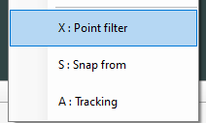
The "Point filter" is activated by right clicking in the context menu or by pressing "X" on the keyboard when IGEMS asks for a point.

Snap from
The "Snap from" option asks for a point that will be used as the last point. This option should be used together with relative coordinates.
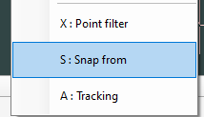
The "Snap from" can be activated by right clicking in the menu or by pressing "S" on the keyboard when IGEMS asks for a point.

Tracking
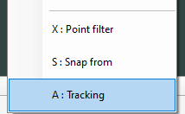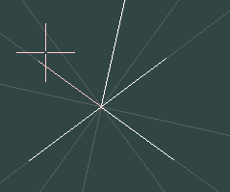
This option will make a temporary ortho mode in 90 degree of all objects that passes through the current points. This is used often together with the direction coordinate.

Grips
If you select some geometry without having any command activated, then grips will be visible at strategic positions. The grip is useful when you want to make fast simple modification of the geometry.
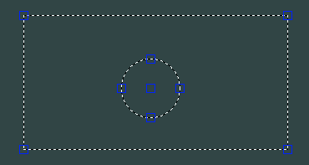
If you click on the grip located in the center of the circle, then you can move the circle. If you click on the quadrants, then you can change the radius of the circle.
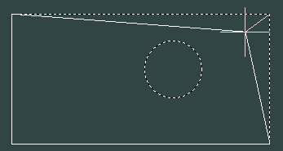
If you click on the corner, you can modify the corner position.
The grips can also be useful when modify Part text and Inkjet text positions.

Select objects
Many commands need objects as input, for example: Erase, Move and Copy.

Selecting Objects
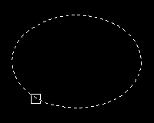
You must use a command that need objects as input. For example, Erase, Move or Copy.
There is different options:
Click on an object to select it.
If you click outside an object, then a second point is needed.
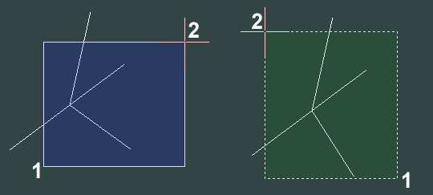
If the second point is to the right side, then the objects that are completely inside the rectangle will be selected.
If the second point is to the left side, then it's enough that just a little part of the objects are inside the rectangle to be selected.
To unselect, hold down the SHIFT key while selecting the object.

Other options
By using right mouse button, you can activate other options.
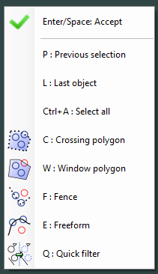
Note! The fastest way to select different options is to use keyboard shortcuts (P, L, Ctrl-A, C, W, F and E).

Previous (P)
This option selects the same object from the previous time "Select object" was used.

Last (L)
This option selects the last object that was drawn.

All (CTRL-A)
This option selects all objects on the drawing.

Crossing
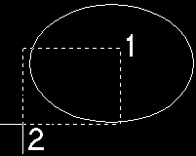
This option uses two points to describe a rectangle. The second point must be to the left of the first point. If an object is inside or if the objects are crossing the rectangle, then the object is selected. Hold down the SHIFT key to un-select the objects.

Crossing polygon (C)
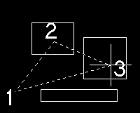
This option uses optional number of points to describe a polygon. If an object is inside or if an object is crossing the polygon, the object will be selected. This feature does not work with the SHIFT key.

Window
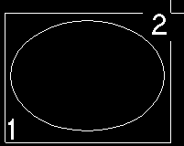
This option uses two points to describe a rectangle. The second point must be to the right of the first point. The object must be completely inside the rectangle to be selected. Hold down the SHIFT key while using "Window" and the objects are de-selected.

Window polygon (W)
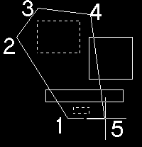
This function uses optional number of points to describe a polygon. The objects must be completely inside the polygon to be selected. This function does not work with the SHIFT key.

Fence (F)
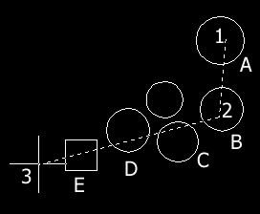
The "Fence" option allows a multi-segment line (polyline) to be drawn. All objects which cross the fence will be selected in the same order as the line crosses the objects. On the picture the "Fence" option is used to draw a fence line through points (1), (2) and (3). Objects (A) to (E) are then selected.

Auto base point
Many CAD commands like Move, Copy and, Scale have an automatic base point selection.
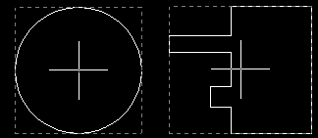
The "Auto base point" is always located in the center of a bounding box of the selected objects.
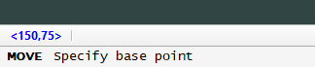
To use the "Auto base point" press the spacebar or Enter key.

System menu
The system menu includes commands for maintenance and support.
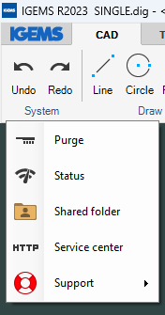

Undo
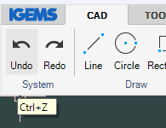
When working with IGEMS press the "Undo" button to correct mistakes and remove changes made with the last command. Up to 20 commands can be undone. Use backspace as a keyboard shortcut instead of CTRL-Z.

Redo
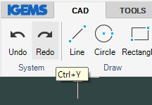
Use "Redo" if too many steps were "undone". Redo can only be used directly after the Undo has been used.

Purge
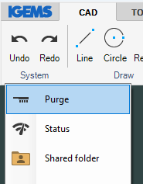
IGEMS will not remove unused layers or blocks when saving a drawing. To fully remove unused information use "Purge". The following information will be written on the command line:
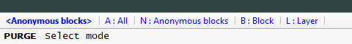
If you right click on the mouse you will have following menu.
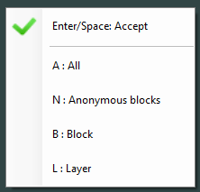
Select "All" to remove Anonymous blocks, Blocks and Layers.

Status
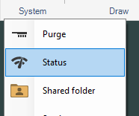
The "Status" command shows current use of RAM memory, the number of rows that have been used on the command line and the number of objects on the drawing.
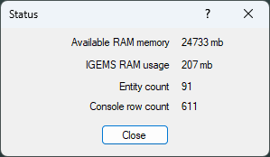

Shared folder
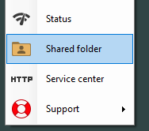
The Shared folder includes all user settings and customizations such as materials, machine settings, postprocessors, lead in/outs and more. It is recommended to make a backup copy of the shared folder from time to time in case of a computer breakdown. It is possible to move the shared folder on a common folder on the network.

Service center
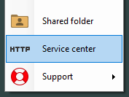
The "Service center" opens to a website to download the latest version, drivers, etc. "Service center" can only be used if the computer is connected to the internet and there’s a valid license of IGEMS.

Support
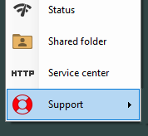
Use the "Support" command if a question or problem needs to be reported to IGEMS support team.
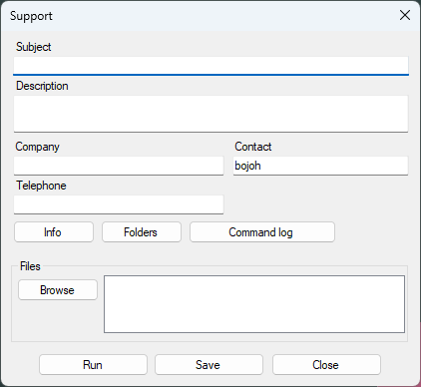
Fill in information about a problem, using the "Browse" button to include any necessary files. Press "Save". The command will create an ISF file with all needed files and other information.
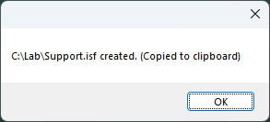
Send the ISF file to your IGEMS reseller or to IGEMS AB.

Run support files
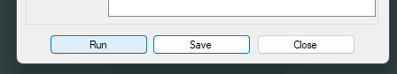
Use the "Run" button to load support files. IGEMS starts up in the same mode with the same files and settings used when the support file was created.
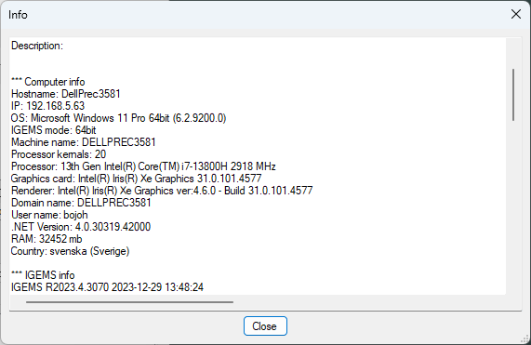
Some general information will show before the drawing is loaded.

Reset support mode
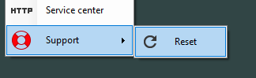
When a support file ISF is loaded then the system will use a temporary Shared folder. This mean that it is not possible to load your standard machine. To go back to normal mode you need to reset the support mode.

CAD commands
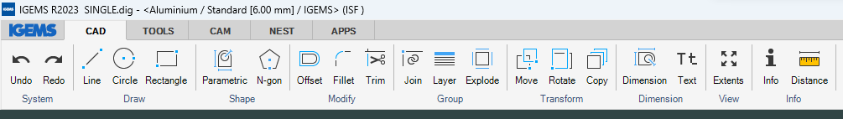
Important!
Be sure to read the information on the command line.
The option between < > is default command. You can accept the default just by spacebar.
For other options you can press the first character on the option or pick on the option with the mouse.
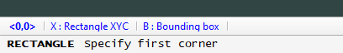
Points can be given by entering coordinates using the keyboard, by clicking on the screen or by object snap. Distance can be given by values or by clicking two points.

Line
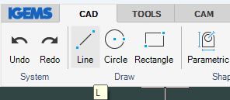
Shortkey "L"
"Line" command asks for a starting point and then the next point. The command is cancelled by using the spacebar, Enter or ESC keys. Backspace can be used to undo the last line segment.
How to enter coordinates

Circle
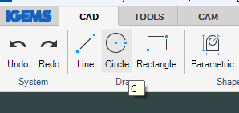
Shortcut "C"
The normal "Circle" command requires a center point and a radius or a diameter as input. Toggle between diameter and radius input using "D" and "R" keys on the keyboard.
How to enter coordinates
The "Draw" menu shows other ways to create a circle.
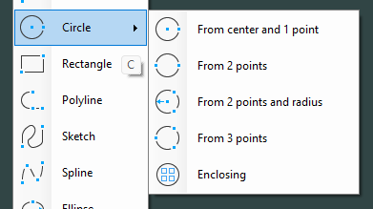

Rectangle
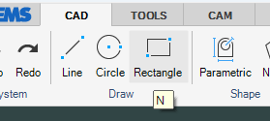
Shortcut "N"
The normal "Rectangle" command creates a rectangular polyline from 2 opposite points.
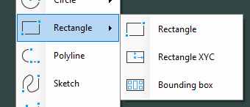
The "Draw" menu shows two other ways to create a rectangle.
How to enter coordinates

Point
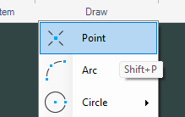
Shortcut "SHIFT+P"
The Point command asks for input of point positions. To cancel the command, press the spacebar, Enter or ESC. Click here for more information how to change the point style.
How to enter coordinates

Arc
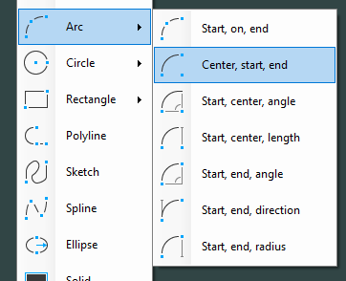
Shortcut "A"
"Arc" entities can be described in many ways. The default Arc mode needs input for a 3 point arc. Six other methods can be used.
How to enter coordinates

Polyline
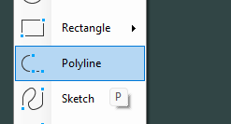
Shortcut "P"
A polyline is a chain of lines and arcs that are joined together into one object. When drawing a polyline toggle between "Line" (type "L") and "Arc" mode (type "A") or SHIFT+C to close the object.
How to enter coordinates

Sketch
This command is little different compare with other drawing commands. You must hold down the left mouse button all time to generate the sketch. When you are finish then press space.
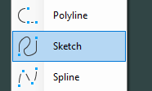

Spline
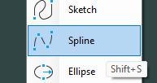
The "Spline" command makes a curve that goes through a set of points. Tangent condition for start and end point can be selected at the end of the command. If no tangent condition applies, then press the spacebar to execute the command.
How to enter coordinates

Ellipse (Shift+E)
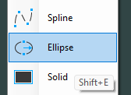
Shortcut "SHIFT+E"
The "Ellipse" command creates an ellipse shape by defining major and minor axis length/radius.
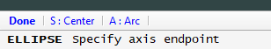

Default
The default command will ask for two points on the major axis length 1 and 2 and the minor axis radius below.
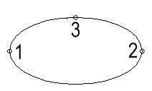

Center mode
Select mode "S: Center" and input a major axis distance starting from center point of ellipse 1, the radius of the major axis 2 and the radius of minor axis 3.
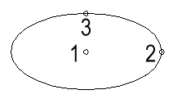
The "Arc" mode creates an open ellipse when defining a start angle and end angle.
Select the "Ellipse" command and select "A: Arc" before defining the ellipse and the angles.
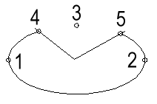
My CNC-controller can't handle ellipses, how can I convert the object to arcs or lines?
You don't have to. It is done automatically by the postprocessor when you make the CNC-file.
How to enter coordinates

Solid
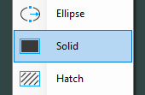
Use the Solid command to fill closed geometries with a selected color.

Hatch
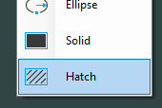
Use "Hatch" command to create a hatch pattern, for example to help illustrate sectioning.
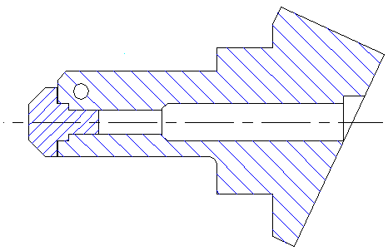
Settings for the "Hatch" command:
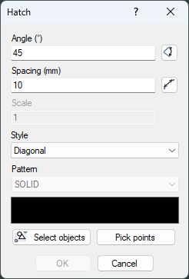

Angle
This is the angle of the Hatch lines.

Spacing
This is the distance between the hatch lines.

Style
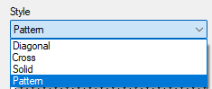
The style can be Diagonal, Cross or Solid or Pattern

Pattern
If you select Pattern, then you can chose between approximately 100 different types.
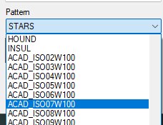

Select objects
Select a closed object and the Hatch will be inside the objects.

Pick points
Pick a point in that area that should be hatched.

Parametric shapes
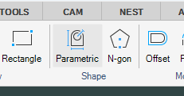
This command has 60 predefined shape types and 8 different kinds of pipe unfolding shapes.
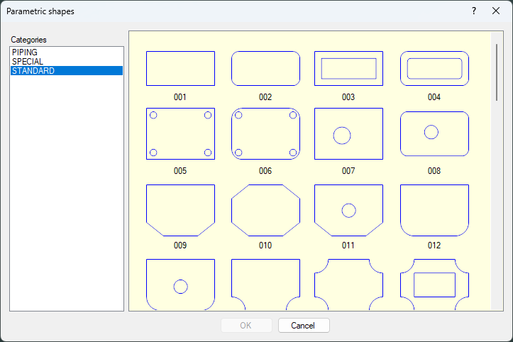
Parametric shapes can be modified by simply opening the selected shape and entering the requested dimensions before inserting the shape into the drawing.
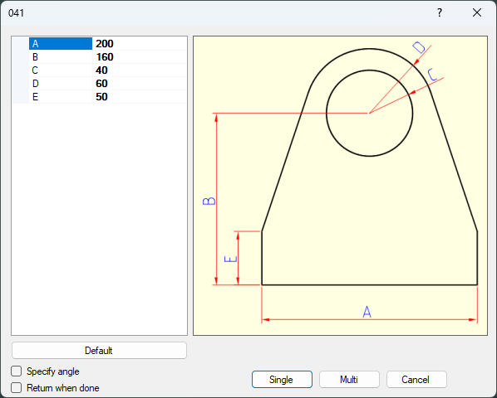

N-gon
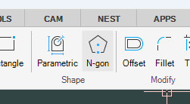
Use this command to create symmetrical polygons (triangles, squares, hexagons, etc.). Input the number of sides followed by the center position on the drawing.
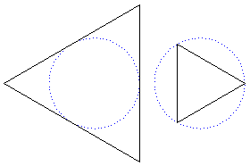
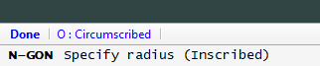
Press the "O" key to control if the N-gon should be inscribed or circumscribed.

Obround
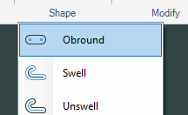
Specify starting point, radius, and a distance (length) to create an obround profile.
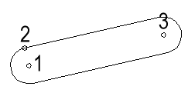
IGEMS will then automatically create the outline contour.

Swell
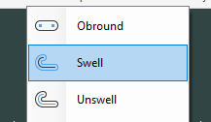
The "Swell" command makes a closed polyline around the selected object.
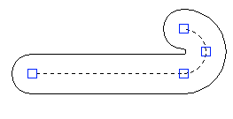
The command asks for center objects and a radius.

Unswell
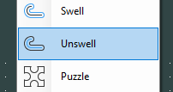
This function do unswell on a geometry that has been swelled. In my opinion meanings less command.

Puzzle
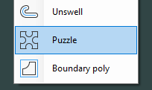
This command shows the following dialog box.
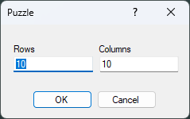
Enter number of pieces in rows and columns. Press OK and enter two opposite points in a rectangle that describe the outside dimension. The command will create a random puzzle.
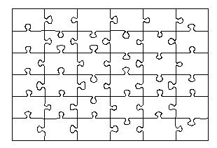
Can the geometry be used to generate a toolpath?
Yes, this can best be done with the "Quick" command.

Boundary poly
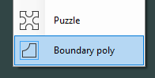
"Boundary poly" command is used to extract enclosed contours out of existing geometry. Activate the command and pick inside the area to extract.
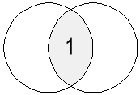

The command will generate a polyline around the darker area when position 1 is selected.

Offset
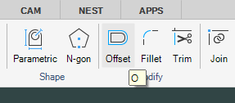
Shortcut "O"
This command creates an offset contour from the selected object with a specified distance. It asks for a distance, object and what side to create the new object.
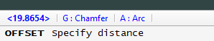
Select "G" for chamfering or "A" to make a fillet on outside corners.
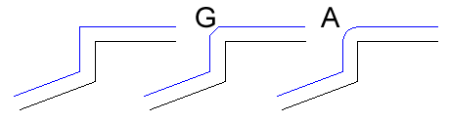

Fillet
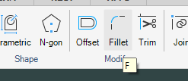
Shortcut "F"
This command creates a tangential arc between two objects after having entered the size of the fillet radius.
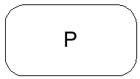
To fillet all corners on a polyline with one click, first enter the fillet radius and then select "P: Polyline" option and select the object.
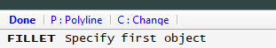
The Change option can replace an existing arc that are between two other objects.

Trim
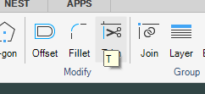
Shortcut "T"
The "Trim" command deletes the portion of an object that intersects with other objects. It is necessary to have at least 2 objects to be able to trim.
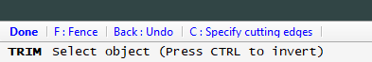
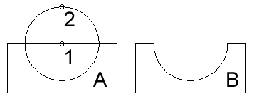
By clicking on the objects at position 1 and 2 gives the result shown in B.

The fence option
Use the "Fence" option to select many objects at the same time
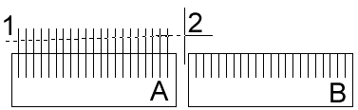

SHIFT Trim
Use the SHIFT key while picking the geometry to invert the trimming to the opposite side. It will remove everything except the portion of the object you are clicking at.
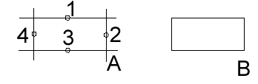
The picking points indicate the portion of the object that should be not trimmed.

Calculate cutting edges
If you have a very heavy drawing (> 500 000 objects) it can take some time for the command calculate. By using this option, you can select a smaller area to speed up the trim.

Zero fillet
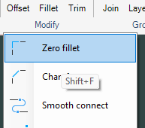
Shortcut "SHIFT+F"
This command will extend or trim 2 segments to intersect with a zero radius.

Chamfer
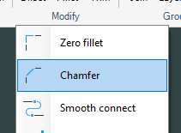
The "Chamfer" command extends or trims 2 segments to intersect and create a chamfer corner.
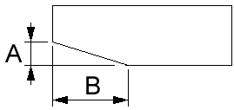
Define the chamfer length on the first segment and then the chamfer length on second segment before accepting. A polyline is chamfered by holding down the ALT button when selecting object. Note! This is probably useful only if the first and second segment is equal.

Smooth connect
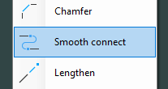
This command will connect two objects with biarc.
A biarc is a smooth curve formed from two circular arcs. To make the biarc smooth the two arcs will have the same tangent as the connecting point where they meet.
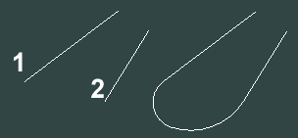
If you select the objects at 1 and 2 the command will generate two arcs with at smooth connection.

Lengthen
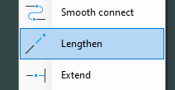
This command dynamically changes length on the selected object. Select near the end of the side to extend and drag the object to desired length.

Extend
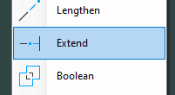
"Extend" an object to the next intersecting object.

Boolean
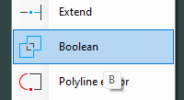
Shortkey "B"
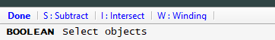
This command can make Boolean functionality on closed objects.
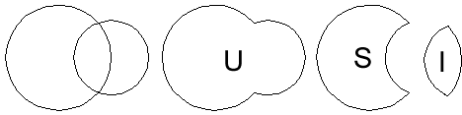
The command is set to (Union) mode by default which means that two objects will be merged into one. The "Intersect" option creates a polyline of the area shared by the two objects. The "Subtract" option removes the overlapping area between the two geometries. The Winding option is more complicated. If the direction of the object is CCW than it's handed as an outside geometry. If it's CW it's handled as an inside geometry. The Winding option will probably be removed.

Polyline editor
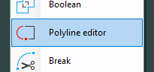
This command is used to check the information in a polyline and the following dialog box is shown:
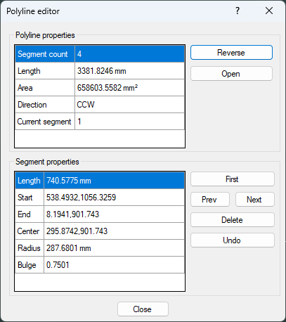
This dialog box shows information about the complete polyline and the different segments in the polyline.
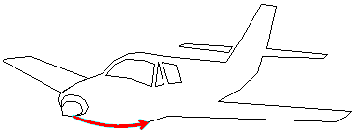
The actual segment is displayed in red, with an arrow indicating the direction of the object.

Reverse
This will reverse the direction of the polyline.

Open/Close
This option is only visible if the polyline is closed or if this option is changed to closed.

First
This will show the first object in the polyline

Previous/Next
This shows information about the next or previous segment.

Delete
This will delete the actual segment.

Break
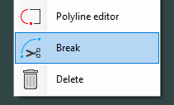
This command breaks objects up into several portions. The command asks for an object and a break point and splits the object at the selected point.

Delete
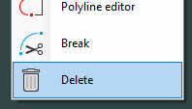
Shortkey "DEL" or "E"
This command deletes the selected objects from the drawing.
Note! Use the "Undo" to restore objects that have been mistakenly deleted.

Join
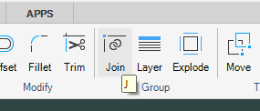
Shortkey "J"
This command joins multiple objects into a polylines. The command first asks for the objects then for a tolerance. The start or endpoints of the objects must be closer than this tolerance to be joined together.
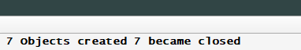
The command line area has information about the result of the command.

Layer
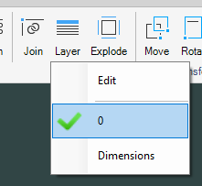
Shortkey "Y"
Some imported file types can include layer information. The several layers on the drawing will be in the list. Click on one of the layers to activate. Press the "Edit" option and the following dialog box will be shown.
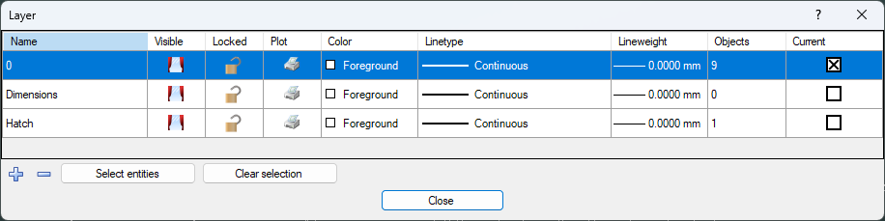
The "Layer" dialog box is used to create or modify existing layers with default line type and line weights. Layers can be "locked" to prevent modifying layer geometry or to block from being printed. You can also delete a whole layer and all information on that layer are removed.

Layer for dimension
The "Dimension" style defines a layer to automatically use for all dimension objects.

Explode
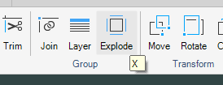
Shortkey "X"
This command explodes a block, polyline or other composite object into separate objects. The opposite command to "Explode" is the "Join" command.

Create block
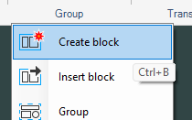
Shortcut "CTRL+B"
Use this command to define a set of objects that can be reused by inserting the block into the drawing.
- Create a figure, like picture below
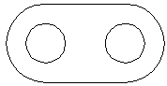
- Start the "Create block" command.
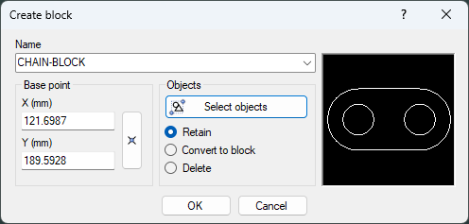

Name
This is the name of the block.

Base point
This is the base point when later inserting the block into the drawing.

Objects
Press this button to select the figure.

Retain
This leaves the figure intact as it is. The block has been saved in the block table.

Convert to block
This converts the figure to an insert and saves the information in the block table.

Delete
This removes the figure from the drawing and saves the block in the block table.
Can the block be inserted into other drawings?
No, it must be defined in the drawing or in the template drawing. Then it can be used on all drawings that use that template.

Insert block
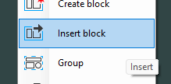
Shortcut "INSERT"
Use the "Insert block" command to insert a previously defined block. The following dialog box is shown.
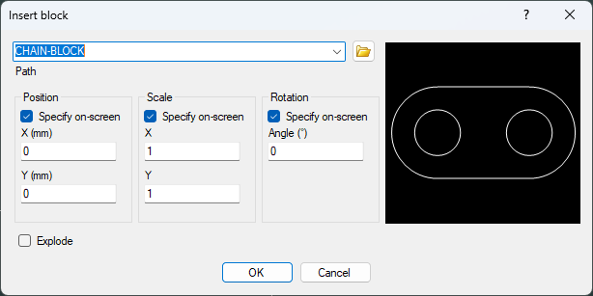
Select the named block to be inserted. It is then possible to position, scale or rotate the block while inserting it into the drawing.

Insert DIG files
To insert DIG files as blocks press the "Folder" button in the dialog box and select the file to be inserted.
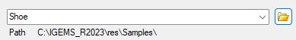

Group
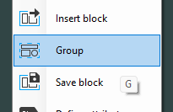
The "Group" command asks for objects. All selected objects will be a member of that group and can now be easily handled together. The "Explode" command breaks up the group into individual segments.

Save block
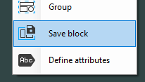
This command works the same way as the "Create block" command but it stores the block as a DIG file. It asks for the objects, the base point and a file name.

Define attributes
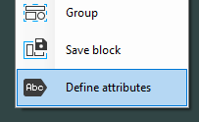
Create a figure and include a text string that can be modified when later inserting the block in the drawing.
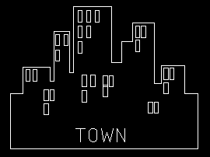
- Create a figure with a text "TOWN"
- Start the command and select the text.
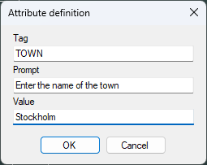
Enter a prompt and a default value.
- Save the figure as a block
- Insert the block.
The following dialog box is shown.
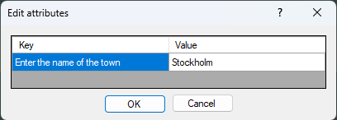
- Change the value to "Gothenburg".
When the block is inserted it will appear as follows:
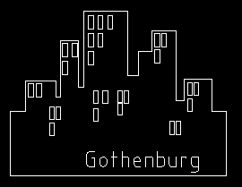
What can these attributes be used for?
For example, to fill in information in a title block.
Can it be inserted in other drawings?
If you use "Create block" then it must be defined in the drawing or in the template drawing. Then it can be used on all drawings that use that template. If you use the "Save block" (save it on disk) option, then you can use it on all drawings.

Move
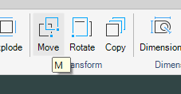
Shortcut "M"
This command asks for an object to move, then a base point and finally a new position. The selected object will be moved to the new position.
How to enter coordinates

Rotate
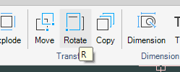
Shortcut "R"
This command rotates an object around a specified point. Use the "Reference" option instead of entering the new rotation angle. After the command is completed there will be a request to "Keep original" or not.

Copy
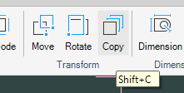
Shortcut "SHIFT+C"
This command asks for an object to copy, then a base point and finally a new positions.
How to enter coordinates

Mirror
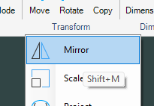
Shortcut "SHIFT+M"
This command asks for an object and then a mirror line. After the command is completed there will be a request to "Keep original" or not.

Scale
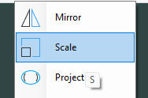
Shortcut "S"
This command asks for objects to scale, then a base point and a scale factor. Instead of entering the "Scale" factor, right mouse clicks to see the following options:
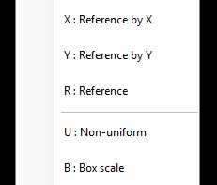

Reference by X
This option automatically calculates the scale factor. Enter the outermost size in X.

Reference by Y
This option automatically calculates the scale factor. Enter the outermost size in Y.

Reference
Asks for a reference length and then a new length. All objects will be scaled by reference to this length.

Non-uniform
Define a scale factor in X and in Y. An input of 2, 3 will make the object two times the original size in X and three times in Y.

Box scale
This option lets different entries for the outermost size in X and Y. In this option it is best to have the zero point at the lower left corner of the selected objects.

Quick move
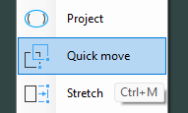
Shortcut "CTRL-M"
"Quick move" automatically selects an object by moving the cursor near the object. Unlike the "Move" command, there is no need to select or input a base point to move the object. The object will highlight a light blue color when the mouse cursor gets close to the object.

Stretch
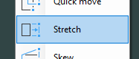
This command changes part of an object's length while keeping other parts the same. The command is mostly used together with the "Crossing" option in the select object.
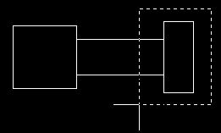
Using Picture as an example, objects completely inside will be moved. Objects that intersect with the crossing rectangle are changed. Objects that are completely outside will remain unchanged.

Skew
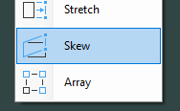
This command asks for objects to be skewed, a base point to skew from and the skew angle in Y and X.

Picture shows an example where Y is skewed 30 degrees (60 degrees from X).

Array
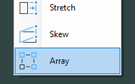
This command is a simple form of nesting that copies objects in a rectangular or polar array. The command asks for which objects to use then shows the following dialog box:
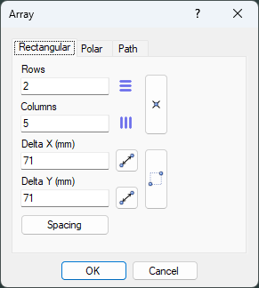

Rectangular
This option copies the selected objects in rows and columns.

Rows and columns
Enter how many copies you want in X and Y.

Delta
"Delta X" and "Delta Y" are the distances between the rows and columns

Spacing
To have a space between each line and column press the "Space" button and enter the space. The "Delta" between the lines and columns is calculated from the dimension of the selected objects.

Polar
This option copies the selected objects in a polar layout.
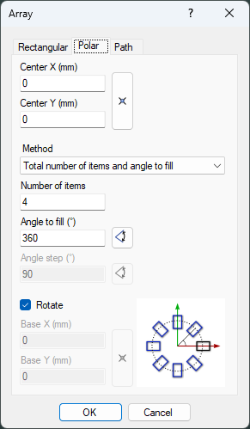

Center
Enter the center of the array. Use the "Pick" button to pick a point.

Method
There are several methods to describe the angles between each copy.

Rotate
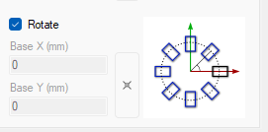
If the selected objects are rotated around the center then the command does not need any more information.
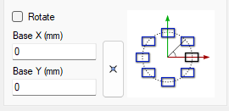
If the objects are copied without rotation, then the command needs a base point for the objects.

Dimension
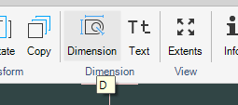
Start the command and click on objects that you want to measure. The command will automatically switch between Horizontal, Vertical and Aligned dimensions.
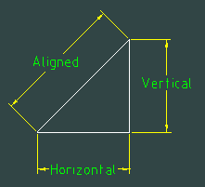
If you need another orientation than suggested than you can press H, V or A keys.
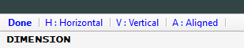

Text
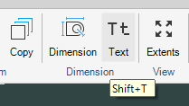
Shortcut "SHIFT+F"
Use this command to insert text into the drawing area. Instead of selecting the start point of the text press "F" to select the font to be used.
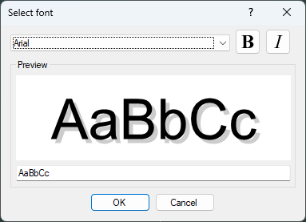
Select font style, insertion base point, height and type the text.
You can control the justification from the console.

The red point is the insertion point
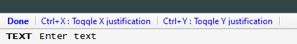
You can modify the settings by double click on the text.
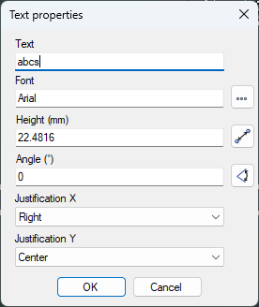

Diameter
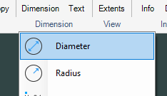
This command is used to add dimensions on circles and arc objects. Select a point on the arc or circle and place the dimension.

Radius
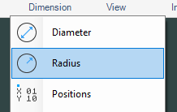
This command creates a dimension showing the Radius for an arc or circle.

Positions
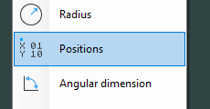
This is an automatic command for circles (holes).
Command ask for Base point and then you can select all circles.
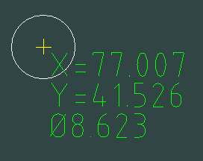

Angular dimension
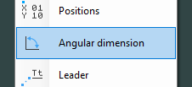
This command creates an angle dimensioning between 2 linear segments. Move the cursor before placing the dimension to select which quadrant to use.

Leader
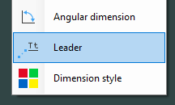
This command will add a leader with information text to an existing object. Select the command and enter the text. Place the text on the drawing area or press the spacebar or Enter to select an object.

Dimension style
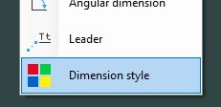
Following dialog will be shown.
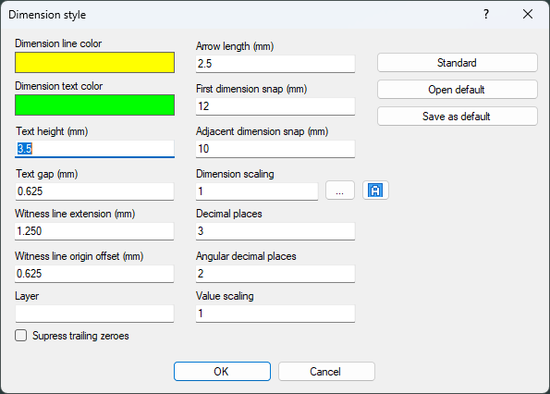

Dimension colors
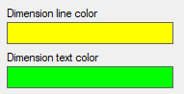
Click on one of the settings and change the color.

Text height
This is the theoretical text height. Normal value is 3.5 mm.

Text gap
This currently only used on the leader, we will probably remove this.

Witness line
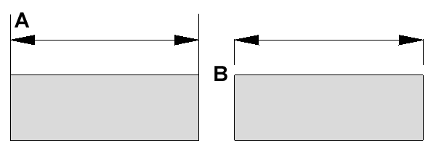
A show the witness line extension and B Witness line origin.

Layer
If you define a layer, then all dimensions will be placed in that layer. In the layer command you can make this layer invisible. That’s a way to turn dimensions on and off for a whole drawing.

Suppress trailing zeroes
If this is checked then all trailing zeroes will be suppressed.
Example: 10.000 will be 10

Arrow length and dimension snap
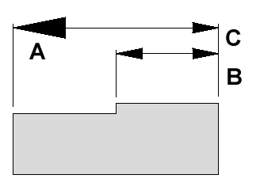
A It's possible to set the length of the arrows.
B is the first-dimension snap distance.
C is adjacent dimension snap distance.

Dimension scaling
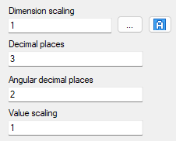
The dimension scaling will scale the most values like text height, arrows, dimension snap. If you will print a large drawing on a small paper, you probably want to scale up the dimensions else it will probably not be possible to see.
By clicking on the dot button, you can set the printing size.
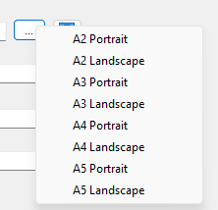
The dimension scaling will then be calculated to have the correct size.

Decimals
Set the number of decimals you want to use for the dimension.

Value scaling
This is an automatic scaling of the sizes. For example, if you measure something that is 50 mm and the scale is 2 then the measurement says 100 mm.

Defaults
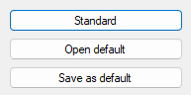
If you click on Standard then all values will be factory settings by IGEMS
If you do some changes and then click on Save as default, then the settings will be saved
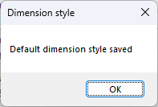
If you click on Open default, then your last saved default will be used again.

Zoom extents
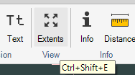
Shortcut "CTRL+SHIFT+E"
Click this button for IGEMS to zoom out so all objects are shown on the screen.
Note! Zoom extents by double clicking the mouse wheel if preferred.

Pan
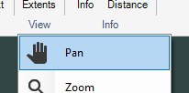
Shortcut "CTRL+SHIFT+P"
The "Pan" command is used to reposition the drawing area in X and Y by selecting a base point and a second point for new position.
Note! Hold down the mouse wheel while moving the mouse to pan is preferred.

Zoom
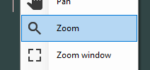
Start the command and then pick a point to zoom in. To zoom out hold down the CTRL key while selecting.
Note! Roll the mouse wheel to zoom out or in is preferred.

Zoom window
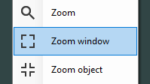
This command needs two points to describe a rectangle. IGEMS will zoom up that area.

Zoom object
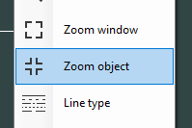

Line type
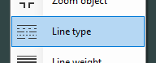
Following dialog will be shown
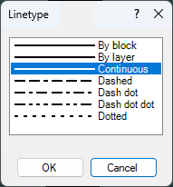
This can be used in two ways:
- If you have some selected objects and you select a linetype then the selected objects will have the new linetype. But default linetype will not be changed. If you make a new line (for example) then it will not be drawn by the new linetype.
- If you have no object selected and you select a linetype then this will be default for following objects.

Layer controlled
Bind different line types to different layers. The linetype will then be changed when you change layer. If a template is configured with predefined layers and line types, line type will never have to be changed manually. Se the Layer command

Line weight
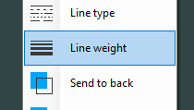
Use this command to show different line weight on the CAD screen.
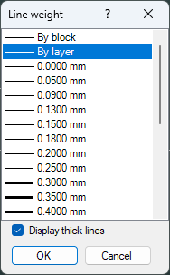
The "Display thick lines" checkbox must be activated to see the different weights on the screen. The "By block" and "By layer" works in the same ways as for color and line type.
This can be used in two ways:
- If you have some selected objects and you select a lineweight then the selected objects will have the new thickness. But default Lineweight will not be changed. If you make a new line (for example) then it will not be drawn by the new lineweight.
If you have no object selected and you select a lineweight then this will be default for following objects. It will be used until it's changed.

Send to back
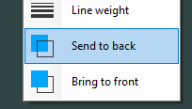
Use this command to control which object should be visible when two objects are on top of each other. This command is often used for pictures or similar objects on the screen.

On the picture above the text is back the part.

Bring to front
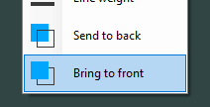
This command works opposite to "Send to back" command. Select object and pick the command to place it on top of other objects.


Info
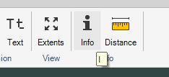
The "Info" command is the fastest way to get information from objects on the drawing.
- Draw two circles. Start the "Info" command and select the circles.
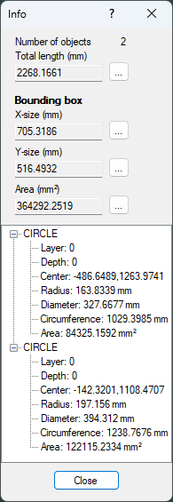
This command shows the following information:

Information about the selection
The upper area of the box provides information about how many objects are selected and their total length. The bounding box gives information about the area and the size needed for the objects.
Can this information be used for calculating cutting costs?
Yes it can, but you have more exact tools if you make a complete cost calculation.

Object information
The lower area of the box provides information about each object in the selection.
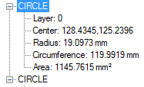
Select one object in the list to highlight that object on the screen.
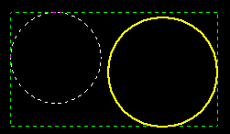
The green rectangle shows the bounding box, the yellow object is the selected object on the screen.

Distance
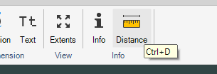
This command needs two points and will display the information on the command line area.
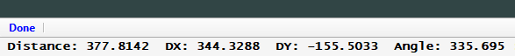
Id
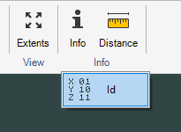
"ID" shows the absolute coordinate in X and Y for the selected position. "Absolute" means the coordinate position in relation to IGEMS World Coordinate System.

CAM-Tools
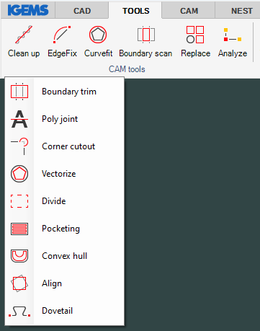
The "CAM-Tools" module includes commands for analyzing, preparing and optimizing the geometry before starting to make a toolpath. To use these commands there must be a license for the "CAM-Tools" module. If you have a subscription license, this module is always included.

Clean up
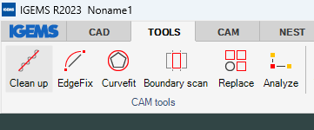
This command removes double objects, overlapping geometry and closes gaps that may occur in the selected geometry. Start the command and enter a tolerance to fit a new curve and select objects.
- Open the drawing Cleanup.dig in the sample directory.
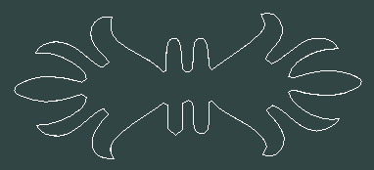
- Start the command and specify tolerance. In this case 0.001 is OK.
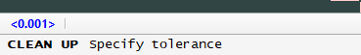
- Select all objects.
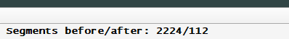
The command removed 2112 unnecessary objects.

Edgefix
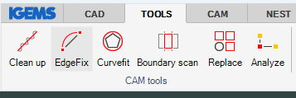
This command replaces a portion of a polyline with an arc or line to increase the quality and smoothness of the curve.
- Open the drawing Edgefix.dig in the samples directory.
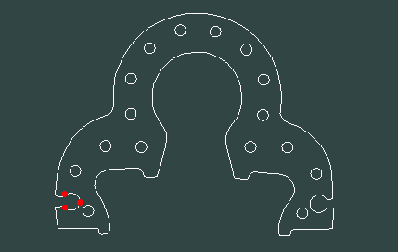
Click on start point A and an end point B. Select position C for the new curve which will replace the old curve with an arc. If you instead of selecting a point, you press the space it will be a line between A and B.


Curvefit
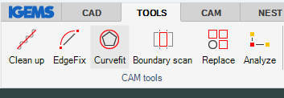
This command converts a polyline consisting of many short lines and arcs into a smooth curve with lines and arcs based on a given tolerance. The feature is useful to eliminate short line segments that may cause the machine not to operate as it should. It also may reduce file size.
- Open the file "Curvefit.dig" in the Samples directory.
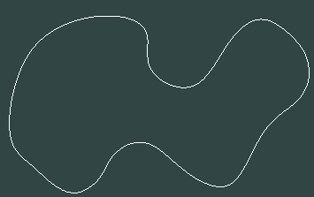
This file has a closed polyline consisting of 944 short lines.
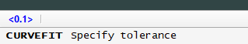
- Specify a tolerance and select the polyline.
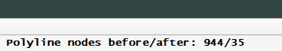
The 944 linear objects have now been converted to 35 arcs.

Boundary scan
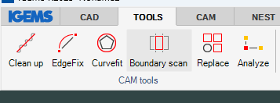
This command extracts closed polylines from enclosed areas.
- Open the file "BoundaryScan.dig" in the Samples directory.
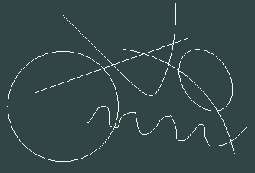
The object can consist of lines, arcs, ellipses, circles and splines.
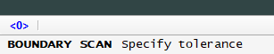
Specify a tolerance.

If there is no gap between the objects, then the tolerance can be 0. If there is a gap, the tolerance value must be larger than the gap.
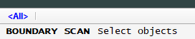
On very large drawings it speeds up the calculation if you select the objects that should be involved in the process. On small drawings its no need to specify involved objects. You can accept by the space bar.
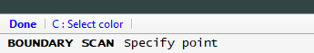
Click on a point inside a bounding area. Press space and move the new object to another position
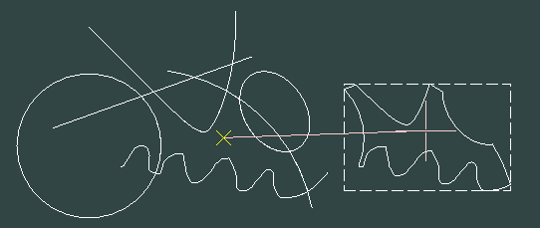
You can select a color by using shortcut "C" while picking the point.

Replace
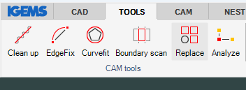
This command replaces objects with other objects.
- Open the file "Replace.dig" in the Samples directory.
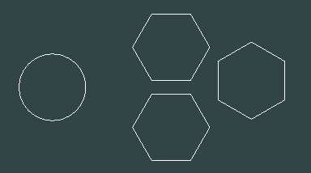
- Start the command and select circle as source object, and all the polygons as target objects
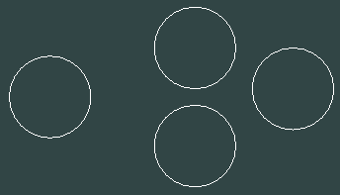
All target objects will be replaced by the source object. The positions are calculated by the center of gravity position.

Analyze
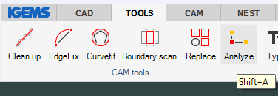
You need to have closed geometries without gaps and overlaps to generate good toolpaths. There are several automatic commands like Cleanup, Curvefit, Boundary scan that can do this. On very tricky drawings you can use the analyze command and fix the problem manually.
- Open the drawing "Analyze.dig" in the Samples directory.
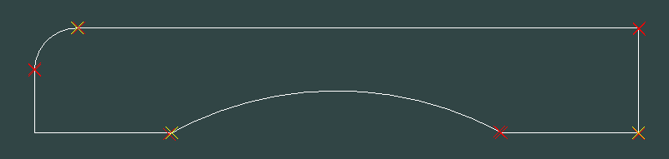
This command creates red X on gaps between objects and yellow X if the objects are overlapped.
To remove the X just click on the command one more time.

Boundary trim
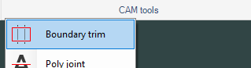
This command trims or deletes objects that are inside or outside a closed geometry.

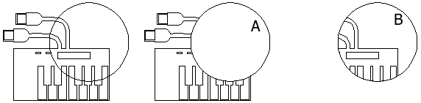
Start the command and select a point on the circle (A). Everything inside the circle is deleted. Objects that are intersecting with the circle are trimmed. Hold down the SHIFT key while selecting the circle to make the opposite result.

Poly joint
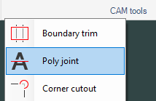
This command is used to join areas together or to split areas. The function must be applied on closed polylines.
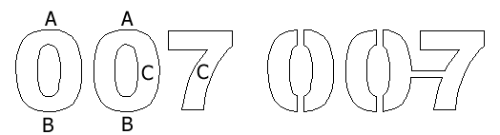
The command asks for a width and then for points. Select a point outside (A) to outside (B) and the geometry is spit up in two geometries. Select a point inside geometry (C) to another inside geometry (C) and the command will join the two geometries.

Corner cutout
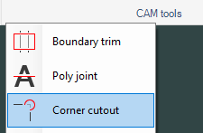
The command shows following dialog
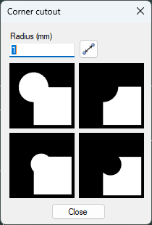
Type the wanted radius and click on the type of cutout you want to use.
Select the two object that should be involved.
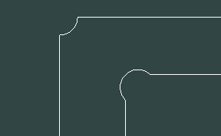

Vectorize
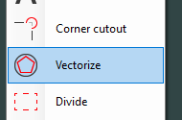
The "Vectorize" command gives an opposite result as the "Curvefit" command. It will convert arcs to many short lines.
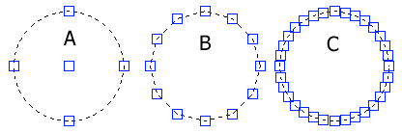
Select the command and enter a tolerance.
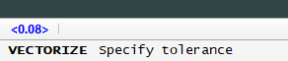
The tolerance decides how much the new curve will deviate from the original curve (A). A small tolerance (C) will create more and shorter line segments and will stay closer to the original curve compared to entering a large tolerance (B).

Divide
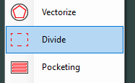
The command will divide selected object in a specified distance or in number of objects

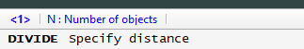

Pocketing
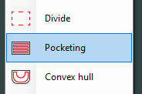
"Pocketing" generates a zigzag pattern that can later be used to create a toolpath for milling.
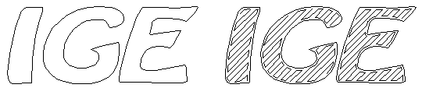
This command expects input for angle and a value for the step over before selecting the closed contour to apply the pocket pattern.

Convex hull
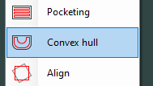
"Convex hull" creates an enclosing polygon around selected objects.
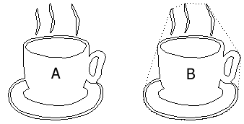
"Convex hull" has only convex geometry - no concave.

Align
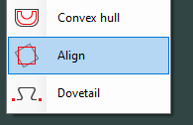
The align command will align object to vertical or horizontal direction
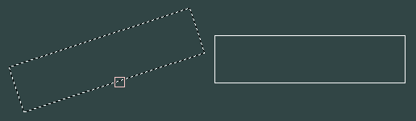

Dovetail
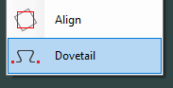
The command asks for a width
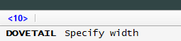
Then start point (P1) and next point (P2)
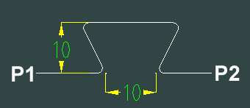

SignMaker
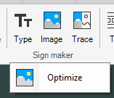
This module includes commands for making signs. For example: Converting images to CAD vectors, converting true type fonts, etc. There must be a license for the "SignMaker" module to use these commands. If you have a subscription license, this module is always included.

Font tracer
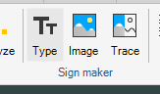
This command converts true type fonts into vector graphics. The following dialog box is shown:
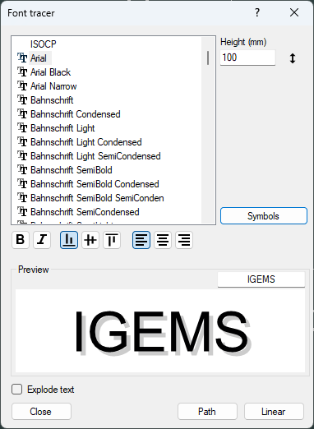

Select font
The preview area will show example text of differing fonts.
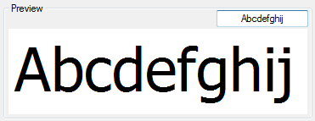

Linear cursor
Click on this button to set the start point for the text.

Object cursor
Use this option to select an object to follow.

Select the start point and the cursor will follow the geometry as the text is typed.

Symbols
Use the "Symbols" button to expand the dialog box:
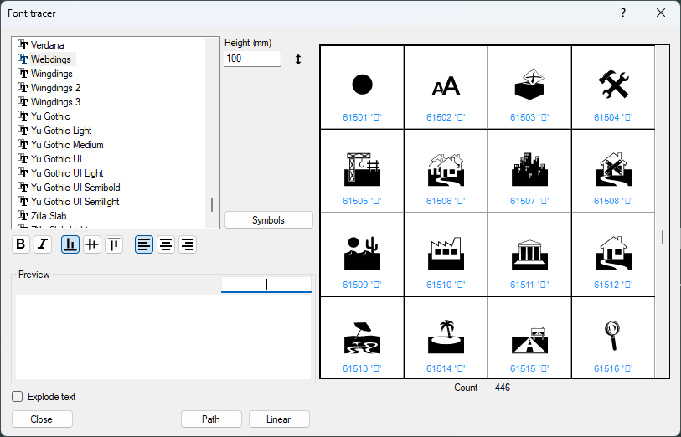
Double click on the sign to insert it onto the drawing.

Explode text
You can also use the Explode command afterwards.
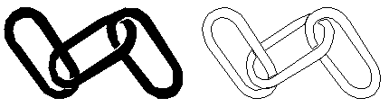

Image
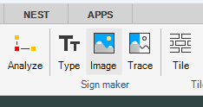
Use the "Image" command to insert images into the IGEMS drawing. The image can be scaled to correct size and used as a background. A common method is to draw an object on the image. These objects can be used to generate a toolpath that cuts the geometry in correct size.
- You can open images from the standard open command. The picture below is from the "FloorTile.png" in the Sample directory.
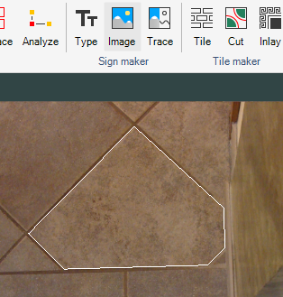
What is the difference between using the image command and insert a image from the IGEMS camera function.
An image will have different scale in the center compared to the edges. The IGEMS camera will have the same scale over the whole image.

Image tracer
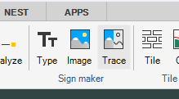
"Image tracer" reads and converts a raster file into lines and arc segments.
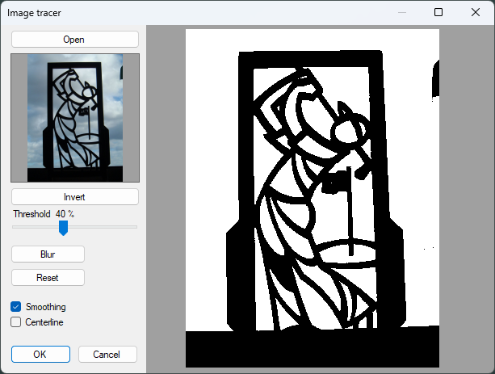

Open
Use this button to select the file and the image will show on the right side of the dialog box. Supported files are PNG, JPG and BMP.
It is also possible to double click on an Image that has been inserted into the drawing with the Image command.

Zoom and pan
You can zoom and pan in the picture on the same way as you zoom and pan on the drawing screen.

Invert
The area that describes the material (black) will now be hole (white) and opposite.

Threshold
Use this setting to control the brightness of the image.

Blur
This command will smooth to the edges if the image. It will make the image less distinct.

Reset
This command will reset the affect of the Blur command.

Smoothing
This option will make the result smoother. It is like the blur, but it's when you press the OK

Centerline
This option should be used on scanned drawings when the geometry is drawn by pen or something similar. Alternative A centerline scanning. Alternative B shows an outline scanned example. This option will draw objects around black areas.
Note! For smoother geometry use the "Curvefit" command afterwards.

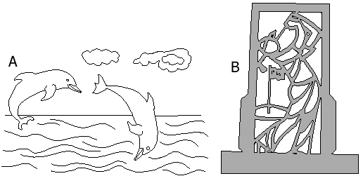

Optimize
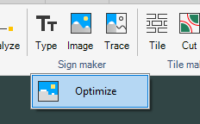
This command can reduce the resolution of the image.
Use the zoom to arrange the image in the scale what is good enough to look at. Press the Optimize command.
The number of pixels on the picture is now converted to the same number of pixels that the image is used on actual screen.
The meaning with this command is to reduce the size of the drawing file.
If you zoom the image to be small on the screen and then use the optimize, then the size of the file will be smaller.

Tile maker
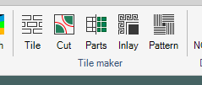
The "Tile maker" module includes a set of commands especially designed for tile cutting. There must be a license for the "Tile maker" module to use these commands. If you have a subscription license, this module is always included.

Tile
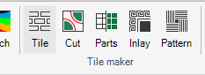
The "Tile" command creates a grid of rectangle or hexagon shapes with a specified part distance. The following dialog box is shown.
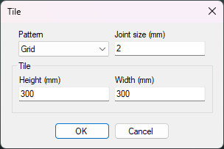

Pattern
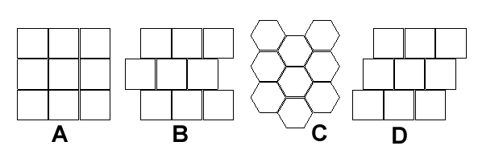
The "Tile" command supports the pattern type: Grid (A), Jagged Grid (B), Hexagons (C) and Jagged Grid 1/3.

Dimensions
The "Height" and "Width" is the X and Y sizes of the tiles and the "Joint size" is the distance between the tiles.

Number of tiles
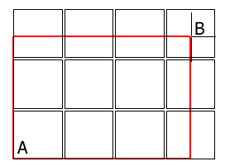
Press "OK" and IGEMS asks for two corner points (A) and (B) that describe the area for the tiles.

Tile cut
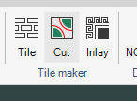
The "Tile cut" command extracts patterns from a drawing and automatically nests and cuts the extracted parts. You don't need any Nesting module to use this command. It has an inbuild special designed nesting algorithm.
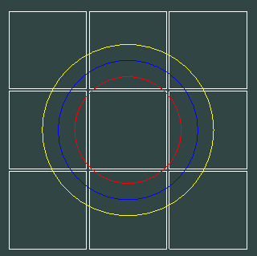
- Prepare a drawing like the picture above.
Make 9 tiles with the "Tile" command.
Make three circles: Yellow, Blue and Red
Start the "Cut" command.
This command needs information from the machine and material. If no machine is selected the following dialog box appears.
Everything inside the red circle will be nested on red tiles, everything between the blue and red circle will be nested on blue tiles and everything between the yellow and blue circle will be nested on yellow tiles.
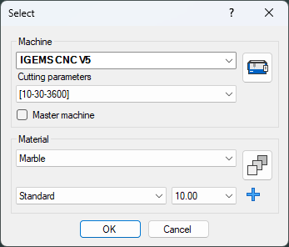
After selecting "Machine" and "Material" the dialog box for "Tile cut" command is shown:
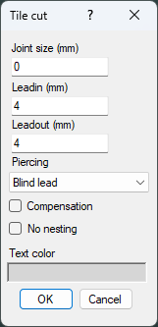

Joint size
Is the distance you want to have between the tiles.
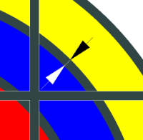

Cutting information
See the "2D-CAM" module for more information about leadin, leadout and piercing type. When the compensation checkbox is activated, the toolpath will be compensated for the tool radius.

Compensation
If you set the Joint size to zero and do not use any tool radius compensation, then you will still have the size of the jet as real distance between parts. If you use compensation, then you can generate parts with no gap between the parts.

No nesting

When the nesting option is activated then the algorithm will try to place as many parts as possible on one tile. Like the example below.
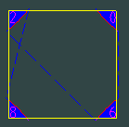
When the nesting option is deactivated then four tiles is needed (one for each parts).
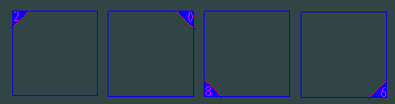
- Press the "OK" button
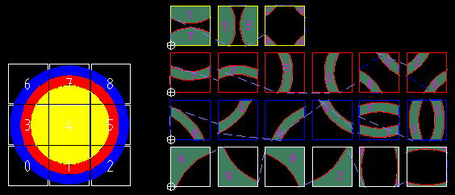
IGEMS will now nest all tiles by color, all toolpaths are added and the job will be ready to post.

Tile fixture
The "Tile fixture" is simple fixture to locate the tiles at correct positions on the cutting machine. The fixture can be made of optional material. The rectangles in the fixture should have the same size as the tiles to be cut.
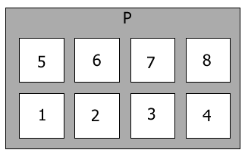
When ready to cut tiles, place them in the fixture. The machine will cut tile 1,2,3,4,5,6,7 and 8 then the machine will go to stop position (P) and stop. It is now possible to unload and load the next 8 tiles, then start the machine again.
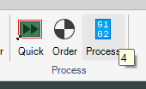
When the postprocessing is started then another dialog box appears that will handle all tile fixture parameters. Read more about the post processing in Section 19.
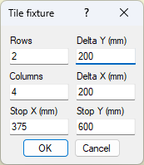
Input the positions of the tiles on the fixture. When tiles are cut the zero point is located on the lower left corner on tile rectangle number one.

Inlay
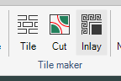
The "Inlay" command is an advanced tool that allows designing of tile floors or other tile decorations by adding textures or colors before extracting the parts.
- Open the sample file "Inlay.dig" located in the Samples directory.
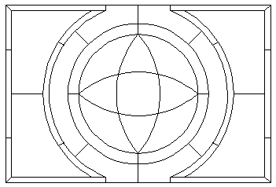
- Start the "Inlay" command.
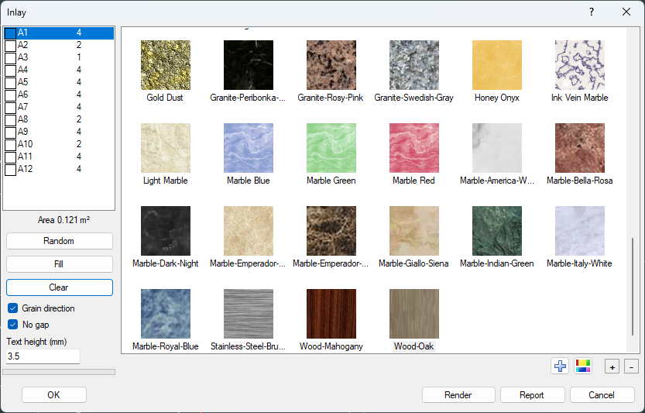
If the drawing already has different colors on certain areas, then the inlay command will use that color. If all objects on drawing have the same color, then it will come up un-colored.
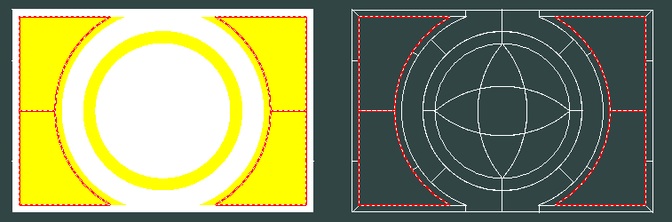

Random coloring

By clicking on the Random button all unidentical areas will have a random color.
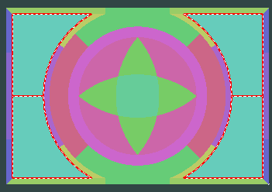

Clear all colors

By clicking on this button, all colored areas will be removed.

Manual coloring
There are two ways of manually attach colors or textures to the inlay.
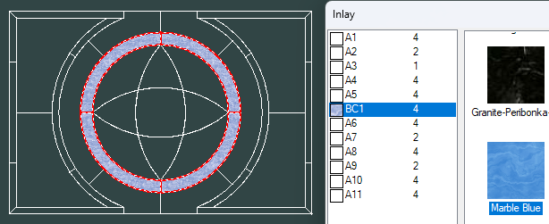
You can select one of the areas (in this example A1 to A12) in the list box, and then double click on one of the textures or colors on the right side of the dialog.

The other way is to first select a material on the right side of the dialog, and then click on the Fill button.
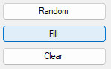
The dialog temporally disappears and you can click in that area that should have selected material.
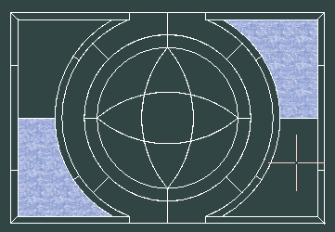
If you are holding down the CTRL key while you click, all identical but mirrored or rotated area also will be filled.

Manage textures
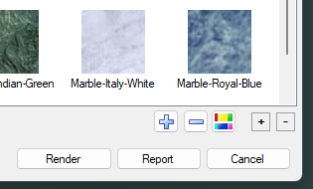
By clicking on the blue + button you can add textures to the chart.
By clicking on the – button you can remove textures and colors on the chart.
By clicking on the color button, you can add colors to the chart.
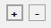
By clicking on the buttons above can you change the scale of the texture.

Grain direction
When this is activated, the command will create 4 different parts (se example below).
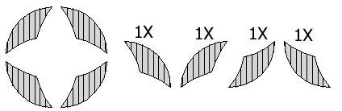
When the parts are mounted the grain direction will be the same for all parts. For material with solid colors the grain direction may not be important.

When Grain direction id de-activated then command will create for copies of the same part
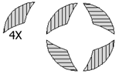
When the parts are mounted the grain direction will be in different directions. This alternative will probably give a better material utilization.

No gap
Use the checkbox "No gap" to control cutting with or without gaps.

With gaps
To cut with gaps cut the parts with no tool radius compensation (no kerf). This means that all external measurements will be smaller and all internal measurements larger.
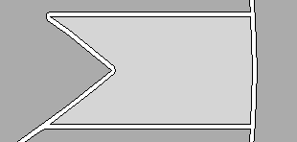
The size of the gap will be the same as the diameter of the jet.

No gaps
To cut with no gaps is normally much more difficult. Cut all parts with tool radius compensation.
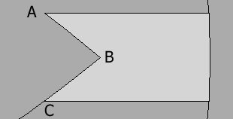
Since the jet cannot make sharp inside corners manual work at positions (A) and (B) or at (a) and (b) are required. Without doing this job the parts will not have proper fit.
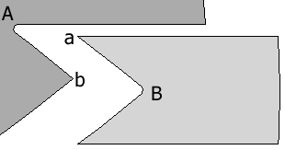
With "No gaps" activated then all outside corners that cause a fitting problem will be adjusted by IGEMS automatically (a) and (b).
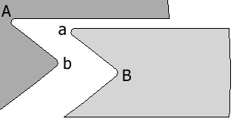
The radius (A) and (a) and the radius (B) and (b) now have the same size and the parts will fit together.
What setting do I use if I want to modify the inside corners manually (A) and (B)?
In that case you should cut with gap and with tool radius compensation (with kerf).

Text and identification
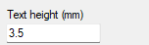
If the text height is larger than 0 then the command will automatically place a text with the name on each part. This can be used as identification of the parts.

Render

The "Render" button creates a more photorealistic image of the layout.

Report
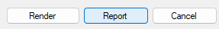
Click the "Report" button to generate a complete report of the inlay.

Generate inlay parts
Press "OK" to generate all parts from the drawing.
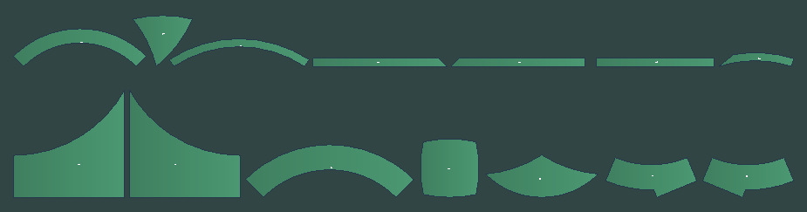
The parts are lined up by material. The final step is to use the normal "Nesting" and "CAM" commands to create the CNC file.

Data Exchange
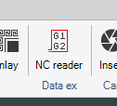
The "Data Exchange" module includes commands that allow the import of extended file formats and analyzing and conversion of existing CNC files. There must be a license for the "Data Exchange" module to use these commands. If you have a subscription license, this module is always included.
If you have a license of Data Exchange, the standard Open and Import command can also import following file formats.
Type | Description
.EPS | Encapsulated Postscript Level 1 and some Level 2 objects
.GEO | Tops files
.HPG | Hpgl files
.MEC | Lantek
.NCP | Old NC file format from Bystronic
.ORD | Flow
.PDF | PDF files
.PLT | Hpgl files
.PS | Postscript Level 1 and some Level 2 objects
.SKYM | Sky Maker Files
.STP | Step file (use the 3D interface)
.SVG | Scalable Vector Graphics
.SVGZ | compressed SVG files,
.TAG | Taglio
.TRG | Tops files
.WMF | Windows Meta Files

NC reader
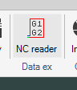
This command imports CNC files and creates lines and arcs according to coordinates in the CNC file. Only the most common format is supported in this command, and it will not understand sub-program calls or jumps. The command asks for a zero point and then the name of the CNC-file.
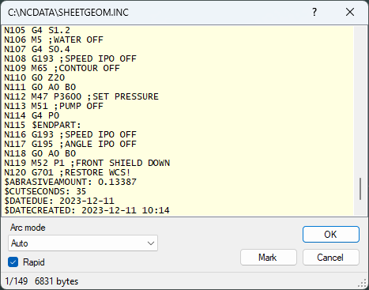
The whole geometry of the file is displayed in gray on the drawing area.
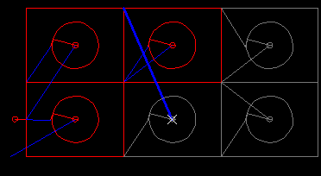
Select a line in the dialog box and the gray object will be replaced by a red or blue object up to that position. The actual movement is highlighted. Click on an object in the drawing area and the line is highlighted. The NC-reader is a tool to analyze an existing CNC-file.
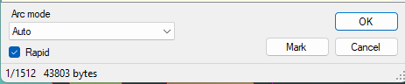
If you click on the "Mark" button, the command will make a point at actual position.
If the geometry looks strange, change the settings of the arc mode.
The checkbox "Rapid" determines if the blue rapid lines are displayed or not.
The bottom line is a summary of the selected line / total number of lines and the file size.

IGEMS Camera
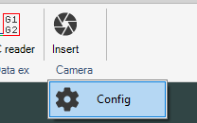
IGEMS have two different cameras, one camera belongs to IGEMS cnc and can be mounted on the machine.
The camera described here is for a fixed mounted camera above the machine.

Before the camera can be used it has to be mounted above the machine or above a measuring table. It also needs to be connected to a router and calibrated.

Parts required for the Camera setup:
- Camera unit.
- Power supply for the Camera.
- Router.
- Ethernet cable between the router and the Camera.

Mounting and calibration of the camera
Mount the camera in the center of the area that you want to cover.
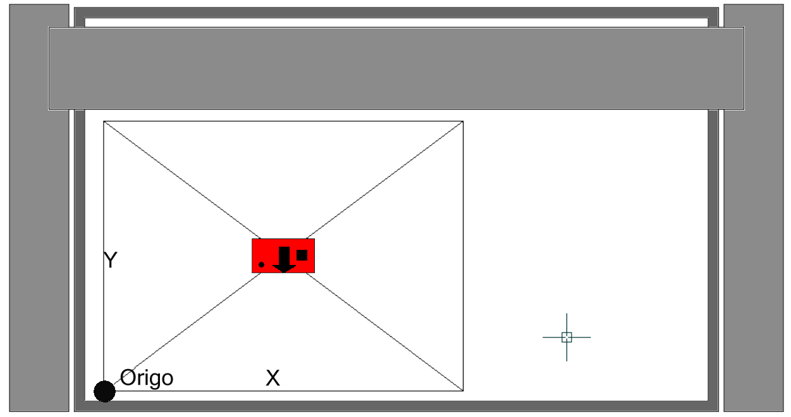

Height between table and lens
The camera has a resolution of 2592 by 1944 (4:3). The longer distance between the table and the camera the larger area will be covered, but the accuracy will be better the closer the camera is to the table. Mount the camera with the arrow pointing to you.
If the X (long side) is the most important then set the camera on a height that is: Wanted X * 0.98 + maximal material thickness to cut.
If the Y (short side) is the most important then set the camera on a height that is:
Wanted Y * 1.32 + maximal material thickness to cut.

Making a jig
You need a jig plate to be able to calibrate the camera. The size of the jig should be the size that you want to cover.
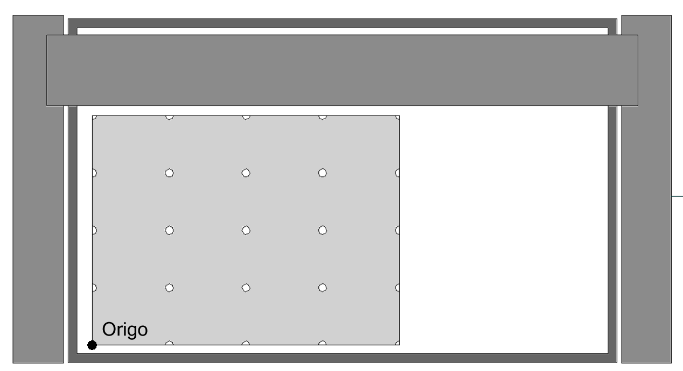
Put the plate on the machine and cut some small holes or markings in the plate. The distance between all holes in X should be the same, a good rule is about 3-4 marks per meter. The distance between the holes in Y direction can be different from X they also must be placed with an equal distance.
Set the coordinate system in the lower left corner of the Jig (For example G54). From now you never need to change the origin (zero point of the machine) when you are using the camera function.

Connect the camera
Connect the camera to the router by a standard Ethernet cable and plug in the power connection. If you prefer to use power from your machine 24V you can do that since the camera can be driven by 9 to 36V. If you don’t use the standard power supply, be sure that the center connection is plus (+)
Red light on Camera means only the Camera has power connected.
When the Green light is off, it is still in the startup process. When flashing it looks to find the IP address and when it shows a steady green light it has found the IP address, and the unit are ready to be used.

Establish connection
Start the configuration by clicking on following button.
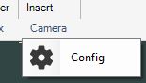
The first step is now to establish the connection.
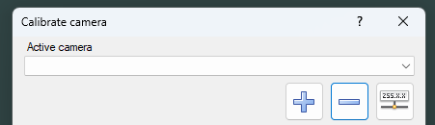
Press the + (plus) button, the configuration will now start to search for the camera. When it’s found then the camera has got an ID
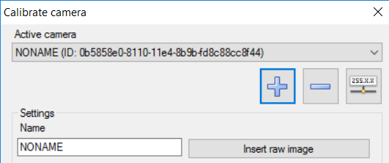
In the picture above you can see that the camera has got an ID.

Adjust the camera angle
If you have followed the instruction then the camera in mounted in the center of the jig.
Press the button "Insert raw image"
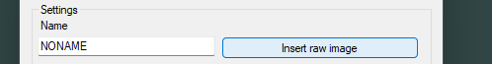
You should now be able to see the jig plate as a picture on the IGEMS screen.
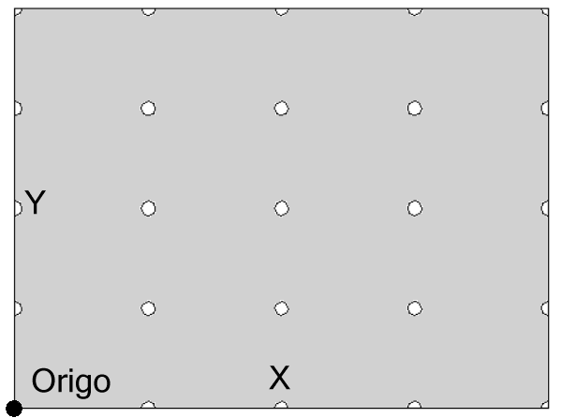
If not, then adjust the camera angle by tilting the camera in a better angle. After the camera angle is adjusted insert a new raw image to check the camera angle. Repeat this to you can see whole jig plate on the picture.

Calibration
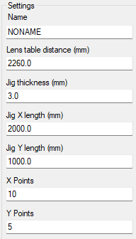
Change all values to it correspond with your actual settings in the machine.

Name
The name is not important, but if you have several cameras installed then you may want to have more describing names than NONAME1 and NONAME2 and so on.

Lens table distance
This value should be the distance between the table and the lens on the camera. This distance is needed to calculate the correct scale when cutting material with different thickness.

Jig thickness
This is the material thickness of the jig plate.

Jig X length
This is the total length of the Jig in X

Jig Y length
This is the total width of the Jig in Y.

X Points
The number of calibration points in X (On Fel! Hittar inte referenskälla. its 5 points).

Y Points
The number of calibration points in Y (On Fel! Hittar inte referenskälla. it’s 5 points).

Pick points
Finally press the button "Pick points".
The dialog box will now disappear, and you can use Zoom, Pan as normal. The command will ask you to click on 25 points (in this case) Click with as high accuracy as possible on each calibration point.
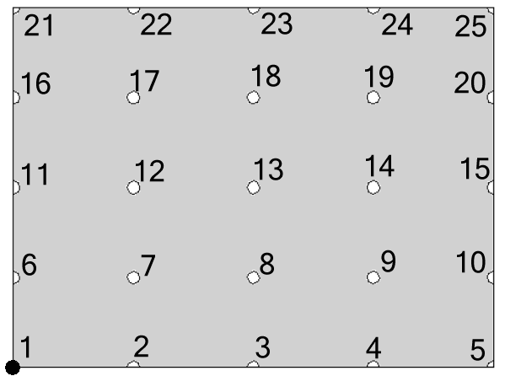
The camera in now ready to use.
Press the Apply button then Close

Using the camera
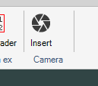
By clicking on the Insert command on the camera application you can insert a photo of machine and the actual sheet. The command is first asking for machine and material. The material thickness is used for calculating the correct scale of the sheet. Then the command asks for zero point.

Fixed zero point
Be sure that a fixed zero point in the controller are used in the CNC-file and this is corresponded to the lower left corner of the jig. (In many controllers the zero points are named as G54, G55, G56 and so on.)
When you insert the image at 0,0 is a good idea to change the Default zero corner (the origin of the toolpath) in the Strategy.
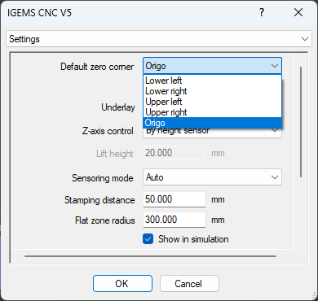

Using a separate camera table
The same equipment can also be used on a separate camera table. In this case do the calibration on this table. The jig during the calibration and the material has to be placed at the lower left corner at the L-square at all times.
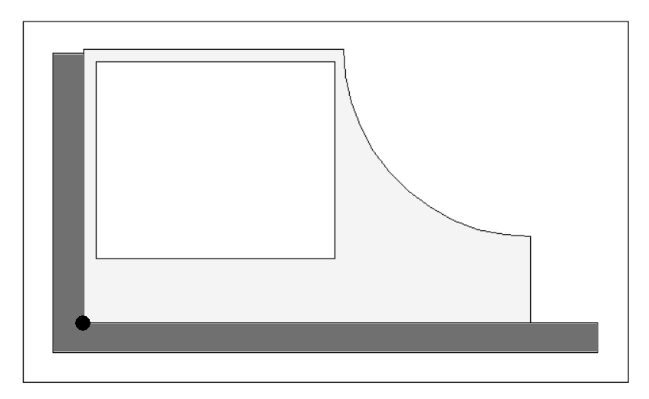
The same L-square is mounted on the machine.
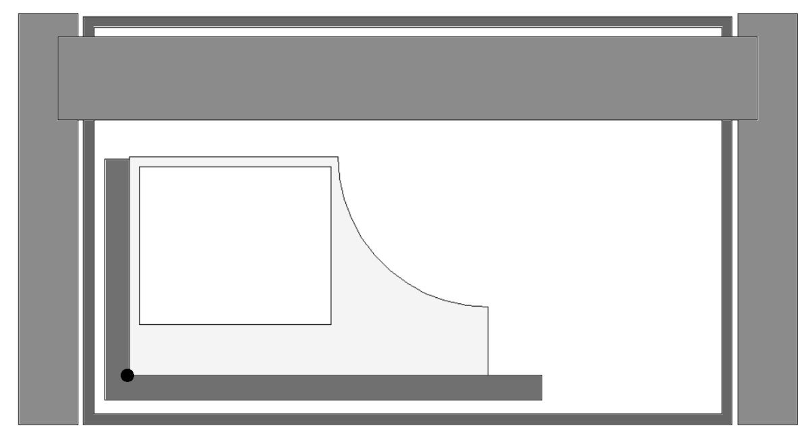
The zero point is located at the same position at the camera table.

Camera troubleshooting
- Check that the Camera is connected to a router
- Make sure the router is set to DHCP
- Port 1645 and 1646 in the router must be open for both TCP and UDP
- Make sure only one subnetwork is connected to the router
- Try to type in a static IP address and see if that helps
- Restart both router and Camera to see if that makes any difference
- The green led lamp on the Camera should be on. If it flashes it means it has not located an IP address.

CAM
This chapter contains information about the most common "CAM" commands. It includes all the tools required to setup the machine and material database, prepare CNC files for the cutting process, postprocessing, calculate cutting times and much more.
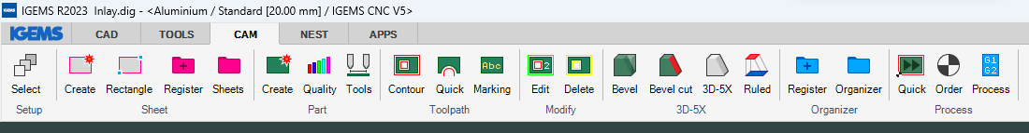

Select machine
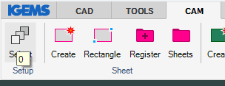
When any "CAM" command is started that needs information from "Machine" or "Material" settings this dialog box is shown.
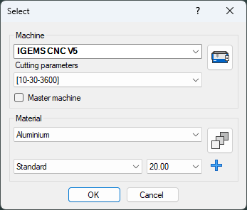

Machine
IGEMS can support many different waterjet machines. Select the machine that you plan to work with. You can find more information about machine settings here.

Cutting parameters
The cutting parameters is used to calculate the cutting speed. You can find more information about cutting speed here.

Master machine
This setting is useful if the CAD/CAM system is installed on the same computer as the CNC (HMI). In that case, drawing will always be opened for actual machine. No matter if the drawing is done for another machine.

Material
Select the material, quality, and the thickness that the job should be done for. You can fine more information how to set up material here.

Create Part
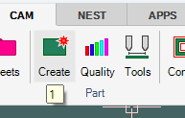
Shortcut "1"
The "Part create" command creates parts from existing geometry on the screen. The parts are used to extract toolpath and are also used by the "Nesting" commands..
- Make geometries like below. Add the two texts inside the geometry
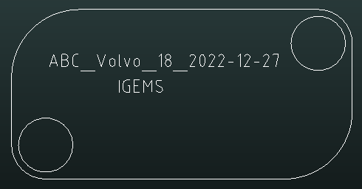
- Start the command and select all objects. (You can select many parts at the same time)
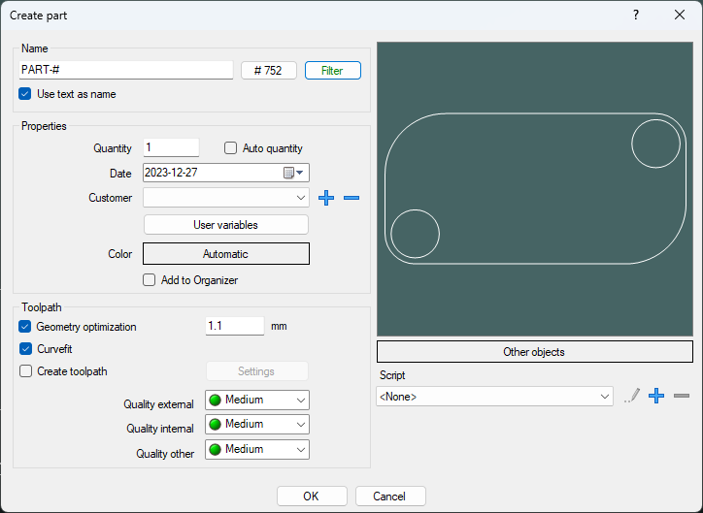

Name
The name of the part is used by the postprocessor and the organizer and doesn't have to be unique. There are several ways of giving parts names:

You can type any name

Automatic by increasing number
If the name includes a "#" sign, then this sign will be replaced by the counter on the button. The counter will be increased by one for every new part created.
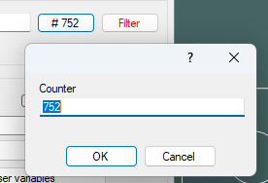
If you click on the #<number> button, you can change the counter to an optional value.
If the name is "IGEMS-#" and the counter is 1000 then the parts will be named: IGEMS-1000, IGEMS-1001, IGEMS-1002 and so on.

By text information inside the geometry
This option is developed for users that have automatic generated geometries and want to automatic set the name off the part. See the "Import" command on page to read more about how to generate names from imported files.
If this checkbox "Use text as name" is activated, then the actual text will be the part name. In our case we have two text lines inside the part. Of this reason there will be an extra question which text should be used.
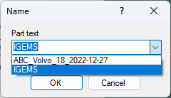
In this case IGEMS will be the name of the part.

Name filter mappings
If you click on the Filter option. Then you will see following dialog.
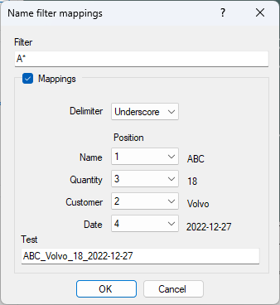
To avoid the previous dialog (choose which text to use) you can add a filter with wildcards. In this case it will take the text that starts with the character "A".
The Mappings will be used as follows:
The delimiter will separate the text in different portions.
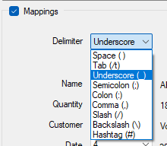
There are 9 different options of delimiter. In this example we have used the Underscore.
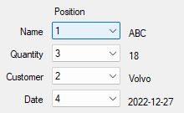
You can now set up which portion of the text that includes the information you need.

Properties
Information in this frame is saved on the part and the information can be used by Organizer, Applications and the Postprocessor. If you need to change the information later, you can do that in the Part properties command
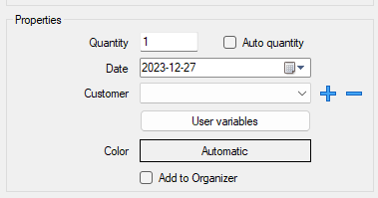

Quantity
Enter the number of parts to produce. The information is used by the "Nesting" and the "Organizer". When importing a file with several identical geometries there are two choices:
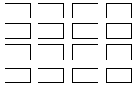
You can set the quantity to 1 and generate 16 identical parts.

Auto quantity
By activating the checkbox, the command will count all identical parts and handle the quantity information automatically. This means that only one part with a quantity of 16 will be created when using this option. All other identical parts are deleted.
Must the part be oriented in the same angle?
No, the part can be rotated in optional directions.

Date
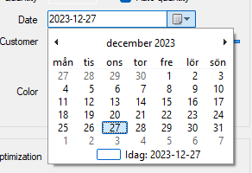
The date information can be used for production date or delivery date. The information is useful if using the Organizer module or in applications for ERP connections.

Customer
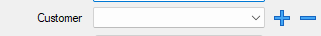
Select an existing customer name in the list. Use the "plus" and "minus" button to add new and delete existing customer names.

User variables
It is possible to create user variables that can be used by the report system or by applications. The data is connected to all selected parts. There is no more information
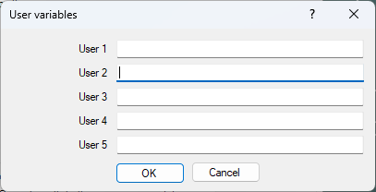

Color

If you turn on the Part color that can be done here. You can have different colors on different parts or on parts that belong to a customer.

Add to Organizer
If you have the organizer module installed, then the checkbox "Add to organizer" will be visible. If the option is checked then the part will automatically be registered in organizer. And removed from the drawing.

Toolpath
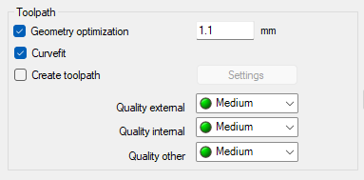

Geometry optimization <value>
It is recommended that the "Geometry optimization" is always activated. The optimization guarantees that the toolpath created on the part is possible to cut with a tool diameter smaller than the optimization value. The value can be changed in the geometry section in the machine setting.

Curvefit
If this checkbox is activated, then "Create" is performing an automatic "Curvefit" operation on the selected geometry.

Create toolpath
If this option is checked then the toolpath will be created automatically using the default settings of the Contour command. If you want to check the settings, then you can click on the settings menu.

Quality
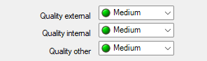
Here you can select which cutting quality on external, internal, and other objects geometry. It important to never use a better quality than required. It can take up to four times longer to cut with X-fine quality than it takes with X-rough quality.
The quality can be changed afterwards. You can read about that here.

Other objects
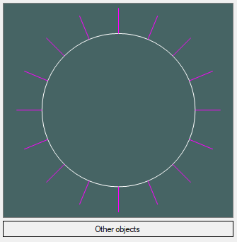
If you have open objects that should be included in the part, then those can be selected by clicking on the button "Other objects". This kind of geometries can be used for cutting or marking.

Object located outside external geometry
To add "Other objects" that are located outside an external geometry, then only one part can be created at a time. Select the circle and then the other objects as "Other objects".

Script
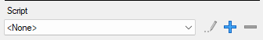
This option is for customizing IGEMS to work with an application or for communication with ERP systems. It will start a LISP scrip. All parts are included in a list with the name *PARTS*. All function in the ILISP language can be used.

It is also possible to add this kind of objects afterwards.

Quality
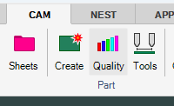
The basic quality is determined in the "Create part" command.
When there are several copies of the same part on the drawing then it is sufficient to modify the quality on just one part. All sister parts will automatically get the same quality.
If you want to have different quality on identical parts you must use the "Split" command to separate them.

Start the command.
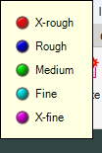
In the upper right corner of the screen are information about colors and qualities. You can in this stage se the quality on all parts on the drawing.
- Select the part that you want to modify. In this case select the rectangular part.

There are 5 different quality levels for abrasive waterjet cutting. The difference in cutting speed can be up to 500% between the roughest and the finest quality. To not waste time it is important to never use a finer quality than necessary. The "X-rough" cut should only be used for separation of material and the "X-fine" is only used when extreme finish is required.
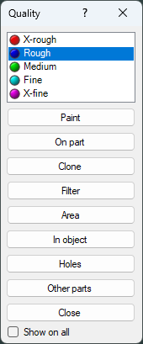
- Select Rough quality.

Paint
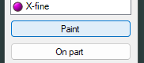
Use this option to paint quality on optional portions of the part. Click on two positions on the geometry and then a third point to decide which portions of part that should be painted.
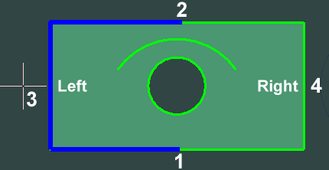
Pick on 1 then 2. Then you can pick on 3 to select left side or 4 to select the right side. You can also double click on the same point then the whole geometry will be selected.

On part
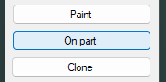
When using this option, the whole part gets the selected quality.

Clone
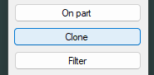
This option can be used to clone quality settings inside a part. On the picture below we want that all 10 holes should have the same quality as the first hole.
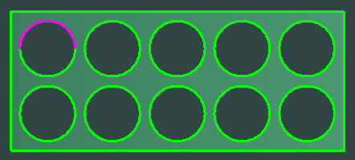
Start the command and select the first hole.
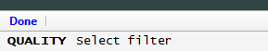
Then select all holes on the part.
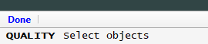
The function is usable for all kinds of geometry, but they have the same geometry as the filter.
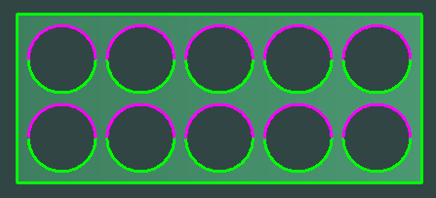
If it was rectangles instead of circles, should that also work?
Yes, it can be all types of geometries, geometries can also be rotated in optional angles.

Filter
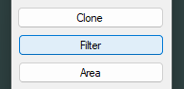
If you for example want to cut all small inside corners (arcs) with a slower speed (better quality) then you need to paint many times. The filter option can make this very easy.

Select the quality you want for the inside corners.
Start the Filter option and select one of the inside arcs.
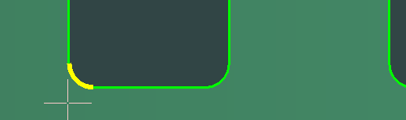
Then select all objects you want to modify. This can be done with a window.
Make a window that includes all identical objects that you want to modify-
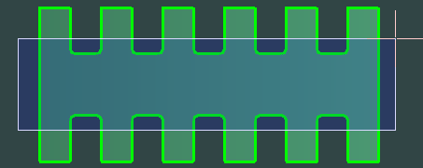
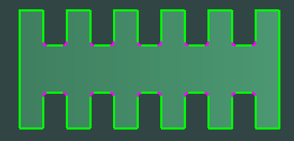

Area
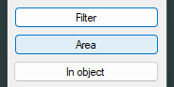

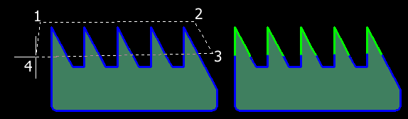
The "Area" option defines a polygon by clicking on optional points. Everything inside the polygon will have the selected quality.

In object
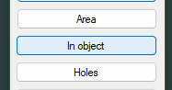
To use this option, you must draw a rectangle, circle, or another closed object.
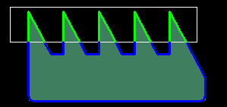
Select a quality then select the closed object. Everything inside the closed object will get the selected quality.

Holes
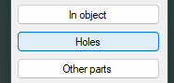
This option is little similar as the Clone option. But in this case the geometry doesn't have to be equal.
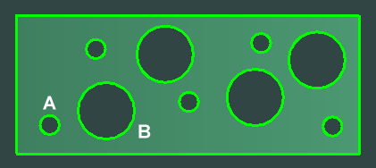
Select the quality that you want to attach to the holes.
Start the Hole option.
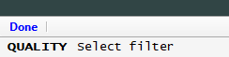
If you want to change the quality only on one size of the holes, then select (A) or (B).
If you want to change the quality on all holes, just press enter.
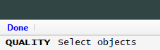
In this we change quality on all holes.
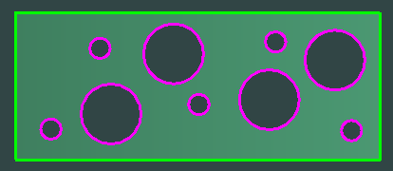

Other parts
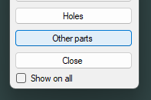
It's normally only possible to change quality on the part you select when you start the quality command. By this option you can change the quality on other part on the drawing. The whole part will in this case have the selected quality.

Show on all
If this checkbox is activated, you can see the quality on all parts on the drawing.

Tool setup
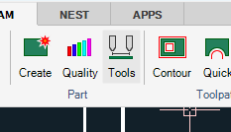
Many machines can change the distance between the tools during the cutting. Number of tools and how they are handled can be set in the Machine setting. If the machine only has one Tool (Jet) then you don’t have to use this command.
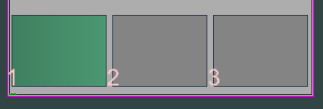
When you are using multiple tools then the first part will be a real part and the other parts will be ghosting parts. By modifying the real part then you also modify the ghost part.
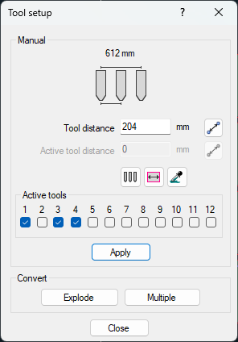

Tool distance and Active tool distance
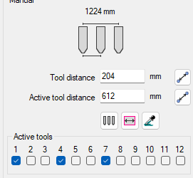
The Tool distance should be given as distance between each tool. The total distance between the two outermost tools is given as information in the top of the dialog. If there is an equal distance between each active tool, then this is written as Active tool distance.

Active tools
Use the checkboxes to control what tools should be active. Above tool number 1, 3 and 4 is activated. This should result in following:
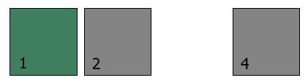
Tool number 1 is always the master tool.

Automatic adjustment

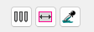

Minimize
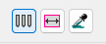
This option measures the size of the parts and set tool distance as close together as possible. Select the part and enter the distance between the parts.

Equal on sheet
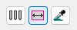
Click on the sheet. The distance will be calculated so all tools get equal distance on the sheet.

Pipette
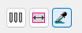
Select a part. All settings in the dialog will be the same as the selected part.

Convert
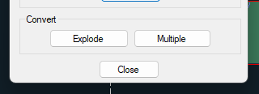

Explode

If you have done the job for a machine with multiple tools and you want to change to a machine with one tool. By clicking on "Explode" all ghost part will be converted to real parts.

Multiple

"Multiple" will do an opposite operation as Explode. It will convert real parts that are in the same alignment as the actual machine settings.

References
Configure machine layout on the "Machine" setup. See page 309.
The "Auto nesting" command makes an own tool configuration.

TAC-LAG
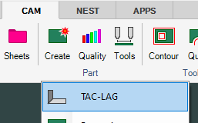
TAC means Taper Angle Control. This is the name we use for correcting the nozzle tilt to get a perpendicular straight cut. LAG is what we call the feature of tilt the nozzle in forward direction when we move out from inside sharp corners. The commands are only useful if you have a 5-axis cutting machine.
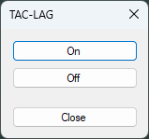
Click the button On and select the geometry that should have TAC-LAG. Or click the button Off and select geometry that should not have TAC-LAG.
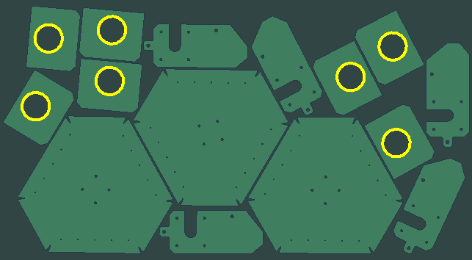
This is the background of this command.
On many 5-axis machine it takes much longer time to cut the geometry when using TAC and LAG. Depending on many things it can take 20-40 % longer time. Of that reason many users just use the
TAC-LAG on geometries that needs to be straight.
Is there a way to control if the geometries should be default On or Off?
Yes, this can be controlled in the machine settings.
What kind of kinematics is good to use for TAC-LAG cutting?
- It should be a solution where the nozzle can tilt in different direction. Not by doing rotations.
- It should be a solution with a fix tool center point. (When the nozzle tilts, the top of the nozzle should not move away).

Properties
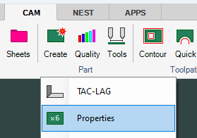
This command can also be started by a double click. This can be activated in the "Shotkeys" command.
The command will show following dialog.
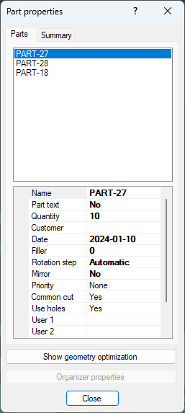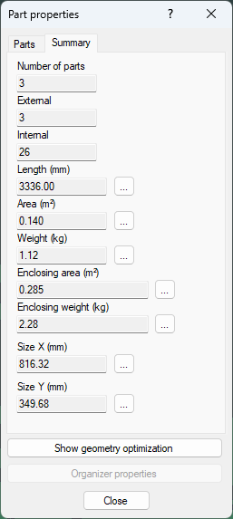

Part
The setting in the Parts tab is similar as the settings in "Create part" and the "Auto nest" on this tab you can change the setting. Multi selection of parts is possible with the properties command. If multiple parts are chosen at once, the quantity will not be able to be changed.

Summary
On the summary tab you have more geometrical information about the part.

Show geometry optimization
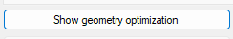
This option will show where the geometry optimization has changed the geometry.
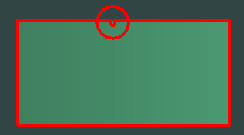
- Start the command and select one or several parts.

Add Other object
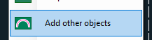
When you create a part then you can also add "Other objects" than external and internal geometries. These other objects can be used for marking, cutting with quick cut or just be visible on the part. By using this command, you can add "Other objects" on already existing parts.

Part text (THIS COMMAND SHOULD BE UPDATED)
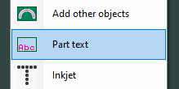
The "Part text" command is used to display information on the part graphically.
- Start the command and select parts and enter a text height.
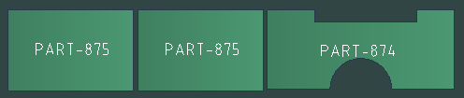
The name or an index number can be written on the parts.

Move Part text
If you click on the text when no command is active, then you can adjust the text position. By using the
grip functionality.
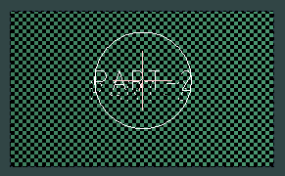

Inkjet
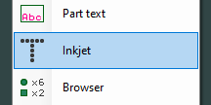
If the machine is equipped with an Inkjet printer, then this command can be used to add inkjet information.
- Start the command and select all parts that should have inkjet text.
The result can be as follows.
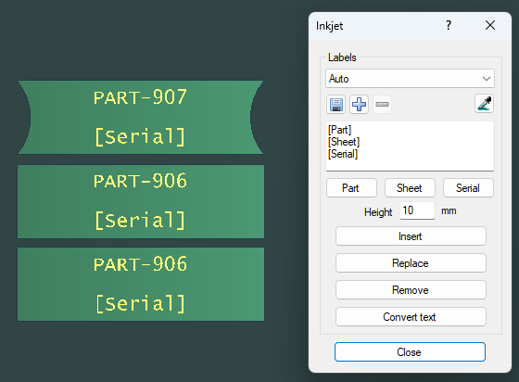
The command will always start up with the label "Auto"

Automatic Part name, Sheet name and Serial number
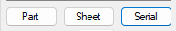
- [Part] means that the part name should be included in the inkjet text.
- [Sheet] means that the sheet name should be included in the inkjet text.
If the parts are not laying on a sheet the Sheet text is not visible.
- [Serial] means that the CNC machine prints a unique number on each part.
It is not all CNC-controllers that can use this feature. The last used serial number must be stored in the CNC memory. IGEMS cnc supports unlimited part series. It is possible to restart the same cutting program over and over and the serial number will count up for each part.

To be compatible with older version of IGEMS it is also possible to use #P for part name and #S for sheet name)
If you move the parts to a sheet and press F5 then the inkjet text for the sheet name will be updated.
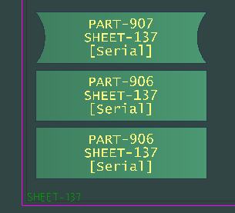

Save, add and remove
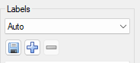
By these options you can save label settings, add, or remove labels settings.
The Auto label will always be default.

Inkjet height
You will probably use the same text height for all inkjet labeling. The text height can be set in the Machine setting.

Insert

Use this option if you want to locate the position for the inkjet text. Some inkjets can only print the text in one direction. That’s means that if the part is rotated then the text must be rotated in opposite direction.
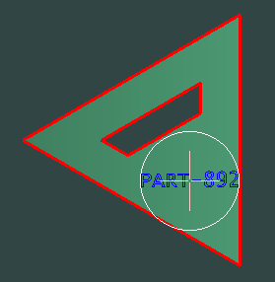
In the case below the part has been rotated in three different directions but the inkjet text is still in horizontal direction. You can set optional directions in the machine setting.
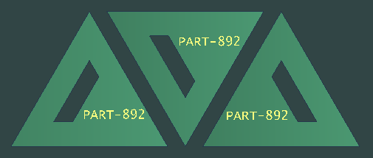

Replace
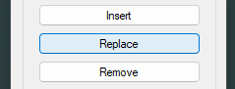
If you already have an inkjet text on correct positions, then you can use this option to replace the text.

Remove
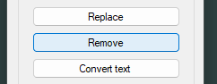
Use this option to remove inkjet text you don't want.

Convert text
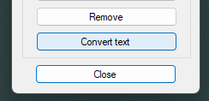
If you have some text or Part text on the parts that you want to convert to inkjet text.
- Start the option and select the parts.

Move inkjet text
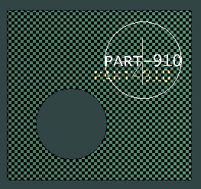
When you click on the text you can se a grip. If you click on the grip, you can move the text to optional position.

Browser
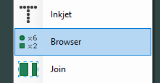
The part browser will open a menu on the left side of the screen.
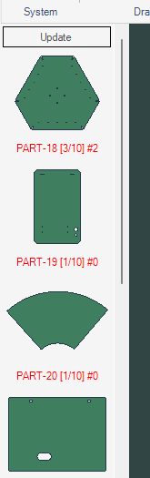
There is a picture of each part.
You can se the name of the part. Inside brackets [] you can see how many parts is located on the screen and how many parts that should be produced.
After the # sign you can see how many are located on a sheet. You need to press the update button located on top off the menu to update the numbers
You can drag part from the menu to the drawing.
If you click on the Brower command again, then you will close the Browser menu.
If you have the Automatic nesting module, then you probably never need to use this command.

Join
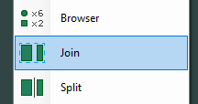
This command can merge several parts into one part.
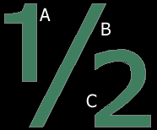
The command will ask for the master part (A) and then for parts that should be joined to this part (B) and (C). The result will be one part with three external geometries with name (A).
The command is useful if you want to keep the geometries together because of pattern matching or similar.

Split
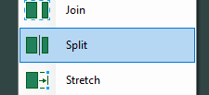
If you have several copies of one part, then all copies will have the same quality, name, and other properties. If you use the split command, then the connection with the original part will be broken. You can then give the "new" part other properties and qualities. You can also use the command to separate a part that has previously been joined.

Part Stretch
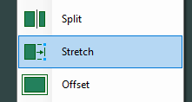
With this command you can change the size of a part.
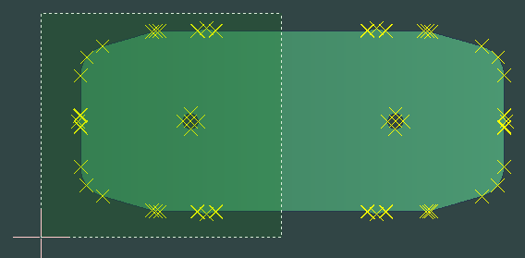
Select an area that you want to stretch.
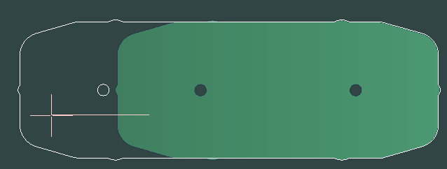
Select two points. It’s a good idea to use direction coordinates.

Part Offset
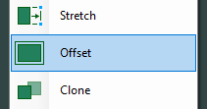
With this command you can increase or reduce the size of a geometry in a part.
- Start the command and pick on the geometry you want to offset
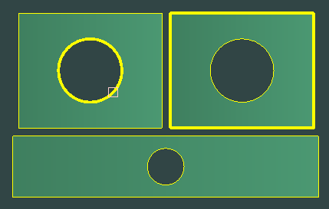
You can select as many geometries as you like.
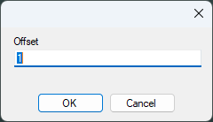
The value is a diameter value. Note! In older version (before 2024.1) this value was a radius value.
A positive value will add more material. This means that the hole will get smaller and the external is getting bigger. If you enter a negative value, then the hole will get bigger and the rectangle smaller.
This means if you measure the hole and it's 0.13 mm to small then you should use -0.13 mm (minus will remove material).

As the command works right now, the command will only modify the part at which you are pointing. It will not modify copies of the same part.
In waterjet cutting small circular holes often get little too small. This command can be used to adjust the size.

Part Clone
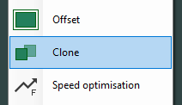
Select first the good parts you want to clone, then the parts you want to replace.
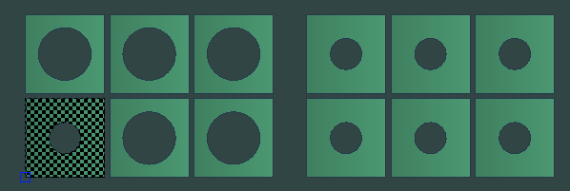
On the right side you can see the parts after the clone.

Contour
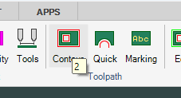
This command add toolpath to parts that should be cut all the way around.
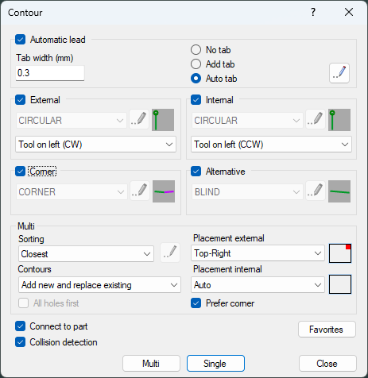

Automatic lead
When this option is activated then leads and piercing types are automatically calculated by an ILISP script. The script automatically generates the optimal piercing type and lead geometry depending on material, thickness, and the geometry of the part. When the Automatic lead is activated then you cannot select your own lead geometry.
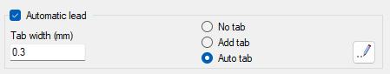

No tab
When this option is activated, the jet will cut all the way around the geometry.
This option is perfect on large part that do not moves or falling in the tank when the cut is finish.

Add Tab
Tabs are used on small parts to avoid them to fall in the tank and to avoid that the parts get dammed at the end of the cut.
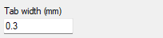
Set the Tab width to a distance large enough to fix the part to the material. The value will be stored on actual material and thickness that you are using.
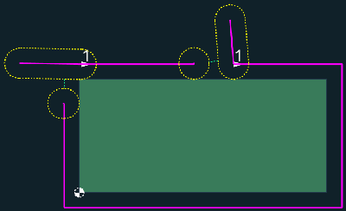
The picture above shows leadins with tabs that fix the part to the material. The cutting is stopped before the part is finish.

Auto tab
If you select the Auto tab option, then the LISP script will automatically switch between No tab and Add tab. This is depending on the size of the part and the layout on the cutting table.

Lead settings
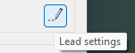
By clicking on the "Lead settings" button following dialog is shown.
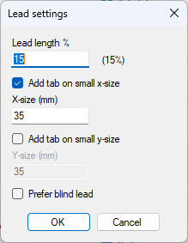

Lead length %
The fastest way of piercing thru the material is to use linear piercing. In linear piercing there is no delay after jet on, the jet will cut through the material during the leadin movement. The value is in percent of thickness. Normal value is 12-15 percent of the thickness. Example: 10 mm thickness will have a lead length of 1.5 + half maximum tool diameter.

Add tab on small x-size
If this checkbox is activated, the function will add a tab if the size of the part in X direction is smaller than the entered value.

Add tab on small y-size
If this checkbox is activated, the function will add a tab if the size of the part in Y direction is smaller than the entered value.
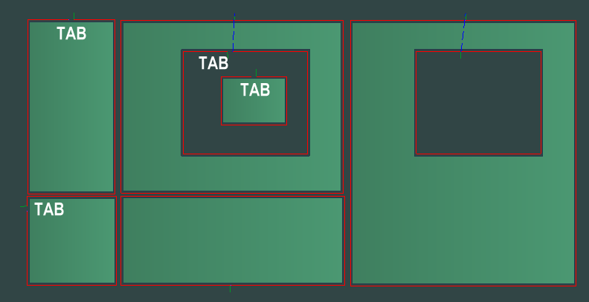
On this example there are some parts that are smaller than 35 mm in X. It’s a high risk that those parts will fall in the tank. These parts will have a tab of 0.3 mm. One of the holes has a part inside. This will also be tabbed to avoid fall into the tank.

Tool radius compensation (kerf)
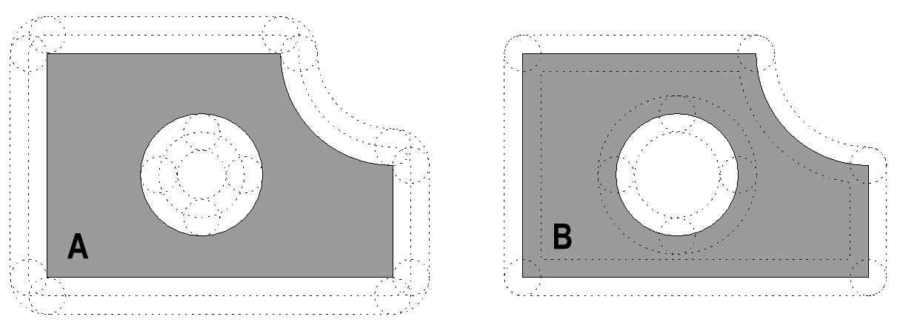
When you are using kerf compensation left or right then the trajectory will be moved outside an external geometry and inside an internal geometry (Se picture A above)
If you select the left option, then the cutting direction will be CW for external geometry and CCW for internal geometry. If you select the right option, then the cutting direction will be opposite. In the most CNC controllers the Left option is G41 and right option G42.
If you cut with no compensation, then the parts will have wrong dimension.

For flat 2D parts the tool radius compensation can be added in IGEMS or in the CNC controller. Most users prefer to add the kerf in the CNC since the dimension then can be adjusted by the operator.
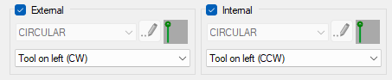
You can choose one following options for External and Internal geometries.
- Tool on left
- Tool on right
- No compensation
The direction CW or CCW is depending on if it's an external or an internal geometry.

Lead selection
It is possible to predefine leads-in and leadouts and create a library of leads that can be selected in the lead lists.
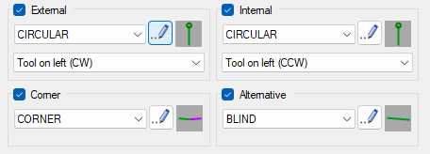
IGEMS can use different leads for external and internal geometries. It is also possible to use a special lead if the lead is placed in a sharp corner. When you place a lead then it is collision detected against all other parts if there is a collision with other parts then the alternative lead will be used.
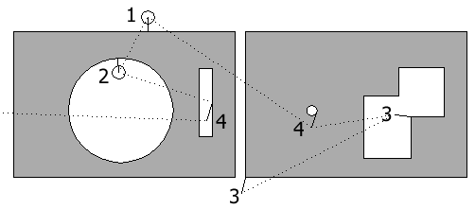
Lead 1 is an external lead, lead 2 is an internal lead, lead 3 is a corner lead and lead 4 is an alternative lead.
Lead 4 seems to damage the material?
No, this is a blind lead and the lead in is not used for cutting. Read more in "Lead definitions"

You can read more about the different piercing types and leads on "Lead definitions"

Favorites
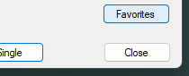
This was a feature we developed before we have the automatic leads. It will probably be removed in future versions of IGEMS

Multi-mode
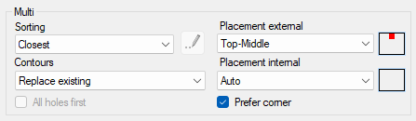
When using "Multi" mode you can select all parts at the same time. The function will sort the internal cutting order of in all parts. It will place the leads at good positions on the geometries. It will select the defined leads depending on the geometries. To be able to do this it need some rules.
To execute the multi command that places the leads automatically press the Multi button.
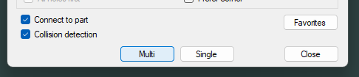

Sorting
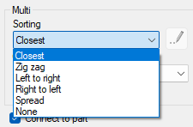
The name of the 6-sorting algorithm is quit self-describing.

Closest
Closest is optimized to give the shortest rapid distance between the parts.

Zig zag
Zig zag has an option dialog to select different zig zag methods. There is a preview in this dialog that are quit self-describing.

Left to right
Will start at the very left hole and continue in right direction.

Right to left
This sort in opposite direction as left to right.

Spead
Spread will take the order very randomly, it's developed for plasma cutting to spread out the heat over larger area.

None
will take the holes in the same order as the holes was drawn.
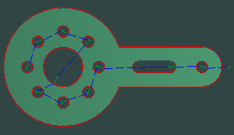
On the picture above the sorting order is set to closest.

Contours
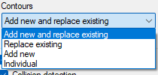
This setting controls which contours the leads should be attached to.

Add new and replace existing
This method adds new and replaces all existing leads on the selected parts. Do not use this option if some leads are placed with other commands that shouldn't change.

Replace existing
In parts with no leads, this choice will not produce anything since it replaces existing leads with the defined leads. This method uses the same lead positions as the already existing leads.

Add new
This method adds leads on contours that have no lead. Use this method when leads were placed by other commands.

Individual
Use this method to select contours transparently inside parts. See picture below.
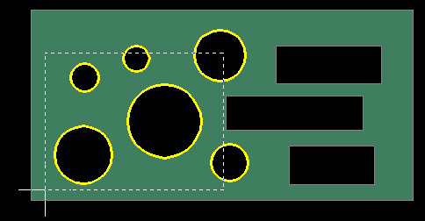
This method adds new and replaces existing leads.

Placement
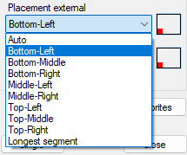
It is possible to set rules where to place the leads both for external and internal geometries.
We recommend that in all normal cases use the option "Auto" since this gives the shortest trajectory.

Prefer corner
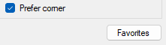
With this option, the leads will be placed in sharp corners. This option is stronger than the other placement rules.
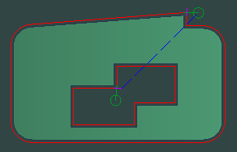

Connect to part
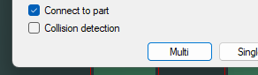
If the toolpath is not connected to the part we also call this disconnected.
This option is also available in other commands. When the toolpath is connected then it is bound to the part. When the part is moved, then the toolpath should be moved. A toolpath that handles more than one part cannot be connected, for example "Common cutline". In the example below the same toolpaths are used for 10 parts.
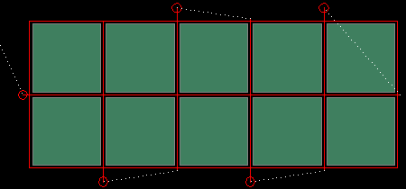
By deactivating this checkbox, a toolpath is created that is disconnected from the parts.
What can a disconnected toolpath be used for?
You can then create several toolpaths on the same part in order to assign different tools on the same parts.
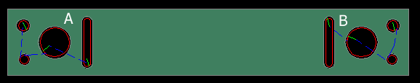
Only the internal cut is in the example above. The contours on the left side (A) are connected to the part, and the contours on the right side (B) are not. It is now possible to assign two different tools to these two geometries.

Collision detection
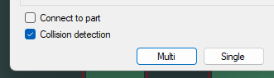
This is the normal stage. In this case it's impossible to place a lead at a position that can damage other parts. If this checkbox is deactivated, then you can place the lead at any position even if its damage other parts.

All holes first
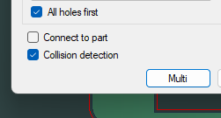
To be able to use this functionality the checkbox "Connect to part" must be deactivated.
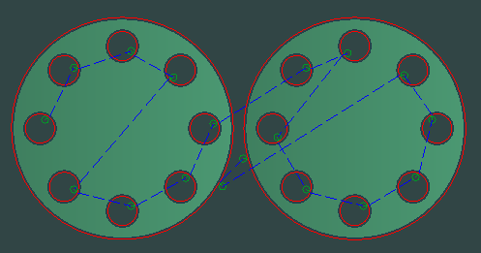
This will generate a disconnected toolpath and all holes are cut before the two external geometries.

Single mode
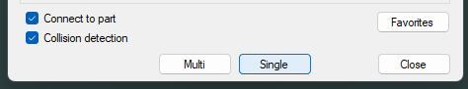
Use the "Single" button to manually attach leads to geometries.
- Open the file "Single.dig" located in the "Sample directory"

- Attach the leads on desired positions by clicking the "Single" button. Start with internal geometries and take the external geometry as the last. The geometries on the part will be cut in the order inputted.
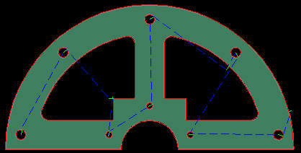

Change position of leads
Change the position of the lead by re-clicking on the same contour.
Can I change the cutting order?
In the "Edit toolpath" command you can change the order.
You can also delete all leads and place them again.
Not in the "Single" mode. This is done in "Multi" mode and using "Edit" toolpath.

Lead definitions
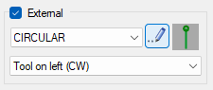
If you click on the Edit button, then following dialog will be shown.
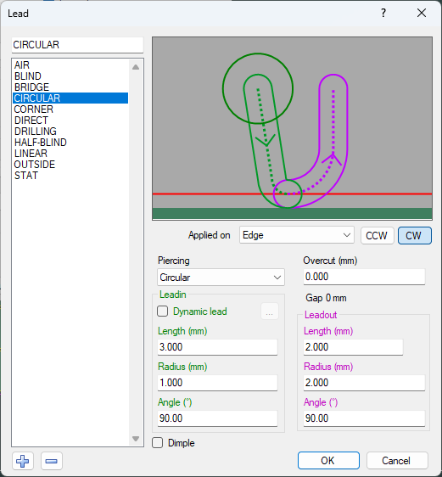
You can add new or delete definitions you don't want by clicking on the plus or minus buttons.
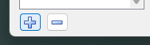

Lead preview
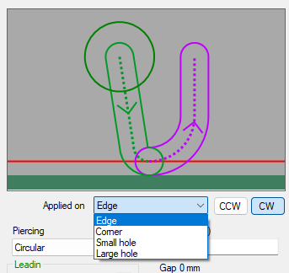
It can be difficult to exactly understand the effect of the different lead settings. On this preview you can zoom and pan. You can see the result when the settings are applied on different kind of geometries or when you change cutting direction CCW or CW. The red objects are the leadin, the blue is the leadout.

Piercing
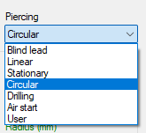
The piercing controls how the jet make the start through the material. The following methods are supported:

Blind lead
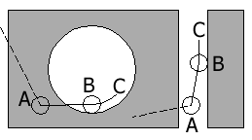
- Rapid to point (A)
- The kerf (G41/G42) is activated, and the jet then makes a linear movement to point (B).
Note! the jet is still off.
- At this point (B) the jet is opened and without any delays the geometry starts to cut.
- After some distance (C) the jet has cuts through the material.

Important!
It must be an overcut when using blind leads. The overcut distance must be at least the distance between (B) and (C). When using "Automatic leads" the overcut distance is calculated automatically.

In AWJ cutting this piercing method can be used on all material that can be pierced with high pressure. The benefit with this method is that it does not require any leadin that can damage parts and material. It also gives an excellent result. Note! Not all CNC-controllers can support this method.

Linear piercing
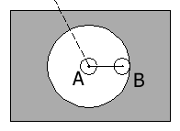
This is the movements:
- Rapid to point (A)
- Jet is opened and then kerf compensation (G41/G42) is activated
- The jet continues to point (B).
- The speed used for the leadin is the X-fine speed.
If the distance between point (A) and (B) is so short that the jet cannot cut through the material, then the jet goes back and forth between (A) and (B) as many times as needed.

Except for Blind lead the linear piercing is the fastest way to cut through the material.
The length of the linear piercing can be set individually on each material and thickness. Read more about the linear piercing on the material settings on page 238.

Advice
The length of the linear piercing should be 12-15% of the material thickness plus half of the tool diameter.
When using "Automatic leads" the linear piercing length is calculated automatically.

Stationary piercing
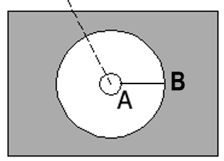
This is the movements:
- Rapid to point (A)
- At this point the jet is open and remains there until the jet has cut through the material.
- The kerf compensation (G41/G42) is activated
- The jet continues to point (B) and then continue to cut the geometry.
Advice
This piercing method takes the longest time and we do not recommend using it. It is supported for compatibility reasons. The stationary piercing time can be set on each material (see page 237 for more information).

Circular piercing
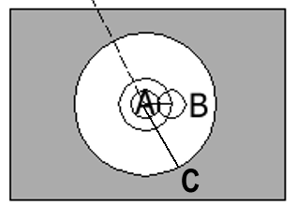
This is the movements:
- Rapid to point (A)
- At this point the jet is opened and then it goes to point (B).
- The jet now makes circular movements around point (A) until the jet has cut through the material.
- The kerf compensation (G41/G42) is activated
- The jet continues to point (C) and then continue to cut the geometry.
Advice
This is an excellent method to use on thick material.
It is also the best method to use for Low pressure piercing sine it reduces the risk of the material cracking.
All parameters like the radius, speed of the movement and time can be set individually for each material. See page 237 for more information.

Drilling
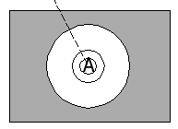
This method is only possible if the machine is equipped with a drilling unit.
All drilling will be performed sheetwise or partwise before the cutting.
If the machine has no drilling unit, then IGEMS uses circular piercing. Set drilling parameters on the "material setup" (see page 230) and control the drilling sequences in the "Strategy" command (see page 300).

Air start
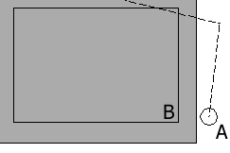
This method is used when a piercing is not needed. For example: Starting outside a sheet or in an existing hole. This method is automatically used for cutting when the start hole has been drilled or pre-pierced.

User piercing
This method is specified in the postprocessor for customization of a special process. Do not use this method if the postprocessor is not developed for this method.

Leadin
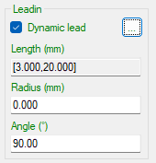

Dynamic lead
When the Dynamic lead is activated the linear length of the leadin is variable. In the picture above length is between 3 to 20 millimeters.
If you make a piercing in a cracking material, then it's a risk that the piercing process will damage the material on the bottom side. Of that reason it's good to have the leadin as long as possible.
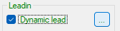
When you click on the dot button you can enter minimum and maximum lead distances.
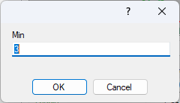
The dynamic lead always tries to place the piecing as long as possible away from the part. But no longer than the maximum distance.
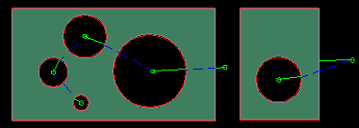
The Dynamic leads are often used together with Circular piecing and Low-pressure piercing.

Advice
Try to use "Automatic lead". It will automatically use this setting if the material should be pierced with low pressure.

Length
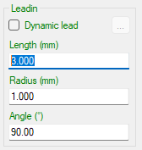
This is the linear first portion of the lead. The length should be at least half of the value specified as "Maximum tool diameter"

Radius
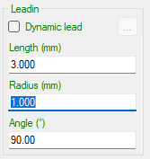
Do never specify a radius that is smaller than the "Maximum tool diameter". If you do so then you will probably get an error on some CNC-controllers.
Advice
We don't recommend using radius on the leadins in waterjet cutting, but some users need this option.

Angle
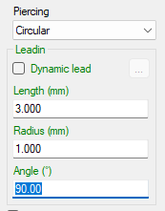
This controls the angle of the leadin.
Please check the "Lead preview" when you play with different parameters.

Leadout
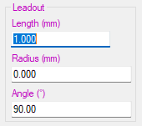
These values are applied on the leadout. Please look at the "Lead preview" to see what's happen when you play with these parameters.

Overcut and gap
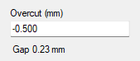
Use negative overcut if you want to make a gap between the leadin and the leadout.
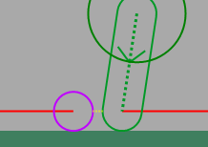
On the picture above you can see the gap as the yellow line between the red and blue lead.
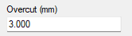
Use a positive overcut if you want to cut the entry part of the geometry two times.
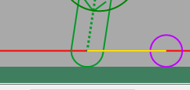
Advice
When using "Automatic leads" then all parameters are calculated automatically.

Dimple
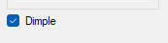
The dimple option will remove more material on the part close at the lead position.
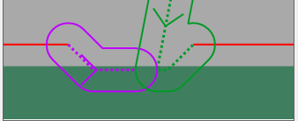

Quick
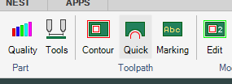
The "Quick" command can be used on all kinds of geometries but is mostly used when it is necessary to only cut contours partially. The command can be used to cut slits or contours. Slit geometry can be created by the "Other object" button in the "Create part" command.
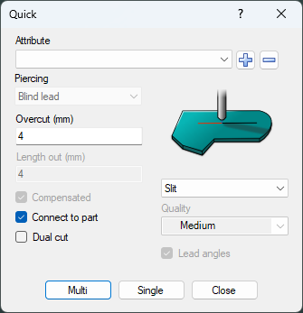

Attribute
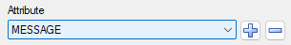
The attribute functionality is the same as for many commands like Quick, Marking, Holes, Toolpath in 3D-5X. You can read more about this here.
We use the attribute to be able to support special requests from users. What different attribute can do is completely up to the postprocessor. Of this reason it is not possible to exactly define what the attribute can do. One example in the drilling command is to use threading taps.
If you click on the "Plus" button, then you can add a new attribute.
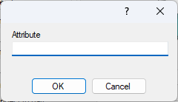
The attribute will then always be visible in the drop-down list. It can be removed by the "Minus" button.

Piercing
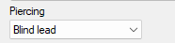
You can use all kind of leads except when you use the "Slit" option. This option can only use the Blind lead"
You can read about different piercing type here.

Slit
- Open the drawing "Quick-Slit.dig" located in the "Sample directory"
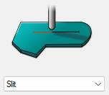
Select the "Slit" option from the drop-down list or click on the picture.

Single on slit
Use the Single option when you want to control the cutting order in detail.
Click on the Single button and click on one of the open objects.

- The start will be on that side you click on.
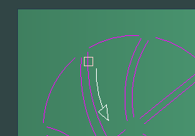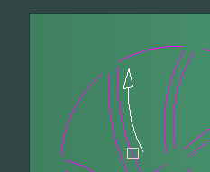

The "Slit" option can be used to cut open or closed objects. Since the geometry itself is used as the leadin it is only possible to use the piercing type "Blind lead". Read more on this on page 137.

Multi on slit
Use the Multi option if the cutting order is not that important.

The Multi option will use a sorting algorithm that is optimized to get short rapid transport between each cut.

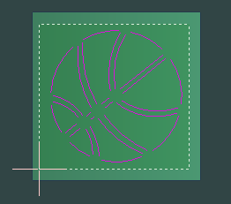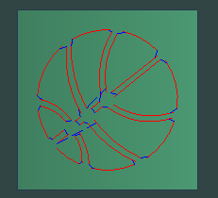

Overcut
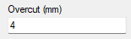
Since the "Slit" option cannot use any traditional leadin since that will damage the slit. Of this reason some parts if the slit will be cut two times.
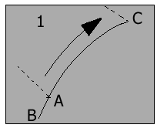
Picture above shows an open slit. The cutting starts at point (A) and continues to point (B). At this point the jet has cut through the material and then moves to point (C). The distances that have been cut two times (A) to (B) is the overcut distance.
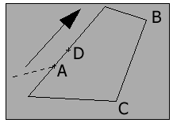
Picture above shows a closed slit. The cutting starts at point (A) and continues all the way around back to (A) and then to (D). The distance between (A) and (D) is the overcut distance.

Dual cut
If you activate Dual cut, then the whole slit will be cut two times. It will start at point (A) then go to points (B) and (C). It will then go back to (B).

Contours
- Open the drawing "Quick-Contour.dig" located in the "Sample directory"
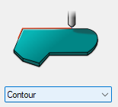
- Select the "Contour" option from the drop-down list or click on the picture.
The Contour option should be used when you want to add a toolpath on an external or Internal geometry, but the toolpath should not cut all the way around.
- Start the command and click on the "Single" button.

- Click on point (1) and (2) If you will cut the part like (A) or (B) is depending on where you click the third point.
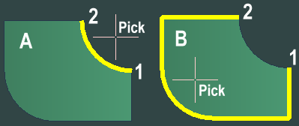

Piercing and Leads
Since this option should be used for external and internal geometries it is possible to use a leadin and optional piercing types. There is also settings for wanted leadin and leadout length.
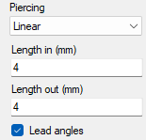

Lead angle
Only use this option together with the "Contour" option. The command also asks for the leadin and leadout angles.
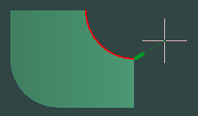

Kerf compensation
Use this option if the jet should use kerf compensation. If this is not activated, then the external geometry will be to small and internal will be too large. Normally this should be activated. You can read more about kerf compensation here.

Connect to part
You can read more about "Connected toolpath" in the "Contour command"
If the toolpath is not connected to the part, then it's possible to specify a separate cutting quality on the toolpath
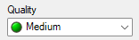

Marking
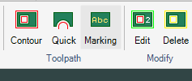
The "Marking" command makes it possible to cut a mark in the material rather than cutting through. Marking of text and contours is made with abrasive waterjet or pure waterjet or with other marking equipment. Marking geometries is created by the "Other object" button in the "Create part" command or with the command "Add other object".
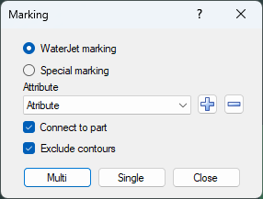

Waterjet marking
Waterjet marking is done with the same jet as for the cutting. Waterjet marking is done with lower pressure and less abrasive than cutting. Of that reason it is possible to do all marking before cutting starts in sheetwise or partwise optimization.

Special marking
In this case the marking is done with a special marking tool that are located beside the jet. Example of marking equipment can be powder, inkjet pen, engraving tool or laser.

Attribute
The attribute functionality is the same as for many commands like Quick, Marking, Holes, Toolpath in 3D-5X. You can read more about this here.

Connect to part
There is more information about connect to part in the "Contour" command.

Exclude contours
When this checkbox is activated no geometries that belong to the contours can be selected.

Multi or Single

Use the "Multi" button to select multiple objects at the same time. Select the "Single" button and click on each object. The starting position will then be at the position where the you click.

Holes
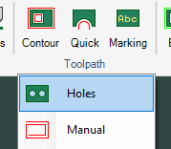
This command can be used for diverse types of cutting processes on point or circular objects. Following dialog is shown:
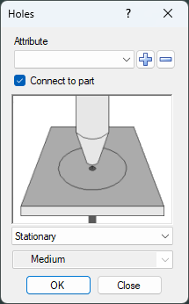

Attribute
The attribute functionality is the same as for many commands like Quick, Marking, Holes, Toolpath in 3D-5X. You can read more about this here.

Connect to part
There is more information about this in the "Contour" command.

Drilling
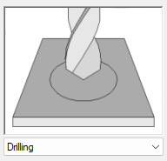
With this option you can make drilling as a separate process. You can drill the hole without doing any cutting.

Marking
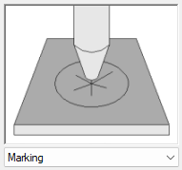
Use this option if you just want to make a mark on top of the surface. The reason may be a position indication for something to be welded or drilled.

Circular piercing
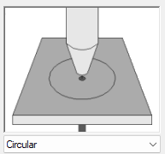
To use a circular piercing is a fast way of cut through the material. This option will make a circular piercing with the diameter entered in the material database.

Cutting
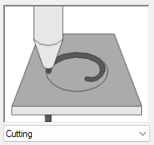
This option makes a circular hole. The holes are machined in a spiral from inside out to get a precision hole. If the hole is not connected to the part then it is possible to enter a quality. This feature is not yet released.

Stationary piercing
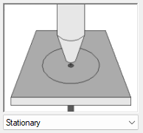
This will make a stationary piercing in the center of the circle or at the point. Stationary piercing should be used only on thin material.

Subroutine
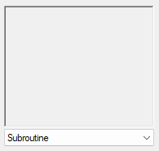
This option require special development of the postprocessor. The idea is that the CNC machine has one or several subroutines stored in the memory. This hole option call for the subroutine at actual position.
In this case the attribute will control the name of the subroutine.
The option will ask for text height
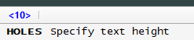
A text "SUB" will be located in the center of the hole.
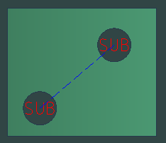

How to attach the hole to the part
- Open the file "Curvefit.dig" in the Samples directory.
- Start the command and select the drilling option
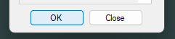
When you press OK you will be prompted to select a filter object.
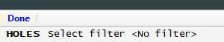
- Select the large hole as filter object.
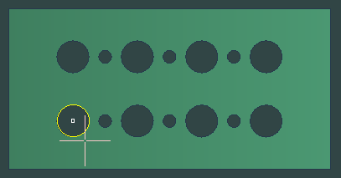
- Then select all holes by a window.
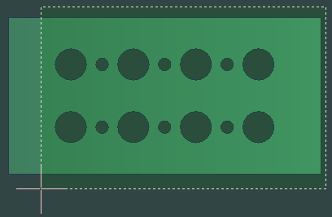
The command will attach the hole to all circles with identical diameter as the filter object.
If you don’t use any filter object then all circles will be attached.
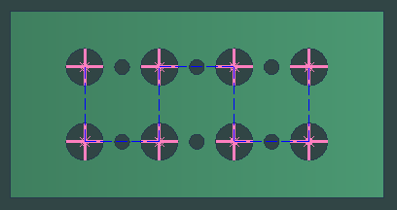

Manual
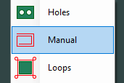
- Open the file "Manual.dig" in the Samples directory.

The "Manual" command is extremely flexible, but requires more manual input from the user. The command can mix created toolpath from IGEMS parts and normal CAD geometry such as lines and arcs. All points and information needed is entered the same way as using "CAD" commands. "Ortho" or "Snap" can be used.
When the command starts the command show this prompt.
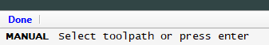

Add movement to a disconnected toolpath
The command only works on disconnected toolpath. To continue to work on an existing toolpath select the disconnected toolpath.

Make a new toolpath
Press "Enter" to create a new toolpath. Then there is an additional question:
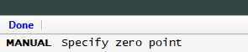
Specify a point for the zero point of the new toolpath.
What is this zero point used for?
The selected position normally has no impact on the result but it can be used by the postprocessors. Set the point as close as possible to desired toolpath.
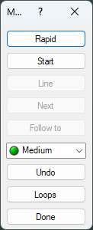
Use this command to create a toolpath step by step. All movements in the machine will be in the same order as the inputted sub-commands.

Rapid
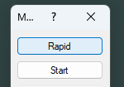
Press this button to add "rapid movements". The jet will always be off when the machine executes this movement. Use the same methods to enter the coordinates as for the "Line" command. Interrupt the "Rapid" command by pressing the spacebar or Enter.
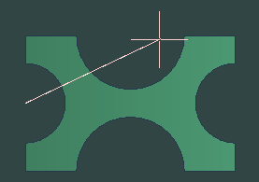

Start
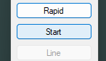
The "Start" command ends the rapid, activates compensation and turns on the jet. The following dialog box is shown.
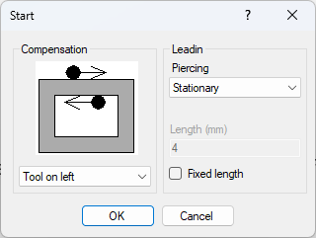

Compensation
Select one of the following tool radius compensation to use: "Tool on left", "Tool on right" or "No compensation". You can read more about tool radius compensation (kerf) here.

Piercing
You can read more about piercing here

Fixed leadin length
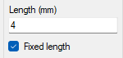
When "Fixed length" box is checked the lead length is always fixed to this value.

Start point
Press "OK" to pick a point on the geometry to follow. To use commands that follow other objects, put the start point on the object. One example to do this is by using "Object snap" commands.
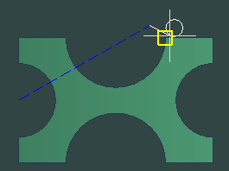

Start without leadin
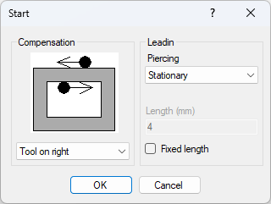
The only way to start "without lead" is when cutting without tool compensation and the "Fixed length" is not activated.

Line
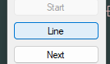
The "Line" option can only be used when the jet is on.
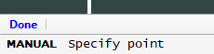
Enter as many lines as needed and move the jet to any position. Interrupt the "Line" command by pressing the spacebar or Enter.
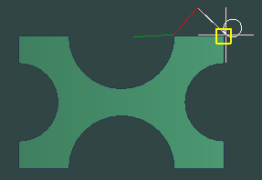

Next
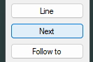
The "Next" option is used when existing objects are located in a chain. For every click on the "Next" button the cursor moves one step forward. To be able to use this function the curser must be located on an object. When there is more than one object that can be used the path to use must be selected.
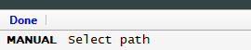
Pick to select cutting direction.
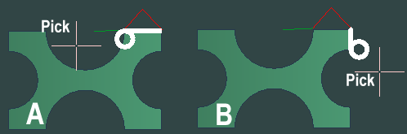
In this case you can see that on alternative (A) the tool radius compensation will be at wrong side.
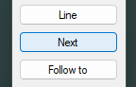
After deciding the path direction then use the "next" button to add one step with every click.
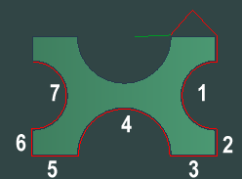

Follow to
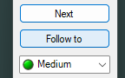
Use the "Follow to" option instead of clicking on the "Next" button many times.
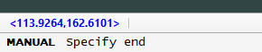
The coordinates show the current position and if accepted the cursor goes all the way around the part and back to current position.
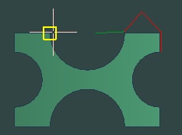
You can also select position on the contour, then all objects up to that position will be added.
Use "Object snap" when selecting this point.
Note! If there are different solution on how to come to that position, there may be a prompt to select path as described on the "Next" option

Cutting quality
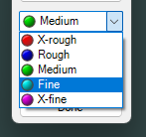
The toolpath will have the selected cutting quality which can be changed at any time. The new quality is valid from the current position. You can also use the "Quality" command to change the cutting quality afterwards.

Undo
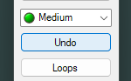
The "Undo" only works on actual toolpath and will undo one step backwards for each time clicked.

Loops
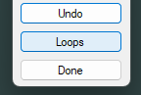
The "Loops" function activates loops on outside corners. The following dialog box is shown:
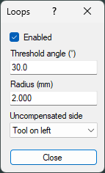
The loops can turn on and off by the enable checkbox. The loops will be generated on coming objects that you can add by Next or Follow to commands.

Threshold angle
Loops will be generated if the geometry direction is changed more than the Threshold angle

Radius
The size of the loops is controlled by the "Radius" setting.

Uncompensated side
When cutting with "No compensation" on CAD objects it is impossible for the function to know what corner is outside. Use this setting to control which corner is treated as outside.
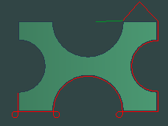

Done
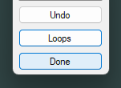
The "Done" button closes the command. You can start the command again and continue on the same cutting. Remember that you must select the toolpath is you have more than one.

Loops FIXA DETTA NÄR VI HAR EN NY DIALOGBOX
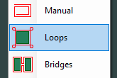

Bridges
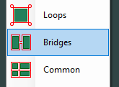
This command creates a disconnected toolpath and connects parts with a bridge. This kind of toolpath is ideal when cutting small parts that can fall down in the tank.
- Open the file "Curvefit.dig" in the Samples directory.

The command shows the following dialog box:
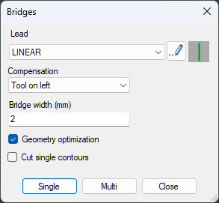

Lead
You can read more about the different piercing types and leads on "Lead definitions"

Compensation
You can read more about tool radius compensation (kerf) here.

Bridge width
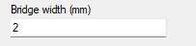
This value is the width of the bridge which may look wider on the screen since the toolpath shows the center of the tool. The value should be that wide that the parts are fixed together , but also that small that it is easy to separate the parts after cutting.
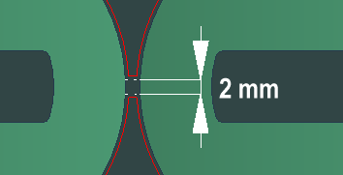

Geometry optimization
This guarantees the part is able to be cut with a specified tool diameter.
You can read more about geometry optimization here.

Cut single contours
This setting is used on the Multi option. If it's activated than the command also will add toolpath on single geometries like holes.

Single
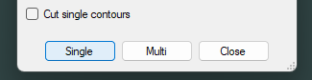
Click on leadin/leadout position (1) and then at position where you want the bridge between the parts.
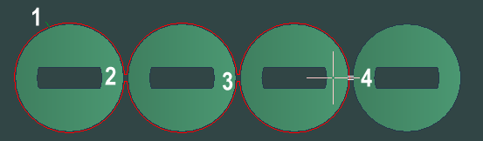

Multi
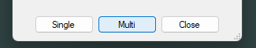
With the Multi option you can select many parts at the same time. The bridge command will join all parts that you select together in one group. You can do several bridges groups the command will not cut the same geometry twice.
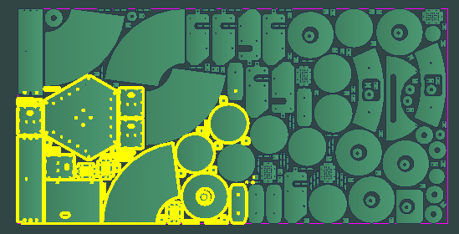
Are there any negative things by using Bridges?
If you take many parts at the same time, it can be a risk that the parts move during the cutting.
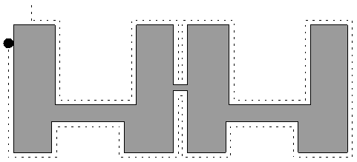

Common cutlines
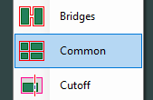
The "Common cutlines" command is used for separating parts with only one cut. This cutting method is much faster than traditional cutting.
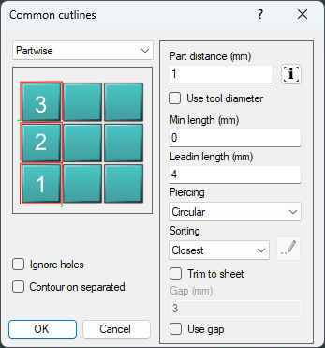
The command support three main different methods.
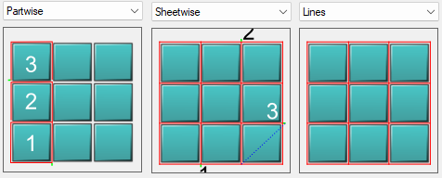
The following settings are common for all methods:

Part distance
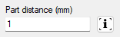
Common cutline generates a toolpath without kerf information. The coordinates in the CNC-file always describe the center position of the jet.
The tool center is located between the parts to be separated.
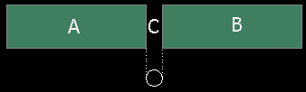
It is important that the distance between the parts is the same as the dimension of the jet. If the distance between the parts (C) is closer, then no toolpath is generated between the parts. If the parts have a larger distance, then (A) and (B) will be cut separately and the (C) portions will be cut two times. The tolerances for the distance are approximately plus/minus 0.01 to 0.05 millimeters.

Info button
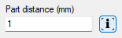
By licking on the Info button, you will have information if some parts are to close to each other.
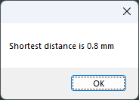
By activate the checkbox "Use tool diameter" the actual tool diameter will be used. The tool diameter is set in the "Cutting parameters"

Min length
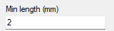
This controls how where the common cutline controls will be applied.
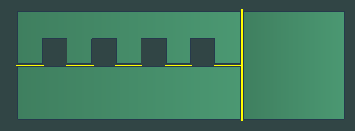
All the yellow lines will be cut with common cutline

Leadin and piercing
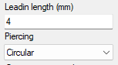
The leadin and piercing is simplified in common cutline. The leadin always go 90 degrees perpendicular to the geometry. The settings above will at least be used once when it starts to cut. If it's needed to turn on/off the jet several time, then it will try to start in an existing toolpath using the piercing type "Air start".
You can read more about piercing here

Ignore hole
If it's already toolpaths attached to the holes, then this checkbox has no affect. The command does never add toolpath in holes if it already has a toolpath.

Run "Contour" on separated parts
If you select parts that are completely separated from other parts, then you can automatically run the "Contour" on these parts.

Cutting quality
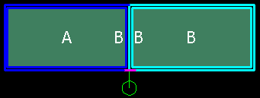
The cutting quality is inherited from the parts. When cutting between two parts that have different cutting quality the toolpath which is common for the part will have the best quality.

Trim to sheet
If the tolerance of a part is not critical, possibly save time by using the edge of the sheet as the edge of the part.
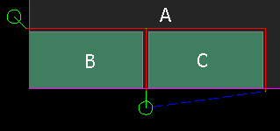
To use this, the parts must be nested close to the edge of the sheet. Check the "Trim to sheet" box.

Sheetwise
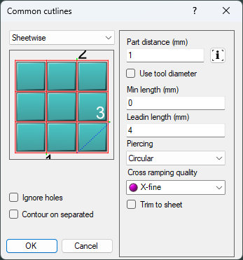
This method needs material free from stresses when there is no risk that the sheet will be moved during the cutting.

Cross ramping quality
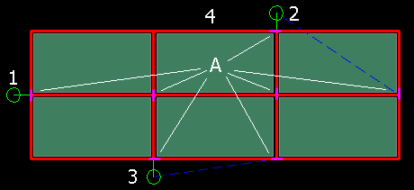
If the material is thick, then the jet will make a jump when crossing a path that is already cut. There is a risk that the material will not be cut at these points.
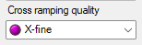
Set the cross-ramping quality to a finer value and the cutting speed will slow down at these points (A).

Cutting order
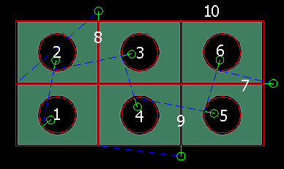
Sheetwise method cuts all holes in all parts and then cuts the lines between the parts. Then the external geometries are cut.

Mix between normal cutting and sheetwise
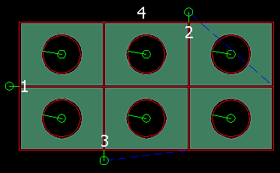
When internal geometries already have a toolpath, the command will skip these holes. Cut holes with another command before using the common cut.

Partwise
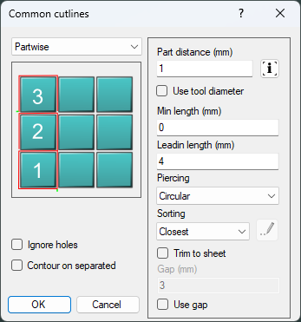
This method cuts each part before starting to cut the next part. There are some settings that differ from the sheetwise option.

Sorting
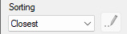
With this setting you can control in which order the selected parts will be cut. You can read more about sorting order here.

Gap
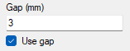
Gap is a nice feature that make micro-joints between the parts.
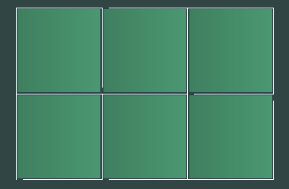

Lines
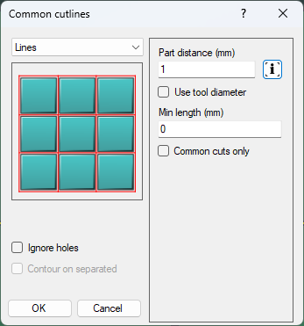
This method only adds CAD objects between the parts and does not add any toolpath. These objects can later be used by other commands like the "Quick" or "Manual" commands.

Common cuts only
When this checkbox is activated then the command will only generate the lines that should be cut with common cutline.

Cutoff
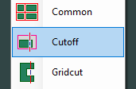
When you start the command, following dialog is shown.
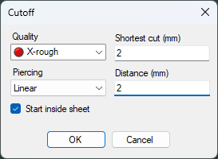
This command is for easier handling of skeleton sheets. The idea is that the parts can remain on the cutting table during the cutoff. If the sheet has not been moved, then the jet cannot damage the parts.
We now plan to divide the sheet as the white line on the sheet below.
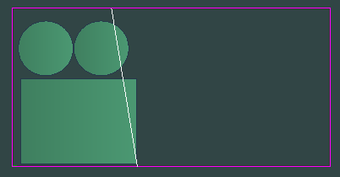

Quality
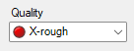
It's waist of time to use a high-quality cut for making separation of the sheet. I suggest you should use X-rough or Rough. You can read more about cutting quality here.

Piercing
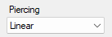
Select on of the piercing types. On very thick material I suggest you should use "Circular" on thin material "Linear". You can read more about piercing here

Shortest cut
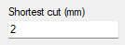
Its no meaning to make a cut if the distance between the parts is very short.
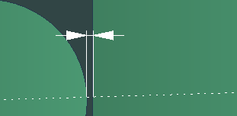

Distance
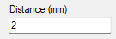
This setting controls how long from the parts the cutoff should start and end.
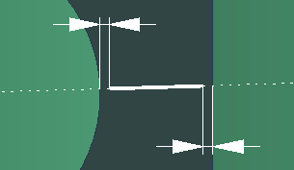

Start inside sheet
If this checkbox is activated, then all cuts inside the sheet will be cut first. If not then the cutting will start at the edge of the sheet.

Do the toolpath

Press OK and select the line
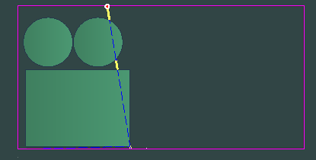
It is now possible to lock the sheet and divide the sheet in two parts.
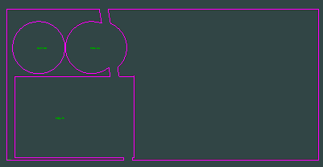

Different methods
There are three different methods to use the "Cutoff":

Cutoff first
Do the cutoff first and then cut the parts on the sheet. Be sure the distance value is large enough to not destroy the parts. In this case run the cutoff first in the "Order" command (see page 286).

Cut part first
Cut all parts first and then the cutoff. If the parts are not unloaded from the machine be sure the distance value is large enough. In this case run the cutoff at the end in the "Order" command (see page 286).

Cut part first, unload and then cut
To first cut and then unload all parts set the distance value to zero. In this case there will be no bridges.

GridCut
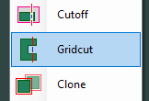
The command shows following dialog
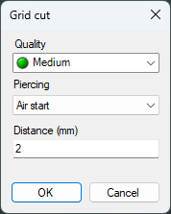
The Gridcut command can be used to cut off sections of a part without turning On and Off the jet between each cut.

In this example we use this part and a line. We want to cut off all the fingers, in the space between the fingers the jet should be moved with highest possible speed.

Cutting quality
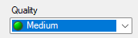
Chose the quality you want for the cut. You can read more about cutting quality here.

Piercing
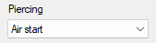
If you start outside the fingers (at the end of the line) you don’t' have to make any piercing.
You can read more about piercing here

Distance
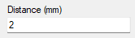
This is the distance from the part where the fastest speed starts and ends.
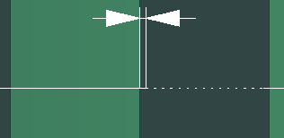

Gridcut
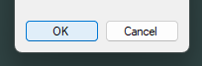
Press OK and select the line.
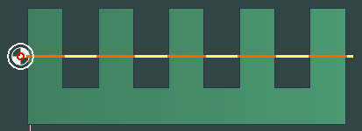

Clone toolpath VI SKALL ÄNDRA DETTA KOMMANDO
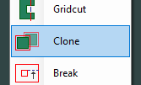

Break toolpath
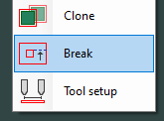
This command breaks a disconnected toolpath in two by dividing at the selected "rapid".
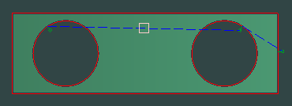
Click point (A) to get two disconnected toolpaths.

Edit toolpath VI BÖR HA ETT MÖTE OM DETTA KOMMANDO
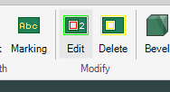
Use the "Edit part" command to modify, reorder and sort cutting order after the toolpath has been assigned to a part. IGEMS shows the cutting sequence order and cutting directions of all parts on the drawing.

This command can also be started by a double click. This can be activated in the "Shotkeys" command.
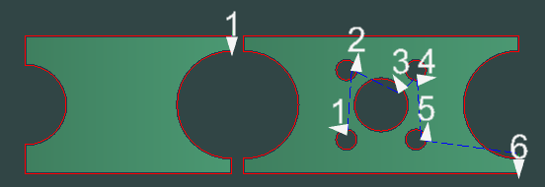
- Select the part to edit

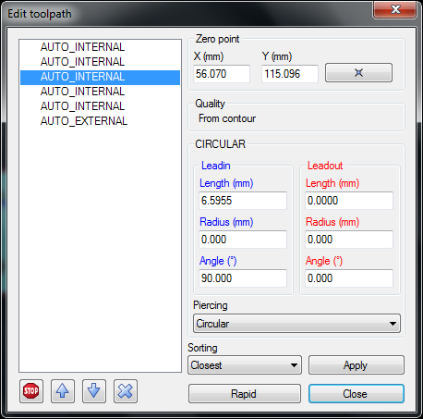

Cutting order
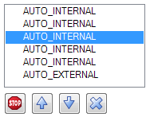
The internal cutting sequence is sorted manually by selecting a contour and moving it up or down in the list using the "arrow" buttons.
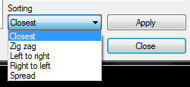
To re-order using a predefined sorting algorithm select the algorithm and press "Apply". Read more about the sorting on the "Contour" command on page 132.

Delete a toolpath

Use the "X" button to delete a toolpath from a contour. This can also be done by using the "Erase Toolpath" command (see page Fel! Bokmärket är inte definierat.).

Make a Stop
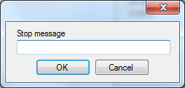
Press the "Stop" button to add a stop in the CNC-file. The stop will take place before the geometry should be cut. If the CNC-controller supports messages the message will be displayed for the operator.
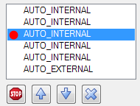
A red circle in front of the text indicates that a stop has been assigned to the node. To remove the stop, press the "Stop" button again. The stop will be done only during the cutting (not on pre-piercing or drilling).

Zero point
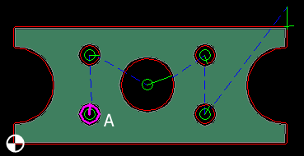
As default the zero point of each part is located in the lower left corner. There is no reason to move this point, unless there are special applications that will not use this point. The selected geometry (A) is always highlighted on the drawing.

Lead and piercings
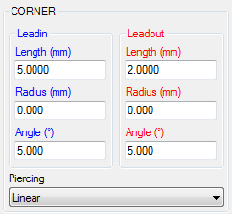
Change the lead and piercings the same way as in the "Contour" command. See pages Fel! Bokmärket är inte definierat. and 136 for more information.

Add extra rapids between contours
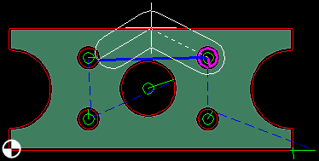
When it is necessary to add extra rapids between nodes in the part to avoid collisions, for example then click on the node to move and press the "Rapid" button. Add as many rapids as needed and press the spacebar to interrupt. To delete an extra rapid press the "rapid" again without giving any points.
What does the thick area around the rapid points mean?
This is the outside tool diameter. The value can be set in the machine setup (see page 313).

Delete toolpath
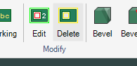
To easily delete an existing toolpath, start the command and select the leads to delete and press Enter.
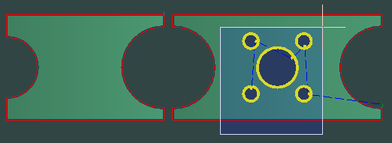
This will erase the toolpath on these five holes.

Micro joints MÅSTE KOMPLETERAS MULTI FUNKAR EJ
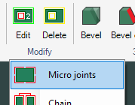
Use this command to add extra leads on the same geometry. The lead's design can prevent small parts from falling down into the water tank of the machine. It can also be used to fix the part in the sheet, so the parts are not moved because of stresses in the material.
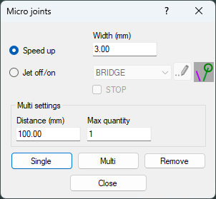
The command has two main options:

Speed up
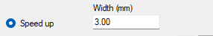
In this case the speed will speed up fastest possible. This speed is defined in the Machine setting. The speed will be that fast that it's not possible to cut through the material. That will be the micro joints.
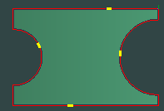
You will see the micro joints as yellow short lines on the toolpath.

Jet On/Off
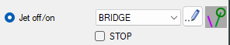
Select the lead you want to use in the drop-down menu or click the "Edit" button to make new lead definitions. You can read more about the different piercing types and leads on "Lead definitions"
If you want to have a stop between jet off and jet on. Then you can activate the stop toggle. Note if you use the Multi option then a stop will be inserted at all micro joints.
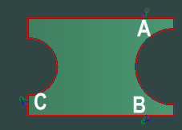
The standard lead is inserted at (A). The other three are micro joints with the same settings as (A).

Single
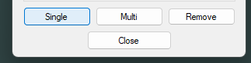
By using this option, you can click on positions where you want the micro joint to be inserted.

Multi
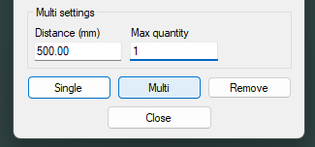
This option can automatically insert micro joints. In this case every 500 mm. To not get too many it is also possible to set a max number of joints.

Remove
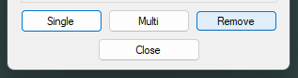
You this option to remove micro joints.

Chain BYT UT DIALOGBOXEN TILL EN LÄNGRE
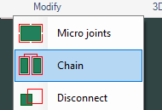
This command can only be used on parts that already have a toolpath. The command joins the different toolpaths together by replacing rapid movements to cutting. The "Chain cut" command creates a toolpath with only one piercing for all selected parts. "Chain" is often use in materials which are difficult to pierce.
- Open the file "ChainCut.dig" in the Samples directory.
Create parts and use the "Contour" command and place the lead on good positions.
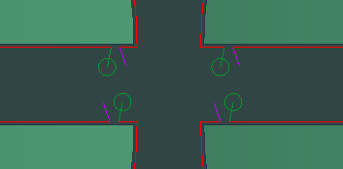
Good contour for this can look as above.
- Start the command and select the cutting quality. The quality can be Rough or X-rough since the quality is just between the parts.
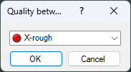
IGEMS will automatically use the "Fence" option on selected parts. The parts are selected in the same order the fence line crosses the parts.
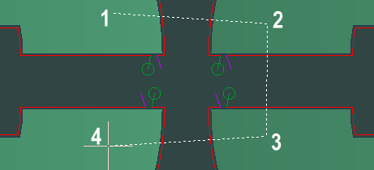
It is also possible to modify the way the jet will take between the parts.
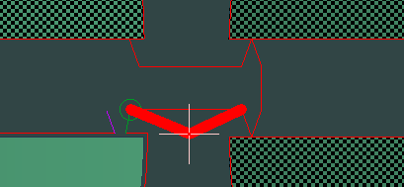

Disconnect
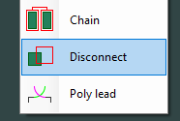
A toolpath connected to the part is the standard way of working, and it is the simplest to handle. The toolpath is attached and will move with the part. In some specific cases, it is necessary to disconnect the toolpath from the part. This command will separate the part and toolpath into individual units.

Poly lead SKALL VI TA BORT DETTA KOMMANDO
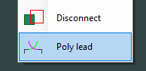
This is a very special command. It will ask for a lead and then an object to add that object to.
This command will probably be removed

Bevel
The Bevel cutting is a simplified 5-axis cutting. It can only be used on flat material.
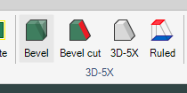
It does not have that many options as the full 3D-5X command.
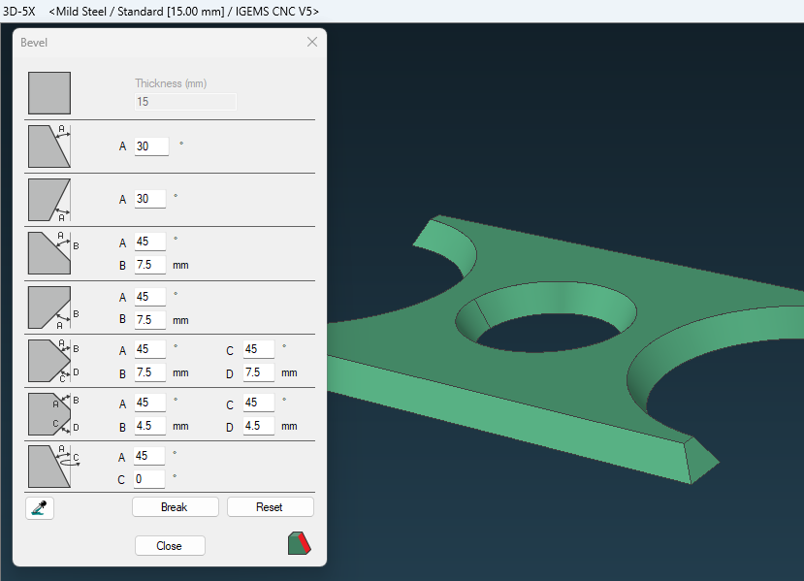

Bevel design
- Open the file "Bevel-1.dig" in the Samples directory.
Start the command and select the part
This command can also be started by a double click. This can be activated in the "Shotkeys" command.
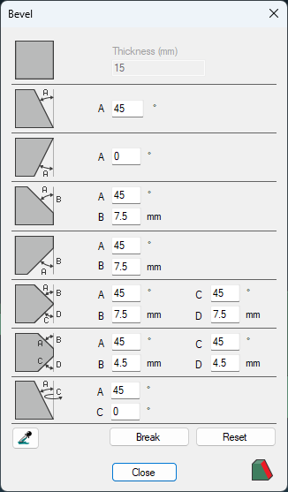
The bevel command works as follow: Click on one of the 8 icons on the left side then click on the edge where the bevel should be applied.
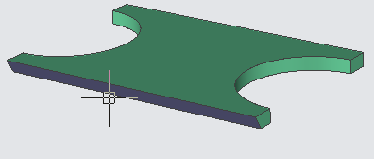
If you click on the top or bottom surface, then all edges around the part will have the selected bevel.
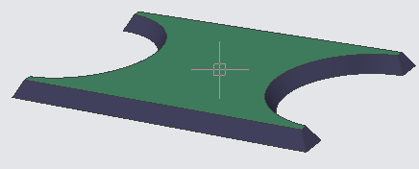

Straight edge

Use this option if you have an edge with a bevel and you want it to be straight. In the most cases this is used when you of mistake added a bevel to an edge.

Top bevel
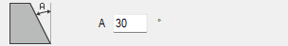
Set the wanted angle and click on the icon. Select edges that should have Top bevel.

Bottom bevel
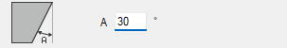
Set the wanted angle and click on the icon. Select edges that should have Bottom bevel.

Top chamfer
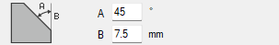
Set the wanted chamfer angle and the length of the straight distance. Select the edges that should have Top chamfer. This type requires two time cutting.

Bottom chamfer
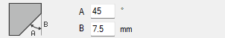
Set the wanted chamfer angle and the length of the straight distance. Select the edges that should have Bottom chamfer. This type requires two-time cutting.

X Bevel
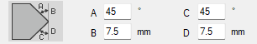
Set the wanted bevel angles and the distance from top or bottom. Select the edges that should have the X-bevel.

K-Bevel
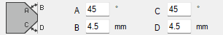
Set the wanted bevel angles and the distance from top or bottom. Select the edges that should have the K-bevel.

Directional bevel
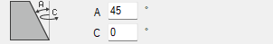
Set the wanted bevel angle and in which direction the jet should point at. If you click at the top surface, the whole part will be cut in that angle. The jet angle and direction will be the same for the whole part.

Check bevel setting
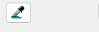
Use this button to check the settings for an actual edge.
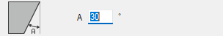
The first setting in actual bevel type is marked as an indication.

Break
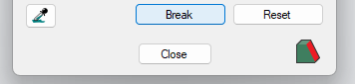
With this feature it's possible to break up a side in two parts. Click on the break command and select where the breakpoint should be.
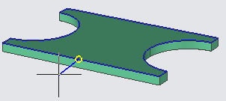
This is needed to be able to change the bevel type at optional position.
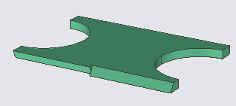

Reset
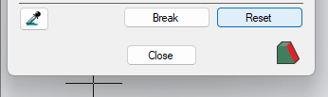
The reset option will make all edges straight.

Close
This button will close the Bevel design and show the part in 2D
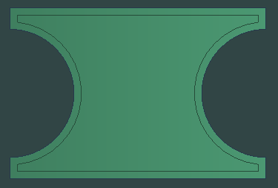

Bevel cut
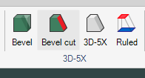
This command should be used to add toolpaths on bevel parts.
Click on the command and select the part.
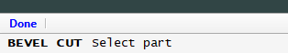
It is also possible to click on the lower right button in the Bevel design.
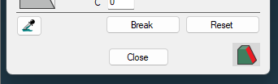
Following dialog will be shown.
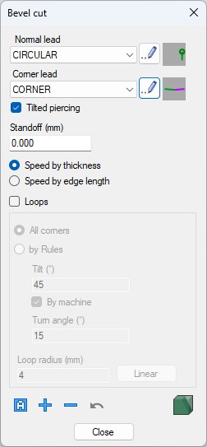

Leads
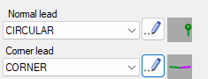
You can read more about leads and piercing at "Lead definitions"

Tilted piercing
Sometimes it's necessary to make the piercing in a tilted angle.
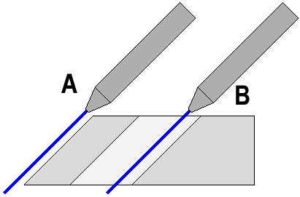
In case (A) when you start from outside it is possible to use a straight piercing, but it will require a very long lead-in. In case (B) it is not possible at allbecause that will damage the part. The piercing angle will be the same as the first contact point on the geometry.

Standoff
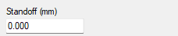
The normal distance (A) between the material and the tip of the nozzle should be 3mm. This is the read area at the picture below. The pint on the surface is also called pivot point or TCP point (Tool Center Point). When the nozzle will tilt in different directions it will be around this point.
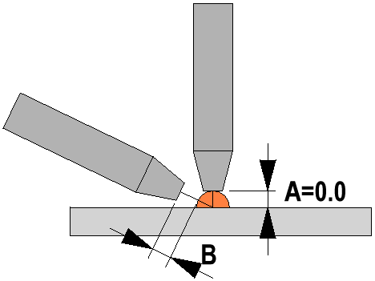
If you need an extra distance (B) between the nozzle and the material, then you should enter the extra distance as Standoff.

Speed
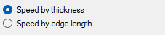
In chamfer, X and K-bevel there are two ways of calculating the speed
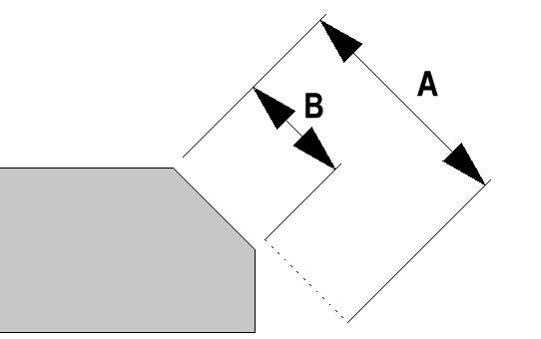
Speed by thickness is probably no good name. The speed will be based by the length the jet has to cut in actual thickness and angle (A) all the way through the material. Speed by edge length is an option that is useful in Chamfer, X and K-bevel. In that case the speed is based by the length of the edge (B).

Loops VI BEHÖVER GÅ IGENOM LOOPS KOMMANDOT
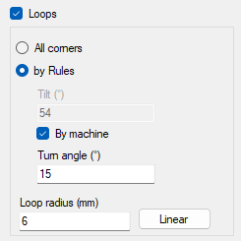

Add the toolpath
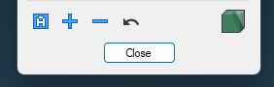

Auto BORDE GÖRA MER AUTOMATISKT

This command requires less input than the add command.
Select curve
Specify start point
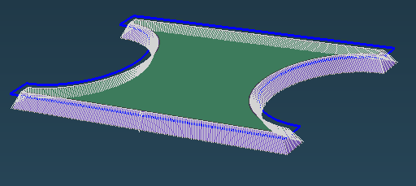

Add

With this command you can add a toolpath and control the options more in detail.
Select curve (click on the curve)
Specify start point (click on wanted position)
Specify end point (press space to go all the way around)
Specify direction (click on one side)

Delete

Use this if you want to delete a toolpath
Delete (Pick on toolpath)

Undo

Use this command if you want to delete the latest added toolpath.

Design
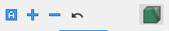
Use this if you want to modify the design.

3D-5X
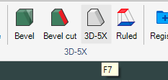
The module 5X-CAM are handled in a 3D environment that we call 3D-5X.
- Click on the icon to start the 3D-5X environment.
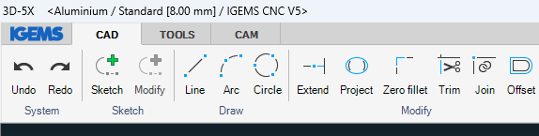
The menu is divided in three tabs CAD, TOOLS and CAM

General interface
The system menu is similar to the system menu in the 2D-environments.
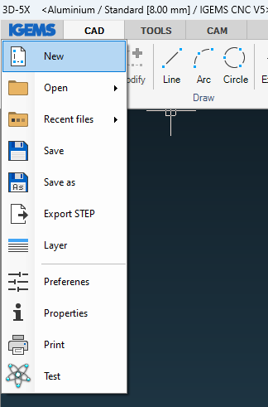

New
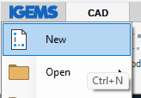
3D-5X is a single drawing system, this means that you can only handle one drawing at a time. You will have following question if the drawing is not empty.
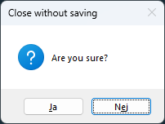

Open
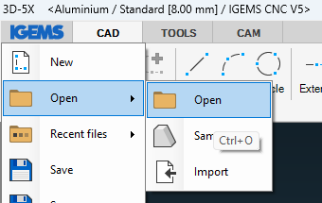
You can open following files in 3D-5X
Type | Description
.STL | Standard Tessellation Language
.STP | Step file (Use the 3D interface)
.STEP | Step file (Use the 3D interface)
.IGES | Initial Graphics Exchange Specification (same as IGS)
.IGS | Initial Graphics Exchange
.OBJ | 3D-viewer file
.DXF | Drawing Exchange Format
.DWG | AutoCAD Drawing files
.DWF | Drawing Web Format
.ASC | Ascii data files
.DAT | Dat files
.3DS | Autodesk 3D studio files
.3D5X | 3D-5X native format.
.MFM | IGEMS kinematic simulation models
.PDF | PDF Files
.BMP | Bit Map Pictures
.JPG | Picture file
.PNG | Picture file
All this files have not

Samples
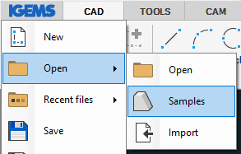
This will open the samples for 3D-5X. Click on the model you want to open.
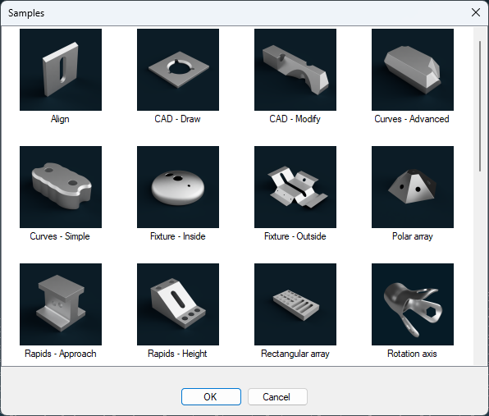

Import
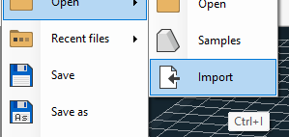
This command will open the file and add it to the existing drawing. 3D-5X is a single drawing system but you can have more than one model open in the same drawing.

Recent file
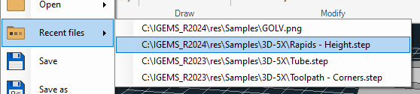
This will show a list of recent used files.

Save
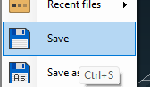
You can save the file in 3D5X format which is IGEMS internal 3D file format. If the file already is saved, it will use actual filename.

Save as
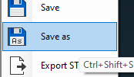
You can save the file in 3D5X format which is IGEMS internal 3D file format. The command will always ask for a filename.

Export STEP
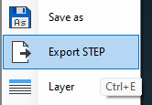
On the command line you will have different options, what should be included in the step file.
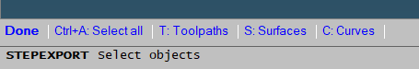

Layer
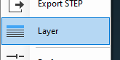
It sometimes happens that the 3D-files has different layers. By this command you can turn on and off layers you don't want to se. The layer command in 3D-5X is more simplified compare with the 2D-environment.
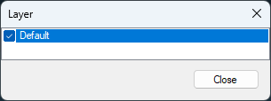

Preferences
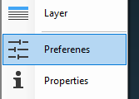
The command will show the following dialog.
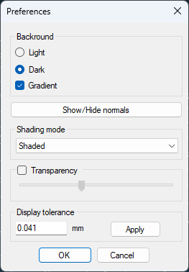

Background
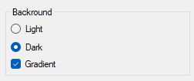
There are two predefined screen background colors, you can also add a gradient that gives a lighter screen at the bottom of the screen.

Show/Hide normals

A normal is a line that points perpendicular out from the surface. On some surface models the normal can points in opposite direction. This can sometimes be a problem when working on very complex models.
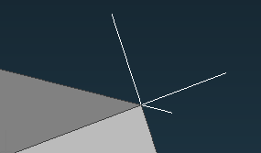
If you click once on the button the normal will, be visible. You need to click one more time to make then invisible.

Shading mode
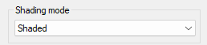
There are four modes: Wireframe, Flat, Shaded or Rendered.
As default the mode is set to Shaded, If you have a heavy model and a slow graphics card you can change to flat or wireframe.

Transparency
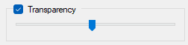
You can use the checkbox to control if the model should be transparency or not. This can also be handled from the display options.

Display tolerance
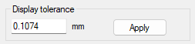
This is the rendering accuracy. If you set a high value, then a round object will be like a polygon.
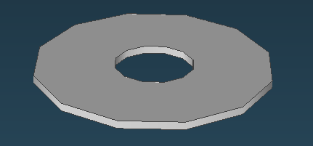
The only reason to adjust this value is if you have an extremely heavy model, then it will not require that many calculations on the graphics card.
Note! The display tolerance will not affect the tolerance or the coordinates in the CNC file.
You can also change the display tolerance at the display options.

Properties
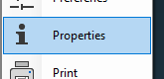
This command shows the box-size of the part and some other information.
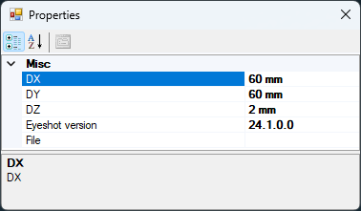

Print
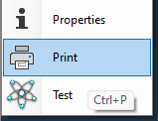
This will make a printout of the screen. There are currently no way to more in detail control what should be printed.

Test
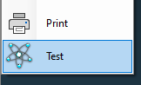
This is an internal command that IGEMS use for testing different things.

Command line
When you are using a command that has different alternatives, then the different options are given in the command line at the bottom of the screen.
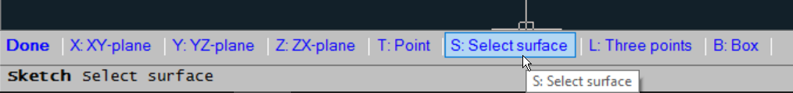
You can click on the different options or type the Shortkey (First letter).

Display options
At lower right corner of the screen, you can click on the "Option" button. This will show you a list of different options that can be used transparently in other commands.
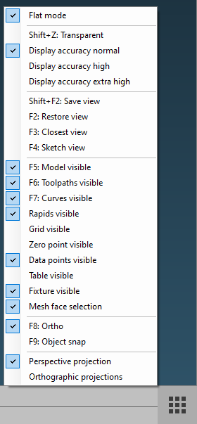

Flat mode
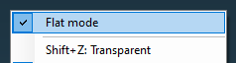
The Flat mode is activated if you have a machine that can't handle Z-coordinates. When the Flat mode is activated then it's not possible to use commands that moves the jet in Z.

Transparent (Shift+Z)
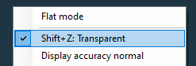
In some cases, it’s easier to show a transparent view of the part. Click on this button if you want to turn the transparency on or off. In some cases, 3D-5X will automatically shift between those modes. You can also hold down the Shift key and press Z to toggle between transparent and non-transparent mode. You can control the level of transparent in the Preferences.

Display accuracy
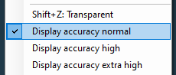
The display accuracy controls the rendering accuracy. You can read more about this here.

Save view (Shift+F2)
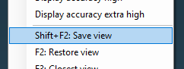
This will save the actual zoom, pan and camera angle in the drawing. If you want to restore the same view just press F2.

Restore view (F2)
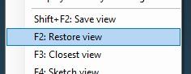
This will restore the view that you have specified by the "Save view" option.

Closest view (F3)
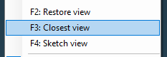
This option will change the camera angle to the closest available side of the cube. It means Top, Front, Right, Back, Left or Bottom.

Sketch view (F4)
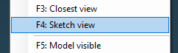
This option is only available if you have a sketch view activated. In that case the camera angle will be set to normal to the sketch plane.

Model visible (F5)
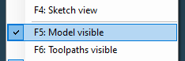
By this option, you can toggle between show model and hide model. It may sometimes be helpful to turn the model off when you inspect a toolpath.

Toolpath visible (F6)
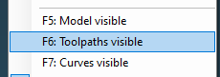
If you have many toolpaths, you can hide or show them by using this option. It can sometimes be helpful to hide them if you want to inspect the model.

Curves visible (F7)
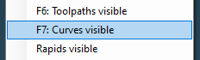
In the same way as you can turn the visibility on and off for models and toolpath you can also do this for curves.

Grid visible
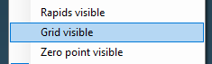
By this option, you can turn the grid on and off. The grid always indicate the machine table or the bottom side of the material. Another option "Table visible" shows a similar grid.

Zero point visible
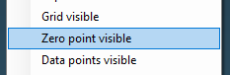
The zero point are as default on the coordinate 0,0,0. You can move the zero point by the "Zero-point" command. By this option, you show or hide the zero-point icon.

Table visible
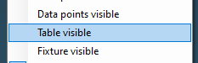
If you activate this option, then the machine table will be visible as a purple rectangle. The size of the rectangle is the size that has been defined in the machine settings.

Fixture visible
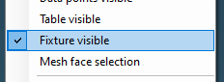
If you have generated a support fixture, then this can be turned On/Off with this setting.

Mesh face selection
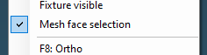
This option is important if you have a mesh model (tessellated file). If this activated, then you can select surfaces. It should normally not be activated since that will slow down the system.

Ortho (F8)
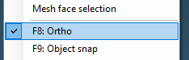
This option is useful when using the inbuilt CAD command. When it’s activated only 8 different angles can be picked. 0, 45, 90, 135, 180, 225, 270 and 315. It has similar functionality as the ortho in 2D.

Object snap (F9)
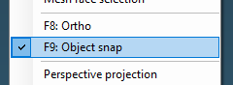
If you click on this option, then following dialog is shown.
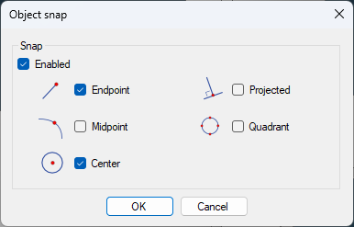
You can activate the different object snaps that should be used when using running object snap. The checkbox Enabled will activate running object snap. The shortcut F9 will not show this dialog, it will toggle the running object snap on or off as it does in 2D.

Perspective projection
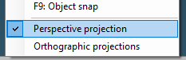
This will activate the view in perspective projection and at the same time deactivate the orthographic projection.

Orthographic projection.
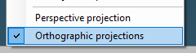
This will activate the view in orthographic projection.
And at the same time deactivate the perspective projection.

Zoom
You need a wheel mouse to handle the screen correctly. By rotate the mouse wheel you can zoom in and out on the model. If you double-click on the mouse wheel, then the model will be zoomed to its extensions.

Pan
By holding down the mouse wheel and at the same time move the mouse then you can pan the model on the screen.

View
By holding down the right mouse button and move the mouse at the same time you can view the model in different camera positions.

Cube
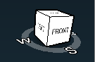
The cube at the upper right corner of the screen is very helpful, you can click on different corners of the cube and the screen will follow the cube rotation.

Undo
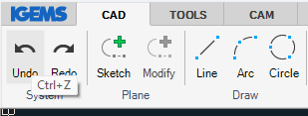
When working with IGEMS press the "Undo" button to correct mistakes and remove changes made with the last command. Up to 20 commands can be undone. Use backspace as a keyboard shortcut instead of CTRL-Z.

Redo
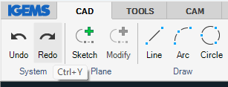
Use "Redo" if too many steps were "undone". Redo can only be used directly after the Undo has been used.

Sketch plane
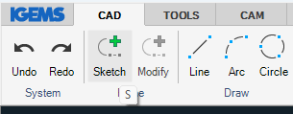
Use this command to define a 2D-Sketch plane.
Ther is eight different ways of defining the plan

XY, YZ and ZX-planes
This is the three predefined planes which is parallel to the 3D-5X world coordinates
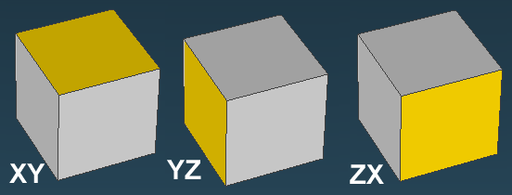
Click on one of these options to activate.
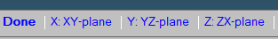

Select surface
This is the default option.
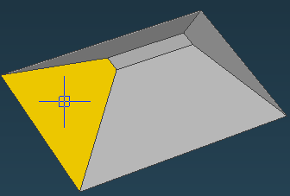
Click on a surface, the sketch plane will be parallel to the surface.

Select curve
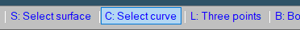
Select this option if you want the sketch plane to be parallel to object.
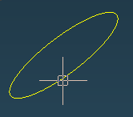

Three points
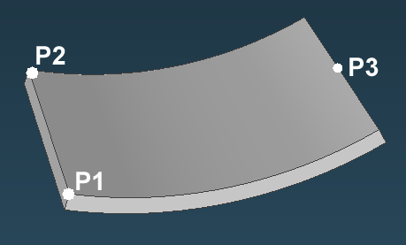
Click on three points on the model. The command will create a plan which passes through these points.

Box
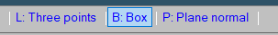
The option will create a box around the model.
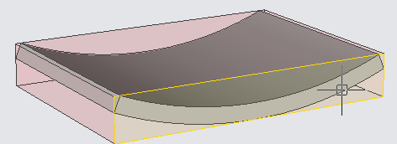
Click on the side of the box, which you want to be parallel with the sketch plane.

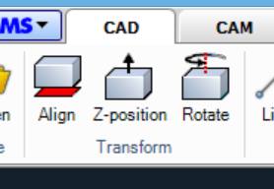

All commands in the Transform area will move the model in the XYZ coordinate system. Note that also the command "Move" can move the model in the coordinate system. The "Move" command will be described later in this documentation.

Align
The first thing you should do after you have open the model is to align the model correctly to the XY plane. The XY plan is the displayed as the grid. Press the Align command.
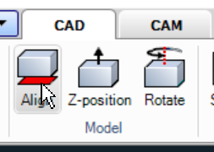
Picture 1
If the grid is not activated it will be turned on temporally during this command. On the bottom line, you can see different options for the align command.

Surface
This option is default and it's good to use if the model is not placed orthogonal in the space.
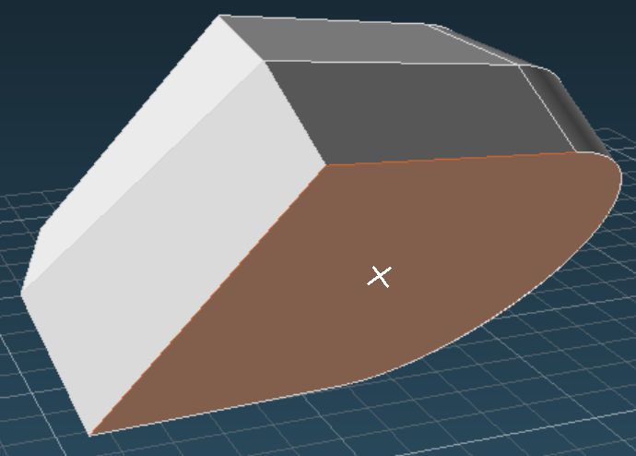
Picture 2
When you move the mouse over the model, you can see that different surface are highlighted. Click on that surface you want should be laying down on the table.

Three points
This option can be used when the other methods does not work. When model is not placed orthogonal in the space and there is no flat surface to click on.
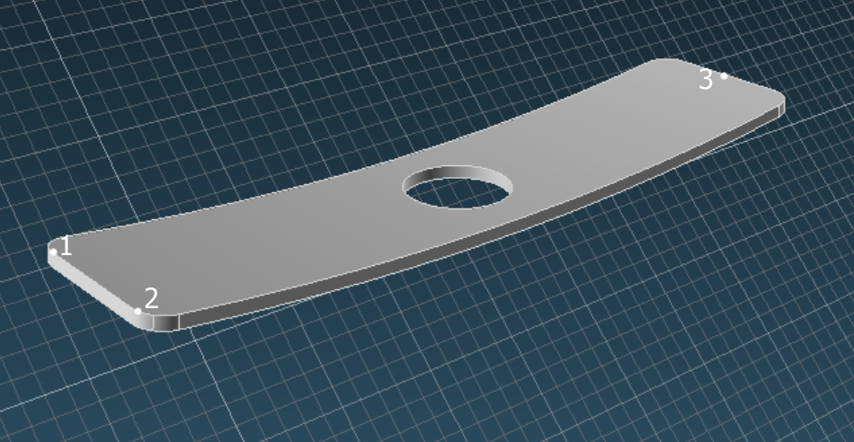
Picture 3
Click on three points. The points describe a theoretical surface that will be laying down on the table. This method can sometimes place the model with upside down. In that case use the box method to rotate the part.

Box
This option will create a 3D-bounding box around the model.
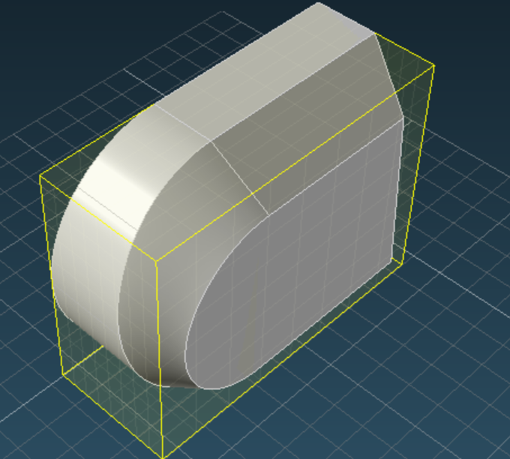
Picture 4
Click on the side that should be laying down on the machine table.

Z-Position
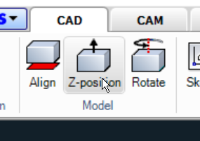
Picture 5
If you have used the Align command, then the lowest position of the part should be located correctly on the grid. If you need to modify the Z level of the part, then you can use the Z-position command.
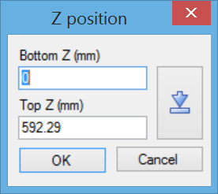
Picture 6
The Bottom Z and Top Z values describes the actual position of the part. If you for example change the Top value to 0 that will automatically change the bottom value to -529.29. If you change any value, then press the OK button to activate.

The button on the right side is a shortcut that moves the part bottom to zero. We recommend that the lowest point on the part should be located on the grid.
Note!
It’s important that the lowest Z position on the model are on the grid. There are other methods to set the Z zero on the table or at top of the model.

Rotate
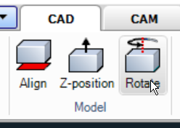
Picture 7
The actual rotation of the model in the XY plan is not that important since you later can rotate the part on the cutting plan. If you however want to rotate the model you can do this by using the rotate command.
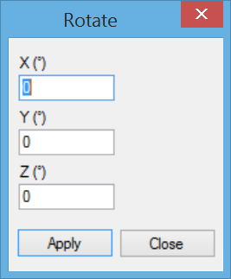
Picture 8
The model can be rotated around the X, Y or Z axis. You can’t exactly control the rotation position, of this reason you may have to use the Z-Position command afterwards.

Curves
The curves will define the top or bottom geometry of the cutting edges. There are two methods to define the curves. From Surfaces or from Edges.
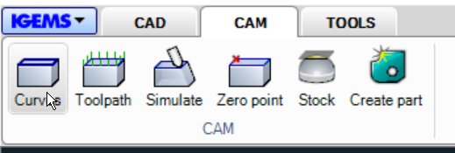
Picture 9
Following dialog will be shown.
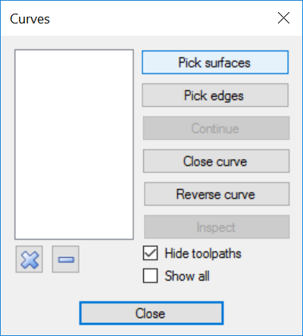
Picture 10

Pick Surfaces
This option is the fastest way of generating curves. By clicking on a surface, the command will generate curves at all border edges of the surface.
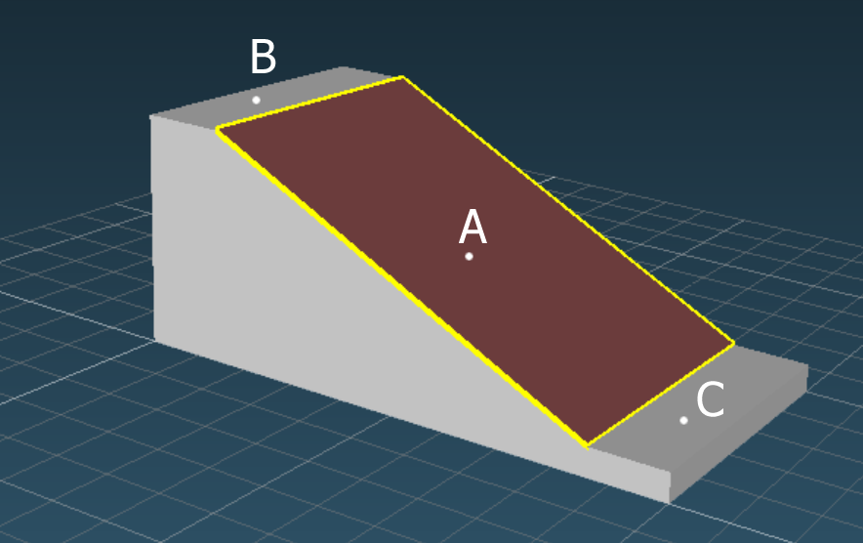
Picture 11
When you click on the surface A then the yellow curves are generated. If you also click on surface B and C then the curves goes around all three surfaces.
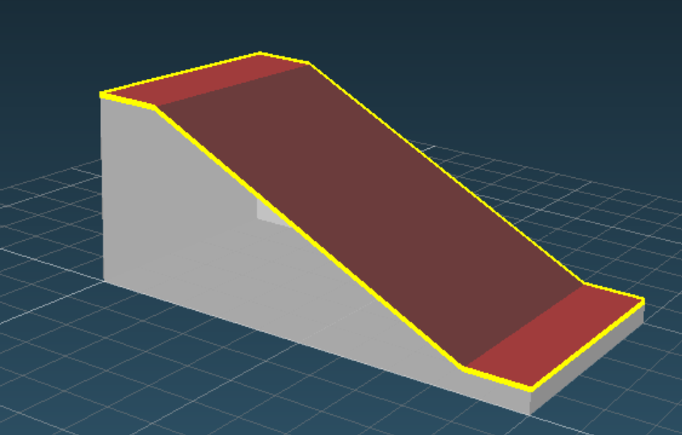
Picture 12
If you click on a surface of mistake, then you can just click on the same surface again to deselect.
When you are finish then press Space or Enter to come back to the Curves dialog.

Pick Edges
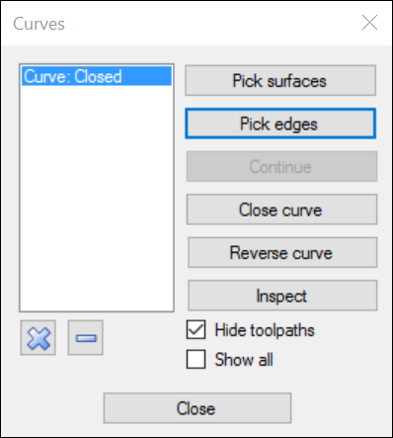
Picture 13
If you need to generate curves on a more complicated part, then you sometimes need to create them from the edges on the model.
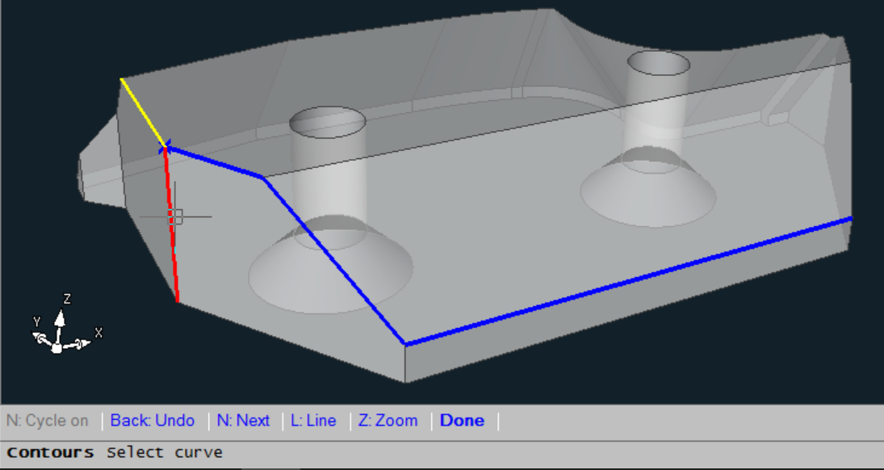
Picture 14
Click on the "Pick edges" button and select an edge on the model.
- The blue edges are the selected edges.
- The red edge is the one that are closest to the mouse cursor and the edge that will be added if you click with the mouse.
- The yellow edge is the suggested edge and that will be selected if you press the "Next (N)" option on the command line. In many case, you can select a whole curve by pressing the "N" button.
- By pressing Backspace, you can undo the last selection.
- By pressing "Z" you will automatically zoom up. This will make it more easy to select a short edge. If you press "Z" again then it will zoom back again.
- By using the option "Line" you can create a line from last point to a new point, this line will automatically be converted to a curve.
- Click "Done" or press Space or Enter to come back to the curves dialog.

Continue
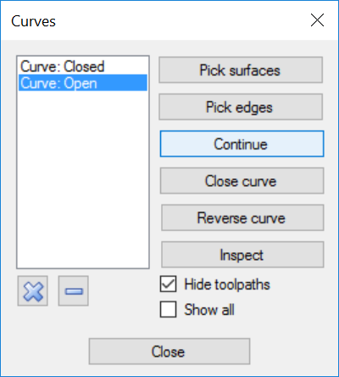
Picture 15
If you have an open curve, then you can continue to add more edges on the curve.

Close curve
If you have an open curve, you can use this button to close the curve. It will be a straight line from the start to the end of the curve.

Reverse curve
When using the "Auto" option in the Toolpath command then the direction of the cutting will be the same as the direction of the curve. By clicking on this button you can reverse the direction of the curve.

Inspect
With this option, you can inspect the curve.
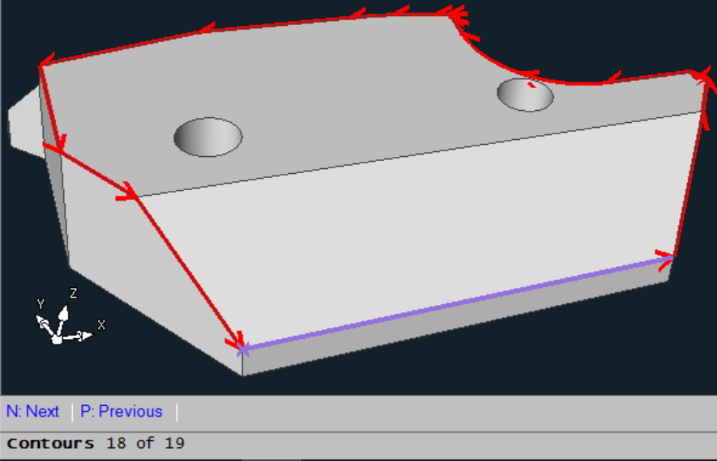
Picture 16
By the shortcut "N" or "P" you can inspect the different segments in the curve.

Delete curves
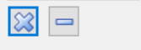
Picture 17
By using the "X" button you can delete all curves. If you are using the " – " button you can delete the selected curve in the dialog.

Other settings
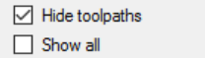
Picture 18
If you have a complicated model with a lot of information, then it can be more easy to work with the curves if you check the "Hide toolpath". Normally is only the selected curve visible. If you check the "Show all" then you can see all curves at the same time.

Toolpaths
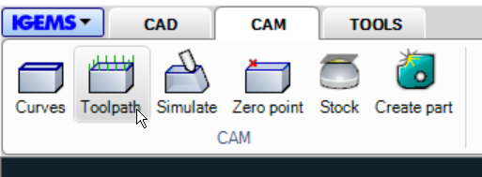
Picture 19
When you press the toolpath command, following dialog will be shown.
To make the option in this command easier to understand, the documentation will explain them in another order than you can find them in the dialog.
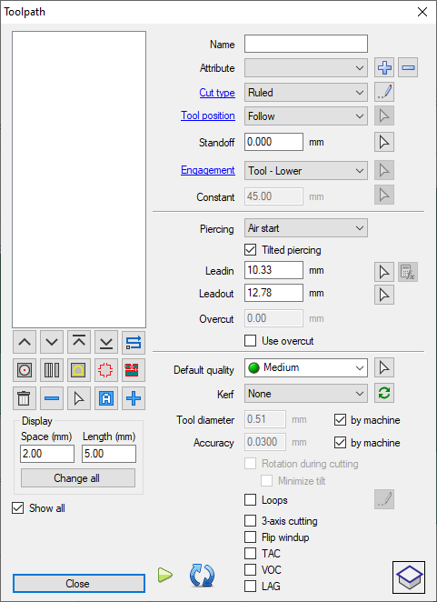
Picture 20

Ref pos
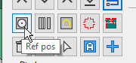
Picture 21
The ref pos command can be used to set a probe point for 5-axis sensoring. Before you can use the command, you must have a toolpath.
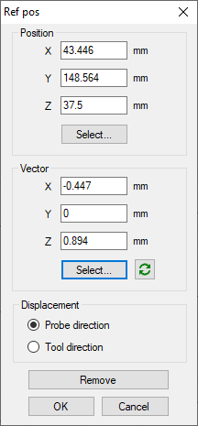
Picture 22
Start to select a position for the probe. It's important to use snap command to set the probe point to a good position.
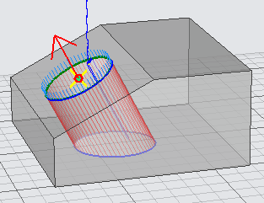
Picture 23
To set the vector direction, point on a surface. The vector direction will be perpendicular to that surface.
Displacement
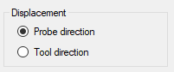
Picture 24
The Probe direction will move the toolpath parallel with the vector direction.
The Tool direction will move the jet with that distance specified by the CNC.
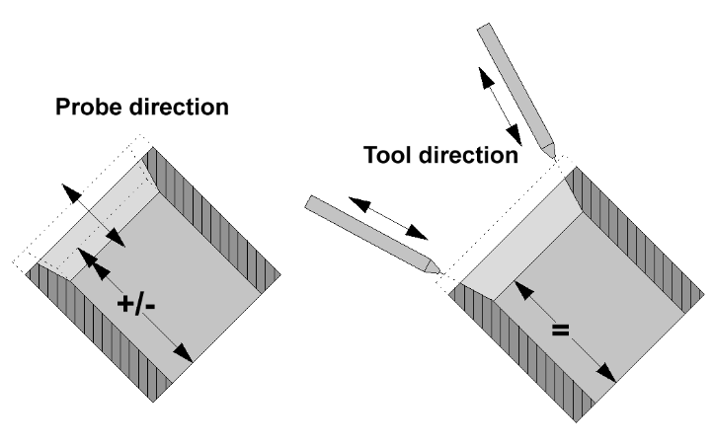

Auto
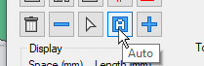
Picture 25
To using this command, you need one curve to generate a straight cut or two curves to generate a toolpath with different cutting angles.

This option will set all the settings automatically, in the most cases this is correct.

Add a toolpath
Before you can add a toolpath, you must add curves (se chapter 12.21). If the profile is identical on top and bottom of the model, then it’s enough with one curve. A closed toolpath goes all the way around the model. An open toolpath only cut a portion of the model.
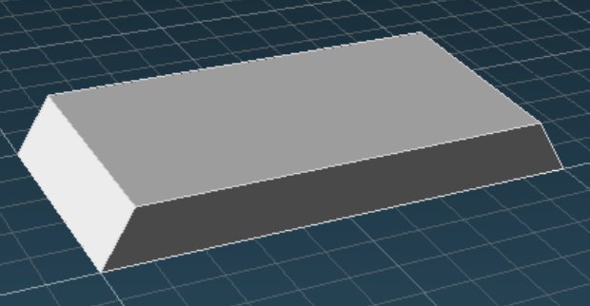
Picture 26
Press the plus button
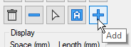
Picture 27
At the lower left corner, you have information what to do
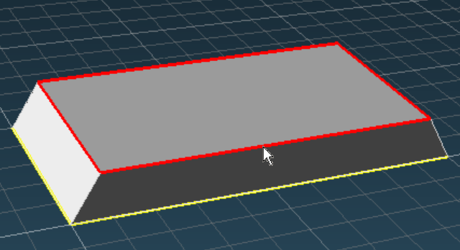
Picture 28
Select upper curve (Pick on the red curve).
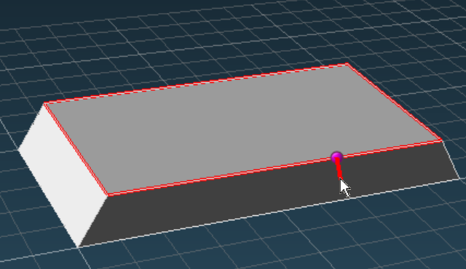
Picture 29
Select start point (Pick where to start on the curve)
Select end point <Close> (Press Enter or Space)
In this case we want to cut all the way around the part to make a closed toolpath. Enter or Space accept the <Closed> option.
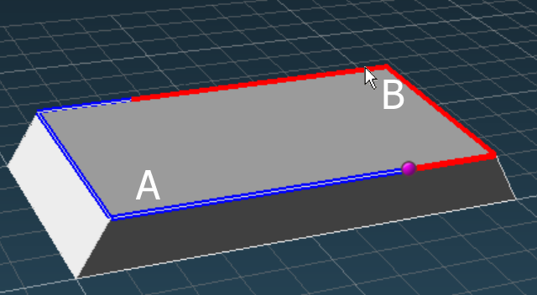
Picture 30
Select direction (click on A for CW or B for CCW direction)
The cutting direction will be at the red portion of the curve.
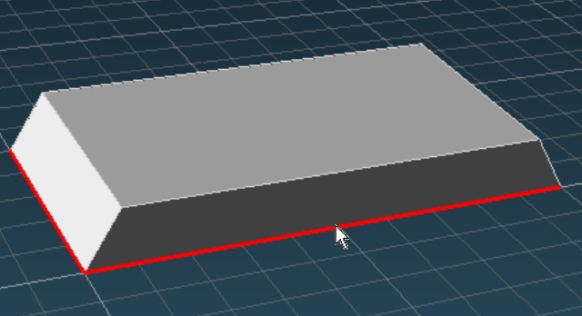
Picture 31
Select lower curve <None> (pick on lower curve)
If you press Space or Enter then the whole toolpath will be with the same angle. When you select the lower curve the toolpath will use different cutting angles to be able to cut the part in a correct way.

Leadin and leadout
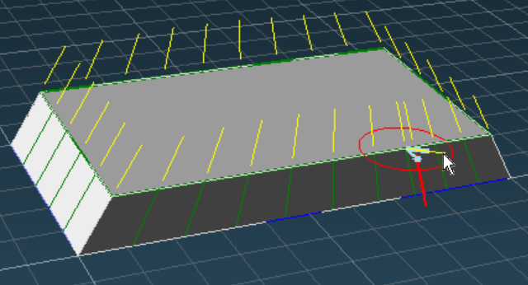
Picture 32
Piercing position <4.0> (Press P or CTRL+Click Surface to change lead plane) 5.1276
If you press Space or Enter the lead length that are inside the <> will be used. If you click on a position the length that are at the end of the information is used.
The angle for the lead is taken from the actual position of the marker when you enter the value.

Lead plane
When you enter the piercing position then 3D-5x analyze the model and will automatically try to use correct lead plan. The red circle is oriented in suggested lead plan. If you don’t agree then you can press "P" to change lead plan. Another way of doing this is to hold down the CTRL key and pick on a surface. The lead plan will then adapt the plan from the selected surface.
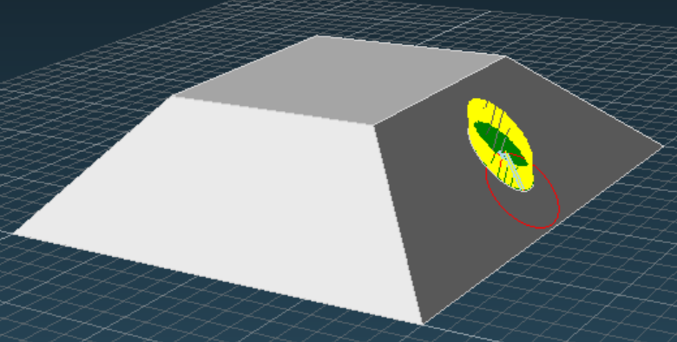
Picture 33
On the picture above you can see a red circle that describe the actual lead plan.

Using a single curve
If you use only one curve (you press Enter or Space on Picture 31) then the direction on the jet will be the same for the curve (toolpath).

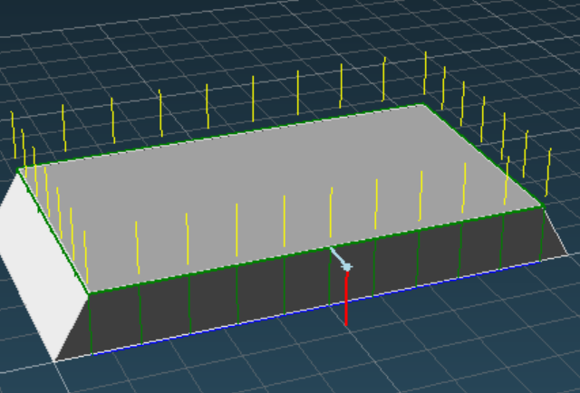
Picture 34

The list of toolpath
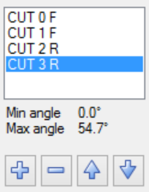
Picture 35
- The toolpath is named in that order it has been created.
- The letter F means a toolpath with a fixed angle (only one curve has been used). R means a ruled toolpath between two curves.
- Under the list of toolpaths, you have information about the minimum and maximum cutting angles that are used on the selected toolpath. If the maximum used angle needs to be larger than the machine can cut, then the name will be displayed in red color. And the cutting vectors on the screen will be red for those vectors.
- You can delete a toolpath by using the minus button.
- You can change the cutting order by using up and down buttons. The name of the toolpath will not be changed.

Visual vectors
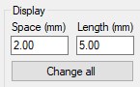
Picture 36
The space controls the distance between the visual vectors. The Length controls the length.
The values does not affect the final CNC-code. On the picture below the space is set to 10 mm.
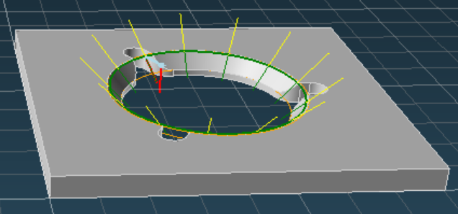
Picture 37
On the example below the visual vector distance is set to 2mm. The distance can be different on each toolpath.
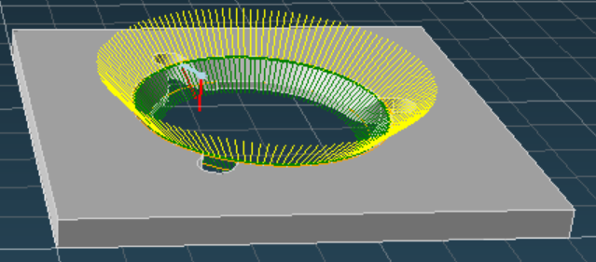
Picture 38

Edit toolpath: Lead settings
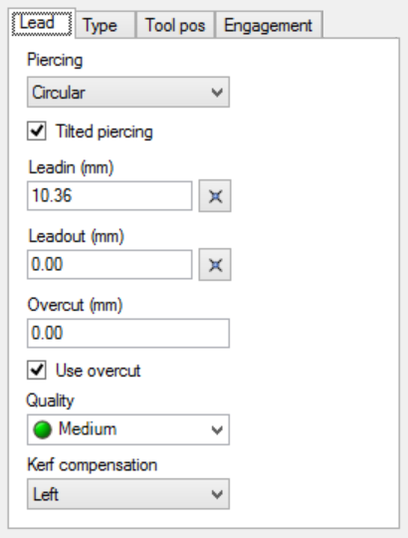
Picture 39
By first select the toolpath you want to edit and then change the values you can modify the toolpath afterwards.

Piercing
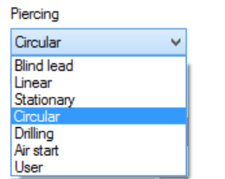
Picture 40
Select the type of piercing you want to use.
- Blind lead: Be sure to use a positive overcut long enough to release the part from the material.
- Linear: Be sure to use a lead long enough to cut true the material. Look at 12.26.1 for calculation of the correct length.
- Stationary: We don’t recommend this method, but it’s still in use on some machines.
- Circular: IGEMS will make an automatic calculation of the needed piercing time. This is in most case the best choice.
- Drilling: Probably not that common, not all machines has a drilling unit, and if they have it cannot be used on tilted piercing.
- Air start: If the start of the leadin is at a position where there are no material.
- User: This is for special developed options that may various between different machines.

Linear piercing distance
If you are using Linear piercing it’s important that the leadin is long enough to be able to cut true the material.
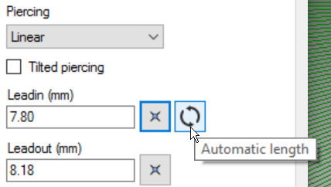
Picture 41
By clicking on the "Automatic length" then the needed length is calculated.

Circular piercing in space
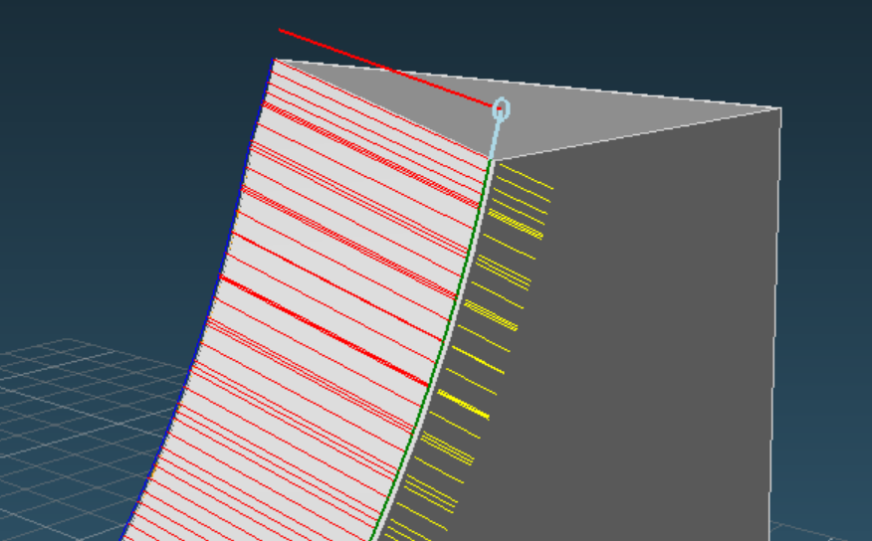
Picture 42
In normal 2D-cutting the circular piercing is always performed in the XY plan. Many machines built-in support for this in the CNC-controller. When cutting complicated parts the lead plan can be optional. The circular piercing will always follow the lead plan. Please look at the documentation for PIERCING in the postprocessor help file to see how this can be implemented in the postprocessor.

Tilted piercing
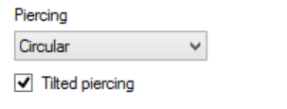
Picture 43
When Tilted piercing is activated then the piercing direction is the same in the beginning and the end of the lead. It will have the same direction as the geometry have where the lead are connected to the geometry.
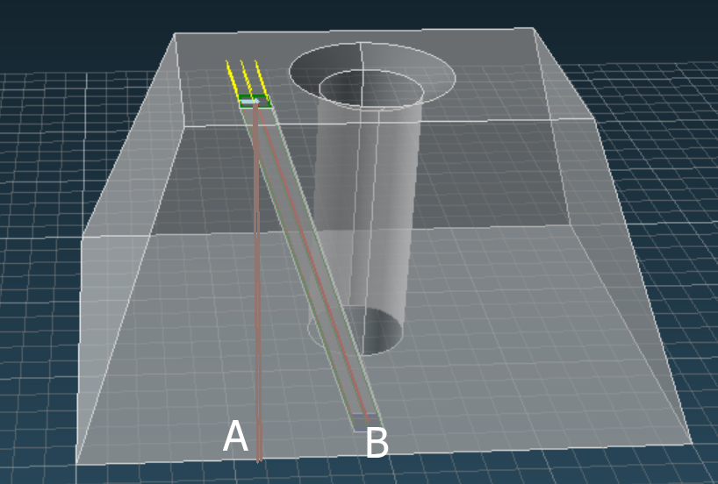
Picture 44
The picture above shows Non Tilted Piercing (A) and Tilted Piercing (B). Option (A) will destroy the part.

Leadin and Leadout
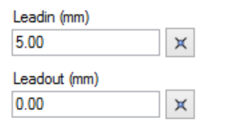
Picture 45
The values shows the actual leadin and leadout distances.
Here is some guidelines:
- If you are using Linear piercing, press the Calculation button if you are not sure what the length should be.
- For circular piercing make the leadin as short as possible, just to avoid damage on the part.
- For a closed toolpath you can normally skip the leadout. It jet makes a lot of damage on the leadout.

Edit lead
By clicking on the button behind the distances you can change the distance, angle and the lead plan by the same mechanism that was used when you entered the lead (see 12.23.1)

Overcut
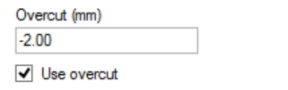
Picture 46
The overcut setting can be negative or positive. A negative value means that the toolpath will leave an area that is not cut. A positive value means that some portions will be cut two times. The checkbox is used to enable or disable the overcut. If not checked there is no overcut.

Quality
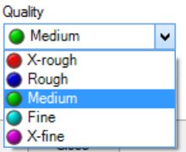
Picture 47
Set the cutting quality you want to have for this toolpath.
Is it possible to paint quality as you can do in 2D?
For the moment this is not possible. The quality will be for the whole toolpath.

Kerf compensation
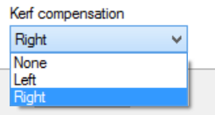
Picture 48
3D-5X always try to analyze if the kerf should be applied on Left or Right side, but it’s a good idea to make an extra check if the kerf is applied correctly.
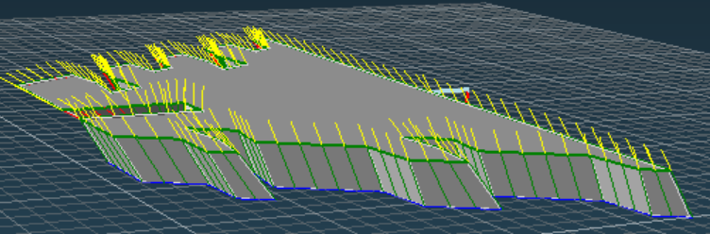
Picture 49
In this case you can see the green jet vectors they are located outside of the model. This is correct.
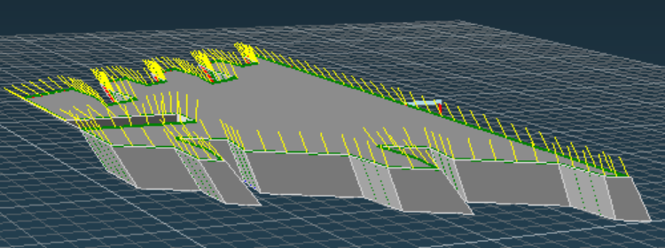
Picture 50
In this case you don’t see the jet vectors, in this case you should change the kerf from Left to Right or opposite.

Edit toolpath: Type
If you used two curves then you can chose between two types of toolpaths Fixed or Ruled.

Fixed type
This is the only possible choice if you have used one curve.
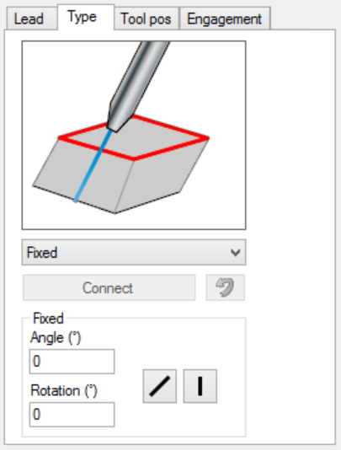
Picture 51
As default the cut will be vertical. If you want that the cut should be in a certain angle then you can press on the Tilt button.
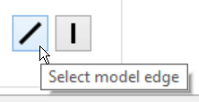
Picture 52

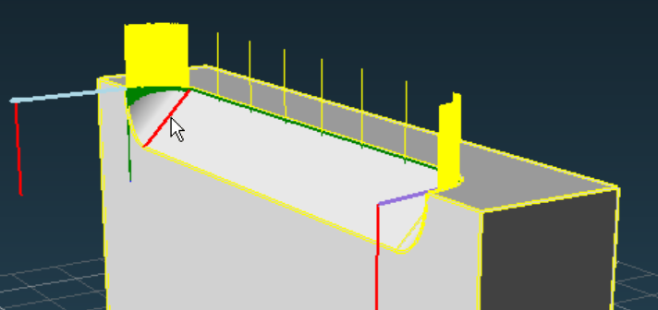
Picture 53
If you press the tilt button and select the ISO line above then the jet direction will be parallel to the ISO line.
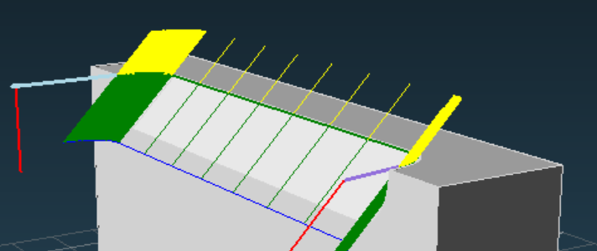
Picture 54
The information about tilt angle and cutting rotation angle are written in the dialog as information.
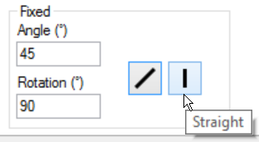
Picture 55
If you press the Straight button, then the jet vectors are changed to vertical.

Ruled type
If you have used two curves to generate the toolpath then you can use fixed or Ruled type of toolpath.
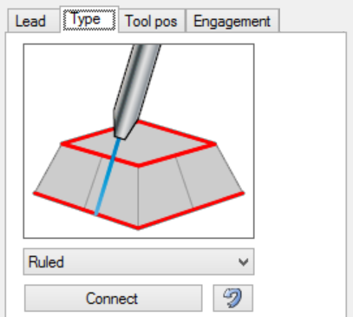
Picture 56
You can click on the picture or select type from the pulldown menu.

Connect
3D-5X will automatically generate connection lines between the Upper and the Lower curves. The jet will have exactly this orientation at those lines. All other vectors are calculated from the upper can lower curves. You normally never need to modify the connection lines, but sometimes when you add curves that not comes from the model you may then have to do that.
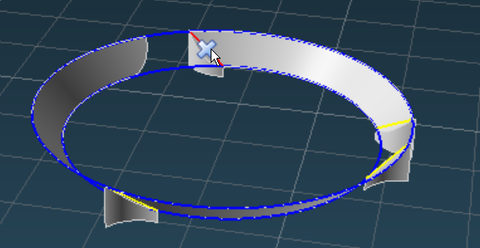
Picture 57
The picture above shows connection lines that ate generated from two circles. The yellow lines are in wrong position, they have to be deleted and replaced by connection lines in better positions.

Delete
If you want to delete all connection then you can press DEL
If you point on the cross that are on the midpoint of the connection then it will be deleted.

Add connections
If you want 3D-5X to replace the connections automatically, then you can press "T". The most flexible way is to click on the upper and lower curves and place the connection lines manually.
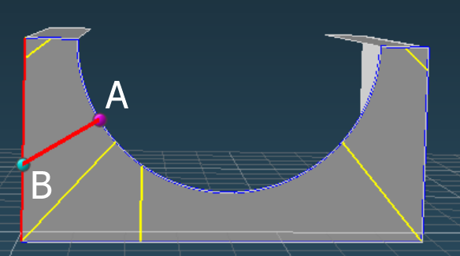
Picture 58
You can click a point on one curve and then on the other curve (A) then (B) in optional order.
<Closest point>
The default option <closest point> will make a calculation and put the second point to the closest position on the curve.

Reverse lower curve
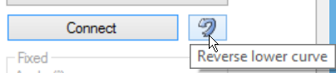
Picture 59
The calculations try to connect upper and lower curves in a correct way. Sometimes (cannot find an example on this), the lower curve can be reversed with at very strange result. When this happen you can try to press this button.

Edit toolpath: Tool position
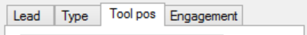
Picture 60
The tool position should be the point where the jet meets the material. The two major settings for the tool position is Fixed Z or Variable Z.
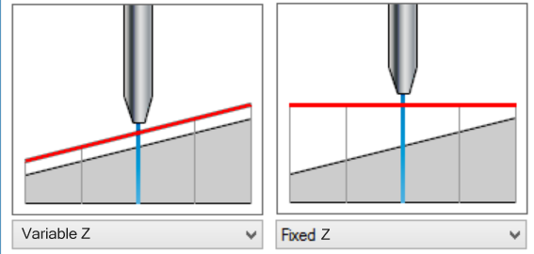
Picture 61

Variable Z
This option should be use if you want that the tool should be following the upper curve. Two different values can be used to modify the position of the jet. It’s the Offset and the Standoff values. Both of this values are moving the jet in the opposite direction of the jet.
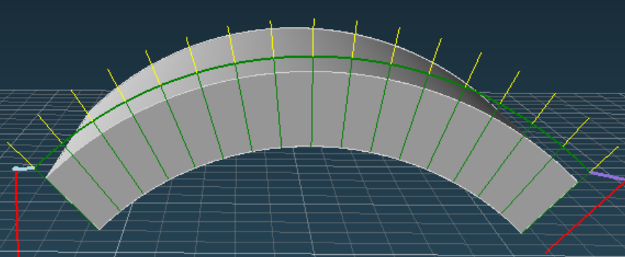
Picture 62

The Offset value
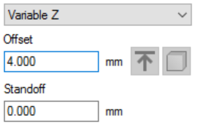
When you change the offset value then the tool position is moved in the opposite direction of the jet. In the example below the offset has been changed to 4 mm.
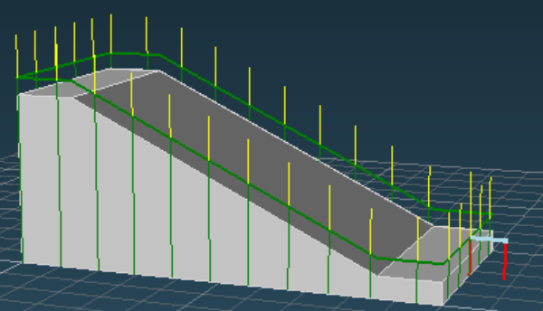
Picture 63
The speed will be calculated from the cutting depth of the model plus the offset value, the green vertical lines.

The Standoff value
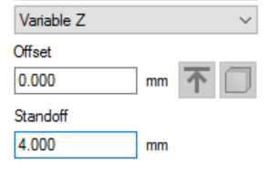
Picture 64
When you change the Standoff value then the jet will also be moved in the opposite direction of the jet. The difference between Offset and Standoff is that the Standoff will not affect the cutting speed. In the picture below the Standoff value is set to 4 mm. The yellow lines that represent the nozzle position.
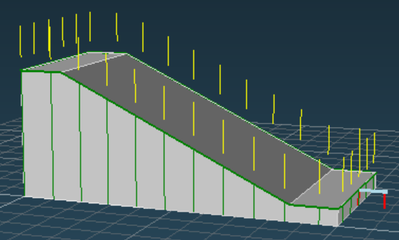
Picture 65
You can use Offset and Standoff at the same time. Offset is the only value that affect the cutting speed.

Fixed Z
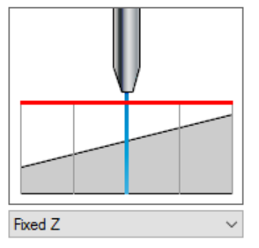
This option should be use if you want that the tool should remain on the same Z during the whole cut. Two values can be used to control the Z it’s the Height and the Offset.

Height
The height value control the jet position and it will affect the cutting speed.
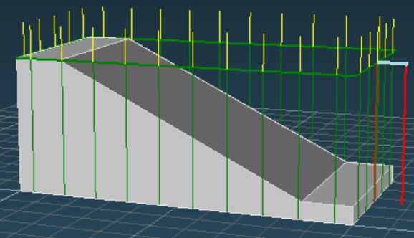
Picture 66
You can set the height by three different input options.
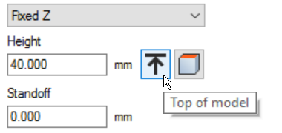
Picture 67
You can write the height manually, and you have two different buttons to select top of the model or a plane on the model.
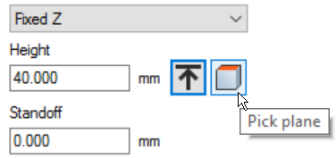
Picture 68

Standoff
The standoff value make an additional correction to the cutting height and will not affect the cutting speed.
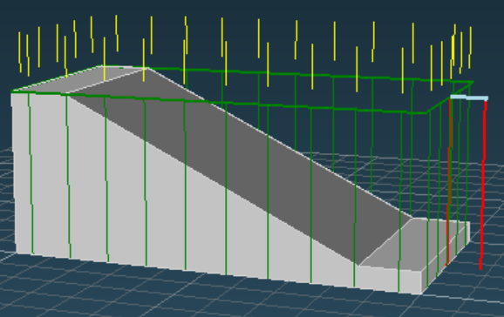
Picture 69
The yellow lines that represent the nozzle position. The green vertical lines represent the cutting depth.
Picture 70

Engagement
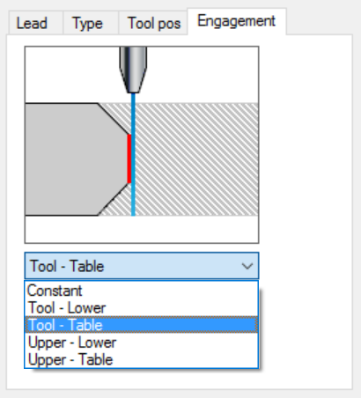
Picture 71
The jet stream will cut everything in its way from the nozzle to the cutting table. Depending of the design of the model you need to base the cutting speed on different cutting depths. Several of this settings can give the same results. It depends of the position of the Tool, Upper and lower curve positions.

Constant
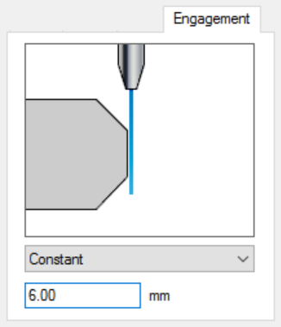
Picture 72
This option can be used if you add a toolpath on a surface with zero thickness or in other case when you exactly want to enter a constant thickness (cutting depth) for the toolpath.
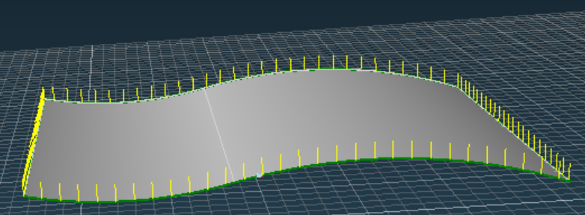
Picture 73

Tool to Lower
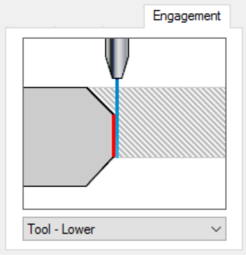
Picture 74
Use this option if the speed should be calculated from the (T) tool position to the (L) lower curve.
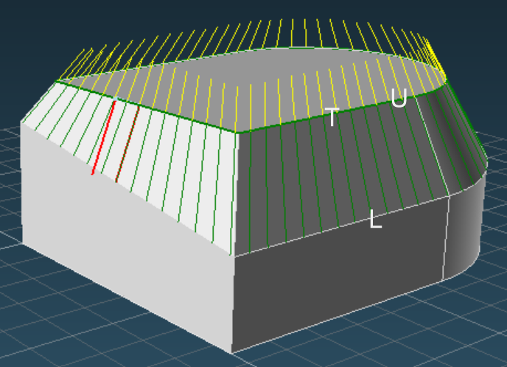
Picture 75
This can for example be used on the model above when the stock profile already are correct and you just want to cut the chamfered part of the model. In this situation it’s the same as (U) Upper to (L) Lower if the Offset is set to zero.

Tool to Table
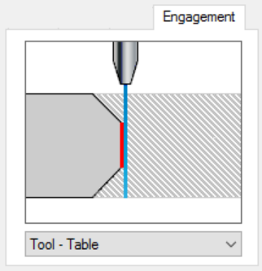
Picture 76
This is probably the most common option. Use this when the speed should be calculated on the whole distance from the (T) Tool position to the (TA) Table.
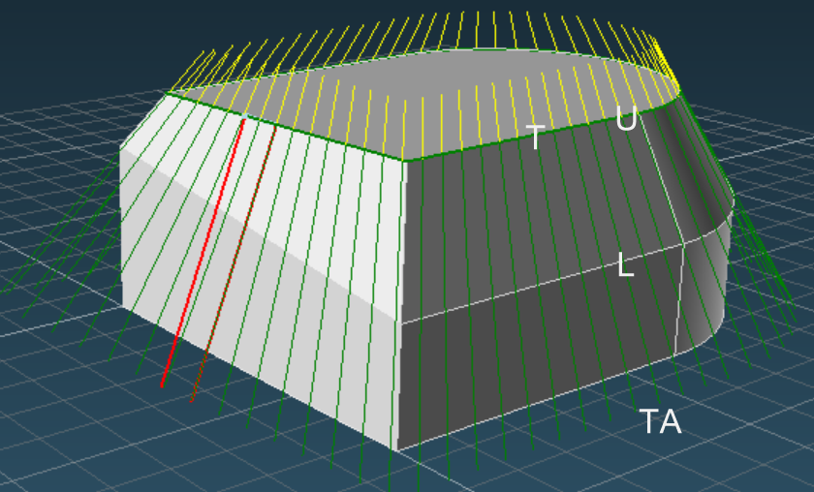
Picture 77
If the offset value is set to zero then should (U) Upper curve to (TA) Table make the same result.

Upper to Lower
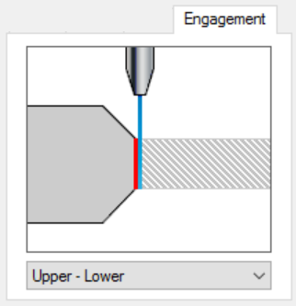
Picture 78
Use this option when the speed should be calculated from the distance between the (U) Upper and (L) Lower curve.
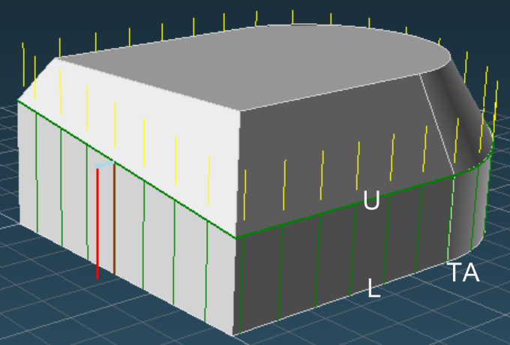
Picture 79
In many situation this option is the same as (U) Upper curve to (TA) Table.

Upper to Table
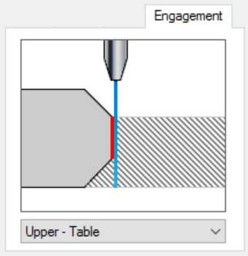
Picture 80
Use this option when the speed should be calculated from the (U) Upper curve to the (TA) Table.

Various
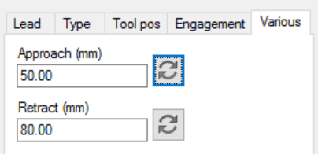
Picture 81
This tab has two new values Approach and Retract. The settings is done to add special rapid transports to avoid crash when moving to or from cuts.
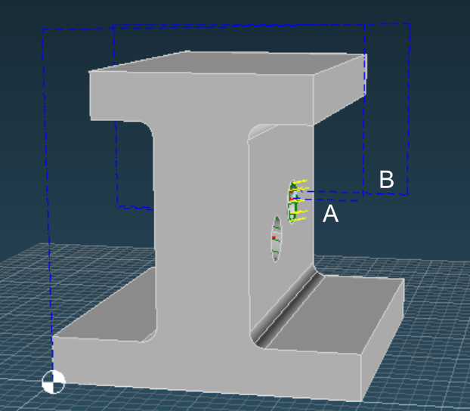
Picture 82
On the picture above the (A) Approach distance is set to 50mm and the (B) Retract distance is set to 80 mm.
In some circumstances the direction of the approach and retract be in wrong direction.
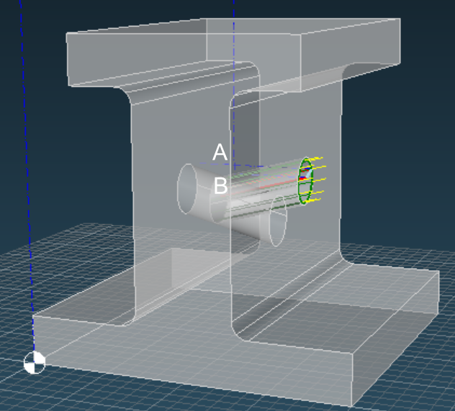
Picture 83
By clicking on one of the reverse buttons you can flip the direction of the movement.
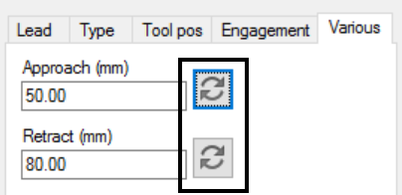
Picture 84

Zero point
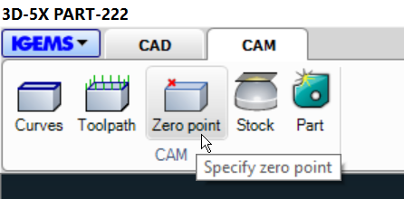
Picture 85
All parts in IGEMS ha a local zero point. It’s normally located at the bottom side at the lower left corner of the part.
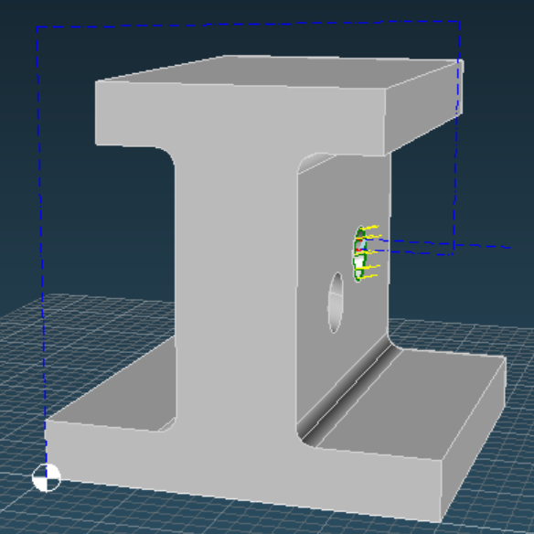
Picture 86
By clicking on the Zero point button you can set the local zero point to an optional position.
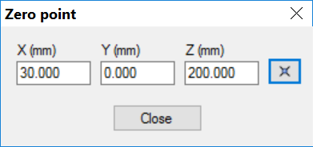
Picture 87
You can click on a point on the model or you can type the values in the dialog box.
This point will now be the local zero point of the part.
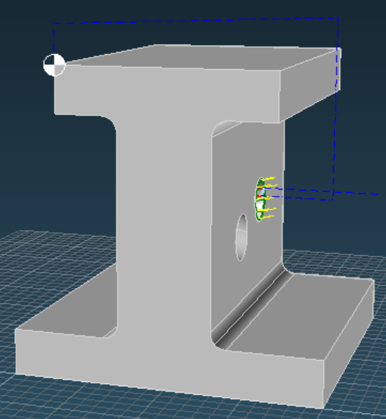
Picture 88

Global zero point
Your drawing may contain several parts. The global zero point is valid for all parts included in the job.
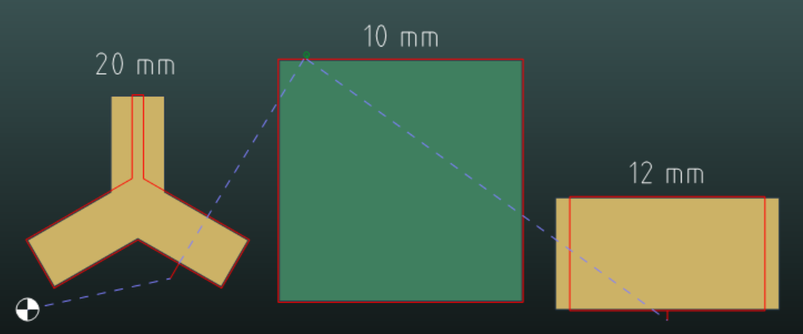
Picture 89
The actual zero point sets in IGEMS cut order command. If there is a 3D-5X part on the job the Z-axis zero is by default set to the table (bottom side of the part).
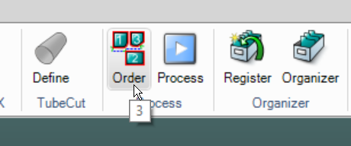
Picture 90
In the cut order command, you can set the zero point in XY to an optional position.
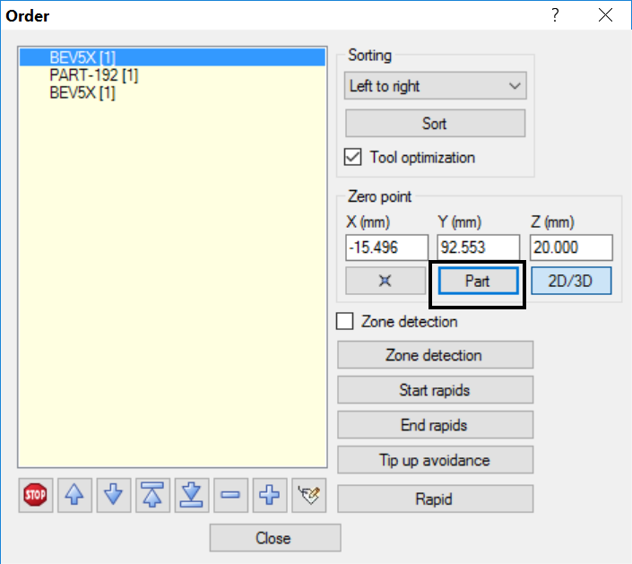
Picture 91
If you want to use the local zero point from a part as the global zero point then select the part and push the Part putton.

Stock
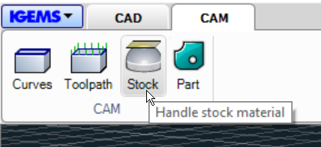
Picture 92
IGEMS will use the height of the model as a base plan for all rapid moves. In some cases this can result in a collision between the part and the nozzle.
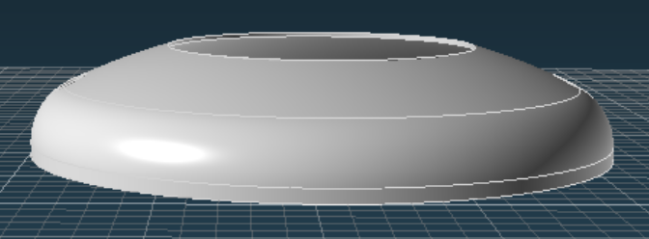
Picture 93
On the example above the model is 70 mm, the original part before cutting is 100 mm. In this case you need to increase the stock size in Z to avoid collisions.
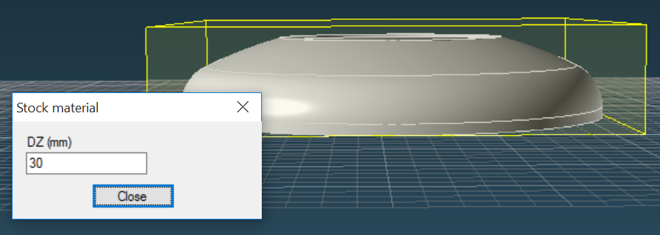

Note!
The postprocessor can be designed in a way to always move the Z-axis to the maximum height between each cut. In this case you do not need to modify the stock values at all.

Create part
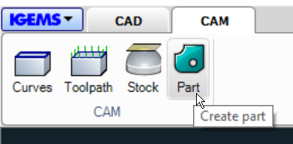
Picture 94
When you have added the toolpath then it’s time to do the postprocessing.
Press the Create part button.
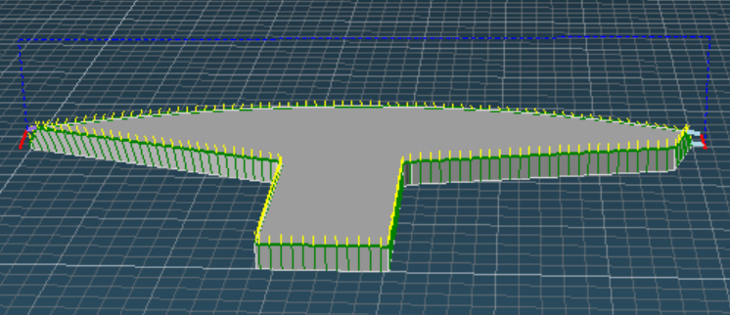
Picture 95
Then enter the normal create part information.
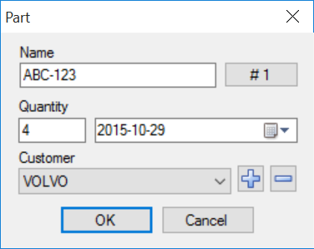
Picture 96
When you press OK the model will be saved as a part in the normal IGEMS screen.
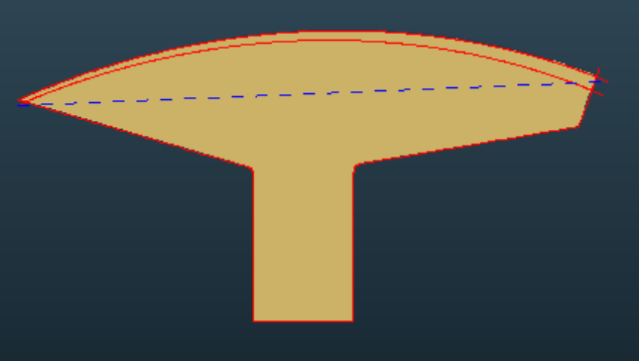
Picture 97
The part can be nested and postprocessed as a normal part.

Z-axis control
IGEMS support several methods for controlling the Z-axis on the machine.

Z-coordinates
To make a real 5-axis toolpath for an advance model needs normally movements in X, Y, Z and two other axis that control the angle of the jet. We recommend that you control the Z-axis with Z-coordinates. The zero for the Z-axis is by default set to the table (backside of the material). Se chapter 12.35 for more information.

High sensor or fixed Z-axis
If you using a configuration where Z-axis are handled by another method, then you may have a problem.

There is one exception and that is if all following points are true.
- You are cutting on a flat material.
- You are using Fixed Z tool position on all toolpaths.
- The Height is set to the Top of the model on all toolpaths.
- The Standoff is set to zero on all toolpaths.
- The Stock (see chapter 12.37) is the same as the thickness of the model.

If the Z-coordinate need to be changed during the cutting then the result may not be as wanted. You will in that case have following message and you can chose to continue or stop.
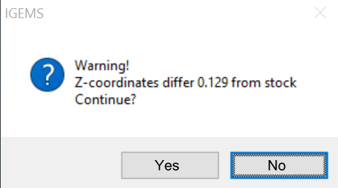
Picture 98
If you answer yes then the CNC-file will be created.
Note! It can have some problem with some dimensions.

CAD
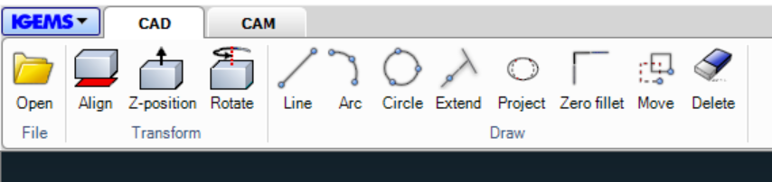
Picture 99
Sometimes it’s necessary to draw vector objects on the model to be able to generate curves that can generate toolpath.

Line
In this case it’s necessary to make a line to be able to make a curve that describe the bottom geometry
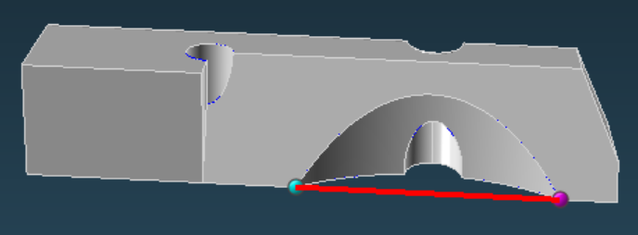
Picture 100

Arc
In this case it’s necessary to add an arc to be able to generate a correct curve.
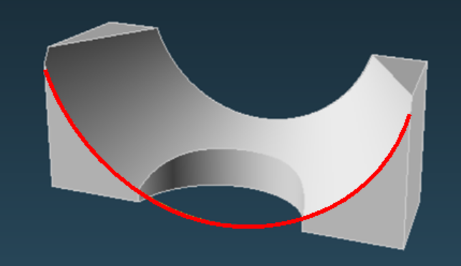
Picture 101

Circle
In this case you can add two circles that describe the round chamfered hole.
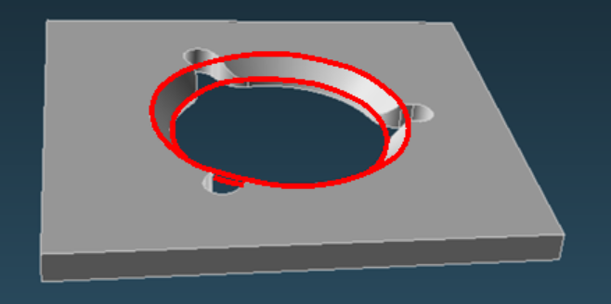
Picture 102

Extend
With this command you can extend an edge. If you start the command and click on an edge you get following message:
Select surface <Specify distance>
If you press space or enter you can enter the length to extend
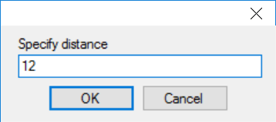
Picture 103
You can also click on a surface and the edge will be extended to that surface.
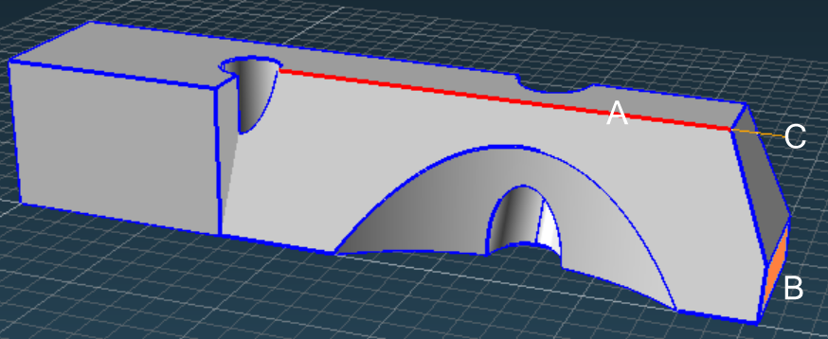
Picture 104
If you selected the edge (A), then you pick on the surface (B) and the line will be extended to (C)

Project
With the project command you can project an edge to a flat surface.
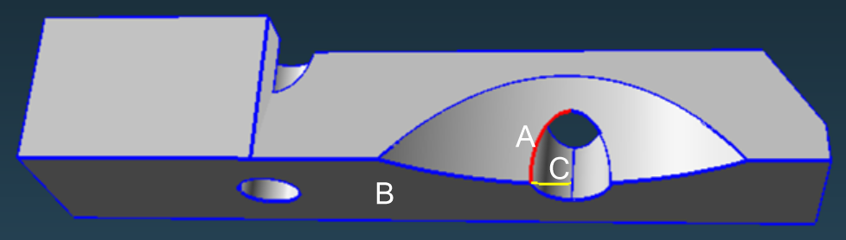
Picture 105
If you select (A) then click on surface (B) then the extra edges (C) will be created.

Fillet zero
With this command you can extend two edges to its closest position.
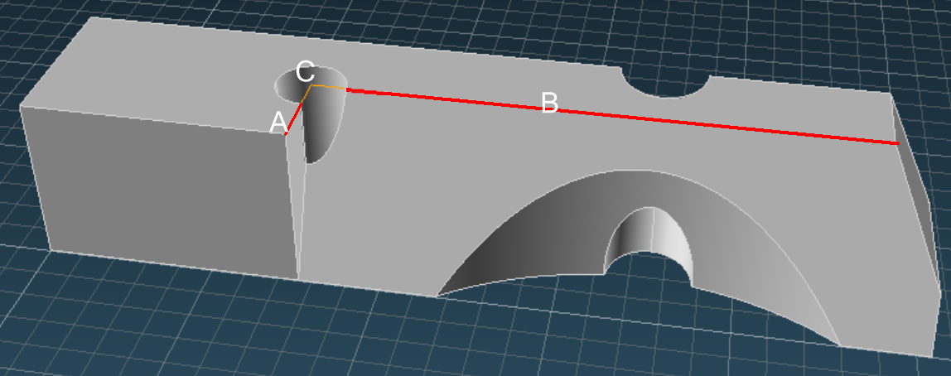
Picture 106
If you select edges (A) and (B) then they will be extended to point (C).

Move
With this command you can move other object that you have created by other Draw command.
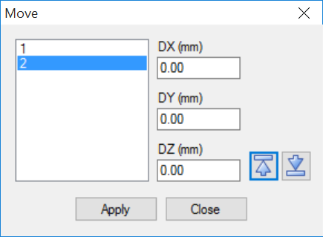
Picture 107
Select the edges and enter the distance to move and then press Apply. By using the arrows up and down you can move the edge to the zero plane or the highest point of the model

Delete
By this command you can delete edges that you have created by other draw command.
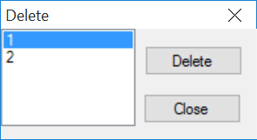
Picture 108
Select the edge and then press the Delete button.

2D-5X
IGEMS "5X-CAM" module provides tools to prepare cutting in a 5-axis cutting machine. Strategies supported are cutting with fixed or various angles in flat material using 2D-5X command. This commands can use standard 2D geometry’s as input.

Ruled bevel
In "Ruled bevel" the bevel part is described by a top and bottom geometry. The part contours is always the top. The bottom geometry can be defined by "Other objects" in the "Create" command or by the "Uniform" option in this command.
- Open the file sample file "FANWHEEL.DIG.
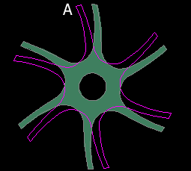
Picture 109
Use a material that is about 10 mm thick and create a part. Select one of the outside geometries as "Other objects"(see page 111 for more information).
- Start the command and select the part.
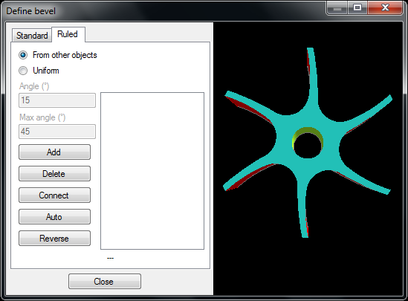
Picture 110

Add from other object
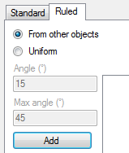
Picture 111
Select the "Add" button and select a point on the top geometry then a point on the bottom geometry.
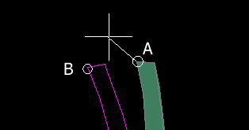
Picture 112
The selected points will create a connection line between the two geometries which is the start position for the cutting.
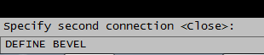
Picture 113
Define a second connection if the "ruled bevel" should not be all the way around. This will be the end of the cut and this bevel will be all around the parts. Press the spacebar or Enter to accept the "Close" option.
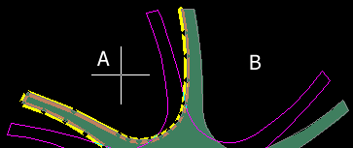
Picture 114
The final information is to select the direction of the cut. Click near (A) to have a CCW direction. Click near (B) to have a CW direction.
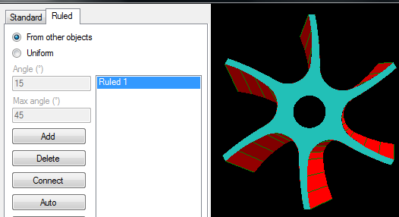
Picture 115
The bevel will now be defined as in Picture 491 above.

Add by uniform offset
This option will create the "Other objects" from the part geometry.
- Open the sample file "UNIFORM.DIG"

Picture 116
Use a material thickness around 10 mm and create a part. Start the "Define" command and select the part.
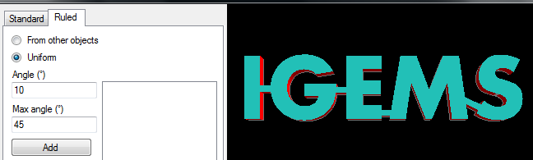
Picture 117

Angle
The offset will be calculated depending on the angle and thickness of the material. Only positive angles are supported so the outside bottom measurements will be wider.

Max angle
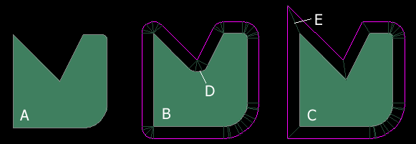
Picture 118
Part (A) is the part before any bevel is added.
Part (B) is the result when the "Angle" and "Max angle" are equal. The cutting angle will be the same on all edges on the part.
Note! Inside corners may be modified (D).
Part (C) has an "Angle" of 10 degrees and "Max angle" of 45 degrees so the outside corners are extended. If the edge at (E) uses a "Max angle" more than allowed the offset will be rounded.

Delete
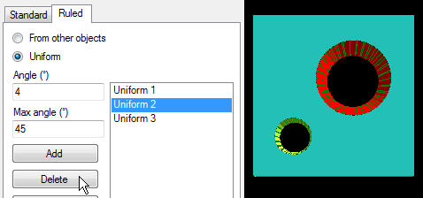
Picture 119
All ruled definitions are shown in the list, and the actual bevel is highlighted in the graphic screen.
Press the "Delete" button to delete a definition.
Note! Deleting a uniform bevel that has changed the part geometry will not restore the original contour. Close the "Define" command and use "Undo" to do that.

Connect
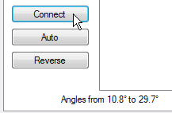
Picture 120
Use the "Connect" command to manually add connection lines. This feature is usable when there is an advance part where the geometry on top and bottom side is very different.
If the top and bottom geometries are symmetric then no more connection lines are needed.
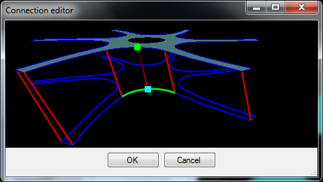
Picture 121
Picture 497 shows the window where the top and bottom geometry by lines can be connected. Hold down the right mouse button for extra functions.
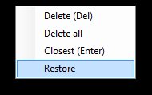
Picture 122

Auto
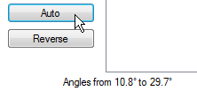
Picture 123
The "Auto" button automatically makes connection lines on the parts. It may be helpful to use this command and then change the connection lines by using the "Connect" command.

Reverse
This command will probably be removed.

Cut bevel
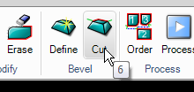
Picture 124
The "Cut bevel" command is used to add toolpaths to bevel parts.

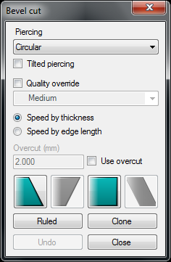
Picture 125
Before adding the toolpath set the following parameters:

Piercing
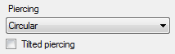
Picture 126
Set the type of piercing to use. Read more about different piercings on page 136.
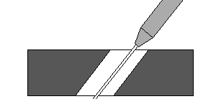
Picture 127
When it is necessary to make a tilted pierce, the tilting direction will be the same as the first point on the contour. Typically it is better to use a vertical pierce instead of a tilted pierce.

Quality and speed
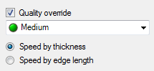
Picture 128
Normally the cutting quality is inherited from the part. Check the "Quality override" for different qualities on different cuts. This is usable for a two or three time bevel cut.
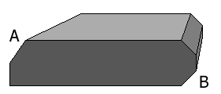
Picture 129
Side (A) shows a two time bevel and (B) a three time bevel.
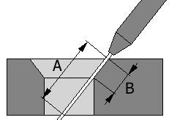
Picture 130
Example (A) shows the thickness of the material in the actual tilted angle. Example (B) shows the edge length. In one time bevel cutting the result will be the same. In two or three time bevel the cutting speed can be very different.

Overcut or micro joints
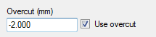
Picture 131
Overcut (positive values) cannot be used when leads are placed in sharp corners. If the value is negative then micro joints can be made. This is very useful when making two or three time bevels.
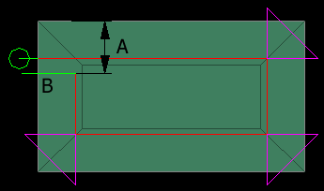
Picture 132
The negative overcut value will make a micro joint (A). The leadout (B) can be in a direction that will create a micro joint.

Applying toolpaths on Standard bevels

Picture 133
These four buttons show the major standard bevel cutting method (YDS, YAS, X and K is a combination of this methods). Methods that are not present on the part are disabled.
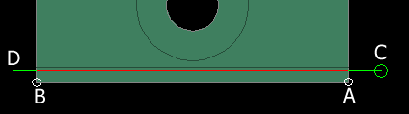
Picture 134
Select the start point (A) and the end point (B). The command then asks for (C) the piercing point (leadin) and the end of the leadout (D).
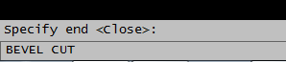
Picture 135
If there is the same type of bevel around the part, then accept the "Close" option by pressing spacebar or Enter.

Applying toolpaths on Ruled bevels
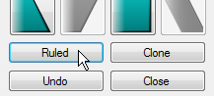
Picture 136
The ruled bevels already contain information about start and endpoint of the cut. Select specific bevel and the position of the piercing point.
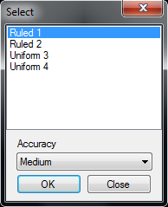
Picture 137
All ruled bevels contain only lines. The "Accuracy" controls the tolerance of this vectorization. "Rough" settings are better than 0.01 mm, "Medium" is better than 0.005 mm and "Fine" is better than 0.001 mm. It is not always true that the finest accuracy will give the best cutting quality.
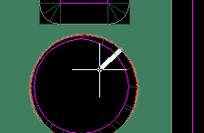
Picture 138
Press the "OK" button to set the leadin and leadout length. The leadin position will be the position for the piercing.

Clone
This feature is helpful when cutting many identical contours. The command asks for a master and then for holes on which to clone the master.
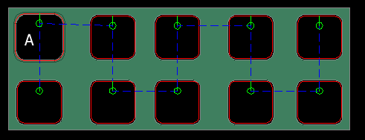
Picture 139
In the example above (A) is the master. The toolpath has been cloned to all other selected holes. Bevel definition must be added to all holes. Clone the toolpath to the contours which have a similar geometry and bevel definition.

Assign bevel cutting to a tool
All parts and toolpaths are assigned to tool one by default. If the 5-axis cutting head is located on another tool then change the default tool assignment in the "machine" settings.

Quick bevel
Ned to write about this

CAM – Material setup
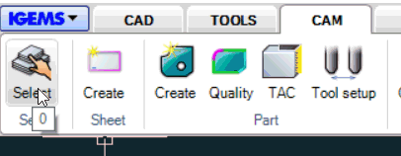
Picture 140
In the Select command you can select Machine, Cutting parameters, Material group, Material quality and thickness.
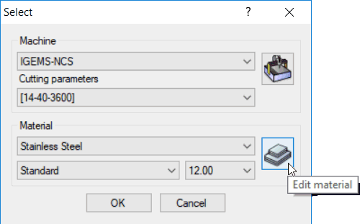
Picture 141
Use the "Edit material" command to create, delete and change material parameters.
On the left side is a tree view. Change the options in the upper left drop-down lists to look at the database in several views.
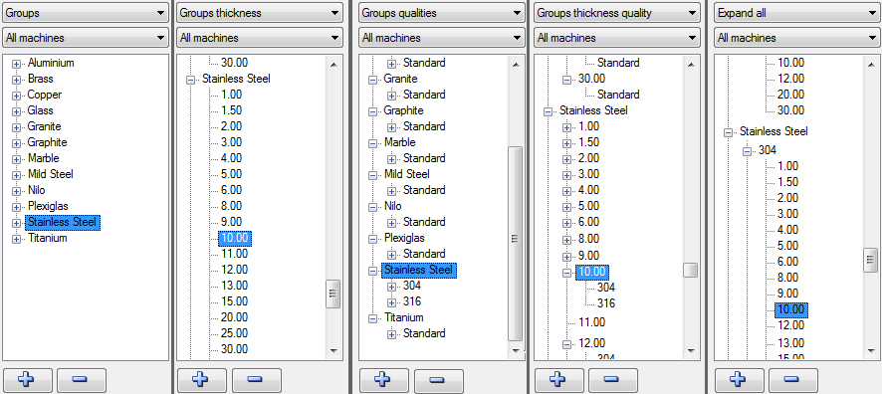
Picture 142

Material groups
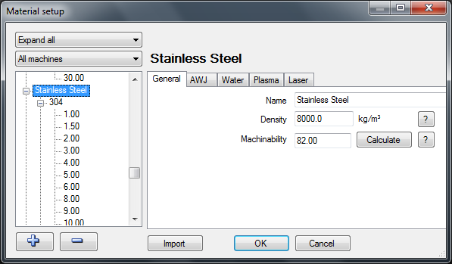
Picture 143

Add or delete groups
All material in a group should be able to use the same speed or piercing times. cutting properties. If a group is selected then add a new group or delete an existing group by clicking on the "plus" or "minus" buttons.
Picture 144
- Press the "plus" button and enter the name "Test" for the new material group.
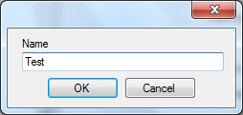
Picture 145
The new group "Test" will be an identical copy of the selected material.
Delete the group and the material file will be deleted.

General properties
On the "General" tab edit all properties that are common for all qualities, thickness and machine types.
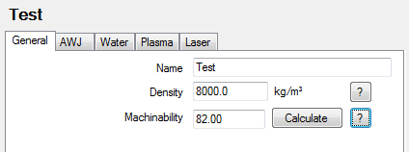
Picture 146

Name
Change the name of the group by changing this field.

Density
IGEMS needs this information to calculate weight on parts. The "question mark" button will show a list of densities for some common materials.
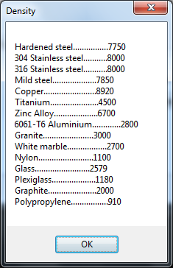
Picture 147

Machinability
This is a material property that describes how easy the material can be cut with abrasive water jet. Material with a low value is more difficult to cut than materials with a high value.
The "question mark" button will show a list of machinability values for some common materials.
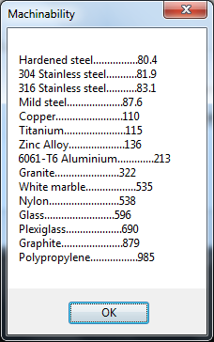
Picture 148

If the Machinability is unknown then calculate the value by making a test cut and then calculate the value. Follow these steps:
- Place the new material on the machine table.
- Make a straight cut with a speed that is so high that the jet cannot cut thru the material.
- Measure the depth of the cut.
- Press the "Calculate" button.
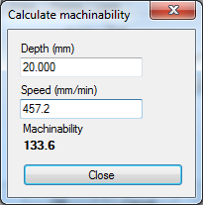
Picture 149
Enter the depth of the cut and the actual cutting speed. The calculator shows the actual machinability value.
Is the machinability depending of other cutting parameters than depth and speed?
Yes, it uses the pressure, orifice size, size of the mixing tube and other parameters defined in the Cutting parameters.

AWJ
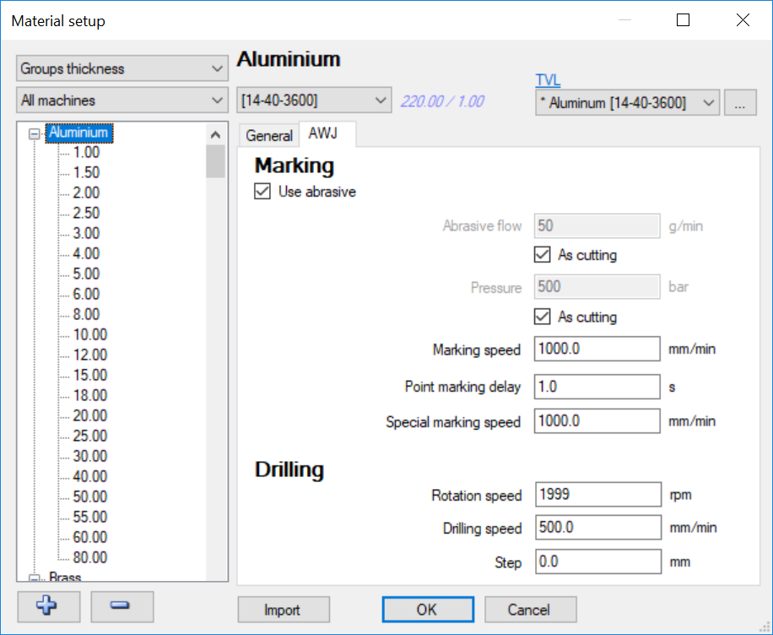
Picture 150

Marking
"Marking" affects only the surface of the material and the information is identical for all thicknesses in this group.
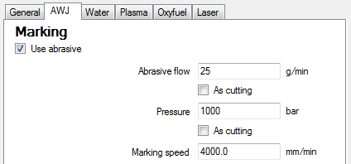
Picture 151

Abrasive flow
On an AWJ machine select whether or not to use abrasive. Select the amount of abrasive in gram/minute or lbs/min. With the "As cutting" option the amount of abrasive will be the same as for cutting.

Pressure
Select the pressure to use for "marking". With the "As cutting" option the pressure will be the same as for the cutting.

Marking speed
This controls the speed for the marking.

Special marking speed
Normally the jet is used as a marking tool. If the machine has another kind of marking tool then this input can be used to control the speed of this tool.

Drilling
The drilling information is identical for all thicknesses.
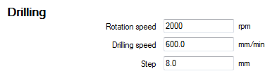
Picture 152
If the machine has the possibility to use one or several of this parameters then they can be used by the postprocessor.

Rotation speed
Enter the rpm/min.

Drilling speed
With a servo-controlled drilling spindle this value will be used. This value affects the time calculation.

Step
These inputs make it possible to use a peck drilling cycle.
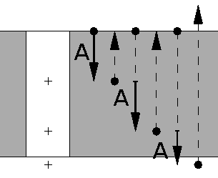
Picture 153
The value controls the depth of each step (see the A value on the picture).
Note! Not all machines support this feature.

Water, Plasma, Oxyfuel and Laser
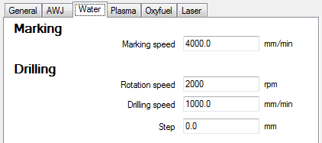
Picture 154
The settings for these four machine types are identical.

Marking
This value controls the marking speed.

Drilling
These values have the same meaning as for the AWJ machine.

Material qualities
The material qualities are used to handle material cost and the "Sheet" commands handle the material stock. The quality information is saved as different tags on each thickness in the material. The information is identical for all machine types.
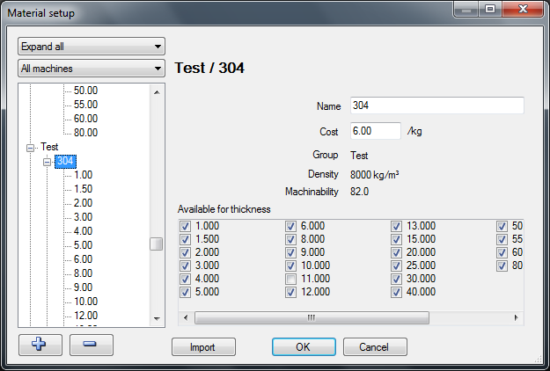
Picture 155

Add or delete qualities
If a quality is selected then add a quality or delete an existing quality by clicking on the "plus" or "minus" buttons.
Picture 156
- Press the "plus" button and enter the name "My private" for the new quality.
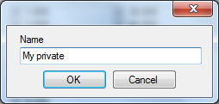
Picture 157
The new quality "My private" will be an identical copy of the selected quality.
Press the "minus" button to delete the quality.

Quality properties
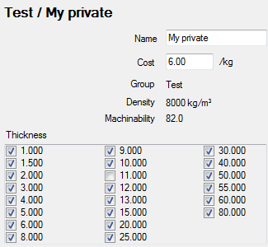
Picture 158

Name
Use this field to change the name of the quality.

Cost
This value is used in the cost calculations.

Thickness
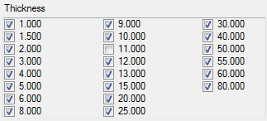
Picture 159
Check the thickness that should be available for the quality.
Why can't I change the density and machinability?
If your material has different weight or machinability, then you should add a new group instead.

Material thickness
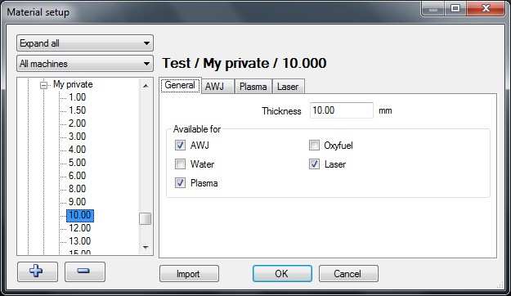
Picture 160

Add or delete thickness
If a thickness is selected in the list then add a new thickness or delete an existing thickness by clicking on the "plus" or "minus" buttons.
Picture 161
- Press the "plus" button and enter the thickness "12.50".
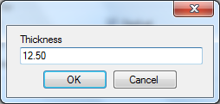
Picture 162
Press the "minus" button to delete.

General
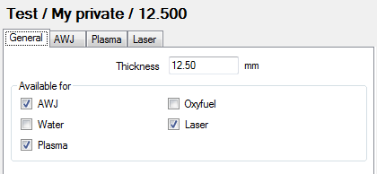
Picture 163
On the general tab change the thickness and control what machine types can be used for this specific material.

AWJ
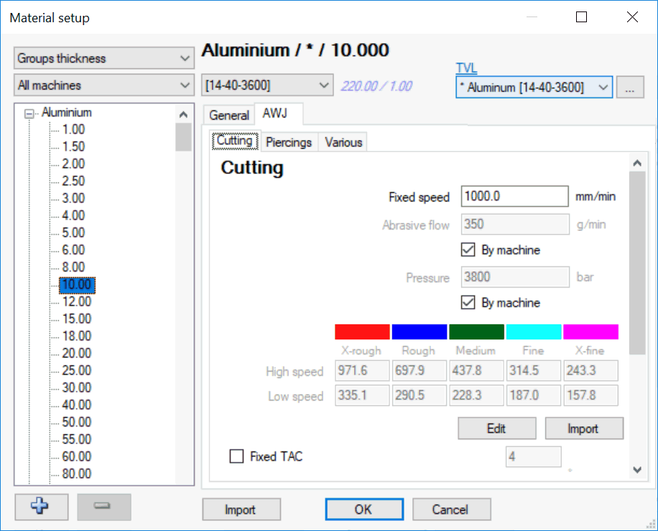
Picture 164

Cutting
On this tab you can find parameters for piercings, cutting and taper control.

Fixed speed
The value is used when "Fixed speed" is selected in the Machine setup. When using fixed speed there is no speed ramping, also the cutting quality does not affect the cutting speed. The settings is made for machines that controls the cutting speed internally in the CNC-controller. For example, Omax and Flow. This value will also be used if no AWJ modules are installed.

Individual cutting parameters
It may be an advantage for certain materials to use other cutting parameters than the machine uses as standard. If that case, set up the individual cutting parameters here.
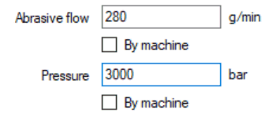
Picture 165
When using the TVL we do not recommend to use individual cutting parameters.

Speeds
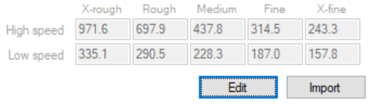
Picture 166
By clicking on the Edit button, you can modify the speeds.

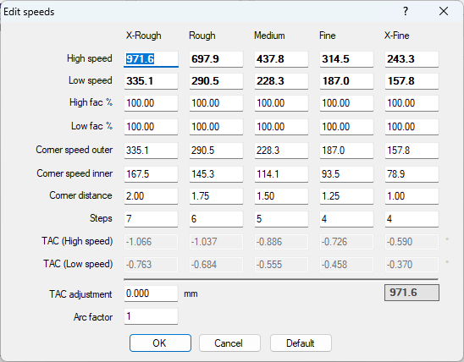
Picture 167

High speed
High speed is used for long straight lines and large circle segments where the radius is larger than the thickness of the material. The IGEMS R2019.2 version will update your current database. It will set the High speed to the same speed as you used before. (It will check if the database was set to Auto or Non-Auto for the actual thickness). Your actual high-speed value will persist.

Low speed
Low speed is used for outside sharp corners where the corner angle is more than 3 degrees. How much the speed is reduced is calculated by a formula. At 90 degree or more the speed is 100% of Low speed.
From version R2019.2, low speed is not used for inside corners, it will update your database and set the value to 100% of default setting if you update from an older version.

High fac %
If you increase the High speed, you will also increase the High factor. It is the same thing, just different way of showing the information. If the factor is 100%, the speed is what we have set it to originally. If you want to cut faster or slower, just change the High speed or High fac.

Low fac %
This is the same as High fac but it will handle the Low speed. First time you start IGEMS with the new Speed optimization, this value will be set 100% no matter of your current settings. If you have changed this value, it is probably because you want to reduce the backlash on inside corners. The inside corners are now handled separately.

Corner speed outer
This speed will be used on all outer corners if the corner angle is 90 degrees or more. (See also Low Speed). It will also be used on the second acceleration speed on inside corners.

Inside Corner speed
To get good inside corners we need to reduce the speed much more than we did before. The value is 50% of the low speed. This is right now hard coded since we have found that this is are a good value in most cases.

Corner distance
The corner distance is the acceleration and de-acceleration distances for outside corners. It is also used as de-acceleration distance for inside corners. When accelerate out from inside corner the distance will be used two times. Accelerate from Inside corner speed to corner speed, then again from corner speed to high speed.

TAC (high speed)
The information shows how many degrees taper that will be used in high speed.

TAC (low speed)
Same as above but shows the taper for low speed.

Speed example
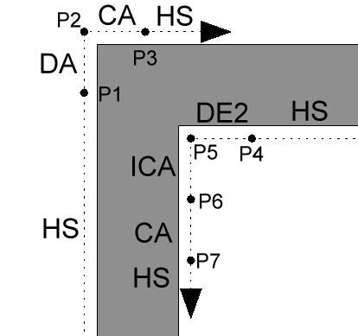
Picture 168

Outside corner
The outside geometry is using medium quality
The distance from start to P1 are using High Speed F437.8
From P1 to P2 the jet will reduce the speed from F437.8 to 228.3
From P2 to P3 the jet will increase the speed from 228.3 to 437.8

Inside corner
The inside corner is using medium quality.
From start to P4 are using High Speed F437.8
From P4 to P5 the jet will reduce the speed from F437.8 to F114.1 (to corner speed inner)
From P5 to P6 the jet will increase the speed from F114.1 to 228.3 (to same as outside corner)
From P6 to P7 the jet will increase the speed from 228.3 to high speed.

Piercing
IGEMS supports different methods to pierce through material. Read more about piercings on page 136.
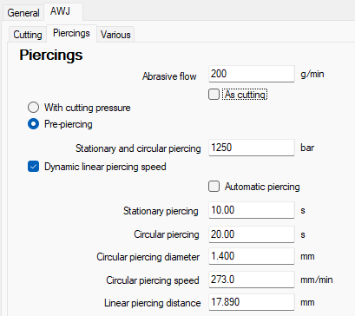

Individual piercing parameters
To use a different amount of abrasive or a different pressure for the piercing enter values here:
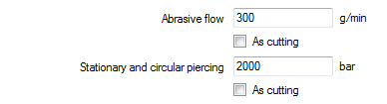
Picture 169
Check the two boxes "As cutting" to not use any special values. When cutting brittle material, piercing at a lower pressure is often needed.

Stationary piercing
Picture 170
The jet will stay in the same position during the entire pierce.
The value is the length of time in seconds that the jet will be on. This piercing method works best on very thin material.

Circular piercing
The jet goes around a small circle during the entire pierce. This is one of the most common methods of piercing on an AWJ machine and works well on thin and thick material.
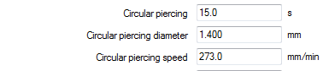
Picture 171

Circular piercing
This controls the piercing time it takes for the jet to cut through the material.

Circular piercing diameter
This is the movement diameter. The diameter in the material will be this value plus the diameter of the jet.

Circular piercing speed
This value is in mm/min. The faster the speed the more number of revolutions is used.
Note! If the diameter is too small, or the speed too high, then the centrifugal acceleration may exceed the acceleration limits. In this case the text will change to red.
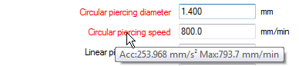
Picture 172
Hold the pointer on the text to see a tooltip with information about the actual accelerations.
The maximum acceleration is set in the machine setup.

Linear piercing
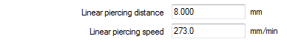
Picture 173
The jet makes a linear movement during the entire piercing. If the distance is longer that the length of the lead then the movement will go back and forth until the specified distance is reached.

Linear piercing distance
This is the length needed for the piercing to be able to cut through the material.

Linear piercing speed
This is the speed that is used for the piercing.

Overcut distance
This value is used as the default overcut distance when the cutting starts directly on the geometry (Lind lead).
Picture 174
This value controls the length of the overlapped cut.

Dynamic leads
Dynamic leads are used to have the piercing position as far away as possible from the geometry. It is a nice feature when cutting material that often breaks on the bottom side during the piercing.
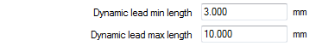
Picture 175

Dynamic lead min length
This should be the shortest acceptable lead length for this material.

Dynamic lead max length
Set this value to the maximum required lead length. While safer to have a longer lead this takes time to cut.

Cutting
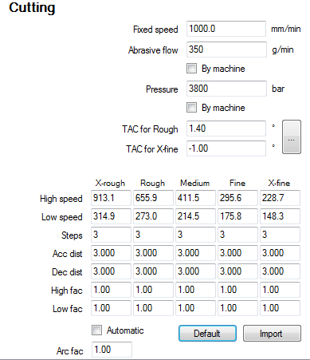
Picture 176
The information in this area controls the thickness depending information for the cutting process.

Fixed speed
This value is used when "Fixed speed" is selected in the Machine setup. When using fixed speed there is no possibility to use qualities or speed ramping. The value is only used on an AWJ machine without using the "AWJ" module.
Picture 177

Individual cutting parameters
It may be an advantage for certain materials to use other cutting parameters than the machine uses as standard. If that case, set up the individual cutting parameters here.
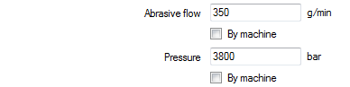
Picture 178

Abrasive flow
This controls the amount of abrasive. To use the standard amount of abrasive check the box "By machine".

Pressure
This value controls the pressure. To use the standard pressure for cutting check the box "By machine".

Note! If there is no machine equipment to automatically change the abrasive amount or the pump pressure then check these boxes, allowing fewer changes for the machine operator.

Taper Angle Control
Depending on material properties and cutting parameters the cut through the material is not always 100% straight.
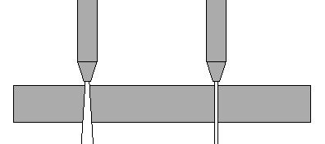
Picture 179
By using the Taper Angle Control feature manually adjust the inclination of the nozzle. IGEMS does not use any mathematic formula to calculate the taper. Make a test cut to adjust the TAC parameters.
Cut a small test part without TAC using cutting quality Rough and X-Fine.
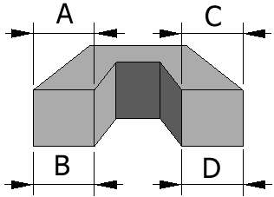
Picture 180
Measure the Rough side A and B. Measure the X-Fine side C and D.
Start the "TAC Calculator" by clicking on the button.
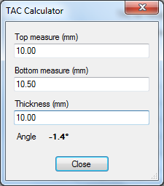
Picture 181
The TAC Calculator calculates the angles. If the measurements are smaller on the bottom side on an outside geometry then the angles are negative else positive.
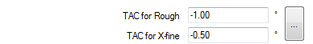
Picture 182

TAC for Rough
Enter the angle for the "rough" measurement.

TAC for X-Fine
Enter the angle for the "X-fine" measurements.
Note! To use the "TAC" option a standard CNC machine is needed with at least 4 or 5-axes controlled by the CNC and the nozzle can be tilted in different directions.

Automatic speed optimizing
The automatic speed optimizing adjusts the cutting speed depending on cutting parameters, material properties and geometry to be cut. Straight lines and large arcs are cut with a higher speed than sharp corners or small arcs. The automatic speed optimizing uses another algorithm than earlier versions of IGEMS. The speeds are therefore not the same as before, but still divided into five qualities.
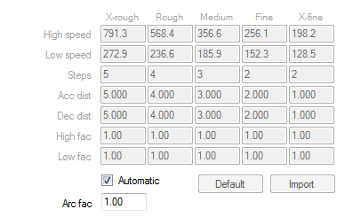
Picture 183
At IGEMS R&D Center, we are constantly updating and fine-tuning cutting parameters. Updating IGEMS may also update cutting speed parameters. The automatic speed optimizing is activated when the checkbox "Automatic" is checked.

Manual speed optimizing
The manual speed optimizing uses the same formulas as IGEMS R8 and R9. Use this option to fine-tune parameters. The values are not changed in an update of IGEMS.
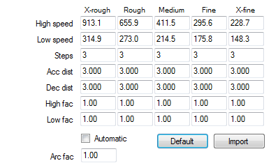
Picture 184
The following parameters can be adjusted:

High speed
This speed is used by straight lines and arc radius larger than the thickness of the material.

Low speed
The low speed is dependent on the geometry. The sharper the corner or the smaller radius size of an arc the lower speed will be used. The speed will never be lower than this value.

Steps
This value is only used if when using the ramping method "Speed interpolation by CNC-file" (defined in the machine setup).

Acceleration distance
This is the total length of all speed increasing steps when the speed changes from low to high speed.

Deceleration distance
This is the total length of all speed decreasing steps when the speed changes from high to low speed.

High speed factor
The speed is calculated by known parameters such as: Machinability, Pressure, Orifice size, Abrasive quality, Amount of abrasive, Nozzle size, Cutting quality and the thickness of the material. If the actual high speed is according to this algorithm then the height factor is 1.00. If the high speed is changed it will also change the high speed factor.

Low speed factor
This factor does the same as "High speed factor" but for the "Low speed" values.

Arc factor
Picture 185
This value controls the cutting speed in the arcs. If this value is set to a higher value then the small arcs will use a higher speed. Normal value is 1.00

Default
Press this button to reset the values to default. This will change all values on this material according to the algorithm.

Import
The database in R10 is different from previous versions. To use old values in IGEMS R10 use the import function.
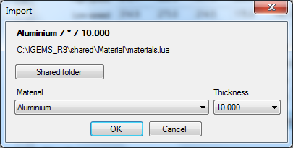
Picture 186

Shared folder
When using this command for the first time, select the location of the shared folder. IGEMS R10 will then remember this location.

Material and Thickness
Be sure to use the same material and thicknesses as in IGEMS R10.
Repeat these steps for every material imported to IGEMS R10.

Nesting
Some nesting parameters can be saved in the material database.
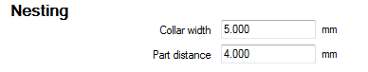
Picture 187

Collar width
This value sets the default value used when creating new sheets.

Part distance
This value sets the default value for the part distance. The value is used in the "Nesting" commands.

Various
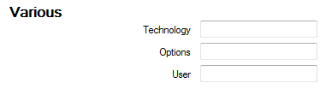
Picture 188
The "Technology", "Options" and "User" settings are read by the postprocessor for handling different equipment or functions in the postprocessor.

Plasma, Oxyfuel and Laser settings
IGEMS is developed for Abrasive Water Jet Cutting, but also supports other machine types such as Plasma, Oxyfuel and Laser machines. These machines have similar inputs.

General import
If there is an older version of IGEMS then import the complete material database.

TVL
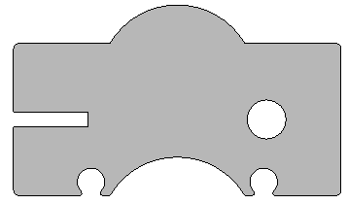
VIDEO
The video above shows how to cut this part with TVL. The result is a part with completely straight edges.

About TVL
The TVL functionality can cut parts with better measurement and with angle compensation.
The new TVL functionality will be released in IGEMS R2019.2. When using the TVL the users should never need to modify any parameters to get a good cutting result. TVL stands for Taper Angle Control, Variable offset and Lag compensation. IGEMS are using the same technology that was carefully described by Axel Henning in papers from Fraunhofer Institute 1997. (Computer Aided Manufacturing for three-dimensional abrasive water jet machining). IGEMS are follow this technology

TAC (Taper Angle Control)
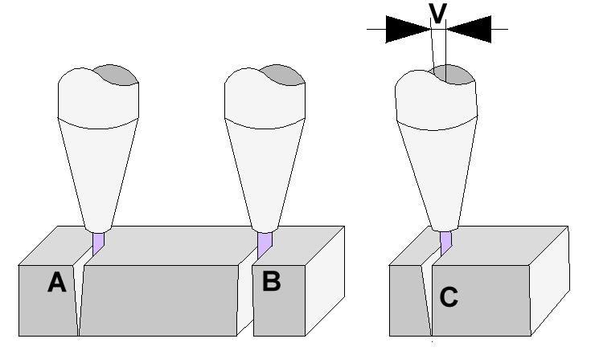
The TAC controls the size of the bottom side of the part.
On a fast-cutting speed, the jet will make a conical cut. On example A the speed is fast, the cut will be much smaller on the bottom side of the part than it is on the top side.
On example B the speed is slower than the result will be opposite, wider at the bottom.
To be able to make a vertical cut and correct measurements the jet has to be tilted in different directions. On example C the jet is tilted with the angle of V and the cut at C will be vertical.

VOC (Variable Offset Control)
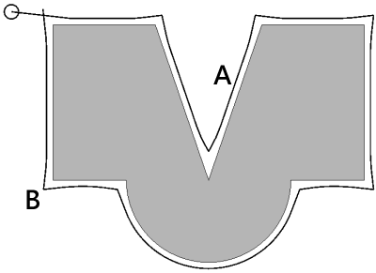
Picture 189
The VOC controls the size of the top side of the part.
The jet will remove more material when you cut with a slow speed than when you cut with a fast speed. To obtain correct measurements the VOC change the kerf depending on the actual cutting speed. On the picture above the kerf is smaller at (A) and wider at (B) since the speed is faster at this point.

LAG (Lag compensation)
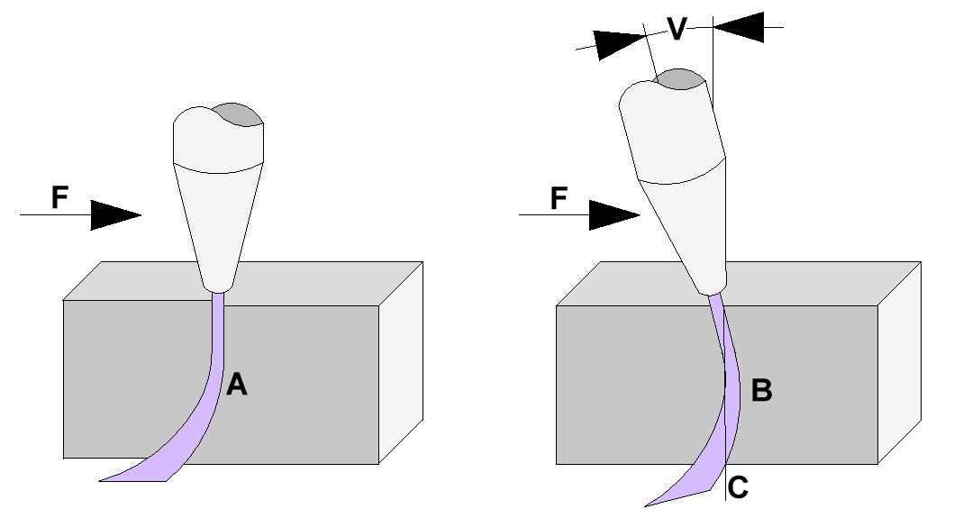
When cutting through the material the jet will be reflected in the opposite direction to the cutting direction F. The reflection is called the LAG. The LAG will be more with a faster cutting speed than with a low speed. The Lag angle V are adjusted that the front position on the top side is perpendicular to the front position on the bottom side.

Pre-defined cutting parameters profiles
To be able to use the TVL technology you must use the same cutting parameters as we have used during the test cuts. In version 2019.2 we have two pre-define profiles but we plan to add more profiles in the future.
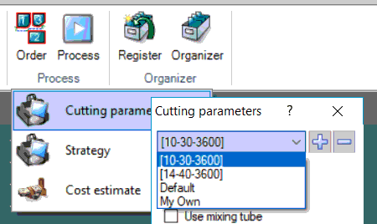
Picture 190

[10-30-3600]
This is for using 25 HP at one jet. Or using two jets at on a 50 HP pump.
- 0.010 inch or 0.0254 mm orifice diameter.
- 0.030 inch or 0.762 mm mixing tube diameter.
- 3600 bar or 52214 PSI nozzle pressure.
- 350 gram or 0.771 lb. abrasive flow per minute.
- GMA Garnet 80 mesh.
- Standoff 3.00 mm or 0.1181 inches.

[14-40-3600]
This is for using 50 HP at one jet or using two jets with a 100 HP pump.
- 0.014 inch or 0.356 mm orifice diameter.
- 0.040 inch or 1.016 mm mixing tube diameter.
- 3600 bar or 52214 PSI nozzle pressure.
- 450 gram or 0.99 lb. abrasive per minute.
- GMA Garnet 80 mesh.
- Standoff 3.00 mm or 0.1181 inches.

Activate TVL
The TVL information is collected from approximately 240 measurements from different speeds and thicknesses in each supported material. All test cuts are done at IGEMS waterjet lab. The idea is that users never need to modify the database to get a good cutting result. At this moment the TVL data is available for following material and cutting profiles.
- Aluminum [10-30-3600]
- Aluminum [14-40-3600]
- Mild steel [10-30-3600]
- Mild steel [14-40-3600]
- Stainless steel [14-40 3600]
Following video shows how to activate the TVL
VIDEO
To activate TVL following these three steps.
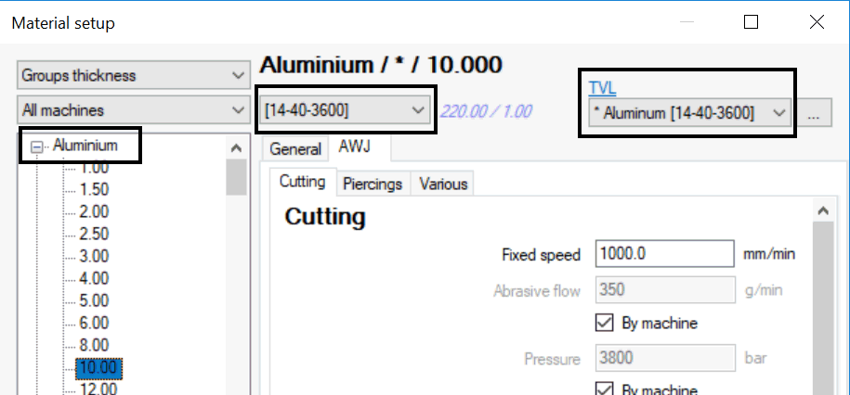
Picture 191
- Select Aluminum, Mild Steel or Stainless Steel.
- Select correct Cutting parameter profile [10-30-3600] or [14-40-3600].
- Select corresponding TVL file.
Be sure to use the selected cutting parameter profile when you do the postprocessing.

Create your own TVL-data
By unselect a TVL file and press the Edit button you will enter the TVL-editor.
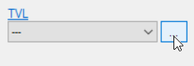
Picture 192
Sine the TVL file is empty we need to fill the form with information.
- Press the + sign and add a thickness.
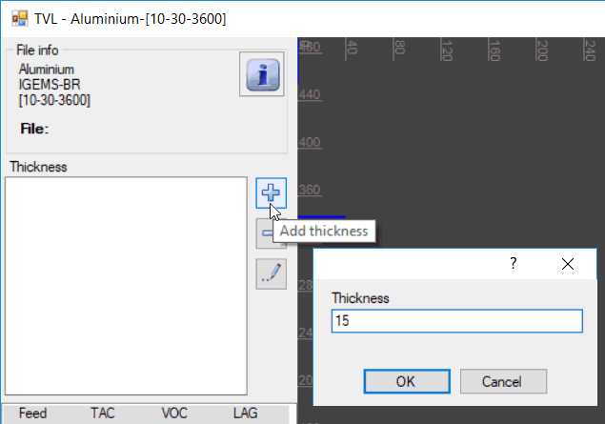
Picture 193
You have now added 15 mm thickness.
Repeat this for all different thickness you plan to use.
- Press the Edit button
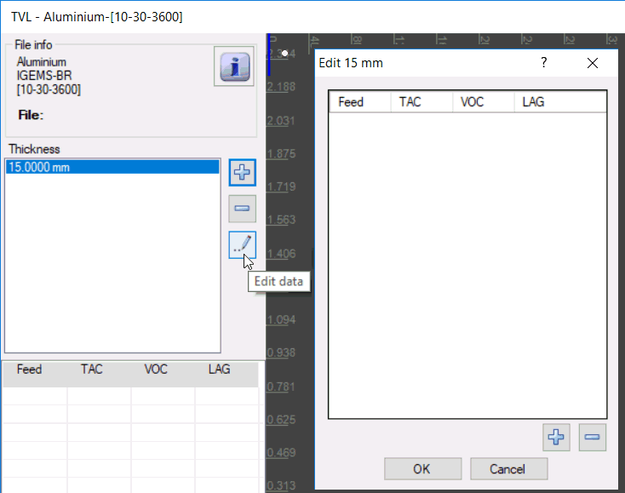
Picture 194
- Click on the + sign to add TVL information for different speeds.
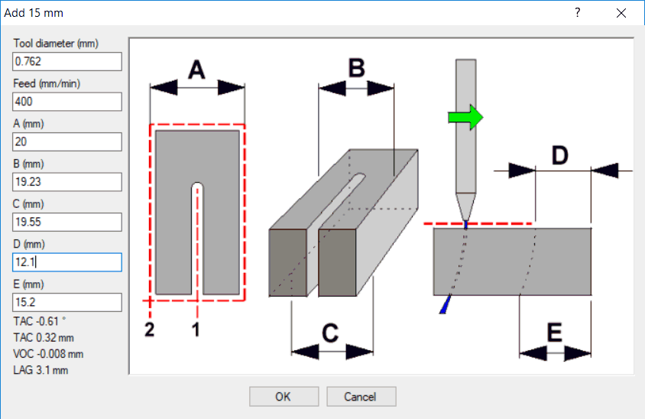
Picture 195
To find the correct values you must make a test cut. The part can be as the picture above, or you can make another part as long as you can measure the needed value A to E.

Set speed
In the machine setting you can change the speed method to fixed. This means that you will use the same speed whole time. In the material database for 15 mm you must set the speed to wanted speed.
VIDEO
In this example we use 400 mm/minute.

Cut 1
Start outside and cut into the part, turn of the jet without making a stop. Note! not all CNC-controller that can make this kind of motions.
VIDEO

Cut 2
Cut around the part do not use any tool radius compensation.

Tool diameter
Set this value to the same size as the mixing tube

Feed
Set the value to the feed that you have set in the machine setting

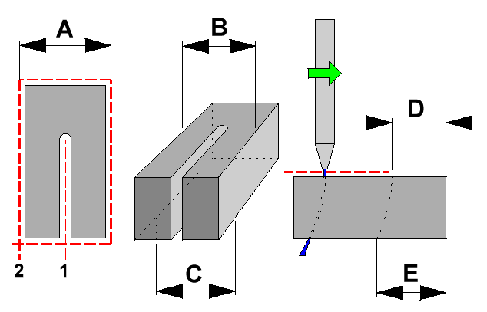
Picture 196

A-value
Set the value to the size you have draw the part in IGEMS.

B-value
Measure the part on top side. This value should be around A minus the tool diameter.

C-value
Measure the part on bottom side. This value should probably be little more than the B-value.

D-value
The D and E values controls the LAG setting. Note! It is important that the machine don't make any stop when turning of the jet.
VIDEO
If the machine makes a stop, then it will destroy the edge in you will not have any correct value for TAC.

Add more speeds
The more speeds you add for every thickness the higher accuracy you will have for the TVL.
We suggest that you add speeds between High speed for X-rough to Inside corner speed for X-fine.
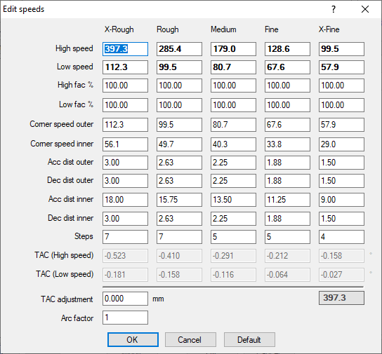
Picture 197

TAC adjustment
This value can be used to in a simple way modify the bottom side of a part. If you want to reduce the outside measurement on the bottom side, enter a negative value. This will increase the bottom measurement on internal holes.
If you enter a positive value then external measurements will increase and internal be reduced.

Arc factor
Large arcs will be cut with high speed, arcs with radius zero (sharp edges) will be cut with low speed. Speeds for the arc radius that are between high and low speed are calculated by a linear function.
The Arc factor controls on what radius size the speed should start to slow down.
Example:
- If the value is set to 2.0 then the radius size is double thickness (increase the speed)
- With the default value 1.0 the size is the same as the thickness.
- If the value is set to 0.5 the size if half of the thickness (reduce the speed).

Add more thicknesses
Repeat the same procedure to add another thickness. Important" For the moment you must have two different thickness to be able to use the TVL.

CAM – Sheet commands

Sheet Create
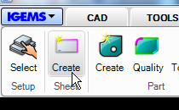
Picture 198
This command creates and inserts sheets onto the drawing area.

Standard sheets
When the command is started there is the following question:
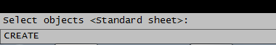
Picture 199

Press the spacebar or Enter for a list of standard sheets.
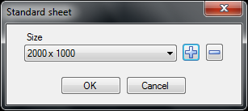
Picture 200

Modify list of standard sheet
Press the "plus" or "minus" buttons to modify the list of standard sheets.
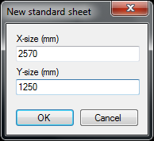
Picture 201
Press the "plus" button to add a new sheet size.

Sheet properties
Select a size in the drop down list and press "OK". Add additional information about the sheet in the following dialog box:
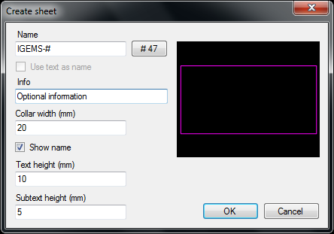
Picture 202

Name
To track all sheets, it is important to use a unique name for the sheet. The "#" sign uses an automatic counter in the same way as on "Part create" (see page 108 for more information).

Info
This information is used by the postprocessors and in the reports.

Collar width
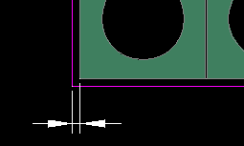
Picture 203
This value controls the distance between the edge of the parts and the edge of the sheets when using "Nesting" commands.

Show name
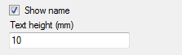
Picture 204
With these settings control height and the name of the sheet is visible on the lower left corner on the sheet.
Picture 205

Subtext
Picture 206
This setting controls the height of the text placed on the sheet when using the "Lock sheet" command.

Insert sheet
Press "OK" to insert the sheet into the drawing.
Picture 207
Pick the position for the lower left corner (A) then the orientation of the sheet (B) or (C).

Irregular sheets
If a sheet has complex geometry, be sure that the geometries are closed before starting the command.
Picture 208
Select the objects that describe the sheet.
Picture 209
The sheet can contain holes and it is also possible to use the "Text as names" function. See page 108 for more information.

Edit sheet properties
Picture 210
To change any parameters on an existing sheet use the same command to change the parameters. Select the sheet instead of geometry. It is also possible to double click on the sheet without starting the command.

From hole
Picture 211
In parts with large internal contours, use this command to keep the internal areas and store as "rest sheets". The new sheet inherits all the properties from the original sheet.
Picture 212
Start the command and click inside a hole in the part (A). This creates a new sheet with same geometry as the hole. Move the mouse and the sheet to a position (B). The new sheet (B) has the same properties as its parent.

Lock sheet
Picture 213
Use this function to convert parts located on sheets to holes.
Picture 214
The sheet now looks as follows:
Picture 215
The external contour and the toolpath creates a hole in the sheet. The text located in the hole is the name of the part. This text height is controlled by the "Subtext height" in the "Sheet create command". See page 250 for more information.
Picture 216
The exact geometry of the part and the piercing geometry (A) are shown on the sheet.

Automatic divide
If a cutoff crosses the sheet, then the sheet automatically will be divided into two. See page Fel! Bokmärket är inte definierat. for more information about "Cutoff" command.
Picture 217
Both sheets (A) and (B) have the same properties.

Unlock
Picture 218
To modify the position of the part on the sheet, use the "Unlock" command. Start the command and select the sheet to unlock.
Picture 219
Now move the geometry on the sheet. When the geometry is in the correct position, lock the sheet again.
Why is it important to move the geometry afterwards?
It is only important if there is some space left on the sheet and you plan to use the sheet again.
Why can the hole be in the wrong position?
For example: If the sheet was not aligned correctly on the machine or the zero point was wrong. Use "rotate" or "move" to correct this.

Divide
Picture 220
The "Lock sheet" command automatically divides a sheet into several parts. To divide a sheet manually, use the "Divide" command.
Picture 221
Make a polyline that describes how to divide the sheet.
Picture 222
The command creates two sheets (B) and (C) with the same properties. The "Divide" command also works with toolpaths from the "Cutoff" command. See page Fel! Bokmärket är inte definierat..

Sheet export
Picture 223
IGEMS has an excellent way to handle the library of sheets and rest sheets.
For every material, there is a corresponding DIG file that contains the sheets. If the actual material is: "Stainless Steel" quality "304" and thickness 10.00, then the corresponding "DIG" file is "Stainless Steel_304_10.00 mm.dig".

Use this command to export Sheets, rest sheets, parts or locked sheets from the drawing into the corresponding file. Save the file after exporting.
Picture 224
If the corresponding file does not exist then IGEMS will create a file. All sheet files are normal IGEMS drawing files located in the Sheet directory in the Shared folder. See Section 3.5 for more information about the shared folder). The file will contain all rest sheets.
Should I lock the sheet before I use the "Export" command?
Do this before or after.
Can I make the nesting and toolpath in the Sheet file?
Yes, handle this file as any other file.

Sheet open
Picture 225
This command opens the corresponding file but will not export any information. See Section 16.6. Use this command to look in the rest sheet library.

History
Picture 226
This command asks for the selection of one or several sheets. It then shows information about sheets and the parts that have been located on the sheet.
Picture 227
Select a part in the dialog box and the location will be highlighted on the sheet.
Picture 228
If the parts were registered in the "Organizer" module then the DBID flag has a positive number. Double click on that line and the "Organizer" shows more detailed information about the part.

Sheets
Select the "sheet tab" to see information about the sheets.
Picture 229

Search
If there are many parts and sheets use the Search function to find the information.
Picture 230
Use the "Search" function to make a search on all.

Inventory
Picture 231
"Inventory" locates rectangular areas on a locked sheet and gives information on area and weight of the rest of the material based on the size. Different colors show the categorized size of each rectangle.
Picture 232
Picture 596 above shows the screen after using "Inventory". Areas are different colors depending on the size of the rectangles. The command shows the following dialog box:
Picture 233
The following options are available in the "Inventory" command:

Reports
This option creates a full report on selected sheets.
Picture 234

Draw
This command creates rectangles around the different colors.

Settings
Picture 235
The "Settings" option defines the categorized size of the areas used in the Inventory.

Migrate
Picture 236
Use the "Migrate" command to migrate sheets/rest sheets previously stored in the "Organizer" from older IGEMS versions into IGEMS R10. Before using this command run the "Open" command in the sheet menu and select the name of material and thickness.
Then select the "Migrate" command and the correct "Shared" folder to import from.
Picture 237
After the migration is completed, the previously stored sheets are imported into the IGEMS R10 sheet files.

Nest Level 1
The Nest Level 1 commands are used to automatically or semi-automatically place parts on a sheet of material and minimize the material waste.

Quick nest
Picture 238

Shortcut "Q"
This command positions individual parts/geometry with a pre-defined distance in relation to other parts/geometries. "Quick nest" works with parts or closed geometries.
Start the command and select the part that should be moved (A).
Picture 239
Move the part that it overlapping part (B).
Picture 240
Part (A) automatically moves out from part (B) to a correct distance. Click on the right mouse button for a list of different available options.
Picture 241
Most of these options are self-describing.
K: Reset
When a part is rotated, this command rotates the part to its original angle.
M: Toggle move/copy
The normal mode is copy. Use this command to switch between these two modes.
A: Align
This automatically aligns the part to an edge.
Picture 242
Hold the edges of part (A) on the edges of part (B) at the point (C).
Picture 243
Press the shortcut A and the two parts will be aligned.
D: Toggle part distance
The material settings define a part distance (0) and there can be a custom distance. The D-key will toggle between these two distances.
C: Custom distance
Use this option to define the custom distance.

Glide nest
Picture 244
The Glide nest is a variant of quick nest function with a different user interface.

The command works as follows:
- Start the command
Part distance <4> (type wanted distance or press space/enter)
Select parts (select part(s) to move)
Move the part on the screen by moving the mouse, the functionality become more understandable if the Ortho mode is not activated.
Picture 245
By following short keys, you can rotate and manage the part. The part can never get closer to another part then selected part distance.
Picture 246

Single nest
Picture 247

The "Single nest" nests one type of geometry on a rectangular area described by two points or It is possible to nest parts and closed geometries. There is no counter; the command will nest as many as possible.
Make a part from a circle. Start the command and select the part.
Picture 248
Set the wanted distance and rotation steps (not important for a circle). If you want to nest a full sheet, then press the "Select sheet". Press OK and define two corner points of the nesting area.
Picture 249
This could be the result when nesting disks.
Picture 250
Press ESC when nesting irregular geometries to interrupt the nesting function.
Picture 251
Information about the number of parts and the utilization inside the nesting area is in the lower left corner.

Rectangle nest
Picture 252

"Rectangle nest" is especially designed to work well when nesting rectangular parts. Select several parts at the same time. The command has a counter to avoid too many parts being nested.
Picture 253
This example uses these four parts. The quantity is set to 10 on all parts. Start the command and select the parts.
Picture 254
With the "Auto nest" module select one or several sheets. Otherwise only a rectangular nesting area by two points can be defined.
Picture 255
The lower left corner of the screen will show how many parts were nested and a utilization percentage based on the enclosed rectangular area used. Press ESC to interrupt the nesting.

Circle nest
Picture 256

Need to write about this.

Nest Report
Picture 257

The "Nest report" is one of several reports generated from IGEMS. Start the command and select the sheet and the parts to generate a report.

Nest Level 2
Nest level 2 are using one of the best nesting algorithm ever made. This is implemented in the new Auto nest command released in IGEMS R2017.2. Nest Level 2 includes the "Auto nest" and the" Re-nest" functions.

Auto nest
Picture 258

Auto nest optimizes the layout of a set of parts on a set of sheets in order to minimize the material used to produce all the parts. By default, Auto nest considers the nesting problem as a whole. It will try to nest all parts at once using a given set of sheets. It will minimize the total surface of sheet used and try to generate the biggest possible remnant in the last sheet. Parts can be of any shape. Sheets can have different sizes, defects and each sheet has a given quantity. "Auto nest" is a true shape nest module that automatically nests multiple parts to a sheet. "Auto nest" also supports nesting with multiple heads in different combinations. It can nest parts in holes of other parts and so on.
- Open the file "AutoNest-01.dig that are located in the Sample directory.
Picture 259
Start the command
Select parts: (Select the 23 part and press enter)
Select sheets and obstacles (Select the four sheets and press enter)
The command will show following window.
Picture 260

Selected parts
On the list on the left side you can see all selected parts and the quantity to nest.
Picture 261

Add or remove parts
By using the buttons, you can add more parts, remove actual parts or delete all parts from the list.

Remove unnecessary parts
This button will remove parts with zero quantity from the list. Parts with zero quantity can occur if you execute the nesting several times without closing the command.

Individual part settings
In this area, you can enter individual settings for each part.
Picture 262

Name
The part will have the name that was used when the part was created. The name of the part cannot be changed in this window.

Quantity
The part has an original quantity that was entered when the part was created. You can either use this quantity or you can use a calculated quantity.
The calculated quantity reduces the original quantity by the number of parts that already are located on a sheet. The normal method is to use the calculated quantity.

If you want to change the number of parts manually then you can change the quantity information.
Picture 263
The value will not modify the original quantity stored in the part, the quantity will be used only during the actual nesting.
How can I modify the different settings so they are stored (remembered from time to time) in the part?
In that case you should do that in the Part properties command.

Filler
If the sheet is full, then the filler value has no affect. If you enter filler parts then this will only be used if there are empty space on the selected sheets.
Picture 264
In this case no filler parts have been entered.
Picture 265
In the case below 20 filler parts (the small green) has been entered, but there is only space for one, without extending the nesting area.
Picture 266
On the right side of the window there is one option that handle the filler area.

Fillers after frontline
Picture 267
With this option the last sheet will be filled up with filler parts. It's not obligatory that the filler parts will be at the end of the sheet. The nest algorithm will use the option that gives the best result.

Rotation step
Picture 268
Normally the "Automatic" option gives the best nest result. Use only the rotation settings if it's not allowed to rotate the part freely.

Allow mirror
Picture 269
If you set this setting to Yes then the part can be mirrored if it's give a better nesting result.
Note! If you nest a part with a toolpath then the cutting direction will be opposite if the part is mirrored. If you use the kerf compensation in the machine then G41 will be changed to G42 or opposite. If you program a CW cutting direction, it will be changed to CCW.

Priority
Each part can have a priority setting.
Picture 270
As default all parts has priority "None". If you give a part higher priority, then Auto nest will try to nest this on the first sheet. Example below with multiple sheet.
Picture 271
If you only have one sheet then Auto nest will try to nest high priority part first on the actual sheet.
Picture 272

Part color
Picture 273
IGEMS will automatically set a temporary color on the part during the nesting. This color will not be visible after you finish the command. The value you see in the list is a RGB value. If you of some reason want to change the value then select another color from the drop down.

Common cutline
Picture 274
Set the value to "Yes" if you want that this part should be nested with common cutline. To use common cutline you also need to activate the general common cutline function.

Use holes
Picture 275
If you want that other parts should be placed in holes in this part, then set this value to "Yes".
Picture 276
A good feature is that the Auto nest try to fill holes in other parts before it start to use space from the sheet.

Part information
The area and the size of the part is visible at the end of the grid.
Picture 277
At the lower left corner, you have a picture of the part.
Picture 278

Multi change
You can change the settings of multiple parts at the same time by holding down the SHIFT or CRTL key when you select part in the list.
Picture 279
When you change the settings in the grid, it will be valid for all selected parts.

Sheets settings
In this area, you can enter individual settings for each selected sheet.
Picture 280

Sheet list
At the left side is a list of selected sheets.
Picture 281
When you select the sheets IGEMS will compare the sizes. If IGEMS finds identical sheets it will still only be one line in the list. The number of the identical sheets will be written inside the brackets. For example, SHEET-4 [6]. The reason why IGEMS group identical sheets in one line is that it simplifies for the nesting routine and that will give a better result.

Sorting methods
Picture 282
The list of sheets is automatically sorted by area, the part that has the smallest area is at the top. The list can also be automatically sorded by name and quantity. You can instruct the nesting to use the sheets in this order in the sheet selection setting.

Create a new sheet
By clicking on this button, you can add a new standard sheet. It will show following dialog. The functionality of this dialog is described in Standard sheets.

Add or remove
By using the + and – buttons you can add or remove sheets in the list.

Move sheets up or down
By using the arrows, you can move selected sheet up or down in the list. This is important if you want to control the exact nest order of the sheets. To be able to use this you must activate By list order in the sheet selection.

Individual Sheet settings
Picture 283

Quantity
If you increase the number than IGEMS will automatically generate new sheets if needed. IGEMS will never use more sheets than the quantity value.

Collar width
Collar width is the border around the sheet that are not used for nesting. If you change the value in the nest it will update the actual sheet. You can read more about collar at the Create sheet command.

Sheet priority
Picture 284
Use the priority settings if you want that the nesting should use a particular sheet before another sheet. A Sheet with Highest priority will be used first.
Note! To be able to use the priority setting, the Sheet selection must be set to Automatic.

Sheet information
Picture 285

Sheet selection
Picture 286
There are two main options to control the nest order of the sheets.

Automatic
In this case IGEMS will select the sheet order automatically. If you have added any Sheet priority then this will be taking in account during the nesting.

By list order
By using this option you will force IGEMS to take the sheets exactly as it is in the list.

Obstacles
When you select the sheets, you can at the same time select obstacles. Obstacles describe areas where you don’t want parts to be placed.

Closed obstacles
Picture 287
In this case two closed geometries are describing the obstacles. Auto nest will not place any parts inside closed obstacles. The example above may give following result.
Picture 288
Also, already placed parts on a sheet can be used as obstacles.

Open obstacles
Picture 289
If the obstacle is open objects, then IGEMS will place parts around the obstacles. This feature can be use if you have a scratch or a damage in the surface of the sheet.
Picture 290

Use parts as obstacles
If you want you can also use already placed parts as obstacles. In the example below the 15 green parts has been placed by Single nest and being selected as obstacles.
Picture 291

Nest settings
On the right side of the dialog is the general nest settings.
Picture 292

Save your favorite settings
Picture 293
If you often switch between different nest settings then you can save your settings as a favorite. You can create a new favorite by clicking on the + button. If you have a favorite activated then you can activate the "Auto save" button that will update the favorite automatically.

Part distance
Picture 294
Auto nest will not place the part closer than this value, except if you are using common cutline. If you activate the checkbox "by material" then the distance will be loaded from actual material. The default part distance on each material can be set in the material settings.

Start corner
Picture 295
With this setting, it's possible to control in which corner Auto nest should start to place parts. Below you can see the result of the different options.
Picture 296

Direction
Picture 297
This setting controls the direction of the nest.

X and Y direction
Picture 298
Above you see the result of X and Y direction.

Corner
Picture 299
The Corner option will try to concentrate the nesting to the start corner.

Multiplicity
Picture 300
This setting is only of interest if you nest on many sheets at the same time.

Multiplicity off
Picture 301
This will probably always give the best utilization. In this case you have to create 5 different CNC-files and cut 5 different sheets.

Multiplicity on
Picture 302
When the value is on then IGEMS will optimize differently, it will try to make as many equal sheets as possible. In this case you have to make only 3 different CNC-files. For the three 3 sheets at the bottom you can use the same CNC-files.

Filler setting
Picture 303
Please read about this at Fillers after frontline.

Multiple tools
Picture 304
Select the maximum tools you want to use and choose between constant or dynamic distance.

Number of cutting tools
Picture 305
Set the value to the maximum number of tools you allow during the nesting. You cannot be sure that all parts will be cut with given number of tools. The number of used tools will automatically be adjusted. In the example below 10 parts should be cut with 3 tools.
Picture 306
In this case 6 parts will be cut with 3 tools, and 4 parts will be cut with 2 tools.

Constant distance
By this option the distance between the tools will be the same all time. Enter wanted distance or click on the arrow button. The arrow button divides the size of the first sheets with number of selected tools. The value will be used as distance. Note! The option Constant distance is only good if the sheets have the same sizes and it's most used if the distance between the tools must be modified manually.

Dynamic distance
Picture 307
With this option the distance between the tools can be adjusted automatically. This will give the best nesting result. The limitations (number of tools, min and max tool distance) can be set in the actual machine setting.

Last sheet
Picture 308
Auto nest is configured to cut as much as possible with as many tools as possible, since this gives the shortest cutting time. To get the most perfect result you may need to re-nest that last sheet. The easiest way to do that is to use the Re-nest sheet function.

Common cutline nest
Common cutline save some space but the most important is the saving of production time. Not all parts are good for common cutline and if you don't want that some parts should be nested as common cutline you can turn of the feature on each part.
Picture 309

Gap
When using the common cutline nest function, part must be placed with the same distance as the diameter of the jet.. If the checkbox "Use tool diameter" is checked then the tool diameter will be taken from the Cutting parameters. If it's not activated then you can type another value,
Note! The nesting will not create the toolpath. It must be generated with the Common cutline function in the 3D-CAM module.

Min length
The most interested parts for time saving are those that have long common edges. To avoid that parts with short common edges are used you can set a Min length filter. If you for example set the value to 100 then parts with shorter common cutline edges will be placed with normal distance.
Picture 310
The common cut can only be placed between identical parts.
During the nesting, the common cutline edges are shown in red color.

Start nesting
Picture 311
The nesting calculation starts when you press the "NEST" button. Following dialog are shown.
Picture 312
In the top of the dialog shows information about the nest results.

Display
Picture 313
These settings do not affect the nesting results, it's only for displaying the nest result in different ways.

By Part
Picture 314
With this setting, each part definition has a unique color. This is the default method.

By layout
Picture 315
This setting is good if you have activated the multiplicity. Each type of layout will be displayed in a unique color.

By priority
This setting displays the parts in up to six different colors. Each priority will have a unique color.

Layout mode
Picture 316
The layout mode is only of interest if the Multiplicity is activated. This setting will move the sheets in lines and columns. The three sheets at the bottom are identical.

Re-nest
Picture 317

The re-nest function is a fast way to re-nest parts that already are placed on the sheet. The Re-nest function will always nest with one tool.
The re-nest command works as follows. The example below need to be re-nest by one tool.
Picture 318
- Start the command
Select sheet (pick on the edge of the sheet)
Part distance <4> (type a value or accept by space/enter)
The re-nest function may update the result to following result.
Picture 319

CAM - Process
This chapter contains detailed information about the commands and possibilities for postprocessing.
Picture 320
Prepare something to process before starting the postprocessing.
- Create a closed geometry to be cut.
- Create the part.
- Add a toolpath using the "Auto" command.

Process
Picture 321
The postprocessor system in IGEMS R10 is built around our internal LISP language called ILISP. The postprocessor is used for creating CNC-files, estimate cutting times, making reports and simulations.
- Press the "Process" button
The "Process" command needs a cut order to continue.
Picture 322
- Select the parts to cut.
This creates a cut order with the default settings from the "Order" command.

The tool radius compensation (kerf) can be calculated in IGEMS or at the CNC-controller. If the kerf is calculated in IGEMS then there is the following dialog box about the Tool diameter to use:
Picture 323
IGEMS automatically calculates the toolpath to obtain the correct measurements of the job. If the kerf needs to be calculated in the CNC-controller there will not be this question.
Picture 324
The postprocessor window shows the selected parts.
The process window has the following choices:

Create CNC-file
Picture 325
- Press the "Process" button.
The postprocessor ask for the name of the CNC-file. When the file has been created it is shown in the process window.
Picture 326
- How can I change to another postprocessor?
The postprocessor is controlled by the machine setup. To make a file for another machine then change to another machine in the "Select" command.
Can I modify or make my own postprocessor?
Yes, modify or make new postprocessors or make applications. Contact IGEMS Software for more information.

Cost estimate
The "Cost estimate" calculates a cutting time, the cost for the cutting and the cost for the material.
- Press the "Cost estimate" button
The postprocessor shows the following:
Picture 327

Cutting cost
The cutting cost for an AWJ machine depends on the following cost parameters:
Picture 328

Machine cost/hour
This cost is the general cost for the machine equipment

Tool cost/hour
To use a machine with several cutting heads is more expensive than using one head. On the other hand it cut double when using two heads. To make it possible to calculate this IGEMS needs to know the cost for each head. The hourly cost should be the sum of the following:
Water + Orifice + Mixing tube + Other costs related to the head

Abrasive cost
This cost should include cost for deposit or recycling. The cost for the grid can also be added to the abrasive cost.

Material cost
The material cost is loaded from the quality level in the material database.
Picture 329
There are different ways to calculate the area for the material cost:
Picture 330

Sheet
This option uses the whole sheet. The option is only available if the cut order is placed on a sheet.

Bounding box
This option uses the area of a bounding box around the parts. When using this option add an extra border around the area.

Outer
This option calculates the area of all parts. It will not reduce the area of the holes in the parts.

Parts
This option calculates the net area of all parts.
Picture 331

Material cost/kg
Click on the "dot" button to change the units to square meters.

Bounding box border
This option is only available when the "Bounding box" option is selected.
Picture 332
The bottom of the window shows the total cost of the job.
- Press the "Report" button
This shows a report that can be printed out and used as base for a quotation.
Are the values calculated here the price or the cost?
That is up to you.
Can the report be customized?
Yes, Chapter X will contain more information about the reports.

Job report
Picture 333
Use this command to make a job report.
- Press the "Report" button
Picture 334
Chapter X will have more information about the job reports.

Simulation
Picture 335
The "Simulation" command visualizes the motions as they will come out in the machine. The simulation will show a simple layout of the machine with cutting heads, drilling and marking units.
- Press the "Simulate" command
Picture 336
The point places the machine on the selected position.
Picture 337
Use these different buttons to play, stop and go forwards or backwards one movement or one geometry at a time.
Picture 338
The right slider controls the simulation speed in play mode.
Picture 339
The "1x" button sets the simulation speed to 1. The simulation then takes the same time as the cutting time.

View code
Picture 340
This command opens the output file by using Notepad.
Note! Create a CNC file before pressing this button.

Order
Picture 341
If cutting only one part or if the cutting order between parts is not important, then skip this command and use the "Process" command directly. Prepare parts before starting.
- Start a new drawing and create three parts in the form of a disk, square and a triangle.
- Add toolpath.
Picture 342
- Start the "Order" command.
The following is shown:
Picture 343
- Select the parts. The following window is shown:
Picture 344
What does the number in parentheses after the part name mean?
This is the tool number that will be used to cut the part.

Manual adjustment of the cut order
Picture 345
The list shows the cutting order of the parts. The DISK will be cut first and the TRIANGLE will be the last part cut. To change the cutting order use the "arrow" buttons to move the parts up or down. To remove or add parts to the cut order use the "plus" or "minus" buttons.

Stop between parts
Picture 346
Use the "Stop" button to add a program stop in front of the parts. If the machine supports "stops" then there will be a program stop just before this part is cut.
Picture 347
If the machine supports the feature to give a message to the machine operator, then the message can be a helpful hint.

Pre-defined cutting orders
Picture 348
When cutting many parts use pre-defined methods to set up the cut order. The result of the "strategies" depends on the quantity and geometry of the parts and sheets.
Select a strategy from the drop down list and press the "Sort" button to sort the cut order in the following ways:

Closest
This method looks from the start point to the next closest point and then to the next closest point again and so on. If optimizes the order to avoid long movements at the end.
Picture 349

Zig zag
Picture 350
This method has different sub-settings:
Picture 351

Left to right
This method starts with the most left part and ends with the most right parts.

Right to Left
This method starts with the most right part and ends with the most left part.
Picture 352

As placed
This method takes the parts in the order they have been placed on the sheet.
Picture 353
This method is mostly used together with other applications.

Manual
Use this method to select the parts in the order they should be cut.

Spread
This method takes the parts randomly and not close to each other. The method is mostly used by Plasma cutting machines to spread the heat out over the whole sheet.
Picture 354

Tool optimization
Picture 355
This example uses only one tool. If a machine is equipped with several tools then this feature is useful since it keeps parts together that use the same tools resulting in less tool changes. Read more about cutting with multiple tools in CHAPTER X.

Zero point
Picture 356
The program has a default location of the zero point that is setup in the "Strategy". Click on this button or enter coordinates to change the zero point to an optional point.

Zone detection
Picture 357
This feature divides the material into working zones with the equal number of tools the machine is equipped with. If zone detection is not activated all parts are cut with tool number 1.
Picture 358
The list will look like this:
Picture 359
The number inside the parentheses shows the tool number to be used.
Activate the checkbox and then press the button to apply. Tool 1 primarily works in zone 1 and tool 4 in zone 4 as illustrated in the below pictures:
Picture 360
The list will look like this:
Picture 361
The above picture shows how tools 1-2-3-4 are assigned with the zone detection feature.
Picture 362

Start rapids
"Start rapids" defines extra rapids from the zero point to the first contour. This feature supports special sheet alignment tools.
Picture 363
Add different "Attributes" for the postprocessor to support different options.
Picture 364
Note! The postprocessor must be specially designed to support this kind of feature.

End rapids
When it is necessary to make a final movement of the tool away from the material, click on the "End rapids" button.
Picture 365

Tip up avoidance
Picture 366
Use this button to detect and avoid a collision and redefine a rapid transportation to avoid crossing parts that are smaller than a specified size in X and.
- Press the "Tip up avoidance" button
Picture 367
Define the smallest parts to avoid by entering the values for DX and DY.
- Click on the "Find collisions" button
If there is a part smaller than the values and a rapid over this part, then define a way around this part.
Picture 368

Click the "Find collisions" button to redefine a rapid toolpath around parts that are smaller from what is defined in the DX, DY.

Box rapid
This method automatically generates extra rapids to avoid moving over existing parts. For best results the cut order should be sorted from left to right and the internal cut order on the part should also be sorted in left to right.
When should this be used?
It is not possible on some older machines to lift the nozzle between each cut. In that case it is important to move around parts to avoid a crash. On modern machines it is not necessary to use this feature.

Rapids
Picture 369
Click this button to add extra rapids to the selected part on the list.
When should this be used?
It makes it possible to move around clamps and other things.

Cutting parameters and Strategy
Picture 370

Cutting parameters
In this dialog you should define the actual settings of your waterjet machine.

Pre-defined settings
Picture 371
When IGEMS is installed first time there are four defined settings. You can use the + and – buttons to add new and delete settings you don't need. The settings that has brackets around the names cannot be deleted or changed. It is predefined of IGEMS to support TVL cutting.

Tool diameter
Picture 372
The tool diameter should be the size of the jet on top side of the cutting. If you activate the checkbox, the tool diameter will be the same as the diameter of the mixing tube. It is also default value for the part distance when using commands for common cutline.

Additional kerf
This setting is enabled only when using Calculated in IGEMS and Controller.
In this case all 5-axis cutting is completely calculated in IGEMS. 2D geometry will be calculated in IGEMS with the tool diameter minus Additional kerf. The additional kerf will then be added by the controller.

AWJ settings
Picture 373
The "Pressure" value should be the pressure the pump is set to (the pressure loss is handled by IGEMS).
All these settings are used in the mathematical formula to calculate the cutting speed.
Click the "Lamp" button to have some hints of good combinations of Nozzle/Orifice/Abrasive.
Picture 374
Where do I select the parameters I want to use?
When you select machine and material in the "select" command then you also select cutting parameters.
Picture 375

Strategy
The "Strategy" command affects how the postprocessor generates the CNC-file, the strategy and workflow for the cutting in the machine.
Picture 376
- Press the "Strategy" button.
Picture 377
The "Strategy" is divided into 7 groups. Select the group in the drop down list located at the top:
Picture 378

Settings
Picture 379

Default zero corner
When a cut order is created then the program zero point is automatically set to the default corner.
Lower left, Lower right, Upper left and Upper right.
Picture 380
If there is a sheet it will be located at the corner of the sheet; if there is no sheet it will be located at the corner of a bounding including all parts.
Can I change the zero point to an optional point?
Yes, please see the "Order" command.

Stand off
This value or feature is not implemented as standard on all postprocessors.
Picture 381
The value is used to control the distance between the end of the nozzle to the material.

Z-axis mode
In the machine setup select up to 4 different Z-axis modes. Only the options available for the machine are in this list.
The implementation of these modes can be different depending of the machine supplier.
Picture 382

Fixed Z-axis
This method is used to not have any Z-axis movement at all.

CNC-controlled
Use this method to move the Z-axis up and down using coordinates.

By height sensor
Use this method to use the height sensor.
When this mode is activated choose one of four different "Sensoring modes":
Picture 383
The sensor measures the height on a time period or a cutting distance.
Picture 384
The time period is calculated from the "Stamping distance", which is the time it takes to cut this distance in medium quality.
Once:
In this case the sensor is used only on the very first piercing on the sheet. This will set the Z-coordinate to zero on the correct level and will not be used any more. It is lifted up during the whole program. The machine will use Z-coordinates to move the nozzle up and down. This method is used for really flat material that not bending during the cutting.

Every piercing:
The sensor is used to measure the height for every new piercing, but it will not be used during the cutting. It is lifted up during the cut.

Stamping:
This is used for large parts on 2D cutting. The sensor is going down and up every (for example 200mm) and adjust the height.

Dragging:
This is used for large parts on Bevel cutting. The sensor is adjusting the height continuously.

Zone:
This method checks the distance to previous height sensoring position and do a sensoring if the distance is more than the value for "Flat zone radius"

Auto:
This method is always recommended. It will automatically check the contour and switch between Zone, Stamping and Dragging depending of distance to previous sensoring and the individual size of each part that will be cut.
Holes around areas A have only one sensoring each. B is a 45-degree bevel cut and will be cut with Dragging sensoring. The outside long geometry has a long straight cut and will be using the stamping method.

By measuring
Use this method when there is a separate height measuring system. This is mostly used on 5-axis machines.

By sheet
Picture 385
This method measures the whole sheet in advance. It only measures points that are close to the cutting geometry and that will be used by the cutting.

By part
Picture 386
This method is a combination of measuring and cutting. It measures the geometry and then cuts the geometry; then it measures again and then cuts again, and so on.

Check part distance
Picture 387
This feature checks the distance between all parts before starting the process.
Picture 388
If parts interfere with each other or are closer than tool distance there is the following message:
Picture 389
Modify the position of the part to avoid cutting damaged parts.
Is there any reason to not having this feature always activated?
If you have extremely large jobs then this check can take some time.

Various
This group of setting handles various functions in the postprocessor.
Picture 390
All drop down menus handle 4 different options:
Picture 391
The choices "No" and "Yes" activate different options in the postprocessor. If "No but ask" or "Yes but ask" is used then there is an extra question during the postprocessing.
Example: If the drop downs are set as follows:
Picture 392
When the postprocessing starts the following dialog box is shown:
Picture 393
All options that were set to "No" or "Yes" are not visible.
All options that were set to "Yes but ask" are shown and checked.
All options that were set to "No but ask" are shown but not checked.

Start pump automatically
This option is only enabled if the machine can be turned on/off from the CNC-file.

Skip pressure init
There is always a pressure initialization if the start pressure is not the same as the cutting pressure. Set this value to "Yes" to always have a pressure initialization.

Skip pressure changes
If the job contains different pressures, then turn of the changes by setting the value to "Yes".

Skip abrasive flow changes
If the job contains different amount of abrasive then turn off this by setting the value to "Yes".

Skip tool init
If the job starts with several tools or not with T1 then there is always a tool distance initialization. To not have a tool distance initialization when starting with T1 only then set this option to "Yes".

Stop after first cut
This option provides a stop after the first geometry has been cut. The reason to have this stop is to check and adjust dimensions.

Stop after first part
This option provides a stop after the first geometry has been cut. The reason to have this stop is to check the part before starting to cut next parts.

Serial production
This option is only possible when cutting parts with high and low pressure. When checked the machine will end with low pressure ensuring that the pressure is correct when starting to cut with the same program again.

Stop pump automatically
This option is only enabled if the machine can be turned on/off from the CNC-file. The feature is helpful if the machine runs in unmanned mode during the night. The instruction in the CNC-file turns off the pump when the job is done.

Use parking position
This feature has the machine go to this position after the job has been done. The position will be taken from the "Parking position".
Picture 394
The coordinates are given from the "machine zero position" ensuring that the position will be the same no matter where the zero point is for the job.

IFPC IGEMS Flexible Process Control
Drilling, marking and pre-piercing can use a feature called IFPC (IGEMS Flexible Process Control)
The IFPC controls when an operation should be executed. The process control can be used on drilling, marking and pre-piercings.
Picture 395
The "By sheet" (A) operations will always be executed first, then the "By tool setup" (B) operations followed by the "By part" (C) operations. The rest of the operations (D) will be done as the last step.

The options below are the same for drilling, marking and pre-piercing:
Picture 396

By sheet
With this option the operations will be done on the whole sheet before the other process is started.
Picture 397
When several kinds of operations (drilling, marking and pre-piercing) are set to "By sheet" then the internal order between the operations are controlled by the priority. The priority 1 will be executed before priorities 2 and 3.
If the priority is set to the same for different operations then it will be executed internally in the order defined in the toolpath.
Is there any typical machine configuration that should not use this optimizing?
The distance between the heads may need to be changed several times when using this method. If you don't have servo controlled tool distance on the machine then use "By tool setup" instead. That will save jobs for the operator.

By tool setup
These options will be done after the "By sheet" step.
Picture 398
After the (B) operation is done the process goes to next step and makes all (C) and (D) operations.
Picture 399
If more than on type of operation is set to "By tool setup" then the internal order between the operations is controlled by the priority. The priority 1 will be executed before priorities 2 and 3.

By part
Picture 400
Use the "By part" to control the processing order of the remaining operations on a part level.
If more than on type of operation is set to "By tool setup" then the internal order between the operations is controlled by the priority. The priority 1 will be executed before priorities 2 and 3.

No optimization
Picture 401
The cutting process is always executed as the last operation. If another kind of operation (drilling, marking, pre-piercing) needs to be executed in the order the toolpath is added then select "No optimization".

Example 1:
First all drillings need to be made over the whole sheet, and then the markings made over the whole sheet. Then the pre-piercings are made over the whole sheet and finally the cutting is done last.
((drilling, drilling, drilling) (marking, marking, marking) (pre-piercing, pre-piercing, pre-piercing) (cutting, cutting and cutting))
Picture 402
Set drilling to "By sheet" and the priority to 1. Set the marking to "By sheet" and the priority to 2. Set the pre-piercing to "By sheet" and the priority to 3. The cutting will be done as the last step.

Example 2
In this example the optimization is as follows:
(Marking, pre-piercing, drilling and cutting together)
(Marking, pre-piercing, drilling and cutting together)
(Marking, pre-piercing, drilling and cutting together)
Picture 403
Set marking to "By part" priority 1. Set the pre-piercing to "By part" priority 2. Set the drilling to "No optimization".

Drilling
Picture 404
If the machine does not have a drilling unit then this option is not in the "Strategy".

The IFPC for drilling
Picture 405
The IFPC controls when the drillings are executed in the process. The IFPC feature is described on page 298.

Drill diameter
When a drilling position thru a "Piercing" or the "Hole" command is added then this is represented as a circle on the screen. This setting controls the size of that circle.

Lift Z-axis between drillings
This option controls if the drilling tool is lifted between every hole.
The drop down list is disabled if the machine does not have this option available.

Pneumatic stroke between drillings
This option controls if a pneumatic stroke up and down is done between every hole.
The drop down list is disabled if the machine does not have this option available.

Lift height
Picture 406
This setting controls the lift height between each hole. If the machine does not have this possibility then lift height setting is disabled.

Drilling tool offset
Picture 407
These values set up the distance between the cutting tool and the drill in X, Y and Z. On many machines this offset is controlled on the CNC-controller. These values are also used by the 2D-simulation to define the drilling tool position.

Marking
This option is only visible if there are any marking devices defined on the machine.
Picture 408

The IFPC for marking
Picture 409
The IFPC controls when the marking should be executed in the process. The IFPC feature is described on page 298.

Lift Z-axis between markings
This controls if the Z-axis is lifted between markings. This control is disabled if the machine cannot use this option. To move the marking tools up and down may take longer time then the marking itself.

Pneumatic stroke between markings
This controls if "pneumatic stroke" should be used between the markings.

Lift height
If the machine has the possibility to move the marking tool to different heights then set this height here. The value is an incremental value from the position above the material.

Pre-piercing
Picture 410
If the machine does not have possibilities to use marking then this option is not visible.

The IFPC for pre-piercing
Picture 411
The IFPC controls when the marking is executed in the process. The IFPC feature is described on page 298.

Lift Z-axis between piercings
This controls if the Z-axis is lifted between piercings. This control is disabled if the machine cannot use this option. If the IFPC makes all piercings before the cutting there is little risk to have the nozzle close to the material during pre-piercings.

Pneumatic stroke between piercings
This option controls if a pneumatic stroke up and down is done between pre-piercing.
The drop down list is disabled if the machine does not have this option available.

Lift height
If the machine has the possibility to move the marking tool to different heights then set this height here. The value is an incremental value from the position above the material.

Cutting
Picture 412

TAC
To use the TAC function the user must have a 5-axis cutting machine and a CNC-controller that can tilt the cutting head in different directions.
Picture 413
How much the nozzle should be tilted in different material can be set in the material database for each material. The functionality to use a 5-axis machine to obtain a straight cut has been used on plasma cutting machines for more than 20 years.

Lift Z between cuttings
Picture 414
If the machine cannot move the nozzle to different heights then this option is disabled. The lift settings are divided into two settings.
Picture 415
Control the lift height between different cuts in the parts and set the lift height between the parts. The line between the parts.

Pneumatic stroke between cuttings
This option controls if a pneumatic stroke up and down is done between pre-piercing.
The drop-down list is disabled if the machine does not have this option available.

Service position before 5-axis cutting
Picture 416
When cutting with tilted jets it is difficult to use a protector and is often not used in combination with 5-axis cutting. To cut without a protector will damage the equipment, add more noise and dust to the environment. Activate this feature to use a protector. The IFPC function will do all piercing before cutting starts. When it comes to the first tilted cutting then the machine will first go to the service position and stop. The operator can then remove the protector and restart the machine that will do the final 5-axis cutting.
Picture 417
The postprocessor uses these coordinates to write instruction for the movement. Use the machine coordinate system and the machine goes to the same position no matter where the local program zero point is located.

Costs
Picture 418
"Cost per tool" and "Abrasive cost" is only available if the machine is an AWJ machine. The costs are used to calculate cutting costs in the "Cost estimate" function in the postprocessing.

Output
Picture 419

The location of the CNC-file
Picture 420
When using a fixed folder, IGEMS suggests the default directory every time a new CNC-file is created. If "Use a fixed folder" is not selected, then IGEMS remembers the last used directory.

Add comments
This setting controls if comments are added to the CNC-file.
N100 M03 (WATER ON)
N105 G04 F0.5
N110 M06 (ABRASIVE ON)
The text inside the parentheses is an example of comments that can be turned on or off if the postprocessor uses the provided MSG function.
Is there any reason to not always add these comments?
It makes the CNC-file larger but that is probably not very important.

View output file
This "No-Yes" option handles if the CNC-file is viewed in the process window.
Is there any reason to not always view the file?
Not really, the viewings of the file take a little longer time.

Copy to backup folder
Picture 421
This feature copies the final CNC-file to a backup folder or a USB-drive. If no USB is connected or if the backup folder does not exist then the procedure is skipped. There is not any disk error.

Settings for the reports
Picture 422

Include detailed part information
This setting controls if the job report includes only a summary or more information about each part.
Picture 423
The information above is only included if this function is activated.

Create report automatically
If this function is activated then it is not necessary to press the "Report" button to make a report as it is created automatically. Decide if the report should be generated as a DOC file or as a PDF file.
Is there any benefit to use DOC file?
The DOC file can be opened and changed by Word, but the PDF file is read only.

Report folder
All reports are created in this directory:
Picture 424
This feature can copy the report file to a backup folder or an USB-drive. If no USB is connected, or if the backup folder does not exist, then the procedure is skipped. There is not any disk error.

CAM – Machine setup
This chapter contains information how to setup the machine and the equipment. The "Machine setup" command is started from the Select command in the Setup menu.
Picture 425
The following dialog box is shown:
- Click on the "Edit machine" button.
Following dialog box is shown.

NOTE! If you do not have enough knowledge about the machine you should not change any parameters on an existing machine. If you want to play with this setting then first make a test machine and make the changes in that machine.
- Select "Save as" button and set the name to "TEST" if you just want to play with different settings. If you want to modify your settings then ignore this button.

Table layout
Picture 426

Layout
IGEMS supports different layouts on the tool alignments.
Picture 427
The number of tools and layout is set in the "Machine" setup. All layouts are compatible at all machines. This means that a completed job done for a machine with three tools can also be run on a machine with one tool or on a machine with a different layout.

Machine orientation on the screen
In IGEMS the user defines the machine coordinate system independently on how the coordinate system is defined in IGEMS. Since new computer screens are much wider now it is recommended that the machine layout in IGEMS is defined so that the long side of the machine is rotated as the long side of the screen.
Picture 428
The black rectangle on the picture defines the first tool.
Picture 429

Width
Enter the length of the side of the machine that is oriented horizontal on the screen.

Height
Enter the length of the side of the machine that is oriented vertical on the screen.

Bar length
This value should be the maximum movement from the left tool in the most left position to the right tool in the most right position.
Picture 430
This value is used by the simulation functionality in the postprocessing.
All the settings in the Table layout should now describe the fundamental dimensions of the machine.

Coordinate system
Picture 431
In IGEMS R10 there is no relation between the CAD coordinate system and the Machine coordinate system.
Select the coordinate system according to the machine layout on the screen.

Swap G2 and G3
According to chosen coordinate system 0-7 the G2/G3 Arc directions are swapped automatically. To manually change the direction, activate this function.
Picture 432

Grid
The grid settings are used in the Automatic Lead functionality.

Clamp zones
By these values you can specify forbidden areas on the sheets. The different nesting modules will not place any parts on the forbidden areas.
Picture 433

Cutting tools
Picture 434
If the machine is equipped with more than one tool, then the postprocessor needs to know how to handle the equipment.
Picture 435
Enter the number of cutting tools. Do not include marking and drilling utilities.

Automatic tool selection
Picture 436
If a job handles different tools, the postprocessor needs to know how to instruct the machine as to which tool is on and off. Old machines may only have manual switches to select tools. If active tools can be changed by the CNC-file then activate this setting.
If you don't have automatic tool selection what will then happen when changing tools?
Then the machine will stop (M00) and the operator must change tool manually.

To handle the distance between the tools
Picture 437

Fixed or normal distance
This value is used as default distance in the "Tool setup" command and in "Auto nest". Using a fixed distance is important for a machine that does not have the ability to change the tool distance.

Min tool distance
This value is used by the dynamic tool distance function in "Auto nest". "Auto nest" never uses a smaller distance than this value.

Max tool distance
This value is also used by the dynamic tool distance function in "Auto nest". "Auto nest" never uses a larger distance than this value.
Picture 438

Manual movable tool distance
Use this option to stop the machine so the operator can change tool distance manually.

CNC-movable tool distance
Select this option if the machine can move the tools on the cross beam automatically

Moving speed
This is the speed that is used when the tools are moved on the cross beam if the tools can be moved by the CNC. The value can be used by the postprocessor and for the time calculations.
Picture 439

Closest tool spacing
This settings controls how non-used tools are packed on the cross beam.
If not activated, then all tools on the beam will have the same distances.
In this example T2 and T3 are used for cutting and the distance should be 500mm.
Picture 440

Park non-used tools
Some machine constructions put non-used tools in a parking position. This means that they are not moved on the cross beam if they are not in use. This information is used to make a more correct simulation.
Picture 441

Calculate tool offsets
Picture 442
When using Tool 1 then the coordinates will always be calculated to this tool. When using another tool then this setting controls how the coordinates should be given.

Example:
When using tool number 3 only and the distance between each tool is 300mm the position is X1000:
Coordinates to first tool gives the value in the CNC-file: 1000-300-300=X400
Coordinates to first used tools gives the value in the CNC-file: X1000

Tool outside diameter
Picture 443
This value is used in the "Tip up avoidance" feature in the "Order" command. It has no affect on the final CNC-file or the postprocessor.

Z-axis control

Max Z-axis movement
This is the max distance between the table up to the most upper position. To not over travel in Z, decrease this value by some millimeters. The maximum Z-axis movement that is used by the machine is this value minus the material thickness and the underlay.

Z-axis zero
This setting is important when you don't use a heigh sensor. It controls the base of the Z-value.
- At table: In this case the thickness of the material is always added to the value. It is often used on advance 5-axis parts.
- On top surface: This is a very common option, and it's always used when you are using a height sensor.
- Upper position: This option is only used by a few machine builders.
If you are using option 2 above, you can make an automatically set of the Z-axis. In that case you should have the machine Z-zero on the table and then move the coordinate in Z to the thickness of the material.
How this is done depends on the CNC controller.
In IGEMS cnc it is done by following line: G52 Z<thickness>.

Fixed Z-axis
Check this method if the machine cannot move the Z-axis from instructions in the CNC-file or if the cutting tool is to be in the same Z-axis position all the time.

CNC-controlled
The CNC-controlled method has three options:

Automatic
This option is used if the tools go up and down with the same codes as for cutting on and off.
It depends on settings in the CNC how much the jet will move up between each cut. The different settings in the strategy that control the lifting of the tools are not used.
The internal IGEMS reports calculate the time depending on the "Max Z-axis movement"," Z-axis speed" and "Acceleration". When using this option, 3D-5X is running in "Flat mode" and functions that use different Z-values are disabled.

By M-codes
Use this if separate M-codes are used to move the cutting equipment up and down. In the strategy it is possible to control whether the tool lifts between different operations or not. The user cannot control how much the tool lifts. The reports calculate the time depending on the "Max Z-axis movement"," Z-axis speed" and "Acceleration". When using this option, 3D-5X is running in "Flat mode" and functions that use different Z-values are disabled

By Z-coordinates
Activate this if the machine supports movement with Z-coordinates in the CNC file. These settings allow the user to have different Z-axis values for different operations in the "Strategy" settings (Drilling, Marking, Pre-piercing and Cutting and movements between parts). The reports calculate the time based on all given heights. All features in 3D-5X can be used.

Increased piercing standoff for CNC controlled Z-axis
This feature is probably possible for all CNC that can work with Z-coordinates. It means it can be a different standoff between piercings and cutting. The increased piercing standoff will be used only for stationery and circular piercing types. If this setting is activated, then the strategy command can control whether it should be used or not.

Number of movable Z-axis
It is possible to add more than one tool on each Z-axis. Picture above shows 6 cutting heads, but only two movable axes. If the number of tools and the number of Z-axis is different, in this case the distance between the tool on each head must be manually adjusted.

Z-axis speed and acceleration
The Z-axis speed (up and down in rapid mode) and the acceleration are used for calculate cutting time.

By height sensor
Activate this option if the machine has a height sensor that controls the Z-axis.
This option has three choices:

Automatic
This option is used if the height sensor is activated and deactivated with the same codes for cutting on and off. This means that the machine will always move the tool to the upper position defined by the "Max Z-axis movement" between each cut. The different settings in the strategy that control the lifting of the tools are disabled. The reports calculate the time depending on the "Max Z-axis movement", "Z-axis speed" and "Acceleration".

By M-codes
This code is used if separate M-codes activate and deactivate the height sensor. The strategy controls if the height sensor is turned on and off between different operations. The user cannot control how much the tool lifts. The reports calculate the time depending on the "Max Z-axis movement", "Z-axis speed" and "Acceleration"

By Z-coordinates
Activate this if the height sensor can be used togheter with Z-coordinates. These settings allow the user to have different Z-axis values for different operations in the "Strategy" settings (Drilling, Marking, Pre-piercing and Cutting and movements between parts). The reports calculate the time based on all given information.

Support increased piercing height when using a heigh sensor
Check this setting if CNC can manage a different standoff for piercing and cutting together with a height sensor. The increased piercing standoff will be used only for Stationary and Circular piercing types. If this setting is activated, then the strategy command can control whether it should be used or not.

Extended sensoring modes
Most machines that support a height sensor can normally use two modes. The options below are what you will get if this checkbox is not activated.
If the checkbox is activated, then you will have six sensoring options in the strategy.
To be able to use Extended sensoring modes then the sensor must have the possibility to go down to correct position and set the Z-axis to zero. The Z-axis zero is always on the top of the material when using a height sensor.

Min Z-axis movement
Set this value to the distance the Z-axis must move up before the sensor starts to lift up from the material.
Depending on the postprocessor this value is also used when the Z-axis is moved down.

Measuring in advance

Machine requirement for measuring in advance
This feature is developed for machines that cannot measure the height during the cutting.
- The machine must be equipped with a measuring tool that can make the measuring before the cutting starts. It can be a type of "Renishaw probe" or laser measurement equipment.
- IGEMS will move the measuring tool to different positions and order a measuring. The CNC must be able to store the values in variables in the controller. For example: R1, R2, R3, R4 and so on.
- The CNC must also have the possibility to make calculations in the CNC file like following example:
G1 X12.77 Y118.87 Z=(R12*0.721 + R18*0.12 + R19*0.159) F233

Max number of measuring points
Some CNC controllers may have limitations on how many variables that can be used. Set this value to a lower value than the maximum numbers.

Offsets
The measuring tool is probably located at an offset from the jet position.
Enter the X and Y distances from the jet to center of the measuring tool. The values should be entered as you see the machine at the IGEMS screen.
If the offset is handled by the controller, then the CNC will add the XY offset. Example:
G0 X500 Y200 MEASURE (R1)
If the offset is handled by the CNC file then the offset will be added to the X and Y value in the CNC file.
G0 X300 Y180 MEASURE.(R1)

Start distance
If you want to cut the open geometry from A to B. You probably do not want to add a measuring point to close to the edge of the part. When using Piercing type "Air start" then no measuring point will be generated closer to the edge than this value.

Marking tools
Marking is useful for identifications, bending lines, welding position and much more. The waterjet can always be used as a marking tool, then the waterpressure is much lower and it can be without or with less abrasive. This tab is if you have additional tools.

Special marking tools

Requirements
The marking tool can be a powder marker, an engraving tool or similar. When this tool is used it must be moved down from a parking position to a marking position that is below the jet before it can be used.
Activate this checkbox if the machine is equipped with a special marking tool.

Offsets
The marking tool is located with an offset from the jet position. The Z-value should be the distance from the jet to the marking tool when the tool is in lower position.
Enter the X, Y and Z distances from the jet to marking tool. The values should be entered as you see the machine at the IGEMS screen.
If the offset is handled by the controller, then the CNC will add the XY offset.
If the offset is handled by the CNC file, then the offset will be added to the X and Y value in the CNC file.

On tool
Enter the tool number that the special marked tool in mounted on.

Inkjet

Requirements
The inkjet

Offsets
Enter the Y, Y and Z-axis difference between the cutting tool and the inkjet marker.
If the offset is handled by the controller, then the CNC will add the XY offset.
If the offset is handled by the CNC file, then the offset will be added to the X and Y value in the CNC file

On tool
Enter the tool number that the special marked tool in mounted on.

Text font
By setting the correct text font that will be used by the inkjet marker, then you will have the same look in IGEMS as you will have on the inkjet marked parts. By clicking on the Font button, you can choose between all fonts installed in windows. Note! It is possible to install additional fonts in windows.

Direction
Select "Horizontal" if the inkjet only supports horizontal printing. This means it will be horizontal in IGEMS. Select "Vertical" if the inkjet text should be vertical in IGEMS and select "Rotated" if the inkjet printer can be rotated and print all directions.

Height
This is a theoretical height sins different characters have different height.

Inkjet Marking speed
Some inkjet marking tools need motion during the printing, others do not. If your printer needs motion, then enter the motion speed.

Multi line text
Some printers can only print one line at a time, others can print multiple lines.

Text justifies
Check this setting if the text should be "Left justify" if not the text will be centered.
Centered and left justify multiline text.

Drilling tools
Some materials (often sandwich materials) needs to be drilled to get the start hole (piercing) else the material can be damaged.
Activate the checkbox if the machine has drilling tools.

Offsets
Enter the X, Y and Z distances from the jet to marking tool. The values should be entered as you see the machine at the IGEMS screen.
If the offset is handled by the controller, then the CNC will add the XY offset.
If the offset is handled by the CNC file, then the offset will be added to the X and Y value in the CNC file.

Adjustable offsets
If the machine has a portable drilling tool and the offsets need to be fine tuned after it has been mounted on the machine. Then you can activate this checkbox. You will then have the possibility to change the offsets in the Strategy command.

Location
If the machine has more than one jet, then you can have drilling tools mounted on all heads. It is also possible to have the drilling tool mounted on one optional head.

Estimated drilling time
When calculating the drilling time IGEMS uses information from different speeds related to the X, Y movement and the actual Z-axis options. This setting is used to fine-tune the estimated drilling time. The setting does not affect the final CNC file.

Speeds

Rapid speed in X and Y
Set the value of the rapid speed supported by the machine. The values entered do not affect the final CNC-file and it's only used for calculations.

Acceleration and deceleration
If X and Y axis have different values, then use the smallest value of the two.

Centripetal acceleration
Programmed speed is something written in the CNC file. It is not sure that the machine can cut at that speed.
This may cause several problems:
- The job and time reports will differ from real cutting time.
- The taper angle depends on the speed. If the machine cannot reach programmed speed, then wrong taper angle will be used.
- If you are using Flying Jet ON/OFF control. The jets may be turned off at the wrong position.
The centripetal acceleration is a setting in the CNC. If you don't know the Centripetal acceleration for your machine, then you can do following test on your machine.
Make a small circle with optional radius. Use a fast programmed speed. Find out what speed the machine will use. To make it easier to calculate a correct value then you can make the movements go many laps around the circle. Example:
G0 X3 Y0
R20=100
$WHILE R20>0
R20=R20-1
G3 X-3.0 Y0.0 I0.0 J0.0 F5000
G3 X-3.0 Y0.0 I0.0 J0.0 F5000
$ENDWHILE
The example above is just a principle and must be adjusted to work on your actual CNC.
Run the circle program and look at the HMI what speed the machine is using.
Press the tree dot button Enter the actual radius and real speed used by the CNC controller.
In this case the calculated centripetal acceleration value vas calculated to 300.00 mm/min.
Enter the Enable checkbox if you have found out the acceleration.

Max and Min cutting speed
Enter the max and minimum cutting speed that will be used on the machine. If you are cutting very thick material, then if possible, set 0.1 mm/min value for Min cutting speed. If the algorithms and the database generate values outside upper and lower values, then IGEMS will modify the values to be inside the span.

Rotation axis speed for 5-axis heads
Enter the max rotation speeds in degree/second and the acceleration in degree/sec²
In IGEMS the primary rotation axis is called A and the secondary rotation axis is called B. The rotation speeds are determined by the speed for the XY and Z movements. AB rotations must reach the target position at the same time as XYZ. Example:
N10 G1 X100 Y100 F100 A0 B0
N20 G1 X110 Y100 F100 A10 B10
At line 20 above is AB motion of 10 degrees and a XY motion of 10 mm. The linear speed is 100mm/min. The XYAB motion will take 6 seconds AB (rotation speed is 1.66 degree/second).
If this checkbox is activated, then IGEMS will reduce the speed of XYZ if needed rotation speed will exceed the max values.

Speed modes

Fixed speed
This mode is used when the CNC-controller calculates all speeds. IGEMS internally uses a speed called "Simulation speed". This speed is the same and never changes, no matter if material or cutting quality changes. IGEMS needs this speed to present reports and for making simulations.
Are there any disadvantages to calculating the speed in the controller?
Yes, you can't make cost estimations and other reports in advance.

Speed interpolation by CNC-file.
To obtain a good cutting result with a fast production then the cutting speed must be optimized for the material, thickness and the geometry. The speed will slow down near sharp corners and speed up on large radius and straight cuts. The CNC file will be quit long since the speed change will be done in small steps.

Speed interpolation by machine
Some CNC controllers have a functionality to make it possible to interpolate with the speed.
If the CNC has this possibility, then this is the best option since it gives a shorter CNC file and a smother movement compared with "Speed interpolation by CNC file".
Example: Siemens FLIN/FNORM functions, Beckhoff G193, IGEMS G194
Note! This speed mode is unusable if the machine does not support cutting speed interpolation.

Postprocessor
These settings handle the fundamentals in the postprocessing, such as naming the file and different formats.

Postprocessor selection

Classic PPI
These are the postprocessors made for revision 1 for IGEMS R2010 to R2024. This will not be supported in the future.

Revision 2 IPF
This is the new type of postprocessor that will be used in the future. If you don't have this type, then contact your reseller or IGEMS.

Create a new postprocessor
The postprocessor is an open text file written in ILISP syntax. The ILISP documentation has detailed information on how to change or develop postprocessors. To make a new postprocessor press the "New" button and enter the name of the new postprocessor.
The name should be given without folder or extension.

Output file
The postprocessor creates a file that can be used by the CNC-machine. The settings below describe the rules for how the file can be named.

Suggest sheet name as output file
If the actual cut order is located on a sheet, then IGEMS will suggest the sheet name as output file. If there is no sheet, then the drawing name will be suggested.

Suggest drawing name as output file
In this case IGEMS will suggest that the output file name will be the same name as the actual drawing. The extension of the file is defined below.

Suggest a number as output file
Many users want to have the output files named as a number (100.CNC, 101.CNC, 102.CNC). With this setting the actual number will be increased by one for every new output file created.

File prefix
Specify here if there should be any prefix added before the number.

Max name length
Specify longest acceptable file name.
Note! This controls only the name not the extension of the file.

File extension
This is the extension of the output file.
The following table describes the result of different settings:
File prefix | Max name length | Number | Extension | Result
 | 8 | 100 | .CNC | 100.CNC
P | 8 | 101 | .CNC | P101.CNC
P000000000 | 8 | 102 | .CNC | P0000102.CNC
P00 | 10 | 103 |  | P00103
 | 3 | 1010 | .CNC | 010.CNC
O | 6 | 104 | .DNC | O104.DNC
Add information where the CNC-file will be saved in the "Strategy" command.
Is it possible to define a folder where the file should be stored?
Yes, but that is done in the strategy setting.

Format

Decimals for movements
This setting controls how many decimals are used to present the movements in the output file. The value is generated by the (RTS <value>) function in the postprocessor.

Decimals for speed
This setting controls how many decimals are used to present the speed in the output file. The value is generated by the (RTF <value>) function in the postprocessor.

Decimals for angles
If using a 5-axis machine this value controls the number of decimals. The value is generated by the (ATS <radian>) function in the postprocessor.

Decimals for delays
This controls how many decimals are used for delays in the output file. The value is generated by the (RTT <second>) function in the postprocessor.

Decimals for speed times
This setting controls how many decimals will be used when the postprocessor works in Time mode. Time mode is used when you have a rotation axis, for example tube cutting.

Suppress trailing zeros
If this checkbox is activated, then all trailing zeros will be removed.
Example: 10.000 will be 10 and 10.100 will be 10.1

Line numbers
This option controls the ILISP function (NTXT). The function generates a text with increasing numbers. Example: N10, N15, N20, N25 and so on. The numbers are used on many controllers. Check the box if line numbers should be used. Set the start value and the increment.

Output units
If this setting is set to "Automatic" then the output file will use the same unit format as IGEMS currently using. You can also set the unit to always generate the CNC file in Metric or Inches units.

Encoding
Ascii is the oldest format and is mostly used on old machines. UTF-8 can handle more different characters and is used on newer CNC controllers. When using UTF-16 and UTF-32 the output file sizes will be much larger than ASCII and UTF-8. If you don't know what format the machine is using, then set the encoding to UTF-8.

Geometry

Max tool diameter
This is a very important setting that controls IGEMS geometry optimizing. It is recommended to set this at least 0.2 to 0.5 mm larger than the largest tool diameter used on the machine.
What will happen if this value is smaller?
The machine will stop with a contour error.

Kerf compensation

Calculated in IGEMS
2D-cutting and 5-Axis cutting will be handled in the same way, all toolpaths are tool radius compensated by IGEMS. When you do the postprocessing then following window will be shown.
You should enter the correct tool diameter in the field.
- If you enter a larger value, then outside geometry’s will be larger and inside geometries be smaller.
- If you enter a smaller value, then outside geometry’s will me smaller and inside geometries larger.
The coordinates in the CNC-file are the same as the movement of the machine. To change the measurements of the parts you must enter a new value and run the postprocessing again.
The tool diameter value must be smaller than the "Max tool diameter" value.

Calculated in IGEMS and Controller
In this case 2D-cutting and 5-axis cutting will be handled in different ways.
In the command "Cutting parameters" you have two different values.
- The Tool diameter is the compensation value that will be used for all 5-axis cutting.
- The Additional kerf (as diameter) should be added by the controller.
In the example above all 5-axis cutting will be compensated in IGEMS for tool diameter 1.0 mm and all 2D-cutting will be compensated in IGEMS for 0.8 mm (1.0 – 0.2=0.8).
The CNC-controller must support G41/G42 or similar and the Tool radius compensation in the machine should be set to diameter 0.2 or radius 0.1. With this method IGEMS will always do the all or the major part of the tool radius compensation, and the machine makes the fine tuning part of the compensation for 2D-parts. The tool diameter value must be smaller than the "Max tool diameter" value.
When you do the postprocessing you can modify the Tool diameter. These modifications will change the 2D and the 5-axis major calculations.

Calculated in Controller
When using tool radius compensation Right or Left (G41 or G42) the coordinates in the CNC-file describe the size of the part (not the machine movement). The Kerf will be added in the CNC-controller. This option makes it possible to adjust the size of the part without creating a new CNC-file.

Tool radius compensation on Bevel cutting
Many customers ask if they could use G41/G42 (compensation in the controller) also on 5-axis cutting. This is not recommended. The reason is that it is impossible for the controller to add a correct compensation. The information in the CNC-file does not hold all that information needed to do this calculation.
- Kerf depending on tilting angle
- The compensation can change cutting planes.
- Forward and Backward tilt.
- Rotax tilt.

Cutting speed on circular movements
This setting is valid only when the kerf is calculated in the CNC file.
When the kerf is calculated in IGEMS the speed is always calculated from the tool center. When using tool compensation in the machine then the controller has two choices.
In the examples the hole has diameter 1.5 and the jet diameter 1.0.
In example A the programmed path speed is on the tool center point (dashed circle). In example B the programmed path speed is set to the work piece contour. This programmed path is three times longer.
To have an optimal result it is important for IGEMS to know which method the controller will use.

Cancel kerf compensation
Picture 444
Some controllers need to make an extra movement to cancel the kerf compensation. If this option is activated, then an extra movement will be added after the kerf compensation has been turned off. The length of the movement is the same as the tool diameter and the speed is the same as maximum cutting speed.

Corner radius
Picture 445
The following pictures show the center of the tool. When the kerf compensation is calculated in the machine then the machine will always make radius on outside corners:
Picture 446

No radius (example A)
Only use this solution when the kerf compensation is calculated in IGEMS.

Radius on inside corner only (example B)
If the kerf is calculated in IGEMS then the inside radius size will be half of the difference between "Max tool diameter" and the actual tool diameter. If the kerf is calculated in the controller then the radius will be half of "Max tool diameter".

Radius on outside corner only (example C)
If the kerf is calculated in the controller then the machine will always make this arc. If the kerf is controlled in IGEMS then turn this radius on or off.

Radius on inside and outside (example D)
See example B and C
Which combination will give the best cutting result?
Example A: Do not use any radius on inside or outside.
What is the other alternative used for?
IGEMS supports many machines and some machines need the other options.

Remove short lines
Picture 447
Using very short lines in combination with using kerf compensation can sometimes cause geometry problems. Linear movements shorter than this value will be removed from the CNC-file.

Divide long objects
Picture 448
This feature splits up long lines or circular movements into shorter steps. It should be easier to restart the machine on a good position if the machine is stopped.
Picture 449

Circle movements
Picture 450

Circle center
The postprocessor gives the possibilities to hardcode one of these two options. If the machine supports both of these methods, then select which method to use.
Picture 451
Example 1 describe the "Incremental circle center" and example 2 the "Absolute circle center".
On many controllers the circle center can be described by the radius. This method is also available in the postprocessor.

Shortest chord
Almost all CNC controllers are using the same G-code (G02 and G03) to describe an arc and a circle. If the distance from the start point to the end point is close then the machine will make a circle.
Picture 452
If (B) is a short arc then the machine may make an unwanted circle movement (C).
The value of the shortest chord must be high enough so no unwanted circles are created.
Chords that are too short will be replaced by a linear movement.

Largest radius
Enter the size of the largest arc or circle that is supported by the CNC-controller. If the radius is larger, then it will be vectorized.

Vectorizing accuracy
Picture 453
The differences between the original arc geometry and the lines will not exceed the vectorizing accuracy.

Largest segment angle
This value controls the largest segment angle that will be generated by the postprocessor. The value can be in range 1 to 360 degrees. If the segment angle is larger than this value the arc will be divided into parts.
In the example (A) the value is set to 360 degrees and the circle movement is not divided. In example (B) the value is set to 180 degrees and in example (C) the value is set to 120 degrees.

Toolpath optimizer
The settings below will be launched in the Major Geometry and Postprocessor update 2021. The toolpath optimizer will analyze the toolpath and try to reduce the length of the CNC file as an extra step before the postprocessing. The Toolpath optimizer are right now only working on 33-5X parts, we plan to use this also on 2D parts later on.
Picture 454

Tilt change
If the geometry is similar on the top and bottom, but if the jet direction must be changed during the cutting then it's possible to divide the tilt change in several steps. The steps depend on the Tilt angle setting. The value is the jet angle change in 3D. Below you can see the difference when the value is set to 1° and 15°
Picture 455
Note! If IGEMS CNC Cutting Angle Interpolation is activated then the Tilt change value will be ignored. The Tilt change is handled internally in IGEMS CNC.

Vectorization angle accuracy
The arcs on the geometry below are vectorized with 0.1 mm accuracy. That may look good on large arcs but not so good on smaller arcs. For example, small R2 the arc in right side will only have 4 vectors
The new Vectorization angle accuracy work in combination with vectorization accuracy and will only modify arcs that has a to rough tangential angle between the vectors.

5-axis kinematic settings

Import kinematic
In Revision 2 all kinematic information is stored in separate folders the "Shared/Sim3D" directory.
In the future all your settings will be automatically correct installed when you update to a new year installation (IGEMS_2021 to IGEMS_2022 to IGEMS_2023 and so on). This will make future updates more automatically.
Use this button to Import a new customized kinematic from the ZIP file that you can receive from IGEMS.

Export Kinematic
Use this button if you want to export a kinematic, this is the kind of ZIP file that should be used in Import kinematic.

Copy kinematic
Use this button if you want to make a copy of an existing kinematic. This is good if you want to do experiment with other settings than your original.

Edit Kinematic
This button will show more settings. The settings are needed to control the movements of the kinematic.

Major axis
The settings for the major axis are very important for constructions where major axis is rotating around a vertical axis. This type of constructions has all singularity problems, later in this text you will have more information how to reduce these problems.
The min and max angles should always be given in the direction as you see on the picture above. This is important since IGEMS must know the rotation limitations to create a working CNC file. If your construction rotates in opposite way you can reverse direction in other settings later in this description. The angles should always be given in motor angles, with the secondary axis set to zero degree.

Minor axis
The minor axis is mounted on the major axis. The most and best option is if minor axis can rotate in both positive and negative direction.
If the construction only can tilt in one direction, it is possible to accept a little rotation in forbidden direction.
If the settings are like the picture above the construction can tilt the jet to the maximum cutting angle, but also accept negative tilt up to 5-degree motor angle. When using TVL it's sometimes needed to tilt the jet in both positive and negative direction, this will result in reduced rotation of the major axis.

Tilt settings

Max tilt angle
The value should be set to the maximum tilt angle of the jet. If you exceed the angle in the 3D-5X environment the toolpath indicates this by red color. You will also have a warning if you try to postprocess a toolpath with too large tilt angle. The value should be entered as a cutting angle (not motor angle).

Singularity limit
The singularity problem occurs when the cutting direction is equal with the major rotation axis and the minor axis is also vertical. When this happens, you can rotate the major axis in any direction, it will not affect cutting angle. If you tilt the jet only very little (example 0.0001 degree) in any direction it can cause the major axis to spin around. IGEMS will try to generate a CNC file that avoid the major axis to spin around if cutting angle are smaller than the "Singularity limit" value.

Max tilt change
If the geometry is similar on the top and bottom, but if the jet direction must be changed during the cutting then it's possible to divide the tilt change in several steps. The steps depend on the "Max tilt change" value. The value is the jet angle change in 3D. Below you can see the difference when the value is set to 1° and 15°
Note! If IGEMS CNC Cutting Angle Interpolation is activated, then the Tilt change value will be ignored. The Tilt change is handled internally in IGEMS CNC.

Clamp TAC
When you cut a part at a fast or normal speed, the dimensions on the bottom side will be increased. If you cut with a really low speed the result can be opposite, the dimension of the bottom side can be less.
This means that the jet must move from a positive to a negative cutting angle (or opposite).
By activate "Clamp TAC" the jet will never move over to and compensate for very low speed.
This setting is implemented because of problem at many machines to solve the Singularity problem.

Singularity avoidance
This setting is also for avoid singularity problems.
If this checkbox is activated, then the Jet will never be exactly straight when cutting with TAC. It will always tilt forward with the value entered in "Singularity limit".

View Kinematics
If you click on this button, you will have a 3D view of the selected kinematic.
You can handle the view with the mouse in a similar way as you do in 3D-5X. If you hold down the left mouse button and move the mouse you can rotate the major axis. If you hold down the Shift key on the keyboard and do the same, then you will rotate the minor axis.

Create preview image
If you click on this button, the actual view will be used as pre-view in the machine setting.

Change color
Use this if you want to change color on some details on the simulation model.
Click on the detail on the model then select wanted color.

Save changes
This will save the color into the model. The new colors will be used in the 3D-simulation.

Reset rotations
This button will reset the rotations of Major and Minor axis to zero.

Rotations
The wheels can be used to rotate Major and Minor axis. Tilt is the actual cutting angle in 3D from the XY plan.

Rotation axis
Picture 456
Activate the checkbox if you have a rotation axis installed on the machine, and if you have this option available in IGEMS.

Orientation
The orientation of the equipment can be controlled by clicking in the picture or from the dropdown list.
Picture 457
It is possible to rotate the part in IGEMS afterwards, but this will give wrong calculation. The rotation of the axis must set up in this way.

Reverse rotation
Picture 458
Check this if the Rotation axis should rotate in opposite direction.

Singularity limit
Picture 459
The singularity problem occurs when the cutting direction is equal with the major rotation axis and the minor axis is also vertical. When this happens, you can rotate the major axis in any direction, it will not affect cutting angle. If you tilt the jet only very little (example 0.0001 degree) in any direction it can cause the major axis to spin around. IGEMS will try to generate a CNC file that avoid the major axis to spin around if cutting angle are smaller than the "Singularity limit" value. There is a similar value for general 5-axis cutting but we have found that’s it's useful to have a special value when using rotation axis.

Manual rotation
Picture 460
If the machine doesn't have a rotation axis and you want to cut a part on several sides then you can activate manual rotation. The postprocessor should be programmed to generate a stop and give a message for the machine operator to rotate the part.

No speed optimization
Picture 461
Normally when IGEMS generate a cutting toolpath we are slowing down in sharp corners. When cutting in tubes there is always a problem that the jet will damage the surface on opposite side. It will be damage more if the movement speed is slowing down. By activate this checkbox the whole geometry will be cut with high speed for actual material and thickness.

Position
Picture 462
The X and Y value will be used as the position from IGEMS world coordinate system.
The Z value should be the distance from the top of the table (Z=0) to the rotation axis center.
Picture 463
When you cut a job in the machine, you do never need to modify the Z-zero point. By using this method, the Z-axis position will be handled automatically no matter of the cutting profile.

Z-axis control
It is possible to use a height sensor on simple jobs, where the Z-coordinate is the same for all toolpaths.
Picture 464
On the alternative A on Picture 464 the tube is not rotated during the cutting. The jet is moving in X and Y but the Z-position is the same. On alternative B the jet is moved along the tube direction and the tubes is rotated also here the Z-position is the same. This kind of cut can be done using a height sensor.
Picture 465
On all alternatives on Picture 466 it is not possible to use a height sensor. The Z-axis zero must be in the center of rotation vector on the rotation axis.

Cutting equipment
Picture 466
IGEMS is designed for Abrasive waterjet but also supports other kinds of cutting machines.
Select what machine type the machine should be set up for.

Abrasive waterjet
Picture 467

General machine speed factor
If it seems that all cutting values in the material setting are too low or too high then change them globally by changing the "General machine speed factor".
The example below shows High speed and Low speed for Stainless steel 12mm.
Picture 468
When the "General machine speed factor" is changed to 1.20 the speed will be increased by 20%.
Picture 469
The values below are for the same material and cutting parameters.
Picture 470
Why can't they all use the same speed factor?
There are many manufacturers of cutting equipment on the market and there is a big difference in qualities.

Pump and pressure settings
Picture 471

Pump on/off controlled from CNC-file
Check this option if the system can turn on or off the pump from the CNC file. It is possible to control whether or not this should done in the "strategy.

Pressure handled manually
If the system cannot change the pressure then the machine will stop and the operator can change pressure manually.

High and Low pressure control
Many systems have two levels of pressure - High and Low. Check this option if the system can switch between these two by using M-codes.

Variable pressure
Select this option if the system can handle the pressure steeples.

Reduce pressure
Picture 472
Check this option if the system reduces the pressure by a "Bleed out valve".
If the system does not have any equipment to release the pressure then it is possible to reduce the pressure by making an extra piercing. The extra piercing will be done in an already pierced position.

Pump size
Picture 473
This refers to the motor size; the value is not used for the moment.

Max pump pressure
Set the value to the highest supported pressure. It will not be possible to set a higher pressure than this in the "Strategy" or at the "Material" settings.

Min pump pressure
Set the value to the lowest supported pressure. It will not be possible to set a lower value than this in the "Strategy" or at the "Material" settings.

Pressure loss
Estimate the pressure loss between the pump and the nozzle.
Some examples:
Bar | Heads | Orifice | Pipe | Length | Loss
3800 | 1 | 0.25 (10) | ¼ | 10 | 6 bar
4100 | 2 | 0.25 (10) | ¼ | 10 | 23 bar
4100 | 4 | 0.36 (14) | ¼ | 30 | 825 bar

Abrasive settings
Picture 474

Abrasive handled manually
Check this option if the system cannot change the amount of abrasive from instructions in the CNC-file. To change amount of abrasive the machine will stop and the operator can manually adjust the abrasive.

High and low abrasive amount
Check this option if the system can switch between two different amounts of abrasive.

Variable abrasive control
Check this option if the system can handle the amount of abrasive steeples.

Water and Abrasive controlled by different codes.
Check this option if using separate M-codes for water and abrasive.

Min and Max abrasive
Picture 475
Enter the "minimum" and "maximum" amount of abrasive that can be used on the system.

Orifices, mixing tubes and abrasive qualities
To avoid selecting unsupported equipment, check the available items in the list below.
Picture 476

Marking delays
This information is needed if the cutting tool is used as a marking tool.
Picture 477
The first two values are needed only if abrasive is used for marking.
"Before moving" is a delay time between Jet On and the first move.

Pre-piercing delays
Picture 478
These values handle the delay between water and abrasive On/Off.

Cutting delays
Picture 479
These values handle the delay between water and abrasive On/Off.
"Before moving" is the same as "minimum piercing time".
Why are there separate delays for pre-piercing and cutting?
Pre-piercing often uses other pressure and abrasive settings. For this reason it is common to use different values.

Various
Picture 480

Report extra
This is extra time added to the cutting time for every marking, pre-piercing and cutting. This gives the possibility to fine-tune the estimated cutting time.

Pressure up
This is the delay time used if the pressure is increasing.

Pressure down
This is the delay time used when the pressure is decreasing.

After cutting
This is the delay time between Jet off and the rapid movement.

Pure waterjet
Picture 481
This machine type does not have as many settings.

Max pump pressure
Set the value to the highest possible on the machine.

Pump on/off controlled from CNC-file
Check this option if the system can turn the pump on/off from the CNC file. Control if this is done or not in the "Strategy".

After piercing and cutting
Picture 482
"After piercing" is the same as "minimum piercing time". "After cutting" is the delay time between Jet off and the rapid movement.

Delays

Low pressure piercing pre-load
Note! The postprocessor must be adapted to support this functionality.

Use abrasive pre-load
If this checkbox is activated, then the abrasive flow will start before the water turns on. This is important when cutting in glass. Pure water can create a shock effect (water hammer). If the abrasive is activated, it grinds through the material in a more controlled way.

Abrasive preload
Enter the time you want to pre-load before the water turns on.
EXAMPLE
M7 (ABRASIVE ON)
G4 S1.25 (ABRASIVE PRE-LOAD)
M3 (WATER ON)
G4 S0.2 (TO OPEN VALVE)

Use Vacuum assist
Vacuum assist is used to suck the abrasive through the nozzle so that the abrasive is properly in position when the water jet is turned on. This is done to achieve a very clean and smooth start. This functionality needs a special vacuum pump and instructions in the postprocessor. This functionality also reduce the risk of sand stop.

Vacuum on delay
Enter the time the vacuum pump should be used before the water is turned on.
EXAMPLE
M9 (VACUUM ON)
M7 (ABRASIVE ON)
G4 S0.9 (VACUM ON DELAY)
M3 (WATER ON)
G4 S0.2 (TO OPEN VALVE)

Jet on delays

To open valve
This is the time it takes between the instruction (for example M3) is executed in the CNC till the water hit the material. Normally this is a very short time. On our lab machines it will take around 0.2 second.

For abrasive to arrive on marking
To avoid sand-stop the most common way is to turn off the abrasive first and then wait until all abrasive is gone from the hose, then turn off the water. When doing marking it is common to leave the abrasive in the hose. If you want to use this method, then set a very low delay time.

For abrasive to arrive on low pressure piercing
If you are using abrasive pre-load then this value is not used. This is the time it takes between the instruction (for example M5) to turn on the abrasive to the abrasive hit the material. This time is depending on the length and the design of hose and the abrasive equipment. In our lab machines (that has a short hose) it takes about 1.2 second.

For abrasive to arrive on cutting
This is the same as for the two options above but for cutting.
EXAMPLE
M3 (WATER ON)
G4 S0.2 (TO OPEN VALVE)
M7 (ABRASIVE ON)
G4 S1.2 (WAIT FOR ABRASIVE TO ARRIVE)

Jet off delays
The three first settings should be the time it takes between the abrasive feeder is turned off and that the hos is completely empty.

To empty hose on marking
Just on marking it is common to set this to a very low value or to zero to keep the some abrasive in the hose between markings. Since the marking is more like a surface preparation then it will give a "nicer" result since there is no water hammer when you turn on the jet.

To empty hose on low pressure piercing
On our machine this will take around 1.5 second. It is also possible to keep the abrasive in the hose. In that case set this value to a very low value or to zero. Remember in that case also to set the corresponding Jet on delay value to a very low value.

To empty hose on cutting
The most common way is to empty the hose between every new cut. On our lab machines this will take around 1.2 seconds.

To close valve
This is the time it takes between the CNC instructions executed until the jet is completely off. We need this delay to avoid that the machine is not moved to next cut until the jet is really off.

EXAMPLE
M9 (ABRASIVE OFF)
G4 S1.2 (TO EMPTY HOSE)
M7 (WATER OFF)
G4 S0.3 (CLOSE VALVE)

Other settings

Sensoring time
IGEMS has an advanced handling of the height sensoring. It can optimize where and when and what type of sensoring that should be used in different situations. (Note! If the CNC controller allow this). To estimate a more correct cutting time, enter the time in seconds it take to make one sensoring.

Report extra
This value is to fine-tuning the estimated cutting time. The value you put here will be added to every piercing on the job.

Pressure up
This is the time it takes to pressure up. This is a value that will be used in the NCN file and in the time reports.

Pressure down
Same as above but for pressure down.

Various
Here you can find various settings for different options in IGEMS
Picture 483

Password
If you activate the password then the user must type in the password to be able to change in the settings. Normally the machine settings should be set up once by the machine builder, of that reason it's common that the password is activated too avoid unwanted changes.

Lead algorithm
If the <Default> algorithm are used then the rules are as in the description in the Automatic lead in the Contour command. The script algorithm is located in the LSP directory in the IGEMS program folder.
If you want to modify the functionality and know how to do, you can click on the edit button and save your copy in the "Shared\Algorithms\Leads" folder.
You can modify the script by clicking on the edit button. More information about the script file can be found in ILISP.DOCX

Organizer start and register script
Picture 484
IGEMS has some scripts to communicate with ERP systems. In the ILISP.docx you can find more information. You can also look at this video.

Sheet value script
When using the Automatic Nesting you can tell the nesting to use the cheapest sheet. If you want to use IGEMS calculation then the value should be set to <Default>.
If you want to modify the functionality and know how to do, you can click on the edit button and save your copy in the "Shared\Algorithms\SheetValue" folder.

Machine layout template
From IGEMS R2019.3 it is possible to automatically insert a picture of the machine table on the IGEMS Screen. The picture (drawing) is belonging to a Machine setup, and if you change machine you will also automatically change the picture.
Do as follows:
- Make a drawing of the machine
- The origin (0,0) of the drawing should be on the same position as (0,0) on the real machine.
- Finally press the Save button.
You can also look at this video.

Organizer
"Organizer" is a separate module in IGEMS used to store part files and relevant information tied to the parts. Information about the parts is stored in an embedded SQL database. The parts itself are stored in the Parts directory in the Shared folder. (See 3.5).

Register
Picture 485
The "Register" command adds information to the database and saves the part as a separate DIG file.
Picture 486
Start the command and select the parts above and the following dialog box is shown:
Picture 487
Press the "Register" button if the information is correct.
Picture 488
Registered parts are then displayed in blue color.
Can a part be registered with an attached toolpath?
Yes, but you will probably have a better nesting result if you have no toolpath attached.

Part information
Edit the part information by double clicking on a registered part.
Picture 489

Normal part properties
Picture 490
Except for the field "Produced" the information is identical for non-registered and registered parts. The "produced" value will be a count up if a Cut order is included with the registration.

Extended part properties
Picture 491
Add extra information to the parts.

Note! This is free text information that can be used by the reports or by the postprocessors.

Files
It is possible to add links to files located on the computer or on the network. Double click on the file and the file type is associated to a program. Then start programs from here.

Release for production
Picture 492
It may be efficient to register a created part for estimation of prices. If a confirmation is needed before cutting starts, uncheck this box. Check the box when the part is ready for production.

User variables
Picture 493
The "User variables" can be defined in the "Advance" options in the "Organizer" dialog box. The "user variables" contains 5 different variable types: Lists, real’s, integers, strings and dates.

Organizer
Picture 494
Use the "Organizer" command to view and insert all stored parts into the drawing.
Picture 495
This dialog box handles all the features in "Organizer".

Predefined profiles
Picture 496
Filters are used to quickly sort out part information with certain criteria such as material, thickness or production dates. The profile contains rules for which parts should be shown, which columns should be visible and the sorting order. Profiles that start and end with an "*" are predefined and cannot be changed.
The following two profiles are predefined:
*Show all*
This profile shows all parts in the database.
*Insert*
This profile shows all parts with the same material activated in IGEMS to be produced.

User defined profiles
Picture 497
Click on the "plus" button to create a new filter profile.
Picture 498
Enter the name of the new filter profile.
Picture 499

Filters
Use the filter dialog box to define rules for what parts should be visible on the screen.
Picture 500

Visible columns
Picture 501
Use the checkboxes to control which columns are visible.

Column position
Picture 502
Hold down and move the mouse pointer at a column to modify the order of the different columns.

Sorting
Picture 503
Sort the list by clicking on a column. Click on the same column several times to switch between increasing or decreasing order. Hold down the CTRL key while clicking on another column to define sub-sorting orders. If some values in column (A) are the same then these will be sorted by column (B) and so on.

Save
Picture 504
Press the "Save" button when the new profile is defined.

Insert parts to the drawing
Picture 505
Check the parts to insert and then press the "Insert" button.
Picture 506
IGEMS will prompt to select the insertion point for each part.

User variables
Picture 507
Press the "Settings" button to create "user variables" that can be located in the parts.
Picture 508
These settings are currently not described in this manual. Please contact IGEMS for information about user variables.

Various
Picture 509

Properties
Clicking on the "Properties" button is the same as double clicking on a part in the list. This will show information about the part.

Delete
Parts can be deleted from the database when checked in the list. However it is recommended to never delete parts from the database.

Report
The "Report" button creates a report with all checked parts.

New database
"Organizer" is pre-installed with a sample database. To start with a new empty database, delete the complete "Organizer" directory. A new empty database will then automatically be created when starting IGEMS. The "Organizer" directory is located in the Shared folder. See Section 3.5 for more information.

Backup
It is recommended to backup a copy of the "Organizer" database on a regular base. Copy the entire "Shared" folder and store it in a safe place. See Section 3.5 for more information.

Update material and machine
Picture 510
This function changes the selected parts to the material and machine that are activated in IGEMS. The function is useful the name of a material is changed in IGEMS or if updating from an older "Organizer".

Automatic count down
Picture 511
Include a cut order (see Section 14.2) while selecting the parts to have the "Organizer" make an automatic countdown of remain parts to produce value.
Picture 512
This example shows a mix of parts. Some are already defined in "Organizer" while others are not. When this information is registered the following dialog box is shown:
Picture 513
This will make a mix of new parts that will be registered and it will count up the produced value on these parts.

APPS
Picture 514
This section can be used to develop special applications and commands for IGEMS by using the programming language ILISP as developer tools. The information on how to write applications will only be available in English and is not covered in this documentation. Only information on how to load applications is provided:

Load app
Picture 515
Start this command and the following dialog box is shown:
Picture 516
Press the "Add" button and select the LSP file to add. A small sample is in the APP folder in IGEMS program directory.
Select ….IGEMS_R10\APP\ANIMALDEMO\ANIMALDEMO.LSP
Picture 517
Give the application a name.
Picture 518
The applications can be grouped together on the menu.
Picture 519
Press the "Image" button and select an image in the same folder as the LSP file. Click "OK to load the first application.
Picture 520
This is just an example on how to load apps.

Picture 521
If interested in how to make applications, download ILISP programming handbook from www.igems.se

Messages
This chapter describe messages generated that can be shown in different situations

2D and 3D thickness mismatch
All 3D-5X parts are collecting the thickness from the actual part. In this case the thickness is 20 mm.
Picture 522
All 2D toolpath is getting the thickness from the material setting.
Picture 523
If you add the toolpath for the hole in 2D then you will have a collision because the jet will go down to the material thickness (15 mm) and the thickness of the real part is 20.00
Picture 524
This problem only occurs if you have 3D and 2D toolpath on the same part.

Kinematic design not suitable for LAG control
The lag control needs as lot of changing of the cutting angle. It is not recommended to use this on kinematic constructions where the major rotation axis is vertical. Below is some example of vertical rotation axis.

Subscription and temporary licenses
The subscription and the temporary licenses are handled from this command.
Picture 525

Activate a temporary license
If you want to try IGEMS for evaluation or some other reason, you need a temporary code. This can be ordered from your IGEMS reseller or from IGEMS AB in Sweden. When you have received the code, click on
"Activate temp" and enter the 16-character code.
Picture 526
All IGEMS functions are now looked up for 7 days or longer.

Activate an industrial license
If you have purchased IGEMS with a time limit (normally one year at a time) click on the Activate button.

If you have an internet connection

Floating License Manager
This option is perfect if you work in a team with users that sometimes needs IGEMS. It will not give you any extra modules, but it will give you a flexible handling of the modules. The Floating License is a like a Bank where you load all your modules. You can install IGEMS in as many computers as you like, when somebody in the team is using a module then this is occupied (taken) and it cannot be used of someone else.
You can load the Floating License with different number of modules. For example:
6 copies of IGEMS CAD, 1 copies of CAM-Tools and 2 copies of Nesting.
The idea is that you don't need to buy a full seat of everything to everybody.
The Floating License Manager require that whole team are connected in the same network

What is Floating License
If the company have many IGEMS users but only a few that needs to use the program at the same time, then a Floating License Manager module is a good solution.
When using this module, you install IGEMS locally in as many computers as you need.
The "Floating License Manager" (FLM) and the USB-Dongle should be installed at the at the server.
It uses a PWD file with different number of modules.
For example:
5*CAD
1*CAM Tools
3*CAM-3X
3*CAM-5X
2*NEST LEVEL 1
The Floating License Manager counts number of simultaneous users. In the example above it only accept 5 CAD users and 3 CAM-3X users. If a user close IGEMS on his local computer then the module will be free for someone else to use.

Install Floating License
When using Floating License Manager then IGEMS are managing the licenses from a program installed in the network. This is how to install
- Be sure to be an administrator
- Run the installation "FloatingLicenceSetupR2.exe"
- Plug the Hardware lock into an USB port.
- Start the Floating License Manager.
- Press the Load password button on the file menu.
- Select the PWD file that you may have received from your reseller.
- Remember the address of the LIC file that is written at the very bottom of the dialog.
Picture 527

In IGEMS
Picture 528
In the Password command, fill in the full network address to the LIC file. Do this in all local computers.
The system is now ready to be used.

Error codes
Floating license: Path does not exist FILENAME
The client cannot find the path to the .LIC file

Floating license: .LIC file empty
This means that the .LIC file exists but it is empty. No passwords have been loaded on the server.

Floating license: Version error: PWD:18.1 IGEMS:19.2
This means the passwords loaded on the server are for an older version of IGEMS.

Floating license: Password corrupt
This means that the .LIC file is not formatted correctly. The reason might be that the file is corrupt or from the wrong Floating License version.

Floating license: Unknown error Locks #X .lock files found #Y
If X=0 or X=1 this means that the FloatingLicense cannot find any dongles on the server.
If X>1 this means that dongles are found and the reason might be that the dongle is date locked. Please check the passwords and the dates on the server and client.

Rental Floating license: Make sure floating license is running on server
When using floating license on a rental system the SERVER and CLIENT need to have the same DATES. Please check the server and client computer dates and make sure they match and that the FloatingLicenseRental is running on the server.

Rental Floating license: Expired
The rental has expired and need to be renewed.

Rental Floating license: lock last used date > computer date. Check server time!
The date on the client computer has been tampered with. Please go to the floating license program and reload the passwords. And make sure the client computer date is correct and that it matches the server computer date.

Maximum number of licenses reached
No more licenses available. Check if other clients are running IGEMS and close them to free up a license.

The CNC-controller
In the past our team was developing CAM software for many types' machines. Waterjet, Milling, Lathe and EDM-wire machines. In 2000 we change strategy and make the decision to focus on the waterjet cutting technology only. Since that we have supported all waterjet machines on the market. In 2011 we open our waterjet lab there we have 2 5-axis waterjet machines, we use them only for test cutting. One machine has two different 5-axis cutting head powered by a Fanuc 31i. The other machine is equipped with IGEMS CNC that are based on a motion controller from Galil.
This is our recommendation for the functionality in a CNC-controller adapted for waterjet cutting.

Cutting speed
A normal CNC file does not contain all necessary information to calculate the speed. Off this reason the speed must be calculated completely in the CAD/CAM system. It can not be done in the CNC-controller.
Picture 529
In the example above the speed must be adapted for the cutting thickness at all positions of the cutting path.

In general we can say that the more special functionality
On this chapter we have summarized our recommendations for how a good

Aotomatic standoff beroende på för stor lutning av stråle är inte bra.

Final words
This manual describes the software at the time of publishing. Our goal with the software is to have a high development pace. If you have an older version of the software there may be parts that do not coincide with this manual.

April 12, 2019

Copyright IGEMS AB
Sweden

You can read more about the different piercing types and leads on "Lead definitions"

There is more information about connect to part in the "Contour" command.

- Open the file "Curvefit.dig" in the Samples directory.

The attribute functionality is the same as for many commands like Quick, Marking, Holes, Toolpath in 3D-5X. You can read more about this here.

You can read more about tool radius compensation (kerf) here.

You can read more about piercing here

You can read more about geometry optimization here.

You can read more about cutting quality here.

