Team R.O.B.O.T.S - Group 16

User Manual

1. Operational Guide

1.1 Registration

Patient Registration
When you sign up as a patient, you'll be prompted to answer health profile questions to enable accurate Heart Disease predictions:
- Basic Information: Name, Email, Password
- Demographics: Age, Sex, Race
- Physical Health: What is your BMI? How many hours do you sleep per day?
- Lifestyle Habits: Have you smoked 100+ cigarettes in your life? Do you consume alcohol heavily? Do you engage in regular physical activity?
- Medical History: Have you been diagnosed with diabetes? Have you ever had a stroke? Do you have asthma, kidney disease, or skin cancer?
Doctor Registration
Doctors simply register with their name, email, password, medical license number, and specialization.

For Login: Enter your registered email and password, then click "Sign In" to access your dashboard.

1.2 Patient Dashboard

Uploading Blood Reports
- Click "Upload Report" from your dashboard
- Select your blood report file (PDF, JPG, or PNG, max 10MB)
- Add report title and test date
- Click "Upload and Analyze"
The system automatically:
- Extracts medical indicators using OCR (Optical Character Recognition)
- Runs predictions for all 3 diseases (CKD, Diabetes, Heart Disease)
- Generates SHAP visualizations for explainability
Processing Time: 30-60 seconds

Viewing Your Predictions

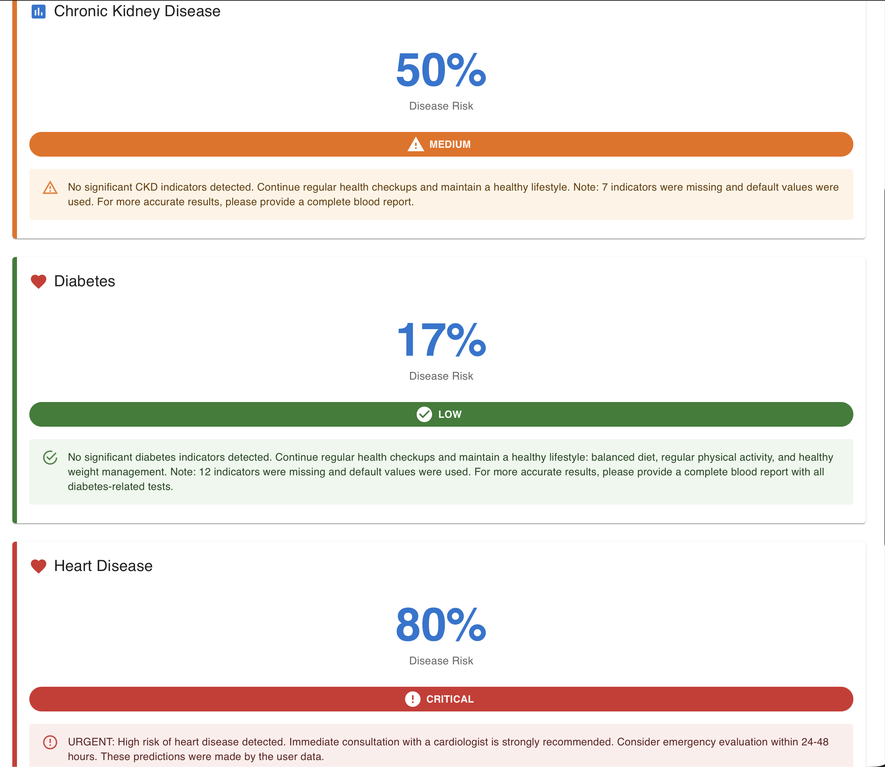
From your dashboard, recent predictions are displayed as cards. Each card shows:
- Disease Type: CKD, Diabetes, or Heart Disease
- Risk Percentage: 0-100%
- Risk Level with color coding:
  - 🟢 Green = Low Risk (0-40%)
  - 🟡 Yellow = Medium Risk (40-60%)
  - 🟠 Orange = High Risk (60-80%)
  - 🔴 Red = Critical Risk (80-100%)
- Prediction Result: Positive or Negative
- Date of Prediction

Blockchain Access Control
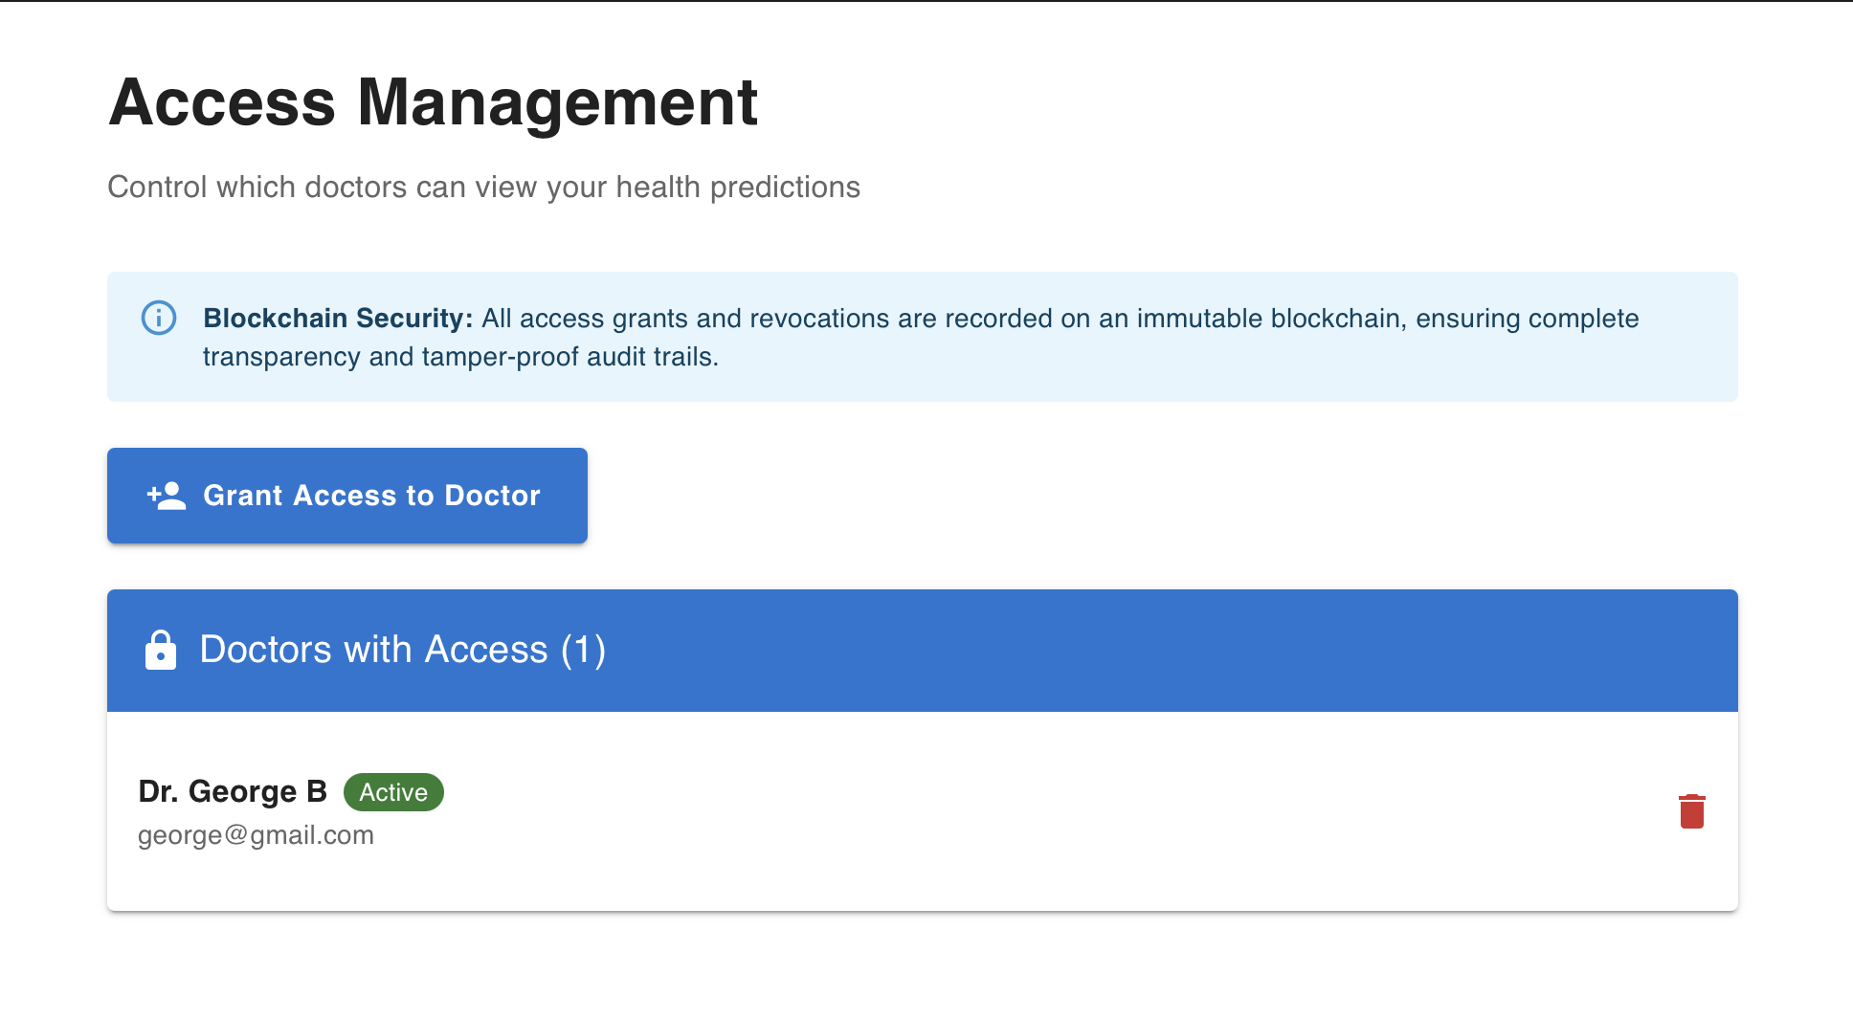
PranaChain uses blockchain technology to give you complete control over who can access your medical predictions. All access grants and revocations are recorded on an immutable blockchain, ensuring complete transparency and tamper-proof audit trails.
Granting Access to Doctors:
- Click the "Grant Access to Doctor" button
- Enter the doctor's email address
- Submit to grant access
The doctor can now view your predictions.
Revoking Access:
- Simply click the red bin icon next to any doctor's name in the "Doctors with Access" list
- The doctor immediately loses access to your predictions
Key Points:
- You have full control over who sees your data
- All access changes are permanently recorded on blockchain
- Doctors can only see predictions you explicitly share
- Access can be granted or revoked instantly at any time

1.3 Doctor Dashboard

Accessing Patient Predictions
Doctors can view all predictions that patients have granted them access to. From the dashboard, you'll see:
- Patient name and disease type
- Risk level and prediction date
- Confidence score
Click on any prediction to view detailed analysis.

Viewing Detailed Predictions
When viewing a patient's prediction, you'll see:
A. Patient Medical Indicators Table
- Complete list of all blood test values and health profile data
- Each indicator shows its value and status (Normal/Abnormal/Risk Factor)
- Reference ranges for clinical interpretation

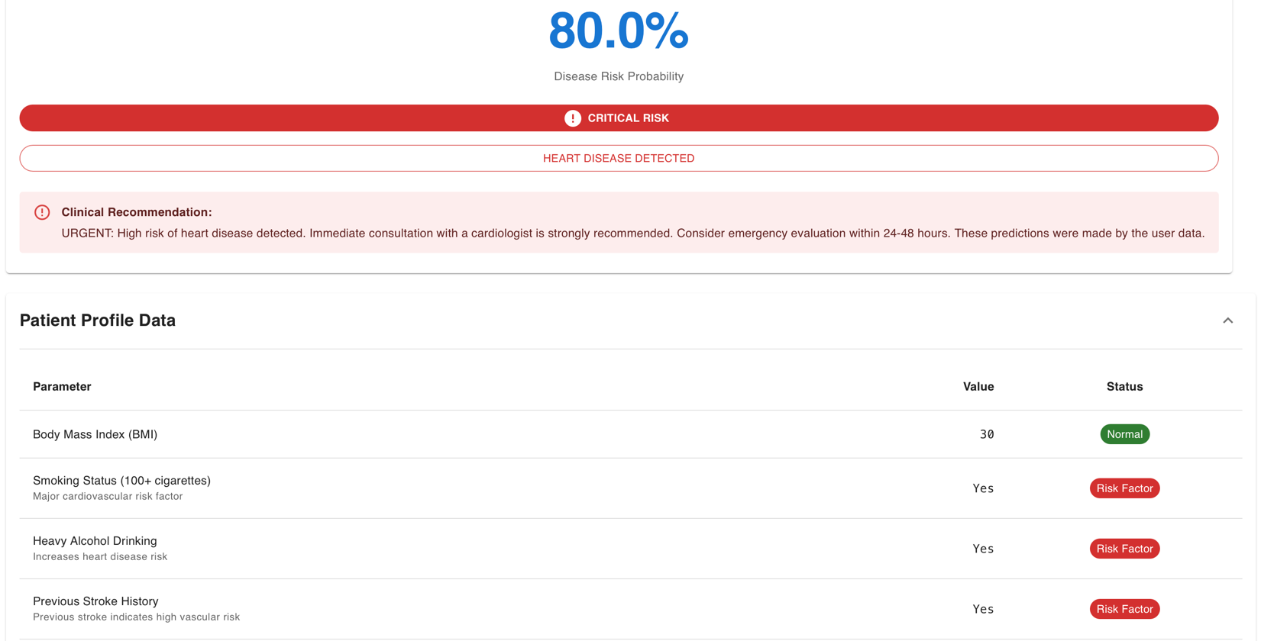

B. SHAP Explainability Charts (CKD & Diabetes)
SHAP (SHapley Additive exPlanations) visualizations show which medical factors contributed most to the prediction:
- 🔴 Red Bars = Factors pushing TOWARD disease (risk factors)
- 🔵 Blue Bars = Factors pushing AWAY from disease (protective factors)
- Bar Length = Magnitude of impact
- Base Value = Average population risk
Example:
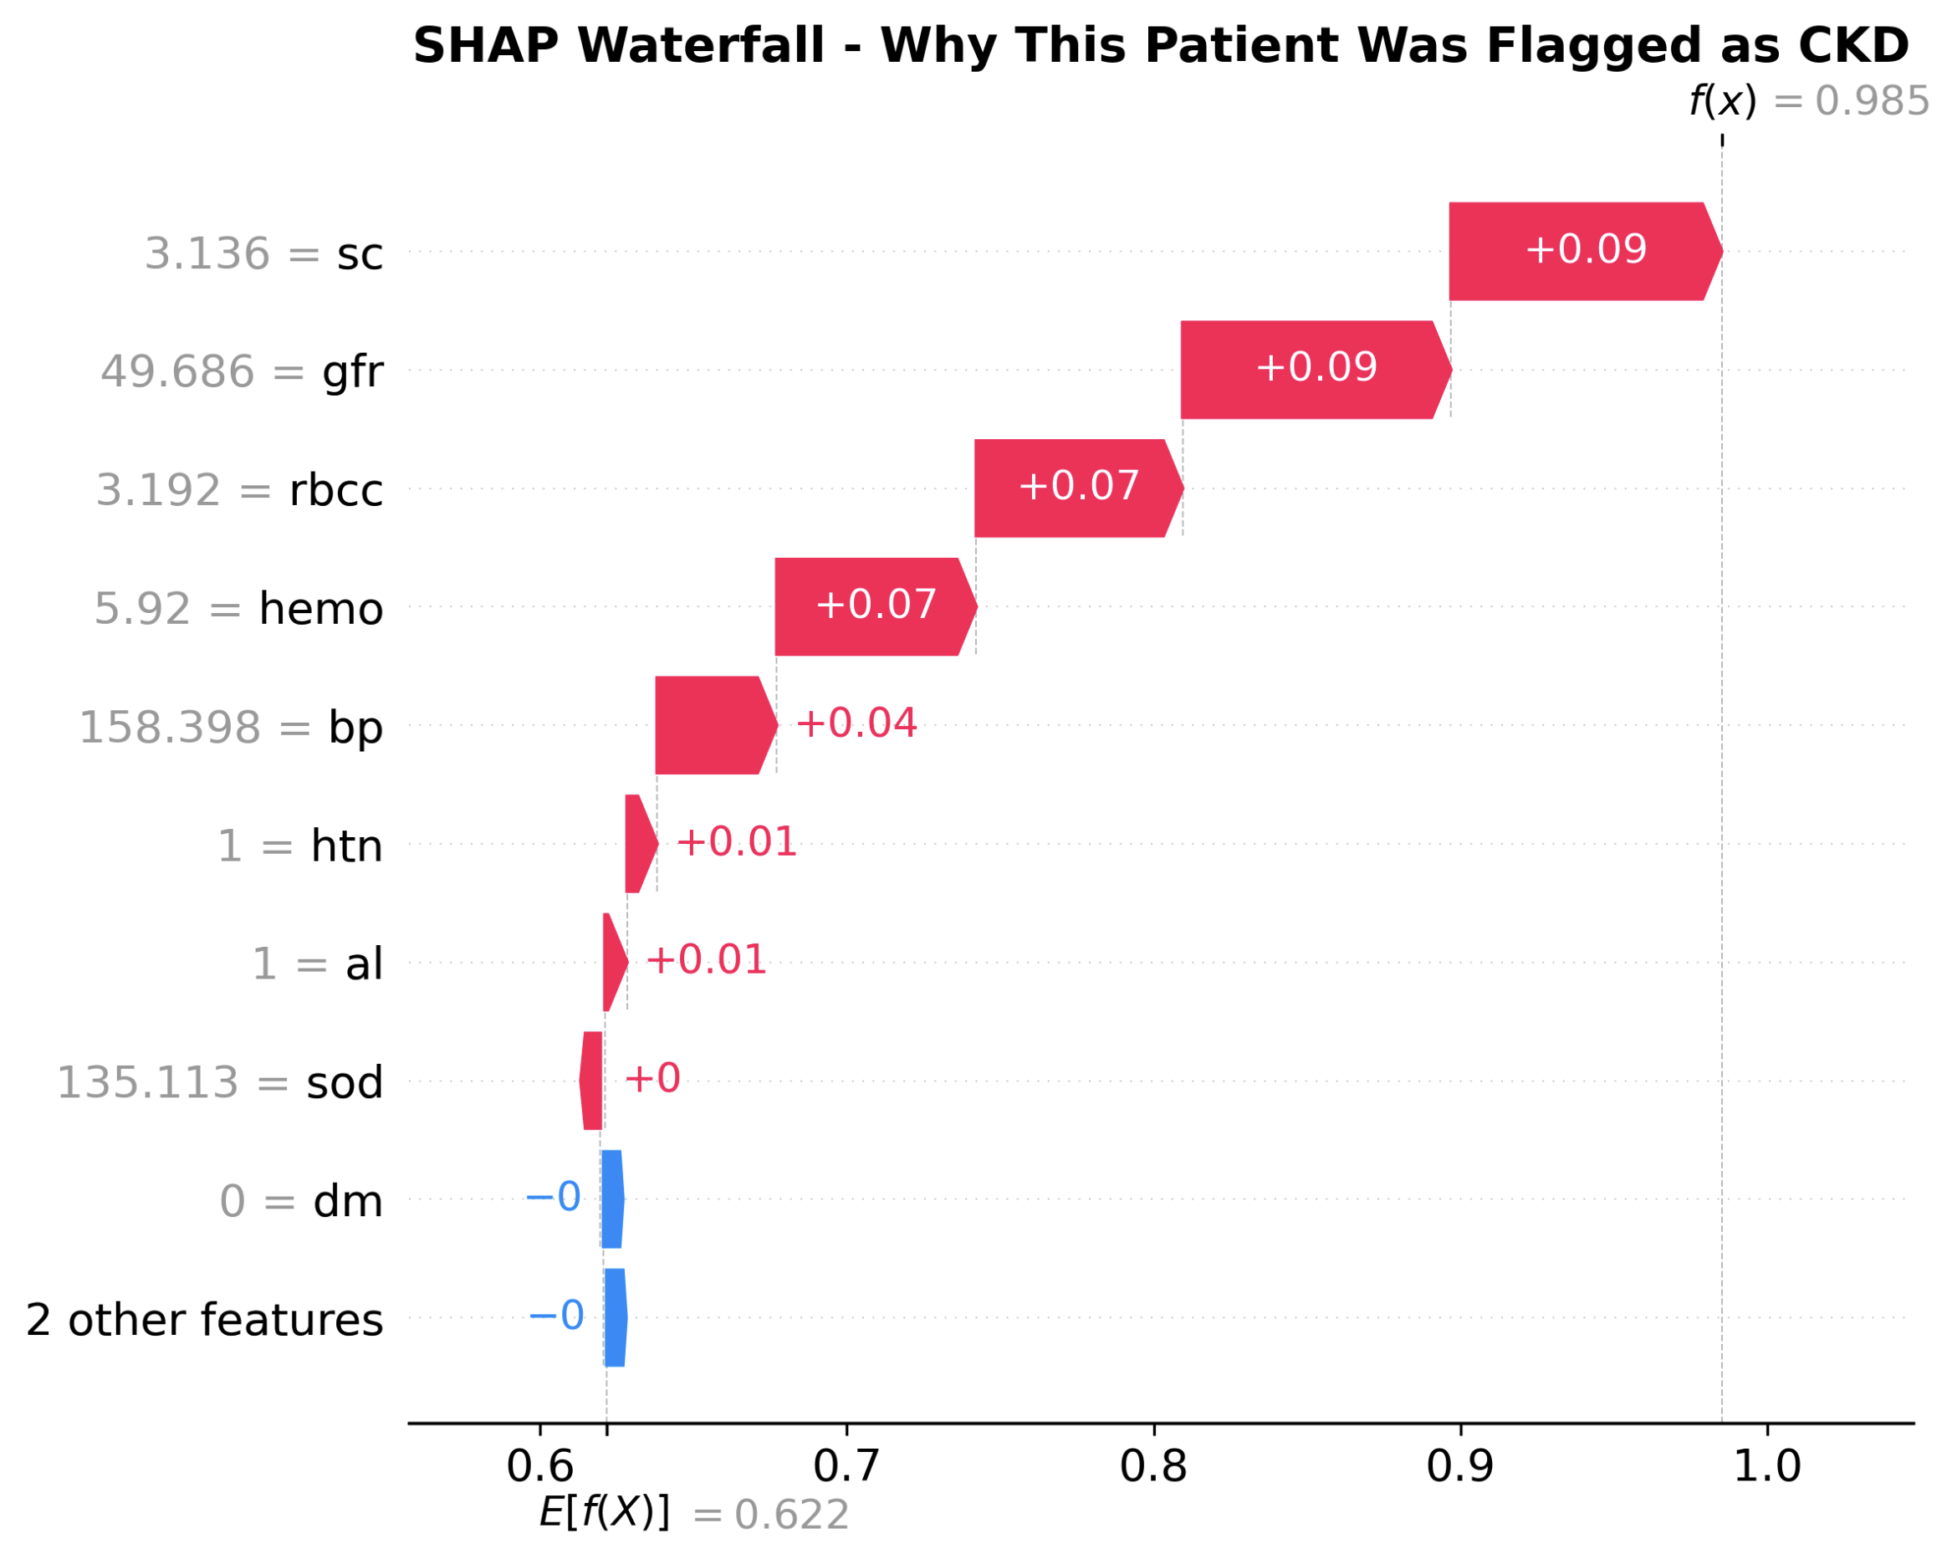

C. Feature Impact Charts (Heart Disease)
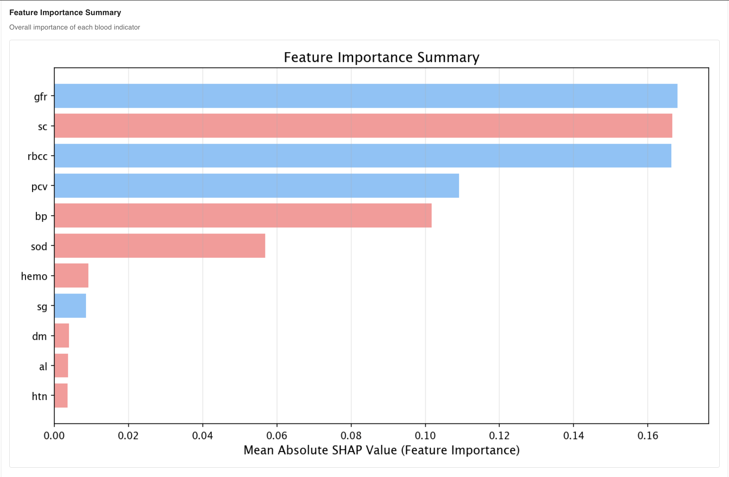
Heart Disease uses patient health profile data rather than blood tests. The chart displays:
- Numeric Health Indicators: BMI, sleep hours, poor health days
- Categorical Health Indicators: Smoking status, diabetes, medical history
These charts show the actual values used in the prediction, with risk factors highlighted.

Adding Clinical Notes
- While viewing a patient's prediction, scroll to "Clinical Notes" section
- Click "Add Notes"
- Enter your professional assessment:
  - Interpretation of AI results
  - Recommended follow-up tests
  - Treatment recommendations
  - Lifestyle modifications
- (Optional) Check "Mark as Reviewed"
- Click "Save Notes"
Your clinical notes will be visible to both you and the patient, promoting transparency and collaborative care.

2. Frequently Asked Questions (FAQs)
Q: How accurate are the AI predictions?
A: The machine learning models are trained on large medical datasets with accuracy rates of 85-95%. However, predictions are screening tools, not diagnoses. Always consult a doctor for medical decisions and proper diagnostic testing.
Q: What if my blood report doesn't have all indicators?
A: The OCR system extracts whatever indicators it can identify from your blood report. For any missing indicators, the model uses medically appropriate default values (typically healthy population averages). The system will flag which indicators were missing. For more accurate predictions, you can manually add missing values if you have that information.
Q: Is my medical data secure?
A: Yes. Your data is protected by:
- Industry-standard encryption (data at rest and in transit)
- Blockchain-based access control (immutable audit trail)
- HIPAA-compliant security practices
- Secure authentication and authorization
- You control who can access your predictions
Q: Can I share predictions with multiple doctors?
A: Yes. You can grant access to as many doctors as needed. Each doctor has independent access that you control separately. You can grant or revoke access to any doctor at any time through the "Manage Access" page.
Q: Can doctors see all my health information?
A: No. Doctors can only see predictions you explicitly grant them access to via the blockchain access control system. They cannot see:
- Predictions you haven't shared
- Your account password
- Other doctors you've granted access to
- Your access management settings
Q: Can I delete my predictions?
A: You can delete blood reports, which automatically deletes all associated predictions. Individual predictions cannot be deleted separately to maintain data integrity. To delete: View the report → Click "Delete Report" → Confirm. This action is permanent and cannot be undone.
Q: How long does prediction processing take?
A: Typically 30-60 seconds for all three diseases (CKD, Diabetes, and Heart Disease). Processing time depends on:
- File size and image quality (affects OCR extraction time)
- Server load
- Internet connection speed

3. GitHub Repository Link
Project Repository: github.com/ayeshmallick/PranaChain
Repository Contents:
- Final source code
- Complete documentation and README file
- Setup and installation instructions
- Testing guidelines

Disclaimer
⚠️ Important Medical Disclaimer
This platform provides screening predictions only, not medical diagnoses. Predictions are based on machine learning models and should be interpreted by qualified healthcare professionals.
Do NOT use predictions as the sole basis for medical decisions. Always consult a licensed physician for proper medical evaluation, diagnostic testing, and treatment.

End of User Manual
Document Version: 2.0 | Copyright © 2025 Group-16



