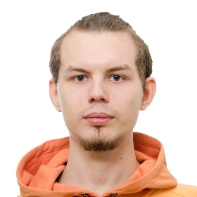

**Ivan Shorin**

[**https://www.linkedin.com/in/ivan-shorin-4949b3251/**](https://www.linkedin.com/in/ivan-shorin-4949b3251/)

Phone +7 (916) 180-00-17 Email: ishorin@icloud.com Discord: #8518

Portfolio: [**https://www.artstation.com/cheeseeater**](%20https://www.artstation.com/cheeseeater)

**education**

### **MIREA - Russian Technological University**

### Bachelor Program «Applied Informatics» Sep 2019 – Jun 2023

### Diploma theme «Designing information system for managing tasks in the field of providing services of 3D modelling».

**TECHNICAL SKILLS**

|  |  |  |
| --- | --- | --- |
| * Blender | * Zbrush | * Adobe Substance Painter |
| * Unreal Engine 5 | * Unity | * Adobe Premier Pro |
| * Photoshop | * Anatomy | * Optimization for game engines |
| * Grooms | * PBR | * Rigging and Skinning |
| * Animation | * Jira PM |  |

|  |  |
| --- | --- |
| **Material status** | **Foreign passport** |
| Single | till 2032 |

**Professional EXPERIENCE**

### **RTU IT LAB** Moscow, Russia

Junior 3D Artist 08/2020 – Present

* Create low poly props for multiple scenes in Unity for educational VR projects of Industrial companies. Props require to be with baked normal map and Ambient Occlusion. Moreover, one pack of props that contains no less than 10 objects need to have only one material with multiple tiles on UV.
* Create low poly characters with rig and animations for Unity. Characters also require to be with baked Normal map and Ambient Occlusion. All animations need to be separated for parts and after division 3D Artist have to make activity tree diagram in Figma for Unity developer.