**Name:** MUNJULURU VENKATA SAISRIJANA

**Roll No:** 22BFA05306

**Course:** Data Analytics with Tableau

1.Bar Chart

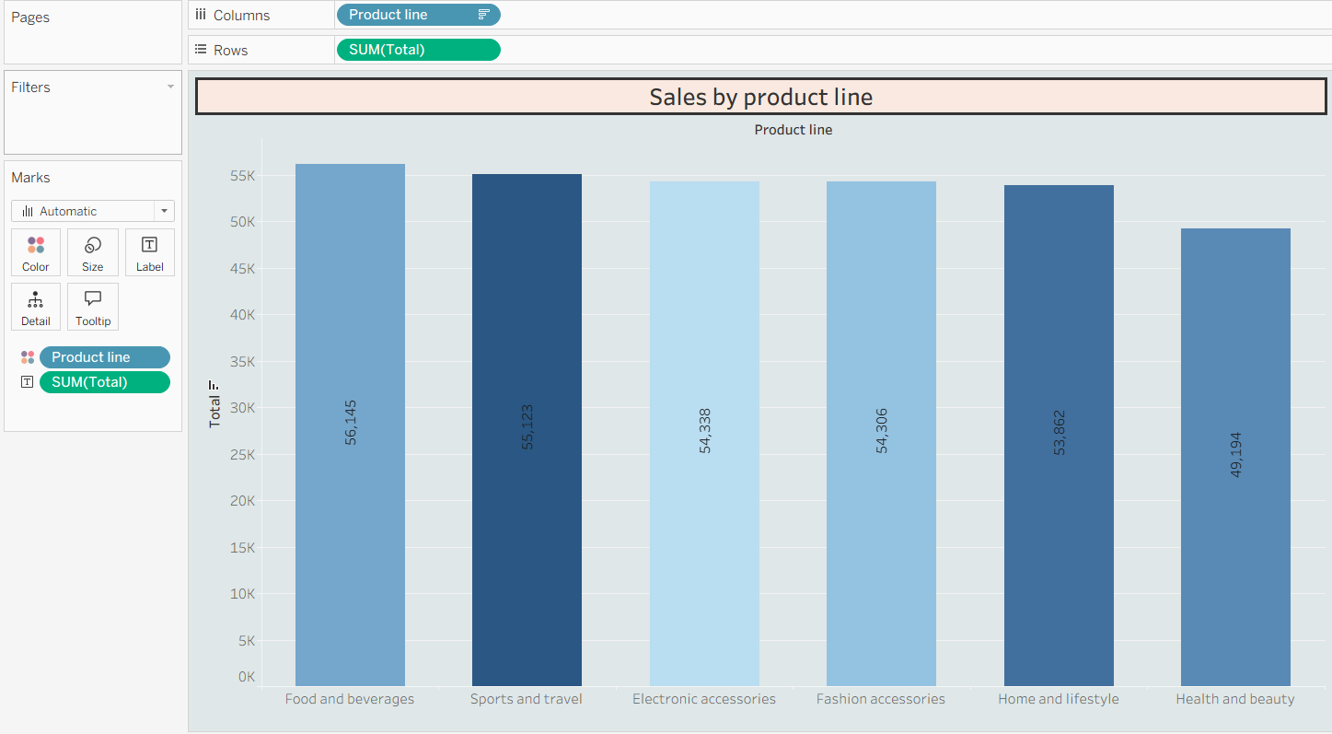

2. Pie Chart

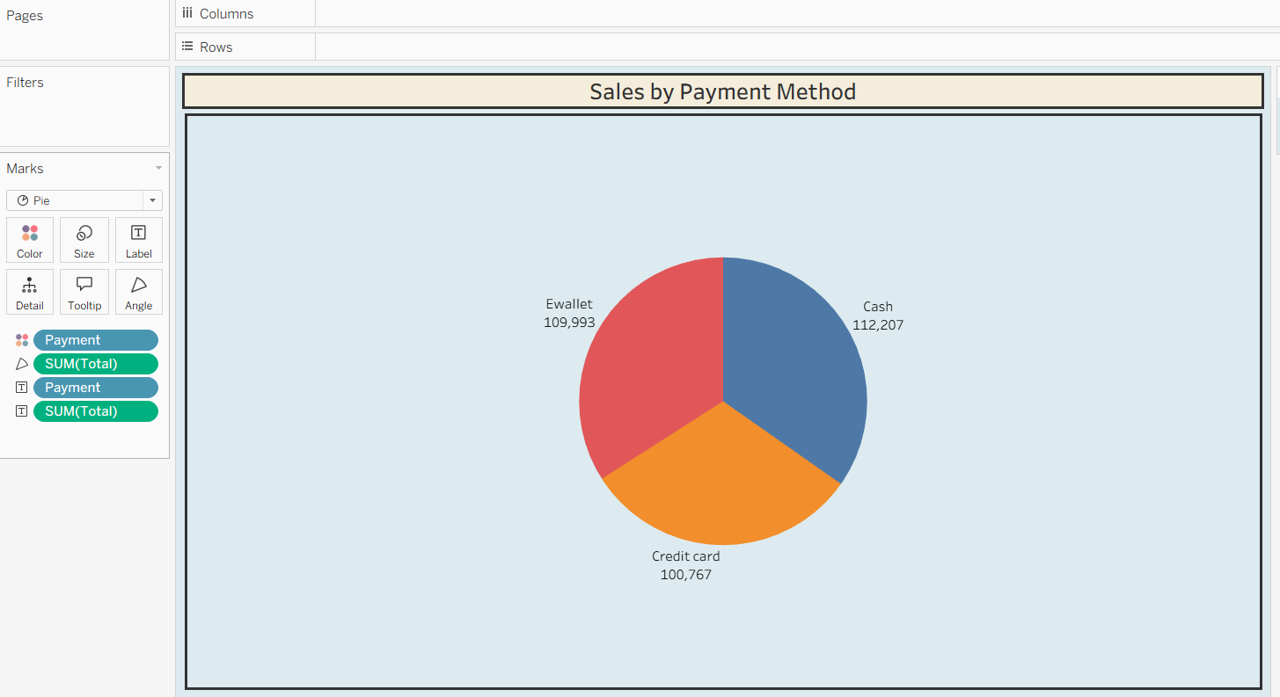

3. Stacked bar chart

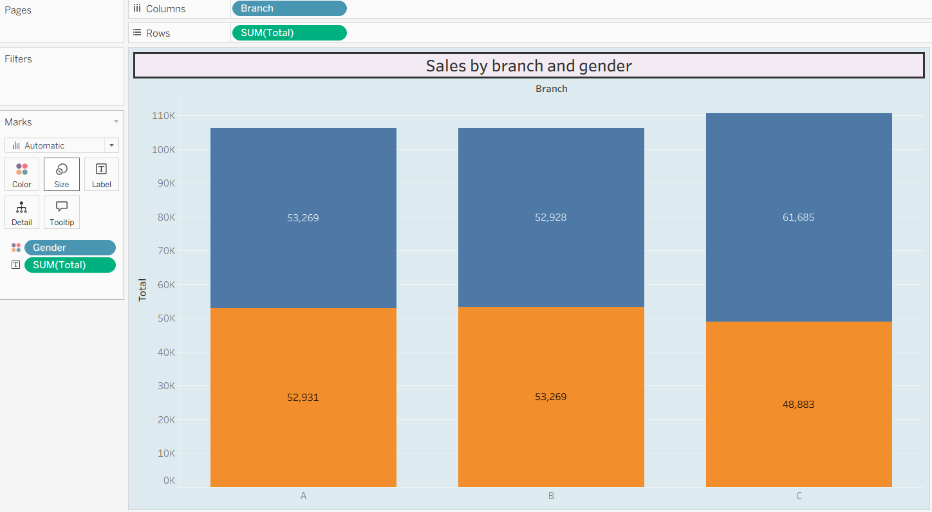

4. Line Chart

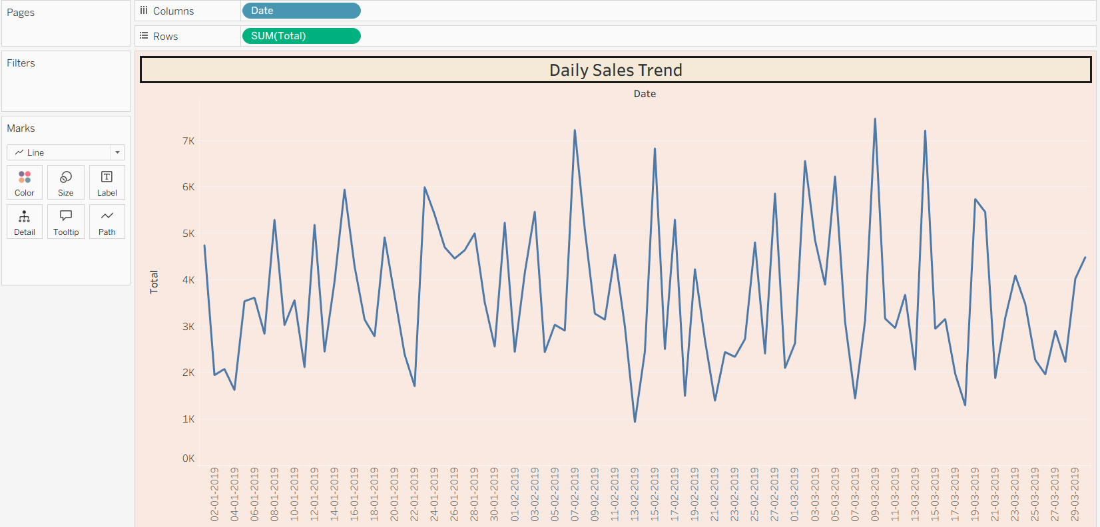

5. Bubble Chart

