**Name:** MUNJULURU VENKATA SAISRIJANA

**Roll No:** 22BFA05306

**Course:** Data Analytics with Tableau

1.Donut Chart

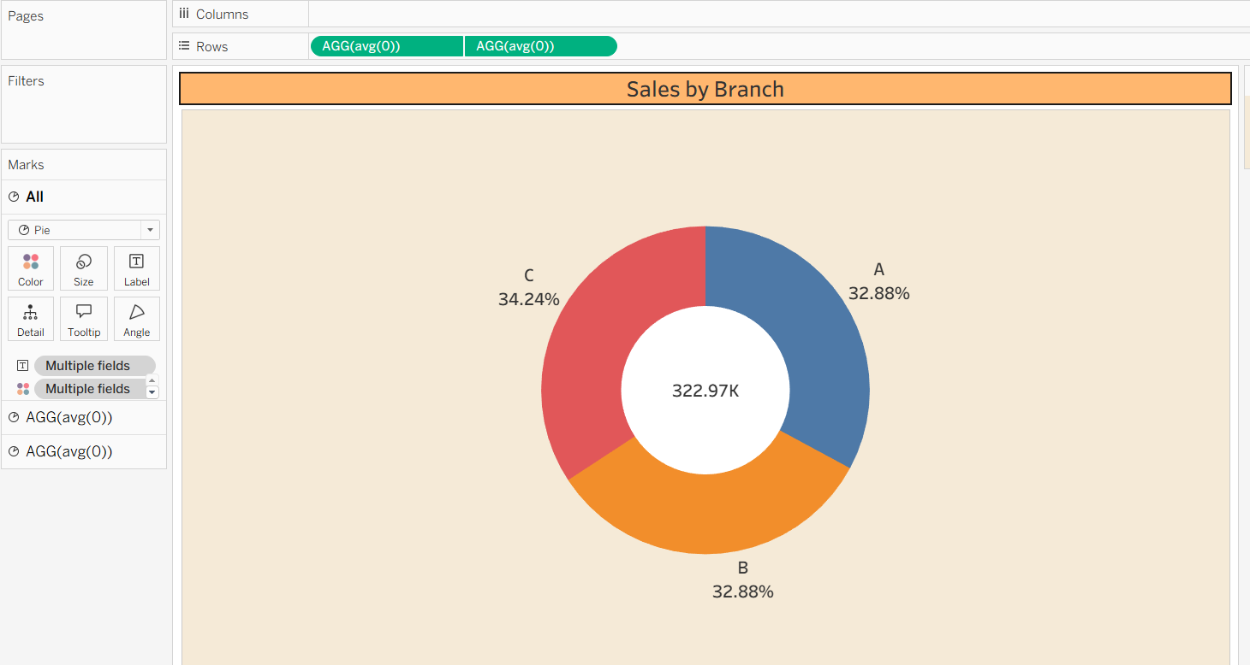

2. Area Chart

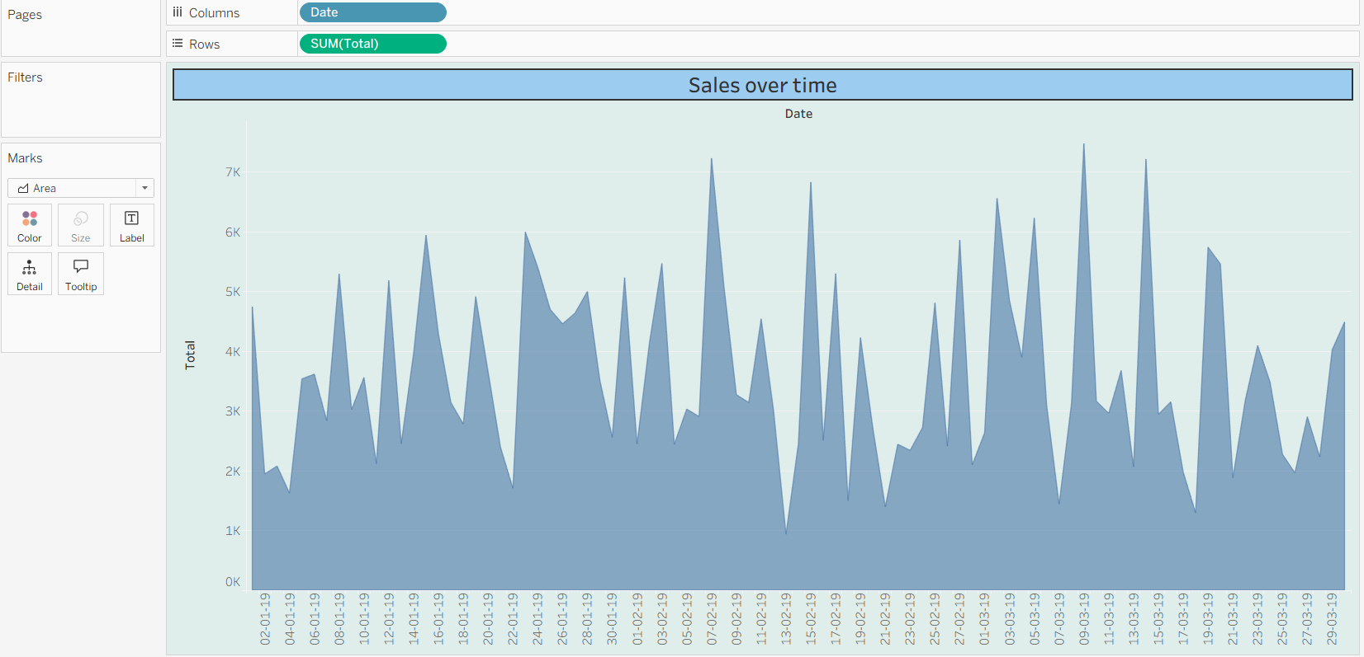

3. Text Table

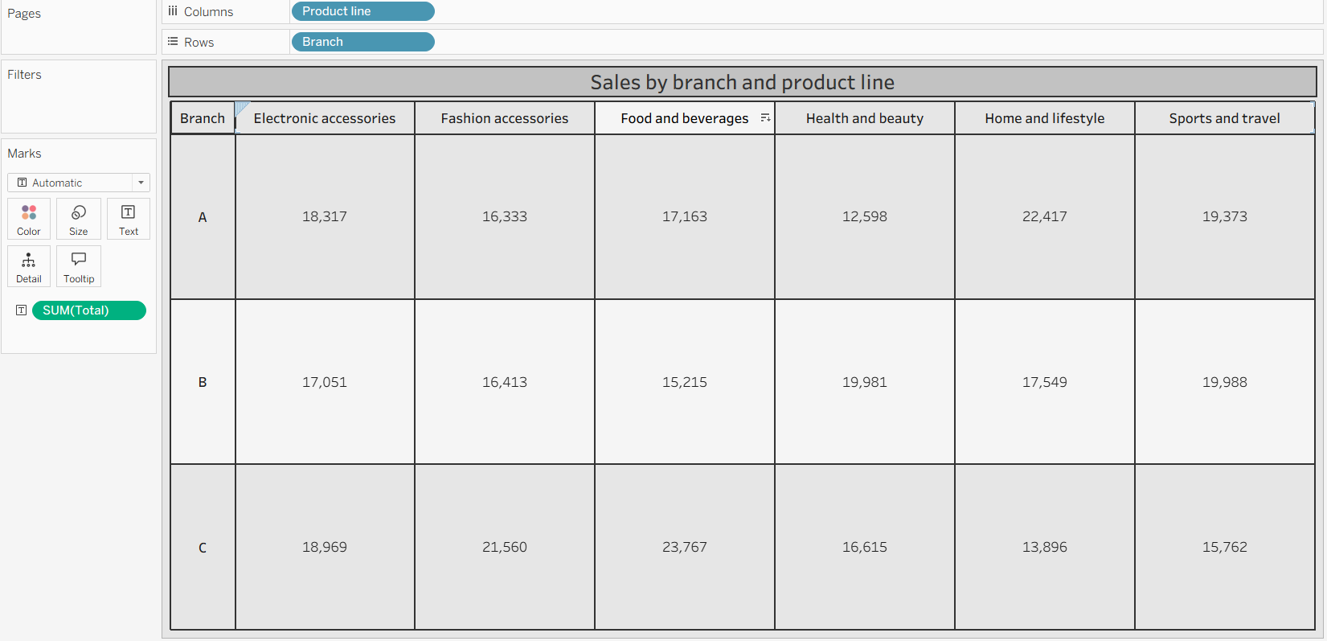

4. Highlight Table

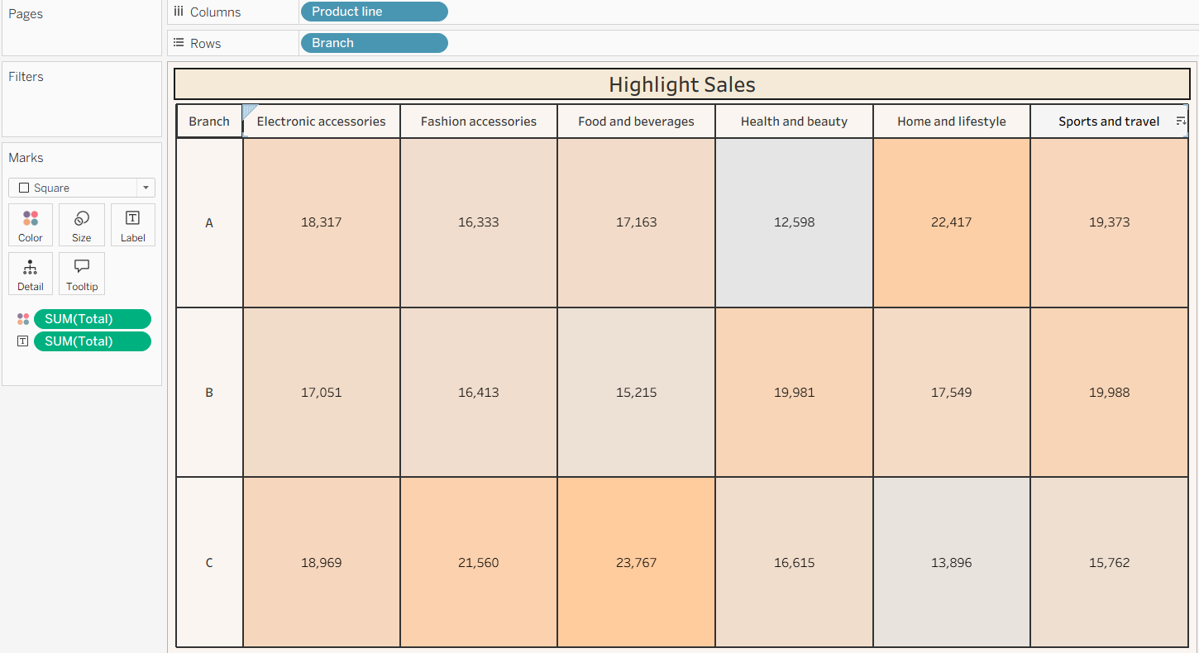

5. Word Cloud

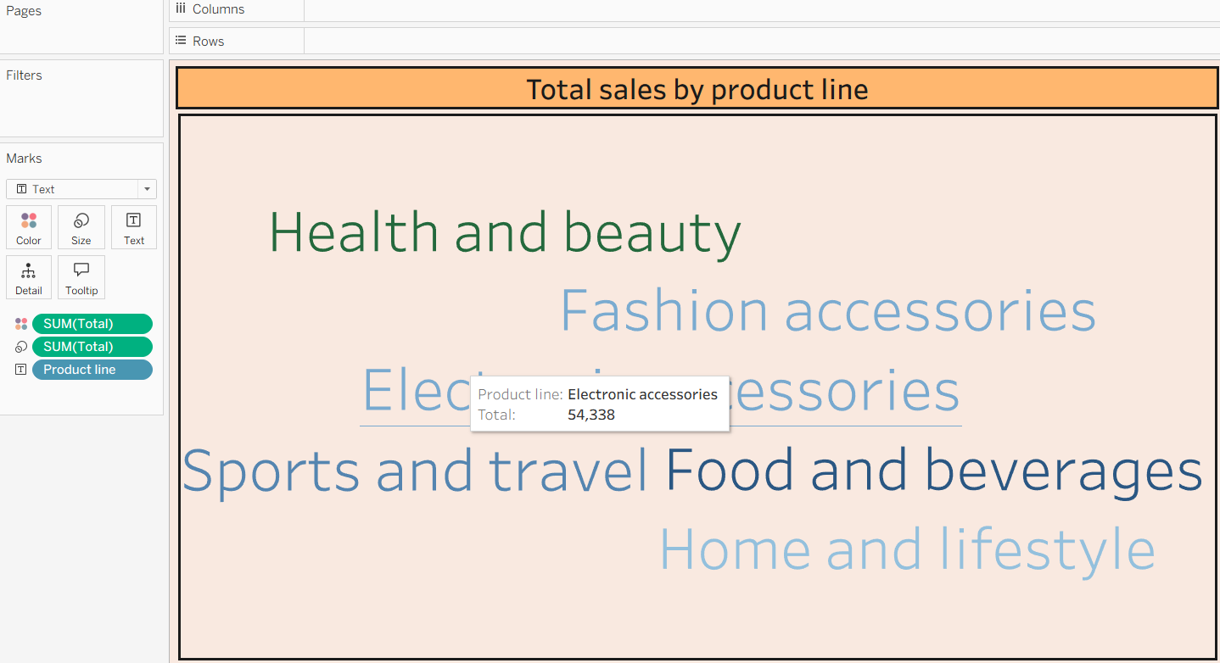

6. Funnel Chart

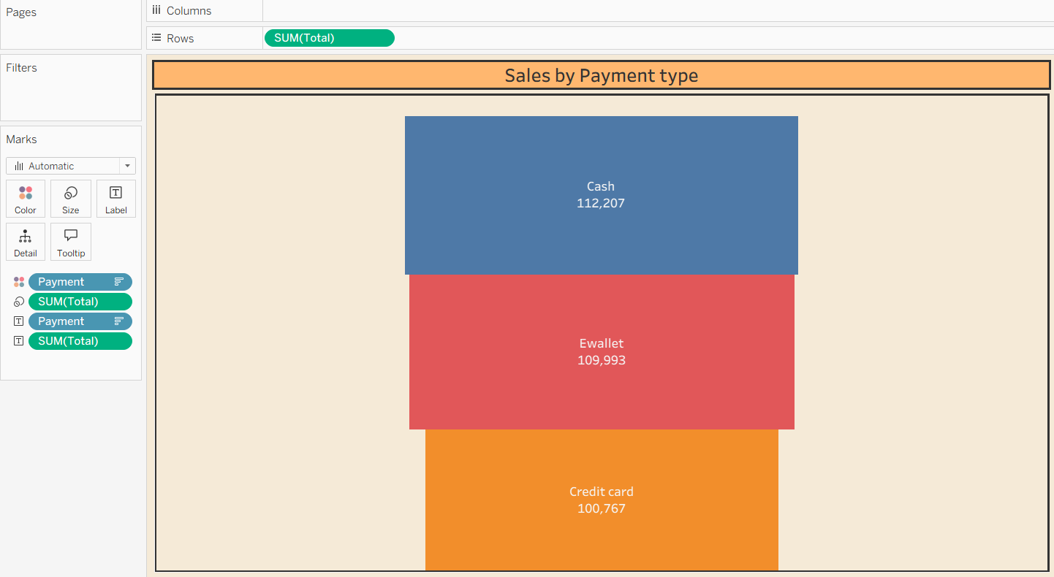

7. Waterfall Chart

