IT314 – Software Engineering

Group 27

Lab 5

Modelling Requirements into Activity Diagram

1. Identify the activities, actions, conditions for each of the sprints

**Activities:**

* Register
* Login as Individual
* Login as Organisation
* Go to Menu or Profile for Individual
* Go to Menu or Profile for Organisation
* Visit Event Page (for organisations only)

**Actions:**

* User visits
* Visit Registration Page
* Register as Individual
* Register as Organization
* Fill and submit the form
* Login as Individual
* Login as organisation
* Visit previous events section
* View previous event details
* Visit future events section
* View future event dates
* Visit ongoing events section
* Register as investor
* Register as startup
* Submit pitch for the start-up fundings
* View pitch of the startups
* View individual menu
* Chat with other users
* Choose whom to chat with
* Send message
* Visit home page
* View/interact with posts
* Create post
* Write content for post
* Provide title for post
* Visit hiring page
* View offers
* Register and submit job application
* Search for profiles
* View profiles
* Request to follow profile
* Visit idea sharing page
* Surf ideas
* Post ideas
* Visit organisation menu
* Visit the event page
* Visit job hiring page
* Enter job specifications
* Submit a job opening
* View applications for job

**Conditions:**

* If user is registered, direct to login page, else to registration page
* While registering, if the username is valid, create account and direct to login page, else direct to registration page
* If user wants to login as individual, redirect to individual login page, else go to login page
* If user wants to login as organisation, redirect to organisation login page, else go to login page
* If user wants to register for ongoing event, take them to the registration page
* If user wants to apply to a job opening, he can register
* If the searched profile exists, user can visit it, otherwise they need to search again
* If user follows a profile and wants to chat, he can chat with them, otherwise they can send request
* If user wants to follow a profile, they can send a request
* If an individual wants to visit profile of someone who shared their idea, he can view the profile
* If an organisation wants to visit hiring page, he can view applications

1. Develop activity diagram for each of the sprints

**Register and Login pages**

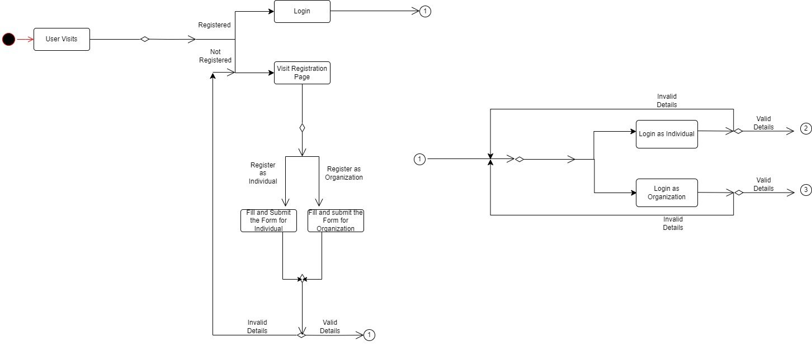

**Login as Individual**

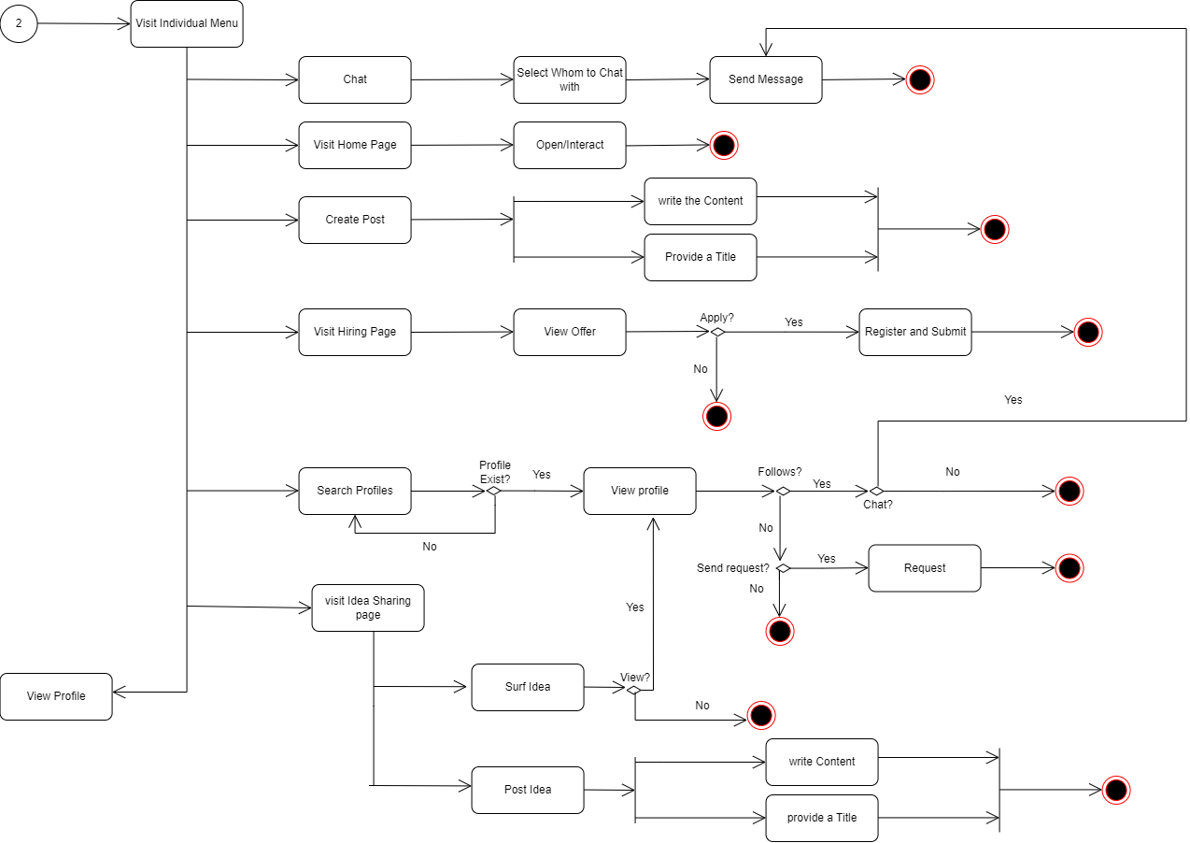

**Login as an Organisation**

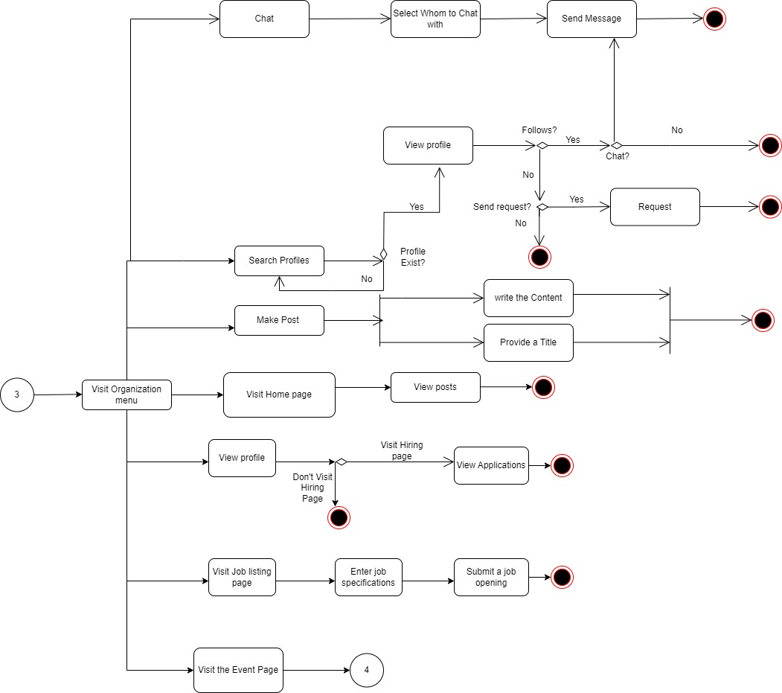

**Visit the Event Page**

