**Elementarium**

**Basic:**

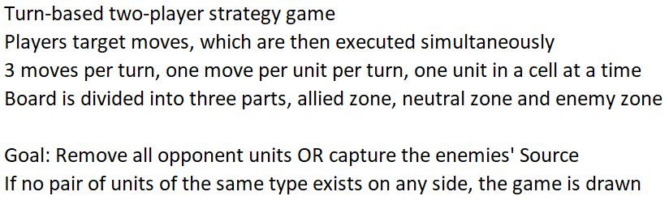

**Board:**

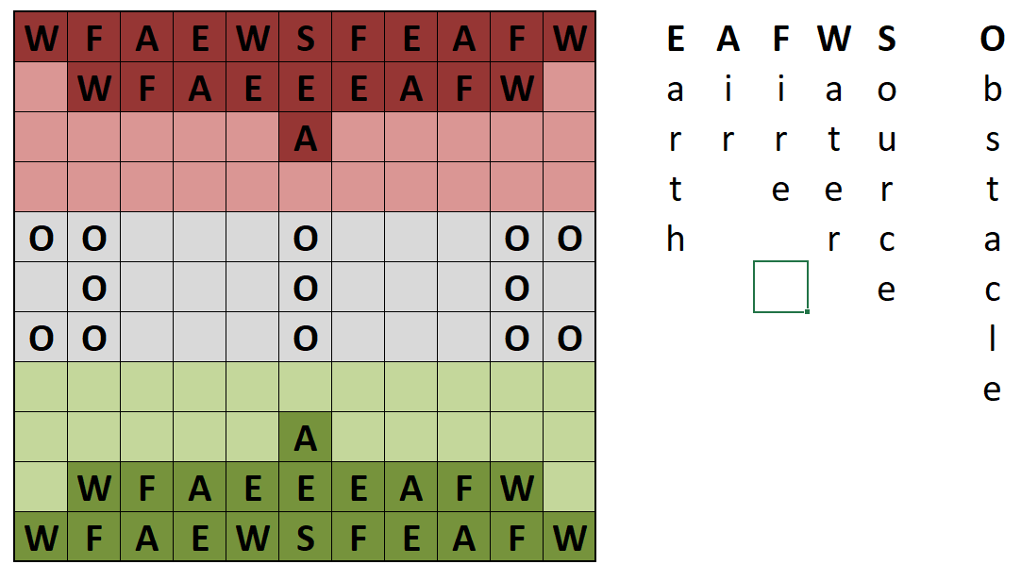

**Movement:**

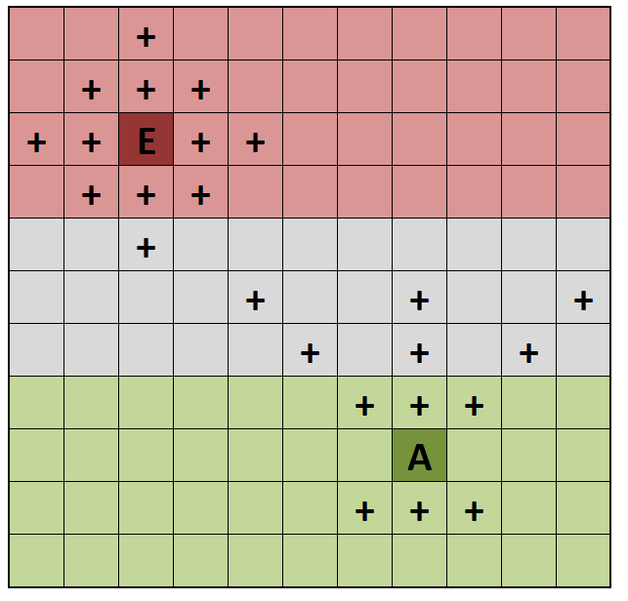 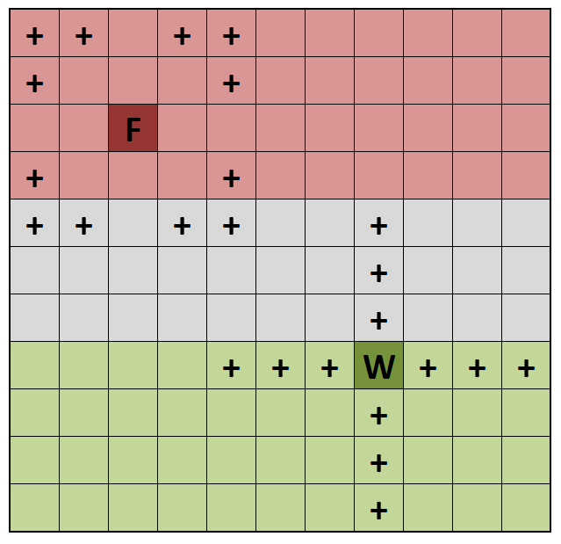

E-, A- and W-units can target enemy units, which are reachable without jumping over other units. Switching places of your own units allowed as far as the number of available moves and the movement patterns allow it.

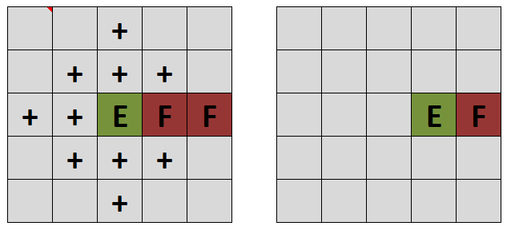

E-, A- and W-units can't jump over obstacles and units. Protecting your units with other units is possible this way.

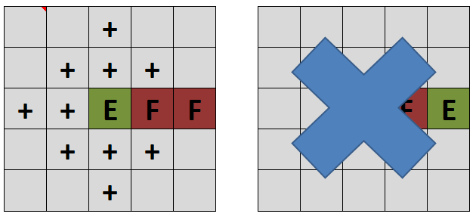

The F-unit is the only one, which can target fields over other units and jump over obstacles.

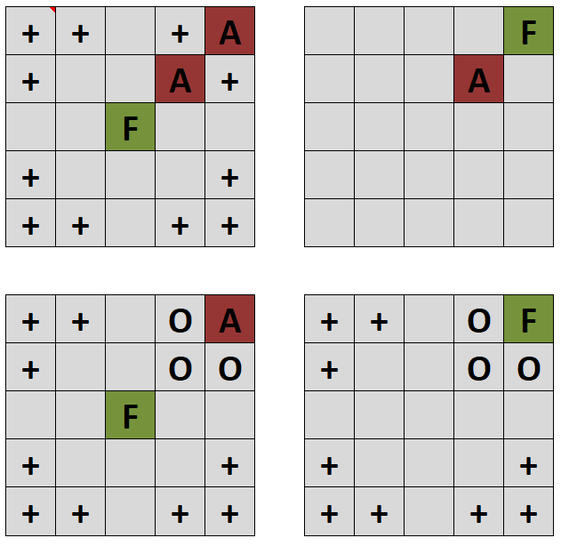

**Source:**

The source can move one field in any direction. The source can only move on friendly territory. If the source targets a field which an enemy's unit is also targeting, the enemy's move is cancelled (the unit remains on its position).

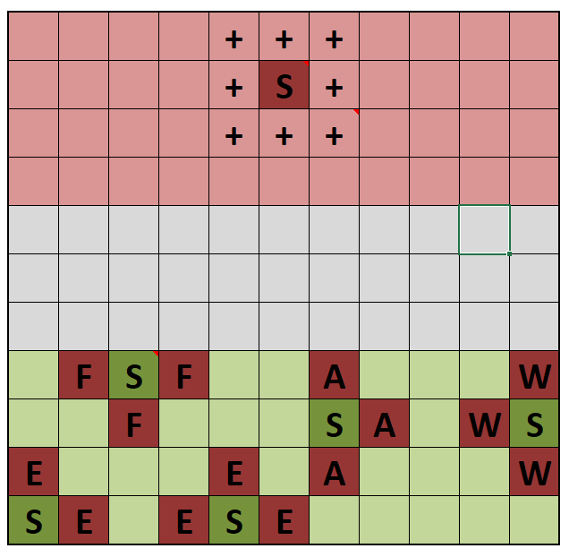

If a unit spawns on the enemy source, the source gets captured and the game ends with a win for the one who captured the enemy's source.

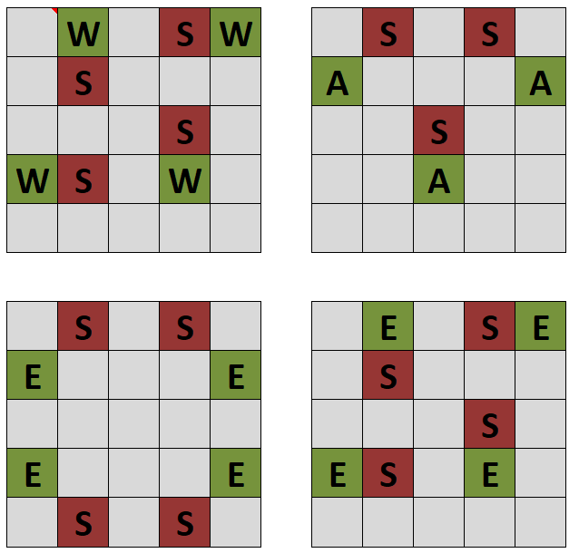

The enemiy's source can be blocked by placing an E-, A- or W-unit. F-units do not block the source. W-unit only blocks vertically and horizontally. A-unit only blocks in the direction of enemy. E-unit blocks in all directions.

**Capturing:**

When two units target the same field, the clash. In a clash, every unit has one it is dominating another one it is dominated by, and a neutral one, where both units are removed from the board. A clash with a unit of same type always results in removal of both.

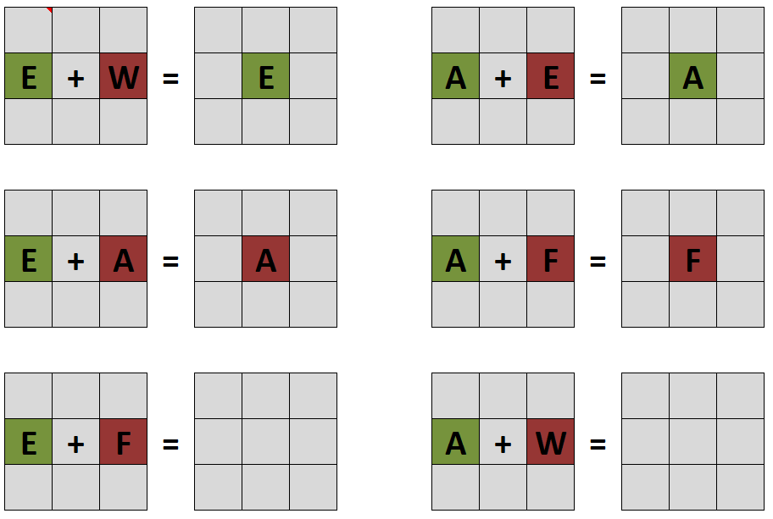

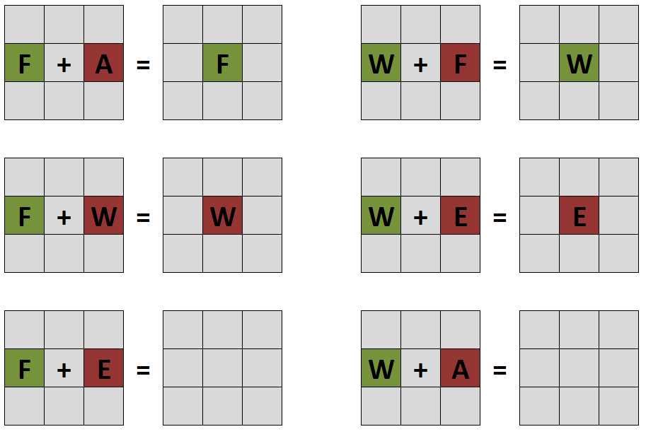

**Spawning:**

Building any of these patterns with units of the same type in the enemy zone spawns a unit of that type.

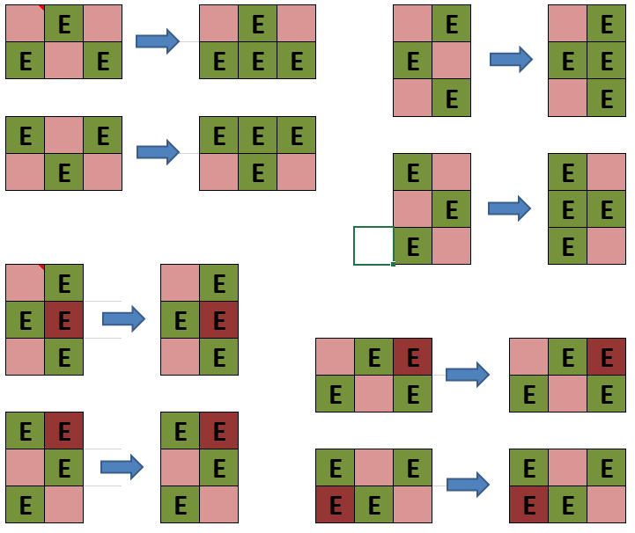

Spawning only works if no enemy unit is in the spawn range. One can block an enemy's spawn.

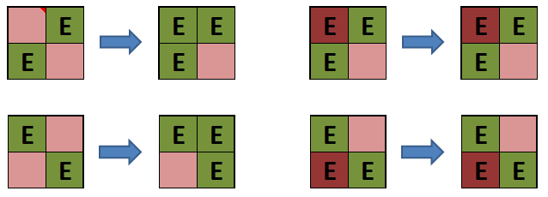

In the corners of the board, two units of the same type are enough to spawn a new unit.