<https://aliexpress.ru/item/4001343564945.html?_ga=2.243407045.1915488067.1633953984-919423421.1631208261&sku_id=10000015754768201&spm=a2g39.orderlist.0.0.4b534aa6TjNrHv>

**Introduction**

This is a binocular camera module which features dual IMX219 cameras onboard, 8Megapixels of each camera. It is suitable for AI vision applications like depth vision and stereo vision. The module supports NVIDIA Jetson Nano Developer Kit B01 version, as well as Raspberry Pi CM3/CM3+ expansion boards like Compute Module IO Board Plus, Compute Module POE Board, etc.

**Specifications**

1. 8 Megapixels 2. Sensor: Sony IMX219 3. Resolution: 3280 × 2464 (per camera) 4. Lens specifications: 4.1. CMOS size: 1/4inch 4.2. Focal Length: 2.6mm 4.3. Angle of View: 83/73/50 degree (diagonal/horizontal/vertical) 4.4. Distortion: <1% 4.5. Baseline Length: 60mm 5 ICM20948: 5.1 Accelerometer: 5.1.1 Resolution: 16-bit 5.1.2 Measuring Range (configurable): ±2, ±4, ±8, ±16g 5.1.3 Operating Current: 68.9uA 5.2 Gyroscope: 5.2.1 Resolution: 16-bit 5.2.2 Measuring Range (configurable): ±250, ±500, ±1000, ±2000°/sec 5.2.3 Operating Current: 1.23mA 5.3 Magnetometer: 5.3.1 Resolution: 16-bit 5.3.2 Measuring Range: ±4900μT 5.3.3 Operating Current: 90uA 6. Dimension: 24mm × 85mm

**Applications**

AI vision applications like depth vision and stereo vision.

**Example**

( the Jetson Nano board is not include )

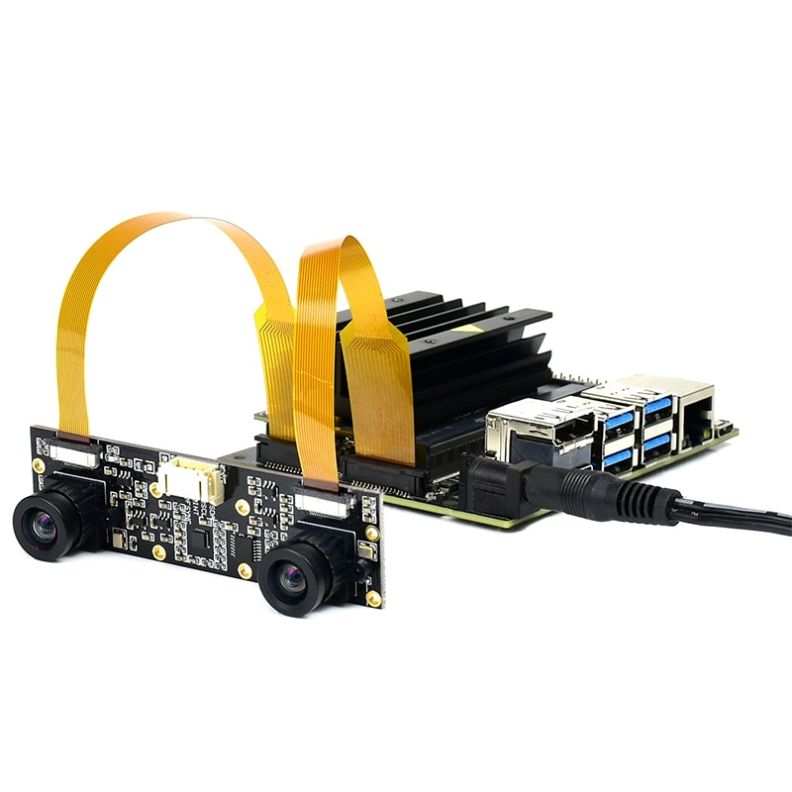

**Dimensions**

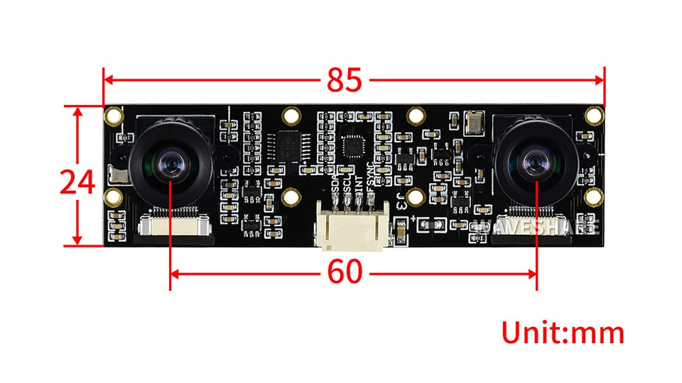

**How to Use**

Please refer to : www.waveshare.com/wiki/IMX219-83_Stereo_Camera

**Packing List :**

1 x IMX219-83 Stereo Camera 2 x FFC 1 x PH2.0 4PIN Wire

