<https://aliexpress.ru/item/4000927963388.html?spm=a2g39.orderlist.0.0.4b534aa6TjNrHv&_ga=2.243407045.1915488067.1633953984-919423421.1631208261>

Bundle1: Jetson nano dev kit B01  
Bundle2: Jetson nano dev kit B01 + 5V/5A Power Supply + 64GB TF Card  
Bundle3: Jetson nano dev kit B01 + 5V/5A Power Supply + 64GB TF Card + Dual-Band Wi-Fi + BT Module  
Bundle4: Jetson nano dev kit B01 + 5V/5A Power Supply + 64GB TF Card + Dual-Band Wi-Fi + BT Module + Raspberry Pi 8MP Camera Module

**Introduction**

NVIDIA Jetson Nano Developer Kit is a small, powerful computer that lets you run multiple neural networks in parallel for applications like image classification, object detection, segmentation, and speech processing. All in an easy-to-use platform that runs in as little as 5 watts.

Jetson Nano delivers 472 GFLOPS for running modern AI algorithms fast, with a quad-core 64-bit ARM CPU, a 128-core integrated NVIDIA GPU, as well as 4GB LPDDR4 memory. It runs multiple neural networks in parallel and processes several high-resolution sensors simultaneously.

Jetson Nano is also supported by NVIDIA JetPack, which includes a board support package (BSP), CUDA, cuDNN, and TensorRT software libraries for deep learning, computer vision, GPU computing, multimedia processing, and much more. The SDK also includes the ability to natively install popular open source Machine Learning (ML) frameworks such as TensorFlow, PyTorch, Caffe / Caffe2, Keras, and MXNet, enables the developers to integrate their favorite AI model / AI framework into products fast and easily.

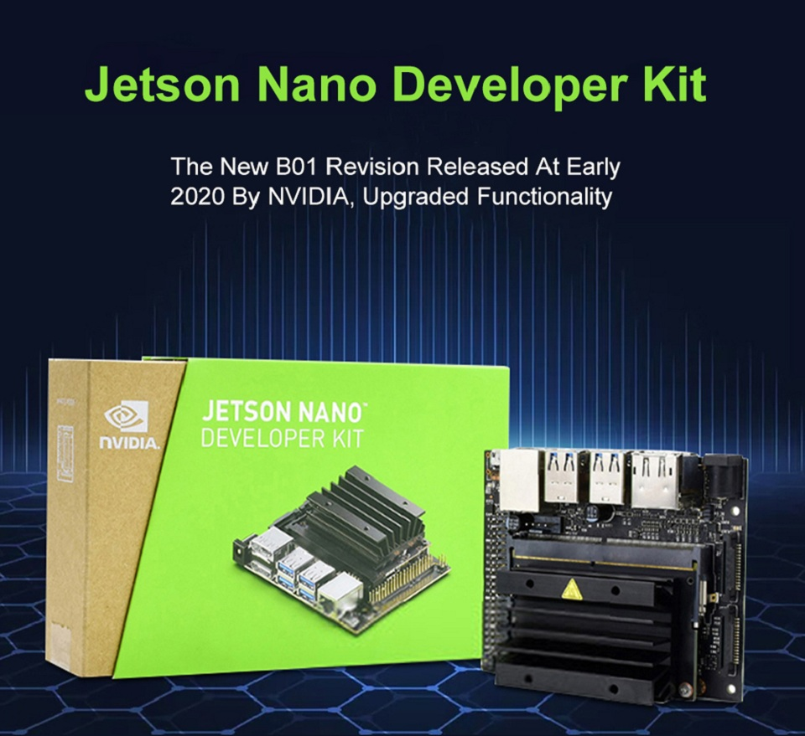

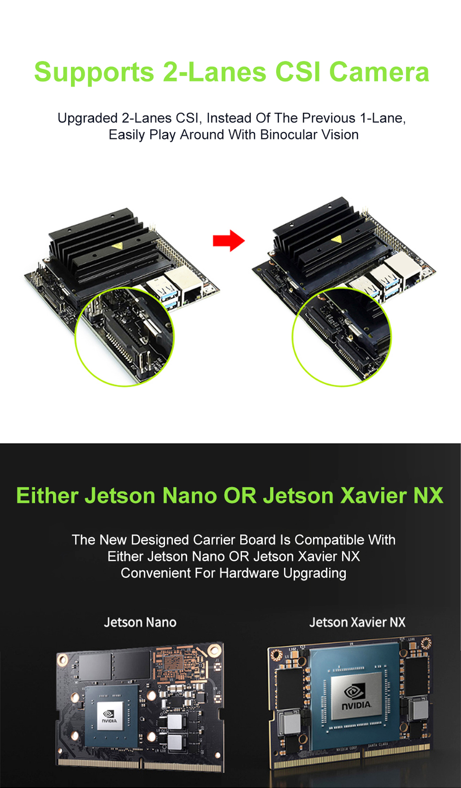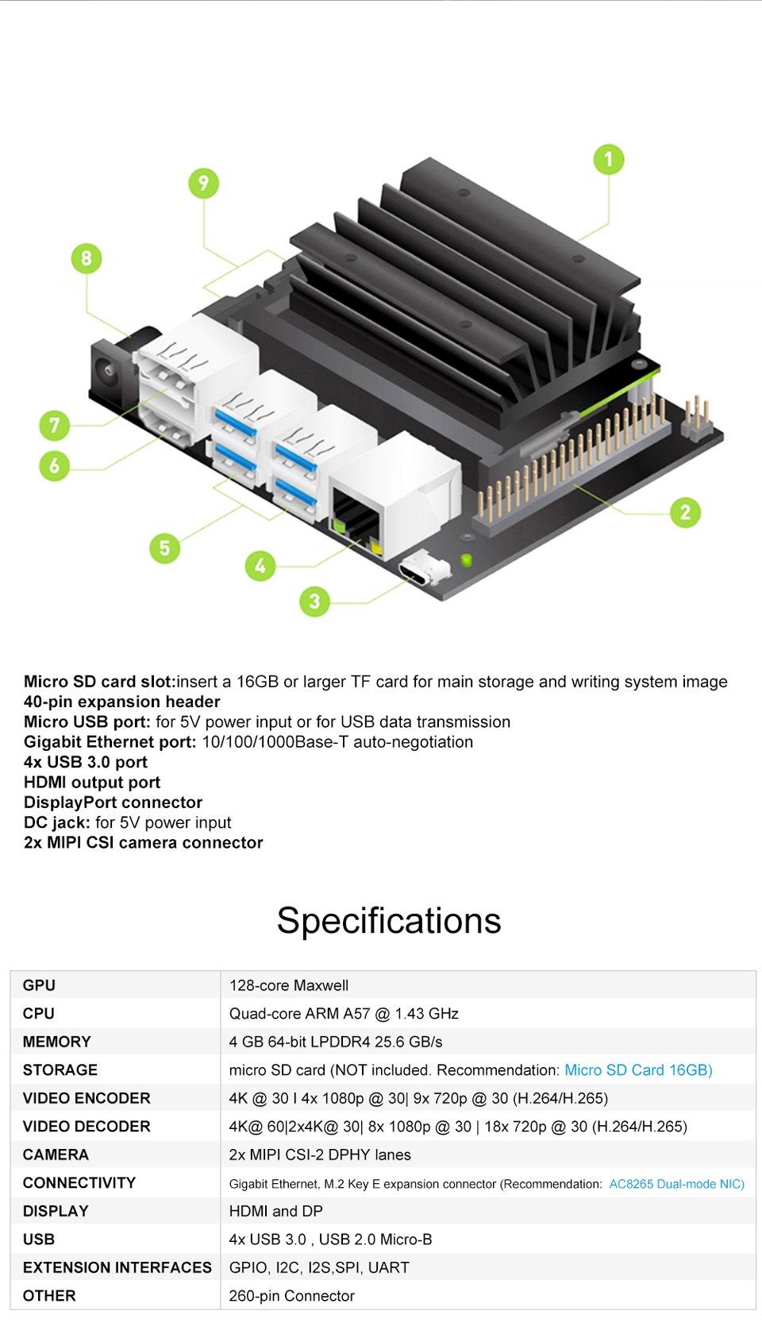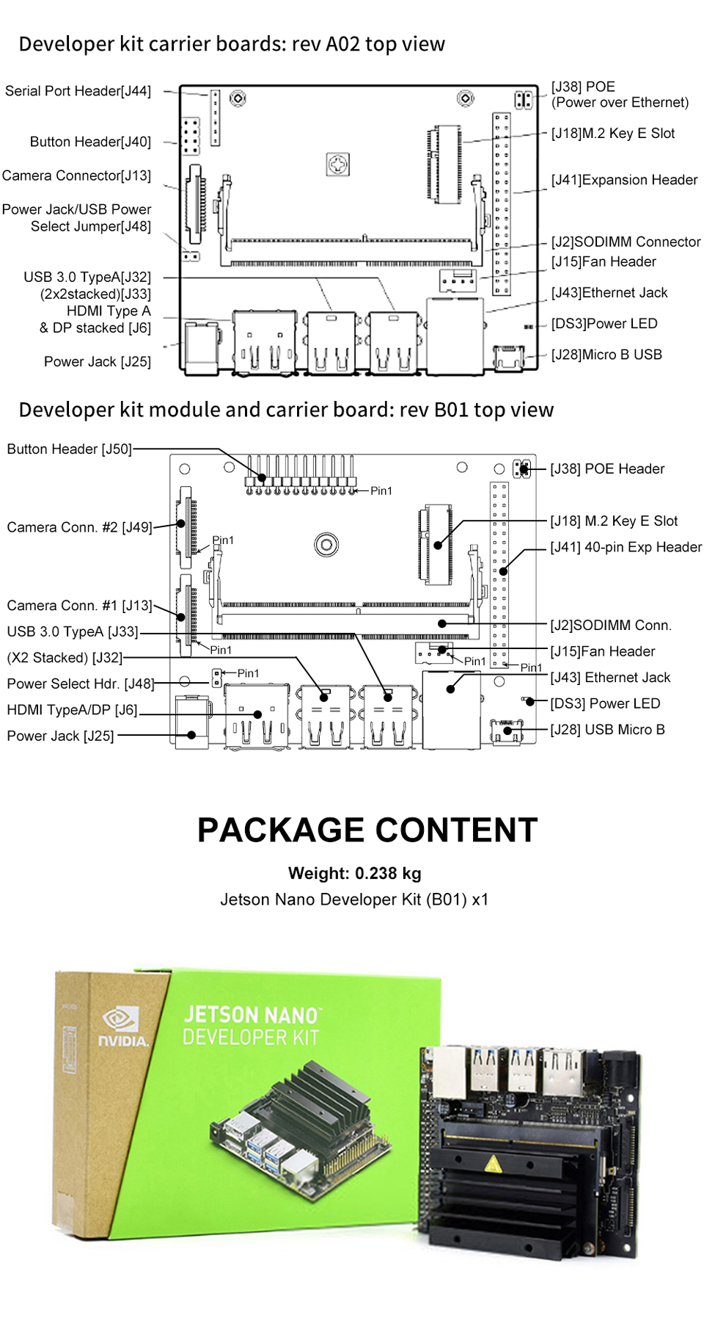

**Shipping List**

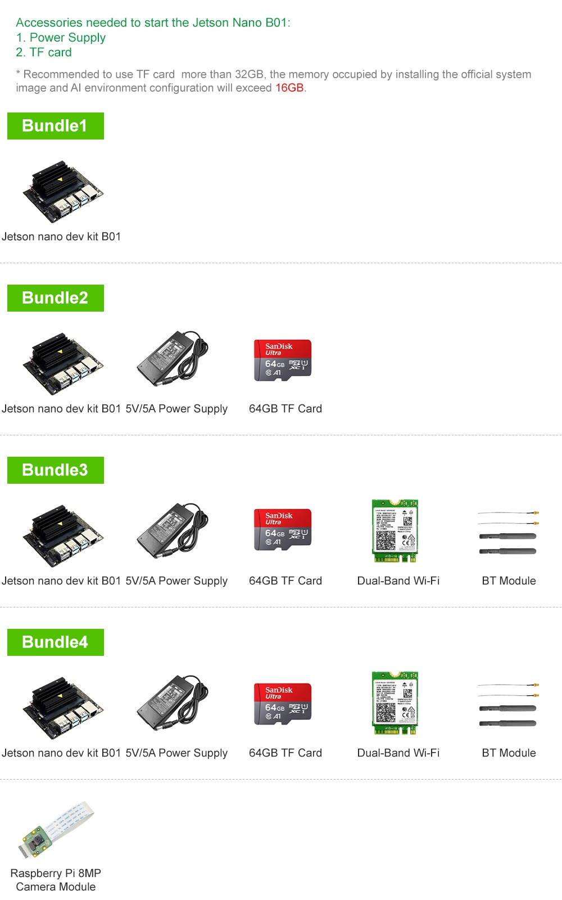

Technical Support

Expert Support: support@ smartfire.cn   Skype: smartfire_cn

Product Customization: support@ smartfire.cn

**Payment**

1. If the payment is not available, your order will be closed automatically.  
2. Seller are responsible for any insurance , problems and damage which caused by shipping service such accidents, delays or other issues.Besides the buyer should to be responsible for any tax and/or dutycharged by their country.

**Shipping Choice**

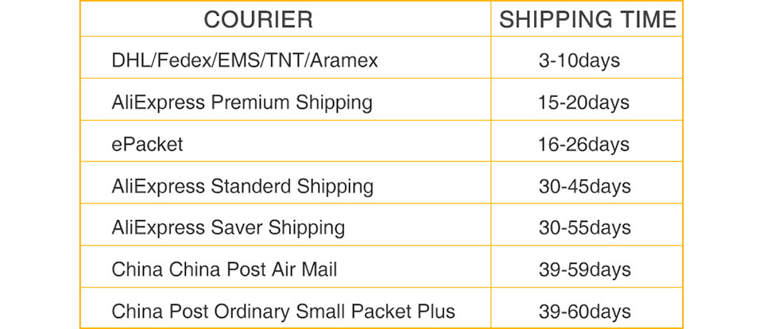

**Self-Help Shipping Guide**

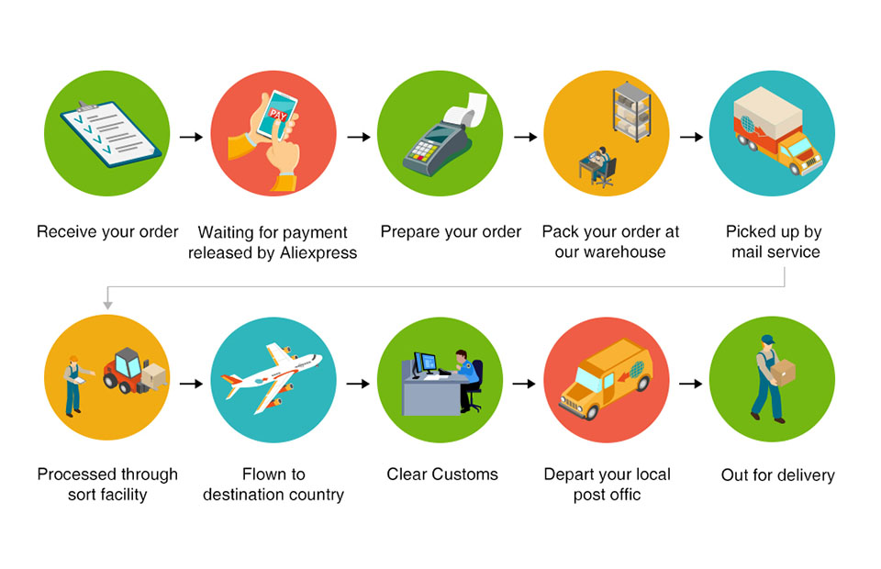

**Shipment**

1. All item will be shipped within 48 hours on receipt of cleared payment.(The earlier you pay, the earlier we ship your order.)  
2. If you need faster shipment, please choose DHL or EMS or FedEx IP(Shipping fare paid by yourself). Or we will deliver via the default method.  
3. Please make sure that your shipping address is 100% correct  
4. We ship items to worldwide with delivery time guarantee

**Contact us**

1.If you have any request please don't hesitate to contact us at first time we will help you and solve your issue within 24 hours.  
2. All emails will be answered within 1 business day. If you do not receive our reply, please kindly re-sent your email and we will reply you as soonas possible.  
3. Warranty services are for replacements only, any problem please kindly email us frist, we will accept your advise & request.



**Return&Refund**

1.Refund or resend new for any orders due to the product quality problem.  
2.We accept any unused item in its original package as return within 7 days of delivery. Buyers must provide the tracking number, specific reason forthe return.  
3. if it's buyer' s reason lead to the return package, buyers need to pay for round shipping fare.  
4. We will refund to buyer after we receive the returns in its original condition package. Or buyers could choose to have a replacement.

**FeedBack**

1.As your feedback is really important to us, please take a few minute to leave the positive feedback if you are satisfied with our products and service .Also we will do the same for you ASAP. Thanks!  
2. Please don't hesitate to contact us before you leaving negative or neutralfeedback. We will try our best to resolve your problem and meet your need.