https://aliexpress.ru/item/1005002037717159.html?spm=a2g39.orderlist.0.0.4b534aa6TjNrHv&\_ga=2.243407045.1915488067.1633953984-919423421.1631208261

Jetson Nano Metal Case

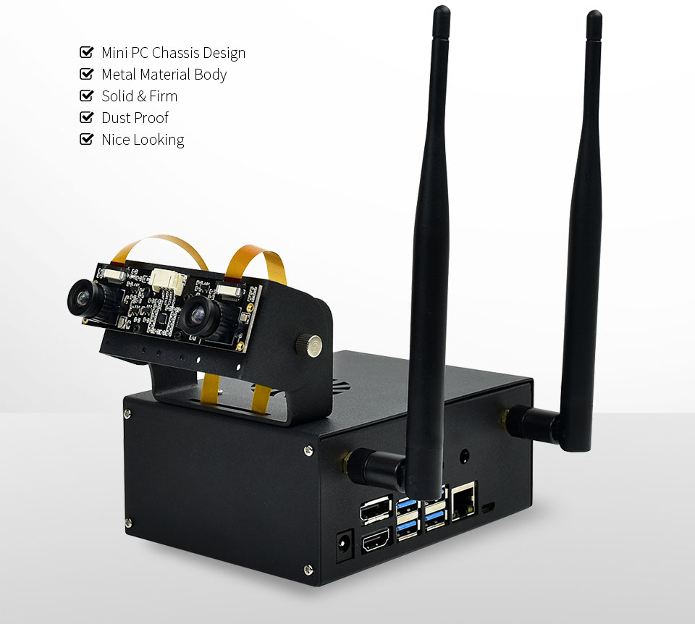Note : Nvidia Jetson Nano board is not include in packing

Special Camera Holder

Mounting Holes For Single Camera Or Binocular Camera, Up To 180° Roll Angle

Recommendation: [Single Camera](https://www.waveshare.com/catalog/category/view/id/385), [Binocular Camera](https://www.waveshare.com/imx219-83-stereo-camera.htm" \t "_blank)

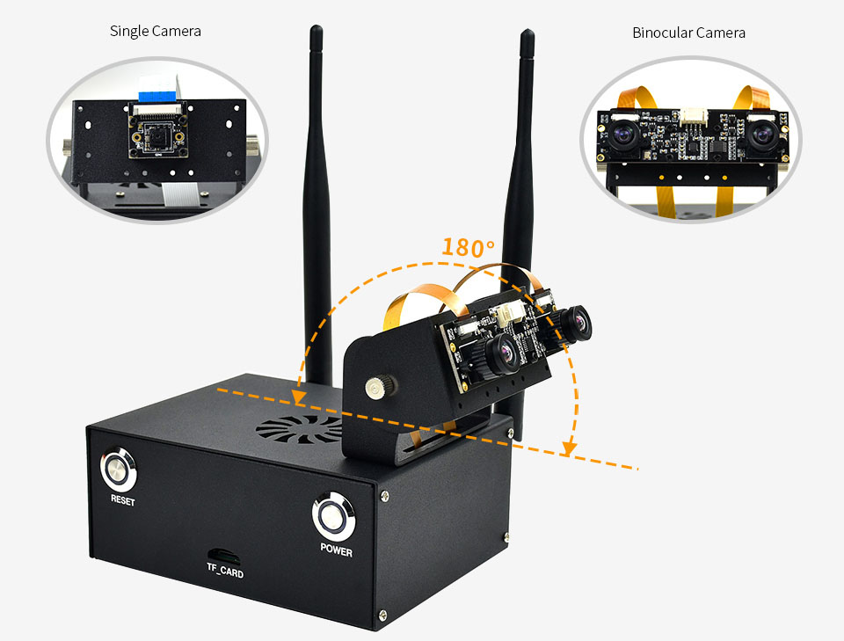

Please note that this camera only for Jetson Nano B01 version , not for A02 version

Invisible Cooling Fan

Heat Dissipation Through The Airflow Vent On The Top, More Elegant Design

Recommendation: [Fan-4020-PWM-5V](https://www.waveshare.com/Fan-4020-PWM-5V.htm)

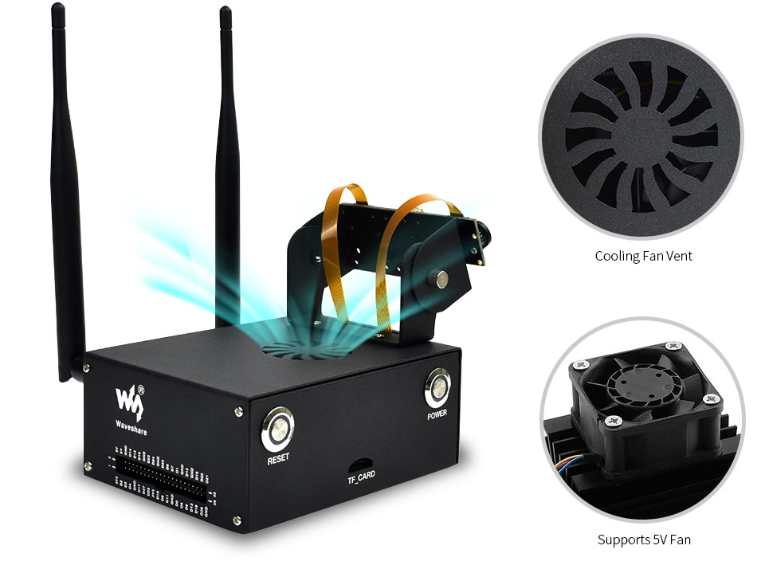

RESET And POWER Buttons

With System Status Indicator (B01 Only, NOT Available For The Original Version)

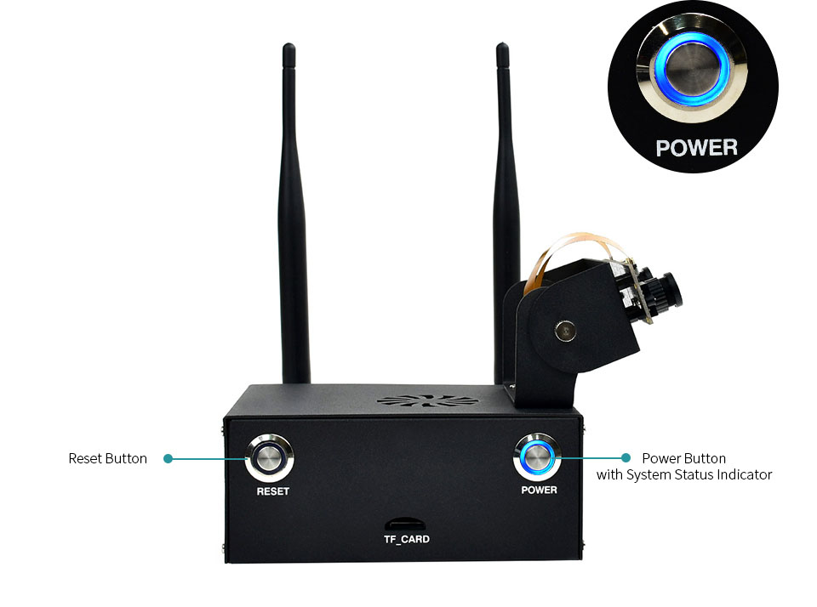

Enabling The 4G Communication

Allows Installing 4G Module Inside

Recommendation: [SIM7600G-H 4G for Jetson Nano](https://www.waveshare.com/SIM7600G-H-4G-for-Jetson-Nano.htm)

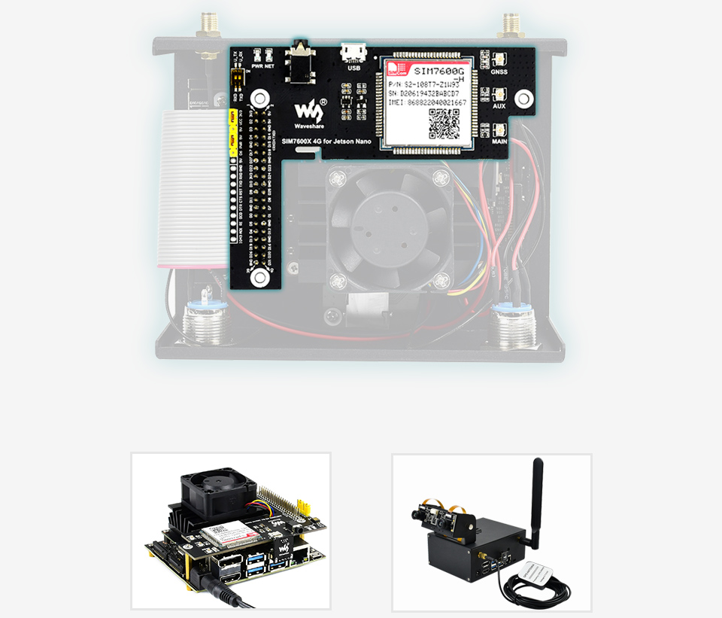

Precise Opening Design

Cut-Outs For GPIO Header, TF Card, And Peripheral Ports

Recommendation: [Wireless NIC with Dual Antennas](https://www.waveshare.com/Wireless-AC8265.htm)

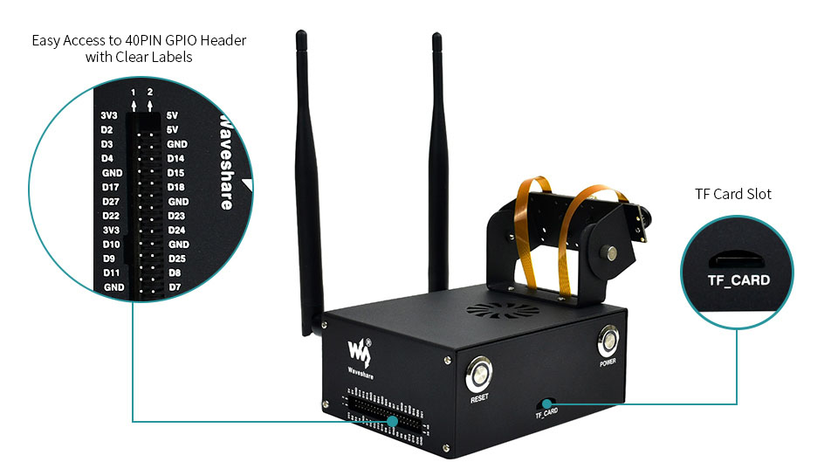 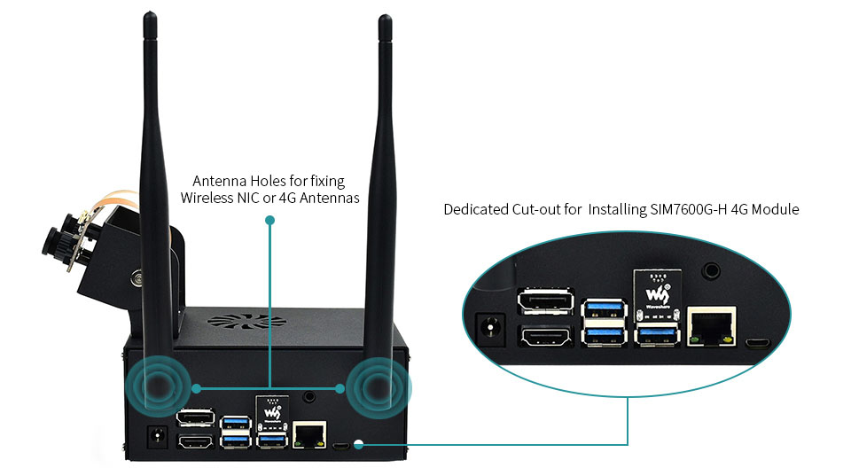

**Packing List:**

( do not include Jetson Nano board)

**Option 1 :**

1. 1x Body case (top and bottom)
2. 1 x Camera holder bottom mount
3. 1 x Camera holder top mount
4. 1 x Jetson Nano adapter board
5. 1 x Micro SD card adapter board
6. 1 x Flat ribbon cable 2\*20PIN
7. 1 x Spanner
8. 1 x Screwdriver
9. 1 x Button with 2PIN wires
10. 1 x Button with 4PIN wires
11. 1 x Screws pack
12. 1 x Jumper

( not include Jetson nano board )

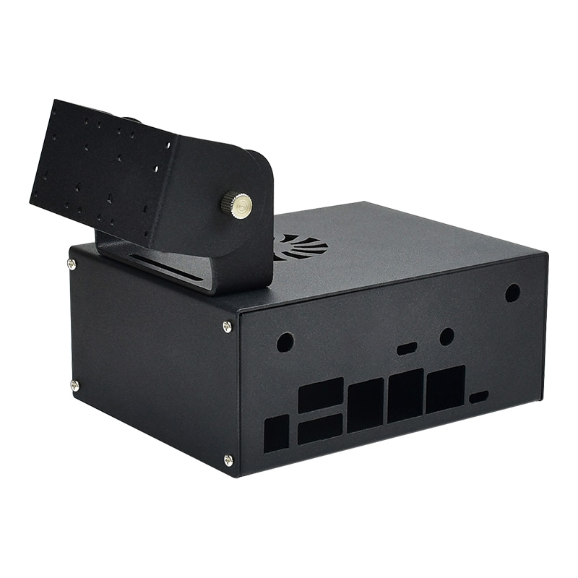

**Option 2 :**

1. 1x Body case (top and bottom)
2. 1 x Camera holder bottom mount
3. 1 x Camera holder top mount
4. 1 x Jetson Nano adapter board
5. 1 x Micro SD card adapter board
6. 1 x Flat ribbon cable 2\*20PIN
7. 1 x Spanner
8. 1 x Screwdriver
9. 1 x Button with 2PIN wires
10. 1 x Button with 4PIN wires
11. 1 x Screws pack
12. 1 x Jumper
13. 2 x Antennas
14. 1 x PWN Fan

( not include Jetson nano board )

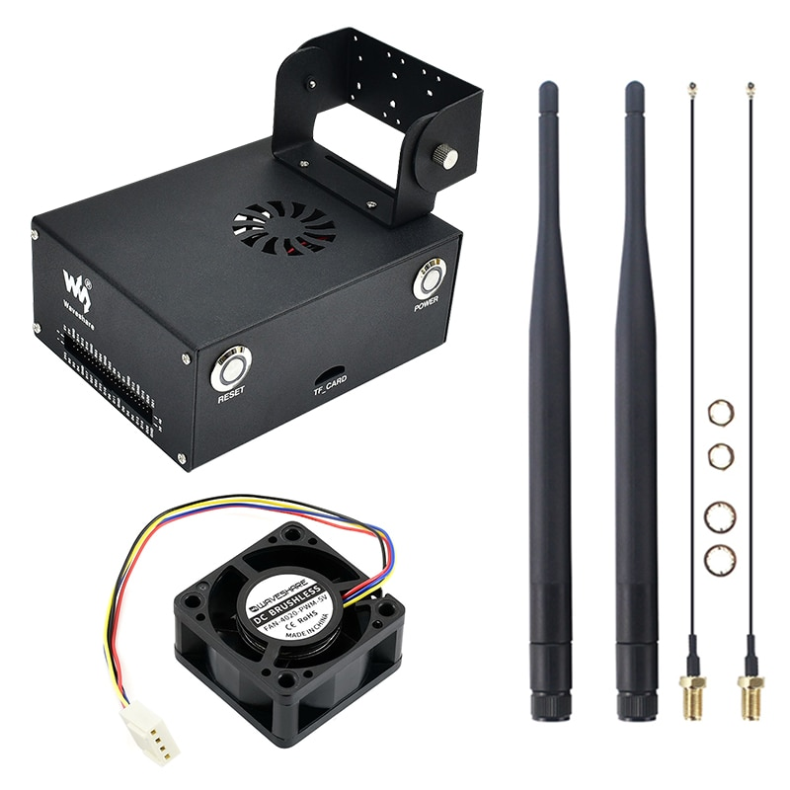

**Option 3 :**

1. 1x Body case (top and bottom)
2. 1 x Camera holder bottom mount
3. 1 x Camera holder top mount
4. 1 x Jetson Nano adapter board
5. 1 x Micro SD card adapter board
6. 1 x Flat ribbon cable 2\*20PIN
7. 1 x Spanner
8. 1 x Screwdriver
9. 1 x Button with 2PIN wires
10. 1 x Button with 4PIN wires
11. 1 x Screws pack
12. 1 x Jumper
13. 2 x Antennas
14. 1 x PWN Fan
15. 1 x Binocular Cam

( not include Jetson nano board )

