NT Dead zone Explorer: A reproducible data pipeline and interactive prototype for the CDU IT Code Fair 2026 Data Innovation Challenge (Theme: Remote Connectivity)

Team Number: DIC003 Team Name: Team ASTRA
30 September 2026
CDU IT Code Fair 2026: Data Innovation Challenge

Table of Contents
NT Dead zone Explorer: A reproducible data pipeline and interactive prototype for the CDU IT Code Fair 2026 Data Innovation Challenge (Theme: Remote Connectivity) 1
Summary 1
Introduction 1
Methodology 2
Data sources and pipeline 2
Distance and classification method 2
The interactive prototype 3
Statistical validation 3
Findings 3
H1 Fragility: nominal coverage overstates resilience 3
H2 Misallocation: the current investment backlog is not population-targeted 4
H3 Compounding vulnerability: connectivity gaps and service gaps overlap heavily 5
Ethical, cultural and community impacts 6
Recommendations 7
For government 7
For industry 7
For community stakeholders 7
Limitations and future work 8
References 9
Appendices 10
Appendix A AI-use declaration 10

Summary
Mobile coverage in the Northern Territory's remote communities is thinner than it looks. We built a reproducible pipeline that joins ten public datasets BushTel's 792-community register, the 2021 Census, the ACMA radiocommunications licence register, NBN footprints, the Mobile Black Spot Program (MBSP), the NT mobile coverage guide, RICT, school locations (NT Department of Education and ACARA) and medical/emergency-facility extracts into one village-level table, and an interactive dashboard ("NT Deadzone Explorer") that turns it into a filterable map, table, and site-selection tool. We tested three hypotheses: that nominal coverage overstates real resilience, that current infrastructure investment is not targeted by population impact, and that connectivity gaps compound with service gaps rather than occurring independently. All three are supported by the data. 75% of communities within reach of a tower have no second network as backup, and two in three people (33,177) in the Census areas that contain those communities live where not one community has a second network; the 8 mobile-black-spot sites still awaiting construction reach no more of the at-risk population than 8 randomly chosen sites would (11% within macro-cell range), versus 44% reachable by the same number of sites chosen with a simple population-weighted method; and 98% of communities beyond the mobile coverage threshold also have no school, medical facility, or emergency service within 10 km. We present these findings with explicit ethical and cultural caveats this analysis is decision support, not a decision, and does not substitute for community consultation and close with recommendations for government, industry and community stakeholders.

Introduction
The Northern Territory's remote and very remote communities are routinely described as "covered" or "not covered" by mobile network, as if connectivity were binary. That framing hides two things that matter more in practice: whether coverage, where it exists, is resilient to a single fault; and whether a connectivity gap is the only gap a community is carrying, or one of several. This report asks a more specific question than "where is the coverage gap": is nominal coverage a reliable proxy for real resilience, is current infrastructure investment reaching the people who need it most, and does a mobile-coverage gap predict other kinds of disadvantage?
We frame this as three testable hypotheses, built directly from linking three data layers for all 792 NT communities listed in the BushTel Community Profile and the 649 Statistical Areas Level 1 (SA1s the Australian Bureau of Statistics' finest geography with a published population) that contain them:
- H1 Fragility: most NT communities within reach of mobile coverage rely on a single carrier network with no independent backup, so nominal “coverage” overstates resilience to a network-level fault.
- H2 Misallocation: current public investment in new mobile infrastructure (the Mobile Black Spot Program, MBSP) is not targeted by population impact, and a simple, reproducible population-weighted method would reach meaningfully more people for the same number of sites.

- H3 Compounding vulnerability: communities with the worst mobile connectivity are not randomly distributed with respect to other essential services they are also disproportionately far from schools, health care, and emergency response.
The purpose is to move past "which places lack coverage" a question the existing NT Mobile Coverage guide already answers at a surface level toward quantifying who is affected, how severely, and where public and industry investment has the most leverage. Scope is the Territory's 792 BushTel-listed communities (779 Remote/Very Remote, 13 Outer Regional near Darwin), using 2021 Census figures, the ACMA licence register, BushTel's own records, and for H3 school, health and emergency-service location data.
Why SA1, not the individual village, carries the population numbers: the Census only publishes reliable population, income and household-size figures at SA1 level the smallest geography ABS releases without breaching privacy-suppression rules. A single remote SA1 can be enormous (the Tanami SA1 spans over 140,000 km² and contains 15 named communities but a population in the hundreds), so population is a property of the region, not the individual settlement. BushTel supplies where people live and how many distinct places; the Census/SA1 layer supplies how many people and how well-off they are; the ACMA tower register supplies what connectivity infrastructure physically exists inside that same footprint. Every finding below is built on that same three-way joint, never on the presence of a single dataset alone.

Methodology

Data sources and pipeline
Ten public datasets are joined through an 11-step automated data pipeline: the BushTel Community Profile (792 communities), the 2021 Census GCP (SA1-level population, income, household size), the ABS ASGS SA1 boundary and Remoteness Area files, the ACMA Register of Radiocommunications Licences (site, licence, client and device tables filtered to carrier transmitters in a handset frequency band and co-location-clustered within 100 m to produce 431 distinct towers from 3,771 NT-registered sites), NBN fixed-line/fixed-wireless footprints, the Mobile Black Spot Program's 49 NT funded sites, the NT Government's own mobile coverage guide, the Remote Indigenous Communications (RICT) community list, Geoscience Australia extracts for medical and emergency facilities, and the NT Department of Education school list, placed at each school's own site with ACARA's School Location 2025 coordinates. Population is only ever the 2021 Census count per SA1: it is never split across the communities inside an SA1, and BushTel's own population figures are never used, so every count of "communities" in this report is a count of places, not people.

Distance and classification method
Tower, MBSP and NBN distances are computed after projecting to EPSG:3577 (Australian Albers, an equal-area metric CRS); service-site distances use great-circle (haversine) distance on Wjorld Geodetic System 1984, documented as marginally less precise but adequate for triage. Every distance in this report is straight-line a triage signal, not a drive-time or signal-strength guarantee; the NT coverage guide itself carries the same caveat ("varies according to local conditions, especially topography and vegetation"). Each of the 792 communities is assigned one of four

resilience tiers, applied identically in the data pipeline and the dashboard: beyond gap threshold (no tower within 15 km and no coverage-guide claim of service), single point of failure (a tower exists within 15 km but none within a 10 km buffer, so a single-site fault removes coverage entirely), single network only (towers within reach but only one carrier network among them), and multiple networks (2 or more independent networks within 10 km). Alongside the tiers, the pipeline records six separate, visible gap flags per community mobile, fixed broadband (outside both NBN fixed footprints), public access (no RICT phone/Wi-Fi point within 2 km), and school, medical and emergency service beyond 15 km plus a count of how many apply and a no connectivity flag when mobile, fixed and public access are all missing.

The interactive prototype
“NT Deadzone Explorer” reads the pipeline's output directly it keeps no data of its own and exposes it as a filterable map, sortable table, insight charts, and a live Recommendations tool. That tool implements the same population-weighted greedy maximum-coverage algorithm used to produce the H2 finding below: repeatedly choosing the candidate site that reaches the most not-yet-reached population, which is provably within (1 − 1/e) ≈ 63% of the best possible answer for this objective (Nemhauser, Wolsey & Fisher, 1978), benchmarked in-app against a population-weighted k-means baseline.

Statistical validation
Each hypothesis was additionally tested with a formal statistical procedure, not just descriptive percentages: two one-sided exact binomial tests plus a chi-square test of independence for H1; two one-sided 10,000-draw Monte Carlo permutation tests for H2 (there is no closed-form sampling distribution for “population reached by k randomly chosen sites under a spatial union-coverage function”, so we built one empirically); and a Mann-Whitney U test per service type plus a Fisher's exact test for H3. Communities in the same SA1 share geography and are not independent observations, so H1 and H3 are also re-checked with a cluster bootstrap that resamples whole SA1s, and H2 with a sensitivity run that drops SA1s already containing a well-covered community.

Findings

H1 Fragility: nominal coverage overstates resilience

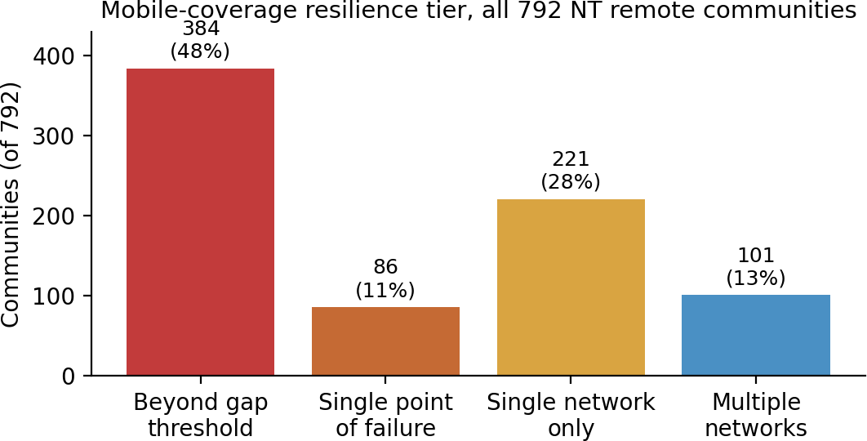

Figure 1. Resilience tier of all 792 NT communities, from the pipeline's tower and network-count join.

384 of 792 communities (48%) sit beyond the 15 km gap threshold entirely. Of the remaining 408 that are within reach of at least one tower, 307 (75%) have no real backup: 86 have no tower within a practical 10 km buffer at all the nearest is 10 –15 km away, a single point of failure and 221 have tower infrastructure within 10 km but only one carrier network (199 of them a single tower). Only 101 communities 13% of the Territory's total have two or more independent networks within 10 km. This is confirmed independently at the infrastructure level: of the 431 distinct towers themselves, 331 (77%) carry only one carrier's equipment, and 325 (75%) carry Telstra meaning a single carrier's outage, not only a natural disaster, could plausibly take an entire region offline. In population terms, counting each SA1's Census population once and never splitting it between communities: of the 50,104 people in the 167 SA1s that contain a tower-reachable community, 33,177 (66%) live in an SA1 where not one community has a second network. Both proportions are tested directly against a 50% null with
a one-sided exact binomial test (village-level p = 1.5×10²; tower-level p = 2.9×10³); because neighboring communities share towers, we also resampled whole SA1s (cluster bootstrap), and the share with a second network stays at most 32% (one-sided 95% bound), well under half and fragility is not evenly spread: a chi-square test shows the fragile rate rising sharply with remoteness 8% in Outer Regional (greater Darwin), 47% in Remote, 86% in Very Remote (χ² = 85.3, p = 3.0×10¹) concentrating the risk exactly where it is hardest to reach.

H2 Misallocation: the current investment backlog is not population-targeted

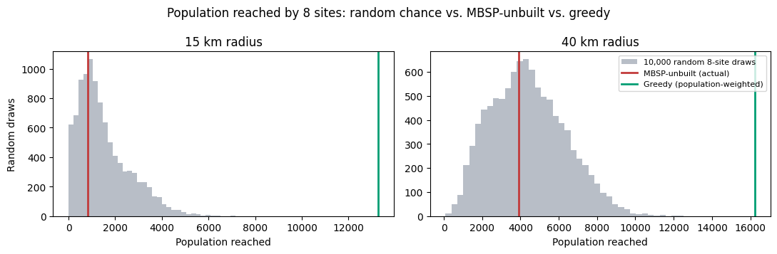

Figure 3. Population reached by the same number of new sites (8), chosen two different ways, at two candidate radii.
Of the Mobile Black Spot Program's 49 funded NT sites, 41 are built and 8 remain unbuilt; the median BushTel community is 219 km from the nearest unbuilt site, more than double its median distance of 102 km to the nearest built one. We tested directly whether that backlog is where the population need is. The at-risk population is the 36,973 people counted in the 125 SA1s that contain a “fragile” community (beyond-threshold, single-point-of-failure or single-network), each SA1 counted once. The 8 still-unbuilt MBSP sites would reach only 3,925 of them (11%) within a 40 km macro-cell range (2.3% within the project's own 15 km gap threshold). Choosing 8 sites from the 691 fragile communities with a population-weighted greedy algorithm instead reaches 16,251 people, 44% almost four times the population, for an identical number of sites. Two Monte Carlo permutation tests against 10,000 random 8-site draws from the same candidate pool make this precise. MBSP's unbuilt sites land at the 43rd percentile of random draws at 40 km and the 32nd at 15 km (p = 0.57 and 0.68 for “reaches more than chance”): their reach is statistically indistinguishable from a random choice, so there is no detectable population targeting an absence of evidence, not proof that MBSP did worse than chance. The greedy selection beats every one of the 10,000 random draws at both radii (p < 0.0001). The same pattern holds when SA1s that already contain a well-covered community (8% of the at-risk population) are left out. This is not evidence that MBSP site selection was wrong: feasibility, land tenure, backhaul availability, staged funding rounds and, critically, community consultation are real constraints this model doesn't see. It is evidence that a reproducible, population-weighted method surfaces meaningfully different priorities than the current backlog, and is worth using as one input into future rounds which is exactly what the dashboard's Recommendations tool is built to let a planner explore.

H3 Compounding vulnerability: connectivity gaps and service gaps overlap heavily

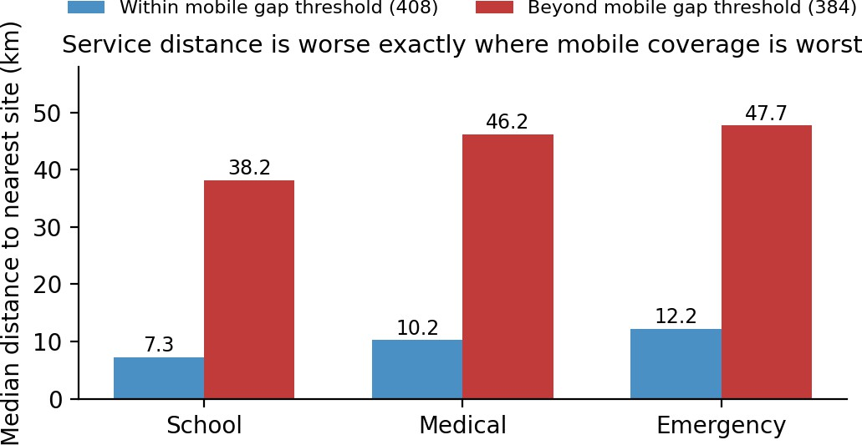
Figure 2. Median distance to the nearest school, medical facility and emergency service, compared for communities inside vs. beyond the mobile-coverage gap threshold.
Communities beyond the mobile-coverage gap threshold are roughly 4–5 times further from every service type we measured than communities within it: a median 38.2 km to the nearest school (vs. 7.3 km), 46.2 km to the nearest medical facility (vs. 10.2 km), and 47.7 km to the nearest emergency service (vs. 12.2 km). The overlap is close to total, not partial: of the 384 communities beyond the mobile gap threshold, 375 (98%) have none of the three service types no school, no medical facility, no emergency service within 10 km, while across all 792 communities only 21% have all three nearby. A mobile-coverage gap in the NT is very rarely an isolated problem: it is the visible edge of a much wider service desert. Every difference above is statistically significant (Mann-Whitney U test per service type, p < 1×10 in all three; large effect sizes, rank-biserial r = 0.64 to 0.72) and the zero-services overlap is not chance either (Fisher's exact test, odds ratio = 65, p = 2×10¹). It survives resampling whole SA1s (every 95% interval for the difference stays above zero), and it holds with every connectivity source counted, not mobile alone: the 269 communities with no connectivity at all no mobile, outside both NBN fixed footprints and no RICT public phone or Wi-Fi within 2 km have no service within 10 km in 99% of cases, against 51% for the rest (odds ratio = 84, p = 9×10). Part of this overlap is shared remoteness towers, schools and clinics tend to sit in the same larger communities, so it shows that gaps occur together, not that one causes another.

Ethical, cultural and community impacts
This dataset describes, at fine geographic resolution, which remote Aboriginal and Torres Strait Islander communities in the NT are most exposed and least resourced. That carries real risk of deficit framing presenting communities only through what they lack and real sensitivity around Indigenous Cultural and Intellectual Property (ICIP). We made several deliberate choices in response. First, we dropped Indigenous population share as an analysis variable, keeping a whole-community view rather than isolating ethnicity as a special or “othered” category; every finding above applies to a community as a whole, not to a demographic subgroup within it.

Second, every distance in this analysis is straight-line triage, not a coverage or drive-time guarantee stated in-app and in every underlying notebook. Used carelessly, a triage number could be cited to justify declining or deferring investment in a community that appears “reached” on paper but is not, in the lived experience of the people there. We present the Recommendations tool explicitly as decision support: the greedy algorithm optimizes population reached per site, and nothing else it cannot see land tenure, community preference, cultural sites, or local infrastructure feasibility, all of which properly belong to the communities and agencies who hold that knowledge. It is offered as one input for a planning conversation, not a replacement for it.
Third, the underlying data carries its own governance obligations we have respected rather than worked around: 2021 Census figures are ABS-suppressed below a small-count threshold, and this pipeline preserves that suppression (flagging census_pop_suppressed rather than estimating a number ABS chose not to publish); the ACMA licence register carries its own usage terms that we have observed; and several data-quality issues in the source extracts mislabeled agencies, postcodes that lose a leading zero.

Recommendations

For government
- Use a reproducible, population-weighted prioritization method such as the greedy max-coverage tool in the dashboard as one explicit input into future MBSP and equivalent funding rounds, alongside (not instead of) the feasibility and community-consultation criteria already in use.
- Fund network-redundancy grants at existing single-network sites, not only new towers: 221 communities already have tower infrastructure and would gain real resilience from a second carrier at an existing site likely cheaper, per person protected, than an all-new build in an unserved area.
- Treat the 98% overlap between mobile-coverage gaps and service deserts (H3) as a signal to co-locate future investment a new tower and a visiting health or education service reaching the same community compounds impact rather than solving one problem twice.

For industry
- Explore infrastructure co-location / network sharing at the 221 single-network sites identified here, similar to the voluntary co-location this project already detects at 30 existing tower clusters a lower-capital path to redundancy than new-site builds.
- Publish site-level network presence (which carriers actually operate at a site, not just licence records) in a form communities and planners can verify against lived experience, closing the kind of guide-vs-register discrepancy this project had to reconcile by hand.

For community stakeholders

- Formalise the feedback loop the NT coverage guide already implies (it is explicitly “GUIDE only”) community-reported coverage experience surfaced real discrepancies against the formal ACMA register in this analysis and is a cheap, high-value data source.
- Treat any connectivity-gap or service-gap ranking, including ours, as a starting point for a conversation with the affected community about priority and sequencing, not as a finished verdict consistent with the ethical framing in the Discussion above.

Limitations and future work
The dashboard currently requires a running Streamlit server and internet-hosted map tiles (OpenStreetMap) and fonts; every dataset it displays is local, so the remaining step toward genuine offline-first operation one of the challenge's suggested angles is bundling a local basemap. Services distances use haversine rather than the projected-CRS method used for towers. Schools sit at their own ACARA site coordinates, except stand-alone preschools (placed at their same-named school) and a few schools ACARA does not list, which keep a locality point. The Census gives no population below SA1 level, so population findings describe SA1s, never individual communities. The six gap flags are kept separate and visible, with only an unweighted count on top: which gap matters more, and how to weigh them, is policy judgement for government and community stakeholders, not something this analysis should decide silently.

References
Australian Bureau of Statistics (2021). 2021 Census General Community Profile DataPack, Northern Territory. https://www.abs.gov.au/census/find-census-data/datapacks
Australian Bureau of Statistics (2021). Australian Statistical Geography Standard (ASGS) Edition 3 SA1 and Remoteness Area boundaries https://www.abs.gov.au/statistics/standards/australian-statistical-geography-standard-asgs/edition-3-july-2021-june-2026/access-and-downloads/digital-boundary-files
Australian Communications and Media Authority (ACMA). Register of Radiocommunications Licences, daily extract. https://www.acma.gov.au/radiocomms-licence-data
Department of Infrastructure, Transport, Regional Development, Communications and the Arts. Mobile Black Spot Program funded base stations. https://www.infrastructure.gov.au/media-communications/phone/mobile-services-and-coverage/mobile-black-spot-program
National Indigenous Australians Agency (2024). Remote Indigenous Communications (RICT) community list.
Northern Territory Government Chief Minister and Cabinet. BushTel Community Profile 2024. https://bushtel.nt.gov.au/
Northern Territory Open Data Portal. Remote Communities with 3G/4G Mobile Coverage and Remote Sites with Mobile Phone Small Cell Coverage. https://data.nt.gov.au/
nbn co (2024). National Broadband Network fixed-line and fixed-wireless technology footprints, via data.gov.au.
Geoscience Australia / National Health Services Directory. Medical and emergency facility extracts, Northern Territory.
Northern Territory Department of Education. NT School List (public).
Australian Curriculum, Assessment and Reporting Authority (ACARA) (2025). School Location 2025, used under the My School terms of use. https://www.acara.edu.au/contact-us/acara-data-access
Nemhauser, G. L., Wolsey, L. A., & Fisher, M. L. (1978). An analysis of approximations for maximizing submodular set functions I. Mathematical Programming, 14(1), 265–294.

Appendices

Appendix A AI-use declaration
In the preparation of this report, generative AI (Claude, via Claude Code) was used to assist with the following tasks:
- Auditing and documenting the existing data pipeline and codebase.
- Computing and cross-checking the statistics cited in the Findings section directly against the processed data files.
- Generating the report's layout.
All cited figures were computed from data/processed/*.csv and are independently reproducible by re-running hypothesis jupyter notebook.
The team members have thoroughly reviewed and verified all AI-assisted work and take full responsibility for all claims, figures, and recommendations presented in this report.

