IT: Theory of Computation

Introduction
The theory of computation is the mathematical study of computing machines and their capabilities. We must therefore develop a model for the data that computers manipulate. We adopt the mathematically expedient choice of representing data by strings of symbols. METHODS OF PROOF
Some forms of argument (“valid”) never lead from correct statements to an incorrect conclusion. Some other forms of argument (“fallacies”) can lead from true statements to an incorrect conclusion.
An axiom is a statement that is assumed to be true, or in the case of a mathematical system, is used to specify the system.
A mathematical argument is a list of statements. Its last statement is called the conclusion. A logical rule of inference is a method that depends on logic alone for deriving a new statement from a set of other statements.
A form of logical argument is valid if whenever every premise is true, the conclusion is also true. A form of argument that is not valid is called a fallacy. This form of argument is called modus ponens

p → q premise 1
p premise 2
q conclusion
It may be difficult to prove a statement q directly . Instead, we may find a statement p with the property that p → q, and then prove p Note: If this can be done, by Modus Ponens, q is true • This strategy is called backward reasoning
Modus Tollens
p → q premise 1
~p premise 2
~p conclusion
A mathematical proof is a list of statements in which every statement is one of the following:
(1) an axiom
(2) derived from previous statements by a rule of inference
(3) a previously derived theorem Its last statement is called a theorem.
Hierarchy of terminology that gives opinions about the importance of derived truths:
(1) A proposition is a theorem of lesser generality or of lesser importance.
(2) A lemma is a theorem whose importance is mainly as a key step in something deemed to be of greater significance.
(3) A corollary is a consequence of a theorem, usually one whose proof is much easier than that of the theorem itself/ a theorem that can be easily established from a theorem that has been proved
(4) A Conjecture : a statement proposed to be a true statement, usually based on partial evidence, or intuition of an expert
mathematical notation is called “set-builder notation.”
Eg:
The union of two sets A and B, denoted by A ∪ B, is the set of all objects that are in A or B (or both) A ∪ B := {x | x ∈ A or x ∈ B}.
The intersection of A and B is the set of all objects that are in both A and B:
A ∩ B := {x | x ∈ A and x ∈ B}.
The difference between two sets A and B, denoted by A − B, is defined as follows:
A − B := {x | x ∈ A and x /∈ B}.

Commutative properties.
A ∪ B = B ∪ A
A ∩ B = B ∩ A
Associative properties.
A ∪ (B ∪ C) = (A ∪ B) ∪ C
A ∩ (B ∩ C) = (A ∩ B) ∩ C
Distributive properties.
A ∪ (B ∩ C) = (A ∪ B) ∩ (A ∪ C)
A ∩ (B ∪ C) = (A ∩ B) ∪ (A ∩ C)
A ∪ (B ∪ C) = (A ∪ B) ∪ (A ∪ C)
A ∩ (B ∩ C) = (A ∩ B) ∩ (A ∩ C)
Other facts.
A ∪ A = A = A ∩ A
A ∪ ∅ = A A ∩ ∅ = ∅
A ∩ B ⊂ A ⊂ A ∪ B
A ∩ B ⊂ B ⊂ A ∪ B
De Morgan’s laws.
A − (B ∪ C) = (A − B) ∩ (A − C)
A − (B ∩ C) = (A − B) ∪ (A − C)
Other facts.
A − B ⊂ A B ∩ (A − B) = ∅
A − B = ∅ ⇐⇒ A ⊂ B
A − B = A ⇐⇒ A ∩ B = ∅

The phrases ‘for every’ and ‘there exists’ are called quantifiers
(∀x ∈ S) P(x), P(x) is true for every x in the set S and
(∃x ∈ S) P(x), there exists at least one element x of S for which P(x) is true
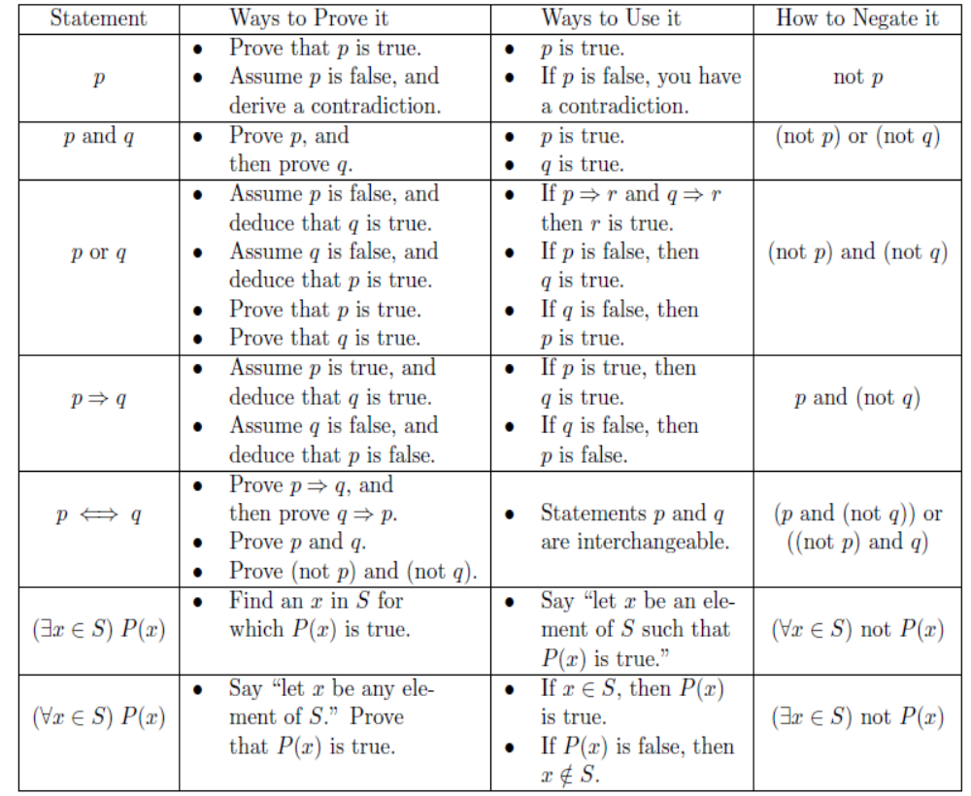

MATHEMATICAL PROOFS (INDIRECT)
An indirect proof uses rules of inference on the negation of the conclusion and on some of the premises to derive the negation of a premise. This result is called a contradiction.
The proof by contradiction method makes use of the equivalence
p ≡ ¬ p → F₀
where F₀ is any contradiction
• One way to show that the latter is as follows:
First assume ¬ p is true, and then show that for some proposition r, r is true and ¬ r is true
• That is, we show ¬ p → ( r ∧ ¬ r ) is true
Example 1: a theorem
If x 2 is odd, then so is x.
Proof: Assume that x is even (neg of concl).
Say x = 2n (defn of even).
Then x² = (2n)² (substitution)
= 2n · 2n (defn of exponentiation)
= 2 · 2n² (commutativity of mult.)
which is an even number (defn of even)
which contradicts the ᴲpremise that x 2 is odd.

Example 2:
Theorem: There are infinitely many primes.
Proof: Suppose that’s not the case.
Then finitely many primes p < p 2 < … < pn.
Let N = p1p2…pn + 1.
Then N is not divisible by any smaller prime number.
So N must itself be prime.
But N > pn, the largest prime. Contradiction
Excercises:
- Show that if 3n + 2 is an odd integer, then n is odd.
- ST There is no largest integer
- Show that √ 2 is irrational
- There are infinitely many primes.
- If five sisters split up 2000 grams of chocolate, then at least one of the sisters receives 400 or more grams of chocolate.
- Given four non-collinear points in the plane, there exist three points which form an angle measuring 90◦ or more.
- If 2^{n} − 1 is not divisible by 7, then n is not a multiple of 3.
- For sets A, B and C show that P(A) ∪ P(B) ∪ P(C) ⊆ P(A ∪ B ∪ C)
- For x, y ∈ R, prove that if x + y = 7 and. xy = 10, then x2 + y2 = 29.
- Prove that there do not exist a, b, c ∈ N such that a3 + b3 = c3
- . Let β be an irrational number. Use proof by contradiction to prove that β − 4 is also irrational.
- Prove there does not exist an integer k such that 4k + 3 is a perfect square.
- Prove: There does not exist a positive real number a such that 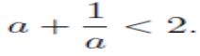

When proving bi-conditional statement, we may make use of the equivalence p ↔ q ≡ ( p → q ) ∧ ( q → p )

Proof by Mathematical Induction
To demonstrate P ⇒ Q by induction we require that the truth of P and Q be expressed as a function of some ordered set S.
1. (Basis) Show that P ⇒ Q is valid for a specific element k in S.
2. (Inductive Hypothesis) Assume that P ⇒ Q for some element n in S.
3. Demonstrate that P ⇒ Q for the element n + 1 in S.
4. Conclude that P ⇒ Q for all elements greater than or equal to k in S.
Theorem 8.
Show that the summation formula
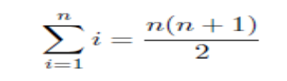……….. (1)
is valid for all integers n.
Proof.
(Basis case) We demonstrate that the formula is valid for n = 1.
By substituting one for n the formula gives us 1 = 1(2)/ 2 , which is true.
(Inductive Hypothesis) Suppose that the formula is valid for some integer n.
To demonstrate that the formula is valid for n + 1 we must use the inductive hypothesis to show that the formula still holds.
By assumption the formula is valid for n. Using basic algebra we add n + 1 to both sides of the equation to demonstrate that the formula is still valid for n + 1. We begin with the left hand side:

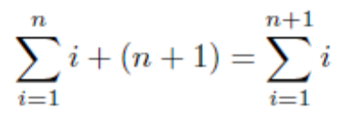……….. (2)
We now demonstrate adding n + 1 to the right hand side. We perform fraction addition and factor out an (n + 1).
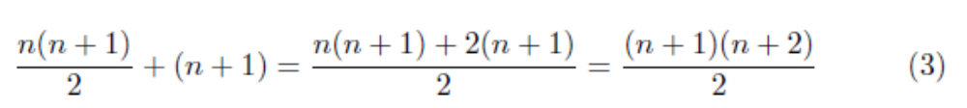
Combining both
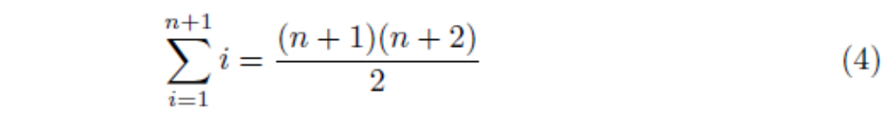
So, by mathematical induction Summation formula for integers is true for integers grater than 1.
Excercises:
- If a1, a2, . . . , an are real numbers and a1a2 · · · an = 0, then ai = 0 for some i with 1 ≤ i ≤ n.
- Any integer n > 1 can be expressed as a product of prime numbers.
- Show that the smallest element of a nonempty set of positive integers is unique.
- Fix a real number x 6= 1. Show that for every positive integer n,
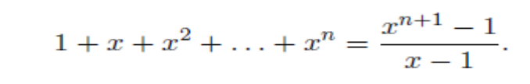

- First we need a way to describe the nth odd number, simply 2n − 1.
PT
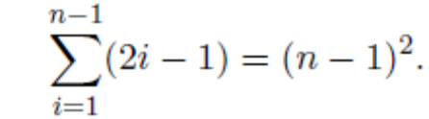

- Guess a formula for

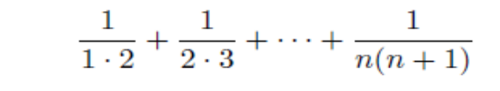
and prove it by induction. Hint: Compute the above expression for some small values of n.
- PT For n > 1, n is divisible by some prime number.
- The set of regions formed by n inﬁnite lines in the plane can be two-colored.
- PT ₹2 and ₹5 stamps can be used to form any value (for values ≥ 4).

Introduction to Theory of Computation

Alphabets and Languages
Alphabet is a finite set of symbols and is denoted by ∑. In fact, any object can be in an alphabet; from a formal point of view, an alphabet is simply a finite set of any sort.
A string over an alphabet is a finite sequence of symbols from the alphabet. A string may have no symbols at all; in this case it is called the empty string and is denoted by ε.
The length of a string is the number of symbols in string. We denote the length of a string w by |w|; thus |101| = 3 and |ε| = 0.
Two strings over the same alphabet can be combined to form a third by the operation of concatenation. The concatenation of strings x and y, written x • y or simply xy, is the string x followed by the string y.
A string v is a substring of a string w if and only if there are strings x and y such that w = xvy. Both x and y could be ε, so every string is a substring of itself; and taking x = w and v = y = ε, we see that ε is a substring of every string. If w = xv for some x, then v is a suffix of w; if w = vy for some y, then v is a prefix of w.
For each string w and each natural number I, the string w^{I} is defined as w⁰ = ε, the empty string; w^{I+1} = w^{I} • w for each I ≥ 0.
The reversal of a string w, denoted by w^{R}, is the string “spelled backwards”: for example, reverse^{R} = esrever.
The set of all strings - including the empty string - over an alphabet ∑ is denoted by ∑*. Any set of strings over an alphabet ∑ - that is, any subset of ∑* - will be called a language. Thus ∑*, ∅, and ∑ are languages.
Since a language is simply a special kind of set, we can specify a finite language by listing all its strings. For example, { aba, cde, fg} is a language over {a,b, …, z}. However, most languages of interest are infinite, so that listing all the strings is not possible. Thus we can specify infinite languages by the scheme
L = { w ∈∑* : w has property P }
eg. { w ∈ {0,1}* : w has an equal number of 0’s and 1’s}, and { w ∈∑* : w = w^{R} }.

If L₁ and L₂ are languages over ∑, their concatenation is L = L₁ • L₂, or simply L₁L₂, where
L = { w : w = x • y for some x ∈ L₁ and y ∈ L₂}.
Example, ∑ = { 0, 1 }, L₁ = { w ∈ ∑*: w has an even number of 0’s} and L₂ = { w : w starts with a 0 and the rest of the symbols are 1’s}, then L₁ • L₂ = { w ∈ ∑*: w has an odd number of 0’s}.
Another language operation is the closure or Kleene star of a single language L, denoted by L* . L* is the set of all strings obtained by concatenating zero or more strings from L. (The concatenation of zero strings is ε, and the concatenation of one string is the string of itself.) Thus,
L* = {w ∈ ∑*: w = w₁ • w₂ • … • w_{k}, for some k ≥ 0 and some w₁,…,w_{k} ∈ L}.
Example, L = {01, 1, 100}, then 110001110011 ∈ ∑*, since it is equal to 1•100•01•100•1• 1.
Note! ε∈L* and ∅* = {ε}.
We write L⁺ for the set LL* . Equivalently,
L⁺= {w : w = w₁ • w₂ • … • w_{k}, for some k ≥ 1 and some w₁,…,w_{k} ∈ L}.

Alphabet - a finite set of symbols.
  - Notation: Σ .
  - Examples: Binary alphabet {0,1},
English alphabet {a,...,z,!,?,...}
String over an alphabet Σ - a finite sequence of symbols from Σ.
  - Notation: (a) Letters u, v, w, x, y, and z denote strings.
(b) Convention: concatenate the symbols. No parentheses or commas used.
  - Examples: 0000 is a string over the binary alphabet.
a!? is a string over the English alphabet.
Empty string: e or ε denotes the empty sequence of symbols.
Language over alphabet Σ - a set of strings over Σ.
  - Notation: L.
  - Examples:
    - {0, 00, 000, ...} is an "infinite" language over the binary alphabet.
    - {a, b, c} is a "finite" language over the English alphabet.
Empty language - empty set of strings. Notation: Φ.
Binary operation on strings: Concatenation of two strings u.v - concatenate the symbols of u and v.
  - Notation: uv
  - Examples:
    - 00.11 = 0011.
    - ε.u = u.ε = u for every u. (identity for concatenation)
Binary relations on strings
Prefix - u is a prefix of v if there is a w such that v = uw.
    - ε is a prefix of 0 since 0 = ε0
Suffix - u is a suffix of v if there is a w such that v = wu.
Substring - u is a substring of v if there are x and y such that v = xuy.
  - Examples:
    - let is a substring of appleton since appleton = app.let.on
    - 0 is a substring of 0 since 0 = epsilon.0.epsilon
Observe that prefix and suffix are special cases of substring.
We call two sets A and B equinumerous if there is a bijection (one-to-one and onto function) f : A → B.
A set is said to be countably infinite if it is equinumerous with Ν, and countable if it is finite or countably infinite. A set that is not countable is uncountable

Machine Grammar Other

Finite State Machine | Right/Left Linear Grammars | Regular Expressions
Deterministic  Pushdown Machine | Context Free Grammars | Syntax Diagrams
Non-Deterministic  Pushdown Machine | LR Grammars
Turing Machine | Unrestricted Grammars | Recursive Sets

Finite state systems?
A switching circuit consists of a finite number of gates, each of which can be in any one of the two conditions 0 or 1.Although the voltages assume infinite set of values, the electronic circuitry is designed so that the voltages corresponding to 0 or 1 are stable and all others adjust to these values. Thus control unit of a computer is a finite state system. applications designed as finite state system. Text editors and lexical analyzers are designed as finite state systems. A lexical analyzer scans the symbols of a program to locate strings corresponding to identifiers, constants etc, and it has to remember limited amount of information.
Finite Automaton(FA) & Transition diagram
The components of FA model are Input tape, Read control and finite control.
(a) The input tape is divided into number of cells. Each cell can hold one i/p symbol.
(b) The read head reads one symbol at a time and moves ahead.
(c) Finite control acts like a CPU. Depending on the current state and input symbol read from the input tape it changes state.
FA consists of a finite set of states and a set of transitions from state to state that
occur on input symbols chosen from an alphabet ∑. Finite Automaton is denoted by a
5- tuple(Q,∑,δ,q0,F), where Q is the finite set of states , ∑ is a finite input alphabet, q0 in
Q is the initial state, F is the set of final states and δ is the transition mapping function
Q * Σ to Q.
Transition diagram is a directed graph in which the vertices of the graph correspond to the states of FA. If there is a transition from state q to state p on input a, then there is an arc labeled ‘a ‘from q to p in the transition diagram.
Applications of automata theory
- In compiler construction.
Lexical analyzers: The tokens of the programming language can be expressed using regular expressions. The lexical analyzer scans the input program and separates the tokens. For eg identifier can be expressed as a regular expression as:
(letter)(letter+digit)*
If anything in the source language matches with this reg exp then it is recognized as an identifier.The letter is{A,B,C,………..Z,a,b,c….z} and digit is {0,1,…9}.Thus reg exp identifies token in a language.

- In switching theory and design of digital circuits.
- To verify the correctness of a program.
- Design and analysis of complex software and hardware systems.
- To design finite state machines such as Moore and mealy machines
- Spell checkers in text editors
Text editors: These are programs used for processing the text. For example
UNIX text editors uses the reg exp for substituting the strings such as:
S/bbb*/b/
Gives the substitute a single blank for the first string of two or more blanks in a given line. In UNIX text editors any reg exp is converted to an NFA with Є -transitions, this NFA can be then simulated directly.

Differences between NFA and DFA
- NFA or Non Deterministic Finite Automaton is the one in which there exists
many paths for a specific input from current state to next state. NFA can be used in
theory of computation because they are more flexible and easier to use than DFA.
- Deterministic Finite Automaton is a FA in which there is only one path for a specific input from current state to next state. There is a unique transition on each input symbol
Є-NFA
Є-closure of a state q0
Є-closure (q0) denotes a set of all vertices p such that there is a path from q0 to p labeled Є. Є
q₀
q₁

Є-closure(q0)={q0,q1}
Regular language
A string x is accepted by a Finite Automaton M=(Q,Σ,δ.q0,F) if δ(q0,x)=p, for some p in F.FA accepts a string x if the sequence of transitions corresponding to the symbols of x leads from the start state to accepting state.
The language accepted by M is L(M) is the set {x | δ(q0,x) is in F}. A language is regular if it is accepted by some finite automaton.
10. What is a regular expression?
A regular expression is a string that describes the whole set of strings according to certain syntax rules. These expressions are used by many text editors and utilities to search bodies of text for certain patterns etc. Definition is: Let Σ be an alphabet. The regular expression over Σ and the sets they denote are:
i. Φ is a r.e and denotes empty set.
ii. Є is a r.e and denotes the set {Є}
iii. For each ‘a’ in Σ , a⁺ is a r.e and denotes the set {a}.
iv. If ‘r’ and ‘s’ are r.e denoting the languages R and S respectively then (r+s),
(rs) and (r*) are r.e that denote the sets RUS, RS and R* respectively.
An expression 010*010*(10*∪ ∅*) is called a regular expression.
The regular expressions over an alphabet Σ is defined as follows:

    - is a regular expression.
    - is a regular expression.
    - a ∈Σ is a regular expression.
    - If α and β are regular expressions then so is αβ.
    - If α and β are regular expressions then so is α∪β or α + β.
    - If α is a regular expressions then so is α*.
    - Parentheses, ( ), can be use to take a precedence.

L* denotes Kleene closure and is given by L* = ∞ U L^{i}
i=0
example : 0* ={Є ,0,00,000,…………………………………} Language includes empty words also
∞
L+ denotes Positive closure and is given by L+ =U L^{i}
i=1
example : 0+ ={0,00,000,…………………………………}

Arden’s Theorem
Arden’s theorem helps in checking the equivalence of two regular expressions. Let P and Q be the two regular expressions over the input alphabet Σ. The regular expression R is given as :
R=Q+RP
Which has a unique solution as R=QP*.
Excercises:
- Write a regular expression to denote a language L which accepts all the strings which begin or end with either 00 or 11.
The regular expression consists of two parts:
L1= (00+11) (any no of 0’s and 1’s) =(00+11)(0+1)*
L2= (any no of 0’s and 1’s)(00+11) = (0+1)*(00+11)
Hence r.e R=L1+L2
=[(00+11)(0+1)*] + [(0+1)* (00+11)]
2. Construct a r.e for the language which accepts all strings with atleast two c’s over the set Σ={c,b}
(b+c)* c (b+c)* c (b+c)*
3. Construct a r.e for the language over the set Σ={a,b} in which total number of a’s are divisible by 3
( b* a b* a b* a b*)*
4. What is: (i) (0+1)* (ii)(01)* (iii)(0+1) (iv)(0+1)⁺
(0+1)*= { Є , 0 , 1 , 01 , 10 ,001 ,101 ,101001,…………………}
Any combinations of 0’s and 1’s.
(01)*={Є , 01 ,0101 ,010101 ,…………………………………..} All combinations with the pattern 01.
(0+1)= 0 or 1,No other possibilities.
(0+1)⁺= {0,1,01,10,1000,0101,………………………………….}
5. Regular expression denoting a language over Σ ={1} having
(i)even length of string (ii)odd length of a string
(i) Even length of string R=(11)*
(ii) Odd length of the string R=1(11)*
6. Regular expression for:
(i)All strings over {0,1} with the substring ‘0101’
(ii)All strings beginning with ’11 ‘ and ending with ‘ab’
(iii)Set of all strings over {a,b}with 3 consecutive b’s.
(iv)Set of all strings that end with ‘1’and has no substring ‘00’
(i)(0+1)* 0101(0+1)*
(ii)11(1+a+b)* ab
(iii)(a+b)* bbb (a+b)*
(iv)(1+01)* (10+11)* 1
7. What are steps in the applications of pumping lemma for regular sets?
Pumping lemma is used to check if a language is regular or not.
(i) Assume that the language (L) is regular.
(ii) Select a constant ‘n’.
(iii) Select a string (z) in L, such that |z|>n.
(iv) Split the word z into u,v and w such that |uv|<=n and |v|>=1.
(v) Achieve a contradiction to pumping lemma that there exists an ‘i’
Such that uv^{i}w is not in L. Then L is not a regular language.
8. Write the exp for the language starting with and has no consecutive b’s Regular expression = (a+ab)*

- (0 + 1)* denotes all strings of 0’s and 1’s.
- (0 + 1)* 00 (0 + 1)* denotes all strings of 0’s and 1’s with at least two consecutive 0’s.
- (1 + 10)* denotes all strings of o’s and 1’s beginning with 1 and not having two consecutive 0’s.
- (0 + ε) (1 + 10)* denotes all strings of o’s and 1’s whatsoever that do not have two consecutive 0’s.
- (0+1)*011 denotes all strings of o’s and 1’s ending in 011.
- 0*1*2* denotes any number of 0’s followed by any number of 1’s followed by any number of 2’s.
- a) If L is accepted by an NFA with ε-transition then show that L is accepted by an
NFA without ε-transition.
b) Construct a DFA equivalent to the NFA.
- M=({p,q,r},{0,1}, δ,p,{q,s})
- Where δis defined in the following table.

δ | 0 | 1
p | {q,s} | {q}
q | {r} | {q,r}
r | {s} | {p}
s | - | {p}
- a)Show that the set L={a^{n} b^{n}/n>=1} is not a regular. (6) b)Construct a DFA equivalent to the NFA given below: (10)
 | 0 | 1
p | {p,q} | P
q | r | R
r | s | -
s | s | S
- a)Check whether the language L=(0^{n} 1^{n} /n>=1) is regular or not? Justify your answer.
b) Let L be a set accepted by a NFA then show that there exists aDFA that accepts L.
- Define NFA with ε-transition. Prove that if L is accepted by an NFA with ε-transition then L is also accepted by a NFA without ε-transition.
- . a) Construct a NDFA accepting all string in {a,b}⁺ with either two consecutive a’s or two consecutive b’s.
b) Give the DFA accepting the following language:set of all strings beginning with a 1 that when interpretedas a binary integer is a multiple of 5.
- Draw the NFA to accept the following languages.
(i) Set of Strings over alphabet {0,1,…….9} such that the final digit has
appeared before. (8)
(ii)Set of strings of 0’s and 1’s such that there are two 0’s separated by a number of positions that is a multiple of 4.
- a)Let L be a set accepted by an NFA.Then prove that there exists a deterministic finite automaton that accepts L.Is the converse true? Justify your answer. (10)
b)Construct DFA equivalent to the NFA given below: (6)
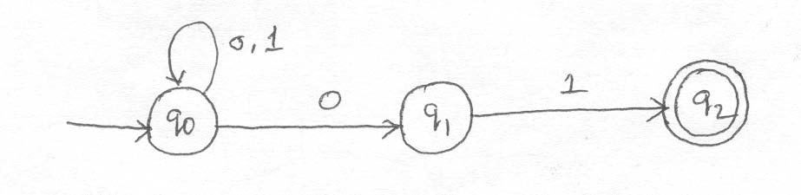
- a) Prove that a language L is accepted by some ε–NFA if and only if L is accepted by some DFA. (8)
b) Consider the following ε–NFA.Compute the ε–closure of each state and find it’s equivalent DFA. (8)
 | ε | A | b | C
p | {q} | {p} | Ф | Ф
q | {r} | ф | {q} | Ф
*r | Ф | ф | ф | {r}

- a) Prove that a language L is accepted by some DFA if L is accepted by some NFA.
b) Convert the following NFA to it’s equivalent DFA
 | 0 | 1
p | {p,q} | {p}
q | {r} | {r}
r | {s} | ф
*s | {s} | {s}

- a) Explain the construction of NFA with εtransition from any given regular expression.
b) Let A=(Q,∑, δ, q0 ,{qf ) be a DFA and suppose that for all a in ∑wehave δ(q0, a)= δ(qf ,a). Show that if x is a non empty string in L(A),then for all k>0,x^{k} is also in L(A).

Conversion of NFA to DFA

Draw the NFA’s transition table
Take the initial state of NFA be the initial state of DFA. Transit the initial state for all the input symbols.
If new state appears transit it again and again to make all state as old state. All the new states are the states of the required DFA
Draw the transition table for DFA
Draw the DFA from the transition table.
5. Conversion of DFA into regular expression.
Arden’s theorem is used to find regular expression from the DFA.
Using this theorem if the equation is of the form R=Q+RP,we can write this as R=QP*.
Write the equations for all the states.
Apply Ardens theorem and eliminate all the states.
Find the equation of the final state with only the input symbols.
Made the simplifications if possible
The equation obtained is the required regular expression.

Minimizing FSM’s

The algorithm to minimize an FSM is based on the fact that the states can be partitioned into disjoint sets where all the states in each state are equivalent. This equivalence relation is defined as follows: two states A and B are equivalent if a given string could start in either place and its acceptance status would be identical. There is a more precise way to say this, but it is obscure and hard to state. Examples will be done in class.

There is a folklore method to minimize an FSM. Reverse it, convert it back to a deterministic FSM and throw out unreachable useless states. Then repeat the process. The reason why this works is not readily apparent. The complexity is worst case exponential.

There is a more intuitive algorithm that has an O(n^2) time algorithm which is basically a dynamic programming style solution. We will do an example in class.

By the way, if you use the right data structure and are clever, you can implement the previous algorithm in O(n log n). Extra credit for any solutions.

1.a)Construct an NFA equivalent to (0+1)*(00+11)
2. Show that the set E={0^{i} 1^{i} |i>=1} is not Regular. (6)
3.a)Construct an NFA equivalent to the regular expression (0+1)*(00+11)(0+1)*.
b)Obtain the regular expression that denotes the language accepted by the following DFA.
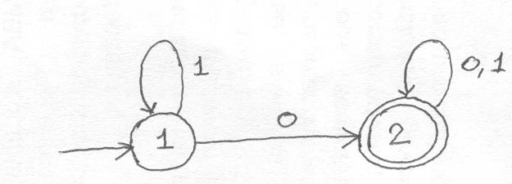
4.a)Construct an NFA equivalent to the regular expression ((0+1)(0+1)(0+1))*
b)Construct an NFA equivalent to 10+(0+11)0*1
5.a)Obtain the regular expression denoting the language accepted by the following DFA (8) b)Obtain the regular expression denoting the language accepted by the following DFA by using the formula Rij ^{k}
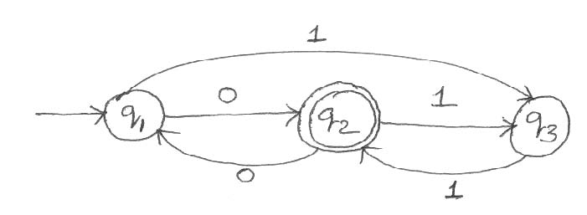
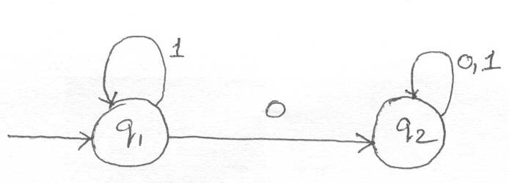
6. a)Show that every set accepted by a DFA is denoted by a regular Expression
b)Construct an NFA equivalent to the following regular expression01*+1.
7. a)Define a Regular set using pumping lemma Show that the language L={0i² / i is an integer,i>=1} is not regular
b)Construct an NFA equivalent to the regular expression 10+(0+11)0*1
8. a) Show that the set L={O^{n2/n} is an integer,n>=1} is not regular.
b)Construct an NFA equivalent to the following regular expression ((10)+(0+1) * 01. (10) 9.a)Prove that if L=L(A) for some DFA A,then there is a regular expression R such that L=L(R).
b) Show that the language {0^{p},p is prime} is not regular.
10.Find whether the following languages are regular or not.
(i) L={w ε{a,b}|w=w^{R}}.
(ii) L={0^{n} 1^{m} 2^{n+m},n,m>=1}
(iii) L={1^{k}|k=n²,n>=1} . (4)
(iv) L1/L2={x | for some y εL2,xy εL1},where L1 and L2 are any two languages and L1/L2 is the quotient of L1 and L2.
11.a) Find the regular expression for the set of all strings denoted by R²13 from the deterministic finite automata given below:
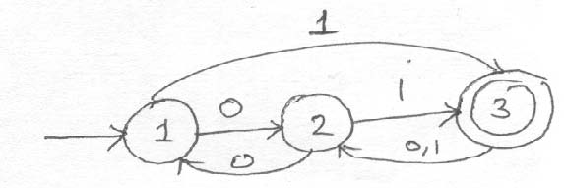
b)Verify whether the finite automata M1 and M2 given below are equivalent over {a,b}.
12.a)Construct transition diagram of a finite automaton corresponding to the regular expression (ab+c *)*b.

13.a)Find the regular expression corresponding to the finite automaton given below.
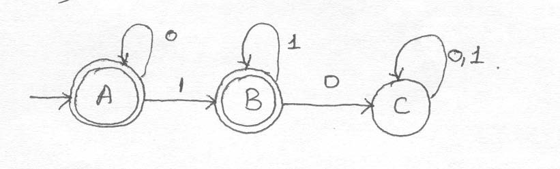
b)Find the regular expression for the set of all strings denoted by R²23 from the deterministic finite automata given below.
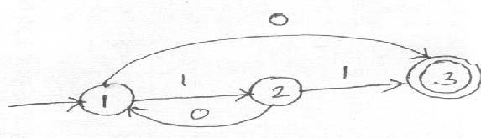
14.a) Find whether the languages {ww,w is in (1+0)*} and {1^{k} | k=n² , n>=1} are regular or not.
b) Show that the regular languages are closed under intersectionand reversal.

Moore machine and Mealy machine
A special case of FA is Moore machine in which the output depends on the state of the machine. An automaton in which the output depends on the transition and current input is called Mealy machine.

Context free grammars
A context free grammar (CFG) is denoted as G=(V,T,P,S) where V and T are finite
set of variables and terminals respectively. V and T are disjoint. P is a finite set of productions each is of the form A->α where A is a variable and α is a string of symbols from (V U T)*.
The language generated by CFG or G
The language generated by G (L(G) ) is {w | w is in T* and S=>*w .That is a
string is in L(G) if:
(1) The string consists solely of terminals.
(2) The string can be derived from S.
Formal language
Language is a set of valid strings from some alphabet. The set may be empty, finite or infinite. L (M) is the language defined by machine M and L( G) is the language defined by Context free grammar. The two notations for specifying formal languages are:
- Grammar or regular expression (Generative approach)
- Automaton (Recognition approach)

(a) derivation (b)derivation/parse tree (c) subtree
(a) Let G=(V,T,P,S) be the context free grammar. If A->β is a production of P and α and γ are any strings in (VUT)* then α A γ => αβγ. (b) A tree is a parse \ derivation tree for G if:
(i) Every vertex has a label which is a symbol of VUTU{Є}.
(ii) The label of the root is S.
(iii) If a vertex is interior and has a label A, then A must be in V.
(iv) If n has a label A and vertices n₁,n₂,….. n_{k} are the sons of the vertex n in order from left with labels X₁,X₂,………..X_{k} respectively then A→ X₁X₂…..X_{k} must be in P.
(v) If vertex n has label Є ,then n is a leaf and is the only son of its father.
(c ) A subtree of a derivation tree is a particular vertex of the tree together with
all its descendants ,the edges connecting them and their labels.The label of the root may
not be the start symbol of the grammar.
Ambiguous grammar
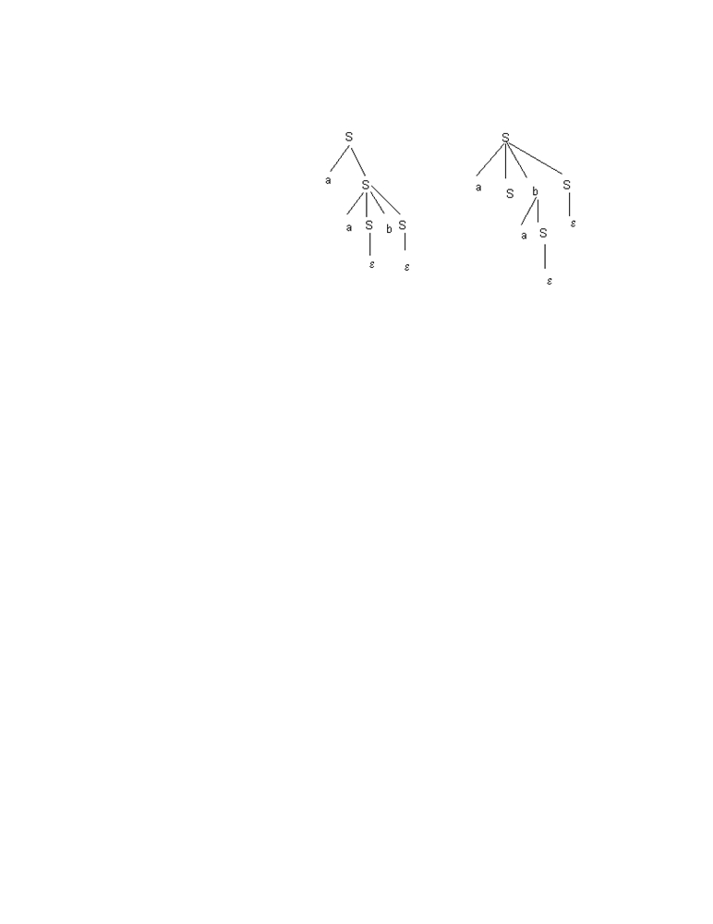
A grammar is said to be ambiguous if it has more than one derivation trees for a sentence or in other words if it has more than one leftmost derivation or more than one rightmost derivation.
Simplification of context free grammar?
- By removing the useless symbols from the set of productions.
- By eliminating the empty productions.
- By eliminating the unit productions.

- Find CFG with no useless symbols equivalent to : S→AB | CA , B→BC | AB, A→a , C→aB | b.
S-> AB
S->CA
B->BC
B->AB
A->a
C->aB
C->b are the given productions.
* *
A symbol X is useful if S => αXβ => w
The variable B cannot generate terminals as B->BC and B->AB.
Hence B is useless symbol and remove B from all productions.
Hence useful productions are: S->CA , A->a , C->b
- Construct CFG without Є production from : S →a | Ab | aBa , A →b | Є ,
B →b | A.
S->a
S->Ab
S->aBa
A->b A->Є B->b B->A are the given set of production.
A->Є is the only empty production.
Remove the empty production S-> Ab , Put A-> Є and hence S-> b.
If B-> A and A->Є then B ->Є
Hence S->aBa becomes S->aa .
Thus S-> a | Ab | b | aBa | aa
A->b B->b
Finally the productions are: S-> a | Ab | b | aBa | aa
A->b ,B->b
- Find the grammar for the language L={a^{2n} bc ,where n>1 }
let G=( {S,A,B}, {a,b,c} ,P , {S} ) where P:
S->Abc
A->aaA | Є
- Find the language generated by :S->0S1 | 0A | 0 |1B | 1
A->0A | 0 , B->1B | 1
The minimum string is S-> 0 | 1
S->0S1=>001
S->0S1=>011
S->0S1=>00S11=>000S111=>0000A111=>00000111 Thus L={ 0^{n} 1 ^{m} | m not equal to n, and n,m >=1}
- Construct the grammar for the language L={ a^{n} b a^{n} | n>=1}.
The grammar has the production P as:
S->aAa
A->aAa | b
The grammar is thus : G=( {S,A} ,{a,b} ,P,S)
- . Construct a grammar for the language L which has all the strings which are all
palindrome over Σ={a, b}.
G=({S}, {a,b} , P, S )
P:{ S -> aSa ,
S-> b S b,
S-> a,
S->b,
S->Є } which is in palindrome.
- Chomsky normal form(CNF)
If the CFG is in CNF if it satisfies the following conditions
- All the production must contain only one terminal or only two
variables in the right hand side.
Example: Consider G with the production of S->aAB , A-> bC , B->b, C->c.
G in CNF is S->EB , E->DA , D-> a , A->FC , F-> b , B->b , C-> c.

- Eliminate unit production from the following grammar
S→ AB | A
A→C | d
C→ b
- Design pushdown automaton which accepts only odd number of a’s over Σ = {a,b}
- Construct a PDA for following grammar
S→ AB
A→ CD
B→ b
C→ a

- Convert the following CFG into CNF
                - S→ aaaaS
S→ aaaa Consider a = ({S,A},{a,b},P,S)
Where P consists of
                - S→ aAS | a
                - A→ SbA | SS | ba
Convert it to its equivalent CNF
Convert the given CFG to GNF
                - S→ ABA
                - A→ aA | ε
                - B→ bB | ε

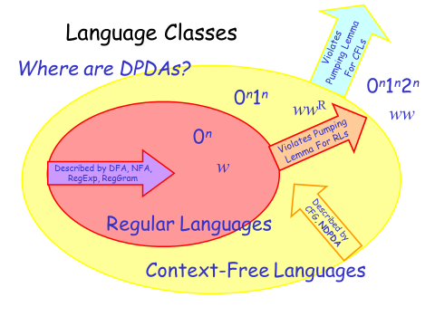

Applications of Context free languages
Context free languages are used in :
- Defining programming languages.
- Formalizing the notion of parsing.
- Translation of programming languages.
- String processing applications.
Uses of Context free grammars
- Construction of compilers.
A parser for grammar G is a program that takes as input a string w and produces as output either a parse tree for w, if w is a sentence of G or an error message indicating that w is not a sentence of G.
- Simplified the definition of programming languages.
- Describes the arithmetic expressions with arbitrary nesting of balanced parenthesis {(,)}.
- Describes block structure in programming languages. Model neural nets.
- Pushdown Automata.
The PDA usually consists of four components:
A control unit.
A Read Unit.
An input tape.
A Memory unit.
A PDA is a computational machine to recognize a Context free language. Computational power of PDA is between Finite automaton and Turing machines. The PDA has a finite control, and the memory is organized as a stack.

A pushdown Automata M is a system (Q, Σ, Ґ ,δ ,q₀, Z₀,F) where
Q is a finite set of states.
Σ is an alphabet called the input alphabet. Ґ is an alphabet called stack alphabet.
q₀ in Q is called initial state.
Zo in Ґ is start symbol in stack.
F is the set of final states.
δ is a mapping from Q X (Σ U {Є} ) X Ґ to finite subsets of Q X Ґ *.
Language acceptances by a PDA and define them.
For a PDA M=(Q, Σ ,Ґ ,δ ,q₀ ,Z₀ ,F ) we define :
Language accepted by final state L(M) as:
*
{ w | (q₀ , w , Z₀ ) |--- ( p, Є , γ ) for some p in F and γ in Ґ * }.
Language accepted by empty / null stack N(M) is:
*
{ w | (q₀,w ,Z₀) |----( p, Є, Є ) for some p in Q}.
String acceptance by a PDA
The input string is accepted by the PDA if:
- The final state is reached .
- The stack is empty
The languages accepted by PDA‘s by final state are exactly the languages accepted by PDA’s by empty stack. To model a context free language, a Pushdown Automata is used.
languages handled by PDA.
(1) L={ a^{n}b^{n} | n>=0 },here n is unbounded , hence counting cannot be done by finite memory. So we require a PDA ,a machine that can count without limit.
(2) L= { ww^{R} | w Є {a,b}* } , to handle this language we need unlimited counting
capability .

Deterministic PDA.
A PDA M =( Q, Σ ,Ґ ,δ ,q₀ ,Z₀ ,F ) is deterministic if:
For each q in Q and Z in Ґ , whenever δ(q,Є,Z) is nonempty ,then δ(q,a,Z) is empty for all a in Σ.
For no q in Q , Z in Ґ , and a in Σ U { Є} does δ(q,a,Z) contains more than one element.
(Eg): The PDA accepting {wcw^{R} | w in ( 0+1 ) * }.
Instantaneous description(ID) in PDA.
ID describe the configuration of a PDA at a given instant.ID is a triple such as (q, w ,γ ) , where q is a state , w is a string of input symbols and γ is a string of stack symbols. If M =( Q, Σ ,Ґ ,δ ,q₀ ,Z₀ ,F ) is a PDA we say that
(q,aw,Zα) |-----( p, w, βα) if δ(q,a,Z) contains (p, β ).
M
‘a’ may be Є or an input symbol.
Example: (q₁, BG) is in δ(q₁, 0 , G) tells that (q₁, 011, GGR )|---- ( q₁, 11,BGGR).

Two types of moves in PDA.
The move dependent on the input symbol(a) scanned is:
δ(q,a,Z) = { ( p₁, γ₁ ), ( p₂,γ₂ ),……..(p_{m},γ_{m} ) }
where q qnd p are states , a is in Σ ,Z is a stack symbol and γ_{i} is in Ґ*. PDA is in state q , with input symbol a and Z the top symbol on state enter state p_{i} Replace symbol Z by string γ_{i.}
The move independent on input symbol is (Є-move):
δ(q,Є,Z)= { ( p₁,γ₁ ), ( p₂,γ₂ ),…………( p_{m},γ_{m} ) }.
Is that PDA is in state q , independent of input symbol being scanned and with Z
Comparison of NFA and PDA.
NFA | PDA
1. The language accepted by NFA is the  regular language.  2. NFA has no memory.  3. It can store only limited amount of information.  4.A language/string is accepted only  by reaching the final state.  5.The languages accepted by NFA and DFA are equivalent | The language accepted by PDA is context free language.  2.PDA is essentially an NFA with a stack(memory).  3. It stores unbounded limit of information  4.It accepts a language either by empty Stack or by reaching a final state  5. The languages accepted by NPDA and DPDA are not equivalent

The pumping lemma for CFLs.
Let L be any CFL. Then there is a constant n, depending only on L, such that if z is in L and |z| >=n, then z=uvwxy such that :
(i) |vx| >=1
(ii) |vwx| <=n and
(iii) for all i>=0 uv^{i}wx^{i}y is in L.
Application of pumping lemma in CFLs?
The pumping lemma can be used to prove a variety of languages are not context free . Some examples are:
L₁ ={ a^{i}b^{i}c^{i} | i>=1} is not a CFL.
L₂= { a^{i}b^{j}c^{i}d^{j} | i>=1 and J>=1 } is not a CFL.

- Construct a PDA accepting {a^{n}b^{m}a^{n}/m,n>=1} by empty stack. Also construct the corresponding context-free grammar accepting the same set
- Construct the grammar for the following PDA.
M=({q0, q1},{0,1},{X,z0},δ,q0,Z0,Φ) and where δis given by
δ(q0,0,z0)={(q0,XZ0)}, δ(q0,0,X)={(q0,XX)},δ(q0,1,X)={(q1, ε)}, δ(q1,1,X)={(q1, ε)},δ(q1, ε,X)={(q1, ε)}, δ(q1, ε, Z0 )={(q1, ε)}. (12)
- Construct a PDA that recognizes the language
{a^{i} b^{j} c^{k}| i,j,k>0 and i=j or i=k}.
- Find a grammar in Chomsky Normal form equivalent to S->aAD;A->aB/bAB; B->b, D->d. (6)
- Convert to Greibach Normal Form the grammar G=({A1, A2, A3},{a,b},P,A1 ) where P consists of the following. A1 ->A2 A3, A2 ->A3 A1 /b,A3 ->A1 A2 /a. (10)
- Show that the language {0^{n}1^{n}2²/n>=1} is not a Context free language. (6)
- Convert the grammar S->AB, A->BS/b, B->SA/a into Greibach NormalForm. (10)
- Construct a equivalent grammar G in CNF for the grammar G1 where G1 =({S,A,B},{a,b},{S->bA/aB,A->bAA/aS/a, B->aBB/bS/b},S) (12)
- Obtain the Chomsky Normal Form equivalent to the grammarS->bA/aB, A->bAA/aS/a, B->aBB/bS/b. (4)
- Begin with the grammar
S->0A0/1B1/BBA->CB->S/AC->S/ ε
and simplify using the safe order Eliminate ε-Productions Eliminate unit production Eliminate useless symbols Put the (resultant) grammar in Chomsky Normal Form (10)
- Let G=(V,T,P,S) be a CFG. Show that if S=α, then there is a derivation tree in a grammar G with yield α. (6)
- Let G be the grammar S->aS/aSbS/ ε. Prove that L(G)={x/each prefix of x has atleast as many a's as b's} (6)
- Explain the Construction of an equivalent grammar in CNF for thegrammar G=({S,A,B}{a,b},P,S)
where P={S->bA|aB, A->bAA|aS|a, B->aBB|bS|b} (10)
- Find a Context free grammar with no useless symbol equivalent to
S->AB/CA, B->BC/ABA->a, C->aB/b. (6)
- Show that any CFL without εcan be generated by an equivalent grammar in Chomsky Normal Form. (10)
- Convert the following CFG to CNF S->ASA|aB A->B|S B->b| ε(12)
- Explain about Greibach Normal Form. (4)

.

Turing Machines
More powerful than either Finite Automata – good for devices with small amounts of memory, relatively simple control or Pushdown Automata – stack-based automata can do everything a general purpose computer of today can do. Turing machine is a simple mathematical model of a computer. TM has unlimited and unrestricted memory and is a much more accurate model of a general purpose computer. The turing machine is a FA with a R/W Head. It has an infinite tape divided into cells, each cell holding one symbol.

A TM consists of a finite control (i.e. a finite state automaton) that is connected to an infinite tape. The tape consists of cells where each cell holds a symbol from the tape alphabet. Initially the input consists of a finite-length string of symbols and is placed on the tape. To the left of the input and to the right of the input, extending to infinity, are placed blanks(symbols used are # or B). The tape head is initially positioned at the leftmost cell holding the input

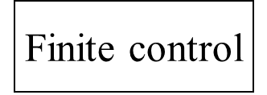

....... | # | # | X₁ | X₂ | ….. | X_{i} | …. | X_{n} | # | # | …....

- In one move the TM, depending upon the symbol scanned by the tape head TM will:
  - Change state, which may be the same as the current state
  - Write a tape symbol in the current cell, which may be the same as the current symbol
  - Move the tape head left or right one cell or stationary(static)
  - The special states for rejecting and accepting take effect immediately

- Formally, the Turing Machine is denoted by the 8-tuple:
  - M = (Q, ∑, Γ, δ, q₀ , #, q_{a})
- Q = finite states of the control
- ∑ = finite set of input symbols, which is a subset of Γ below
- Γ = finite set of tape symbols
- δ = transition function. δ(q,X) are a state and tape symbol X. The output is the triple, (p, Y, D)
Where p = next state, Y = new symbol written on the tape, D = direction to move the tape head D ∈ { L,R,S} ie., δ : Q X Γ to Q X Γ X {L,R,s}
- q₀= start state for finite control
- #( or B) = blank symbol. This symbol is in Γ but not in ∑.
- q_{accept} = set of final or accepting states of Q or halting state
TM always halts when it is in an accepting state.
.
Instantaneous Description
- The ID shows all non-blank cells in the tape, pointer to the cell the head is over with the name of the current state
  - use the turnstile symbol ├ to denote the move.
As before, to denote zero or many moves, we can use ├*
The ID of a TM M is denoted as α₁q α₂ . Here q is the current state of M is in Q; α1 α2 is the string in Ґ * that is the contents of the tape up to the rightmost nonblank symbol or the symbol to the left of the head, whichever is the rightmost
Multitape Turing Machines
- A multitape Turing machine is like an ordinary TM but it has several tapes instead of one tape.
- Initially the input starts on tape 1 and the other tapes are blank.
- The transition function is changed to allow for reading, writing, and moving the heads on all the tapes simultaneously.
This means we could read on multiples tape and move in different directions on each tape as well as write a different symbol on each tape, all in one move

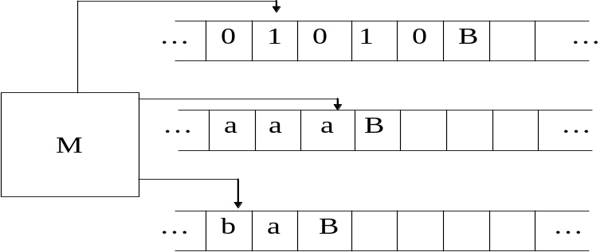

language accepted by TM?
The language accepted by M is L(M) , is the set of words in Σ * that cause M to enter a final state when placed ,justified at the left on the tape of M, with M at qo and the tape head of M at the leftmost cell. The language accepted by M is:
{ w | w in Σ * and q₀w |--- α1 p α2 for some p in F and α1 ,α2 in Ґ * }.
TM can accept the string by entering accepting state. It can reject the string by entering non-accepting state. It can enter an infinite loop so that it never halts.

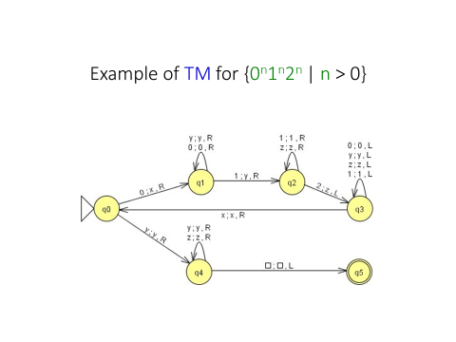
We use the simplicity of the TM model to prove formally that there are specific problems (i.e. languages) that the TM cannot solve. Three classes of languages:
  - Turing-decidable or recursive: TM can accept the strings in the language and tell if a string is not in the language. Sometimes these are called decidable problems.
  - the language accepted by non-deterministic Turing machine is same as recursively enumerable language
  - The languages that is accepted by TM is said to be recursively enumerable (r. e ) languages. Enumerable means that the strings in the language can be enumerated by the TM. The class of r. e languages include CFL’s.
  - The recursive sets include languages accepted by at least one TM that halts on all inputs.
- Recursive languages
- 1. A language is said to be recursive if and only if there exists a membership algorithm for it.
- 2. A language L is recursive iff there is a TM that decides L.
- (Turing decidable languages) that decide languages algorithms.
- Recursively enumerable languages

- 1. A language is said to be regular expression if there exists a TM that accepts it.

- 2. L is recursively enumerable iff there is a TM that semi-decides L.
- TMs (Turing acceptable languages) TMs are that semi-decides languages are not
- algorithms.

  - Turing-recognizable or recursively enumerable : TM can accept the strings in the language but cannot tell for certain that a string is not in the language. Sometimes these are called partially-decidable.
  - Undecidable : no TM can even recognize ALL members of the language.
  - r.e language is Turing acceptable and recursive language is Turing decidable languages.
  - Turing-decidable or recursive: TM can accept the strings in the language and tell if a string is not in the language. Sometimes these are called decidable problems.
  - Turing-recognizable or recursively enumerable : TM can accept the strings in the language but cannot tell for certain that a string is not in the language. Sometimes these are called partially-decidable.
  - Undecidable : no TM can even recognize ALL members of the language.

Applications of TM:
  - Recognizers of languages.
  - Computers of functions on non negative integers.
  - Generating devices.
Difference between 2-way FA and TM
Turing machine can change symbols on its tape , whereas the FA cannot change symbols on tape. Also TM has a tape head that moves both left and right side , whereas the FA doesn’t have such a tape head.
Turing machine construction techniques
• Storage in finite control : The finite control(FC) stores a limited amount of information. The state of the Finite control represents the state and the second element represent a symbol scanned.
• Multiple tracks.
• Checking off symbols: Checking off symbols is useful method when a TM recognizes a language with repeated strings and also to compare the length of substrings.
(eg) : { ww | w Є Σ * } or {a^{i}b^{i} | i>=1}.
This is implemented by using an extra track on the tape with symbols Blank or √.

• Shifting over : A Turing machine can make space on its tape by shifting all nonblank symbols a finite number of cells to the right. The tape head moves to the right , repeatedly storing the symbols in the FC and replacing the symbols read from the cells to the left. The TM can then return to the vacated cells and prints symbols.
- A multi-tape Turing machine consists of a finite control with k-tape heads and k- tapes ; each tape is infinite in both directions. On a single move depending on the state of finite control and symbol scanned by each of tape heads ,the machine can change state print a new symbol on each cells scanned by tape head, move each of its tape head independently one cell to the left or right or remain stationary.
- A multi-tape Turing machine consists of a finite control with k-tape heads and k-
tapes ; each tape is infinite in both directions. On a single move depending on the state of finite control and symbol scanned by each of tape heads ,the machine can change state print a new symbol on each cells scanned by tape head, move each of its tape head independently one cell to the left or right or remain stationary.

• Subroutines.
- Multi-head TM:A k-head TM has some k heads. The heads are numbered 1 through k, and move of the TM depends on the state and on the symbol scanned by each head. In one move, the heads may each move independently left or right or remain stationary.
- 2-way infinite tape TM: the tape is infinite in both directions. The leftmost square is not distinguished. Any computation that can be done by 2-way infinite tape can also be done by standard TM.
- different types of Turing machines.
- two way finite tape TM
- multi tape TM
- nondeterministic TM
- multi dimensional TM
- multihead TM

- TM used as a transducer?
- A TM can be used as a transducer. The most obvious way to do this is to treat the entire nonblank portion of the initial tape as input , and to treat the entire blank portion of the tape when the machine halts as output. Or a TM defines a function y=f(x) for strings x ,y Є Σ* if: q₀X | --- q_{f}Y, where q_{f} is the final state.
Universal TMs are TMs that can be programmed to solve any problem, that can be solved by any Turing machine. A specific Universal Turing machine U is:
Input to U: The encoding “M “ of a Tm M and encoding “w” of a string w.
Behavior : U halts on input “M” “w” if and only if M halts on input w.

- Church’s Hypothesis?
The notion of computable function can be identified with the class of partial recursive functions is known as Church-hypothesis or Church-Turing thesis. The Turing machine is equivalent in computing power to the digital computer.
THE CHURCH-TURING THESIS
Every computational process that is intuitively considered to be an algorithm can be converted to a Turing machine.
or
Anything that can be computed by algorithm (in our intuitive sense of the term “algorithm”)can be computed by a Turing Machine.
- Any mechanical computation can be performed by a Turing Machine
- There is a TM-n corresponding to every computable problem
- We can model any mechanical computer with a TM
- The set of languages that can be decided by a TM is identical to the set of languages that can be decided by any mechanical computing machine
- If there is no TM that decides problem P, there is no algorithm that solves problem P.

Excercises:
- Design a TM to perform proper subtraction.
2. Design a TM to accept the language L={0^{n}1^{n} | n>=1}
3. Explain how a TM can be used to determine the given number is prime or not.
It takes a binary input greater than 2,written on the first track, and determines whether it is a prime. The input is surrounded by the symbol $ on the first track. To test if the input is a prime, the TM first writes the number 2 in binary on the second track and copies the first track on to the third. Then the second track is subtracted as many times as possible, from the third track effectively dividing the third track by the second and leaving the remainder.
If the remainder is zero, the number on the first track is not a prime. If the remainder is non zero,the number on the second track is increased by one. If the second track equals the first,the number on the first track is the prime. If the second is less than first,the whole operation is repeated for the new number on the second track.
- Construct a turing machine for the language of even number of 1’s and even number of 0’s over Σ = {0,1}
- Construct a turing machine for concatenation of the two strings of unary numbers.
- Construct a turing machine for reversing a binary string on the input tape.

- State and explain RICE theorem.
- Explain about Post’s correspondence problem

THE HALTING PROBLEM

The Halting Problem (Set Halt)-Given an arbitrary machine M and starting configuration C, does M halt eventually when started on C

HALT_{TM} = { (M,w) | M is a TM that halts on string w }
Theorem: HALT_{TM} is undecidable
Assume, for a contradiction, that TM H decides HALT_{TM}
We use H to construct a TM D that decides A_{TM}
On input (M,w), D runs H on (M,w)
If H rejects then reject
If H accepts, run M on w until it halts:
Accept if M accepts and
Reject if M rejects

Rice’s Theorem
we prove that many languages involving Turing machines (or Java
programs) are undecidable.
Define T to be the set of binary encodings of all Turing machines, i.e.,
T = {hMi : M is a Turing machine with input alphabet {0,1}}
Theorem 5.3.1 (Rice) Let P be a subset of T such that
1. P 6= ;, i.e., there exists a Turing machine M such that hMi 2 P,
2. P is a proper subset of T , i.e., there exists a Turing machine N such
that hNi 62 P, and
3. for any two Turing machines M1 and M2 with L(M1) = L(M2),
(a) either both hM1i and hM2i are in P or
(b) none of hM1i and hM2i is in P.
Then the language P is undecidable.

Post Correspondence Problem
- Many problems related to grammars can be shown to be no more complex than the Post Correspondence Problem (PCP).
- Each instance of PCP is denoted: Given n>0, Σ a finite alphabet, and two n-tuples of words
( x₁, … , x_{n} ), ( y₁, … , y_{n} ) over Σ,
does there exist a sequence i₁, … , i_{k} , k>0, 1 ≤ i_{j} ≤ n, such that
x_{i1} … x_{ik} = y_{i1} … y_{ik} ?
- Example of PCP:
n = 3, Σ = { a , b }, ( a b a , b b , a ), ( b a b , b , b a a ).
Solution 2 , 3, 1 , 2
b b a a b a b b = b b a a b a b b
Linear Bounde

Linear-bounded automatad Automata Linear Bounded Automata
- A Turing machine that uses only the tape space occupied by the input is called a linear-bounded automaton (LBA).
A linear bounded automaton (lba) is a multi-track Turing
machine which has only one tape, and this tape is exactly the same length
as the input. computation is restricted to an area bounded by a
constant (the number of tracks) times the length of the input. This is very
much like a programming environment where the sizes of values for variables is
bounded.

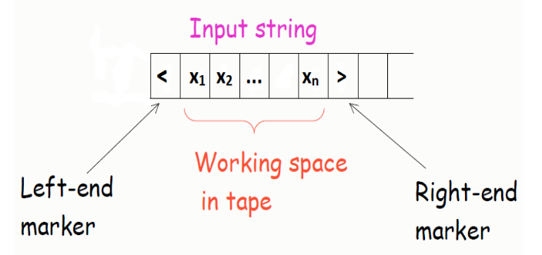

An lba configuration is the same as a Turing machine configuration and consists of:
a) an instruction,
b) the tape head's position, and
c) the content of the tape.A linear bounded automaton is a nondeterministic Turing machine
M = (Q;_; 􀀀; _; s; t; r ) such that:
There are two special tape symbols < and >(the left end marker and right end marker).
The TM begins in the con_guration (s;< x >; 0).
The TM cannot replace < or > with anything else, nor move the tape head left of < or right of >.
Suppose that a given LBA M has q states, m characters in the tape alphabet , and the input length is n.

For any nondeterministic linear bounded automaton there is another which can locate and examine m configurations reachable (by the first lba) from some input if there are at least m reachable configurations.

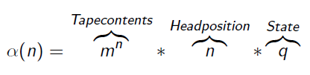
A language is accepted by an LBA i_ it is context sensitive.
If L is a CSL, then L is accepted by some LBA.
Derivation simulates moves of LBA
Three types of productions
1 Productions that can generate two copies of a string in __, along with some symbols that act as markers to keep the two copies separate.
2 Productions that can simulate a sequence of moves of M. During this portion of a derivation, one of the two copies of the original string is left unchanged; the other, representing the input tape to M, is modi_ed accordingly.
3 Productions that can erase everything but the unmodifi_ed copy of the string, provided that the simulated moves of M applied to the other copy cause M to accept.
Indu

Computational Complexity
Complexity of Computation & Complexity Classes
two types of Complexities:
Time Complexity
Space Complexity.
By time/space complexity we mean the time/space as a function of input size required by an algorithm to solve a problem.
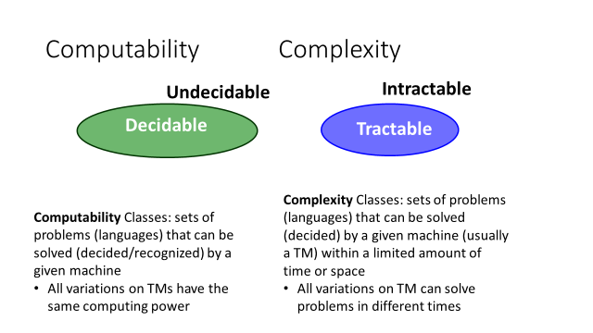
Tractable: “Decidable in a reasonable amount of time and space
- intractable:
as they grow large, we are unable to solve them in reasonable time
- What constitutes reasonable time?
  - Standard working definition: polynomial time
  - On an input of size n the worst-case running time is O(n^{k}) for some constant k
  - O(n²), O(n³), O(1), O(n lg n), O(2^{n}), O(n^{n}), O(n!)
  - Polynomial time: O(n²), O(n³), O(1), O(n lg n)
  - Not in polynomial time: O(2^{n}), O(n^{n}), O(n!)
  - O( f ), Ω( f ), o( f ), Θ( f )
    - General notations y: functions from positive integer to real
  - Big O
  - Intuition: the set O(f) is the set of functions that grow no faster than f
  - Asymptotic growth rate
    - As input to f approaches infinity, how fast does value of f increase
  - Omega (Ω): the set Ω(f) is the set of functions that grow no slower than f
- The complexity of a problem is the complexity of the best possible algorithm with the lowest order of growth of complexity for solving that problem or performing that task
- Input size: number of tape squares it takes to write down the input
- Running time: number of steps it takes before TM enters a final state
- Input size = log m
- Computational Complexity: deals with classifying problems by how hard they are.
- Necessary condition for an algorithm to be efficient is that it should run in poly-time
Problems are categorized into 2 types
(i) Decision Problem- Given an input and a question regarding a problem, determine if the answer is yes or no
Eg: Let ∑ be a set of alphabets and let L ⊆ ∑* be a language. Given a string x ∈ L or x ∉ Lis decision problem
(ii) Optimization Problem- Find a solution with the “best” value
Complexity classes:
The basic idea for problem classification based on whether there exists a polynomial-time (computer) algorithm that can provide the solution to a problem
P-problem: A problem is assigned to the P-problem (polynomial time) class if the number of steps needed to solve it, is bounded by some power of the problem's size. A problem is assigned to this class if the number of steps is bounded by a polynomial.
The class P comprises of all languages L ⊆ ∑* such that there exist a polynomial time algorithm A to decide L. In other words given a string x ∈ ∑* the algorithim A can determine in timep(|x|) whether x ∈ L or x ∉ L.
i.e.,A decision problem D is solvable in polynomial time or in the class P, if there exists an algorithm A such that
- A takes instances of D as inputs.
- A always outputs the correct answer “Yes” or “No”.
- There exists a polynomial p such that the execution of A on inputs of size n always terminates in p(n) or fewer steps.
- P is the class of languages that can be decided in Polynomial Time on a deterministic, single-tape Turing machine.
- Class of languages that can be decided in Polynomial Time by a 2-tape TM
- The class of all sets L that can be recognized in polynomial time.
- The class of all decision problems that can be decided in polynomial time.
- Fractional Knapsack
- MST
- Sorting
Computationally Tractable – Intractable Problems
A problem is computationally tractable if there exists an algorithm of polynomial complexity for all instances and solves the problem. Conversely, a problem is computationally intractable (also computationally complex or computationally hard) if the (provably) optimal algorithm for solving the problem cannot solve all of its instances in polynomial time.
Deterministic algorithms are where no step is random. If the program/algorithm chooses a step non-deterministically such that it is always the right choice, then such an algorithm is called non-deterministic algorithm.

NP-problem: A problem is called NP (nondeterministic polynomial) if its solution (if one exists) can be guessed and verified in polynomial time; nondeterministic means that no particular rule is followed to make the guess. A problem is assigned to the NP-problem (nondeterministic polynomial time) class if it permits a nondeterministic solution and the number of steps of the solution is bounded by some power of the problem's size. The class of P-problems is a subset of the class of NP-problems

The class NP comprises of all language L ⊆ ∑ * such that given a string x ∈ L a proof of the membership of x ∈ L can be found and verified in time p(|x|).
The class Co-NP comprises of all language L ⊆ ∑* such that ∑*- L ∈NP.
Note: We can easily verify CO-P=P and thus P ⊆NP ∩ CO-NP.
- P and NP
- P corresponds to a class of problems that can be solved in polynomial time
- NP corresponds to a class of problems whose solution can be checked in polynomial time.
- P=NP?
- We know that P is a subset of NP
- Whether NP is also a subset of P, is not known.
Probably false, but nobody has been able to prove
The class PSPACE comprise of all languages L ⊆ ∑ * such that there exists an algorithm A that uses polynomial working space with respect to the input size to decide L. In other words given a string x ∈ ∑* the algorithm A can determine using space, i.e., p(|x|) whether x ∈ L or x∉ L.
We will state without proof the following result that follows from Savitch’s theorem:
PSPACE=NSPACE
Polynomial Time reducibility:
A language L₁⊆ ∑ * is said to be polynomial time reducible to L₂ ⊆∑ * if there is a polynomial time computable function f ( ) such that ∀ x ∈ ∑*, x ∈ L₁ if and only if f (x) ∈ L₂ . We denote this by L₁ ∝_{p}L₂. we can clearly observe that polynomial time reductions are transitive.
- We say that problem A is easier than problem B, (i.e., we write “A ≤_{p} B”)
if we can solve A using the algorithm that solves B.
- Idea: transform the inputs of A to inputs of B
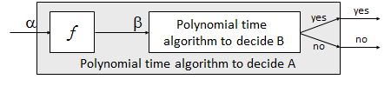
- Use a polynomial time reduction algorithm to transform A into B
- Run a known polynomial time algorithm for B
- Use the answer for B as the answer for A
Language L is polynomial-time reducible to language M if there is a function computable in polynomial time that takes an input x of L and transforms it to an input f(x) of M, such that x is a member of L if and only if f(x) is a member of M.
Let E and D be two decision problems. We say that D is polynomial-time reducible to E if there exists an algorithm A such that
- A takes instances of D as inputs and always outputs the correct answer “Yes” or “No” for each instance of D.
- A uses as a subroutine a hypothetical algorithm B for solving E.
- There exists a polynomial p such that for every instance of D of size n the algorithm A terminates in at most p(n) steps if each call of the subroutine B is counted as only m steps, where m is the size of the actual input of B.

Completeness:
A language L ⊆∑* is said to be complete with respect to any complexity class C if all problems in that complexity class C can be reduced to L.Thus we formally define the notion of NP-Completeness.
NP-complete: NP-complete problems is related to polynomial-time reducibility. Any NP-complete problem can be transformed into any other NP-complete problem in polynomial time. Thus, if it could be proved that any NP-complete problem is formally intractable, all such problems would have proved intractable, and vice-versa.
Q is an NP-Complete problem if:
1) Q is in NP … Q ∈ NP
2) every other NP problem polynomial time reducible to Q …. A ≤_{p} Qfor all A ∈ NP

A decision problem E is NP-complete if every problem in the class NP is polynomial-time reducible to E
A language L ⊆ ∑ * is said to be NP-Complete if
(i) L∈NP
(ii) ∀L′∈NP, we have L′ ∝_{p} L.
The above definition is not very suitable to prove a language L to be NP-Complete since we have infinitely many language in the class NP to be reduced to L. Hence for providing NP-Completeness we resort to the following equivalent definition.
Eg:-SATISFIABILITY problem.

- NP-complete problems.
- A problem PI1 is NP complete, if every problem in NP can be reduced to PI1 in polynomial time.
- That means if you solved PI1, you solved every problem in NP.
- First problem that was proven to be NP-complete was CNF satisfiability. Given a logical expression in conjunctive normal form, is there an assignment for the logical variables for which the expression will evaluate to true.
- Cook proved that CNF-satisfiability is NP-complete
- Since then 1000’s of problems have been shown to be NP-complete.
- If you can show that one NP-complete problem PI can be solved in polynomial time, you have proven that P=NP. Because all the other problems can be reduced (using a polynomial reduction) to PI and solved in polynomial time.

- Hamiltonian cycle problem (HCP)
A Hamiltonian circuit (HC) is a cyclic ordering of a set of nodes such that there is an edge connecting every pair of nodes in the graph in order. The cyclic condition ensures that the circuit is closed, and the requirement that all the nodes are included (with no repeats) ensures that the circuit does not cross over itself, and passes through every node. The problem is to find if a HC exists for a given graph, thus determining if a given graph has a cycle visiting each vertex exactly once. This is considered to be the Hamiltonian cycle problem.
- Travelling salesman problem (TSP):
Given a graph in which the nodes (cities) are connected by directed edges (routes), where the weight of an edge is the distance between two cities, the problem is to find a path that visits each city once, returns to the starting city, and minimizes the distance travelled. The only known solution that guarantees the shortest path, requires a solution time that grows exponentially with the problem size (i.e., number of cities). This is an example of an NP-complete problem, for which no known efficient (i.e., polynomial time) algorithm exists.
Other well-known NP-problems are: the Graph coloring problem, the Independent set problem, the Bin packing problem, the Satisfiability problem (SAT), the 3-Satisfiability problem (3SAT), the Maximum clique problem, and others.

NP-hard: A problem is NP-hard if an algorithm for solving it can be translated into one for solving any other NP-problem (nondeterministic polynomial time) problem. The NP-hard class is a superset containing the NP-complete
If a problem is NP and all other NP problems are polynomial-time reducible to it, the problem is NP-complete. Thus, finding an efficient algorithm for any NP-complete problem implies that an efficient algorithm can be found for all such problems, since any problem belonging to this class can be transformed to any other member of the class.
- A problem B is NP-Hard if:
A ≤_{p} B for all A ∈ NP
- NP-Hard are problems that are at least as hard as the hardest problems in NP.
- Note that NP-Complete problems are also NP-hard.
- NP hard problems
- These are problems whose solution cannot be checked in polynomial time.
- Usually,optimization problems
- Can a given graph be colored with k-colors? (NP complete)
- What are the minimum number of colors required to color a graph? (NP hard)
- If we can solve an NP hard problem in polynomial time, we can solve all the NP-complete problems in polynomial time (P=NP). Example:
- find the minimum number of colors required to color a graph (NP-hard) in polynomial time,
- if the graph can be colored with k-colors (NP-complete) in polynomial times.
- one NP-complete problem solved in polynomial time, we can solve all NP-complete problems in polynomial time.
- Decidable problems are those for which you can write an algorithm
- These problems are called undecidable (Turing)
- Halting problem
- Blank tape problem

Cook’s Theorem
Cook’s theorem states that the satisfiability problem is NP-complete.
We assume that languages in NP are over the alphabet {0, 1}* .
Lemma 1, states that we can restrict the form of a computation of a NTM that accepts languages in NP.
Lemma 1 If L ∈ NP, then L is accepted by a 1-tape NTM N with alphabet {0, 1} such that for
some polynomial p(n), the following properties hold.
• N’s computation is composed of two phases, the guessing phase and the checking phase.
• In the guessing phase, N nondeterministically writes a string #y directly after the input
string, and in the checking phase, N behaves deterministically.
• N uses at most p(n) tape cells, never moves its head to the left of w, and takes exactly p(n)
steps in the checking phase.
A Boolean formula f over variable set V is in conjunctive normal form (CNF) if
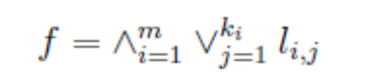
for some values of m and ki, 1 <= i<= m, where literal l_{i,j} is either x or for some x ∈ V .
For each i, the term 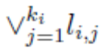 is called a clause of the formula.
f is satisfiable if there exists a truth assignment to the variables in V that sets f to true.
CNFSAT is the set of satisfiable Boolean formulas in CNF.
Theorem 1 (Cook’s Theorem) CNFSAT is NP-complete.
Proof sketch:. To prove that CNFSAT is NPcomplete, we show that for any language
L ∈ NP, L ≤_{p} CNFSAT.
Let L ∈ NP and let N be a NTM accepting L that satisfies the properties of Lemma 1. Let
the transition function of N be δ . Let the states of N be q0, ..., qr. Let s0, s1, s2 denote 0, 1, #,
respectively. Assume that the tape cells are numbered consecutively from the left end of the input,
starting at 0. On input w of length n, we show how to construct a formula in CNF form fw, which
is satisfiable iff w is accepted by N. The variables of fw are as follows:
Variables Range Meaning
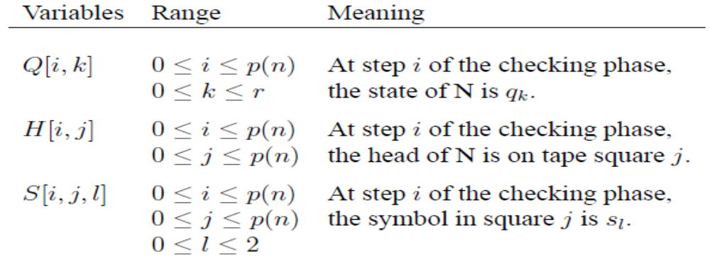

A computation of N naturally corresponds to an assignment of truth values to the variables.
Other assignments to the variables may be meaningless. For example, an assignment withQ[i, k] =
Q[i, k0] = true, k 6= k0, would imply that N is in two different states at step i, which is impossible.
Our goal is to construct fw so that it is satisfied only by assignments to the variables that
correspond to accepting computations of N on w. The clauses of fw are constructed to ensure that
the following conditions are satisfied:
1. At each step i of the checking phase, N is in exactly 1 state.
2. At each step i, the head is on exactly one tape square.
3. At each step i, there is exactly 1 symbol in each tape square.
4. At step 0 of the checking phase, the state is the initial state of N in its checking phase, and
the tape contents are w # y for some y.
5. At step p(n) of the checking phase, N is in an accepting state.
6. The configuration of N at the (i + 1)st step follows from that at the i^{th} step, by applying the
transition function of N.
Consider condition 1. For each i, we have the following clause:
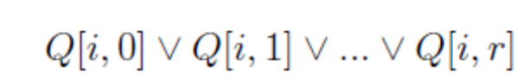

This clause ensures that the machine is in at least 1 state at step i. We also need clauses to ensure
that N is not both in state qj and qj0 :

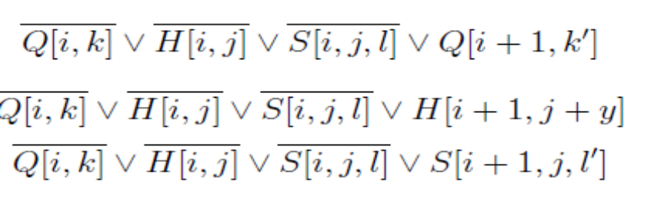
All of the clauses for condition 1 to 6 can be computed in polynomial
w is accepted by N if and only if fw is satisfiable.

