1. vi /etc/ssh/sshd_config 🡨 Disable direct root login
2. systemctl restart sshd
3. passwd b80944 🡨 Change password to a simple password (R00tProd)
4. subscription-manager register
5. subscription-manager auto-attach
6. subscription-manager attach
7. cat /etc/os-release
8. yum update
9. sestatus
10. vi /etc/sysconfig/selinux 🡨 Disable selinux

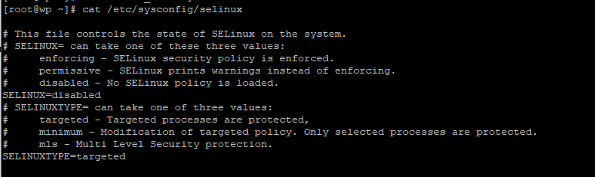

1. systemctl disable firewalld
2. iptables -L
3. yum update 🡨 Apply patches
4. shutdown -r now
5. subscription-manager repos --enable rhel-server-rhscl-7-rpms 🡨 Red Hat Software Collections channel repository

PHP 5.6 version in RHEL 7

<https://access.redhat.com/solutions/2705621>

1. yum install rh-mariadb103-mariadb.x86_64
2. yum install rh-mariadb103-mariadb-server.x86_64
3. systemctl status rh-mariadb103-mariadb
4. systemctl start rh-mariadb103-mariadb
5. systemctl enable rh-mariadb103-mariadb
6. /opt/rh/rh-mariadb103/root/usr/bin/mysql_secure_installation
7. yum install rh-php73-php.x86_64
8. yum install rh-php73-php-mysqlnd.x86_64
9. yum install httpd24-httpd

What is the difference between httpd versions in RHEL?

<https://access.redhat.com/solutions/1439113>

1. find / -name httpd.conf
2. vi /opt/rh/httpd24/root/etc/httpd/conf/httpd.conf
3. cd /opt/rh/httpd24/root/var/www/html
4. chgrp apache /opt/rh/httpd24/root/var/www/html
5. wget <http://wordpress.org/latest.tar.gz> <--- Log onto PC browser and copy the link
6. gunzip latest.tar.gz
7. mv latest.tar /home/b80944/
8. cd /home/b80944/
9. tar -xvf latest.tar
10. rsync -rv ./ /opt/rh/httpd24/root/var/www/html
11. cd /opt/rh/httpd24/root/var/www/html
12. chmod -R g+w .
13. /opt/rh/rh-mariadb103/root/usr/bin/mysql -u root -p

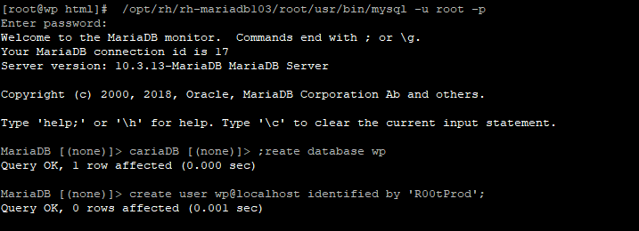

MariaDB [(none)]> create database wp ;

Query OK, 1 row affected (0.000 sec)

MariaDB [(none)]> create user wp@localhost identified by 'R00tProd';

Query OK, 0 rows affected (0.001 sec)

MariaDB [(none)]> create user wp@localhost identified by 'R00tProd';

Query OK, 0 rows affected (0.001 sec)

MariaDB [(none)]> grant all privileges on wp.* to wp@localhost;

Query OK, 0 rows affected (0.000 sec)

MariaDB [(none)]> flush privileges;

Query OK, 0 rows affected (0.000 sec)

MariaDB [(none)]> quit

Bye

1. systemctl status httpd24-httpd.service
2. systemctl start httpd24-httpd.service
3. systemctl enable httpd24-httpd.service
4. systemctl status httpd24-httpd.service
5. Put in the public IP f the server.

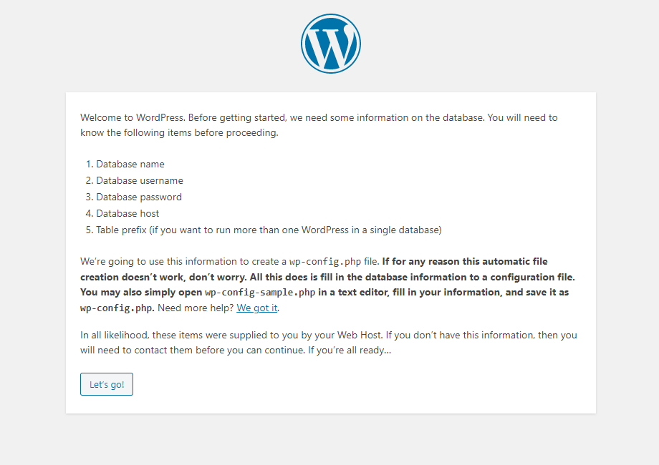

2.

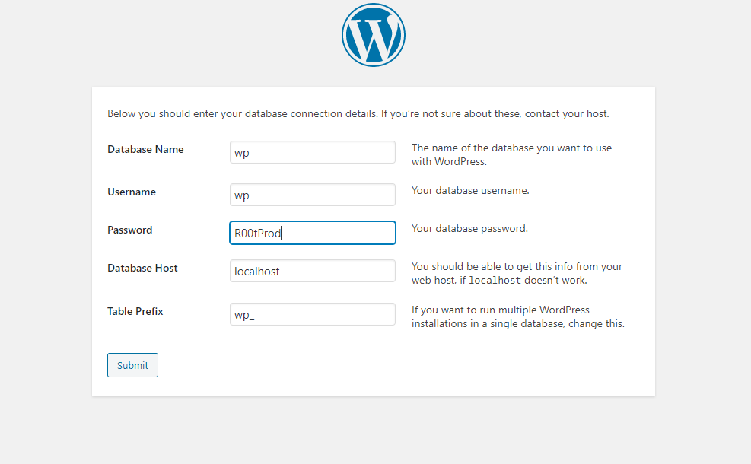

3.

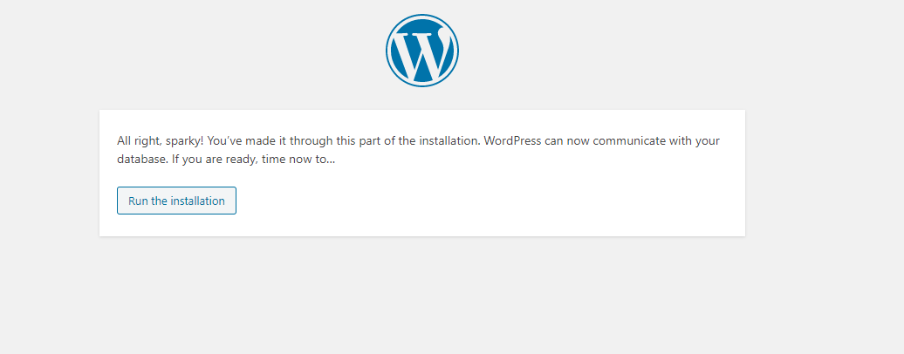

4.

