**Example 1 Solved**

When a procedure has a pop-up message to the user, some of our customizations are missing. Look at the screenshot below, notice the application in the task bar...  
  
1) The logo is the default "K" matching the message Icon.  
2) The name shown in the task bar is "Kaseya Agent Servic..." instead of our company name.

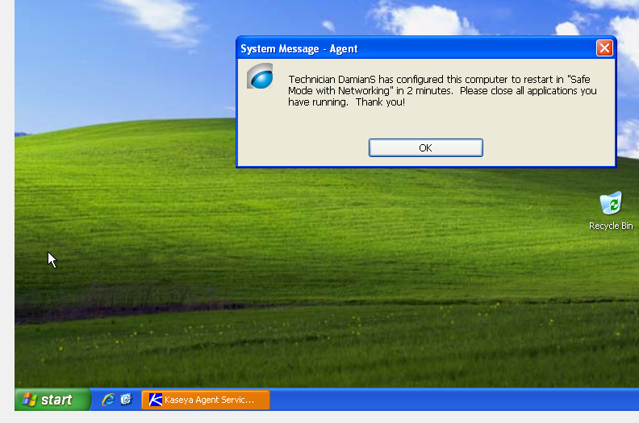

After checking that the customizations icons I had uploaded were working and the agent was up to date.

We went to Community.Kaseya.com under the Knowledge Base area.

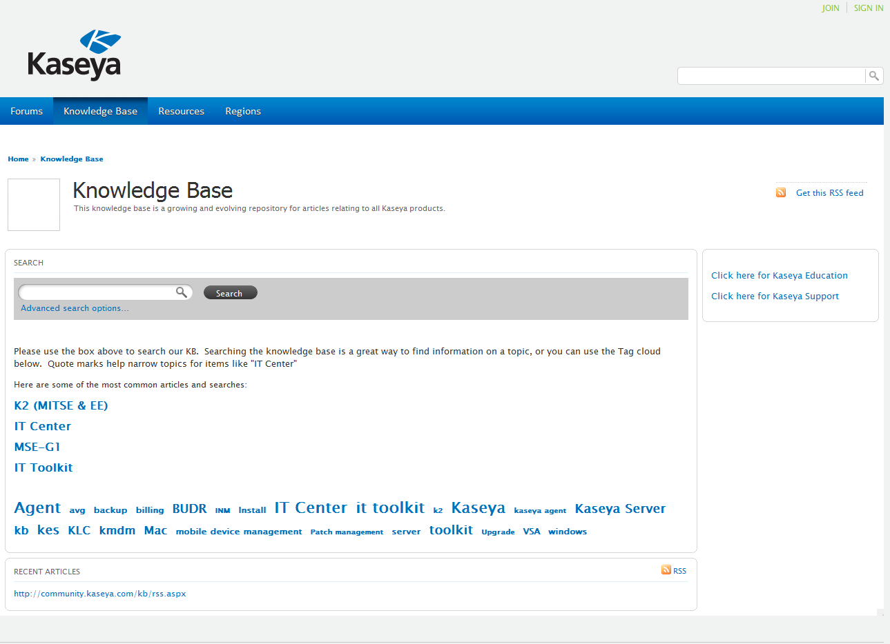

After a quick search we find the following post about Agent updates.

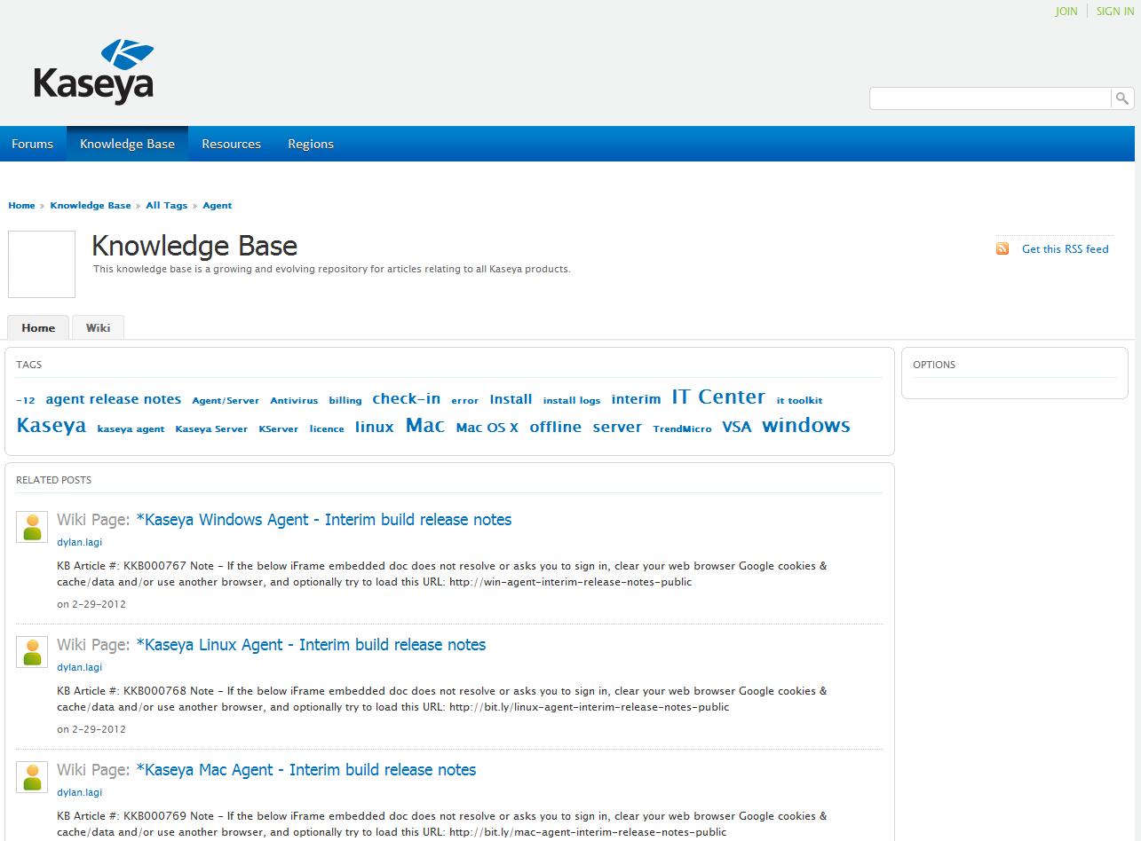

Within the first post we find the following information.

==================================================

**Kaseya K2 v6.2.0.0 Windows Agent - Interim build release notes**

*6.2.0.3*

AgentMon.exe - Fixed files being redirected to VirtualStore folder in Write File command on 64-bit systems. Include new crypto library support.

*6.2.0.2*

AgentMon.exe - Fixed bug that was causing the Security Products audit to be blank on XP because the WMI info is in a different namespace.

*6.2.0.1*

KaUsrTsk.exe, AgentMon.exe - Fix icon showing up in taskbar when displaying script message (Name branding issue).

KEventLog.dll - Fixed issue with audit log types returned when information type is selected.

==================================================

As can be seen the problem we are having is fixed with version 6.2.0.1 as we always want to be with the latest update. We locate the following information on how to update the agent to the newest version.

==================================================

Update your Windows version to the latest v6.2 version for these particular machines. Download this updated Agent install build here:  
  
Win - http://dl.kaseya.com/download/support/agents/windows/kagentsilent/6203/kagentsilent.zip  
See this Wiki KB Article for updating Agent Installation files + updating already installed previous Agent versions:  
<http://community.kaseya.com/kb/w/wiki/manually-update-agent-installation-files.aspx>

==================================================

We perform the update as per the instructions and then push the new agent version to our machines. Testing our message again we find the error is corrected on our machines. With just a simple search we were able to correct the problem, and avoid a ticket that could have taken important time.