

512-bit test: “512-bit palintext block for ex. 2 Encryption and Operation Modes”

In HEX: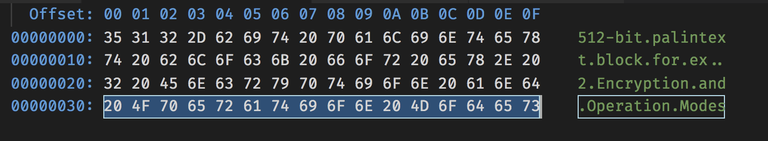

128-bit key: “encyption_key128”

HEX:

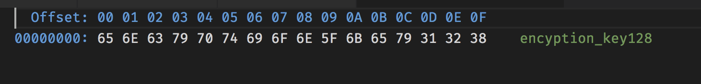

Algoryth:

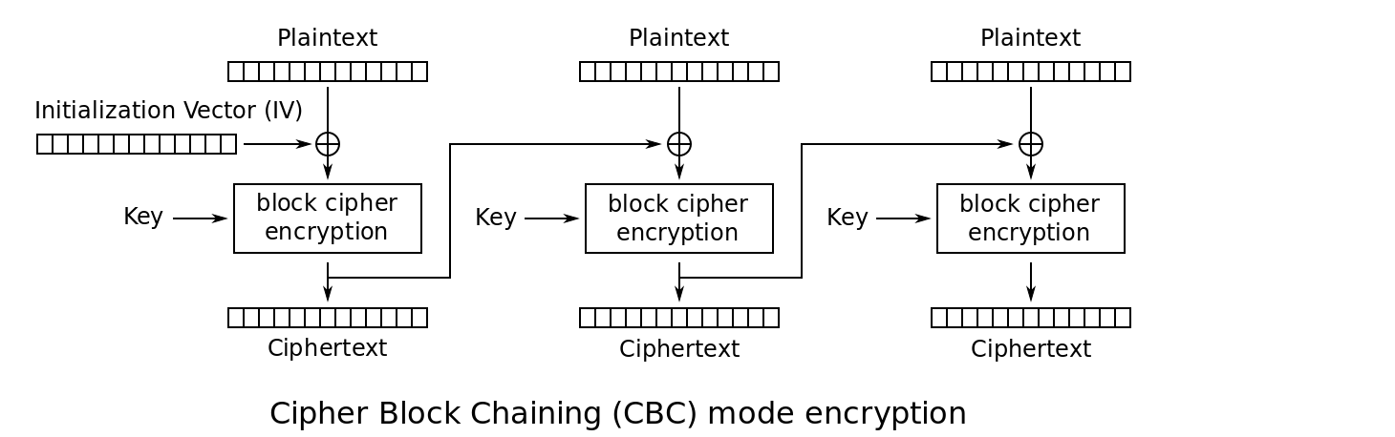

HEX_key:

656E63797074696F6E5F6B6579313238

First Step (at first step we don’t have Initialization Vector – use 00000000000000000000000000000000):

**1st block plaintext:**

**3531322D6269742070616C696E746578**

**XOR**

**00000000000000000000000000000000**

**Result:**

**3531322D6269742070616C696E746578**

Ciphertext in hex:

89803093dde97ad6ad5a588d55002632

Second Step:

**2nd block palintex:**

**7420626C6F636B20666F722065782E20**

**XOR**

**89803093dde97ad6ad5a588d55002632**

**Result XOR:**

**fda052ffb28a11f6cb352aad30780812**

Ciphertext in hex:

aa9cd8d59036e4aa28ab3a502fb0a2d9

**3rd block palintex:**

**3220456E6372797074696F6E20616E64**

**XOR**

**aa9cd8d59036e4aa28ab3a502fb0a2d9**

**Result XOR:**

**98bc9dbbf3449dda5cc2553e0fd1ccbd**

Ciphertext in hex:

67dcb534df63bb39242defa17fa38e90

**4th block palintex:**

**204F7065726174696F6E204D6F646573**

**XOR**

**67dcb534df63bb39242defa17fa38e90**

**Result XOR:**

**4793c551ad02cf504b43cfec10c7ebe3**

Ciphertext in hex:

994b2e77f1243e419b72b43441929156

If I correctly understand- answers: bold and navy font