# Changelog RelevantAds Zoiper Application

Version 0.3.0 – 0.4.0 (12.03.‎2017, 5:22:01)

Common

* Add incoming calls dialog. User can Accept or Reject call. Call will be save to Activities. If phone of caller was find in database – get Client from database, if phone no exist in database – create new client.
* Add settings for SIP account.
* Notes for clients and activities now are changeable and multiline.
* DB: Phone field change from string to long.
* Add Time of Activity column instead of End Time column
* Change production connection string
* Add re-instanciate Zoiper connection

Version 0.2.0 (08.03.‎2017, 00:41:47)

Common

* Add Zoiper integration

GUI

* Add changelog document. Need click application version in top right corner for open:

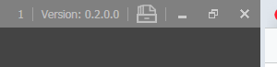

* Add button for open logs folder. Need click icon in top right corner for open:



* Clients screen:

1. Remove “Call” and “Hangup” buttons from bottom panel
2. Add “Call”, “Hold call”, “Unhold call” and “Hangup call” buttons near each client phone number:

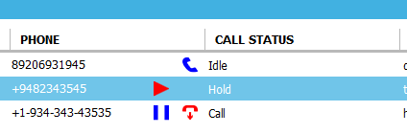

1. Add “Add Client” button to bottom panel. You can create your own clients for test calls (while CRM API with get clients not implemented):

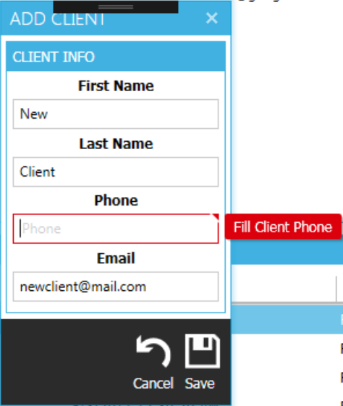

Version 0.0.1

Common

* First demo application