**My@yichu （Project: 我的@衣橱）**

**iSmarror**

iSmarroris a hardware that will be installed on the clothing store of the shopping mall. it could take a picture controlled by user's mobile phone. After users try a new clothing and take a look in front of the mirror. They can take a picture for compare and share to friend. The camera has been realized by a android app on the mobile phone. The mobile phone will be installed inside the mirror. The screen will be light off always for save energy.

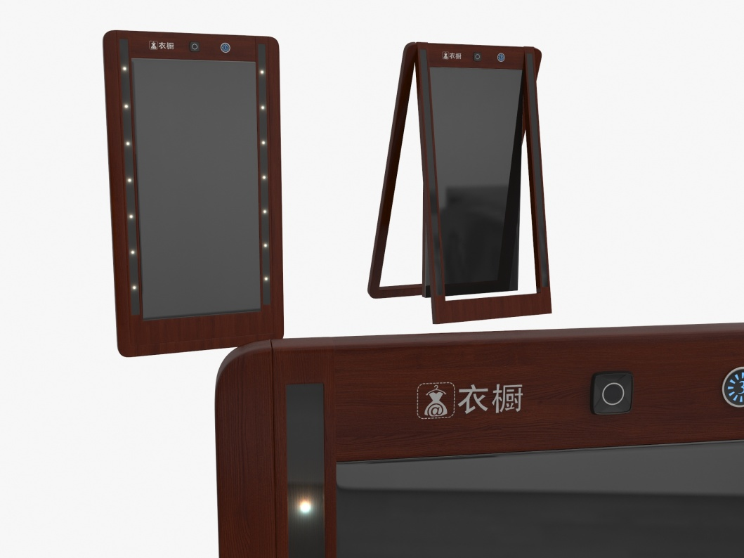

* Take a picture by user's mobile phone (Wechat App)
* Get the User ID who is take a picture
* Send the photo to sever with User ID and time/location info
* User Security: For example, only if the user near the iSmarror the user can control the camera and take a picture. After take a picture the user will be asked whether the user will take a picture again. If the user choose "yes", then the user could take a picture again. If the user choose "no", the camera could be controlled by other users.
* At same time if more than one users want to take a picture the iSmarror only will be controlled by one user. There will send a promotion to other users. The iSmarror will be controlled by the first user.
* Camera function.
  + focus
  + light
  + Save power

**User-end (Wechat)**

User could get the app just throuth follow our service account in wechat. Scan the QR-code by the wechat user can easily follow our service account and get the services.



After the users follow our service account in Wechat, the app will be added on user's Wechat.

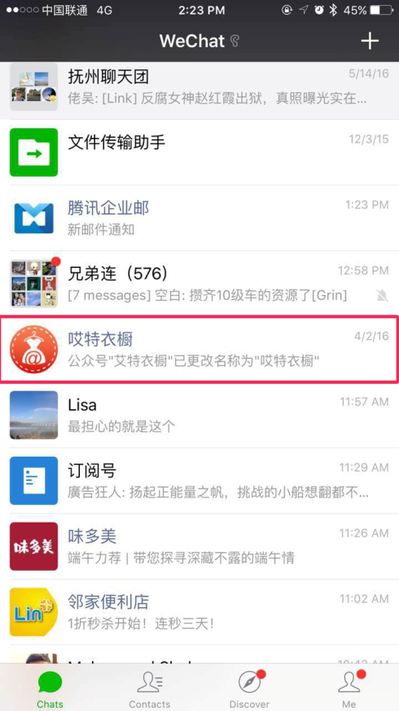

Open the app:

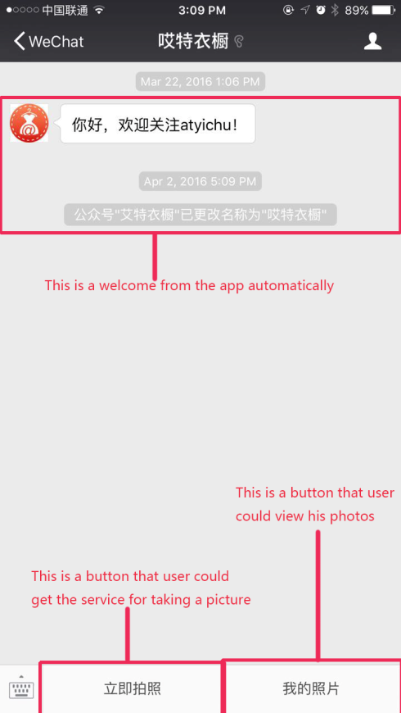

Clike the button "立即拍照"（“立即拍照” means "Take a picture" ）:

if there is a iSmarror beside of the user, there will display the list of the iSmarror. ("beside of the user" means there is a iSmarror avaliable in the security distance. We are setting the security distance is 50m juged by the GPS. The security distance also depend on the GPS. We just don't want some guy control the iSmarror remotely (for example 20km away) and take a picture. We think the security is very important for users.

* + iSmarror is available

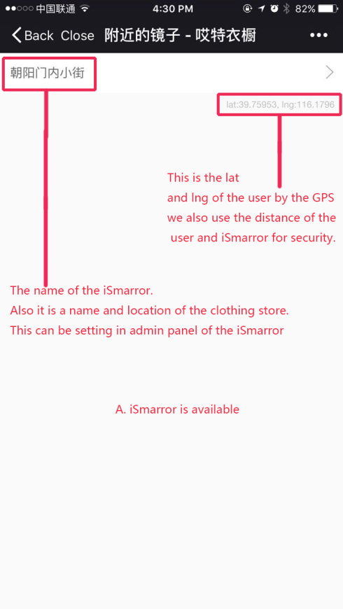

* + iSmarror is unavailable

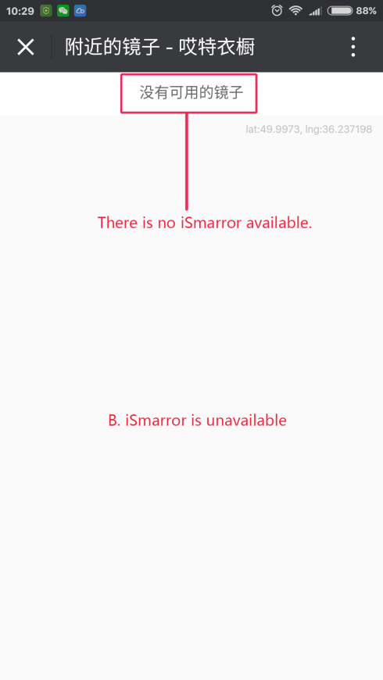

Select the iSmarror if there is a iSmarror available:

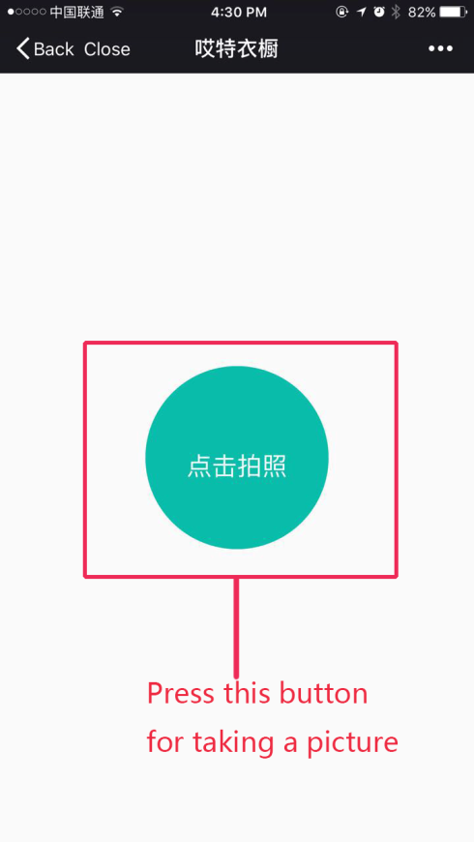

if the user press this button the iSmarror will take a picture 3 seconds later with a voice promotion.

After taking a picture there will be a promotion that does the user will take a picture again. If the user choose "YES" then taking a picture again. if the user choose "NO" . the iSmarror will be disconnected with the user.("disconnected" means the iSmarror will not be controlled by this user. On the technology the user could connected with the iSmarror by Bluetooth or network. But for us ,the user just send a request of taking a picture to Server and the Server will send the request to iSmarror. After the user take a picture the photo will be send to server and download by the user. We don't let user connect to the iSmarror directly by Bluetooth or other way . Because we think it is not user-friendly ).

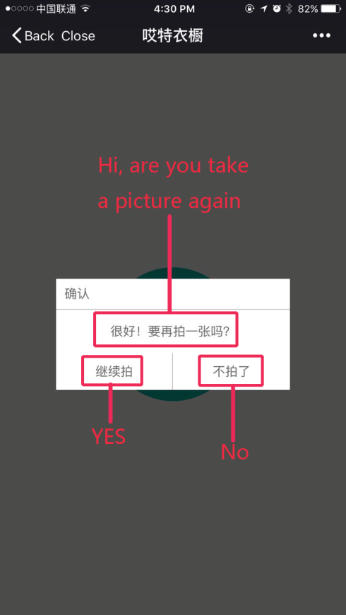

Clike the button "我的照片"（“我的照片” means "My Photos" ）:

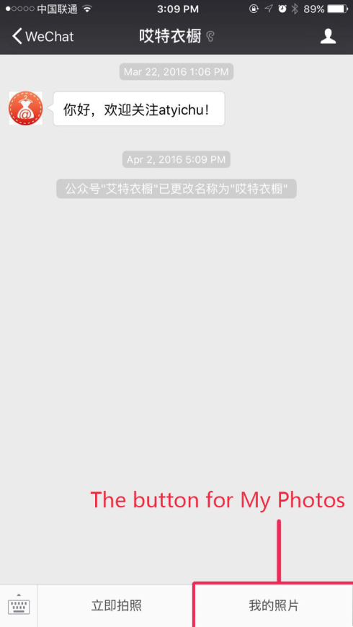

There will display the photos list.

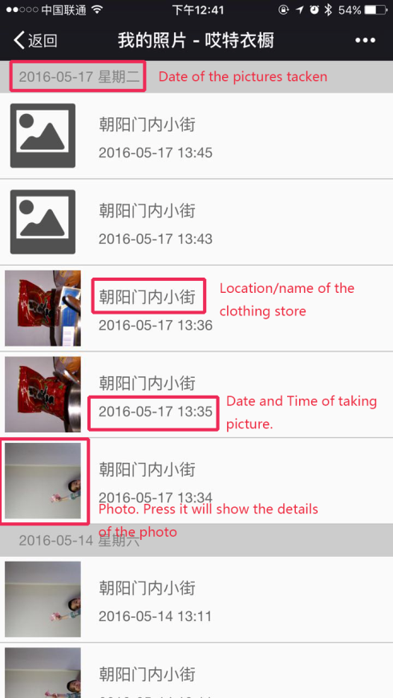

For now we have finish the main function of the app. (Wechat and Camera ) But there is still some problem.

1.User-friendly : theme according to the new design with angularjs.

2.User could add a comments on the photo.

3.Account system. (PLEASE CHECK MORE INFORMATION IN DEVELOPMENT DOCUMENTATION FOR WECHAT). The user also could login the website/iOS or Android App by same account .

4.Share the photos to friend by instant message or Wechat message.

5.Develop the website. The user also could view/share/edit/add comments for the photos on website.

6.Add clothing information by the RFID device. ( These will need be supported by the Business Center part)

We will provide the code that we have finished by other team. Also we will provide the new graphic design for website. "My Photo" is similar to the Pinterest.com.

The exits codes are develop by Python with REST based on Django.

The admin panel for iSmarror is: <http://www.atyichu.cn/aadminb/>