Magento – Order Decimal Factor Module

**This document will explain the flow of the module**

* The module is built on Magento CE 2.2.5
* In this module, we have to multiply the decimal factor with the total amount of the order.
* In Magento, whether order is paid or not, is determined by the order state i.e. if the order is in processing state then it shows that order is paid. We get the processing state when the invoice is created.
* In Magento, if the payment is done online (through PayPal, Stripe or Braintree etc.) then invoice is generated automatically but if it is paid by COD/money order (order status is pending) then in that case we have to generate the invoice from admin panel.
* So Decimal Factor module will store the order id, amount paid multiplied by decimal factor once the invoice is created or once the order is in “Processing State”

**Steps to install the module:**

1. Unzip the folder and copy the code from the folder “Netsolution” under app>code
2. After copying the code the structure should look like app > code > Netsolution > Orderdecfactor
3. After doing above steps please run the command “ php bin/magento setup:upgrade” through SSH
4. Then run the command “php bin/magento cache:flush”

**Steps to check the module on admin:**

1. Login to the admin , module settings will appear under “Stores > Configuration > Netsolution > General Configuration”, please check the screen shot as below:-

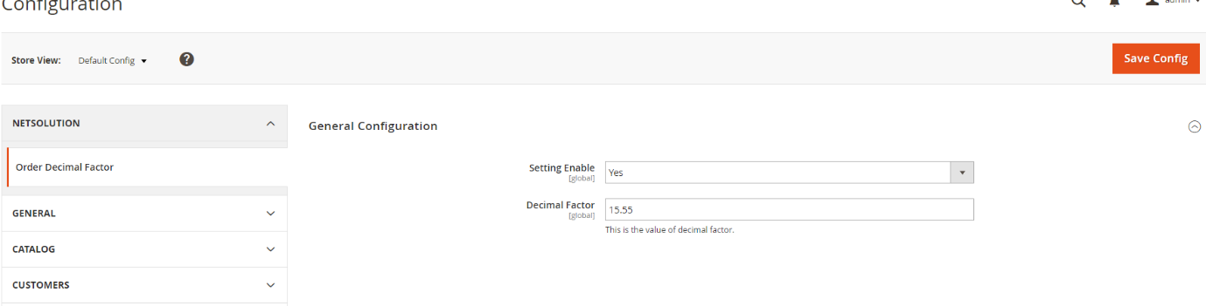

1. Save the settings, “Setting Enable” if set as “Yes” then the module will multiply the decimal factor with the order paid amount and store the value in database.
2. Decimal factor is the value, which will get multiply with order paid amount.
3. In database, we can check the table “netsolution_orderdecfactor” in which values are stored.
4. We have also created the grid in admin where we can check the values i.e. “Order Id”, ”Decimal Factor”, ”Amount Paid”, ”Final Value”.
5. To check the grid, please go to Admin > Netsolutions > Order Details. Please refer below screenshot for the same,

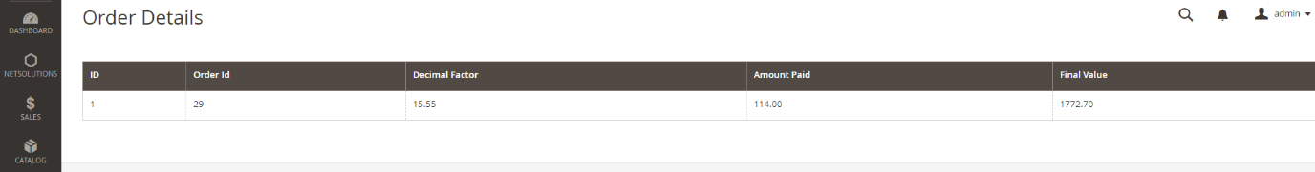

**How to Test:**

1) Place the order from frontend and complete the payment process.

2) If payment is done online then order state should be processing, it can be check from Admin > Sales > Orders > Status (in order listing).

3) If payment is done by COD/money order (order status: pending) then create the invoice manually from Admin > Sales > Orders > Order Detail > Click on Invoice from top menu and generate the invoice.

4) For the order status: “Processing” (Admin > Netsolutions > Order Details), you will see values related: order, decimal factor and final value.

Thank you

Net Solutions

Tel: +91-172-431-5000

Fax: +91-172-431-5003

Email: [info@netsolutionsindia.com](mailto:info@netsolutionsindia.com)

Web: <http://www.netsolutionsindia.com>